PROJECT

1.Introduction

1.1 Overview

Economic freedom is the fundamental right of every human to control his or her own labor and property. In an economically free society, individuals are free to work, produce, consume, and invest in any way they please. In economically free societies, governments allow labor, capital, and goods to move freely, and refrain from coercion or constraint of liberty beyond the extent necessary to protect and maintain liberty itself.

For much of human history, most individuals have lacked economic freedom and opportunity, condemning them to poverty and deprivation.

Today, we live in the most prosperous time in human history. Poverty, sicknesses, and ignorance are receding throughout the world, due in large part to the advance of economic freedom. In 2022, the principles of economic freedom that have fueled this monumental progress are once again measured in the Index of Economic Freedom, an annual guide published by The Heritage Foundation, Washington's No. 1 think tank.

We measure economic freedom based on 12 quantitative and qualitative factors, grouped into four broad categories, or pillars, of economic freedom:

1) Rule of law property (rights, government integrity, judicial effectiveness)

2) Government size (government spending, tax burden, fiscal health)

3) Regulatory efficiency (business freedom, labor freedom, monetary freedom)

4) Open markets (trade freedom, investment freedom, financial freedom)

1.2 Purpose

The heritage foundation website states that “Economic freedom is the fundamental right of every

2. Problem Definition &

Design thinking

2.1 EMPATHY MAP

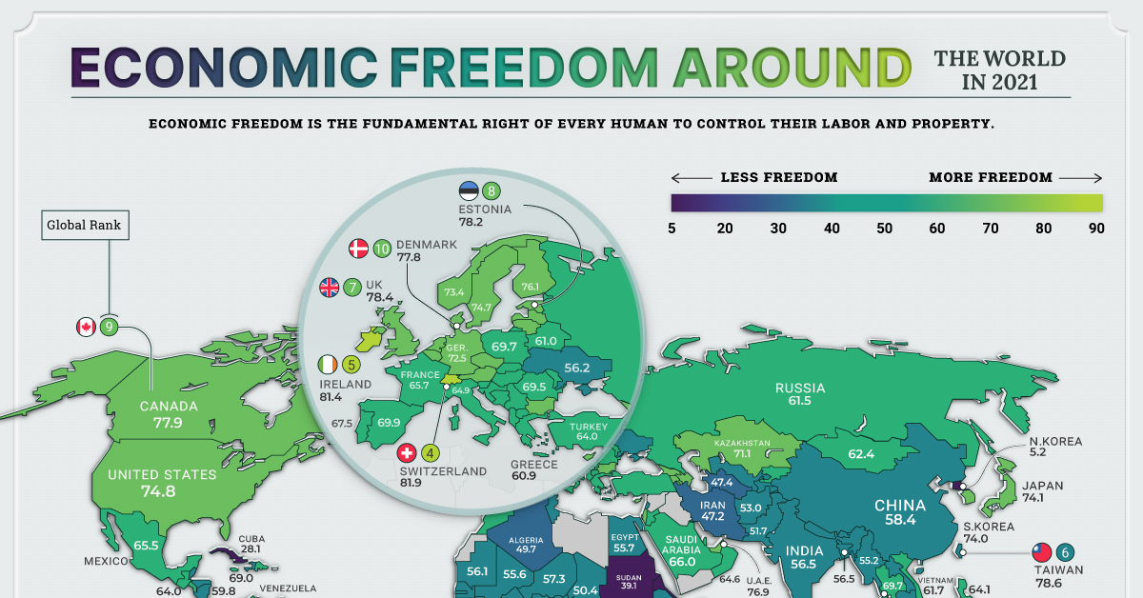

2.2 IDEATION & BRAINSTORMING

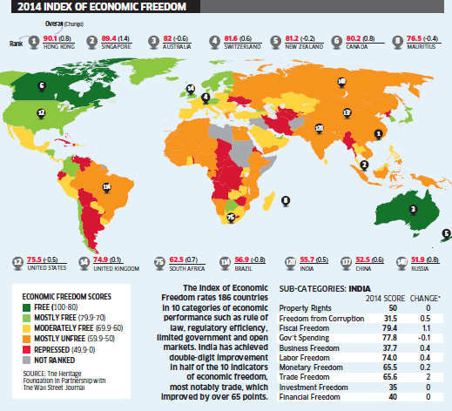

3.RESULT

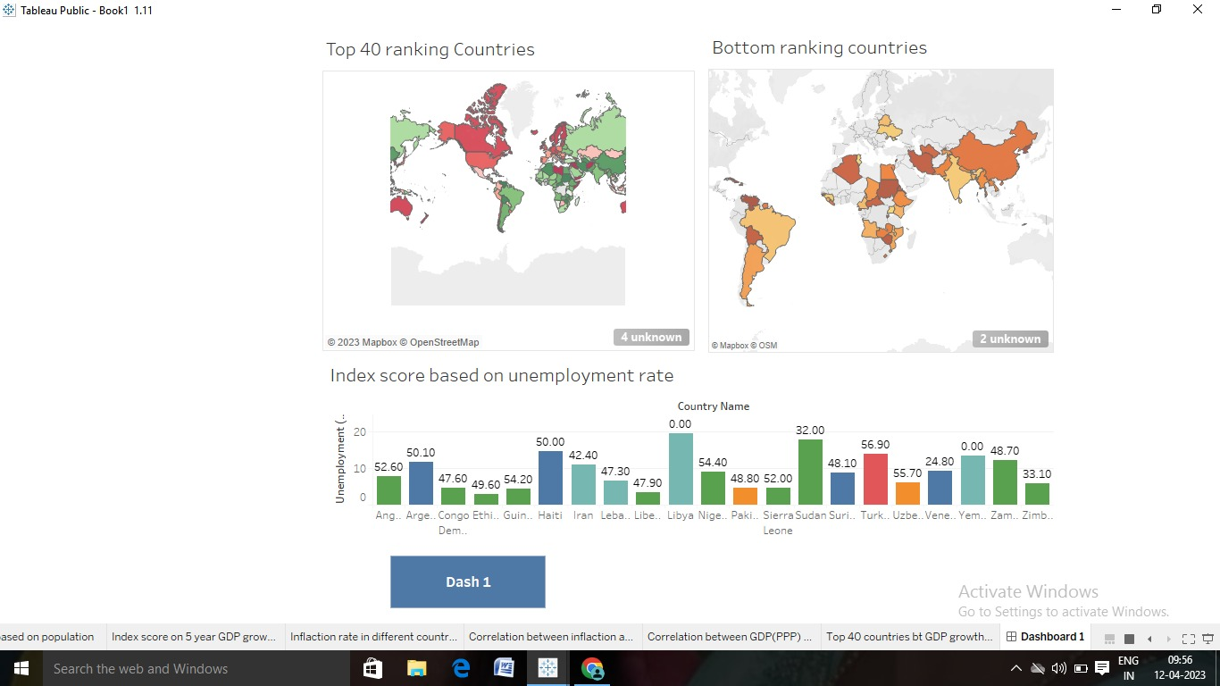

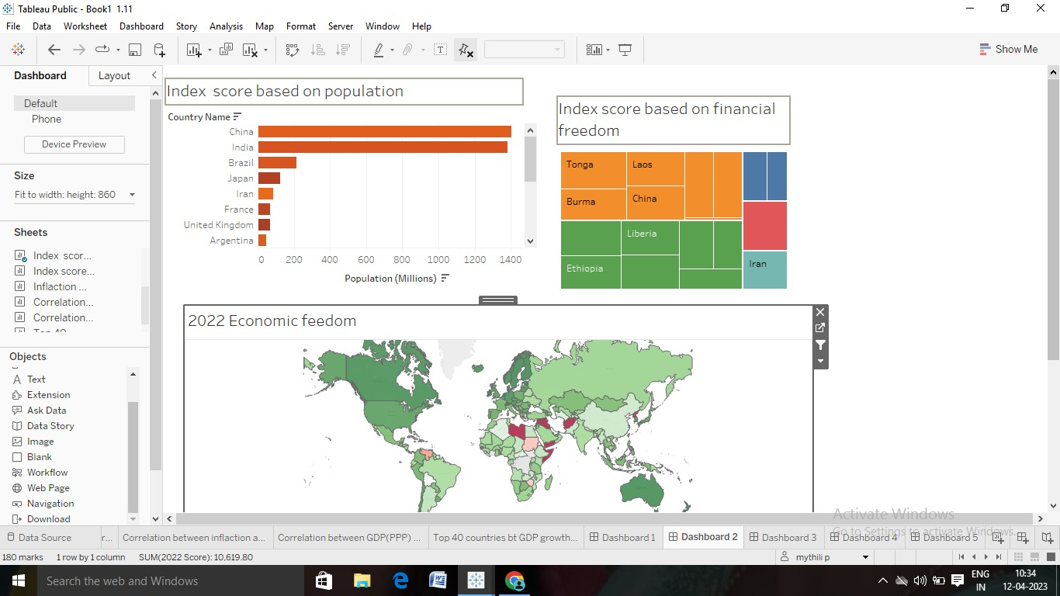

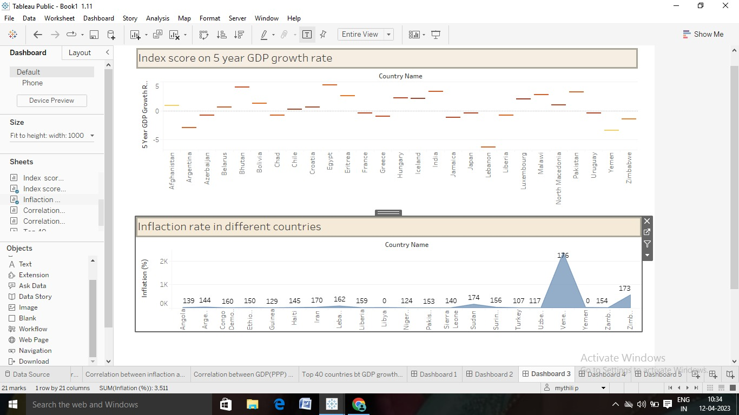

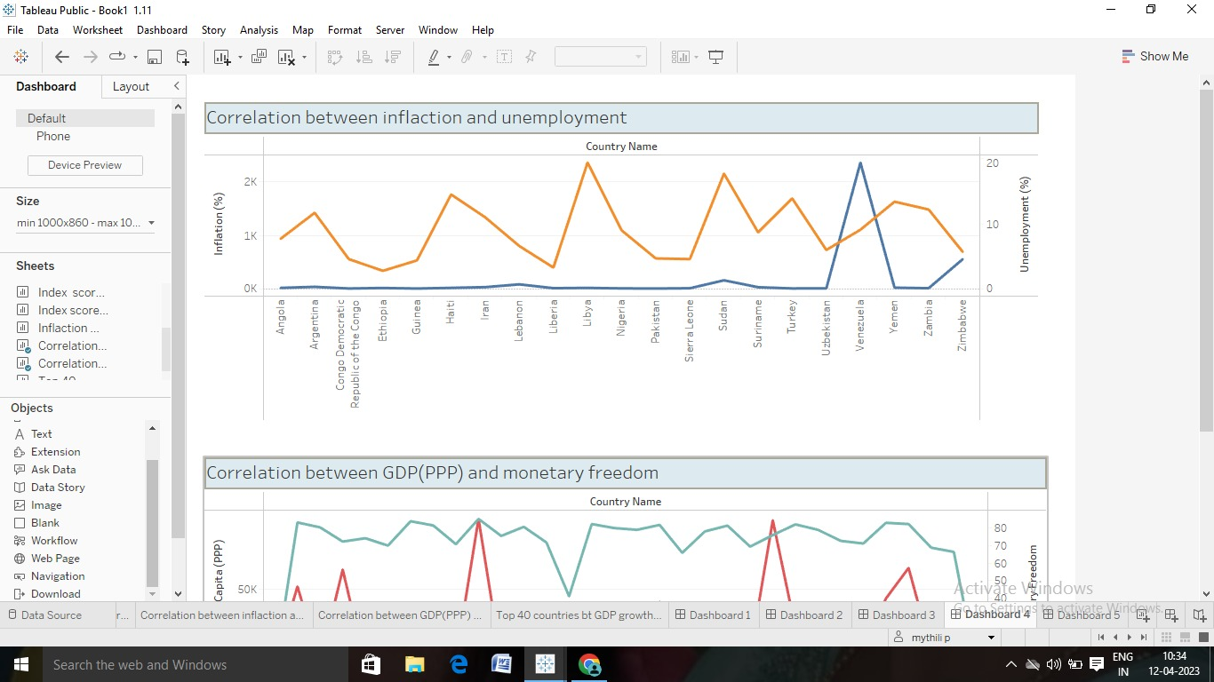

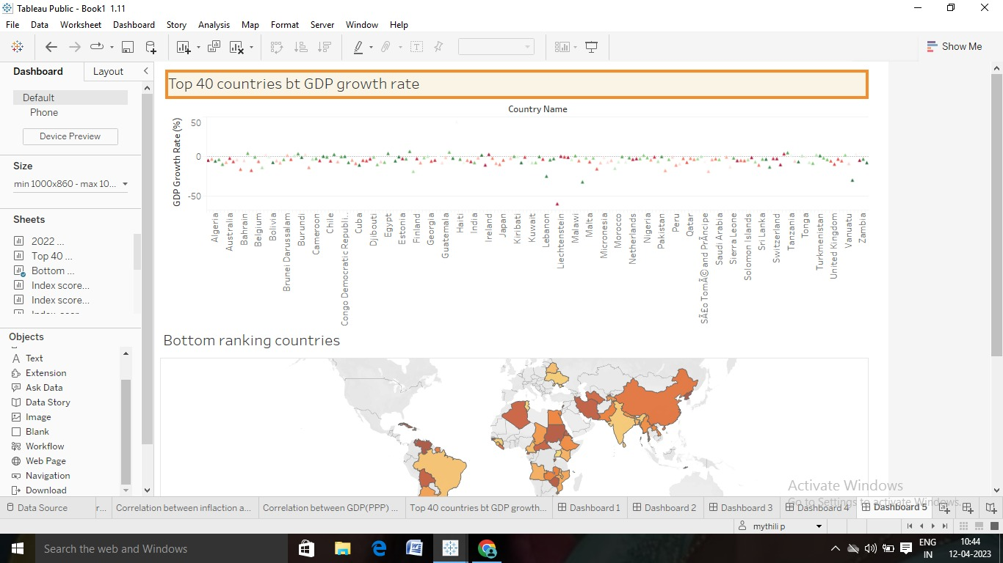

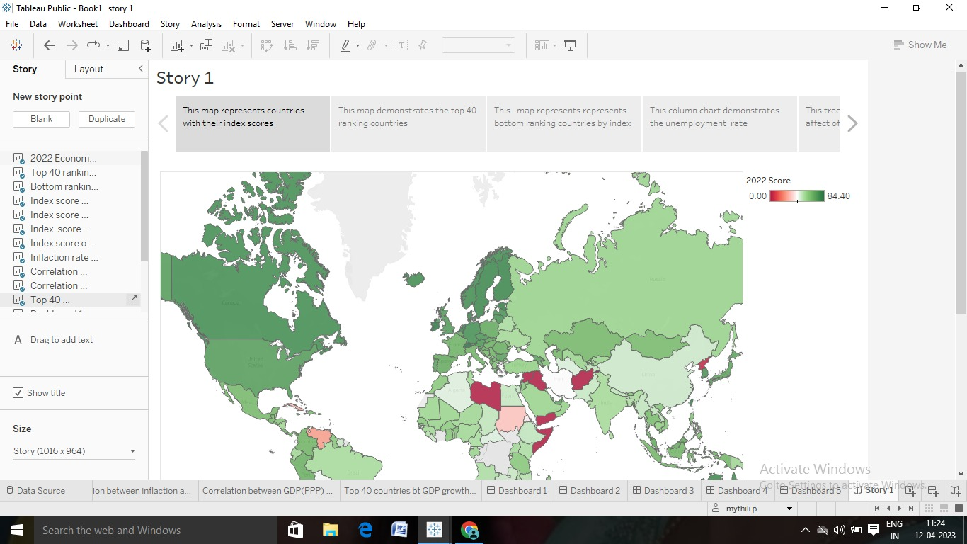

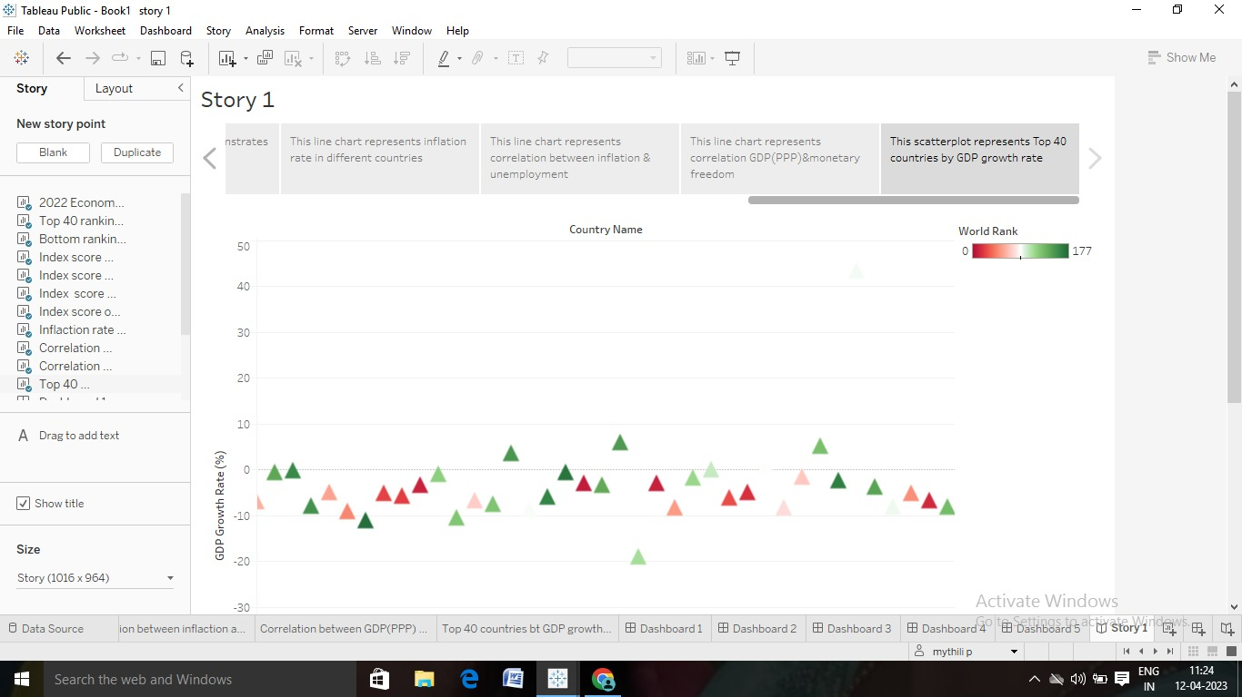

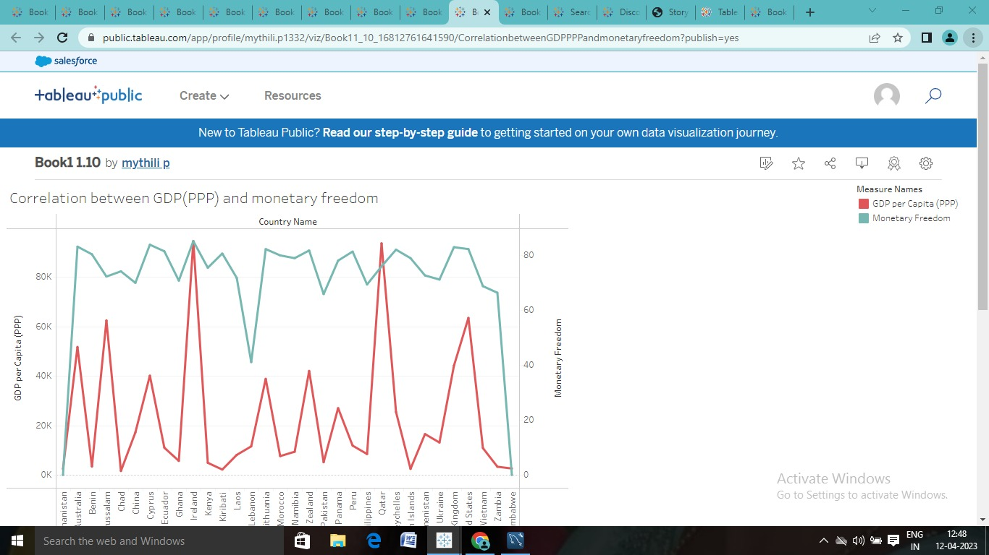

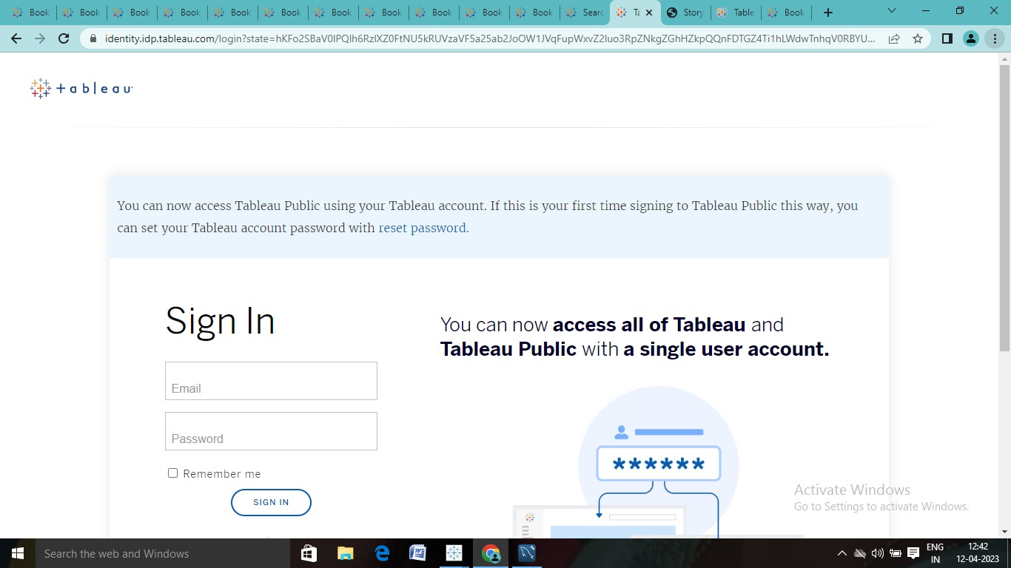

4.advantages

The absence of economic growth implies the continued existence of poverty and hardship. The IMF (2001) and others perceive the prospects for global economic growth to be relatively weak.

Neoclassical economic theory explains economic growth as a function of four factors: capital, labour, human capital and technology (Romer 1990). But which economic policies are most favorable to growth? A new line of research on economic freedom answers as Adam Smith did long ago. “Economic freedom” means the degree to which a market economy is in place, where the central components are voluntary exchange, free competition, and protection of persons and property (Gwartney and Lawson 2002, 5).

The goal is to characterize the institutional structure and central parts of economic policy. Economic freedom may constitute an explanatory factor for growth and the distribution of income. In econometric analysis, economic freedom is thus an independent variable. However, economic freedom may also be affected by other variables and thereby constitute a dependent variable, possibly influenced by factors such as political freedom, wealth or democracy.1 The most ambitious attempt to quantify economic freedom is The Economic Freedom of the World Index (EFI) (Gwartney and Lawson 2002).2 Since 1996, data updated yearly has been published, now covering the years 1970, 1975, 1980, 1985, 1990, 1995 and 2000.

Disadvantages:

* Damage to the environment – [economic activities](https://www.carboncollective.co/sustainable-investing/primary-economic-activity/) can damage the environment; the wellbeing of the environment is not the focus of the market economy. Government regulations will have to mandate the safety of the environment.
* Monopolies – technology breakthroughs can result in monopolies. Monopolies tend to take advantage of consumers
* The disparity between income and wealth – if the [return on capital](https://www.carboncollective.co/sustainable-investing/return-on-invested-capital/) is higher than the economic growth it will cause an income and wealth disparity. Destabilizing the economy in the long run.
* Automatic resource allocation – may result in specific not-very-profitable yet vital sectors left-off without enough resources which might have severe consequences over the long run.
* Crises prone – for example, the profit motive may result in the adoption of automation and worker exploitation thereby dropping the disposable income and hence reducing consumption and plunging the economy into a recession
* No government intervention – can lead to manufacturers charging the customers whatever fee they want.
* Inequality – It faces inequality problems among the citizens.
* Profit as a motive – As the government is in no control of production, profit is the only motive for the production of goods.
* Poor working conditions – There might be poor working conditions as there is no government regulation in place.
* Unemployment – Unemployment may rise as there is no government check in the market.

5.application:

The Heritage Foundation's Index of Economic Freedom website features a [heat map](https://www.heritage.org/index/heatmap) that allows you to view the changes in the world over time. In addition to being academically interesting, the change to economic freedom over time can be a significant data source for investors, particularly those interested in [emerging markets](https://www.investopedia.com/terms/e/emergingmarketeconomy.asp).

The index of economic freedom can provide a guide as to whether the potential for hot emerging market picks like the [BRIC nations](https://www.investopedia.com/terms/b/bric.asp) (Brazil, Russia, India, and China) are actually seeing the policy changes necessary for that growth to benefit international investors. On the opposite end, negative changes in the index can be a signal to investors to trim their direct and indirect exposure to nations that are experiencing a decline.

Conclusion:

Economic freedom has been recognized as potentially important for economic growth. A comprehensive empirical study examining the relative effects of both was absent from the literature. This paper is one attempt to fill the gap in the literature. Using panel data technique, it investigated the impact of economic freedom on economic growth in the MENA countries over the period 2000 to 2009.

was found that economic freedom is to have a positive and significant effect on economic growth. The economic freedom index is broken down into the five categories. It was observed that only legal structure and security of property rights protection as two ingredient of economic freedom index have negatively correlated with growth. The property rights must be protected through strong and unbiased judicial system. Establishment of impartial and strong judicial system may decrease the process of growth through sufficient provision of protection to property rights. We also found that government size is positively correlated with economic growth as increase in government size positively affects the better allocation of resources. Two other indexes of economic freedom are also positively correlated with economic growth

7.future scope:

Scope refers to the extent to which something deals with or the extent to which something is concerned. Consumption of goods and services is the most basic way to define its scope. However, in reality, the scope of economics is much more than the regular consumption of goods and services. It can be distinguished as follows:

**Microeconomics**

Micro refers to small; it is the study of individual units of consumption of goods and services as well as that of production and much more. It is concerned with one single household, office, industry or market.

Moreover, concepts such as product pricing and consumer or firm behavior are a part of it. Various types of markets are also studied under this. Hence, the consumption of goods and services and the behavior responsible for it is a part of microeconomics.

**Macroeconomics**

Macro means large; it is the study of the overall production and consumption of goods and services. It is concerned with national income, GDP, GNP or gross national product. Concepts such as macro-level business cycles, national budget, unemployment and money supply are a part of macroeconomics.

8.appendix

[**Index of Economic Freedom**: Promoting Economic Opportunity and ...](https://www.heritage.org/index/)

[**Economic Freedom** | Fraser Institute](https://www.google.com/url?client=internal-element-cse&cx=012684331380167808104:oe5oj--md1a&q=https://www.fraserinstitute.org/studies/economic-freedom&sa=U&ved=2ahUKEwjC16j5nqf-AhVEjVYBHUI0DwUQFnoECAgQAQ&usg=AOvVaw2lwAu3v1zNIN8VAUXPhCwe)

[**Index of Economic Freedom**: Definition, Factors, and How It's Used](https://www.google.com/url?client=internal-element-cse&cx=012684331380167808104:oe5oj--md1a&q=https://www.investopedia.com/terms/i/index-of-economic-freedom.asp&sa=U&ved=2ahUKEwjC16j5nqf-AhVEjVYBHUI0DwUQFnoECBEQAQ&usg=AOvVaw1Fuu77edzFdMaODarTYYFW)

[**Index of Economic Freedom** - Definition, Latest News, and Why ...](https://cleartax.in/g/terms/index-of-economic-freedom)