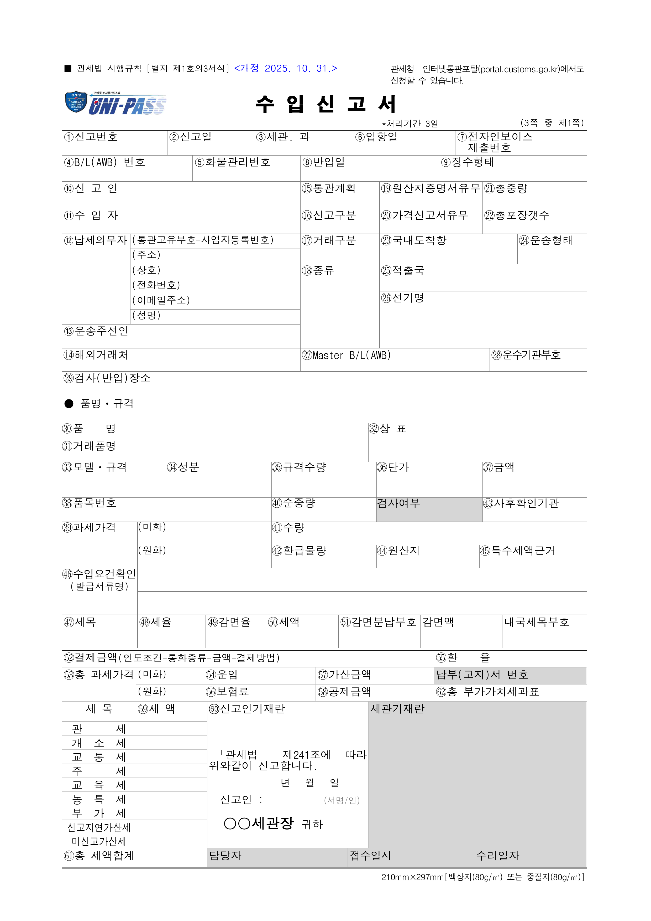
{{decl_no}}
{{decl_date}}
{{customs_office}}
{{arrival_date}}
{{bl_no}}
{{cargo_control_no}}
{{warehouse_in_date}}
{{collect_type}}
{{declarant}}
{{importer}}
{{taxpayer_address}}
{{taxpayer_company}}
{{taxpayer_tel}}
{{taxpayer_email}}
{{taxpayer_name}}
{{forwarder}}
{{overseas_partner}}
{{master_bl}}
{{carrier_code}}
{{inspect_place}}
{{clearance_plan}}
{{co_yn}}
{{total_weight}}
{{decl_kind}}
{{price_decl_yn}}
{{total_packages}}
{{trade_kind}}
{{arrival_port}}
{{transport_type}}
{{goods_kind}}
{{shipping_country}}
{{vessel_name}}
{{first_goods_name}}
{{first_brand}}
{{first_trade_goods_name}}
{{first_model_spec}}
{{first_composition}}
{{first_spec_qty}}
{{first_unit_price}}
{{first_amount}}
{{first_hs_code}}
{{first_net_weight}}
{{first_post_check_org}}
{{first_customs_value_usd}}
{{first_qty}}
{{first_customs_value_krw}}
{{first_refund_qty}}
{{first_origin}}
{{first_special_tax_basis}}
{{first_tax_type}}
{{first_tax_rate}}
{{first_reduction_rate}}
{{first_tax_amount}}
{{payment_amount}}
{{exchange_rate}}
{{total_customs_value_usd}}
{{freight}}
{{addition_amount}}
{{total_customs_value_krw}}
{{insurance}}
{{deduction_amount}}
{{total_vat_base}}
{{tax_customs}}
{{tax_excise}}
{{tax_traffic}}
{{tax_liquor}}
{{tax_education}}
{{tax_rural}}
{{tax_vat}}
{{tax_late_penalty}}
{{tax_no_decl_penalty}}
{{total_tax}}
