**1) React**

**Exercise 1: ReactJS-HOL**

**App.js**

import React from 'react';

function App() {

  return (

    <div>

      <h1>Welcome to the first session of Reeeact</h1>

    </div>

  );

}

export default App;

**index.css**

body {

  margin: 0;

  font-family: -apple-system, BlinkMacSystemFont, 'Segoe UI', 'Roboto', 'Oxygen',

    'Ubuntu', 'Cantarell', 'Fira Sans', 'Droid Sans', 'Helvetica Neue',

    sans-serif;

  -webkit-font-smoothing: antialiased;

  -moz-osx-font-smoothing: grayscale;

}

h1{

  color: red;

  margin: auto;

}

code {

  font-family: source-code-pro, Menlo, Monaco, Consolas, 'Courier New',

    monospace;

}

**index.js**

import React from 'react';

import ReactDOM from 'react-dom/client';

import './index.css';

import App from './App';

import reportWebVitals from './reportWebVitals';

const root = ReactDOM.createRoot(document.getElementById('root'));

root.render(

  <React.StrictMode>

    <App />

  </React.StrictMode>

);

reportWebVitals();

**Output:**

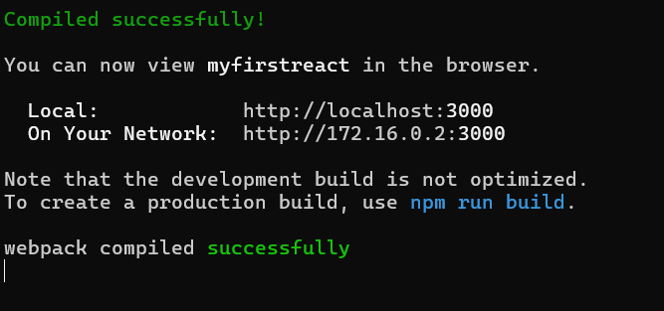

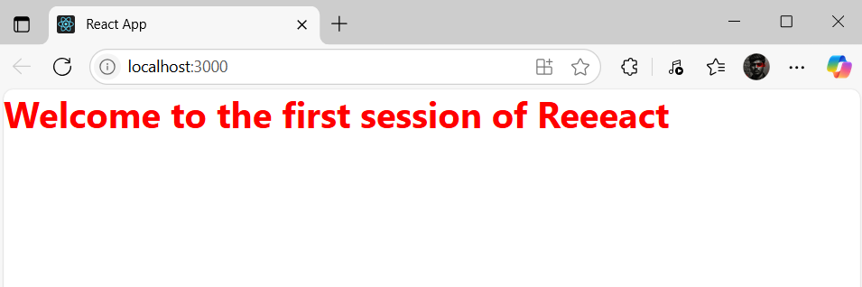

**Exercise 2: ReactJS-HOL**

**Components**

**About.js**

import React, { Component } from 'react';

class About extends Component {

  render() {

    return (

      <div>

        <h2>Welcome to the About page of the Student Management Portal</h2>

      </div>

    );

  }

}

export default About;

**Contact.js**

import React, { Component } from 'react';

class Contact extends Component {

  render() {

    return (

      <div>

        <h2>Welcome to the Contact page of the Student Management Portal</h2>

      </div>

    );

  }

}

export default Contact;

**Home.js**

import React, { Component } from 'react';

class Home extends Component {

  render() {

    return (

      <div>

        <h2>Welcome to the Home page of Student Management Portal</h2>

      </div>

    );

  }

}

export default Home;

**App.js**

import React from 'react';

import Home from './Components/Home';

import About from './Components/About';

import Contact from './Components/Contact';

function App() {

  return (

    <div>

      <h1>Student Management Portal</h1>

      <Home />

      <About />

      <Contact />

    </div>

  );

}

export default App;

**Output:**

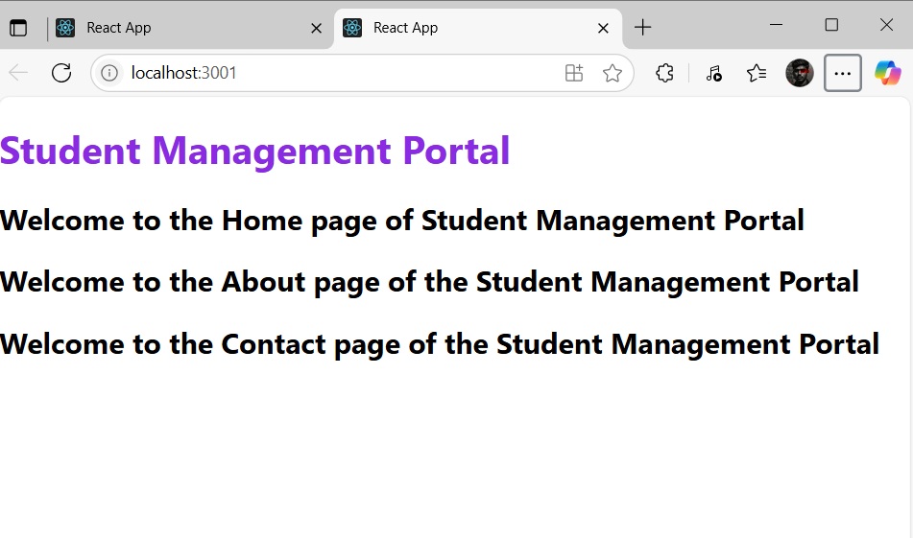

**Exercise 3: ReactJS-HOL**

**Components**

**CalculateScore.js**import React from 'react';

import '../Stylesheets/mystyle.css';

function CalculateScore(props) {

  const average = props.Total / props.Goal;

  return (

    <div className="score-card">

      <h2>Student Score Report</h2>

      <p><strong>Name:</strong> {props.Name}</p>

      <p><strong>School:</strong> {props.School}</p>

      <p><strong>Total Marks:</strong> {props.Total}</p>

      <p><strong>Goal Subjects:</strong> {props.Goal}</p>

      <p><strong>Average Score:</strong> {average.toFixed(2)}</p>

    </div>

  );

}

export default CalculateScore;

**Stylesheets**

**mystyle.css**

.score-card {

  background-color: #f2f2f2;

  border: 2px solid #4CAF50;

  padding: 20px;

  margin: 20px auto;

  width: 60%;

  border-radius: 10px;

  font-family: 'Segoe UI', Tahoma, Geneva, Verdana, sans-serif;

  box-shadow: 0 4px 6px rgba(0, 0, 0, 0.1);

}

.score-card h2 {

  color: #4CAF50;

}

**App.js**

import React from 'react';

import CalculateScore from './Components/CalculateScore';

function App() {

  return (

    <div>

      <h1>Score Calculator App</h1>

      <CalculateScore Name="Rahul" School="ABC High School" Total={450} Goal={5} />

    </div>

  );

}

export default App;

**Output:**

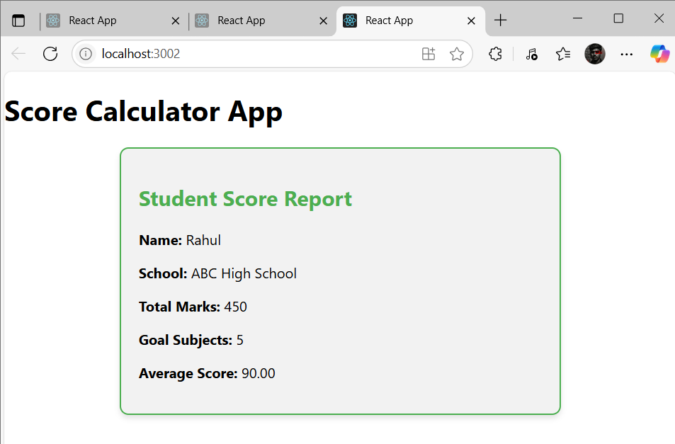

**Exercise 4: ReactJS-HOL**

**Post.js**

class Post {

  constructor(userId, id, title, body) {

    this.userId = userId;

    this.id = id;

    this.title = title;

    this.body = body;

  }

}

export default Post;

**Posts.js**

import React, { Component } from 'react';

import Post from './Post';

class Posts extends Component {

  constructor(props) {

    super(props);

    this.state = {

      posts: [],

    };

  }

  loadPosts() {

    fetch('https://jsonplaceholder.typicode.com/posts')

      .then((response) => response.json())

      .then((data) => {

        const postObjects = data.map(

          (post) => new Post(post.userId, post.id, post.title, post.body)

        );

        this.setState({ posts: postObjects });

      })

      .catch((error) => {

        console.error('Error loading posts:', error);

      });

  }

  componentDidMount() {

    this.loadPosts();

  }

  componentDidCatch(error, info) {

    alert('Something went wrong: ' + error.toString());

  }

  render() {

    return (

      <div>

        <h1>Blog Posts</h1>

        {this.state.posts.map((post) => (

          <div key={post.id} style={{ marginBottom: '20px' }}>

            <h2>{post.title}</h2>

            <p>{post.body}</p>

          </div>

        ))}

      </div>

    );

  }

}

export default Posts;

**App.js**

import React from 'react';

import Posts from './Posts';

function App() {

  return (

    <div className="App">

      <Posts />

    </div>

  );

}

export default App;

**Output:**

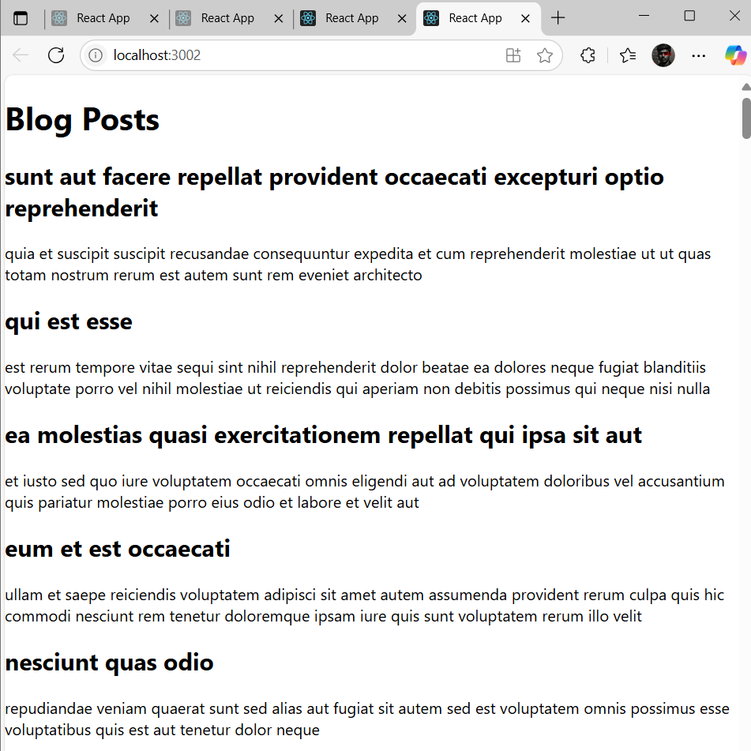

**Exercise 5: ReactJS-HOL**

**CohortDetails.module**

.box {

  width: 300px;

  display: inline-block;

  margin: 10px;

  padding: 10px 20px;

  border: 1px solid black;

  border-radius: 10px;

  vertical-align: top;

}

dt {

  font-weight: 500;

  color: brown;

}

**CohortDetails.js**

import React from 'react';

import styles from './CohortDetails.module.css';

const CohortDetails = ({ cohort }) => {

  const headingColor = cohort.status === 'Ongoing' ? 'green' : 'blue';

  return (

    <div className={styles.box}>

      <h3 style={{ color: headingColor }}>{cohort.name}</h3>

      <dl>

        <dt>Started On</dt>

        <dd>{cohort.startDate}</dd>

        <dt>Current Status</dt>

        <dd>{cohort.status}</dd>

        <dt>Coach</dt>

        <dd>{cohort.coach}</dd>

        <dt>Trainer</dt>

        <dd>{cohort.trainer}</dd>

      </dl>

    </div>

  );

};

export default CohortDetails;

**App.js**

import React from 'react';

import CohortDetails from './CohortDetails';

const cohorts = [

  {

    name: 'INTADMDF10 -.NET FSD',

    startDate: '22-Feb-2022',

    status: 'Scheduled',

    coach: 'Aathma',

    trainer: 'Jojo Jose'

  },

  {

    name: 'ADM21JF014 - Java FSD',

    startDate: '10-Sep-2021',

    status: 'Ongoing',

    coach: 'Apoorv',

    trainer: 'Elisa Smith'

  },

  {

    name: 'CDBJF21025 - Java FSD',

    startDate: '24-Dec-2021',

    status: 'Ongoing',

    coach: 'Aathma',

    trainer: 'John Doe'

  }

];

function App() {

  return (

    <div style={{ padding: '20px' }}>

      <h2>Cohorts Details</h2>

      {cohorts.map((c, index) => (

        <CohortDetails key={index} cohort={c} />

      ))}

    </div>

  );

}

export default App;

**Output:**

