**1) React**

**Exercise 1: ReactJS-HOL**

**App.js**

import React from 'react';

import ListofPlayers from './ListofPlayers';

import IndianPlayers from './IndianPlayers';

function App() {

  const flag = false; // Change to false to test the other component

  return (

    <div className="App">

      <h1>🏏 Cricket App</h1>

      {flag ? <ListofPlayers /> : <IndianPlayers />}

    </div>

  );

}

export default App;

**ListofPlayers.js**

import React from 'react';

const ListofPlayers = () => {

  const players = [

    { name: "Virat", score: 85 },

    { name: "Rohit", score: 45 },

    { name: "Dhoni", score: 90 },

    { name: "Raina", score: 65 },

    { name: "Bumrah", score: 30 },

    { name: "Kohli", score: 75 },

    { name: "Ashwin", score: 55 },

    { name: "Pant", score: 95 },

    { name: "Sharma", score: 20 },

    { name: "Jadeja", score: 60 },

    { name: "KL Rahul", score: 88 }

  ];

  // Filter using arrow function

  const below70 = players.filter(player => player.score < 70);

  return (

    <div>

      <h2>All Players:</h2>

      <ul>

        {players.map((p, index) => (

          <li key={index}>{p.name} - {p.score}</li>

        ))}

      </ul>

      <h2>Players with score below 70:</h2>

      <ul>

        {below70.map((p, index) => (

          <li key={index}>{p.name} - {p.score}</li>

        ))}

      </ul>

    </div>

  );

};

export default ListofPlayers;

**IndianPlayers.js**

import React from 'react';

const IndianPlayers = () => {

  const T20players = ["Virat", "Rohit", "Pant", "KL Rahul"];

  const RanjiTrophy = ["Pujara", "Iyer", "Siraj", "Gill"];

  // Merge arrays

  const mergedPlayers = [...T20players, ...RanjiTrophy];

  // Destructure

  const oddPlayers = mergedPlayers.filter((_, index) => index % 2 !== 0);

  const evenPlayers = mergedPlayers.filter((_, index) => index % 2 === 0);

  return (

    <div>

      <h2>Merged Players:</h2>

      <ul>

        {mergedPlayers.map((p, index) => <li key={index}>{p}</li>)}

      </ul>

      <h2>Even Team:</h2>

      <ul>

        {evenPlayers.map((p, index) => <li key={index}>{p}</li>)}

      </ul>

      <h2>Odd Team:</h2>

      <ul>

        {oddPlayers.map((p, index) => <li key={index}>{p}</li>)}

      </ul>

    </div>

  );

};

export default IndianPlayers;

**Output:**

**FLAG = FALSE**

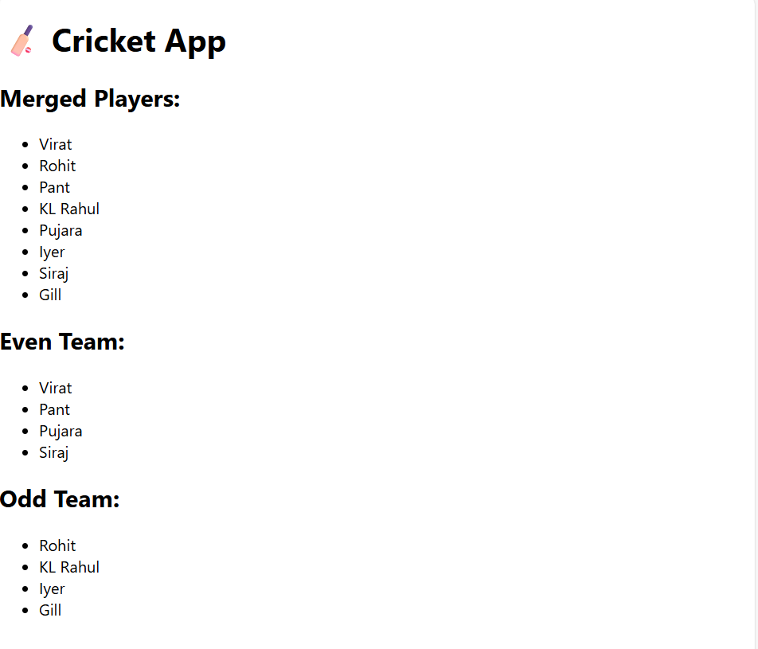

**FLAG = TRUE**

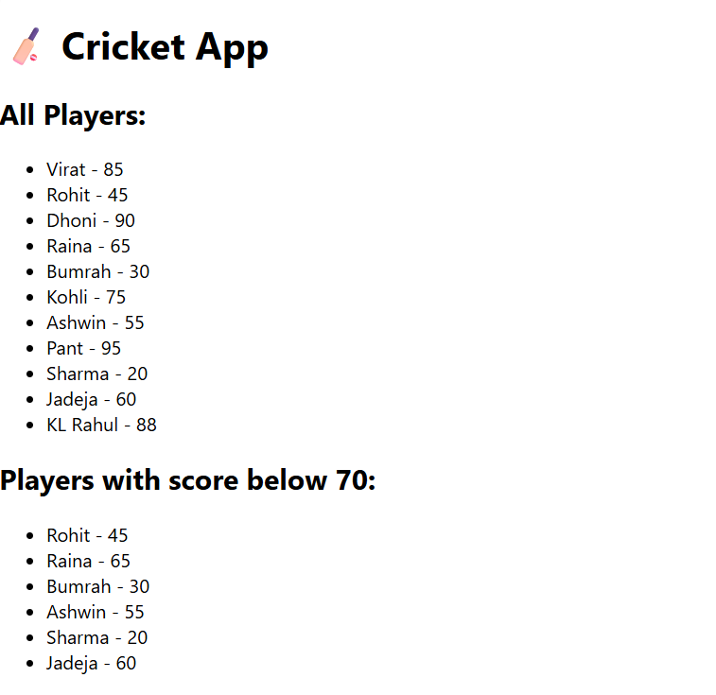

**Exercise 2: ReactJS-HOL**

**App.js**

import React from 'react';

function App() {

  // 1. Create a heading using JSX

  const heading = <h1 style={{ textAlign: 'center' }}>🏢 Office Space Rental App</h1>;

  // 2. Add an image of an office space

  const imageUrl = "https://tse4.mm.bing.net/th/id/OIP.P6z1LIpkSovyY-cN7YrR1AAAAA?r=0&rs=1&pid=ImgDetMain&o=7&rm=3";

  // 3. Create a single office object

  const office = {

    name: "Skyline Tower",

    rent: 55000,

    address: "123, Marina Street, Chennai"

  };

  // 4. Create a list of office objects

  const officeList = [

    { name: "Skyline Tower", rent: 55000, address: "123, Marina Street, Chennai" },

    { name: "Ocean View", rent: 65000, address: "456, Bay Road, Mumbai" },

    { name: "Tech Hub", rent: 48000, address: "789, Silicon Lane, Bangalore" },

    { name: "Cloud Nine", rent: 72000, address: "101, Startup Valley, Hyderabad" },

  ];

  // 5. Function to determine rent color

  const getRentStyle = (rent) => ({

    color: rent < 60000 ? 'red' : 'green',

    fontWeight: 'bold'

  });

  return (

    <div style={{ fontFamily: 'Arial', padding: '20px' }}>

      {heading}

      <div style={{ textAlign: 'center' }}>

        <img src={imageUrl} alt="Office Space" style={{ width: '600px', height: '300px', borderRadius: '10px' }} />

      </div>

      <h2>Single Office Detail:</h2>

      <p><strong>Name:</strong> {office.name}</p>

      <p><strong>Rent:</strong> <span style={getRentStyle(office.rent)}>₹{office.rent}</span></p>

      <p><strong>Address:</strong> {office.address}</p>

      <hr />

      <h2>All Office Listings:</h2>

      <ul>

        {officeList.map((off, index) => (

          <li key={index} style={{ marginBottom: '10px' }}>

            <strong>{off.name}</strong> <br />

            Rent: <span style={getRentStyle(off.rent)}>₹{off.rent}</span> <br />

            Address: {off.address}

          </li>

        ))}

      </ul>

    </div>

  );

}

export default App;

**Output:**

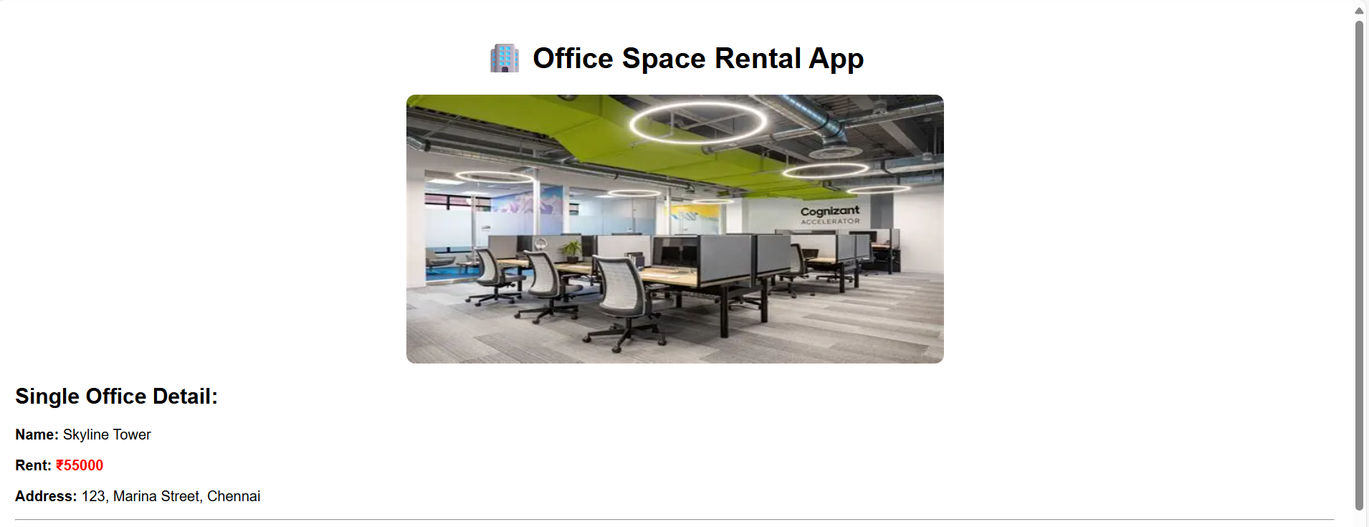

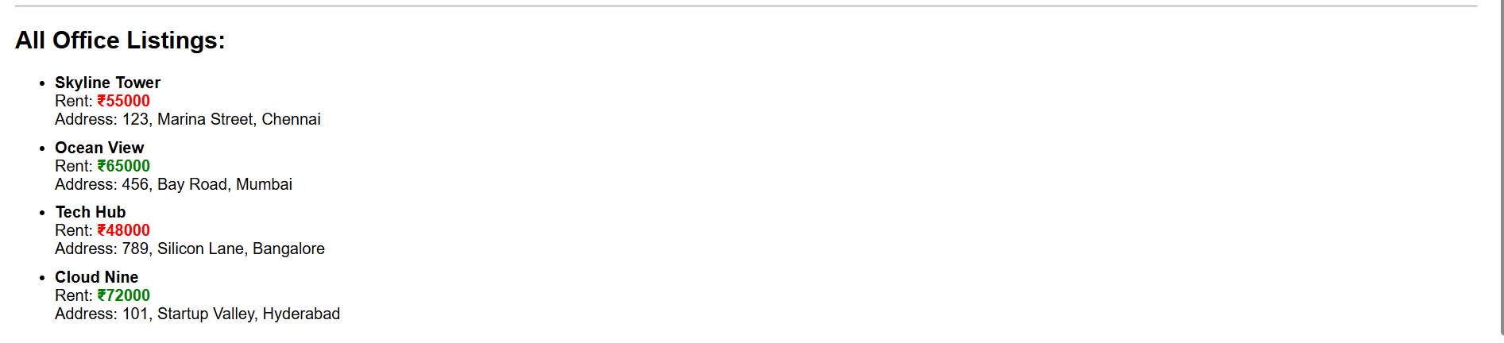

**Exercise 3: ReactJS-HOL**

**Components**

**Counter.js**import React, { useState } from 'react';

const Counter = () => {

  const [count, setCount] = useState(0);

  const increment = () => {

    setCount(prev => prev + 1);

    sayHello();

  };

  const decrement = () => {

    setCount(prev => prev - 1);

  };

  const sayHello = () => {

    alert("Hello! Counter increased.");

  };

  return (

    <div>

      <h2>Counter: {count}</h2>

      <button onClick={increment}>Increment</button>

      <button onClick={decrement}>Decrement</button>

    </div>

  );

};

export default Counter;

**CurrencyConvertor.js**

import React, { useState } from 'react';

const CurrencyConvertor = () => {

  const [rupees, setRupees] = useState('');

  const [euro, setEuro] = useState(null);

  const handleSubmit = (e) => {

    e.preventDefault();

    const converted = parseFloat(rupees) / 90; // Example rate

    setEuro(converted.toFixed(2));

  };

  return (

    <div>

      <h2>Currency Convertor (INR ➜ EUR)</h2>

      <form onSubmit={handleSubmit}>

        <input

          type="number"

          placeholder="Enter amount in INR"

          value={rupees}

          onChange={(e) => setRupees(e.target.value)}

        />

        <button type="submit">Convert</button>

      </form>

      {euro && <p>Converted Value: €{euro}</p>}

    </div>

  );

};

export default CurrencyConvertor;

**SyntheticEventExample.js**

import React from 'react';

const SyntheticEventExample = () => {

  const handleClick = (e) => {

    e.preventDefault(); // synthetic event

    alert("I was clicked");

  };

  return (

    <div>

      <button onClick={handleClick}>Click Me (Synthetic Event)</button>

    </div>

  );

};

export default SyntheticEventExample;

**WelcomeButton.js**

import React from 'react';

const WelcomeButton = () => {

  const sayMessage = (msg) => {

    alert(msg);

  };

  return (

    <div>

      <button onClick={() => sayMessage("Welcome!")}>Say Welcome</button>

    </div>

  );

};

export default WelcomeButton;

**App.js**

import React from 'react';

import Counter from './components/Counter';

import WelcomeButton from './components/WelcomeButton';

import SyntheticEventExample from './components/SyntheticEventExample';

import CurrencyConvertor from './components/CurrencyConvertor';

function App() {

  return (

    <div className="App">

      <h1>React Event Examples</h1>

      <Counter />

      <WelcomeButton />

      <SyntheticEventExample />

      <CurrencyConvertor />

    </div>

  );

}

export default App;

**Output:**

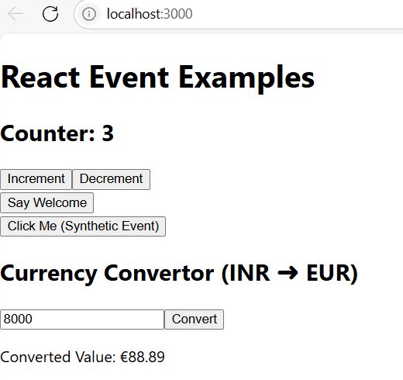

**Exercise 4: ReactJS-HOL**

**Components**

**FlightDetails.js**import React from 'react';

const FlightDetails = () => {

  return (

    <div>

      <h3>Flight Details</h3>

      <ul>

        <li>Flight: AI-202 | From: Chennai | To: Delhi</li>

        <li>Flight: AI-305 | From: Mumbai | To: Bangalore</li>

      </ul>

    </div>

  );

};

export default FlightDetails;

**GuestPage.js**

import React from 'react';

import FlightDetails from './FlightDetails';

const GuestPage = () => {

  return (

    <div>

      <h2>Welcome Guest (Please Login)</h2>

      <FlightDetails />

      <p>Please login to book tickets.</p>

    </div>

  );

};

export default GuestPage;

**UserPage.js**

import React from 'react';

import FlightDetails from './FlightDetails';

const UserPage = () => {

  return (

    <div>

      <h2>Welcome User (You Logged In)</h2>

      <FlightDetails />

      <button>Book Ticket</button>

    </div>

  );

};

export default UserPage;

**App.js**

import React, { useState } from 'react';

import GuestPage from './components/GuestPage';

import UserPage from './components/UserPage';

function App() {

  const [isLoggedIn, setIsLoggedIn] = useState(false);

  const handleLoginLogout = () => {

    setIsLoggedIn(prev => !prev);

  };

  return (

    <div className="App">

      <h1>Ticket Booking App</h1>

      <button onClick={handleLoginLogout}>

        {isLoggedIn ? "Logout" : "Login"}

      </button>

      {isLoggedIn ? <UserPage /> : <GuestPage />}

    </div>

  );

}

export default App;

**Output:**

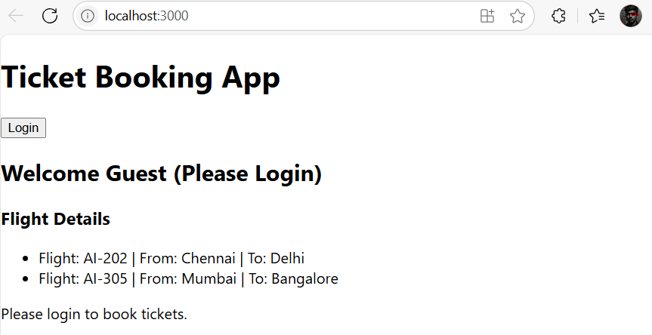

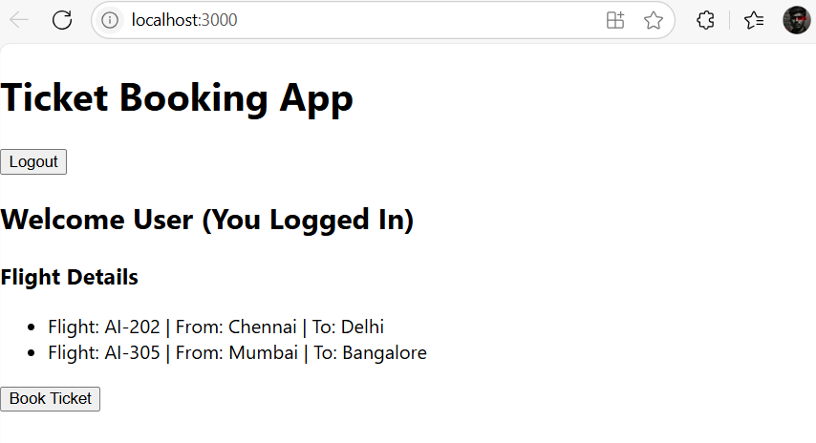

**Exercise 5: ReactJS-HOL**

**Components**

**BlogDetails.js**import React from 'react';

const BlogDetails = () => {

  return (

    <div>

      <h2>Blog Details</h2>

      <ul>

        <li>Title: React Patterns</li>

        <li>Author: Dan Abramov</li>

      </ul>

    </div>

  );

};

export default BlogDetails;

**BookDetails.js**

import React from 'react';

const BookDetails = () => {

  return (

    <div>

      <h2>Book Details</h2>

      <ul>

        <li>Title: Atomic Habits</li>

        <li>Author: James Clear</li>

      </ul>

    </div>

  );

};

export default BookDetails;

**CourseDetailsjs**

import React from 'react';

const CourseDetails = () => {

  const courses = [

    { id: 1, name: 'React Basics', duration: '4 weeks' },

    { id: 2, name: 'Advanced React', duration: '6 weeks' },

    { id: 3, name: 'React with Redux', duration: '5 weeks' }

  ];

  return (

    <div>

      <h2>Course Details</h2>

      <ul>

        {courses.map(course => (

          <li key={course.id}>

            {course.name} - {course.duration}

          </li>

        ))}

      </ul>

    </div>

  );

};

export default CourseDetails;

**App.js**

import React, { useState } from 'react';

import BookDetails from './components/.js';

import BlogDetails from './components/BlogDetails';

import CourseDetails from './components/CourseDetails';

function App() {

  const [showBook, setShowBook] = useState(true);

  const [showBlog, setShowBlog] = useState(false);

  const [showCourse, setShowCourse] = useState(false);

  return (

    <div className="App">

      <h1>Blogger App</h1>

      <div>

        <button onClick={() => setShowBook(!showBook)}>Toggle Book</button>

        <button onClick={() => setShowBlog(!showBlog)}>Toggle Blog</button>

        <button onClick={() => setShowCourse(!showCourse)}>Toggle Course</button>

      </div>

      {/* IF Statement */}

      {showBook ? <BookDetails /> : null}

      {/* Ternary Operator */}

      {showBlog ? <BlogDetails /> : <p>Blog is hidden</p>}

      {/* Logical && operator */}

      {showCourse && <CourseDetails />}

    </div>

  );

}

export default App;

**Output:**

