Task 1 — Document 05: System Architecture
05_system_architecture.md • SIH 2026 — Sovereign AI Workbench (PS 26117) • MRPL

Problem Statement ID: PS 26117 / SIH26117 Title: Sovereign On-Premise Agentic AI Workbench using Open-Weight Multimodal LLMs for Confidential Industrial Work Organization: Mangalore Refinery and Petrochemicals Limited (MRPL) Category: Software | Theme: Smart Automation

🏗️ Architectural Overview
The Sovereign AI Workbench is structured around a 4-tier modular, air-gapped architecture. Designed for single-node workstation or edge server deployment, the system decouples user interface, backend routing, vector search processing, and local LLM runtime execution.
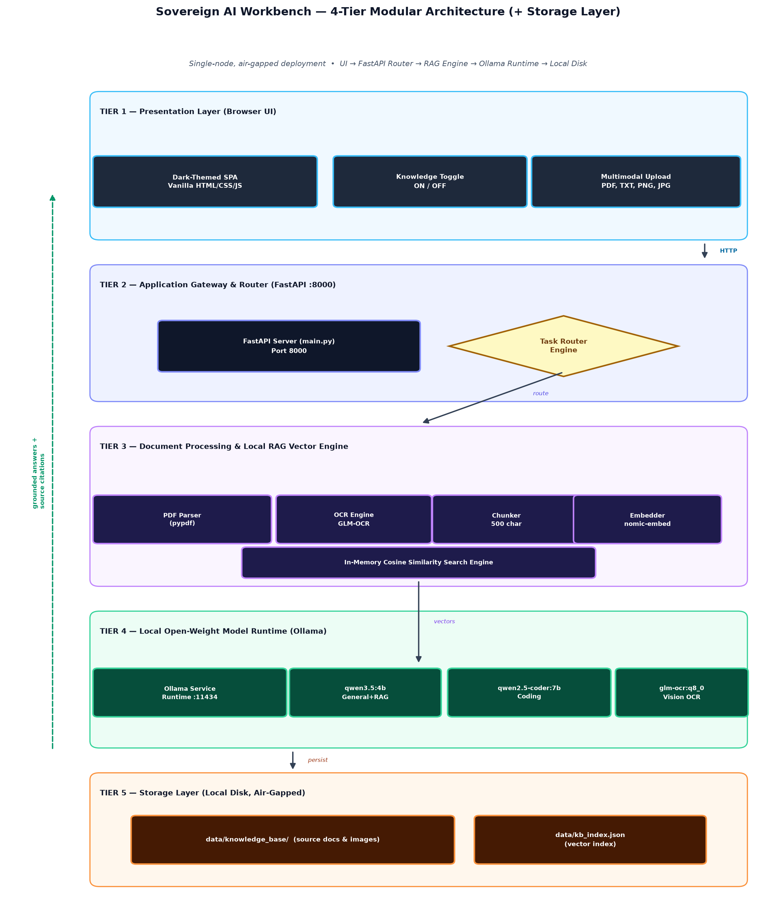
Figure — System Architecture: 4-tier air-gapped design (UI → FastAPI → RAG engine → Ollama → disk) [source: Mermaid block 1]

🧩 Architectural Layer Details

1. Presentation Layer (Web UI)
- Technology: Single-page application using HTML5, CSS3 (Flexbox/Grid, Dark Modern Palette), and asynchronous JavaScript (fetch API).
- Functionality:
- Chat window rendering user prompts and AI responses with markdown support.
- Interactive file uploader with real-time status notifications.
- Knowledge ON/OFF toggle controlling RAG augmentation.
- Real-time display of retrieved source documents and cosine similarity scores.

2. Application Gateway Layer (main.py)
- Technology: Python FastAPI with Uvicorn ASGI server.
- Functionality:
- Serves static UI assets (frontend/index.html).
- Endpoints: POST /upload for file processing, POST /chat for conversational Q&A.
- Task Router: Inspects prompt text and parameters to select the execution path (Coding Model vs. RAG Grounded Model vs. General LLM).

3. Document Processing & Local Vector RAG Engine
- Text Parser: pypdf extracts clean text streams from multi-page PDFs.
- OCR Extractor: Invokes glm-ocr:q8_0 via local Ollama API to transcribe scanned images.
- Chunking Module: Splits documents into overlapping semantic chunks (500 characters) to preserve contextual boundaries.
- Embedding Pipeline: Transmits text chunks to local nomic-embed-text model via Ollama to generate 768-dimensional dense vector representations.
- Vector Storage & Search: Saves chunk metadata and vectors into data/kb_index.json. Executes fast in-memory dot-product cosine similarity search to retrieve top-K matching contexts.

4. Local Model Execution Layer (Ollama)
- Runtime: Ollama daemon running on localhost (http://127.0.0.1:11434).
- Model Palette:
- qwen3.5:4b: Primary general-purpose LLM for conversational chat and grounded RAG synthesis.
- qwen2.5-coder:7b: Code generation specialist.
- glm-ocr:q8_0: Document image OCR specialist.
- nomic-embed-text: High-speed text embedding generator.

5. Storage Layer
- Physical Disk Storage: All files reside in local workstation directory d:\isha\sovereign-ai\data\.
- Air-Gap Security: Zero external network connections; completely self-contained.

