Task 1 — Document 06: Workflow & User Flow Diagrams
06_workflow_user_flow_diagram.md • SIH 2026 — Sovereign AI Workbench (PS 26117) • MRPL

Problem Statement ID: PS 26117 / SIH26117 Title: Sovereign On-Premise Agentic AI Workbench using Open-Weight Multimodal LLMs for Confidential Industrial Work Organization: Mangalore Refinery and Petrochemicals Limited (MRPL) Category: Software | Theme: Smart Automation

🔀 1. High-Level User Flow Chart
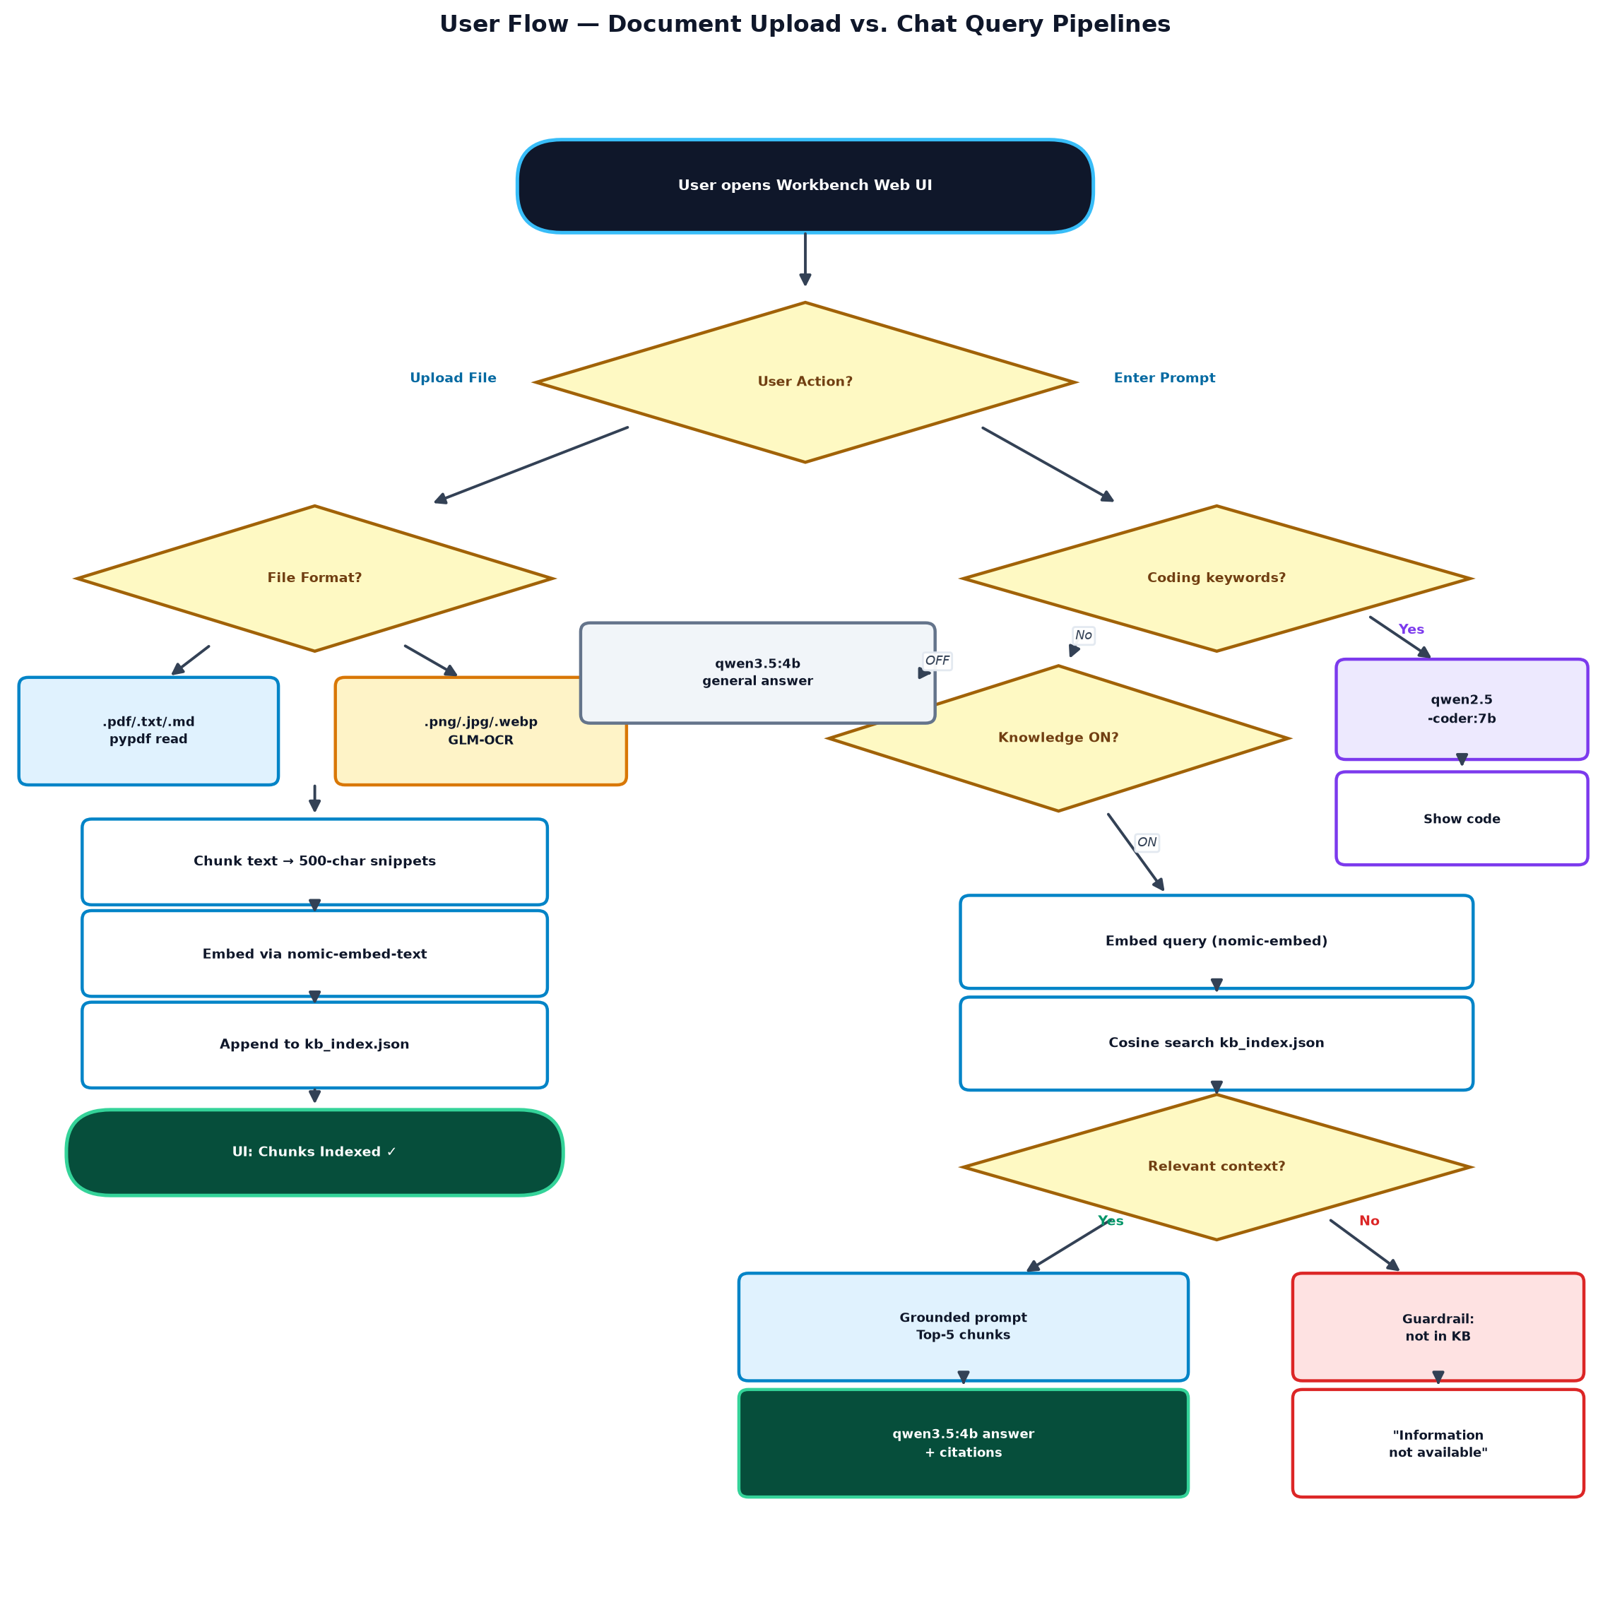
Figure — User flow: upload pipeline (left) vs chat query pipeline (right) [source: Mermaid block 1]

🔄 2. Detailed Sequence Diagrams

Sequence 1: Image Upload & GLM-OCR Ingestion Pipeline
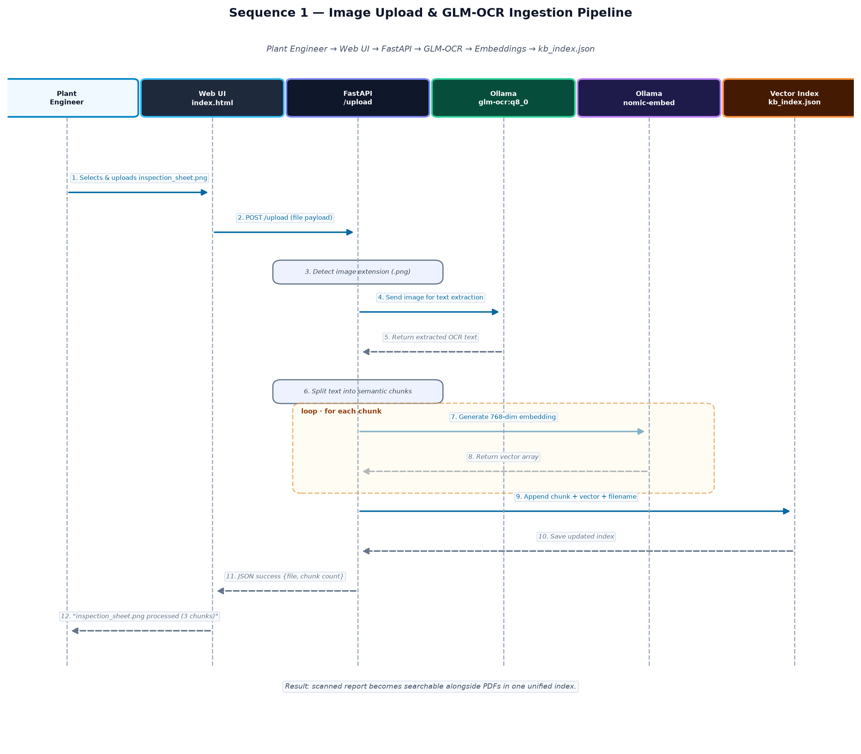
Figure — Sequence: image upload & GLM-OCR ingestion pipeline [source: Mermaid block 2]

Sequence 2: Grounded RAG Query Execution (Knowledge ON)
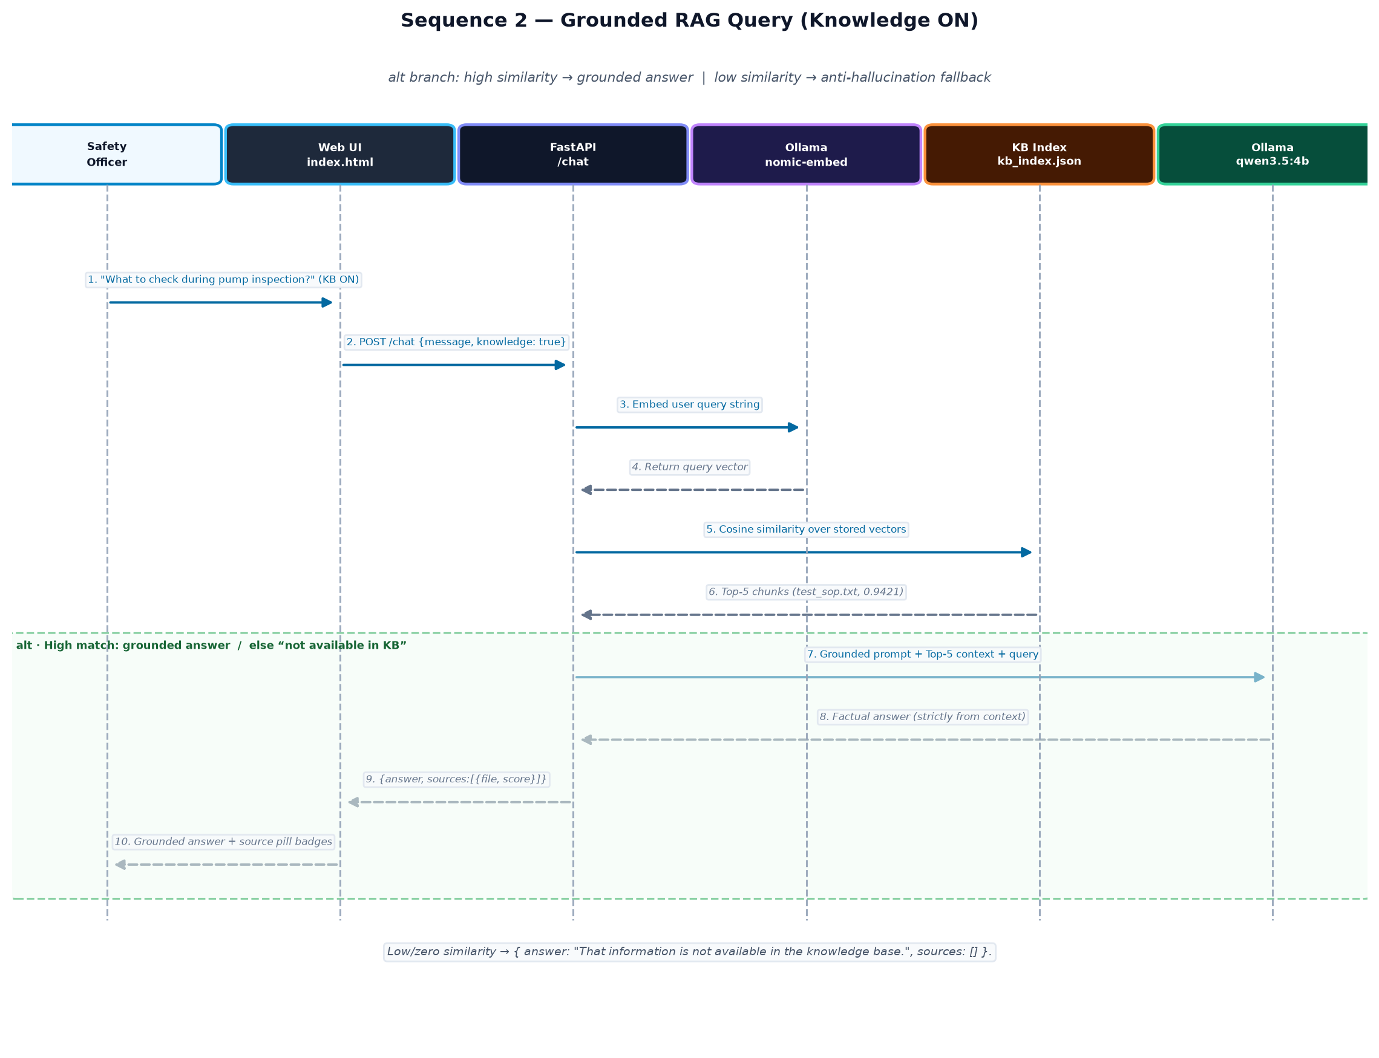
Figure — Sequence: grounded RAG query execution (Knowledge ON) [source: Mermaid block 3]

Sequence 3: Code Generation Task Routing
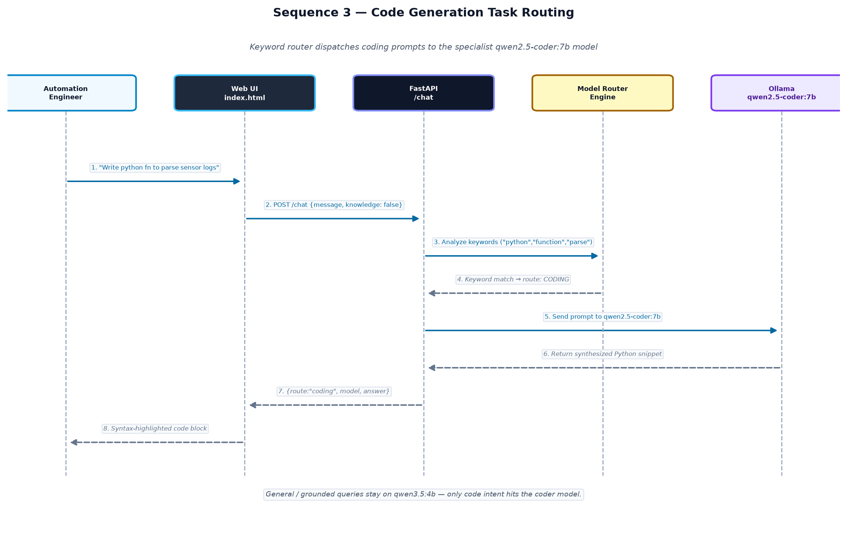
Figure — Sequence: code-generation task routing to qwen2.5-coder:7b [source: Mermaid block 4]

