Task 1 — Document 07: Data Flow Diagrams (DFD)
07_data_flow_diagram.md • SIH 2026 — Sovereign AI Workbench (PS 26117) • MRPL

Problem Statement ID: PS 26117 / SIH26117 Title: Sovereign On-Premise Agentic AI Workbench using Open-Weight Multimodal LLMs for Confidential Industrial Work Organization: Mangalore Refinery and Petrochemicals Limited (MRPL) Category: Software | Theme: Smart Automation

📊 1. DFD Level 0 — Context Diagram
The Level 0 Context Diagram represents the system boundary of the Sovereign AI Workbench, showing external entities (Plant User, Local Disk Storage, Local Model Runtime) and major data inputs/outputs.
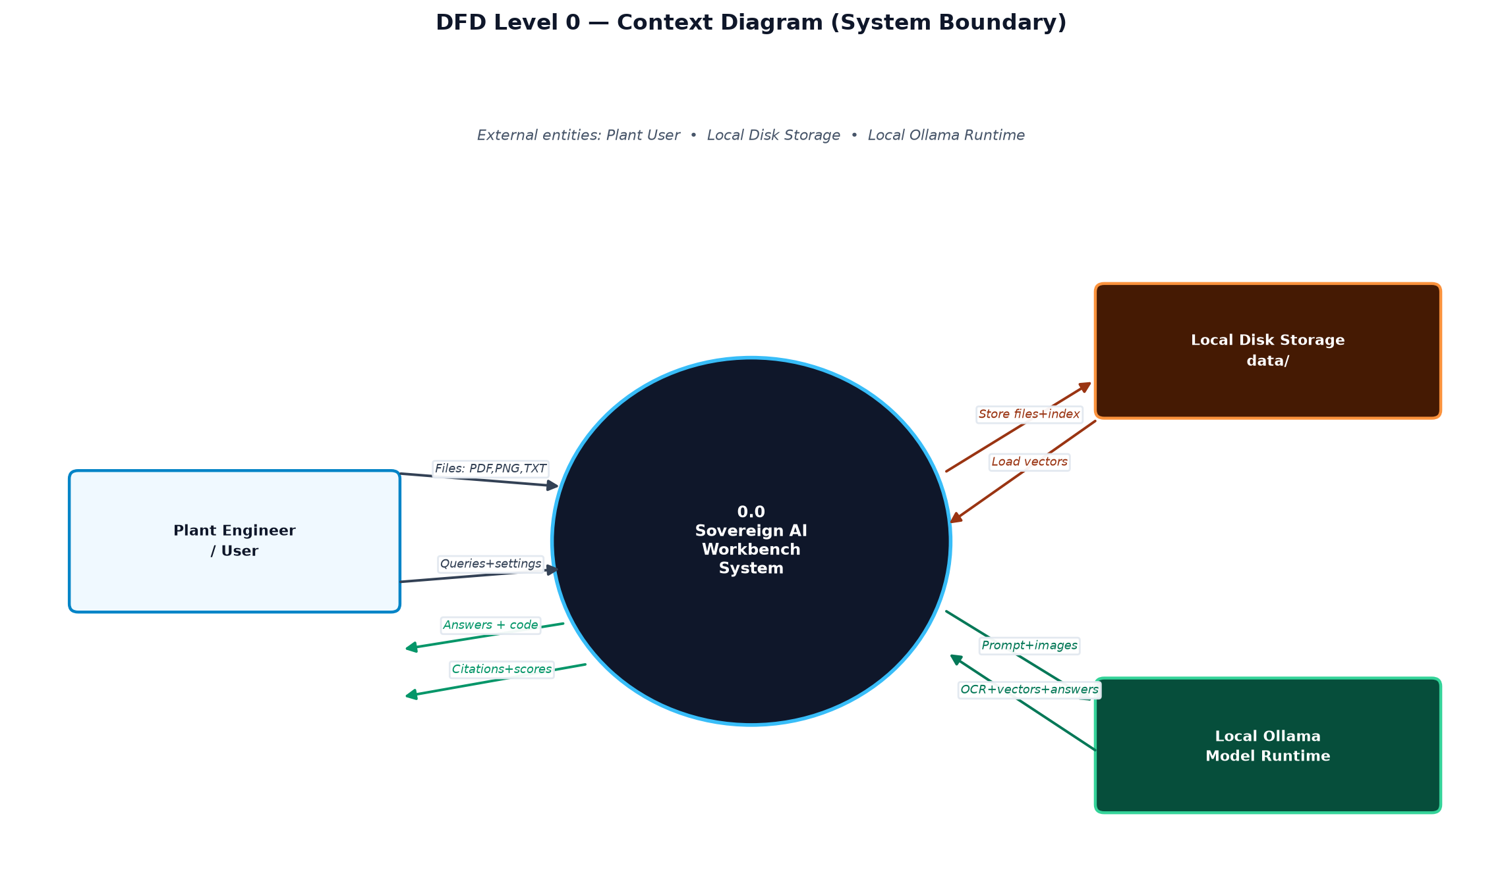
Figure — DFD Level 0 context diagram (system boundary & external entities) [source: Mermaid block 1]

🔄 2. DFD Level 1 — System Process Overview
Level 1 decomposes the system into four main logical data processes: Document Parsing/OCR, Vector Embedding & Indexing, Task Routing & Retrieval, and Grounded Inference.
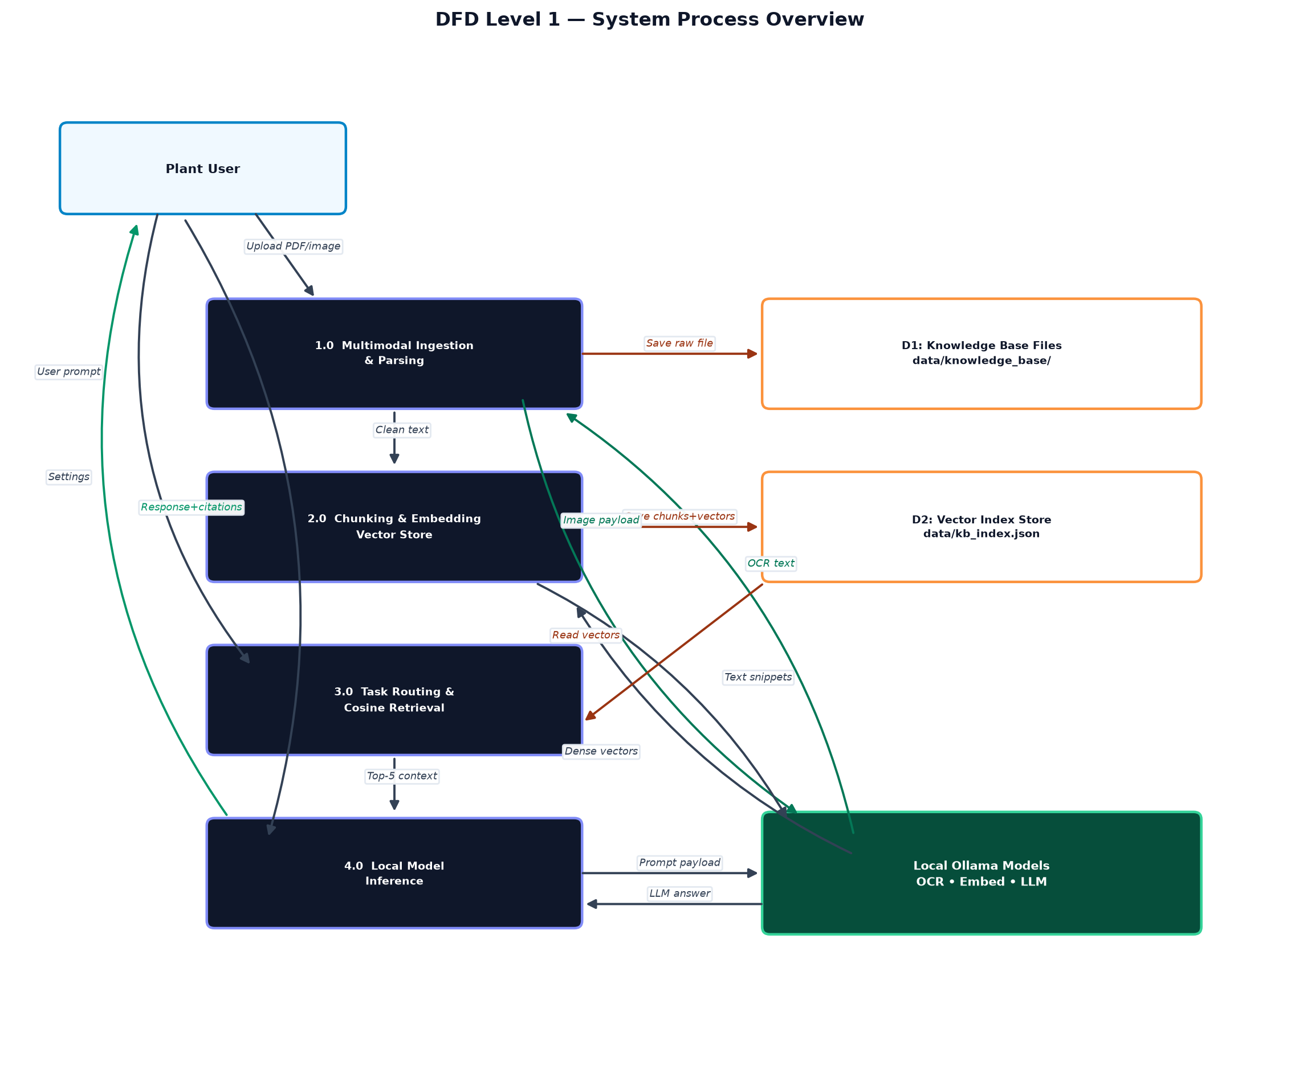
Figure — DFD Level 1: four system processes, stores D1/D2, Ollama runtime [source: Mermaid block 2]

🔬 3. DFD Level 2 — Process 1.0 (Multimodal Document & Image Ingestion Pipeline)
Level 2 zooms into Process 1.0 to depict the exact transformation steps from raw uploaded documents to clean text chunks.
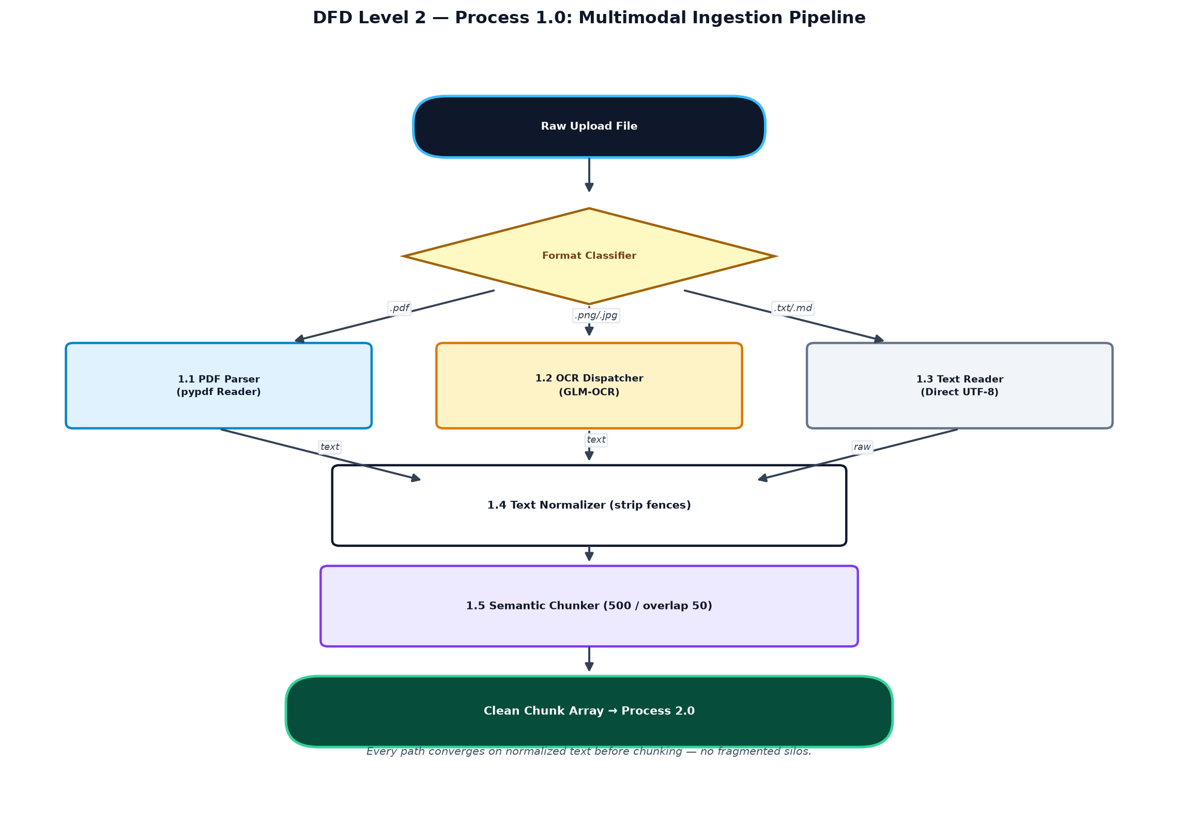
Figure — DFD Level 2: Process 1.0 multimodal ingestion pipeline detail [source: Mermaid block 3]

📖 4. Data Dictionary
Data Element | Type | Source | Destination | Description
uploaded_file | Binary Stream | User UI | Process 1.0 | PDF document or image file uploaded via form payload.
ocr_prompt_payload | Base64 / Path | Process 1.2 | Ollama (glm-ocr) | Image payload sent to local OCR model.
raw_text_stream | String | Process 1.0 | Process 1.4 | Extracted text before normalization.
chunk_record | JSON Object | Process 2.0 | D2: kb_index.json | Contains chunk_id, text, source_file, and 768-dim embedding array.
user_query | String | User UI | Process 3.0 | Text prompt entered by user in Web UI.
query_vector | Array[768] | Process 3.0 | Cosine Search Engine | 768-dimensional float embedding of user query.
cosine_match_score | Float [0.0 - 1.0] | Cosine Search Engine | Process 4.0 | Cosine similarity score between query vector and chunk vector.
grounded_response | JSON Object | Process 4.0 | User UI | Contains generated LLM answer text, route used, and source document metadata array.

