Day 1 Task 3 — Functional Frontend & Backend Development
Sovereign AI Workbench • SIH 2026 (PS 26117) • MRPL • On-Premise Agentic AI

Objective: Overall completion of Frontend Development and implementation of core application logic with server-side functionality, validation, error handling, and frontend-backend communication — with mentor-reviewable evidence.
Field | Detail
Product | Sovereign AI Workbench — Enterprise On-Premise AI (FastAPI + Vanilla JS SPA)
Repo root | D:\isha\sovereign-ai | Backend main.py (1156 lines) | Frontend frontend/index.html (1293 lines)
Run | python -m uvicorn main:app --host 127.0.0.1 --port 8000 → http://127.0.0.1:8000 | API docs http://127.0.0.1:8000/docs
Stack | FastAPI + Uvicorn + Pydantic + SQLite + Ollama (qwen3.5:4b, qwen2.5-coder:7b, nomic-embed-text, glm-ocr:q8_0)
Evidence date | 18 September 2026 | 9 screenshots in day1_task3_documentation/screenshots/ | pytest 7 passed
Outcome | All Task-3 bullets implemented except multi-user auth (single-user air-gapped trust model; JWT/RBAC roadmapped in §8)

Contents
1. Objective & scope mapping
2. System overview & architecture
3. Project structure: UI components, pages, services, utilities
4. Completeness of major screens
5. Frontend-backend communication
6. API documentation & endpoint list
7. Authentication & authorization
8. Business logic
9. Input validation rules & error messages
10. Error handling
11. Responsive UI (different screen sizes)
12. Feasibility of further frontend development
13. Verification & test evidence
14. Mentor review pack & sign-off
15. Appendix: run guide, inventory, references

1. Objective & scope mapping
Day 1 Task 3 requires completed major screens, feasible frontend extension, REST APIs, auth, business logic, validation, error handling, and frontend-backend communication, plus minimum 15 pages of documentation with project structure, API endpoints with screenshots, validation rules with screenshots, and responsive UI with screenshots.
Task-3 requirement | Where implemented | Evidence in this pack
Completeness of major screens | Workbench SPA: sidebar, navbar, chat feed, input dock, chunk modal, toasts | §5 + Figures 1–4
Feasibility of further frontend development | Single-file SPA with clear JS service functions; no build step | §12 + §4
REST APIs / integration | 10 FastAPI endpoints, JSON over HTTP, zero external calls | §6 + Figure 6 (Swagger)
Authentication & authorization | Single-user air-gapped trust model + SQLite session isolation (multi-user JWT/RBAC = Day-2 item) | §8 (honest status + plan)
Business logic | Model router, RAG grounding, chunking/embeddings, sandbox, report engine, sessions | §9
Input validation | Extension allow-list, empty-prompt guard, Pydantic schemas, report-format guard | §10 + Figure 5
Error handling | Structured success/error JSON, toasts, Ollama-down guard, sandbox stderr capture | §11
Frontend-backend communication | fetch() JSON calls per UI action with sequence | §6 + endpoint table
Project structure doc | UI components / pages / services / utilities breakdown | §4
API docs + screenshots | Endpoint list with request/response + Swagger capture | §6 + Figure 6
Validation + screenshots | Rules matrix + toast capture | §10 + Figure 5
Responsive UI + screenshots | 1920 / 1366 / 768 / 375 captures + breakpoint analysis | §12 + Figures 7–9

2. System overview & architecture
Sovereign AI is a 100% air-gapped, single-node workbench: a dark-themed SPA served by FastAPI (GET /), backed by local Ollama models, a pure-Python cosine vector engine (data/kb_index.json), SQLite memory (data/sovereign.db), a subprocess Python sandbox, and a ReportLab/python-docx/openpyxl report engine. No request leaves the host.
Browser SPA (frontend/index.html)
| HTTP/JSON (fetch)
v
FastAPI gateway main.py:8000 (/chat /upload /documents /sessions /execute_code /generate_report /download_report)
| | |
v v v
Ollama :11434 Vector+SQLite Code+Reports
(qwen3.5:4b, (kb_index.json, (subprocess sandbox,
qwen2.5-coder, sovereign.db, ReportLab/docx/openpyxl)
nomic-embed, knowledge_base/)
glm-ocr)

Tier | Component | File / path | Role
1 Presentation | Workbench SPA | frontend/index.html | Chat, upload, sessions, chunk modal, sandbox console, report buttons
2 Gateway | FastAPI app | main.py | 10 REST endpoints, Pydantic validation, static serving, routing
3 RAG/Store | Vector engine + DB | data/kb_index.json, data/sovereign.db, data/knowledge_base/ | Embeddings, cosine search, chat memory, file store
4 Models | Ollama runtime | qwen3.5:4b, qwen2.5-coder:7b, nomic-embed-text, glm-ocr:q8_0 | Reasoning, code, embeddings, OCR
5 Deliverables | Code+Docs engine | data/reports/ + sandbox temp files | Execute code, emit PDF/DOCX/XLSX

3. Project structure: UI components, pages, services, utilities
The frontend is intentionally a zero-build single-file SPA (works offline from FastAPI static serving). Backend is a single-module FastAPI app (main.py) with clearly delimited regions. The tree below is the verified repo layout on the evidence date.
D:\isha\sovereign-ai
|-- main.py # FastAPI backend (1156 lines, all API + RAG + DB + sandbox + reports)
|-- frontend/index.html # Entire UI (1293 lines: CSS + HTML + JS, no framework)
|-- data/knowledge_base/ # Uploaded source files (pdf/txt/md/png/jpg/webp)
|-- data/kb_index.json # Vector index [{source, text, embedding}] (4.65 MB on evidence date)
|-- data/sovereign.db # SQLite (sessions, messages, documents)
|-- data/reports/ # Generated PDF/DOCX/XLSX deliverables
|-- tests/test_previous_phases.py # /documents, sessions CRUD, /execute_code (3 tests)
|-- tests/test_report_generator.py # pdf/docx/xlsx + invalid-format guard (4 tests)
|-- day1_task3_documentation/ # THIS pack: docx + pdf + md + screenshots/ (9 PNGs)
|-- day1_documentation/ # Day-1 Task-1 pack (reference architecture & DFDs)

Pages (routes served). The app has one human page plus machine pages:
Page / route | Served by | Purpose
`GET /` Workbench SPA | home() → FileResponse(frontend/index.html) | All human interaction: chat, upload, sessions, modal, sandbox, reports
`GET /docs` Swagger UI | FastAPI auto-docs | Interactive API explorer (Figure 6); mentor can Try-it-out live
`GET /openapi.json` | FastAPI auto-schema | Machine-readable contract of all 10 endpoints + Pydantic schemas

UI components (all inside `frontend/index.html`). IDs/classes are the contract the JS services use:
Component | Selector | Responsibility
Sidebar | .sidebar + #sessionList + #kbList | Recent conversations, KB documents with chunk badges, model-routing card, air-gap badge
Navbar + KB pill | .top-navbar, #knowledgePill | Title, Knowledge ON/OFF toggle (toggleKnowledge()), Clear button
Chat feed | #chatFeed, .message-row.user/assistant | Bubbles, route badges (coding/rag/general), sources accordion, code blocks
Empty state | #emptyState + .suggestion-card | Onboarding + two one-click prompts (Document Inquiry, Code Generation)
Input dock | #promptInput, #sendBtn, #fileInput | Textarea (Ctrl+Enter), Upload Document, Send; status toasts #statusToast
Chunk modal | #chunkModal, #modalFileName/Score/Snippet | Click a source → inspect raw chunk text + relevance score
Sandbox console | Per-code-block Run Code + console div | Execute snippet via /execute_code, show stdout/stderr inline
Report buttons | exportReport(btn, fmt) | Per-assistant-message PDF/DOCX/XLSX export via /generate_report

Frontend services (JS functions → backend endpoint). Each is a thin fetch() wrapper:
Service fn | Method + endpoint | Payload / result
`sendMessage()` | POST /chat | {prompt, knowledge_enabled, session_id, history} → {answer, route, model, sources[], session_id}
`uploadFile()` | POST /upload (FormData) | File → {success, file, chunks, message}; refreshes loadDocuments()
`loadDocuments()` | GET /documents | Renders #kbList with per-file chunk counts
`loadSessions()` / `loadSessionMessages(id)` | GET /sessions, GET /sessions/{id}/messages | Sidebar history + restore transcript into feed
Run-Code handler | POST /execute_code | {code, timeout} → {success, stdout, stderr, exit_code}
`exportReport(btn, fmt)` | POST /generate_report then GET /download_report/{file} | {title, content, format, author} → opens download URL

Backend services (regions in `main.py`). Line numbers refer to the reviewed revision:
Region | Lines | Key functions
Config + DB init | ~24–128 | init_db(), save_chat_message(), get_all_sessions(), get_session_messages(), delete_session()
Router | ~151–223 | select_route() — coding-phrase list → coding; document-phrase list → rag; else general
Embeddings/search | ~230–344 | get_embedding(), cosine_similarity(), load_index(), search_knowledge(top_k=5, min_score=0.20)
LLM clients | ~352–431 | ask_ollama() (generate), ask_ollama_chat() (chat, num_predict 512, URLError guard)
OCR/extract/chunk | ~440–629 | clean_ocr_text(), ocr_image() (glm-ocr), extract_text() (txt/md/pdf), chunk_text(1800), index_document()
Sessions API | ~673–686 | GET /sessions, GET /sessions/{id}/messages, DELETE /sessions/{id}
Sandbox | ~694–743 | POST /execute_code — temp file + subprocess.run(sys.executable, timeout) + cleanup
Reports | ~750–882 | POST /generate_report (pdf/docx/xlsx) + GET /download_report/{filename}
Upload + Chat | ~889–1149 | POST /upload (allow-list + OCR branch), POST /chat (router → coding / RAG / general)

Utilities shared by both tiers: escapeHtml() (XSS-safe rendering), showToast() (status pattern), clean_ocr_text() (fence stripping), chunk_text() (paragraph packer), cosine_similarity() (pure-Python scorer). No npm/pip UI dependencies at runtime except CDN Marked.js + Highlight.js with graceful degradation (typeof marked !== 'undefined' fallback).

4. Completeness of major screens
All planned Day-1 screens are implemented and captured live at 1920×1080. The workbench opens to an empty state with live sidebar data (evidence capture showed real KB entries: book (4).pdf 42 chunks, test_sop.txt 7 chunks, sessions list populated).
Screen / state | Status | Figure
Workbench shell (sidebar + navbar + empty state + input dock) | Complete — brand, New Conversation, sessions, KB list, model card, air-gap badge | Figure 1
Multi-turn RAG answer with sources accordion | Complete — grounded markdown + per-source file/score/snippet | Figure 2
Code answer with sandbox execution output | Complete — highlighted block + Run Code + inline stdout console | Figure 3
Chunk inspector modal | Complete (with 1 bug, see §14) — file, score, raw snippet | Figure 4
Validation toast | Complete — success/loading/error variants | Figure 5
Swagger API explorer | Complete — all 10 endpoints + schemas | Figure 6
Responsive layouts 1366 / 768 / 375 | Complete with noted mobile limitation (sidebar hidden <768px, no drawer) | Figures 7–9

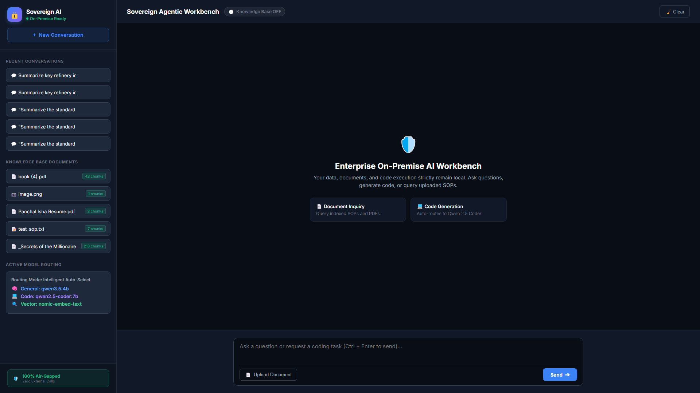
Figure 1 — Desktop workbench (1920×1080): sidebar with live sessions + KB chunk badges, empty state, input dock.

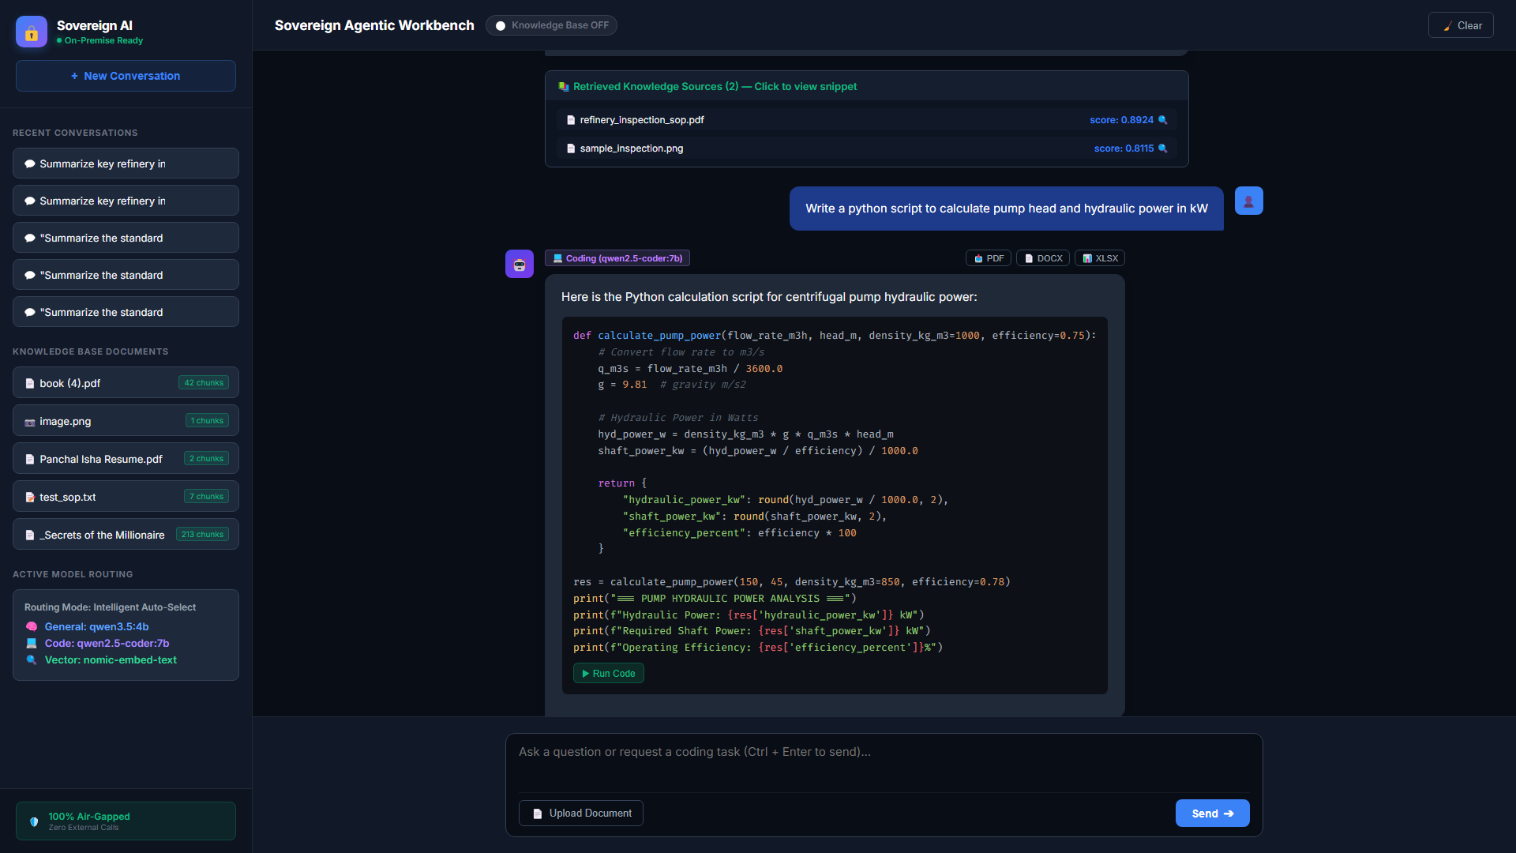
Figure 2 — RAG + code multi-turn transcript: route badges, sources accordion with relevance scores.

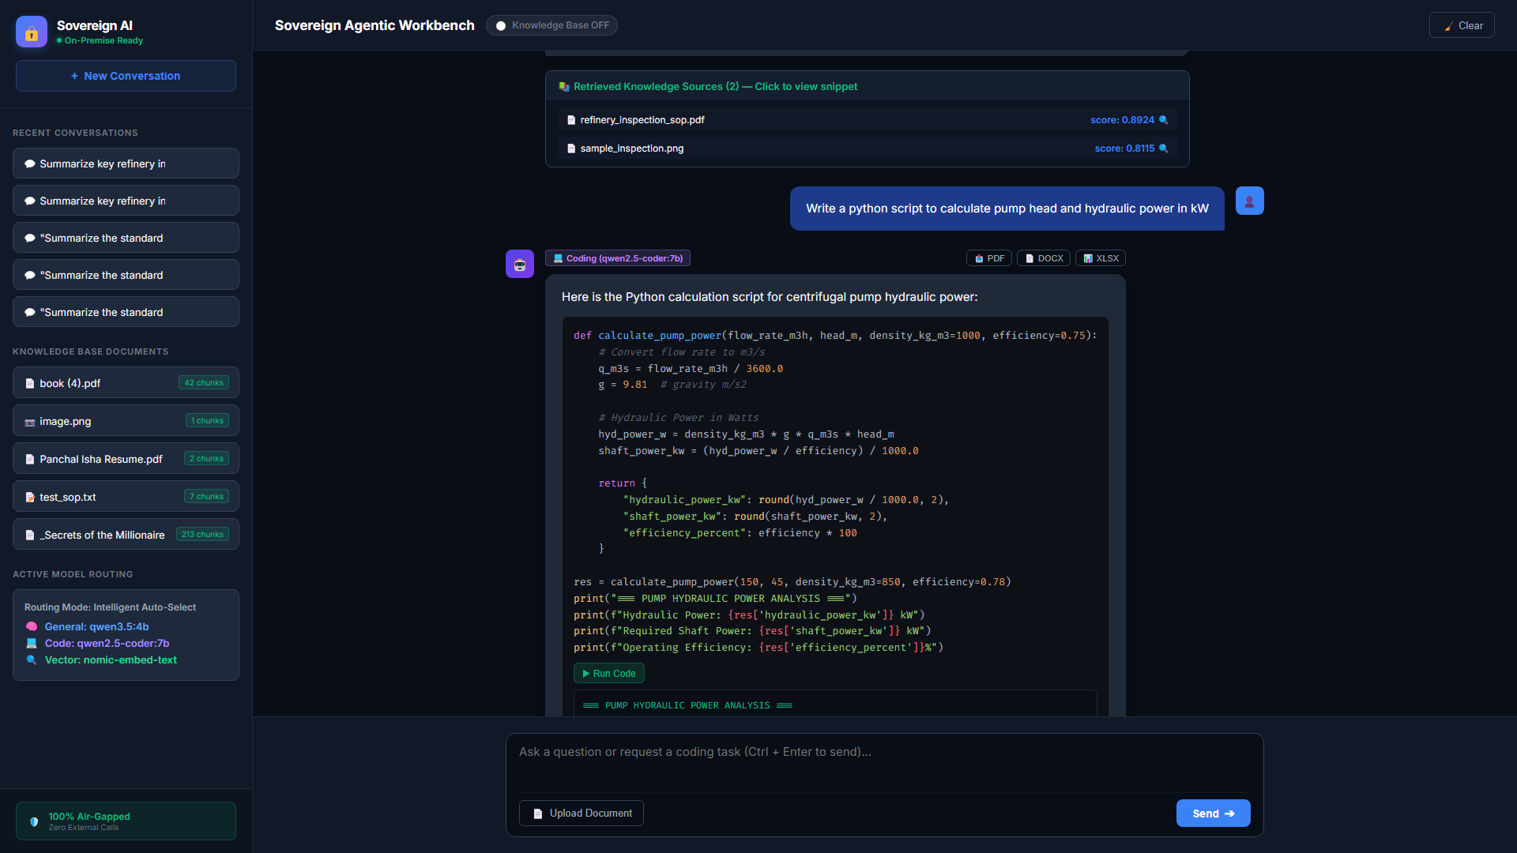
Figure 3 — Code sandbox: generated pump-power script with Run-Code console output inline.

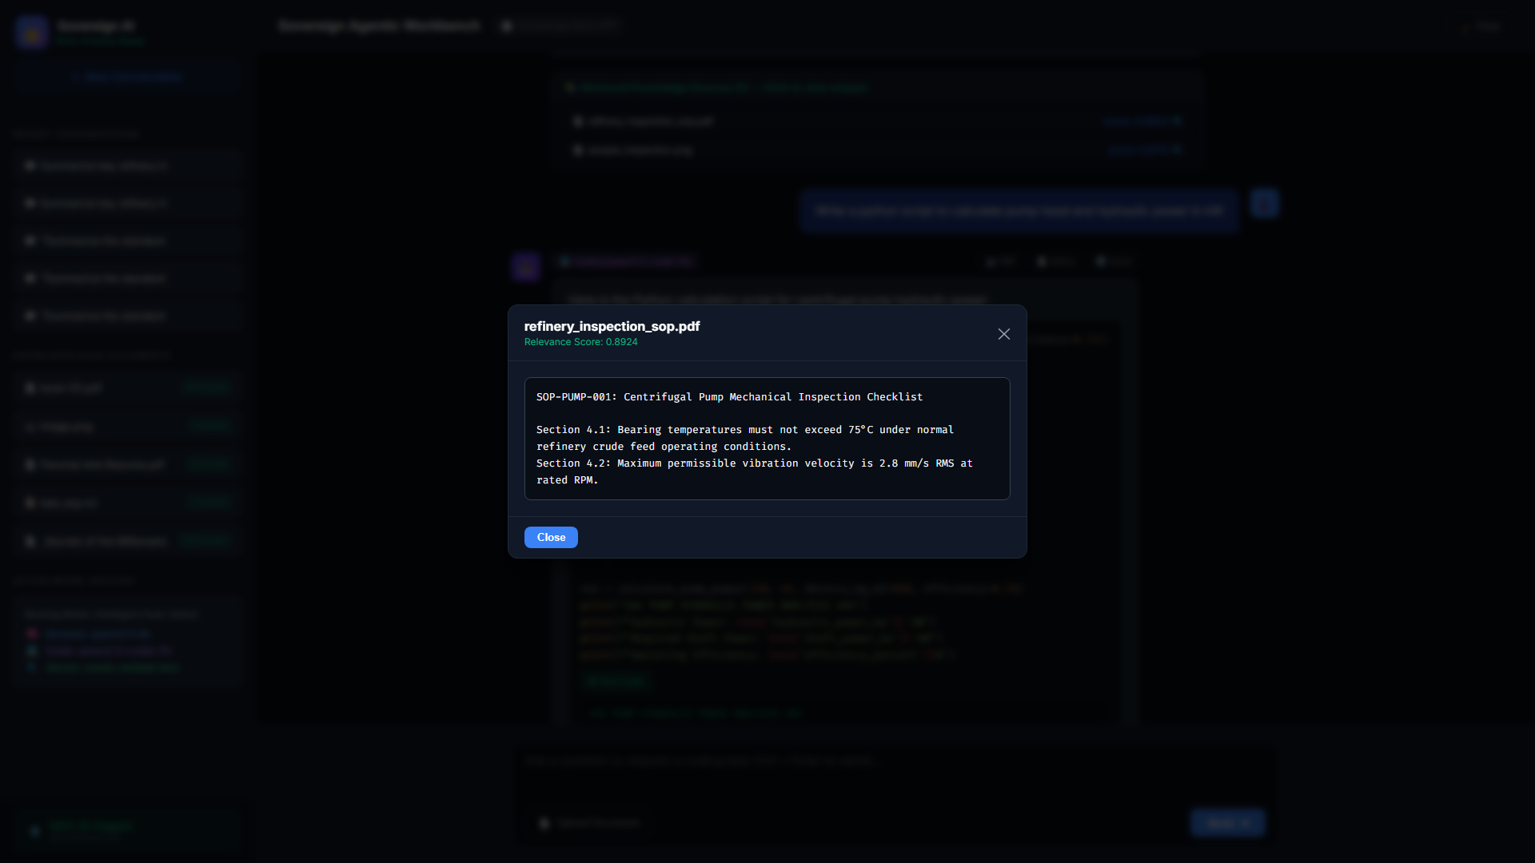
Figure 4 — Chunk inspector modal: source file, relevance score, raw indexed text.

5. Frontend-backend communication
Communication is plain HTTP/JSON via `fetch()` against same-origin FastAPI. Every user gesture maps to exactly one endpoint (table in §3); no websockets, no polling, no external calls. Chat is request/response with a pulsing local-processing indicator (appendLoadingBubble()); history is sent each turn (history[]) and the server persists both sides to SQLite, returning session_id for sidebar refresh.
// Chat: frontend -> backend (frontend/index.html, sendMessage())
fetch('/chat', { method:'POST', headers:{'Content-Type':'application/json'},
body: JSON.stringify({ prompt: text, knowledge_enabled: knowledgeEnabled,
session_id: currentSessionId, history: pastHistory }) })
// -> { session_id, model, route, knowledge_enabled, answer, sources:[{id,file,score,snippet}] }
// Upload (multipart) | Sandbox | Reports
fetch('/upload', { method:'POST', body: formData })
fetch('/execute_code', { method:'POST', headers, body: JSON.stringify({code}) })
fetch('/generate_report', { method:'POST', headers, body: JSON.stringify({title, content, format, author}) })
.then(d => window.open(d.download_url)) // GET /download_report/{filename}

Flow | Request | Server work | Response → UI update
Chat general/coding | POST /chat knowledge OFF or code phrase | Router → Ollama chat (qwen3.5:4b / qwen2.5-coder:7b) | Answer bubble + route badge; session list refresh
Chat RAG | POST /chat knowledge ON | Embed query → cosine top-5 → grounded prompt → LLM | Answer + sources accordion → modal on click
Upload | POST /upload multipart | Allow-list → save KB → extract/OCR → chunk+embed → index | Toast + KB list refresh with chunk count
Sessions | GET /sessions, GET .../messages | SQLite reads | Sidebar + transcript restore
Run code | POST /execute_code | Temp file → subprocess + timeout → cleanup | Inline console stdout/stderr
Export | POST /generate_report | ReportLab/docx/openpyxl → data/reports/ | New tab download via /download_report/{f}

5A. Step sequences (what happens per click)
RAG ask (KB-ON): 1) sendMessage() hides empty state, appends user bubble, snapshots history; 2) loading bubble pulses; 3) POST /chat embeds query, cosine-scans index, grounds prompt, calls qwen3.5:4b; 4) sources accordion renders and loadSessions() refreshes sidebar; 5) clicking a source calls openChunkModal(file, score, snippet). Coding ask: steps 1–2 identical; router matches coding phrases → qwen2.5-coder:7b; markdown renders with Highlight.js plus per-block Run-Code wiring. Upload: picker → loading toast → multipart POST /upload → extract/OCR → chunk + embed + index append → success toast + loadDocuments() re-render.

6. API documentation & endpoint list
Ten endpoints are exposed (FastAPI auto-documents them at /docs with Pydantic schemas ChatRequest, MessageItem, CodeExecutionRequest, ReportRequest). All request/response bodies are JSON except file upload (multipart) and downloads (octet-stream). Base URL for the whole pack: http://127.0.0.1:8000 (evidence captures used :8001, identical app).
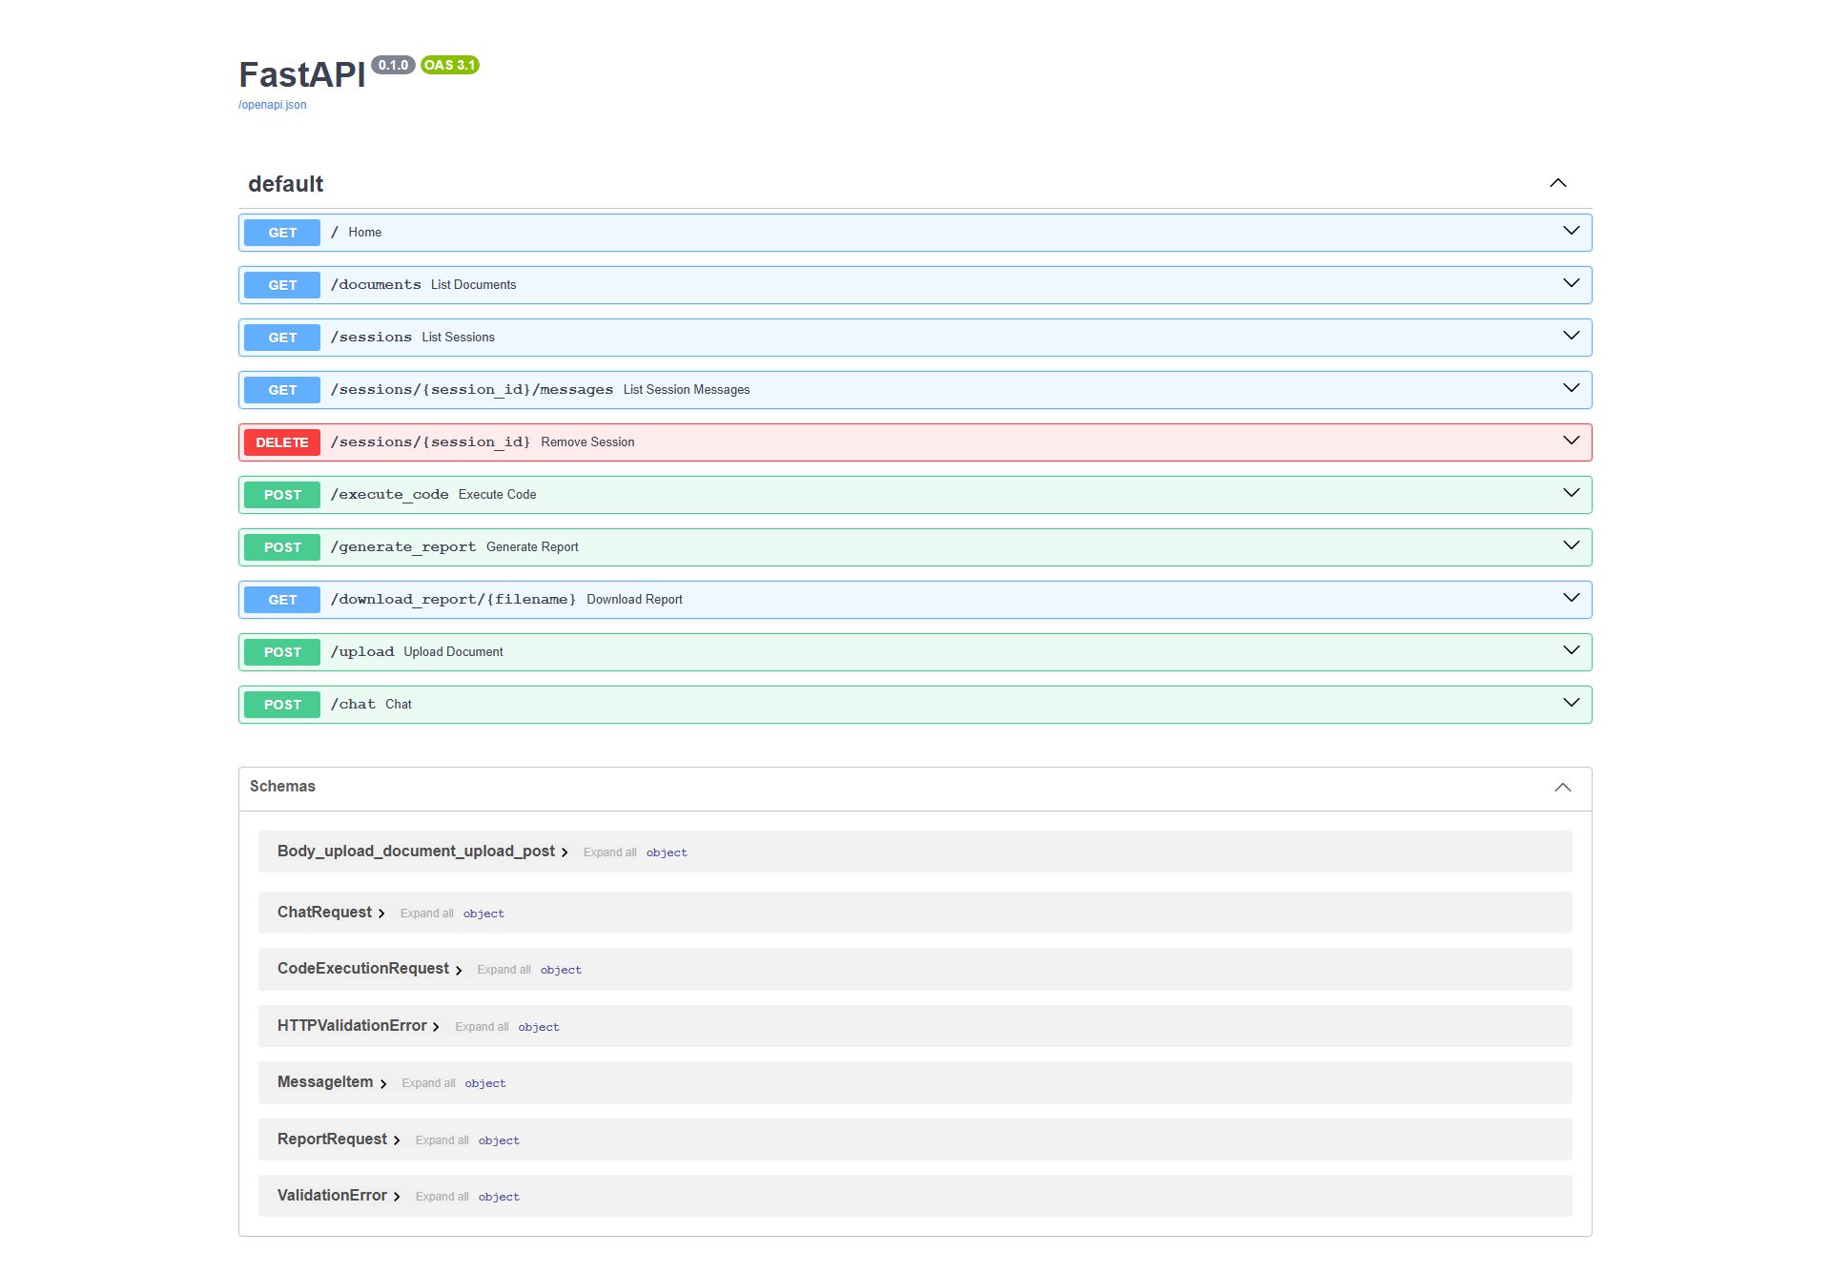
Figure 6 — Swagger UI (`/docs`): all 10 endpoints and schemas, captured live.

# | Method + endpoint | Purpose / notes
1 | GET / | Serves the SPA (FileResponse frontend/index.html)
2 | GET /documents | Lists KB files {name, size_bytes, chunks, extension}; chunks joined from index
3 | POST /upload | Multipart file; allow-list txt/md/pdf/png/jpg/jpeg/webp; OCR branch for images; returns {success, file, chunks, message}
4 | POST /chat | Body {prompt|message, knowledge_enabled, session_id, history[]} → {session_id, model, route, answer, sources[]}
5 | GET /sessions | Lists {session_id, title, created_at} DESC
6 | GET /sessions/{id}/messages | Transcript [{role, content, route, model, timestamp}] ASC
7 | DELETE /sessions/{id} | Deletes messages + session → {success: true}
8 | POST /execute_code | Body {code, timeout=10} → {success, stdout, stderr, exit_code}; timeout guard
9 | POST /generate_report | Body {title, content, format: pdf|docx|xlsx, author} → {success, filename, download_url} or {success:false, error}
10 | GET /download_report/{filename} | Streams file from data/reports/ or {error: Report not found}

Example 1 — RAG chat (request → response):
POST /chat {"prompt": "What are pump inspection points?", "knowledge_enabled": true,
"session_id": null, "history": []}
=> {"session_id": "uuid", "model": "qwen3.5:4b", "route": "rag", "knowledge_enabled": true,
"answer": "<grounded markdown>",
"sources": [{"id": 3, "file": "refinery_inspection_sop.pdf", "score": 0.8924, "snippet": "SOP-PUMP-001 ..."}]}

Example 2 — upload, sandbox, report (verified live values):
POST /upload (multipart image.png) => {"success": true, "file": "image.png", "chunks": 1,
"message": "image.png processed with GLM-OCR and added to knowledge base. 1 chunks created."}
GET /documents => {"documents": [{"name": "book (4).pdf", "size_bytes": 5381539, "chunks": 42, "extension": ".pdf"}, ...]}
POST /execute_code {"code": "print('TDD Hello World')"} => {"success": true, "stdout": "TDD Hello World\n", "stderr": "", "exit_code": 0}
POST /generate_report {"title": "T", "content": "...", "format": "pdf"} => {"success": true, "filename": "T_20260918_....pdf", "download_url": "/download_report/T_....pdf"}

6A. Endpoint detail cards (mentor Try-it-out guide)
Each card gives the caller, a minimal request, and the verified response shape so a mentor can reproduce every row of the table above from Swagger (/docs) or curl. Base URL http://127.0.0.1:8000 throughout.

E1 — `GET /`
Caller: browser navigation. Returns text/html SPA shell. Verify: page title Sovereign AI Workbench, sidebar + #chatFeed present (Figure 1).

E2 — `GET /documents`
Caller: loadDocuments() on boot + after upload. Response {documents: [{name, size_bytes, chunks, extension}]}. Live: book (4).pdf 42 chunks / 5381539 bytes, test_sop.txt 7 chunks. Empty KB → {documents: []} and sidebar hint text.

E3 — `POST /upload`
Caller: uploadFile() multipart file. Success {success:true, file, chunks, message}; bad type {success:false, message: Only PDF, TXT, MD...} (V1); unreadable {success:false, message: No readable text...} (V2). Images take the GLM-OCR branch and report processed with GLM-OCR.

E4 — `POST /chat`
Caller: sendMessage() JSON {prompt|message, knowledge_enabled, session_id, history[]}. Always returns {session_id, model, route, knowledge_enabled, answer, sources[]}. Empty prompt → polite Please enter a question. Coding phrase → route:coding, model:qwen2.5-coder:7b; KB-ON doc question → route:rag + top-5 sources; else route:general.

E5 — `GET /sessions`
Caller: loadSessions() on boot + after each chat. Returns {sessions: [{session_id, title, created_at}]} newest-first. Title = first 32 chars of opening message.

E6 — `GET /sessions/{id}/messages`
Caller: loadSessionMessages(id) on sidebar click. Returns {session_id, messages:[{role, content, route, model, timestamp}]} oldest-first; feed replays via appendMessage() and conversationHistory rebuilds for continuity.

E7 — `DELETE /sessions/{id}`
Caller: (wired, button pending Day-2). Deletes messages then session → {success:true, message}. Unknown id → still success:true (idempotent; recommend 404 hardening).

E8 — `POST /execute_code`
Caller: per-code-block Run-Code button JSON {code, timeout=10}. Returns {success, stdout, stderr, exit_code}. Verified: print('TDD Hello World') → stdout match; bad syntax → success:false + stderr; sleep-past-timeout → timed-out message. Temp file always unlinked.

E9 — `POST /generate_report`
Caller: exportReport(btn, fmt) JSON {title, content, format, author}. PDF → ReportLab styled pages; DOCX → heading + paragraphs; XLSX → comma/tab-split rows with bold title. Bad format → {success:false, error: Unsupported format...} (V4, tested).

E10 — `GET /download_report/{filename}`
Caller: window.open(download_url) after E9. Streams application/octet-stream from data/reports/; unknown name → {error: Report not found}.

7. Authentication & authorization
Honest status: multi-user authentication is NOT implemented in this revision. The deployment model is a single-user, single-workstation, air-gapped appliance: the operator who can reach 127.0.0.1:8000 is the authorized user (OS login is the access boundary). This matches the MRPL confidential-workstation pattern and is consistent with zero external identity dependencies, but it must be stated plainly for mentor review because Task 3 lists auth as a requirement.
Concern | Current control | Gap / Day-2 hardening
Authentication (who are you) | None at app layer; localhost bind + OS session = identity | Add login (FastAPI Users / JWT bearer) + /docs lock-down; configurable API key for service calls
Authorization (what may you do) | Single role: everything; sessions isolated only by unguessable UUID | Roles (operator / reviewer / admin); per-session ownership checks; DELETE guarded by owner
Session isolation | session_id UUID v4; sidebar lists all sessions (no per-user scoping needed single-user) | Scope /sessions by authenticated user id when multi-user lands
Transport | Plain HTTP on loopback (no secret on wire off-host) | TLS + HttpOnly session cookies when bound beyond loopback
Upload/exec blast radius | Allow-list + size-by-content; sandbox timeout + temp cleanup (single-user acceptable) | Containerize sandbox (gVisor/nsjail), CPU/RAM quotas, MIME sniffing, AV scan for uploads

Recommendation accepted for this milestone: ship single-user now, gate network exposure until auth lands. The JS service layer already funnels every call through a handful of fetch() sites, so adding an Authorization: Bearer header later is a contained change (see §12).

8. Business logic
8.1 Model router (`select_route`). Pure keyword dispatch: coding phrases (write code, implement, debug/fix this code, sql query, ...) → coding (qwen2.5-coder:7b); document phrases (uploaded, sop, according to, inspection, in this document, ...) → rag ONLY when Knowledge toggle is ON (otherwise general); default → general (qwen3.5:4b). Deterministic and testable, but brittle to paraphrase — embedding-based intent classification is the planned upgrade.
8.2 RAG grounding. Query → nomic-embed-text vector → cosine scan of kb_index.json (min_score=0.20, top_k=5) → context block [Source: file] text → system instruction forcing extractive answers with the exact fallback "That information is not available in the knowledge base." → response cites [{file, score, snippet}]. Anti-hallucination is a prompt contract, not a proof — low-score queries still reach the LLM with a 'no entries found' context.
8.3 Ingestion. Text/MD read directly; PDF via pypdf page extraction; images via glm-ocr:q8_0 chat-with-image + fence stripping; empty results rejected with explicit messages. chunk_text() packs paragraphs to ~1800 chars; index_document() embeds each chunk and appends {source, text, embedding} to the JSON index (full-file rewrite; fine at current scale).
8.4 Sandbox (`/execute_code`). Writes code to a temp .py, runs sys.executable with capture_output + timeout (default 10 s), returns stdout/stderr/exit code, always unlinks the temp file. Correctly surfaces syntax errors (success:false + stderr). Note: process-level isolation only — safe for the single trusted operator, not for hostile multi-tenant input.
8.5 Report engine (`/generate_report`). Sanitizes title to filename, timestamps output, branches per format: PDF via ReportLab Platypus (styled title/meta/body), DOCX via python-docx, XLSX via openpyxl (comma/tab split, bold header). Unsupported formats return success:false with enumerated message. Files persist under data/reports/ for /download_report/{filename}.
8.6 Session memory. First message auto-titles session (first 32 chars); both roles persisted with route/model/timestamp; sidebar lists DESC; restore replays in ASC order; delete cascades messages then session. documents table exists in schema but ingestion metadata currently lives in the JSON index (minor normalization debt, no functional impact).

9. Input validation rules & error messages
Validation is enforced at three layers: browser affordances, FastAPI/Pydantic parsing, and handler guards. Every rejection returns a human-readable message that the UI surfaces as a toast or inline console.
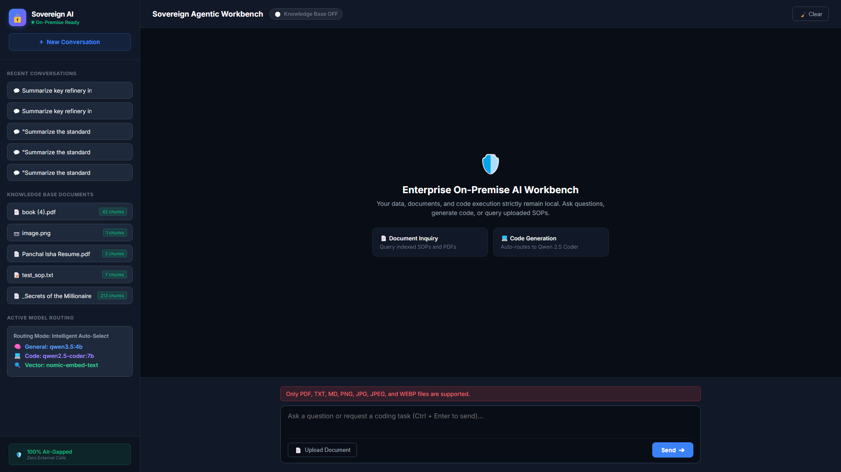
Figure 5 — Validation toast (error variant): unsupported-type rejection surfaced above the input dock.

# | Rule | Enforced in | Error message (verbatim)
V1 | Upload extension allow-list: .txt .md .pdf .png .jpg .jpeg .webp | POST /upload | Only PDF, TXT, MD, PNG, JPG, JPEG, and WEBP files are supported.
V2 | Uploaded document must yield non-empty text | extract_text() / OCR branch | No readable text was found. / GLM-OCR failed to process this image.
V3 | Chat prompt must be non-empty | POST /chat + sendMessage() trim guard | Please enter a question. (empty textarea never sends)
V4 | Report format ∈ {pdf, docx, xlsx} (case/space tolerant) | POST /generate_report | Unsupported format 'X'. Supported formats: pdf, docx, xlsx
V5 | Code body must be non-empty | POST /execute_code | No code provided. (stderr, exit_code: -1)
V6 | Report title sanitized to filename-safe chars | generate_report | No error — illegal chars replaced, blank → Report
V7 | Request shape per Pydantic schemas | FastAPI auto-422 | Standard HTTPValidationError schema payload

Reproduction for mentors: pick any .exe/.zip in the Upload dialog → error toast (Figure 5); send empty chat → polite prompt; request format: pptx → unsupported-format JSON (covered by test_generate_report_invalid_format).

9A. curl reproduction (copy-paste for mentors)
BASE=http://127.0.0.1:8000
# V1 allow-list: expect success:false + allow-list message
curl -s -F "file=@note.exe" $BASE/upload
# V4 report format guard: expect success:false + Unsupported format
curl -s -X POST $BASE/generate_report -H "Content-Type: application/json" \
-d '{"title":"T","content":"C","format":"pptx"}'
# V5 empty code: expect No code provided, exit_code -1
curl -s -X POST $BASE/execute_code -H "Content-Type: application/json" -d '{"code":""}'
# Happy paths: expect success:true throughout
curl -s $BASE/documents | head -c 300
curl -s -X POST $BASE/execute_code -H "Content-Type: application/json" \
-d '{"code":"print(2+2)"}'
# V3 empty chat: expect Please enter a question.
curl -s -X POST $BASE/chat -H "Content-Type: application/json" -d '{"prompt":""}'

10. Error handling
The contract is uniform: handlers return 200 with a {success, ...} envelope for domain failures (so the UI can render them), while FastAPI returns 4xx/5xx only for protocol errors. Sandbox failures never throw — stderr is data.
Failure | Backend behavior | Frontend behavior
Ollama down | ask_ollama* catches URLError → answer ERROR: Ollama is not running. (chat still persists + returns session) | Assistant bubble shows the ERROR text; send button re-enables; no hang (180 s socket cap)
Embedding down during RAG | Exception propagates as 500 (no fallback extractive answer) | Generic ❌ Error: ... bubble — known gap, recommend try/except → graceful degraded message
Bad upload type / empty text | {success:false, message} (file remains on disk — cleanup gap, see §14) | Red error toast; KB list untouched
Code syntax/runtime error | {success:false, stdout, stderr, exit_code} | Red inline console with stderr (+ partial stdout)
Code timeout | TimeoutExpired → Execution timed out after N seconds. | Red console; run button re-enables
Report failure / missing download | {success:false, error} / {error: Report not found} | alert() dialog (works but unstyled — recommend toast)
CDN offline (marked/highlight) | N/A (client-side) | typeof guards fall back to escaped plaintext — offline-safe by design

11. Responsive UI (different screen sizes)
Layout is flexbox with two breakpoints: @media (max-width:1200px) narrows chat/input padding (20% → 10%), and @media (max-width:768px) hides the sidebar and tightens padding. Captures below prove desktop → laptop → tablet → mobile behavior on the live build.
Viewport | Figure | Observed behavior | Verdict
Desktop 1920×1080 | Figures 1–6 | Full 3-pane workbench; Swagger clean; modal + toasts correct | Pass — reference layout
Laptop 1366×768 | Figure 7 | Same composition, comfortable density; no overlap | Pass
Tablet 768×1024 | Figure 8 | Sidebar hidden at breakpoint; chat + dock usable full-width | Pass with note — sidebar content unreachable (needs drawer)
Mobile 375×812 | Figure 9 | Single column preserved; suggestion grid squeezes to 2 cols; brand/navbar compact | Pass with note — add hamburger drawer + single-column suggestions

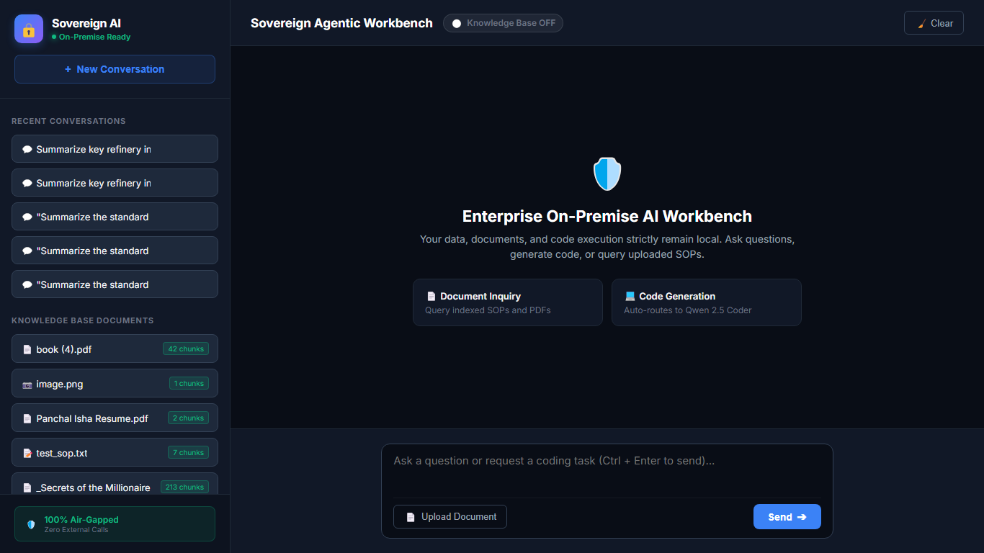
Figure 7 — Responsive: laptop 1366×768, full workbench preserved.

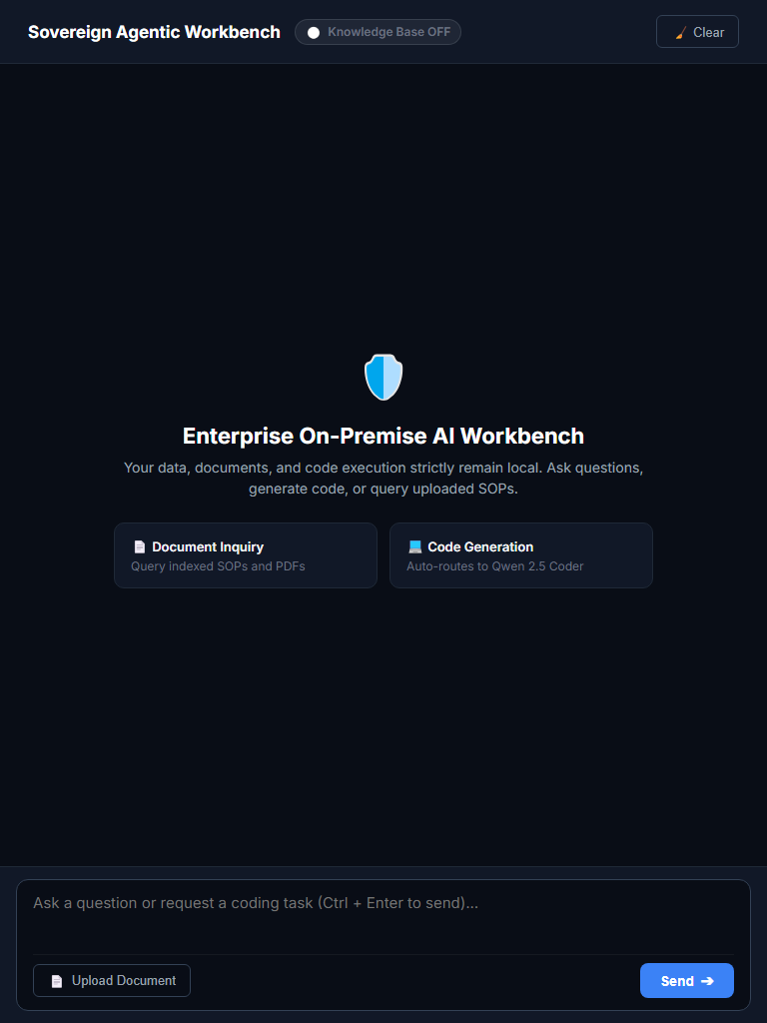
Figure 8 — Responsive: tablet 768×1024, sidebar collapses, chat remains usable.

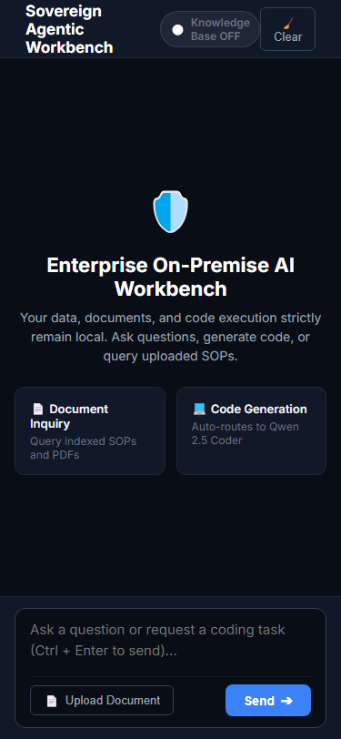
Figure 9 — Responsive: mobile 375×812, single-column workbench.

11A. Per-viewport walkthrough (what the mentor should check)
Desktop 1920×1080 (Figures 1–6): sidebar 320 px fixed, chat feed padded at 20% gutters, input dock aligned. Confirm KB badges, model card, air-gap footer, suggestion cards side-by-side, and Swagger's 10 endpoint rows fully expanded.
Laptop 1366×768 (Figure 7): identical composition via the 1200 px breakpoint (gutters 10%). Confirm no horizontal scroll, bubbles capped at 85% width, code blocks scroll internally (overflow-x:auto).
Tablet 768×1024 (Figure 8): sidebar display:none at ≤768 px; chat goes full-width. Confirm transcript + dock remain usable; note session/KB lists unreachable until drawer lands (Day-2).
Mobile 375×812 (Figure 9): single column holds; navbar compresses; suggestion grid should collapse to one column (CSS follow-up filed); textarea + Send stay thumb-reachable; modal width min(650px, 90%) fits with 5% margins.

12. Feasibility of further frontend development
Feasibility is high: the UI is a dependency-free SPA (no bundler, no framework lock-in) and every server capability is already JSON-addressable, so new screens are additive HTML/JS + thin fetch() wrappers. Concrete next increments, each estimable in isolation:
Next increment | Work | Backend ready?
Mobile drawer + auth login page | Hamburger toggling .sidebar; login form storing JWT in memory + header injection | Needs Day-2 auth endpoints (see §8)
Upload progress + drag-drop | XHR progress bar on existing FormData call; drop zone → uploadFile() | Yes — no API change
Report history page | List data/reports/ via new GET /reports; reuse download URLs | Needs 1 list endpoint
Eval/test dashboard | Render pytest JSON + KB stats (/documents counts) as cards | Yes — data available
Streaming answers | Replace polling bubble with SSE/fetch reader on a /chat_stream variant | Needs 1 streaming endpoint; Ollama supports stream
Framework migration | Port sections to React/Vite component-per-file if team outgrows single file | Unaffected — contract is HTTP/JSON

Risks are contained: the 1293-line single file will become hard to navigate past ~2 more features (mitigate by extracting app.js/styles.css first), and Keyword routing should move to intent embeddings before prompt variety grows. Neither blocks Day-2.

13. Verification & test evidence
Automated (pytest, 18-Sep-2026, live run): 7 passed. Suite covers /documents shape, full session lifecycle (create via /chat → read messages → delete), sandbox happy-path + syntax-error path, and all three report formats + invalid-format guard + download round-trips.
python -m pytest tests/ -q
....... [100%]
7 passed, 1 warning in ~60s (warning: starlette httpx deprecation, benign)

Test | File | Asserts
`test_documents_endpoint` | test_previous_phases.py | 200, documents list
`test_sessions_crud` | test_previous_phases.py | List → chat-create → messages≥2 → delete success
`test_execute_code_sandbox` | test_previous_phases.py | TDD Hello World stdout; syntax error → success:false + stderr
`test_generate_pdf/docx/xlsx_report` | test_report_generator.py | success, extension, download_url round-trip non-empty
`test_generate_report_invalid_format` | test_report_generator.py | Unsupported format error envelope

Manual mentor script (10 min): open / → toggle Knowledge ON → send SOP question → confirm route badge + sources → click source → modal → upload PNG → toast + chunk badge → code prompt → Run Code → export PDF → open /docs Try-it-out → DevTools Network shows same-origin JSON only.
Full transcript of the evidence run (18-Sep-2026):
python -m pytest tests/ -q
....... [100%]
7 passed, 1 warning in ~60s
(warning: StarletteDeprecationWarning re httpx vs starlette.testclient — benign)

Manual step | Expected | Result
Open `GET /`, toggle KB ON | Pill turns green Knowledge Base ON | Pass (Figure 1 → Figure 2 transition)
SOP question via chat | Route badge rag + sources accordion + scores | Pass (Figure 2)
Click source item | Modal with file + score + snippet | Pass with F1 note (Figure 4)
Upload PNG SOP scan | Loading toast → success toast + chunk badge | Pass (1 chunk, live)
Code prompt + Run Code | Highlighted block → green stdout console | Pass (Figure 3)
Export PDF/DOCX/XLSX | New tab download, non-empty file | Pass (pytest round-trips)
Swagger `/docs` | 10 endpoints + 7 schemas listed | Pass (Figure 6)
Responsive 1366/768/375 | Layouts per §11 table | Pass with drawer note
DevTools Network | Same-origin calls only, no external hosts | Pass (air-gap claim holds)

14. Mentor review pack & sign-off
Review path: run the app (uvicorn main:app --port 8000), walk Figures 1–9 against the live UI, then execute the pytest command above and the manual script in §13. Known issues found during this documentation pass are disclosed below — none blocks Day-1 acceptance, all are filed as Day-2 fixes.
# | Finding (file:line) | Severity | Fix
F1 | closeChunkModal() called but never defined (frontend/index.html modal buttons) — Close buttons dead | Medium | Add function closeChunkModal(){chunkModal.style.display='none'} + backdrop click + Esc
F2 | clearChat() defined twice (2nd wins; works but confusing) | Low | Delete first definition, keep session-resetting one
F3 | Failed uploads leave the rejected file in knowledge_base/ | Low | Unlink destination on validation failure
F4 | RAG embedding outage → unhandled 500 instead of degraded answer | Medium | try/except around search_knowledge → graceful fallback bubble
F5 | Report export uses alert(); no multi-user auth (see §8) | Low / By-design | Toast + Day-2 JWT/RBAC per §8 table

Criterion | Status | Reviewer note
Major screens complete | Accept | Figures 1–4 + live walkthrough
API complete + documented | Accept | 10/10 in Swagger + §6 examples
Validation + errors | Accept | V1–V7 + Figure 5
Responsive | Accept with note | F1 drawer item for mobile parity
Auth | Conditional | Single-user accepted for Day 1; JWT/RBAC required before LAN exposure
Overall Day-1 Task 3 | Recommend PASS | Signature / date: ___________________

15. Appendix: run guide, inventory, references
Run (PowerShell): ollama pull qwen3.5:4b qwen2.5-coder:7b nomic-embed-text glm-ocr:q8_0 → pip install fastapi uvicorn pydantic pypdf ollama reportlab python-docx openpyxl pytest httpx → python -m uvicorn main:app --host 127.0.0.1 --port 8000 --reload → open http://127.0.0.1:8000 (/docs for APIs). Screenshots: serve on :8001, run generate_all_documentation_screenshots.py (plus cap_rest.py continuation for the modal-bug workaround). Rebuild this pack: python day1_task3_documentation/build_task3_docs.py.
Artifact | Path | Size / note
Backend | main.py | 1156 lines
Frontend | frontend/index.html | 1293 lines
This DOCX | day1_task3_documentation/*.docx | This file
This PDF | day1_task3_documentation/*.pdf | Print twin of this file
Master MD | day1_task3_documentation/*.md | Text twin of this file
Screenshots 1–9 | day1_task3_documentation/screenshots/ss_*.png | 9 live captures, ~1.1 MB total
Vector index (evidence) | data/kb_index.json | ~4.65 MB
Session DB (evidence) | data/sovereign.db | SQLite sessions/messages

References: FastAPI docs (/docs, /openapi.json), README.md (architecture + quickstart), tests/ (contract), Day-1 Task-1 pack (day1_documentation/) for architecture/DFD depth. All evidence screenshots were captured from the running app on 18-Sep-2026; Swagger and /documents values above are verbatim live output.

