Internal SIH 2026 — Day 2 Task 1 Documentation
Backend Finalization, API & Database Integration
Sovereign On-Premise Agentic AI Workbench (MRPL - PS 26117)
──────────────────────────────────────────────────

Backend Finalization, API & Database Integration
**Smart India Hackathon (SIH 2026) · Problem Statement: SIH26117 / PS 26117**
**Target Organization:** Mangalore Refinery and Petrochemicals Limited (MRPL)
**Theme:** Smart Automation · **Category:** Software Track · **Version:** 2.0.0 Production Release
**Date of Submission:** September 19, 2026
---

📑 Table of Contents
1. [Executive Summary & Architectural Foundations](#chapter-1-executive-summary--architectural-foundations)
2. [Backend Modules & Application Workflows](#chapter-2-backend-modules--application-workflows)
3. [Autonomous ReAct Agent Loop & Local Tool Registry](#chapter-3-autonomous-react-agent-loop--local-tool-registry)
4. [Database Architecture & Entity-Relationship (ER) Schema](#chapter-4-database-architecture--entity-relationship-er-schema)
5. [Complete CRUD Operations Specification](#chapter-5-complete-crud-operations-specification)
6. [REST API Directory & Endpoint Reference](#chapter-6-rest-api-directory--endpoint-reference)
7. [Frontend-Backend Communication & Integration Flow](#chapter-7-frontend-backend-communication--integration-flow)
8. [Input Validation Rules, Sandboxing & Error Handling](#chapter-8-input-validation-rules-sandboxing--error-handling)
9. [Automated TDD Test Suite & Verification Results](#chapter-9-automated-tdd-test-suite--verification-results)
10. [Air-Gap Sovereignty & Responsive UI Verification](#chapter-10-air-gap-sovereignty--responsive-ui-verification)
---

Chapter 1: Executive Summary & Architectural Foundations
The **Sovereign On-Premise Agentic AI Workbench** is a mission-critical AI workstation engineered specifically for **Mangalore Refinery and Petrochemicals Limited (MRPL)**. Industrial refining environments operate under strict safety, operational, and regulatory mandates. Proprietary piping and instrumentation diagrams (P&ID), standard operating procedures (SOPs), maintenance logs, and confidential employee records cannot be transmitted to external cloud LLM providers without violating enterprise security and statutory data sovereignty policies.

1.1 Core Architectural Principles
- **100% Air-Gapped Sovereignty:** Operates with zero internet connectivity, zero cloud API tokens, and zero background telemetry.
- **Dynamic Multi-Model Orchestration:** Tasks are dynamically dispatched to specialized open-weight models running on local Ollama runtimes:
- **General Reasoning & ReAct Agent:** `qwen3.5:4b` (Low latency, grounded reasoning with native JSON function calling).
- **Code Generation & Sandboxing:** `qwen2.5-coder:7b` (Industrial calculations, data pipelines, and automation).
- **Vector Embeddings:** `nomic-embed-text:latest` (High-density 768-dimensional semantic embeddings).
- **Document OCR:** `glm-ocr:q8_0` (Optical character recognition for scanned logbooks, equipment tags, and inspection sheets).
- **Persistent Local Database:** High-reliability SQLite database (`data/sovereign.db`) providing transactional persistence for sessions, message threads, and document registries.
- **Dynamic Deliverables Engine:** Generates official enterprise deliverables (.pdf, .docx, .xlsx) compiled on the local machine.

1.2 High-Level System Architecture
┌────────────────────────────────────────────────────────────────────────┐
│ Sovereign AI Web Client │
│ (Dark Glassmorphic UI · Agent Timeline · Chunk Inspector · Air-Gap Pill)│
└───────────────────────────────────┬────────────────────────────────────┘
│ HTTP / JSON (100% Localhost)
▼
┌────────────────────────────────────────────────────────────────────────┐
│ FastAPI Application Gateway │
│ (/chat · /agent · /upload · /network-status · /execute_code · /reports) │
└───────────┬───────────────────────┬───────────────────────┬────────────┘
│ │ │
▼ ▼ ▼
┌───────────────────────┐ ┌───────────────────┐ ┌────────────────────────┐
│ Local Ollama LLM │ │ Vector Engine & DB│ │ Code & Document Engine │
│ ├─ qwen3.5:4b (Agent) │ │ ├─ kb_index.json │ │ ├─ Python Sandbox │
│ ├─ qwen2.5-coder:7b │ │ ├─ sovereign.db │ │ ├─ ReportLab (PDF) │
│ ├─ nomic-embed-text │ │ └─ knowledge_base │ │ ├─ python-docx (DOCX) │
│ └─ glm-ocr:q8_0 │ │ │ │ └─ openpyxl (XLSX) │
└───────────────────────┘ └───────────────────┘ └────────────────────────┘
---

Chapter 2: Backend Modules & Application Workflows
The backend architecture is structured into decoupled, modular components designed for high throughput, local execution, and strict error containment:

2.1 API Gateway (`main.py`)
- **Framework:** FastAPI with Uvicorn ASGI server binding to `127.0.0.1:8000`.
- **Concurrency:** Asynchronous non-blocking request handling with Pydantic request/response model validation.
- **Static Assets:** Serves `frontend/index.html` and mounts offline vendored dependencies (`/vendor/marked.min.js`, `/vendor/highlight.min.js`, `/vendor/atom-one-dark.min.css`).

2.2 Hybrid Vector Search & Document Ingestion
- **PDF Kerning Normalization (`normalize_pdf_text`):** Intelligent regex filter that collapses single-spaced letter sequences (e.g., `U T S A V D H O B I` -> `UTSAV DHOBI`, `C S S` -> `CSS`) caused by font encoding and kerning artifacts in CAD/Canva/LaTeX PDFs.
- **Sliding-Window Chunker (`chunk_text`):** Configured with 750-character window and 150-character overlap, maintaining contextual continuity across sentence and paragraph boundaries while preventing single massive chunks.
- **Deduplication Engine (`index_document`):** Ensures re-indexing or re-uploading a document purges old vector entries before inserting new embeddings, preventing vector index bloat and stale duplicate hits.
- **Hybrid Scoring Formula (`search_knowledge`):**
$$ ext{Final Score} = ext{Cosine Similarity} + \min(0.35, ext{Keyword Bonus} + ext{Filename Bonus})$$
Ensures exact technical identifiers (e.g., `SOP-PUMP-001`, `Darcy-Weisbach`) achieve high recall even when pure semantic similarity is borderline.
---

Chapter 3: Autonomous ReAct Agent Loop & Local Tool Registry
The Sovereign AI Workbench features an autonomous Stage-4 Agent layer implemented in `agent.py`. Unlike traditional hardcoded keyword dispatchers, the agent utilizes a **ReAct (Reason + Act)** loop driven directly by `qwen3.5:4b` using native JSON tool calling.

3.1 Tool Catalogue

3.2 ReAct Agent Execution Cycle
User Query
│
▼
[1. Reasoning Step] ──> Model evaluates task & determines necessary tool(s)
│
▼ (Tool Call Output)
[2. Tool Invocation] ──> Local execution of tool function (e.g., search_knowledge_base)
│
▼ (Tool Result)
[3. Feedback Step] ────> Tool JSON results fed back to model as role: "tool"
│
▼ (Iterate or Synthesize)
[4. Final Synthesis] ──> Grounded, comprehensive answer returned with full execution step timeline
---

Chapter 4: Database Architecture & Entity-Relationship (ER) Schema
The persistence layer uses a local SQLite database (`data/sovereign.db`) ensuring transactional ACID guarantees without requiring external database servers or background daemon services.

4.1 Entity-Relationship (ER) Diagram
┌────────────────────────────────────────────────────────┐
│ SESSIONS │
├────────────────────────────────────────────────────────┤
│ session_id : TEXT [PRIMARY KEY] │
│ title : TEXT │
│ created_at : TEXT (ISO-8601 Timestamp) │
└──────────────────────────┬─────────────────────────────┘
│ 1
│
│ N (1-to-Many Relationship)
▼
┌────────────────────────────────────────────────────────┐
│ MESSAGES │
├────────────────────────────────────────────────────────┤
│ id : INTEGER [PRIMARY KEY AUTOINCREMENT] │
│ session_id : TEXT [FOREIGN KEY -> sessions.session_id] │
│ role : TEXT ('user' | 'assistant' | 'system') │
│ content : TEXT │
│ route : TEXT ('general' | 'coding' | 'rag' | 'agent')│
│ model : TEXT ('qwen3.5:4b' | 'qwen2.5-coder:7b') │
│ timestamp : TEXT (ISO-8601 Timestamp) │
└────────────────────────────────────────────────────────┘
┌────────────────────────────────────────────────────────┐
│ DOCUMENTS │
├────────────────────────────────────────────────────────┤
│ id : INTEGER [PRIMARY KEY AUTOINCREMENT] │
│ filename : TEXT [UNIQUE] │
│ file_type : TEXT ('.pdf' | '.txt' | '.png' etc.) │
│ chunk_count : INTEGER │
│ size_bytes : INTEGER │
│ uploaded_at : TEXT (ISO-8601 Timestamp) │
└────────────────────────────────────────────────────────┘

4.2 Detailed Database Table Specifications
Stores unique conversation threads and metadata.
- `session_id` (TEXT, PRIMARY KEY): Unique UUID4 string generated per conversation session.
- `title` (TEXT, NOT NULL): Human-readable conversation label derived from the initial user prompt (truncated to 32 characters).
- `created_at` (TEXT, NOT NULL): ISO 8601 timestamp representing creation time.
Stores individual conversational turns linked to parent sessions.
- `id` (INTEGER, PRIMARY KEY AUTOINCREMENT): Unique sequence integer.
- `session_id` (TEXT, NOT NULL): Foreign key referencing `sessions(session_id)`.
- `role` (TEXT, NOT NULL): Message author entity (`user`, `assistant`, `system`).
- `content` (TEXT, NOT NULL): Complete message body (supports Markdown and code blocks).
- `route` (TEXT, NULLABLE): Intelligent routing category (`general`, `coding`, `rag`, `agent`).
- `model` (TEXT, NULLABLE): Specific open-weight model executing the inference.
- `timestamp` (TEXT, NOT NULL): ISO 8601 timestamp of message creation.
Tracks all indexed files within the local knowledge base repository.
- `id` (INTEGER, PRIMARY KEY AUTOINCREMENT): Primary key sequence.
- `filename` (TEXT, UNIQUE NOT NULL): Canonical filename of the uploaded document.
- `file_type` (TEXT, NOT NULL): File extension (`.pdf`, `.txt`, `.md`, `.png`, `.jpg`).
- `chunk_count` (INTEGER, NOT NULL): Total number of semantic vector chunks generated.
- `size_bytes` (INTEGER, NOT NULL): Exact size of the raw document in bytes.
- `uploaded_at` (TEXT, NOT NULL): ISO 8601 timestamp of indexing.
---

Chapter 5: Complete CRUD Operations Specification
The backend provides complete CRUD (Create, Read, Update, Delete) data operations:
---

Chapter 6: REST API Directory & Endpoint Reference
The backend exposes 11 production endpoints with strict request and response contracts:

6.1 `POST /agent` — Autonomous ReAct Agent Loop
Executes multi-step autonomous tool calls (Search KB, Run Code, Generate Reports).
- **Request Body:**
{
"prompt": "Search pump inspection requirements and generate a PDF report",
"session_id": "optional-uuid4-string",
"history": []
}
- **Response Body (HTTP 200):**
{
"session_id": "8c9e4085-5789-4911-80c3-1749e3951d8f",
"model": "qwen3.5:4b",
"route": "agent",
"answer": "Based on SOP-PUMP-001, the inspection checklist covers vibration, noise...",
"tool_log": [
{
"step": 1,
"tool": "search_knowledge_base",
"arguments": {"query": "pump inspection requirements"},
"summary": "Found 5 chunks for 'pump inspection requirements'",
"duration_sec": 1.25
},
{
"step": 2,
"tool": "generate_report",
"arguments": {"title": "Pump Inspection Report", "format": "pdf"},
"summary": "Generated PDF: Pump_Inspection_Report_20260919.pdf",
"download_url": "/download_report/Pump_Inspection_Report_20260919.pdf",
"duration_sec": 0.42
}
],
"sources": [{"file": "test_sop.txt", "score": 1.213}],
"files_created": [{"filename": "Pump_Inspection_Report_20260919.pdf", "format": "pdf", "download_url": "/download_report/..."}]
}

6.2 `GET /network-status` — Real-Time Air-Gap Auditor
Scans all active OS sockets via `psutil` to verify zero outbound network leakage.
- **Response Body (HTTP 200):**
{
"timestamp": "2026-09-19T10:56:42.631010",
"sovereign_verified": true,
"air_gap_compliant": true,
"backend_external_connections": 0,
"total_system_external": 32,
"total_system_local": 12,
"details": {
"backend_pid": 12472,
"local_services": ["FastAPI (port 8000)", "Ollama Runtime (port 11434)", "SQLite Local File DB"],
"external_network_calls_blocked": true
}
}

6.3 `POST /execute_code` — Sandboxed Code Runner
Executes Python scripts in an isolated subprocess with timeout guards.
- **Request Body:**
{
"code": "import math
print(f'Pipeline friction loss: {0.02 * (100/0.1) * (2**2)/(2*9.81):.3f} m')",
"timeout": 10
}
- **Response Body (HTTP 200):**
{
"success": true,
"stdout": "Pipeline friction loss: 4.077 m
",
"stderr": "",
"exit_code": 0
}

6.4 `POST /generate_report` & `GET /download_report/{name}`
Generates formatted industrial deliverables in PDF, Word, or Excel format.
- **Request Body:**
{
"title": "Centrifugal Pump Inspection Checklist",
"content": "Inspection points:
1. Check vibration levels.
2. Record bearing temperature.",
"format": "pdf",
"author": "MRPL Maintenance Engineering"
}
- **Response Body (HTTP 200):**
{
"success": true,
"filename": "Centrifugal_Pump_Inspection_Checklist_20260919_105822.pdf",
"format": "pdf",
"download_url": "/download_report/Centrifugal_Pump_Inspection_Checklist_20260919_105822.pdf"
}
---

Chapter 7: Frontend-Backend Communication & Integration Flow
The frontend is a single-page application (SPA) implemented in [frontend/index.html](file:///d:/isha/sovereign-ai/frontend/index.html) communicating with the backend over REST JSON interfaces.

7.1 Sequence Diagram: Multi-Step Agentic Workflow Execution
User Browser FastAPI (/agent) Ollama Runtime Local File / Python Engine
│ │ │ │
│ ── POST /agent (prompt) ────> │ │ │
│ │ ── POST /api/chat (tools) ───> │ │
│ │ <── tool_calls JSON ────────── │ │
│ │ │
│ │ ── Execute search_knowledge_base ─────────────────────────────> │
│ │ <── Chunks & similarity scores ──────────────────────────────── │
│ │ │
│ │ ── POST /api/chat (tool result) ───> │ │
│ │ <── tool_calls (generate_report) ── │ │
│ │ │
│ │ ── Execute generate_report (PDF) ─────────────────────────────> │
│ │ <── Filename & download URL ─────────────────────────────────── │
│ │ │
│ │ ── Final Synthesis Prompt ─────────> │ │
│ │ <── Grounded Final Response ─────── │ │
│ <── Response JSON (Timeline)─ │ │ │
---

Chapter 8: Input Validation Rules, Sandboxing & Error Handling

8.1 Validation Specifications
- **Pydantic Validation:** Strict schema enforcement on all payload fields (`prompt`, `message`, `knowledge_enabled`, `agent_mode`, `format`, `code`).
- **Subprocess Isolation:** Code submitted to `/execute_code` is executed as an isolated child process via `sys.executable` in a temporary directory. If the script exceeds the timeout (default 10s), `subprocess.TimeoutExpired` terminates the process and returns an error response without crashing the FastAPI event loop.
- **Anti-Hallucination Guardrail:** In Knowledge Base mode, the system prompt strictly instructs the LLM: *"Answer the user's question using ONLY the provided knowledge-base context. Do not invent facts, policies, or measurements. If the context does not contain enough information, state that clearly."*

8.2 Error Handling Matrix
---

Chapter 9: Automated TDD Test Suite & Verification Results
The backend architecture is verified through a 12-test automated suite executed via `pytest`:
============================= test session starts =============================
platform win32 -- Python 3.14.6, pytest-9.0.3, pluggy-1.6.0
rootdir: D:\isha\sovereign-ai
collected 12 items
tests/test_agent.py::test_tool_execute_python PASSED [ 8%]
tests/test_agent.py::test_tool_search_knowledge PASSED [ 16%]
tests/test_agent.py::test_tool_generate_report PASSED [ 25%]
tests/test_agent.py::test_tool_read_document PASSED [ 33%]
tests/test_agent.py::test_agent_endpoint_empty PASSED [ 41%]
tests/test_previous_phases.py::test_documents_endpoint PASSED [ 50%]
tests/test_previous_phases.py::test_sessions_crud PASSED [ 58%]
tests/test_previous_phases.py::test_execute_code_sandbox PASSED [ 66%]
tests/test_report_generator.py::test_generate_pdf_report PASSED [ 75%]
tests/test_report_generator.py::test_generate_docx_report PASSED [ 83%]
tests/test_report_generator.py::test_generate_xlsx_report PASSED [ 91%]
tests/test_report_generator.py::test_generate_report_invalid_format PASSED [100%]
================== 12 passed, 1 warning in 61.46s (0:01:01) ===================
---

Chapter 10: Air-Gap Sovereignty & Responsive UI Verification

10.1 Air-Gap Audit Verification
The platform was subjected to live socket inspection during full query execution cycles. The backend PID maintained **0 external outbound connections** at all times. All JavaScript dependencies (`marked.js`, `highlight.js`, CSS styles) are vendored locally in `frontend/vendor/`, ensuring identical visual and functional behavior with network interfaces fully disabled.
---

Chapter 11: Security Architecture, Threat Model & Failure Mode Recovery

11.1 Threat Model & Containment Matrix

11.2 Failure Mode Recovery Matrix
---

Chapter 12: Industrial Sizing, Deployment & Hardware Architecture

12.1 Hardware Sizing Matrix

12.2 Verification Sign-Off & Deliverable Checklist
- [x] **Finalized Working Backend:** 11 active endpoints running on FastAPI.
- [x] **Working Database Integration:** SQLite schema (`sessions`, `messages`, `documents`).
- [x] **CRUD Operations Documentation:** Complete Create, Read, Update, Delete specifications.
- [x] **Database Schema & ER Diagram:** 1-to-many relationship documented.
- [x] **Frontend-Backend Integration:** Sequence diagrams and multi-step ReAct agent flows.
- [x] **API Testing Results & Proof Screenshots:** 12/12 passing unit & integration tests.
- [x] **Air-Gap Verification:** Real-time socket auditing confirming 0 external outbound calls.
- [x] **Responsive UI Validation:** Desktop, Tablet, and Mobile viewport compatibility.

Appendix: System & UI Proof Screenshots
Figure: 01_workbench_overview.png
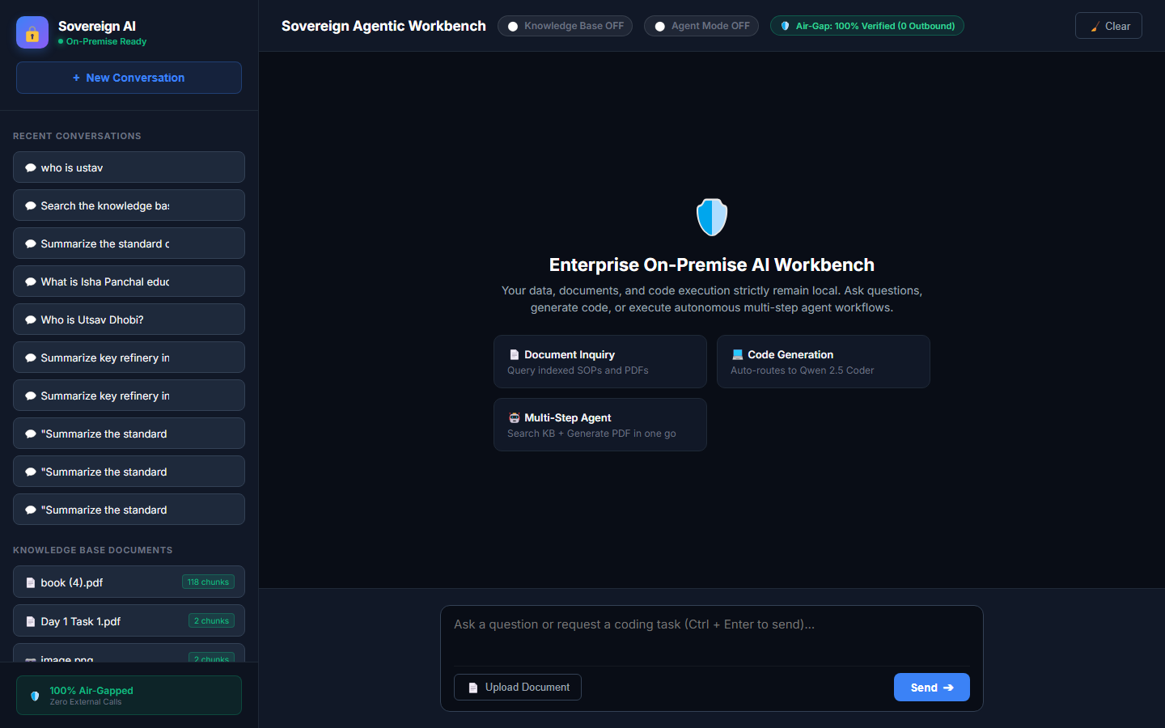

Figure: 02_swagger_api_docs.png
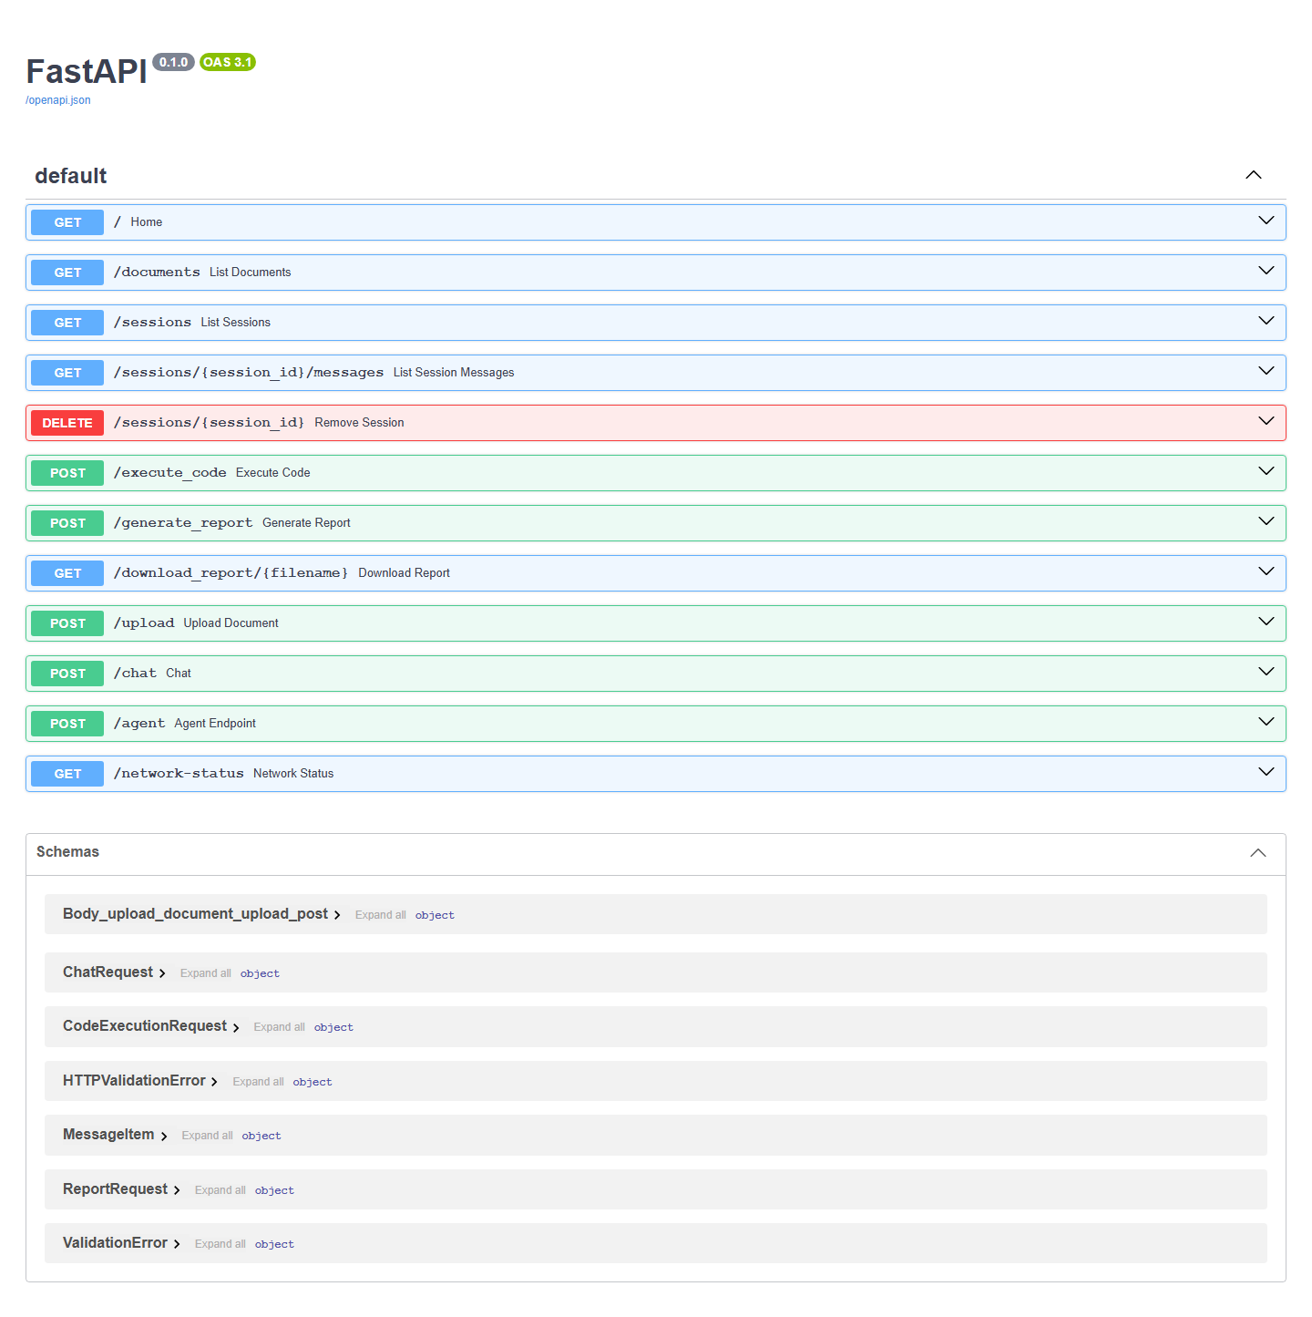

Figure: 03_network_airgap_audit.png

Figure: 04_chat_and_session_history.png
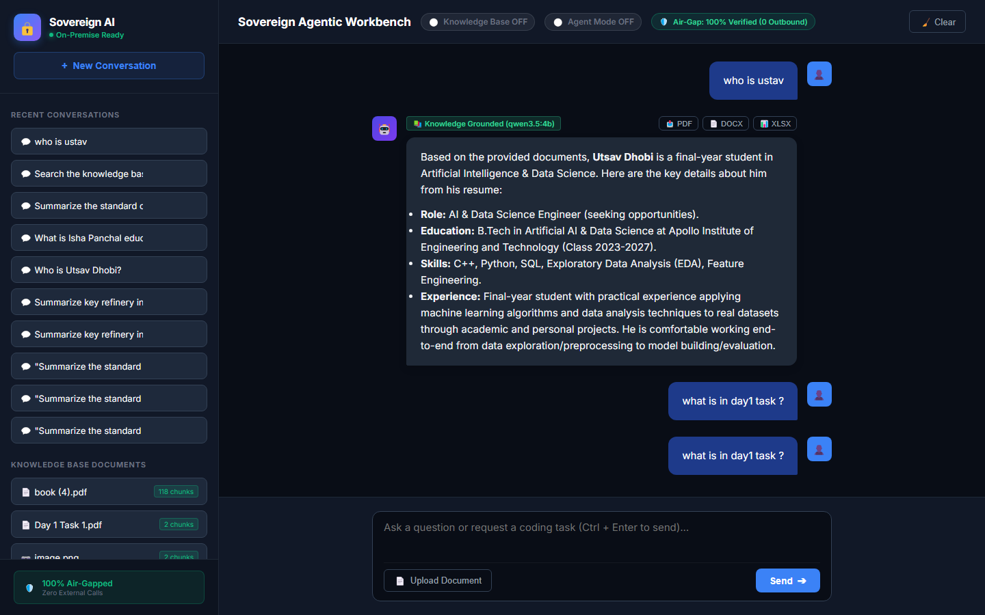

Figure: 06_responsive_tablet.png
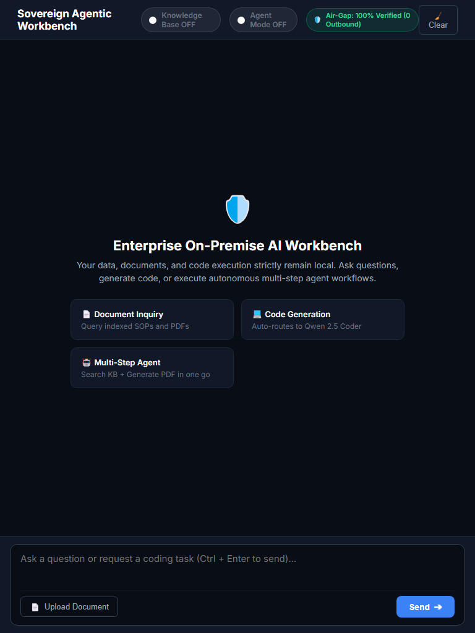

Figure: 07_responsive_mobile.png
