**Name : Jagruti D. Shinde**

**Unique_Id : 2005498**

**Topic : Automotive Suspension System**

**AUTOMOTIVE SUSPENSION SYSTEM**

**INTRODUCTION:**

Suspension is the system of tires, tire air, [springs](https://en.wikipedia.org/wiki/Spring_(device)), [shock absorbers](https://en.wikipedia.org/wiki/Shock_absorber) and [linkages](https://en.wikipedia.org/wiki/Linkage_(mechanical)) that connects a [vehicle](https://en.wikipedia.org/wiki/Vehicle) to its [wheels](https://en.wikipedia.org/wiki/Wheel) and allows relative motion between the two. Suspension systems must support both road holding/[handling](https://en.wikipedia.org/wiki/Automobile_handling) and [ride quality](https://en.wikipedia.org/wiki/Ride_quality), which are at odds with each other. It is important for the suspension to keep the road wheel in contact with the road surface as much as possible, because all the road or ground forces acting on the vehicle do so through the contact patches of the [tires](https://en.wikipedia.org/wiki/Tire). The suspension also protects the vehicle itself and any cargo or luggage from damage and wear.

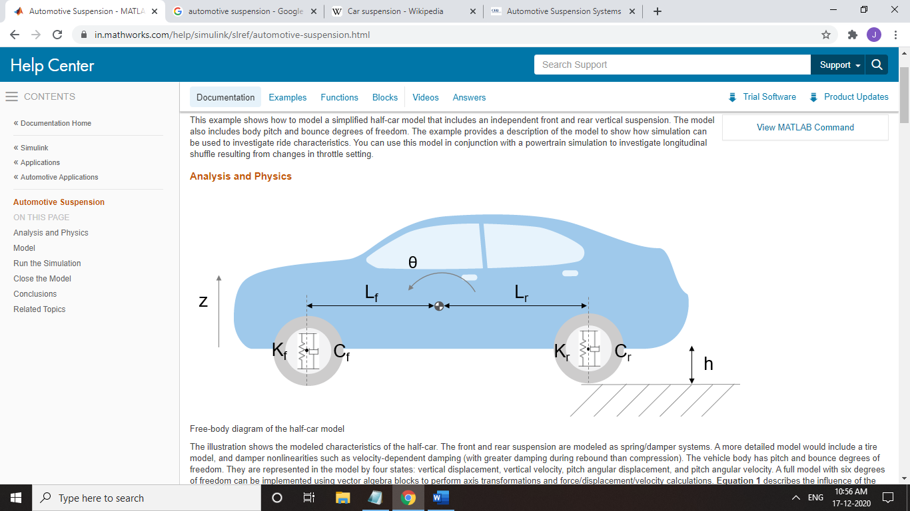

Free body diagram

Ff : Upward force on body from front suspension

Fr : Upward force on body from rear suspension

Kf/Kr : Front/rear suspension damping rate

Lf/Lr : Horizontal distance from gravity center to front/rear suspension

Theta : Pitch/rotational angle

d(Theta)/dt : Rotational velocity

Z : Vertical distance

dZ/dt : Vertical velocity

h : Road height

**MATHEMATICAL EQUATIONS:**

* Influence of the front suspension on the bounce (i.e. vertical degree of freedom):

Ff = 2Kf(Lf*Theta-(Z+h)) + 2Cf(Lf*d(Theta)/dt - dZ/dt)

* Pitch moment due to front suspension:

Mf = -Lf*Ff

* Influence of the rear suspension on the bounce (i.e. vertical degree of freedom):

Fr = 2Kr(Lr*Theta+(Z+h)) - 2Cr(Lr*d(Theta)/dt + dZ/dt)

* Pitch moment due to front suspension:

Mr = -Lr*Fr

* Resolves the forces and moments result in body motion, according to Newton's Second Law:

Mb*d2(Z)/dt = Ff + Fr - Mb*g

Iyy*d2(Theta)/dt = Mf + Mr + My

d2(Z)/dt = ((Ff + Fr)/Mb)-g

Where:

Mb : Body mass

My : Pitch moment induced by vehicle acceleration

Iyy : Body moment of inertia about gravity center

MODEL:

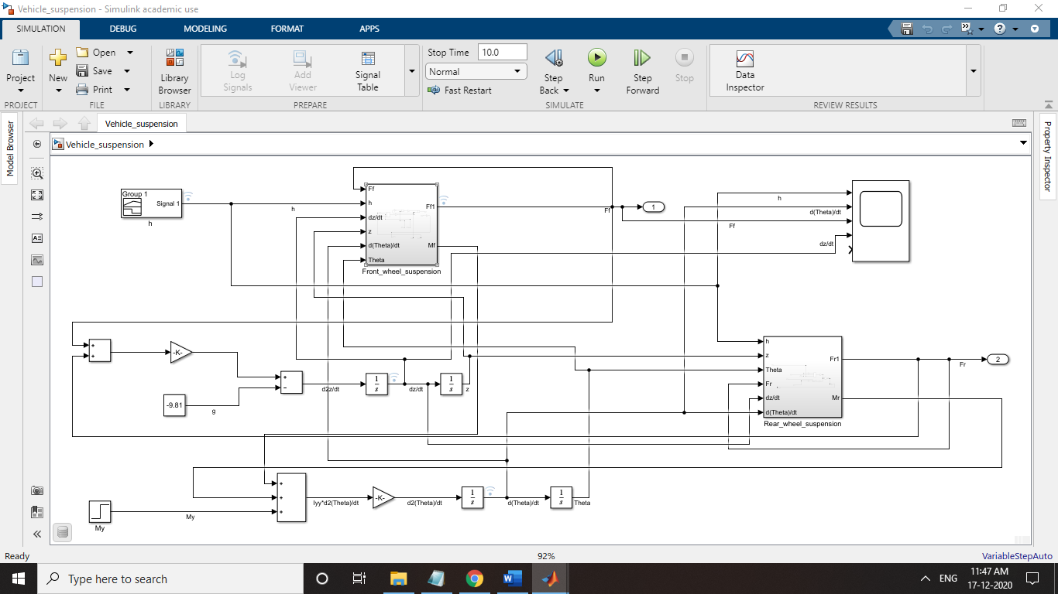

Model

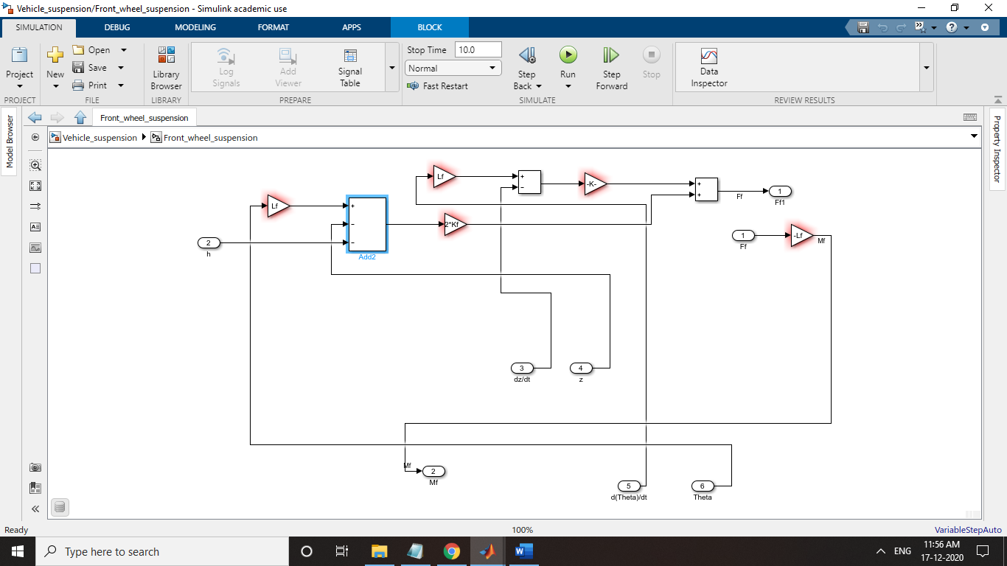

Front wheel suspension model

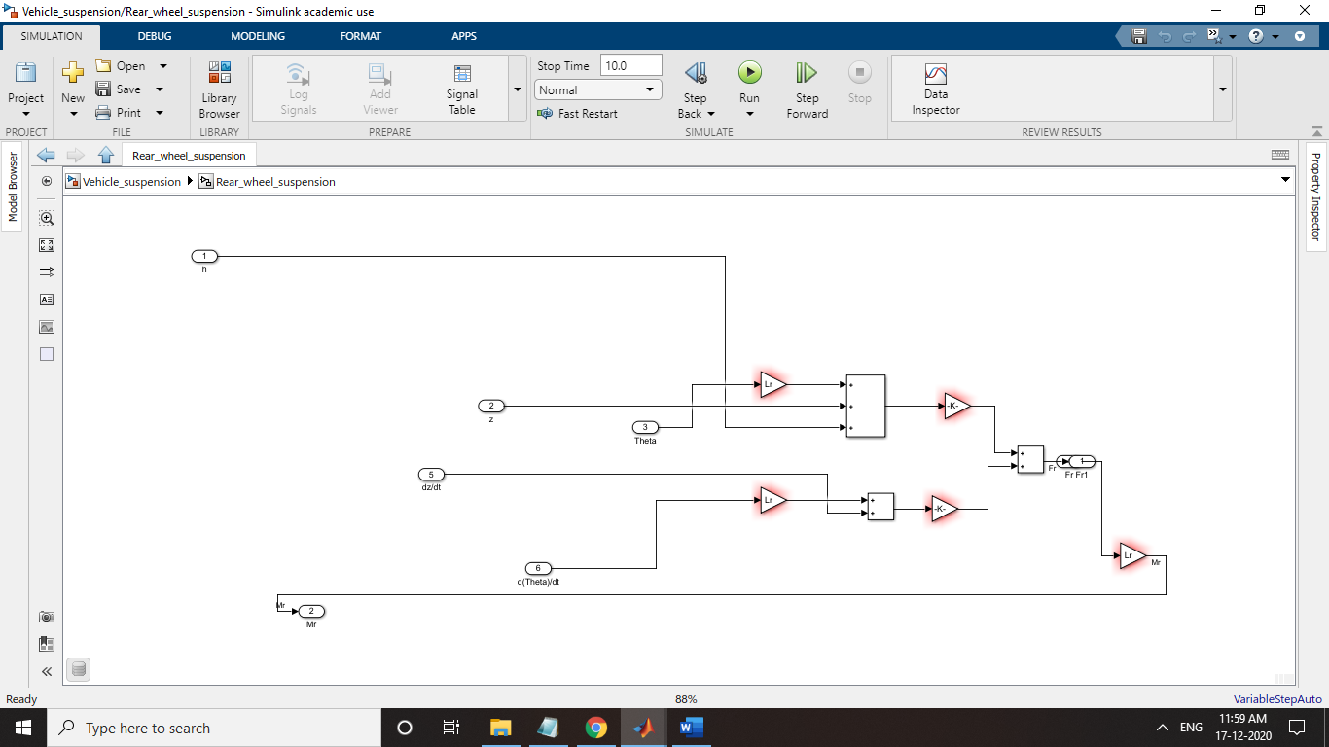

Rear wheel suspension model

RESULT:

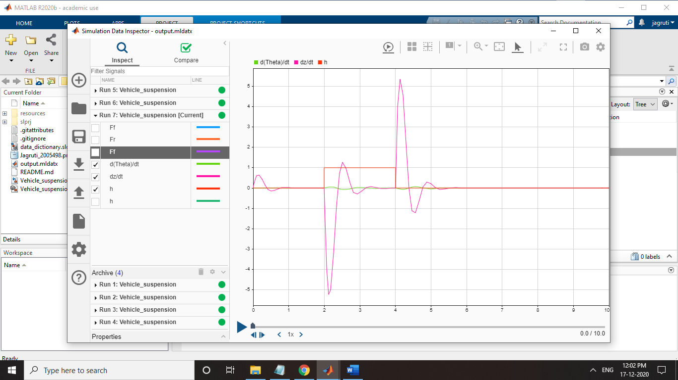

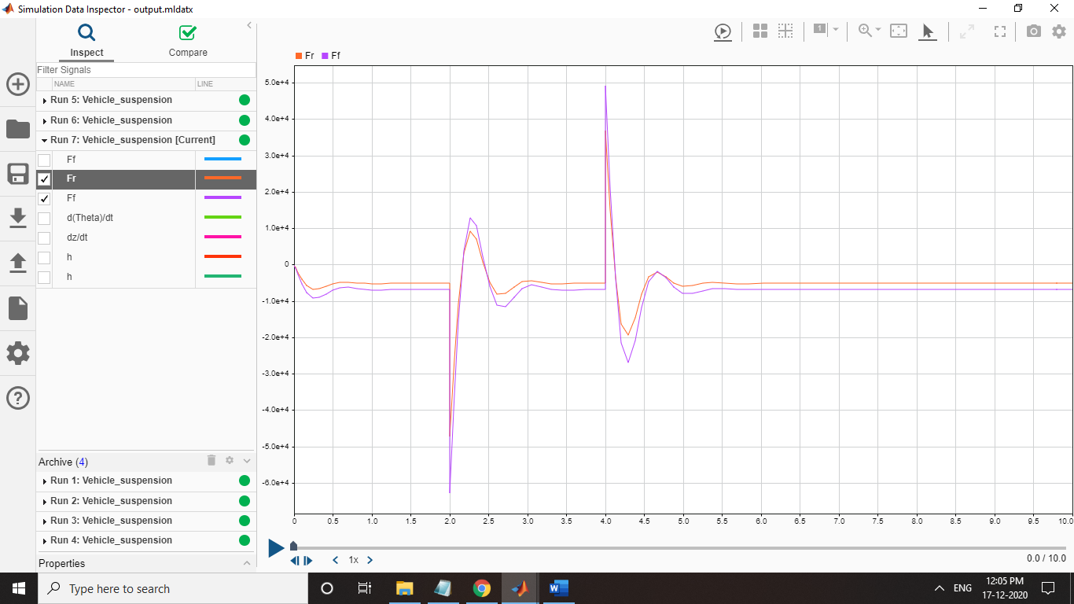

DEFAULT INITIAL CONDITION:

Lf=0.9m

Lr=1.2m

Mb=1200Kg

Iyy=2100Kg*m^2

Kf=28000N/m

Kr=21000N/m

Cf=2500 N*Sec/m

Cr=2000 N*Sec/m

CONCLUSION:

This model allows us to simulate the effects of changing the suspension damping and stiffness, thereby investigating the tradeoff between comfort and performance. In general, racing cars have very stiff springs with a high damping factor, whereas passenger vehicles have softer springs and a more oscillatory response.