Person 1: Login
FixIt, Landlord–Tenant Maintenance App. Complete work for the Login screen.
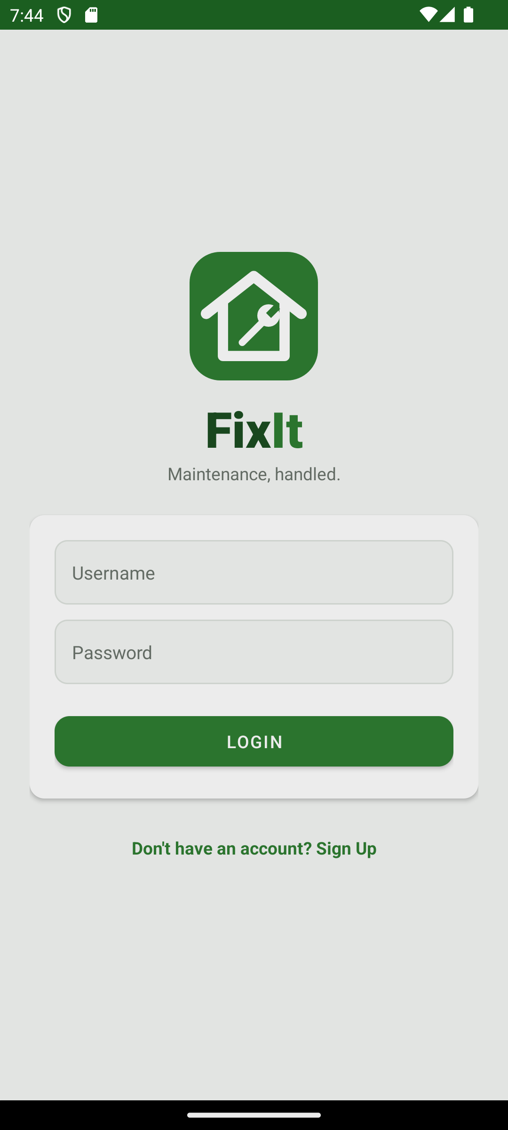
The Login screen on the emulator (activity_login.xml, portrait)

What it does
- Shows the FixIt logo, wordmark and tagline above a white card with the username and password fields and the Login button.
- Empty field: toast “Please fill in all fields”.
- Wrong credentials: toast “Username or password is incorrect”.
- Success: saves the user id and role to SharedPreferences, then opens Tenant Home or Landlord Home depending on the role.
- “Don't have an account? Sign Up” opens the Sign Up screen.
- On first start with an empty database it creates the demo accounts and requests (see below).
- User entity with user_id, name, username (unique), password, email, role, unit_number and landlord_id.
- UserDao with insert, login, getByUsername, getLandlordByUsername, getById and countUsers.

Screen components
Component | ID | Notes
ImageView: logo | none | ic_fixit_logo vector, 104dp
TextViews: “Fix” + “It”, tagline | none | Two-tone wordmark, “Maintenance, handled.”
EditText: username | etUsername | Shared input style
EditText: password | etPassword | inputType textPassword
Button: Login | btnLogin | Primary button style
TextView: sign up link | tvGoSignup | Opens SignupActivity

Demo accounts
Created automatically when the database is empty.
Role | Username | Password | Unit | Landlord
Landlord | landlord1 | landlord123
Landlord | landlord2 | landlord123
Tenant | tenant1 | tenant123 | A-101 | landlord1
Tenant | tenant2 | tenant123 | A-102 | landlord1
Tenant | tenant3 | tenant123 | B-201 | landlord2

For the rest of the team
- Read the logged-in user with LoginActivity.PREFS_NAME (“fixit_prefs”), KEY_USER_ID and KEY_ROLE.
- Roles are User.ROLE_TENANT and User.ROLE_LANDLORD.
- Passwords are stored as plain text.

LoginActivity.java
Path: app/src/main/java/com/fixit/app/LoginActivity.java
package com.fixit.app;

import android.content.Context;
import android.content.Intent;
import android.os.Bundle;
import android.widget.Button;
import android.widget.EditText;
import android.widget.TextView;
import android.widget.Toast;

import androidx.appcompat.app.AppCompatActivity;

import java.util.concurrent.ExecutorService;
import java.util.concurrent.Executors;

public class LoginActivity extends AppCompatActivity {

public static final String PREFS_NAME = "fixit_prefs";
public static final String KEY_USER_ID = "user_id";
public static final String KEY_ROLE = "role";

private final ExecutorService executor = Executors.newSingleThreadExecutor();

private EditText etUsername;
private EditText etPassword;

@Override
protected void onCreate(Bundle savedInstanceState) {
super.onCreate(savedInstanceState);
setContentView(R.layout.activity_login);

etUsername = findViewById(R.id.etUsername);
etPassword = findViewById(R.id.etPassword);
Button btnLogin = findViewById(R.id.btnLogin);
TextView tvGoSignup = findViewById(R.id.tvGoSignup);

seedDemoUsers();

btnLogin.setOnClickListener(v -> attemptLogin());
tvGoSignup.setOnClickListener(v ->
startActivity(new Intent(this, SignupActivity.class)));
}

// Demo accounts and requests, inserted once when the database is empty.
private void seedDemoUsers() {
executor.execute(() -> {
AppDatabase db = AppDatabase.getInstance(getApplicationContext());
UserDao users = db.userDao();
RequestDao requests = db.requestDao();
if (users.countUsers() > 0) return;

int landlord1 = addUser(users, "Landlord 1", "landlord1", "landlord123",
User.ROLE_LANDLORD, null, null);
int landlord2 = addUser(users, "Landlord 2", "landlord2", "landlord123",
User.ROLE_LANDLORD, null, null);

int tenant1 = addUser(users, "Tenant 1", "tenant1", "tenant123",
User.ROLE_TENANT, "A-101", landlord1);
int tenant2 = addUser(users, "Tenant 2", "tenant2", "tenant123",
User.ROLE_TENANT, "A-102", landlord1);
int tenant3 = addUser(users, "Tenant 3", "tenant3", "tenant123",
User.ROLE_TENANT, "B-201", landlord2);

addRequest(requests, tenant1, "Kitchen sink is leaking",
"Water drips from the pipe under the kitchen sink every time the tap is on. The cabinet floor is getting wet.",
Request.STATUS_PENDING, 2, null);
addRequest(requests, tenant1, "Air conditioner not cooling",
"The bedroom AC runs but only blows warm air since yesterday evening.",
Request.STATUS_DONE, 12, null);
addRequest(requests, tenant1, "Front door lock is stuck",
"The key turns only halfway and the door is hard to lock at night.",
Request.STATUS_PENDING, 1, null);

addRequest(requests, tenant2, "Bathroom light keeps flickering",
"The ceiling light in the bathroom flickers and sometimes turns off by itself.",
Request.STATUS_DONE, 8, null);
addRequest(requests, tenant2, "Repaint the living room walls",
"I would like the living room walls repainted in a lighter color.",
Request.STATUS_REJECTED, 5, Request.REJECT_REASONS[0]);

addRequest(requests, tenant3, "Water heater is not working",
"There has been no hot water for two days. The heater makes a clicking sound but does not heat.",
Request.STATUS_PENDING, 1, null);
addRequest(requests, tenant3, "Broken window latch",
"The latch on the bedroom window broke off and the window does not close tightly.",
Request.STATUS_PENDING, 3, null);
addRequest(requests, tenant3, "Wardrobe door came off",
"The left door of the built-in wardrobe came off its hinge.",
Request.STATUS_REJECTED, 9,
Request.REJECT_REASONS[1] + Request.REASON_SEPARATOR + Request.REJECT_REASONS[3]);
});
}

private int addUser(UserDao dao, String name, String username, String password,
String role, String unit, Integer landlordId) {
User user = new User();
user.name = name;
user.username = username;
user.password = password;
user.email = username + "@example.com";
user.role = role;
user.unitNumber = unit;
user.landlordId = landlordId;
return (int) dao.insert(user);
}

private void addRequest(RequestDao dao, int tenantId, String title, String description,
String status, int daysAgo, String rejectReasons) {
Request request = new Request();
request.tenantId = tenantId;
request.title = title;
request.description = description;
request.status = status;
request.createdAt = System.currentTimeMillis() - daysAgo * 24L * 60L * 60L * 1000L;
request.rejectReasons = rejectReasons;
dao.insert(request);
}

private void attemptLogin() {
String username = etUsername.getText().toString().trim();
String password = etPassword.getText().toString();

if (username.isEmpty() || password.isEmpty()) {
Toast.makeText(this, "Please fill in all fields", Toast.LENGTH_SHORT).show();
return;
}

executor.execute(() -> {
User user = AppDatabase.getInstance(getApplicationContext())
.userDao().login(username, password);
runOnUiThread(() -> {
if (user == null) {
Toast.makeText(this, "Username or password is incorrect",
Toast.LENGTH_SHORT).show();
} else {
onLoginSuccess(user);
}
});
});
}

private void onLoginSuccess(User user) {
getSharedPreferences(PREFS_NAME, Context.MODE_PRIVATE)
.edit()
.putInt(KEY_USER_ID, user.userId)
.putString(KEY_ROLE, user.role)
.apply();

Class<?> home = User.ROLE_LANDLORD.equals(user.role)
? LandlordHomeActivity.class
: TenantHomeActivity.class;
startActivity(new Intent(this, home));
finish();
}

@Override
protected void onDestroy() {
super.onDestroy();
executor.shutdown();
}
}

activity_login.xml
Path: app/src/main/res/layout/activity_login.xml
<?xml version="1.0" encoding="utf-8"?>
<ScrollView xmlns:android="http://schemas.android.com/apk/res/android"
xmlns:app="http://schemas.android.com/apk/res-auto"
android:layout_width="match_parent"
android:layout_height="match_parent"
android:background="@color/fixit_background"
android:fillViewport="true">

<LinearLayout
android:layout_width="match_parent"
android:layout_height="match_parent"
android:gravity="center_vertical"
android:orientation="vertical"
android:padding="24dp">

<ImageView
android:layout_width="104dp"
android:layout_height="104dp"
android:layout_gravity="center_horizontal"
android:contentDescription="FixIt logo"
android:src="@drawable/ic_fixit_logo" />

<LinearLayout
android:layout_width="match_parent"
android:layout_height="wrap_content"
android:layout_marginTop="12dp"
android:gravity="center"
android:orientation="horizontal">

<TextView
android:layout_width="wrap_content"
android:layout_height="wrap_content"
android:fontFamily="sans-serif-black"
android:text="Fix"
android:textColor="@color/fixit_logo_dark"
android:textSize="40sp" />

<TextView
android:layout_width="wrap_content"
android:layout_height="wrap_content"
android:fontFamily="sans-serif-black"
android:text="It"
android:textColor="@color/fixit_primary"
android:textSize="40sp" />
</LinearLayout>

<TextView
android:layout_width="match_parent"
android:layout_height="wrap_content"
android:layout_marginBottom="24dp"
android:gravity="center"
android:text="Maintenance, handled."
android:textColor="@color/fixit_text_secondary"
android:textSize="14sp" />

<androidx.cardview.widget.CardView
style="@style/Widget.FixIt.Card"
android:layout_width="match_parent"
android:layout_height="wrap_content">

<LinearLayout
android:layout_width="match_parent"
android:layout_height="wrap_content"
android:orientation="vertical"
android:padding="20dp">

<EditText
android:id="@+id/etUsername"
style="@style/Widget.FixIt.Input"
android:layout_width="match_parent"
android:layout_height="wrap_content"
android:autofillHints="username"
android:hint="Username"
android:imeOptions="actionNext"
android:inputType="text"
android:maxLines="1" />

<EditText
android:id="@+id/etPassword"
style="@style/Widget.FixIt.Input"
android:layout_width="match_parent"
android:layout_height="wrap_content"
android:layout_marginTop="12dp"
android:autofillHints="password"
android:hint="Password"
android:imeOptions="actionDone"
android:inputType="textPassword"
android:maxLines="1" />

<Button
android:id="@+id/btnLogin"
style="@style/Widget.FixIt.Button.Primary"
android:layout_width="match_parent"
android:layout_height="wrap_content"
android:layout_marginTop="20dp"
android:text="Login" />
</LinearLayout>
</androidx.cardview.widget.CardView>

<TextView
android:id="@+id/tvGoSignup"
android:layout_width="match_parent"
android:layout_height="wrap_content"
android:layout_marginTop="16dp"
android:clickable="true"
android:focusable="true"
android:gravity="center"
android:minHeight="48dp"
android:text="Don't have an account? Sign Up"
android:textColor="@color/fixit_primary"
android:textSize="14sp"
android:textStyle="bold" />

</LinearLayout>
</ScrollView>

User.java
Path: app/src/main/java/com/fixit/app/User.java
package com.fixit.app;

import androidx.room.ColumnInfo;
import androidx.room.Entity;
import androidx.room.Index;
import androidx.room.PrimaryKey;

@Entity(tableName = "users", indices = {@Index(value = "username", unique = true)})
public class User {

public static final String ROLE_TENANT = "tenant";
public static final String ROLE_LANDLORD = "landlord";

@PrimaryKey(autoGenerate = true)
@ColumnInfo(name = "user_id")
public int userId;

public String name;

public String username;

public String password;

public String email;

public String role;

@ColumnInfo(name = "unit_number")
public String unitNumber;

// Set for tenants only: the user_id of their landlord.
@ColumnInfo(name = "landlord_id")
public Integer landlordId;
}

UserDao.java
Path: app/src/main/java/com/fixit/app/UserDao.java
package com.fixit.app;

import androidx.room.Dao;
import androidx.room.Insert;
import androidx.room.Query;

@Dao
public interface UserDao {

@Insert
long insert(User user);

@Query("SELECT * FROM users WHERE username = :username AND password = :password LIMIT 1")
User login(String username, String password);

@Query("SELECT COUNT(*) FROM users")
int countUsers();

@Query("SELECT * FROM users WHERE username = :username LIMIT 1")
User getByUsername(String username);

@Query("SELECT * FROM users WHERE username = :username AND role = 'landlord' LIMIT 1")
User getLandlordByUsername(String username);

@Query("SELECT * FROM users WHERE user_id = :userId LIMIT 1")
User getById(int userId);
}

