FixIt: Project Documentation
Landlord–Tenant Maintenance App | Android (Java, XML, Room) | Version 1.0 | 14 November 2026
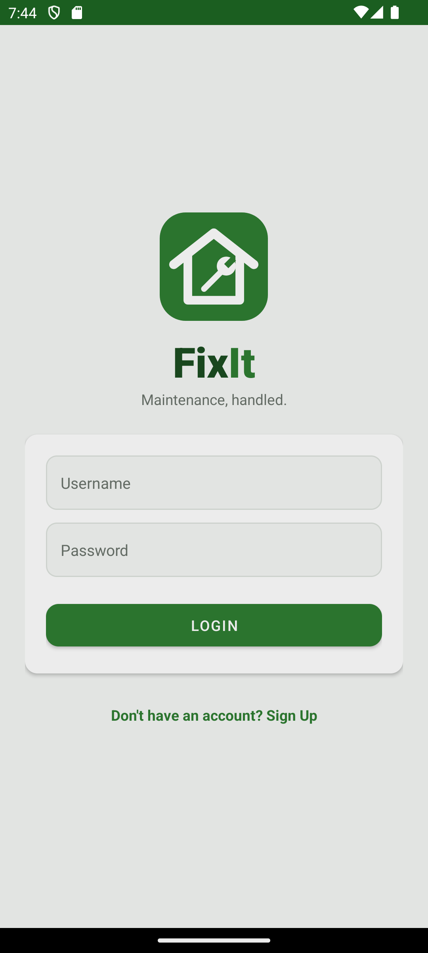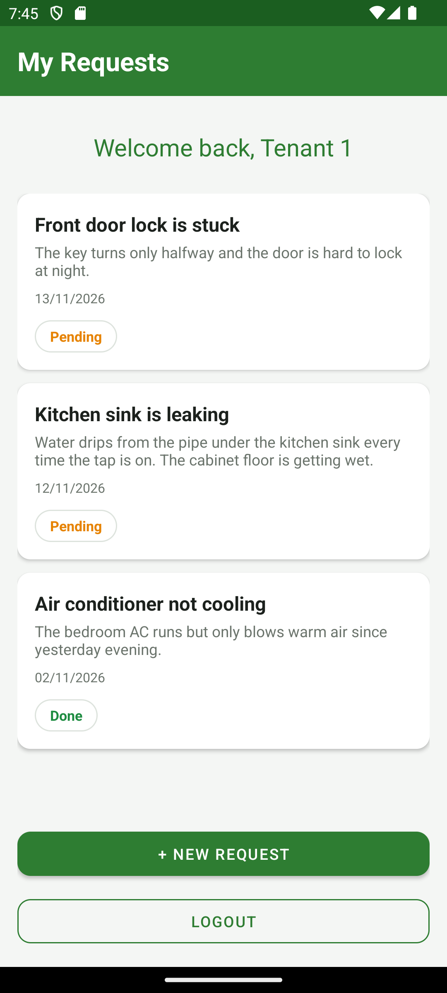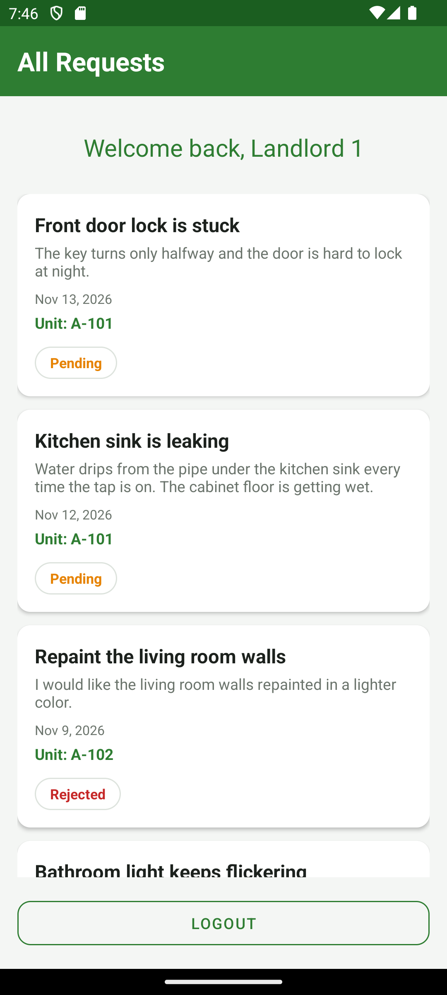

1. Overview
FixIt connects tenants and landlords around maintenance. A tenant reports a problem in their unit; the landlord sees the request, then completes it or rejects it with a reason. Both sides see the current status.
The app runs entirely on the device: accounts and requests are stored in a local SQLite database through Room. There is no server.

2. Features

Tenants
- Sign up with name, username, email, password, unit number and the username of their landlord.
- Submit maintenance requests (title and description).
- See their own requests with a coloured status badge: Pending (orange), Done (green) or Rejected (red).
- Edit or delete a request while it is Pending.
- Tap a Rejected request to see the reasons the landlord gave.

Landlords
- See only the requests from their own tenants, Pending first, with each tenant's unit number.
- Open a request to read the details and the tenant's name, unit and email (tap the + button).
- Mark a request Done, or Reject it by ticking reasons from a checklist. A request can be reopened.
- Contact the tenant by email, with the request title as the subject.
- Receive a notification when a new request is submitted.

Everyone
- Welcome message with the user's name on the home screens.
- Password rule at sign up: starts with a letter, at least 4 letters and 3 numbers.
- One consistent design: green title bars, white cards, rounded buttons and Back buttons on inner screens.

3. Demo accounts and data
The app creates these accounts and eight sample requests the first time it starts with an empty database.
Role | Username | Password | Unit | Landlord
Landlord | landlord1 | landlord123
Landlord | landlord2 | landlord123
Tenant | tenant1 | tenant123 | A-101 | landlord1
Tenant | tenant2 | tenant123 | A-102 | landlord1
Tenant | tenant3 | tenant123 | B-201 | landlord2
Requests: Tenant 1 has three (two Pending, one Done), Tenant 2 has two (one Done, one Rejected), Tenant 3 has three (two Pending, one Rejected).

4. Screens

4.1 Login and Sign Up
Login | 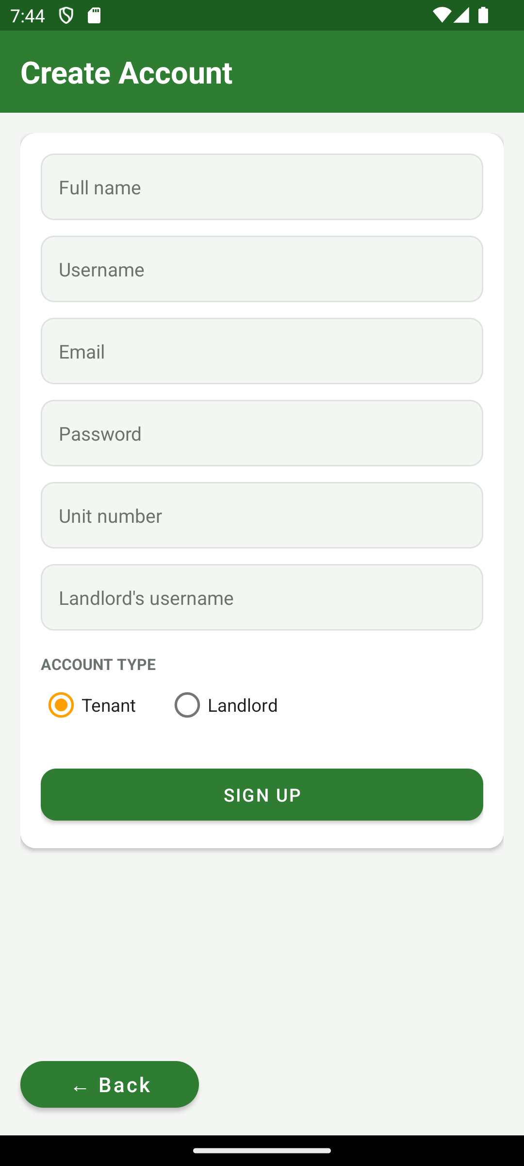  Sign Up
Login checks the username and password. Empty fields show “Please fill in all fields”; wrong credentials show “Username or password is incorrect”. On success the user id and role are saved and the tenant or landlord home screen opens.
Sign Up asks for name, username, email, password, account type, and (for tenants) unit number and the landlord's username. The unit and landlord fields are hidden for landlords.

4.2 Tenant screens
My Requests | 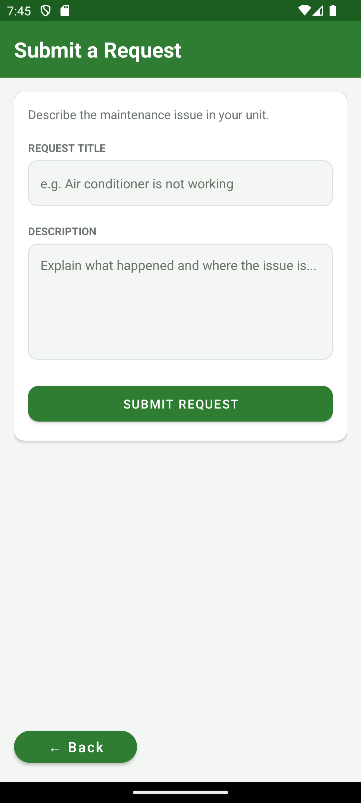  New request | 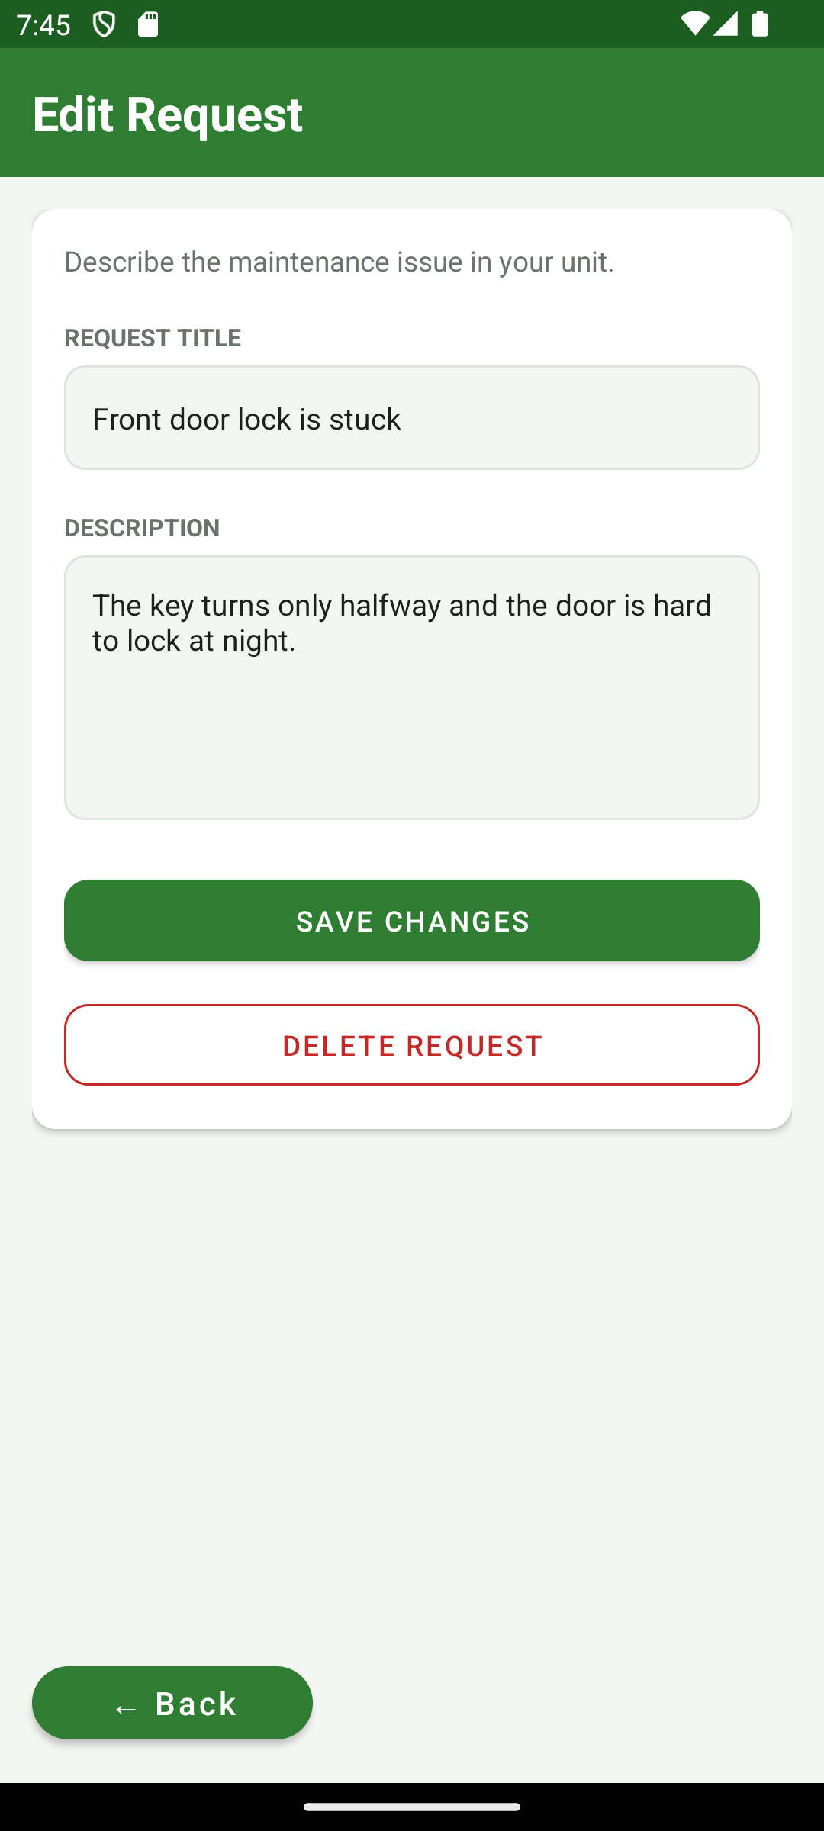  Edit request
My Requests lists the tenant's own requests; the whole page scrolls, and “+ New Request” and Logout stay at the bottom. Tapping a Pending request opens the same form as New Request, filled in, with Save Changes and Delete Request (with a confirmation).
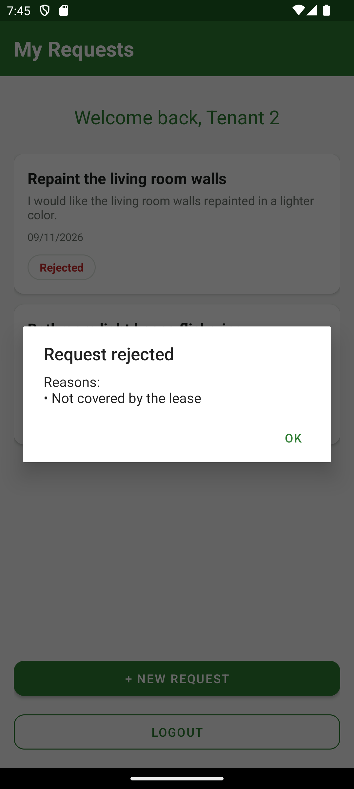
Rejected request: reasons

4.3 Landlord screens
All Requests | 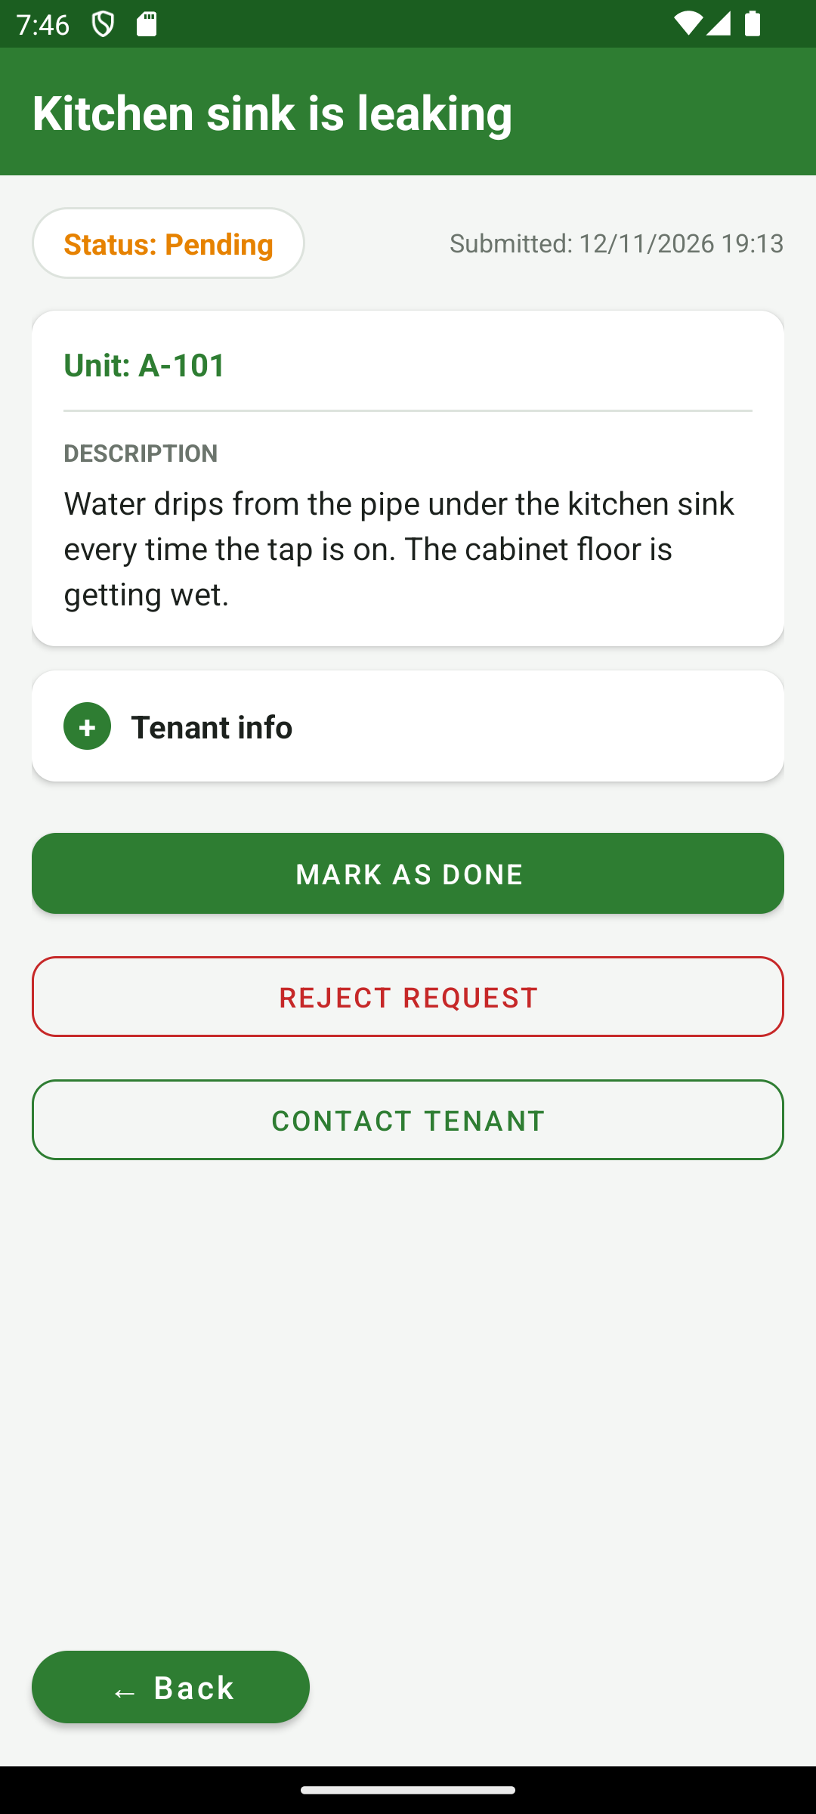  Request detail | 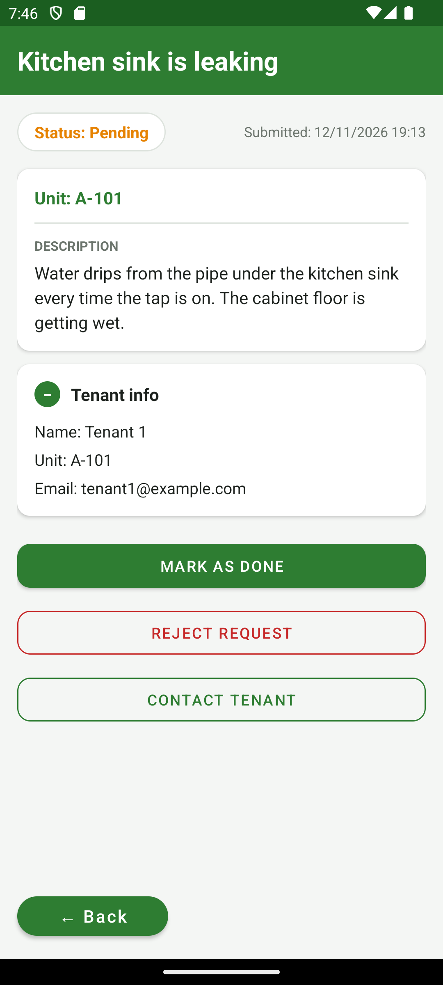  Tenant info (+)
All Requests shows the requests of the landlord's tenants, Pending first. Request Detail shows the status badge, date, unit and description. The + button opens the tenant's name, unit and email.
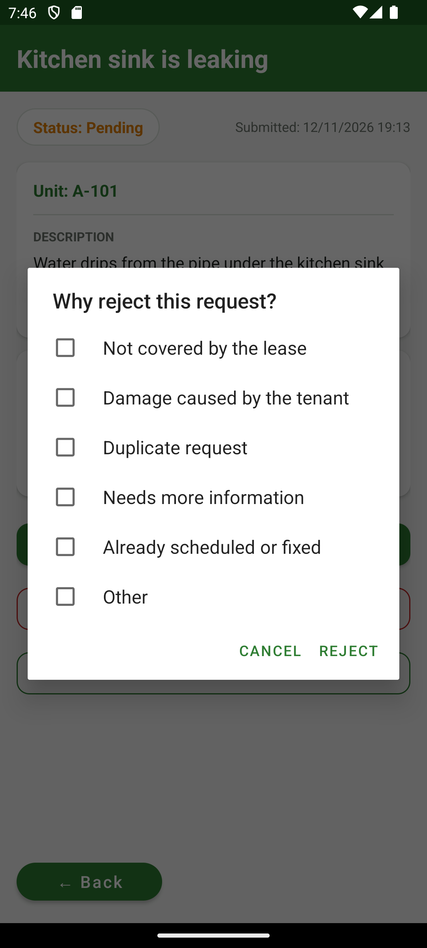  Reject: reasons checklist | 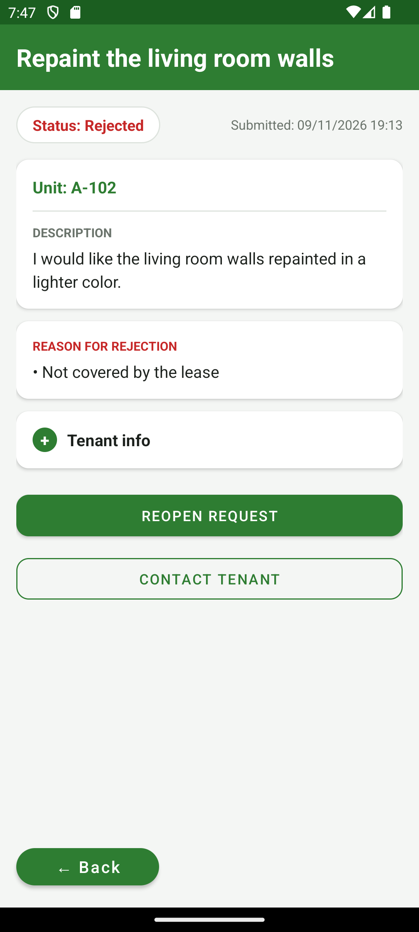  A rejected request
Reject Request opens a checklist of reasons (at least one must be ticked). The request then shows as Rejected with the reasons; Reopen Request puts it back to Pending.

5. How a request moves
- A tenant submits a request. It is saved as Pending and a NEW_REQUEST broadcast is sent.
- The receiver shows a notification and tells the landlord screen to refresh.
- The landlord opens the request and either marks it Done or rejects it with reasons.
- The tenant sees the new status badge, and the reasons for a rejection.
- The landlord can reopen a Done or Rejected request, which clears any reasons and sets it back to Pending.

Who can do what
Status | Tenant | Landlord
Pending | Edit, delete | Mark Done, Reject, contact tenant
Done | View only | Mark as Pending, contact tenant
Rejected | Tap to read the reasons | Reopen Request, contact tenant

6. Data model

Table users
Column | Type | Notes
user_id | INTEGER | Primary key, auto-generated
name | TEXT | Shown in the welcome message and tenant info
username | TEXT | Unique (index)
password | TEXT | Stored as plain text
email | TEXT | Used by Contact Tenant
role | TEXT | “tenant” or “landlord”
unit_number | TEXT | Tenants only
landlord_id | INTEGER | Tenants only: the user_id of their landlord

Table requests
Column | Type | Notes
request_id | INTEGER | Primary key, auto-generated
tenant_id | INTEGER | The tenant who submitted it (users.user_id)
title | TEXT | Short summary
description | TEXT | Details
status | TEXT | Pending, Done or Rejected
created_at | INTEGER | Milliseconds since 1970
reject_reasons | TEXT | Reasons joined with “|”; only set while Rejected
A landlord's requests are found through the link tenant → landlord: requests whose tenant has landlord_id equal to the landlord's user_id.

Database versions
Version | Change
1 | Users and requests tables
2 | Added users.landlord_id and the unique username index (old data was rebuilt)
3 | Added requests.reject_reasons, with a migration that keeps existing data

7. Architecture
Class | Responsibility
LoginActivity | Sign in, save the session, seed the demo data on an empty database
SignupActivity | Create accounts, validate fields, password rule and landlord username
TenantHomeActivity, RequestAdapter | Tenant's request list; tap to edit or view rejection reasons
NewRequestActivity | Create a request, or edit/delete a Pending one
LandlordHomeActivity | Landlord's request list, notification permission, refresh receiver
RequestDetailActivity | Details, tenant info, Done/Pending, Reject with reasons, contact tenant
NewRequestReceiver | Receives NEW_REQUEST, shows the notification, sends a refresh broadcast
User, UserDao, Request, RequestDao | Room entities and queries
AppDatabase | Room database fixit_db (version 3), singleton, migration 2→3

Key design decisions
- Database work runs on a background thread (an executor), never on the main thread; results are posted back to the UI.
- The logged-in user is kept in SharedPreferences file “fixit_prefs” with keys user_id and role.
- Screens share one look through styles in themes.xml and colours in colors.xml.
- Notifications use a broadcast restricted to the app's own package, so other apps cannot trigger them.

8. Business rules
Rule | Where it is enforced
Password starts with a letter and has at least 4 letters and 3 numbers | Sign Up (toast on failure). Login does not re-check it.
Username is unique | Sign Up check and a unique database index
Email contains “@” | Sign Up
Tenants need a unit number and an existing landlord username | Sign Up (“Landlord not found”)
Landlords see only their own tenants' requests | RequestDao.getForLandlord
Only the owner can edit or delete a request, and only while Pending | New Request screen, re-checked right before saving
Rejecting needs at least one reason and a Pending request | Request Detail

9. Design system
Element | Value | Use
Primary green | #2E7D32 | Title bars, main buttons, links, logo
Pending | #E68200 | Status badge text
Done | #1E8C41 | Status badge text
Rejected / danger | #C62828 | Rejected badge, Reject and Delete buttons
Background | #F4F6F4 | Screen background behind the white cards
Text / secondary text | #1C211D / #6B746C | Body text, labels
Components: full-width green title bar, white cards (12dp corners, light shadow), boxed input fields, rounded main button (green fill) and secondary button (green outline), green pill-shaped Back button at the bottom-left, rounded status badges.

10. Build and run
Item | Version
Android Studio | Current stable release (Android Gradle Plugin 8.5.0, Gradle 8.7)
Java | 17 or newer (Android Studio's bundled JDK works)
Android SDK | compileSdk 34, targetSdk 34, minSdk 24 (Android 7.0)
Libraries | AppCompat 1.7.0, Material 1.12.0, ConstraintLayout 2.1.4, RecyclerView 1.3.2, CardView 1.0.0, Room 2.6.1
Open the project folder in Android Studio, wait for Gradle sync, choose an emulator and press Run. Details are in the Getting Started guide.

11. Manual test plan
There are no automated tests. Run these on the demo data; tick the box when a case passes.
ID | Steps | Expected result | Pass
T1 | Login as tenant1 / tenant123 | Tenant home opens with “Welcome back, Tenant 1” | ☐
T2 | Login with a wrong password | Toast: Username or password is incorrect | ☐
T3 | Login with empty fields | Toast: Please fill in all fields | ☐
T4 | Sign up a tenant: all fields, password abcd123, landlord username landlord1 | Account created, returns to Login, new tenant can log in | ☐
T5 | Sign up with password abc12345, abcdefgh or 1abcd234 | Toast: Password must start with a letter and have at least 4 letters and 3 numbers | ☐
T6 | Sign up with an existing username | Toast: Username already taken | ☐
T7 | Sign up as tenant with landlord username that does not exist | Toast: Landlord not found | ☐
T8 | Tenant submits a new request | Toast: Request submitted; request is Pending in the list | ☐
T9 | Tenant taps a Pending request, edits the title, saves | Toast: Request updated; list shows the new title | ☐
T10 | Tenant deletes a Pending request and confirms | Request disappears; Cancel keeps it | ☐
T11 | Tenant taps a Done request | Toast: Completed requests can't be edited | ☐
T12 | Login as landlord1, then landlord2 | landlord1 sees Tenant 1 and 2 requests; landlord2 sees only Tenant 3's | ☐
T13 | Landlord opens a request and taps + | Tenant name, unit and email appear; − hides them | ☐
T14 | Landlord marks a Pending request Done | Badge turns green; button reads Mark as Pending | ☐
T15 | Landlord taps Reject Request, ticks nothing, presses Reject | Toast: Select at least one reason; dialog stays open | ☐
T16 | Landlord rejects with two reasons | Badge turns red; reasons card lists both | ☐
T17 | Tenant taps the rejected request | Dialog lists the reasons | ☐
T18 | Landlord taps Reopen Request | Back to Pending; reasons cleared | ☐
T19 | Keep landlord screen open, submit a request as a tenant | Notification appears and the list refreshes | ☐
T20 | Landlord taps Contact Tenant | Email app opens to the tenant's address with the title as subject | ☐
T21 | Scroll the lists with many requests | The whole page scrolls; buttons stay at the bottom | ☐

12. Known limitations and future work
- Passwords are stored as plain text; they should be hashed.
- The new-request notification is shown to whichever landlord is logged in on the device, not only the tenant's landlord (the app has no server).
- No automated tests.
- Phone numbers are not collected, so the landlord can only contact a tenant by email.
- Requests cannot have photos.

13. Team
Person | Screen | Files
1 | Login | LoginActivity, activity_login.xml, User, UserDao
2 | Sign Up | SignupActivity, activity_signup.xml, AppDatabase, build.gradle
3 | Tenant Home | TenantHomeActivity, activity_tenant_home.xml, RequestAdapter, item_request.xml
4 | New Request | NewRequestActivity, activity_new_request.xml, Request, RequestDao
5 | Landlord Home | LandlordHomeActivity, activity_landlord_home.xml, NewRequestReceiver
6 | Request Detail | RequestDetailActivity, activity_request_detail.xml, AndroidManifest.xml, testing

