SCS B105: DATA COMMUNICATIONS AND NETWORKS
1.1 Introduction
In Data Communications, data generally are defined as information that is stored in digital form. Data communications is the process of transferring digital information between two or more points. Information is defined as the knowledge or intelligence. Data communications can be summarized as the transmission, reception, and processing of digital information. For data communications to occur, the communicating devices must be part of a communication system made up of a combination of hardware (physical equipment) and software (programs). The effectiveness of a data communications system depends on four fundamental characteristics: delivery, accuracy, timeliness, and jitter.
- Delivery: The system must deliver data to the correct destination. Data must be received by the intended device or user and only by that device or user.
- Accuracy: The system must deliver the data accurately. Data that have been altered in
transmission and left uncorrected are unusable.
- Timeliness: The system must deliver data in a timely manner. Data delivered late are useless. In the case of video and audio, timely delivery means delivering data as they are produced, in the same order that they are produced, and without significant delay. This kind of delivery is called real-time transmission.
- Jitter: Jitter refers to the variation in the packet arrival time. It is the uneven delay in the
delivery of audio or video packets. For example, let us assume that video packets are sent every 30ms. If some of the packets arrive with 30ms delay and others with 40ms delay, an uneven quality in the video is the result.

1.2 Components of a data communications system
A data communications system has five components:
Message: The message is the information (data) to be communicated. Popular forms of information include text, numbers, pictures, audio, and video.
Sender: The sender is the device that sends the data message. It can be a computer, workstation, telephone handset, video camera, and so on.
Receiver: The receiver is the device that receives the message. It can be a computer, workstation, telephone handset, television, and so on.
Transmission medium: The transmission medium is the physical path by which a message
travels from sender to receiver. Some examples of transmission media include twisted-pair wire,
coaxial cable, fiber-optic cable, and radio waves.
Protocol: A protocol is a set of rules that govern data communications. It represents an
agreement between the communicating devices. Without a protocol, two devices may be
connected but not communicating, just as a person speaking French cannot be understood by a
person who speaks only Japanese.
1.3 NETWORK
A network is a set of devices (often referred to as nodes) connected by communication links. A node can be a computer, printer, or any other device capable of sending and/or receiving data generated by other nodes on the network.
1.3.1 Network Criteria
A network must be able to meet a certain number of criteria. The most important of these are
performance, reliability, and security.
- Performance - Performance can be measured in many ways, including transmit time and response time. Transmit time is the amount of time required for a message to travel from one device to another. Response time is the elapsed time between an inquiry and a response. The performance of a network depends on a number of factors, including the number of users, the type of transmission medium, the capabilities of the connected hardware, and the efficiency of the software. Performance is often evaluated by two networking metrics: throughput and delay. We often need more throughputs and less delay.
- Reliability - In addition to accuracy of delivery, network reliability is measured by the frequency of failure, the time it takes a link to recover from a failure.
- Security - Network security issues include protecting data from unauthorized access, protecting data from damage and development, and implementing policies and procedures for recovery from breaches and data losses.

1.3.2 Network Models
Computer networks can be represented with two basic network models: peer-to-peer client/server and dedicated client/server. The client/server method specifies the way in which two computers can communicate with software over a network.
- Dedicated client/server network: Here, one computer is designated as server and the rest of the computers are clients. Dedicated Server Architecture can improve the efficiency of client server systems by using one server for each application that exists within an organization.The designated servers store all the networks shared files and applications programs and function only as servers and are not used as a client or workstation. Client computers can access the servers and have shared files transferred to them over the transmission medium. In some client/server networks, client computers submit jobs to one of the servers and once they process the jobs, the results are sent back to the client computer.
- Peer-to-peer client/server network: Here, all the computers share their resources, such as hard drives, printers and so on with all the other computers on the network. Individual resources like disk drives, CD-ROM drives, and even printers are transformed into shared, collective resources that are accessible from every PC. Unlike client-server networks, where network information is stored on a centralized file server PC and made available to tens, hundreds, or thousands client PCs, the information stored across peer-to-peer networks is uniquely decentralized. Because peer-to-peer PCs have their own hard disk drives that are accessible by all computers, each PC acts as both a client (information requestor) and a server (information provider). The peer-to-peer network is an appropriate choice when there are fewer than 10 users on the network, security is not an issue and all the users are located in the same general area.

In general, the dedicated client/server model is preferable to the peer-to-peer client/server model for general purpose data networks. However there some advantages of peer-to-peer over client-server this include:
- No need for a network administrator.
- Network is fast/inexpensive to setup & maintain.
- Each PC can make backup copies of its data to other PCs for security.
- Easiest type of network to build, peer-to-peer is perfect for both home and office use.
1.3.3 Network Topologies
In computer networking, topology refers to the layout of connected devices, i.e. how the
computers, cables, and other components within a data communications network are interconnected, both physically and logically. The physical topology describes how the
network is actually laid out, and the logical topology describes how the data actually flow
through the network. There are four basic topologies possible:
- bus
- star
- ring
- mesh

- Bus Topology
Bus networks use a common backbone to connect all devices. A single cable, (the backbone) functions as a shared communication medium that devices attach or tap into with an interface connector. A device wanting to communicate with another device on the network sends a broadcast message onto the wire that all other devices see, but only the intended recipient actually accepts and processes the message. The bus topology is the simplest and most common method of interconnecting computers. The two ends of the transmission line never touch to form a complete loop. A bus topology is also known as multidrop or linear bus or a horizontal bus.
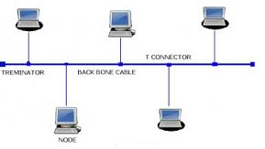

Advantages
- It is very reliable topology because if any node fails, the bus itself is not affected and the remaining nodes can continue operating without interruptions.
- Very simple to install and maintain nodes can be easily affected or removed with minimal wring changes (easy to expand).
- Uses the least amount of cables.
- It has a resistant architecture; its simplicity makes it very reliable.
- Cheap than other topologies.
Disadvantages
- Fault diagnosis and isolation is difficult.
- The bus can be a bottle neck to the network when the network traffic is very heavy.
- Entire network shuts down if there is a break in the main cable(bus).
There are 3 common wiring implementation for bus networks
- 10 Base 2 ( thicknet, Cheaper Net)
- 10 Base 5 (Thicknet)
- 10 Base T (UTP)
NOTE: Bus topology is widely used for systems that do not emphasize the sharing of common resources.
- Star Topology
A star topology is designed with each node (file server, workstations, and peripherals) connected directly to a central network hub or concentrator. Data on a star network passes through the hub or concentrator before continuing to its destination. The hub or concentrator manages and controls all functions of the network. It also acts as a repeater for the data flow. This configuration is common with twisted pair cable; however, it can also be uses with coaxial cable or fiber optic cable.
Star network represent a very popular form of configuration for time-sharing i.e. appropriate for system that demand central control.

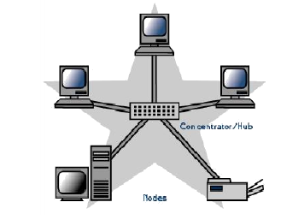
Advantages
- A star topology gives great fault tolerance as any terminal cable failure will not affect the rest of the network (unless the server fails).
- Physically adding new device/terminal to a star network is very simple compared to any of the other topologies, you simply run a cable from the terminal to the hub/switch.
- Ease of service since only area of concentration is at the hub.
- Diagnostics are much easier to perform for example a defective cable line is easy to find there is only one node for every cable accessing the hub.
Disadvantages
- The dependency of the whole topology on one single point, the hub. If the hub goes down, the whole system is dead.
- Although a star requires far less cable than a mesh, each node must be linked to a central hub.

- Ring Topology
The ring topology connects several workstations or nodes on a single transmission media which form a ring. Each node on the cabling acts as repeater, boosting the signal between workstations. Data travels around the ring in only one direction and passed through each nude. Each node on the ring topology has a particular address as the message pass around the ring the workstation/ node validate the address. If the message is not addressed to it, the node transmits the message to the next computer on the ring.
This type of network is commonly used in systems that connect widely dispersed mainframe computers. A ring network allows organizations to engage in distributed data processing system in which computers can share certain resources with other units while maintaining control over their own processing functions. The ring arrangement is the least frequently used with microcomputers. However, as stated above, if often used to link mainframes over wide geographical areas to build distributed data processing system.

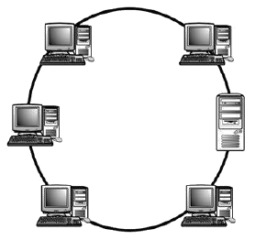

Advantages
- Each node has equal chance of receiving and sending the data.
- It is simple to implement because it requires simple software.
- Does not require server to manage the connectivity between computers.
- Performs better than a star topology under heavy network load.
Disadvantages
- One malfunctioning workstation can create problems for the entire network.
- Network modification/reconfiguration is more difficult and disrupts network operation.
- It is more difficult to diagnose faults.

- Mesh Topology
The mesh topology incorporates a unique network design in which each computer on the network connects to every other, creating a point-to-point connection between every device on the network. Unlike each of the previous topologies, messages sent on a mesh network can take any of several possible paths from source to destination. A mesh network in which every device connects to every other is called a full mesh.

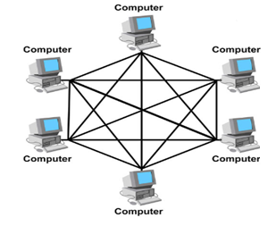

Advantages:
- The use of dedicated links guarantees that each connection can carry its own data load, thus eliminating the traffic problems that can occur when links must be shared by multiple devices.
- A mesh topology is robust. If one link becomes unusable, it does not incapacitate the entire system.
- There is the advantage of privacy or security. When every message travels along a dedicated line, only the intended recipient sees it. Physical boundaries prevent other users from gaining access to messages.
- Point-to-point links make fault identification and fault isolation easy. Traffic can be routed to avoid links with suspected problems. This facility enables the network manager to discover the precise location of the fault and aids in finding its cause and solution.
Disadvantages:
- Disadvantage of a mesh are related to the amount of cabling because every device must be connected to every other device.
- Installation and reconnection are difficult.
- The sheer bulk of the wiring can be greater than the available space (in walls, ceilings, or floors) can accommodate.
- The hardware required to connect each link (I/O ports and cable) can be prohibitively expensive.

HYBRID TOPOLOGIES
- Tree
- Star-wired ring
Of these two hybrid topologies, the star-wired ring is most frequently used.

- THE STAR-WIRED RING

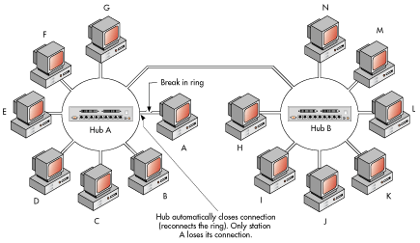
As it suggests, the star-wired ring combines the attributes of both the star and ring topologies. In a star-wired ring physical topology, individual devices are connected to a control hub; within each hub the physical connections form a ring. Where multiple hubs are used the ring in each hub is opened, leaving two ends. Each open end is connected to an open (each to a different hub) so that the entire network cable forms one physical ring.

Advantages
- Fault diagnosis and isolation are relatively easy.
- The modular design results in a network that is easy to expand.
Disadvantages
- Network configuration can be technically complicated.
- The cabling system is complicated.
TREE
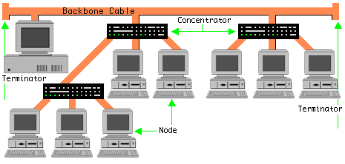
A tree topology combines characteristics of linear and star topologies. It consists of groups of star-configured workstations connected to a linear bus backbone cable. Tree topologies allow for the expansion of an existing network to meet their needs.
Advantages of a Tree Topology
- It is easy to extend
- It simplifies fault isolation
Disadvantages of a Tree Topology
- If the backbone line breaks, the entire segment goes down
- More difficult to configure and wire than other topologies.

1.3.4 Line Configuration
Line configuration refers to the way two or more communication devices attach to a link. For communication to occur, two devices must be connected in some way to the same link at the same time. There are two possible line configurations: point to point or multipoint.
A point to point configuration involves only two locations or stations, whereas a multipoint configuration involves three or more stations.
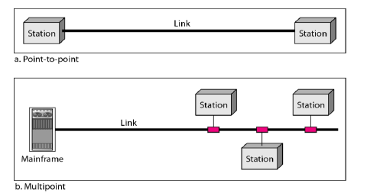
A point- to- point line configuration provides a dedicated link between devices. The entire capacity of the channel is reserved for transmission between those two devices.
A multi-point also called multidrop line configuration is one in which more than two specific devices share a link.

1.3.5 Types of Networks
Computer Networks are mostly classified on the basis of the geographical area that the network covers, the topology used, the transmission media used and the computing model used. Based on the geographical area covered the networks may be LAN,MAN or WAN.
  - Local area network(LAN)
A local area network (LAN) is a network that connects computers and devices in a limited geographical area such as home, school, computer laboratory, office building, or closely positioned group of buildings. LANs use a network operating system to provide two-way communications at bit rates in the range of 10 Mbps to 100 Mbps. In addition to operating in a limited space, LANs are also typically owned, controlled, and managed by a single person or organization. They also tend to use certain connectivity technologies, primarily Ethernet and Token Ring.
  - Metropolitan area network(MAN)
A MAN is optimized for a larger geographical area than a LAN, ranging from several blocks of buildings to entire cities. Its geographic scope falls between a WAN and LAN. A MAN might be a single network like the cable television network or it usually interconnects a number of local area networks (LANs) using a high capacity backbone technology, such as fiber-optical links, and provides up-link services to wide area networks and the Internet. MANs typically operate at speeds of 1.5 Mbps to 10 Mbps and range from five miles to a few hundred miles in length. Examples of MANs are FDDI (fiber distributed data interface) and ATM (asynchronous transfer mode).
  - Wide area network(WAN)
Wide area networks are the oldest type of data communications network that provide relatively slow-speed, long-distance transmission of data, voice and video information over relatively large and widely dispersed geographical areas, such as country or entire continent. WANs interconnect routers in different locations. A WAN differs from a LAN in several important ways. Most WANs (like the Internet) are not owned by any one organization but rather exist under collective or distributed ownership and management. WANs tend to use technology like ATM, Frame Relay and X.25 for connectivity over the longer distances.
DIFFERENCE BETWEEN LAN AND WAN
- LAN is restricted to limited geographical area of few kilometers. But WAN covers great distance and operate nationwide or even worldwide.
- In LAN, the computer terminals and peripheral devices are connected with wires and coaxial cables. In WAN there is no physical connection. Communication is done through telephone lines and satellite links.
- Cost of data transmission in LAN is less because the transmission medium is owned by a single organization. In case of WAN the cost of data transmission is very high because the transmission mediums used are hired either telephone lines or satellite links.
- The speed of data transmission is much higher in LAN than in WAN. The transmission speed in LAN varies from0.1 to 100 megabits per second. In case of WAN the speed ranges from 1800 to 9600 bits per seconds (bps)
- Few data transmission errors occur in LAN compared to WAN. It is because in LAN the distance covered is negligible.

1.3.6 Advantages of Networks
Computers in a networked environment provide numerous advantages when compared to computers in a stand alone environment. The immense benefits that the computer networks provide are in the form of excellent sharing of computational resources, computational load,
increased level of reliability, economy and efficient person-to-person communication.
Following are some of the major advantages of using computer networks.
- Resource Sharing - The main aim of a computer network is to make all programs, equipment, and data available to anyone on the network without regard to the physical location of the resource and the user. Users need to share resources other than files, as well. A common example being printers.Printers are utilised only a small percentage of the time; therefore, companies don’t want to invest in a printer for each computer. Networks can be used in this situation to allow all the users to have access to any of the available printers.
- High Reliability - Computer networks provide high reliability by having alternative sources of supply. For example, all files could be replicated on two or three machines, so, if one of them is unavailable (due to hardware failure), the other copies could be used. In addition, the presence of multiple CPUs means that if one goes down, the others may be able to take over its work, although at reduced performance.
- Saving Money - Small computers have a much better price/performance ratio than larger ones. Mainframes are roughly a factor of ton faster than personal computers but they cost much more. This imbalance has caused many systems designers to build systems consisting of personal computers, one per user, with data kept on one or more shared file server machines.In this model, the users are called clients, and the whole arrangement is called the client-server model.
- Scalability - The ability to increase the system performance gradually as the workload grows just by adding more processors. With centralized mainframes, when a system is full, it must be replaced by a larger one, usually at great expense and even greater disruption to the users. With client-server model, new clients and new servers can be added when needed.
- Communication Medium - A computer network can provide a powerful communication medium among widely separated users. Using a computer network it is easy for two or more people who are working on the same project and who live far apart to write a report together. When one worker, makes a change to an on-line document, the others can see the change immediately, instead of waiting several days for a letter. Such a speedup makes cooperation among far-flung groups of people easy whereas previously it was impossible.
- Increased Productivity - Networks increase productivity as several people can enter data at the same time, but they can also evaluate and process the shared data. So, one person can handle accounts receivable, and someone else processes the profit-and-loss statements.

1.4 STANDARDS ORGANIZATIONS FOR DATA COMMUNICATIONS
An association of organizations, governments, manufacturers and users form the standards organizations and are responsible for developing, coordinating and maintaining the standards. The intent is that all data communications equipment manufacturers and users comply with these standards. The primary standards organizations for data communication are:
1. International Standard Organization (ISO)
ISO is the international organization for standardization on a wide range of subjects. It is comprised mainly of members from the standards committee of various governments throughout the world. It is even responsible for developing models which provides high level of system compatibility, quality enhancement, improved productivity and reduced costs. The ISO is also responsible for endorsing and coordinating the work of the other standards organizations.
2. International Telecommunications Union-Telecommunication Sector (ITU-T)
ITU-T is one of the four permanent parts of the International Telecommunications Union based in Geneva, Switzerland. It has developed three sets of specifications: the V series for modem interfacing and data transmission over telephone lines, the X series for data transmission over public digital networks, email and directory services; the I and Q series for Integrated Services Digital Network (ISDN) and its extension Broadband ISDN. ITU-T membership consists of government authorities and representatives from many countries and it is the present standards organization for the United Nations.
3. Institute of Electrical and Electronics Engineers (IEEE)
IEEE is an international professional organization founded in United States and is compromised of electronics, computer and communications engineers. It is currently the world’s largest professional society with over 200,000 members. It develops communication and information processing standards with the underlying goal of advancing theory, creativity, and product quality in any field related to electrical engineering.
4. American National Standards Institute (ANSI)
ANSI is the official standards agency for the United States and is the U.S voting representative for the ISO. ANSI is a completely private, non-profit organization comprised of equipment manufacturers and users of data processing equipment and services. ANSI membership is comprised of people form professional societies, industry associations, governmental and regulatory bodies, and consumer goods.
5. Electronics Industry Association (EIA)
EIA is a non-profit U.S. trade association that establishes and recommends industrial standards. EIA activities include standards development, increasing public awareness, and lobbying and it is responsible for developing the RS (recommended standard) series of standards for data and communications.
6. Telecommunications Industry Association (TIA)
TIA is the leading trade association in the communications and information technology
industry. It facilitates business development opportunities through market development, trade promotion, trade shows, and standards development. It represents manufacturers of communications and information technology products and also facilitates the convergence of new communications networks.
7. Internet Architecture Board (IAB)
IAB earlier known as Internet Activities Board is a committee created by ARPA (Advanced Research Projects Agency) so as to analyze the activities of ARPANET whose purpose is to accelerate the advancement of technologies useful for U.S military. IAB is a technical advisory group of the Internet Society and its responsibilities are:
- Oversees the architecture protocols and procedures used by the Internet.
- Manages the processes used to create Internet Standards and also serves as an appeal board for complaints regarding improper execution of standardization process.
- Responsible for administration of the various Internet assigned numbers
- Acts as a representative for Internet Society interest in liaison relationships with other organizations.
- Acts as a source of advice and guidance to the board of trustees and officers of Internet Society concerning various aspects of internet and its technologies.

8. Internet Engineering Task Force (IETF)
The IETF is a large international community of network designers, operators, vendors and researchers concerned with the evolution of the Internet architecture and smooth operation of the Internet.
9. Internet Research Task Force (IRTF)
The IRTF promotes research of importance to the evolution of the future Internet by creating focused, long-term and small research groups working on topics related to Internet protocols, applications, architecture and technology.

  - SIGNALLING
Signaling is the way data is transmitted across the medium. It uses electrical energy to communicate. Somehow the data, or bits and bytes must be represented in such a way that the sender can create a message and the receiver can understand it. This is done by means of encoding(also called modulation). The original signal is altered in a certain way to allow it to represent data.
The information to be communicated can exist in either of two forms: Analog and Digital. A characteristic of analog information is that it changes continuously and digital data on the other hand consist of discrete states: ON or OFF,1 or 0.
  - Baud Rate vs Data Rate
The term signaling rate(or baud rate) is the number of times the signal level changes in a channel per second. Signaling elements are generally represented either by a change in voltage on a transmission line(digital signaling) or by changes in the phase, frequency or amplitude of an analog carrier signal(analog signaling). The terms baud rate and data-rate (usually expressed as bits per second) do not mean the same thing and are sometimes confused.
If only one bit of information is encoded in each signaling element, then the baud rate and the data rate (or bit-rate) will be the same. If two signaling levels are used, each element will represent either one or zero. If more than two signaling levels are used, however, it becomes possible to encode more than one bit per signal element. If four signaling levels are used for example, each signaling level can represent two bits, and the bit-rate will be twice the baud rate.
Parameters | Baud Rate | Bit Rate
Basics | The Baud rate refers to the total number of signal units transmitted in one second. | The Bit rate refers to the total Bits transmitted in one unit time.
Meaning | Baud rate indicates the total number of times the overall state of a given signal changes/ alters. | Bit rate indicates the total bits that travel per second.
Determination of Bandwidth | The Baud rate can easily determine the overall bandwidth that one might require to send a signal. | The bit rate cannot determine the overall signal bandwidth.
Generally Used | It mainly concerns the transmission of data over a given channel. | It mainly focuses on the efficiency of a computer.
Equation | Baud Rate = Given Baud Rate / Total Bits transmission in a signal unit | Bit Rate = Total Bits transmission in a unit of signal x Bit rate

2.2 Data Encoding Techniques
Encoding is the process of converting the data or a given sequence of characters, symbols, alphabets etc., into a specified format, for the secured transmission of data. Decoding is the reverse process of encoding which is to extract the information from the converted format. There are four possible combinations of encoding techniques:
- Digital data, digital signal
- Digital data, analog signal
- Analog data, digital signal
- Analog data, analog signal
    - Digital Data, Digital Signals
Digital-to-digital encoding is the representation of digital information by a digital signal. When binary 1s and 0s generated by the computer are translated into a sequence of voltage pulses that can be propagated over a wire, this process is known as digital-to-digital encoding.
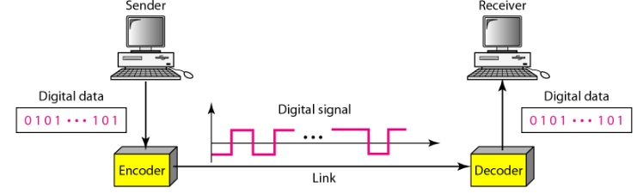
There are basically following types of digital-to-digital encoding available:
- Unipolar
- Polar
- Bipolar.

2.2.1.1 Unipolar
The simplest and most primitive type of encoding is Unipolar encoding. Typically, one voltage level stands for binary 0 and another voltage level for binary 1. Polarity refers to whether you have a positive or a negative pulse. Unipolar encoding uses only one polarity. Binary 1’s are represented by positive value and 0’s as zero value. Also called unipolar non return to zero(NRZ)
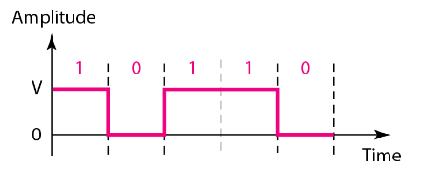
Unipolar encoding is very simple and easy to implement however it cannot be used for high-speed data transfer.

2.2.1.2 Polar
Polar encoding uses two levels of voltages say positive and negative. For The signal does not return to zero; it is either a positive voltage or a negative voltage. Polar encoding may be classified as:
- Non-Return To Zero (NRZ) – NRZ-I, NRZ-L, NRZ-S
- Return To Zero (RZ)
- Biphase –Manchester, Differential Manchester
  - Non-Return to Zero (NRZ)
Non-Return to Zero (NRZ) Data Encoding Uses two different voltage levels (one positive and one negative) as the signal elements for the two binary digits. NRZ may be further divided into NRZ-L , NRZ-I and NRZ-S.

Non Return to Zero Level (NRZ – L)
In NRZ-L, the level of the signal is dependent upon the state of the bit. In NRZ-L coding, binary 0 bit is represented by positive voltage and bit 1 is represented by negative voltage level. If the data bit stream contain continuous 0’s or 1’s then receiver receives continuous constant voltage. It is difficult to identify the total number of bits transmitted by the sender. Clock synchronization is required to identify the total number of bits to be transmitted
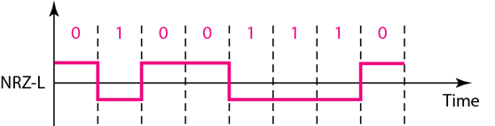

Non Return to Zero Invertive (NRZ - I )
In NRZ-I , the signal is inverted if a 1 is encountered. The amplitude also changes between positive and negative voltage. The states is changes for 1 and for bit 0 no change. It remains the same state.
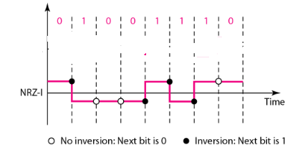

Non Return to Zero Invertive (NRZ - S )
In NRZ-S, the signal is inverted if a 0 is encountered. The states is change for only for 0, for bit 1, no state change.

  - Return to Zero (RZ)
In the RZ scheme, halfway through each interval, the signal returns to zero. In RZ scheme, 1 bit is represented by positive-to-zero and 0 bit is represented by negative-to-zero. This means that for every 1, there is a signal transition, which helps the receiver develop synchronization to the incoming data stream. RZ signal requires two signal changes to encode one bit and therefore occupies more bandwidth.
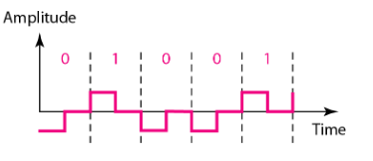

  - Bi-phase Encoding
The signal level is checked twice for every bit time, both initially and in the middle. Hence, the clock rate is double the data transfer rate and thus the modulation rate is also doubled. The clock is taken from the signal itself. The bandwidth required for this coding is greater. There are two types of Bi-phase Encoding.
- Manchester
- Differential Manchester
- Manchester
In this type of coding, the transition is done at the middle of the bit-interval. In Manchester encoding, a negative-to-positive transition represents binary 1, and positive-to-negative transition represents 0. Manchester has the same level of synchronization as RZ scheme except that it has two levels of amplitude.

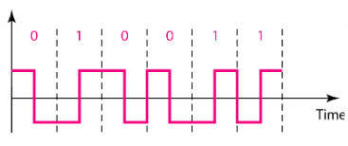
The advantage of this scheme is that the transition serves as a clocking mechanism and errors can be detected if there is no transition. However, bandwidth requirements for this is scheme is high compared to other schemes.
- Differential Manchester
In differential Manchester encoding, a binary 0 is marked by a transition at the beginning of an interval, whereas a 1 is marked by the absence of a transition. In this encoding method, detecting changes is often more reliable, especially when there is a noise in the channel.
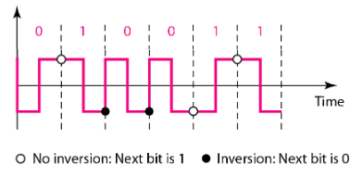
      - Bipolar
Bipolar uses three voltage levels. These are positive, negative, and zero. In Bipolar encoding scheme, zero level represents binary 0, and binary 1 is represented by alternating positive and negative voltages. If the first 1 bit is represented by positive amplitude, then the second 1 bit is represented by negative voltage, third 1 bit is represented by the positive amplitude and so on. This alternation can also occur even when the 1bits are not consecutive. Bipolar can be classified as:
- Alternate Mark Inversion (AMI)
- Pseudoternary

    - Alternate Mark Inversion (AMI)
In Bipolar AMI encoding scheme, 0 bit is represented by zero level and 1 bit is represented by alternating positive and negative voltages.
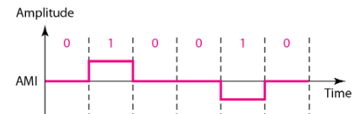
There variation of Bipolar AMI this include:
- Bipolar 8-Zero Substitution(B8ZS)
- High-Density Bipolar 3(HDB3)
Bipolar 8-Zero Substitution(B8ZS)
In B8ZS encoding scheme, an octet of all zeros are substituted by the following rules:
- In the last voltage pulse preceding the octet of all zero’s is positive, the eight zeros of the octet are encoded as:
000+-0-+
- If the last voltage pulse preceding the octet of all zeros is negative, the eight zeros of the octet are encoded as:
000-+0+-
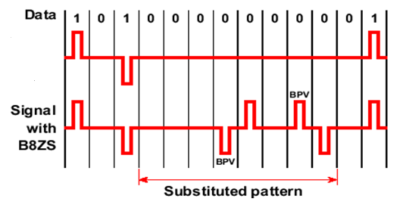
AMI
This scheme introduced two code violations of bipolar AMI code. At the receiving end the receiver decodes the encoded bits and replaces octets by strings of all zeros.
High Density Bipolar 3 Zeros (HDB3)
HDB3 encoding scheme is also based on bipolar-AMI encoding. In this scheme, string of four zeros is replaced with a code violation, by applying the following rules:
- If the polarity of the preceeding pulse is negative and the number of bipolar pulses (ones) since last substitution is odd, then substitution occurs as 000 and if the number of bipolar pulses (ones) since last substitution is even, then substitution occurs as: +00+
- If the polarity of preceding pulse is positive and the number of bipolar pulses (ones) since last substitute is odd then substitution 0 occurs as: 000+ and if the number of bipolar pulses (ones) since last substitution is even, then substitution occurs as: -00- .
The rules are shown below in tabular form:
Polarity of Preceeding Pulse | Number of bipolar pulses since last substitution
 | Odd | Even
- | 000- | +00+
+ | 000+ | -00-

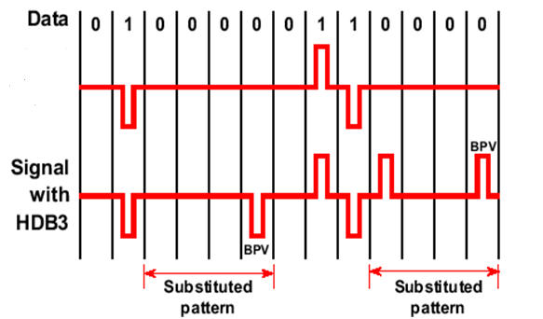
AMI

    - Pseudoternary
In case of pseudoternary encoding scheme, binary 1 is represented by no line signal(i.e no transition) and binary 0 is represented by positive and negative pulses
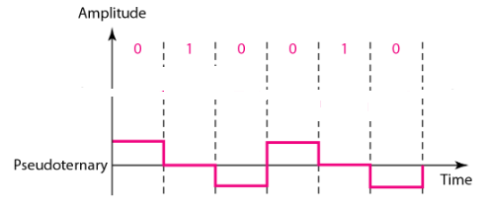

Example 1
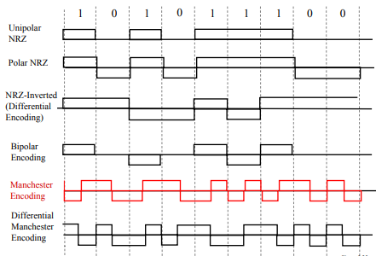

Example 2
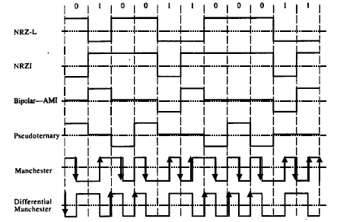
Example 3
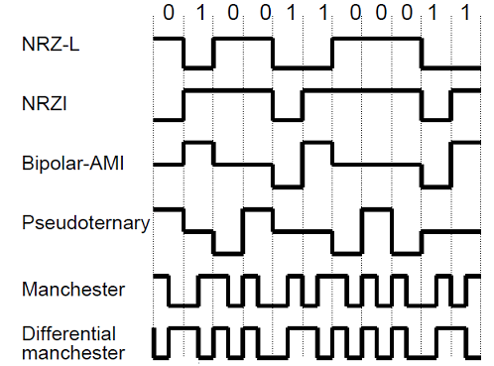

2.2.2 Digital Data, Analog Signals
Basis for analog signaling is a continuous, constant-frequency signal known as the carrier frequency. A modem (modulator-demodulator) converts digital data to analog signal. Digital data is encoded by modulating one of the three characteristics of the carrier: amplitude, frequency, or phase or some combination of these.
2.2.2.1 Amplitude shift keying (ASK):
Amplitude shift keying is a form of modulation which represents digital data as variations in the amplitude of a carrier wave. 1 binary digit represented by presence of carrier, at constant amplitude while 0 binary digit represented by absence of carrier.
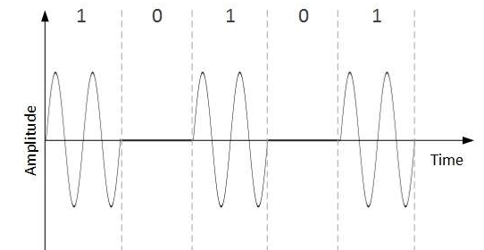
Relatively inexpensive to implement however Inefficient modulation technique since it is much more susceptible to noise.
2.2.2.2 Frequency shift keying (FSK):
In Frequency Shift Keying, the change in frequency define different digits. Two different frequencies near carrier frequency represent '0' ,''1'.
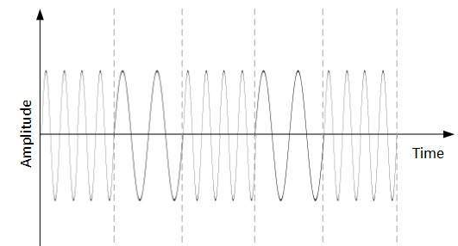
2.2.2.3 Phase shift keying (PSK):
The phase of the carrier is discretely varied in relation either to a reference phase or to the phase of the immediately preceding signal element, in accordance with data being transmitted. Phase of carrier signal is shifted to represent '0' , '1'.
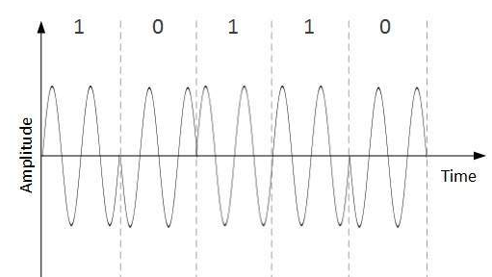
Example of the three techniques
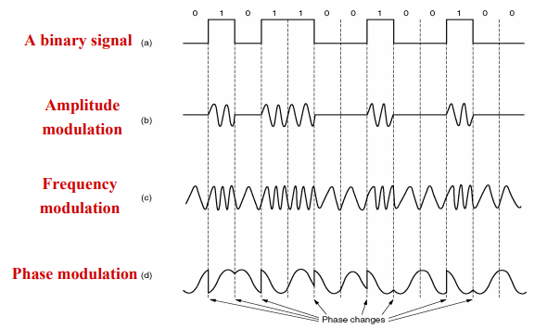
2.2.3Analog data, digital signal
The process of transforming analog data into digital signal is called digitization. The device used for converting analog into digital form for transmission and subsequently recovering the original analog data from the digital is known as a codec(coder-decoder). There are two principal techniques used in codecs:
- Pulse code modulation
- Delta modulation
2.2.3.1 Pulse Code Modulation (PCM)
Pulse code modulation is a method that is used to convert an analog signal into digital signal so that a modified analog signal can be transmitted through the digital communication network. PCM is in binary form, so there will be only two possible states high and low(0 and 1). We can also get back our analog signal by demodulation. PCM is the standard method used in PSTN (Public Switched Telephone Network) to convert analog data into digital data.
Analog transmission is not particularly efficient. When the signal-to-noise ratio of an analog signal deteriorates due to attenuation, amplifying the signal also amplifies noise. Digital signals are more easily separated from noise and can be regenerated in their original state. The conversion of analogue signals to digital signals therefore eliminates the problems caused by attenuation. The digital signal is subsequently used to reconstruct the analogue signal. The accuracy with which the analogue signal can be reproduced depends in part on the number of bits used to encode the original signal. PCM makes it easy to combine digitized voice and digital data into a single, high speed digital signal and propagate it over an optical fiber cable.
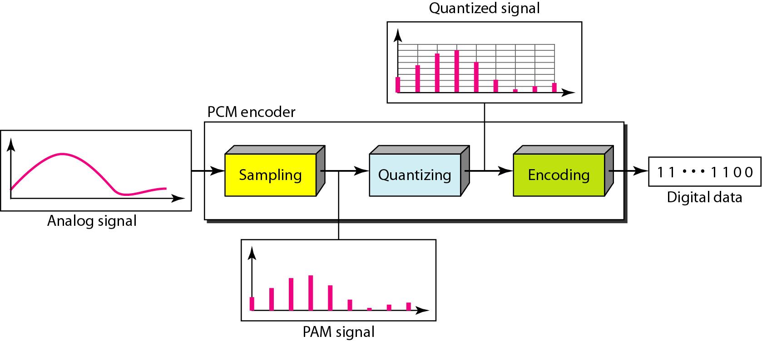

In pulse code modulation, the analog message signal is first sampled, and then the amplitude of the sample is approximated to the nearest set of quantization level. This allows the representation of time and amplitude in a discrete manner. Thereby, generating a discrete signal. This discrete signal is then converted into its binary form for the transmission of the signal. The signal gets transmitted in the coded format and must be decoded at the receiver in order to have the original message signal.
The Pulse Code Modulation process is done in three steps Sampling, Quantization, and Encoding. There are two specific types of pulse code modulations such as differential pulse code modulation(DPCM) and adaptive differential pulse code modulation(ADPCM).

PCM Processes
A PCM encoder has the following three processes:
- Sampling
- Quantization
- Encoding

Sampling:
Sampling is the process of taking amplitude values of the continuous analog signal at discrete time intervals (sampling period Ts).
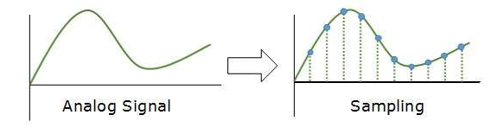
Most important factor in sampling is the rate at which analog signal is sampled. According to Nyquist Theorem, the sampling rate must be at least two times of the highest frequency of the signal.
Quantization:
Quantization involves assigning a numerical value to each sampled amplitude value.
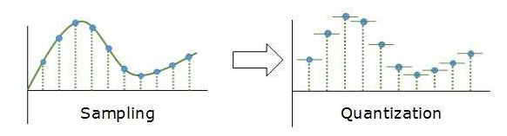
The quantizer will rounds off each sample to the nearest discrete level. The sampler provides a continuous range signal and hence still an analog one. The quantizer performs the approximation of each sample thus assigning it a particular discrete level.
As it basically rounds off the value to a certain level this shows some variation by the actual amount. Thus we can say, quantizing a signal introduces some distortion or noise into it. This is known as quantization error.
Encoding:
Once the amplitude values have been quantized they are encoded into binary using an Encoder.
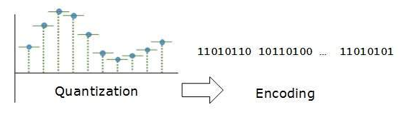
An encoder performs the conversion of the quantized signal into binary codes. This unit generates a digitally encoded signal which is a sequence of binary pulses that acts as the modulated output.
As it is a binary encoder thus generates a binary coded sequence. That is transmitted through the transmission path.

Basic Elements of PCM

The transmitter section of a Pulse Code Modulator circuit consists of Sampling, Quantizing and Encoding, which are performed in the analog-to-digital converter section. The low pass filter prior to sampling prevents aliasing of the message signal. The basic operations in the receiver section are:
- regeneration of impaired signals
- decoding, and
- reconstruction of the quantized pulse train.
Low Pass Filter
This filter eliminates the high frequency components present in the input analog signal which is greater than the highest frequency of the message signal, to avoid aliasing of the message signal.
Sampler
This is the technique which helps to collect the sample data at instantaneous values of message signal, so as to reconstruct the original signal. The sampling rate must be greater than twice the highest frequency component W of the message signal, in accordance with the sampling theorem.
Quantizer
Quantizing is a process of reducing the excessive bits and confining the data. The sampled output when given to Quantizer reduces the redundant bits and compresses the value.
Encoder
The digitization of analog signal is done by the encoder. It designates each quantized level by a binary code. The sampling done here is the sample-and-hold process. These three sections (LPF, Sampler, and Quantizer) will act as an analog to digital converter. Encoding minimizes the bandwidth used.
Regenerative Repeater
This section increases the signal strength. The output of the channel also has one regenerative repeater circuit, to compensate the signal loss and reconstruct the signal, and also to increase its strength.
Decoder
The decoder circuit decodes the pulse coded waveform to reproduce the original signal. This circuit acts as the demodulator.
Reconstruction Filter
After the digital-to-analog conversion is done by the regenerative circuit and the decoder, a low-pass filter is employed, called as the reconstruction filter to get back the original signal. Hence, the Pulse Code Modulator circuit digitizes the given analog signal, codes it and samples it, and
then transmits it in an analog form. This whole process is repeated in a reverse pattern to obtain the original signal.

Advantages of Pulse Amplitude Modulation (PAM):
- Immune to channel induced noise and distortion.
- Repeaters can be employed along the transmitting channel.
- Encoders allow secured data transmission.
- It ensures uniform transmission quality
Disadvantages of Pulse Amplitude Modulation (PAM):
- Pulse code modulation increases the transmission bandwidth.
- A PCM system is somewhat more complex than another system.

      - Delta Modulation
While the conversion of an analog signal into a binary signal, the PCM (pulse code modulation) technique is used. But this system has a disadvantage like it requires large bandwidth So these can be overcome by using Delta Modulation. It is one type of technique used for the conversion of an analog signal into a digital version.
With delta modulation an analog input is approximated by a staircase function that moves up or down by one quantization level(δ) at each sampling interval (T_{s}). Where the staircase function is overlaid on the original analog waveform. The important characteristic of this staircase function is that its behavior is binary. At each sampling time the function moves up or down a constant amount δ. Thus the output of the delta modulation process can be represented on a single binary digit for each sample.
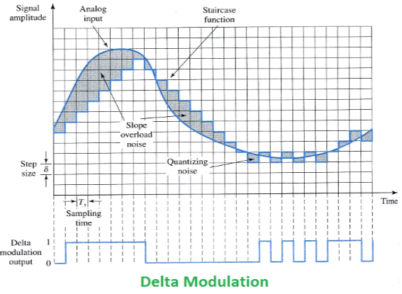
1 = Signal up one step, 0 = Signal down one step
The present sample value is compared with the previous sample value and the indication, whether the amplitude is increased or decreased is sent. The difference between the input signal x(t) and the staircase approximated signal confined to two levels, i.e. +δ, -δ. If the difference is positive then the approximated signal is increased by +δ, if the difference is decreased then the approximated signal is decreased by -δ. A zero is transmitted for –δ and a one is transmitted for +δ
Delta modulation systems are subject to two types of quantization error slope overload distortion and granular noise.
Slope overload distortion
The slope overload distortion happens when the signal changes rapidly and the slope is high. In this condition, the Delta Modulation method adds or subtracts a fixed step size value and cannot be close to the actual signal, which produces considerable errors in transmission. To reduce this error, the step size must be increased.
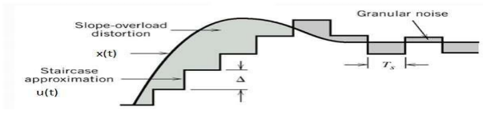
Granular noise
Granular noise occurs when step size is too large compared to small variations in the input signal. This means that for very small variations in the input signal, the staircase signal is changed by large amount because of large step size. The error between the input and approximated signal is called granular noise. The solution to this problem is to make step size small.
Block diagrams for Delta Modulation
Delta modulation consist of two parts the transmitter and receiver block
Transmitter Section
The transmitter is also known as Delta modulator. It consists of a 1-bit quantizer and a delay circuit along with two summer circuits. The transmitter block diagram also shows:
- Present sample value is X(nTs)
- The previous sample value is u([n-1]Ts)
- e(nTs) is an error signal between the present sample and previous sample
- b(nTs) is the quantizer output signal
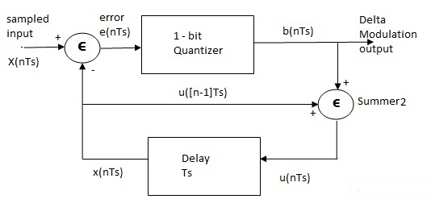
The accumulator block summer2 adds the quantizer output signal and previous sample approximation, and this results in u(nTs). The previous sample is achieved by delaying the present sample period approximation.
u(nTs)=u([n-1]Ts) + b(nTs)
Present samples value x(nT_{s} ) and staircase approximated signal xˆ(nT_{s} ) are subtracted to get error signal e(nT_{s} ). Thus, depending on the sign of e(nT_{s} ), one bit quantizer generates an output of +Δ or -Δ .If the step size is +Δ, then binary ‘1’ is transmitted and if it is -Δ, then binary ‘0’ is transmitted .

Receiver Section
At the receiver end also known as delta demodulator, it comprises of a low pass filter(LPF), a summer, and a delay circuit. The summer block and delay circuit block are called as Accumulator.
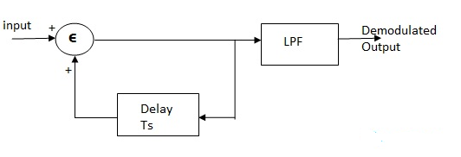
The binary signal transmitted is provided to the accumulator section. The accumulator generates the staircase approximated signal with having delayed by one sample period of Ts.
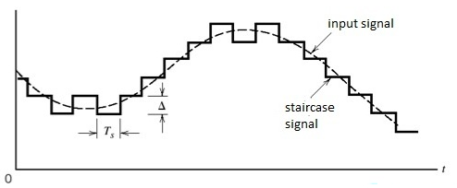
The transmitted signal along with the delayed signal is added at the summation unit. If here the input is binary 1 then after a delay the output of the accumulator shown increased step size +Δ. However, in the case of binary 0 as input, a decrease in step size is noticed. This generates the staircase signal equivalent to the message signal.
The output of the accumulator is provided to the LPF that smoothens the staircase signal in order to regenerate the original message signal.
Applications of delta modulation
It is widely used in radio communication devices and digital voice storage and voice information transmission where signal quality is less important.
Advantages of Delta Modulation
- Simplicity: Delta modulation is a relatively simple ADC technique that requires minimal hardware complexity.
- Low cost: Delta modulation requires fewer components than other ADC techniques, making it more cost-effective.
- High accuracy: Delta modulation can provide high accuracy compared to other ADC techniques, especially when the signal to be converted is relatively stable.
- Robustness: Delta modulation is relatively robust and can handle noise and interference well.
- Low power consumption: Delta modulation requires low power consumption, making it suitable for use in battery-powered devices.
- High data rate: Delta modulation can support high data rates, making it suitable for use in high-speed communication systems.
Disadvantages of Delta Modulation
- Limited dynamic range: Delta modulation has a limited dynamic range, which means it is not suitable for encoding signals with large amplitude variations.
- Limited resolution: The resolution of delta modulation is limited by the size of the reference signal step, which means it may not be suitable for encoding high-resolution signals.
- Quantization noise: Delta modulation introduces quantization noise, which is the difference between the encoded signal and the original signal. This noise can be reduced by increasing the reference signal step size, but this also reduces the resolution of the encoded signal.
- Complex decoding: Delta modulation requires complex decoding algorithms, which can make it more difficult to implement compared to other analog-to-digital conversion techniques.
- Sensitive to errors: Delta modulation is sensitive to errors in the reference signal, which can result in errors in the encoded signal. This can be mitigated by using error correction techniques, but this also increases the complexity of the decoding process.

Difference between Pulse Code Modulation (PCM) and Delta Modulation (DM):
S.NO | PCM | DM
1. | In PCM, feedback does not exist in transmitter or receiver. | While in DM, feedback exists in transmitter.
2. | Per sample 4, 8, or 16 bits are used. | Here, only one bit is used per sample.
3. | PCM requires highest transmitter bandwidth. | DM requires lowest transmitter bandwidth.
4. | PCM is complex in terms of complexity of implementation. | While DM is simple in terms of complexity of implementation.
5. | PCM has good signal to noise ratio. | While DM has poor signal to noise ratio.
6. | PCM is costly. | DM is cheap.
7. | PCM may be a technique wont to digitally represent sampled analog signals. | Digital to analog and analog to digital converter.
8. | In PCM, signal requires encoder and decoder both sides. | In DM, signal can modulate and demodulate.
9. | PM is mostly used in video telephony and audio telephony. | DM is mostly used in speeches as well as images.

    - Analog data, analog signal
Analog-to-analog conversion, or modulation, is the representation of analog information by an analog signal. It is a process by virtue of which a characteristic of carrier wave is varied according to the instantaneous amplitude of the modulating signal. This modulation is generally needed when a bandpass channel is required. Bandpass is a range of frequencies which are transmitted through a bandpass filter which is a filter allowing specific frequencies to pass preventing signals at unwanted frequencies. Analog to Analog conversion can be done in three ways:
- Amplitude Modulation
- Frequency Modulation
- Phase Modulation
2.2.4.1 Amplitude Modulation(AM)
In Amplitude Modulation transmission, the carrier signal is modulated so that its amplitude varies with the changing amplitudes of the modulating signal. The frequency and phase of the carrier remain the same. Only the amplitude changes to follow variations in the information. The following figure shows how this concept works.
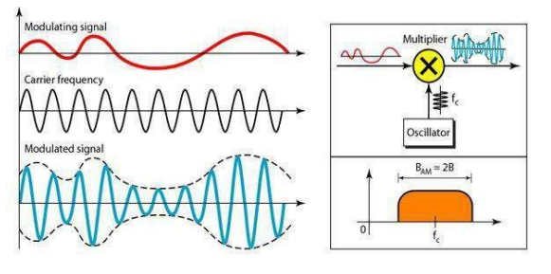
AM is normally implemented by using a simple multiplier because the amplitude of the carrier signal needs to be changed according to the amplitude of the modulating signal.
2.2.4.2 Frequency Modulation(FM)
In Frequency Modulation transmission, the frequency of the carrier signal is modulated to follow the changing voltage level (amplitude) of the modulating signal. The peak amplitude and phase of the carrier signal remain constant, but as the amplitude of the information signal changes, the frequency of the carrier changes correspondingly.

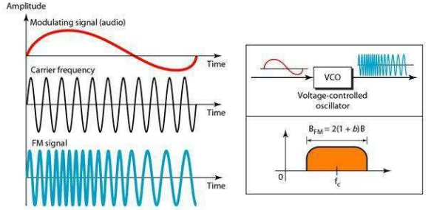
FM is normally implemented by using a voltage-controlled oscillator as with FSK. The frequency of the oscillator changes according to the input voltage which is the amplitude of the modulating signal.
2.2.4.3 Phase Modulation(PM)
In Phase Modulation transmission, the phase of the carrier signal is modulated to follow the changing voltage level (amplitude) of the modulating signal. The peak amplitude and frequency of the carrier signal remain constant, but as the amplitude of the information signal changes, the phase of the carrier changes correspondingly. It is proved mathematically that PM is the same as FM with one difference. In FM, the instantaneous change in the carrier frequency is proportional to the amplitude of the modulating signal; in PM the instantaneous change in the carrier frequency is proportional to the derivative of the amplitude of the modulating signal.
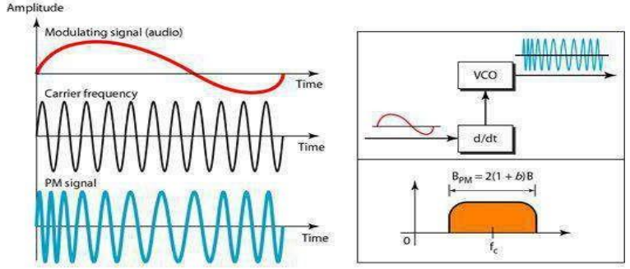
PM is normally implemented by using a voltage-controlled oscillator along with a derivative. The frequency of the oscillator changes according to the derivative of the input voltage which is the amplitude of the modulating signal.
  - Reasons for migration from analog to digital transmission
- The declining cost of digital technology - The advent of very large scale integration (VLSI) has lend to drop in cost and size of digital circuitry
- Data integrity – The use of repeater rather than amplifier prevents the accumulation of noise and other signal impairments. This makes digital transmission more economical than analogue transmission.
- Capacity utilization- Satellite channel and optical fibre communication links provide high bandwidths, move secure and economical. A high degree of multiplexing is needed for effectively utilize much capacity. The division multiplexing TDM rather than analog (FDM) technique provides the means to utilize this high capacity.
It is now economical to build transmission links using digital technology and therefore saving the cost of transmission because data can pass through a small path.
- Security and Privacy - It is easier to hide data to avoid other people reading it/interfering with it when you apply digital technology during transmission i.e encryption techniques are applicable to digital data.
- Integration – Digital transmission treats both analog and digital data uniformly and hence achieve economy of scale i.e voice, video can be integrated as digital data.

2.4 Baseband and Broadband transmission
Both baseband and broadband describe how data is transmitted between two nodes. Baseband technology transmits a single data signal/stream/channel at a time while broadband technology transmits multiple data signals/streams/channels simultaneously at the same time.
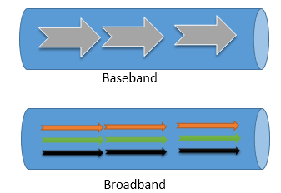
    - Baseband Transmission
Baseband technology uses digital signals in data transmission. It sends binary values directly as pulses of different voltage levels. Digital signals can be regenerated using repeaters in order to travel longer distances before weakening and becoming unusable because of attenuation.
Baseband supports bidirectional communication. It means, this technology can send and receive data simultaneously. To support bidirectional communication, this technology uses two separate electric circuits together; one for sending and another for receiving.
Although baseband transmits only a single data stream at a time, it is possible to transmit signals of multiple nodes simultaneously. This is done by combining all the signals into a single data stream. To combine the signals of multiple nodes, a technology known as multiplexing is used. Baseband supports the Time Division Multiplexing (TDM).
    - BroadBand Transmission
Broadband technology uses analog signals in data transmission. This technology uses a special analog wave known as the carrier wave. A carrier wave does not contain any data but contains all properties of the analog signal. This technology mixes data/digital signal/binary values into the carrier wave and sends the carrier wave across the channel/medium.
To transmit data of multiple nodes simultaneously, this technology supports the Frequency Division Multiplexing. FDM (Frequency Division Multiplexing) divides the channel (medium or path) into several sub-channels and assigns a sub-channel to each node. Each sub-channel can carry a separate carrier wave.
Analog signals can be regenerated using amplifiers in order to travel longer distances. Broadband supports only unidirectional communication. It means, nodes connected at both ends of a medium can send or receive data but can’t perform both actions simultaneously. Only one action is allowed at a time.
    - Baseband vs Broadband transmission
Baseband Transmission | Broadband Transmission
In baseband transmission, the type of signaling used is digital. | In broadband transmission, the type of signaling used is analog.
Baseband Transmission is bidirectional in nature. | Broadband Transmission is unidirectional in nature.
Signals can only travel over short distances. | Signals can be travelled over long distances without being attenuated.
It works well with bus topology. | It is used with a bus as well as tree topology.
Support TDM based multiplexing | Support FDM based multiplexing
Use coaxial, twisted-pair, and fiber-optic cables | Use radio waves, coaxial cables, and fiber optic cables
Mainly used in Ethernet LAN networks | Mainly used in cable and telephone networks
In baseband transmission, Manchester and Differential Manchester encoding are used. | Only PSK encoding is used.
Baseband transmission have 50 ohm impedance. | Broadband transmission have 70 ohm impedance.
Baseband transmission is easy to install and maintain. | Broadband transmission is difficult to install and maintain.
This transmission is cheaper to design. | This transmission is expensive to design.

3.0 DATA TRANSMISSION
Data transmission refers to the process of transferring data between two or more digital devices. Data is transmitted from one device to another in analog or digital format. Basically, data transmission enables devices or components within devices to speak to each other. Data is transferred in the form of bits between two or more digital devices. There are two methods used to transmit data between digital devices:
- serial transmission
- parallel transmission.

Serial transmission has three classifications: asynchronous , synchronous and Isochronous.

3.1 Parallel data transmission
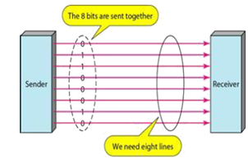
In parallel data transmission, all bits of the binary data are transmitted simultaneously. For example, to transmit an 8-bit binary number in parallel from one unit to another, eight transmission lines are required. Each bit requires its own separate data path. All bits of a word are transmitted at the same time. This method of transmission can move a significant amount of data in a given period of time.
The major problem with parallel transmission is “skewing” because the wires in parallel transmission have slightly different properties(not intentionally) so some bits may arrive before others, which means that the original “meaning” of the message is lost and thus leads to corruption.
Another challenge with parallel transmission is for large binary words, cabling becomes complex and expensive. This is particularly true if the distance between the two units is great. Long multiwire cables are not only expensive, but also require special interfacing to minimize noise and distortion problems.

3.2 Serial data transmission
In Serial data transmission, bits are transmitted serially, one after the other. The least significant bit (LSB) is usually transmitted first. While sending data serially, characters or bytes have to be separated and sent bit by bit. Thus, some hardware is required to convert the data from parallel to serial. At the destination, all the bits are collected, measured and put together as bytes in the memory of the destination. This requires conversion from serial to parallel.
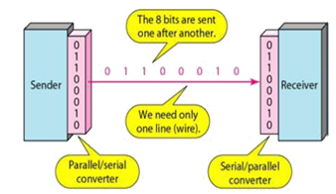

One of the major difficulties in data transmission is that of synchronising the receiver (destination) with the sender (source). This is the main problem with serial communication. The receiver must be able to detect the beginning of each new character in the bit stream that is being presented to it and if it is not able to achieve this, it will not be able to interpret the incoming bit stream correctly. The three mechanisms used for synchronisation are:
- Asynchronous Communication
- Synchronous Communication
- Isochronous Communication
    - Asynchronous Communication
This is the simplest scheme of serial transmission mode. Here data is transmitted one character at a time(8 bits). Each character is preceded by a start code and followed by a stop code. This can either be a single 0 or 1 digit respectively, and when no data is send, the transmitter sense out a continuous stop code (a series of ones). 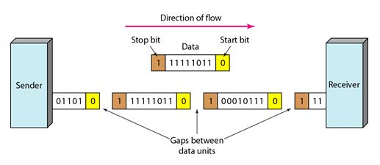
The start and stop bits and the gap alert the receiver to the beginning and end of each byte and allow it to synchronize with the data stream. This mechanism is called Asynchronous, because at byte level sender and receiver need not to be synchronized.
Asynchronous communication is most frequently used to transmit character data and is ideally suited for characters that are transmitted at irregular intervals, such as, when users are typing in character data from the keyboard.
A typical frame used to transmit a character data has four components:
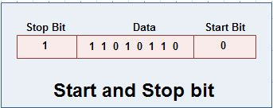
- A start bit: Signals the starting a frame and enables the receiving device to synchronise itself with the message.
- Data Bits: Consists of 7 or 8 bits when character data is being transmitted.
- Parity Bits: Optionally used as a crude method for detecting transmission errors.
- A stop bit or bits: Signals the end of the data frame.
Error detection in asynchronous transmission makes use of the parity bit. Parity techniques can detect errors that affect only one bit and if two or more bits are affected by errors, the parity techniques may not be able to detect them.
Advantages of Asynchronous Communication
- Asynchronous transmission is simple, inexpensive and is ideally suited for transmitting small frames at irregular intervals (e.g.,Data entry from a keyboard).
- As each individual character is complete in itself, if a character is corrupted during transmission, its successor and predecessor will not be affected.
- It is possible to transmit signals from sources having different bit rates.
- The transmission can start as soon as data byte to be transmitted becomes available.
Disadvantages of Asynchronous Communication
- As start, stop and parity bits must be added to each character that is to be transmitted, this adds a high overhead to transmission. This wastes the bandwidth; as a result, asynchronous transmission is undesirable for transmitting large amounts of data.
- Successful transmission inevitably depends on the recognition of the start bits, hence, as these bits can be easily missed or occasionally spurious, as start bits can be generated by line interference, the transmission may be unsuccessful.
- Due to the effects of distortion the speed of asynchronous transmission is limited.

3.2.2 Synchronous Communication
In synchronous communication the whole block of data bits is transferred at once, instead of one character at a time. Here, transmission begins at a predetermined regular time instant. A sync signal is used to tell the receiving station that a new frame is arriving and to synchronise the receiving station. Sync signals, generally utilise a bit pattern that cannot appear elsewhere in the messages, ensuring that they will always be distinct and easy for the receiver to recognise.
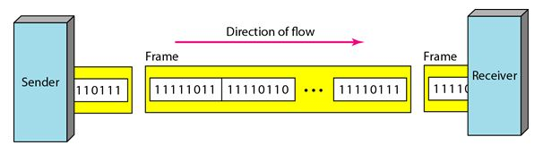
As the transmitter and receiver remain in synchronisation for the duration of the transmission, frames can be of longer length. As frames are longer the parity method of error detection is not suitable because, if multiple bits are affected, then, the parity technique will not report error accurately. Hence, the technique used with synchronous transmission is the Cyclic Redundancy Check (CRC).
The transmitter uses an algorithm to calculate a CRC value that summarises the entire value of data bits. This CRC value is appended to the data frame. The receiver uses the same algorithm, recalculates the CRC and compares the CRC in the frame to the value that it has calculated. If these values match then, it is sure that the frame was transmitted without error.
An end bit pattern indicates the end of the frame. Like sync the bit pattern for end is such that, it will not appear elsewhere in the messages, ensuring that they will always be distinct and easy for the receiver to recognise at the end of the frame. Serial synchronous transmission is used for high-speed communication between computers. It is used when high volumes of data are to be
transmitted.
Advantages of Synchronous Communication
- Synchronous transmission is more efficient because, only 4 additional bytes (for start and end frames).are required to transmit up to 64 k bits.
- Synchronous transmission is not really prone to distortion, as a result, it can be used at high- speeds.
Disadvantages of Synchronous Communication
- Synchronous transmission is expensive as complex circuitry is required and it is difficult to implement.
- If an error occurs during transmission, rather than just a single character the whole block of data is lost.
- The sender cannot transmit characters simply, as they occur, but has to store them until it has built up a block. Thus, this is not suitable where characters are generated at irregular intervals.

3.2.3 Comparison between Asynchronous and Synchronous
Synchronous Transmission | Asynchronous Transmission
In Synchronous transmission, Data is sent in form of blocks or frames. | In asynchronous transmission, Data is sent in form of byte or character.
Synchronous transmission is fast. | Asynchronous transmission is slow.
Synchronous transmission is costly. | Asynchronous transmission economical.
In Synchronous transmission, time interval of transmission is constant. | In asynchronous transmission, time interval of transmission is not constant, it is random.
In Synchronous transmission, There is no gap present between data. | In asynchronous transmission, There is present gap between data.
Efficient use of transmission line is done in synchronous transmission. | While in asynchronous transmission, transmission line remains empty during gap in character transmission.
Synchronous transmission needs precisely synchronized clocks for the information of new bytes. | Asynchronous transmission have no need of synchronized clocks as parity bit is used in this transmission for information of new bytes.

3.2.4 Isochronous Communication
This method combines the approaches of asynchronous and synchronous communications. The Isochronous Transmission Format is also known as START-STOP mode or CHARACTER mode. Each character or byte is framed as a separate and independent unit of DATA that may be transmitted and received at irregular and independent time intervals. The characters or bytes may also be transmitted as a contiguous stream or series of characters.
Advantages of Isochronous Communication
- Isochronous transmission guarantees transmission rates, and it is almost deterministic.
- It has low overheads.
- It has high speed.
Disadvantages of Isochronous Communication
- In isochronous transmission its necessary to ensure that the clocking device is fault tolerant.
3.2.5 Differences between Serial and Parallel Transmission
Serial Transmission | Parallel Transmission
In serial transmission, data(bit) flows in bi-direction. | In Parallel Transmission, data flows in multiple lines.
Serial Transmission is cost-efficient. | Parallel Transmission is not cost-efficient.
In serial transmission, one bit transferred at one clock pulse. | In Parallel Transmission, eight bits transferred at one clock pulse.
Serial Transmission is slow in comparison of Parallel Transmission. | Parallel Transmission is fast in comparison of Serial Transmission.
Generally, Serial Transmission is used for long-distance. | Generally, Parallel Transmission is used for short distance.
The circuit used in Serial Transmission is simple. | The circuit used in Parallel Transmission is relatively complex.

  - DUPLEXITY
The term duplexity defines the direction of signal flow between two linked devices. This is also called transmission mode or communication mode. Each communication channel has a direction associated with it, and transmission media provide the direction. Therefore, the transmission mode is also known as a directional mode. The transmission mode is defined in the physical layer. The three basic ways in which this can be done are:
- Simplex.
- Half Duplex
- Full Duplex, sometimes called Duplex.

3.3.1 simplex mode(SX)
In simplex mode, the communication is unidirectional, as on a one-way street. Only one of the two devices on a link can transmit; the other can only receive. Commercial radio broadcasting is an example. Simplex lines are also called receive-only, transmit-only or one-way-only lines.

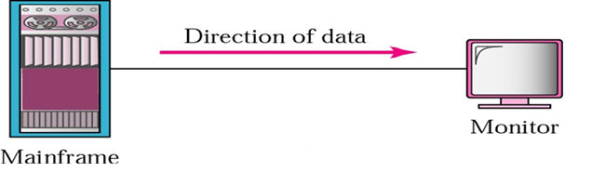
3.3.2 half-duplex(HDX) mode
In half-duplex mode, each station can both transmit and receive, but not at the same time. When one device is sending, the other can only receive, and vice versa. The half-duplex mode is used in cases where there is no need for communication in both directions at the same time; the entire capacity of the channel can be utilized for each direction.
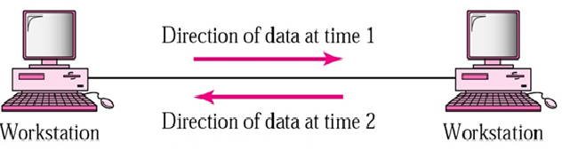
For example, in walkie-talkies, the speakers at both ends can speak, but they have to speak one by one. They cannot speak simultaneously.
3.3.3 full-duplex mode(FDX)
In full-duplex mode (called duplex), both stations can transmit and receive simultaneously.. The full-duplex mode is used when communication in both directions is required all the time. The capacity of the channel must be divided between the two directions.
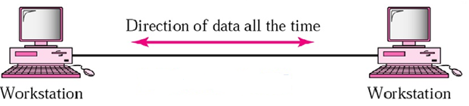
For example, in a telephone conversation, two people communicate, and both are
free to speak and listen at the same time.

4.0 MULTIPLEXING
multiplexing or muxing is a method by which multiple analog or digital signals are combined into one signal over a shared medium. The aim is to share a scarce resource. The multiplexed signal is transmitted over a communication channel such as a cable. The multiplexing divides the capacity of the communication channel into several logical channels, one for each message signal or data stream to be transferred. A reverse process, known as demultiplexing, extracts the original channels on the receiver end.
Multiplexing is achieved by using a device called Multiplexer (MUX) that combines n input lines to generate a single output line. Multiplexing follows many-to-one, i.e., n input lines and one output line.
Demultiplexing is achieved by using a device called Demultiplexer (DEMUX) available at the receiving end. DEMUX separates a signal into its component signals (one input and n outputs). Therefore, we can say that demultiplexing follows the one-to-many approach.
4.1 Types of Multiplexers
There are mainly two types of multiplexers, namely analog and digital. They are further divided into Frequency Division Multiplexing (FDM), Wavelength Division Multiplexing (WDM), and Time Division Multiplexing (TDM).

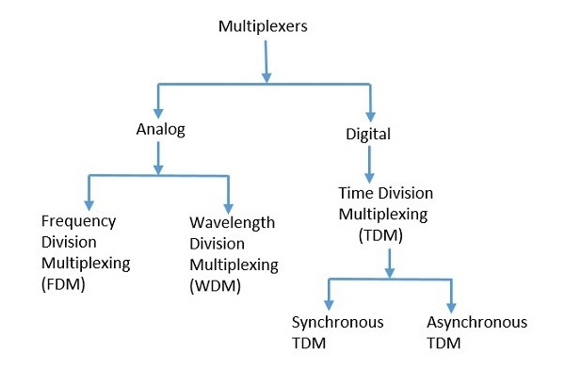
4.1.1 Analog Multiplexing
The signals used in analog multiplexing techniques are analog in nature. The analog signals are multiplexed according to their frequency (FDM) or wavelength (WDM).
  - Frequency division multiplexing (FDM)
Frequency Division Multiplexing (FDM) is primarily used with analogue signals rather than digital data streams. It works by dividing the entire bandwidth which is available in a data source, into sub-channels that each have a different frequency; hence the name ‘frequency division’.
CH0
CH3

CH6

Bandwidth
CH5

CH4

CH3
CH3

CH2
CH3

CH1
CH3

Frequency
CH3

Each sub-channel then carries separate signals through a transmission line or an aggregated channel (a combination of channels with higher bandwidth). The sub-channels can travel independently through a transmission line or they can travel simultaneously besides one another.
These sub-channels are then separated by the strips of unused bandwidth called guard bands. These guard bands prevent the signals from overlapping. A demultiplexer applies a set of filters that each extract a small range of frequencies near one of the carrier frequencies.
Advantage of FDM:
- The senders can send signals continuously.
- FDM support full duplex information flow.
- FDM is used for analog signals.
- Noise problem for analog communication has lesser effect.
- FDM process is very simple and easy modulation and demodulation.
- It does not require any synchronization between sender and receiver.
Disadvantage of FDM:
- Each user requires a precise carrier frequency.
- FDM technique is used only when low-speed channels are required.
- It requires a high bandwidth channel.
- Inflexible, one channel idle and other one busy
- It suffers the problem of crosstalk.
- Large number of modulators and filters are required.
- All the FDM channels get affected due to wideband fading.
Applications of FDM:
- FDM is commonly used in TV networks.
- It is used in FM and AM broadcasting. Each FM radio station has different frequencies, and they are multiplexed to form a composite signal. The multiplexed signal is transmitted in the air.
  - Wavelength Division Multiplexing(WDM)
Wavelength Division multiplexing (WDM) is conceptually tha same as FDM, except that the multiplexing and demultiplexing involves light signals transmitted through fiber-optic channels. The idea is the same; we are combining different signals of different frequencies. However, the difference is that the frequencies are very high.
Although WDM technology is very complex, the idea itself is very simple. We want to combine multiple light sources into one single light at the multiplexer and do reverse at the demultiplexer. Combining and splitting of light sources are easily handled by a prism.
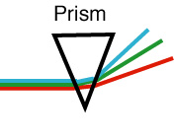
The prism bends a beam of light based on the angle of incidence and the frequency. Using this technique, multiplexer can be made to combine several input beams of light, each containing a narrow band of frequencies, into one output of a wider band of frequencies. A demultiplexer can also be made to reverse the process.

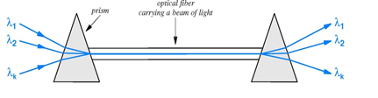
The inputs and outputs of such multiplexing are wavelengths of light denoted by the Greek letter λ, and informally called colors.
Advantages of WDM
- Speed: Works with low speed equipment
- Transparency: WDM is transparent. It does not depend on the protocol that has to be
transmitted.
- Scalable: It is scalable. Instead of switching to a new technology, a new channel can easily be added to existing channels.
- Capacity Increment: It is easy for network providers to add additional capacity in a few days if customers need it.
Disadvantages of WDM
- Complexity: Complex transmitters and receivers.
- Reliability and Cost: They must be wide-band, which means they are more expensive and possibly less reliable.

4.1.2 Digital Multiplexing
The term digital represents the discrete bits of information. Hence, the available data is in the form of frames or packets, which are discrete.
  - Time division multiplexing
Time-division multiplexing (TDM) is a digital process that allows several connections to share the high bandwidth of a line. Instead of sharing a portion of the bandwidth as in FDM, time is shared. Time Division Multiplexing is the process of dividing up one communication time slot into smaller time slots.
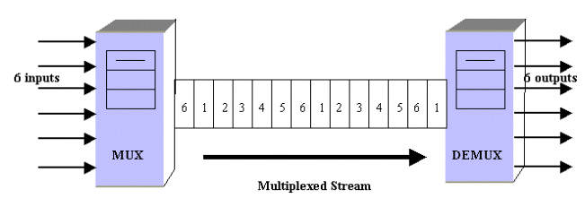
Time Division Multiplexing (TDM) system, a single path and carrier frequency is used. Each user is assigned a unique time slot for their operation. A central switch or multiplexer goes from one user to the next in a specific predictable sequence and time. TDM system can be applied when the data rate capacity of the transmission medium is greater than the data rate required by the sending and receiving devices. TDM is more efficient than FDM, in that it does not require guard bands and it operates directly in digital form. In TDM, the transmission between the multiplexers is provided by a single high speed digital transmission line. Types of Time Division Multiplexing It can be categories into two types:
- Synchronous TDM
- Asynchronous TDM
  - Synchronous TDM
A Synchronous TDM is a technique in which time slot is preassigned to every device. In Synchronous TDM, each device is given some time slot irrespective of the fact that the device contains the data or not. If the device does not have any data, then the slot will remain empty. In Synchronous TDM, signals are sent in the form of frames. Time slots are organized in the form of frames. If a device does not have data for a particular time slot, then the empty slot will be transmitted. If there are n devices, then there are n slots.
Bandwidth

CH₀ CH₁ CH₂ CH₃ CH₄ CH₅ CH₆ CH₇ CH₈ CH₉
Time

The most popular Synchronous TDM are T-1 multiplexing, ISDN multiplexing, and SONET multiplexing.
Disadvantages of Synchronous TDM:
- The capacity of the channel is not fully utilized as the empty slots are also transmitted which is having no data.
- The speed of the transmission medium should be greater than the total speed of the input lines.
  - Asynchronous TDM
An asynchronous TDM is also known as Statistical TDM. An asynchronous TDM is a technique in which time slots are not fixed as in the case of Synchronous TDM. Time slots are allocated to only those devices which have the data to send. Therefore, we can say that Asynchronous Time Division multiplexor transmits only the data from active workstations.
Bandwidth

1 2 3 4 5 6 7 8 9 10

Time

An asynchronous TDM technique dynamically allocates the time slots to the devices. In Asynchronous TDM, total speed of the input lines can be greater than the capacity of the channel. Asynchronous Time Division multiplexor accepts the incoming data streams and creates a frame that contains only data with no empty slots. In Asynchronous TDM, each slot contains an address part that identifies the source of the data.
The difference between Asynchronous TDM and Synchronous TDM is that many slots in Synchronous TDM are unutilized, but in Asynchronous TDM, slots are fully utilized. This leads to the smaller transmission time and efficient utilization of the capacity of the channel. In Synchronous TDM, if there are n sending devices, then there are n time slots. In Asynchronous TDM, if there are n sending devices, then there are m time slots where m is less than n (m<n). The number of slots in a frame depends on the statistical analysis of the number of input lines.
Advantages of TDM
- The user gets full bandwidth of the channel in a particular time slot.
- For bursty signals such as voice or speech TDMA gives maximum utilization of the channel.
- Most suitable technique for digital transmission.
- It does not require precise carrier matching at both end of the links.
- Can expand the number of users on a system at a low cost.
Disadvantages of TDM
- It is not much suitable for continues signals.
- Initial cost is high.
- The noise problem for analog communication has greater effect.
- Extra guard times are necessary.
- Synchronization is necessary.

5.0 TRANSMISSION MEDIA
Introduction
The transmission medium is the physical path between transmitter and receiver in a data
transmission system. The information is usually a signal that is the result of a conversion of data from another form. Transmission media can be generally categorized as either unguided or guided.
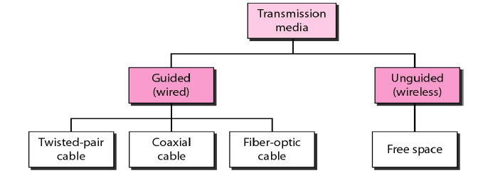

5.1 Guided Transmission Media
Guided Transmission Media uses a "cabling" system (or some sort of conductor) that guides
the data signals along a specific path. The data signals are bound by the "cabling" system.
Guided Media is also known as Bound Media. The conductor directs the signal propagating
down it. Only devices physically connected to the medium can receive signals propagating
down a guided transmission medium. Examples of guided transmission media are copper wire and optical fiber.

5.1.1 Twisted-Pair (TP)
A twisted-pair (TP) transmission line is formed by twisting two insulated conductors around each other. Usually, a number of pairs of these wires are put together into a cable. The cable may contain more than a hundred pairs of wires for long-distance communications. Twisted-pair wires are the most common media in a telephone network. These wires support both analog and digital signals and can transmit the signal at a speed of 10 Mbps over a short distance. The twisting of wires with different twisting lengths reduces the effect of cross talk and low-frequency interference.
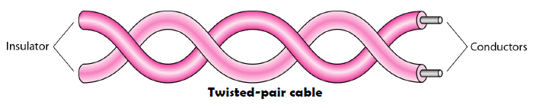
Twisted-pair transmission lines are also the transmission medium of choice for most local
area networks because twisted-pair cable is simple to install and relatively independent when compared to coaxial and optical fiber cables. The two basic types of twisted-pair transmission lines specified are unshielded twisted pair (UTP) and shielded twisted pair (STP).
  - Unshielded twisted-pair:
UTP cable consist of four twisted pairs of copper wires, enclosed in a protective plastic cover, with the greater number of pairs corresponding to more bandwidth. Bandwidth can be improved by controlling the number of twists per foot and also the manner in which multiple pairs are twisted around each other. The minimum number of twists for UTP cable is two per foot. The two individual wires in a single pair are twisted around each other, and then the pairs are twisted around each other, as well. This is done to reduce crosstalk and electromagnetic interference, each of which can degrade network performance.
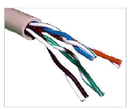

Twisted pairs are color-coded to make it easy to identify each pair. One wire in a pair is identified by one of five colors: blue, orange, green, brown or slate (gray). This wire is paired with a wire from a different color group: white, red, black, yellow or violet. Typically, one wire in a pair is solid-colored, and the second is striped with the color of its mate -- e.g., a solid blue wire would be paired with a white-and-blue striped wire -- so they can be easily identified and matched.
UTP Categories
The Electronic Industries Association (EIA) has developed standard to grade UTP cable by quality; Category 1 as the lowest quality and category 6 as the highest quality.
- Category 1: The basic twisted-pair cabling used in telephone systems. This level of quality is fine for voice but inadequate for data transmission.
- Category 2: This category is suitable for voice and data transmission of up to 2Mbps.
- Category 3: This category is suitable for data transmission of up to 10 Mbps. It is now the standard cable for most telephone systems. At least three twist per feet
- Category 4: This category is suitable for data transmission of up to 20 Mbps.
- Category 5: This category is suitable for data transmission of up to 100 Mbps.
- Category 6: CAT- 6 is recently proposed cable type comprised of four pairs of wire capable of operating at transmission rates of up to 400Mbps.
Advantages Of Unshielded Twisted Pair:
- It is smaller in size. Hence installation is easier as it does not fill up wiring ducts.
- It is less expensive compare to other networking media types.
- It is thin and flexible which further makes installation easier.
- UTP cables are used in most of the networking architecture.
Disadvantage:
- It is more susceptible to interference compare to most of the other cable types. Twisting of pair helps to certain extent but it does not make cable impervious to electrical noise completely.
- It can be used up to cable segment lengths of about 100 meters only.
- UTP cable should follow specifications for number of twists or braids permitted per meter of cable to reduce crosstalk.

  - Shielded Twisted Pair (STP) Cable:
STP is also the type of twisted pair which stands for Shielded twisted pair. Shielded twisted-pair cable encases the signal-carrying wires in a conducting shield as a means of reducing the potential for electromagnetic interference. How effective the shielding is depends on the material used for the shield,its thickness and frequency, the type of electromagnetic noise field, the distance from the noise source to the shield, any shield discontinuity and the grounding practices. Also, crosstalk and signal noise can increase if the effects of the shield are not compensated for.
Some STP cables, use a thick braided shield that makes a cable heavier, thicker and more difficult to install than its UTP counterpart. Other STP cables use only a thin outer foil shield. These cables, known as screened twisted-pair cables or foil twisted-pair cables, are thinner and less expensive than braided STP cable.
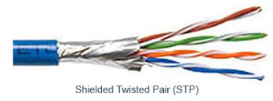

Shielding Types
Common shield construction types include:
  - Individual shield
Individual shielding with aluminum foil for each twisted pair or quad. Common names: pair in metal foil, shielded twisted pair, screened twisted pair. There only one type under this category:
- U/FTP –Unshielded with Foiled Twisted Pairs - This type of cable has no overall shielding but individual twisted pairs are wrapped in a foil screen, offering some protection from EMI and crosstalk from adjacent pairs and other cables.

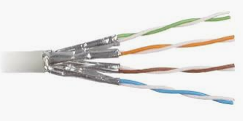

  - Overall shield
Overall foil, braided shield or braiding with foil across all of the pairs within the 100 ohm twisted pair cable. Common names: foiled twisted pair, shielded twisted pair, screened twisted pair. This type of shielding helps prevent EMI from entering or exiting the cable. There three categories here this include F/UTP, S/UTP, and SF/UTP.

- F/UTP Foiled with Unshielded Twisted Pair - An overall foil shield (F) with unscreened twisted pairs (UTP) and a drain wire. When the drain wire is correctly connected, unwanted noise is redirected to ground, offering extra protection against EMI/RFI. This cable is very much like common UTP cables, with the addition of foil underneath the main cable jacket. Another common name for this cable is FTP. F/UTP cables are common in 10GBaseT applications.

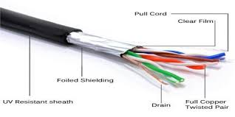
- S/UTP: Shielded with Unshielded Twisted Pairs. –This cable construction has an overall braid screen with unshielded twisted pair. This cable is often referred to as an STP, however this term should be used with caution due to other shielded cables also using this term.
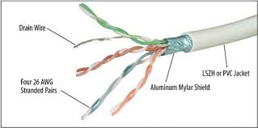

- SF/UTP: Shielded and Foiled with unshielded twisted pairs - This cable has both an overall braid shield and foil shield with unshielded twisted pairs. This cable offers effective protection from EMI both from the cable and into the cable as well as much better grounding due to the additional braid.
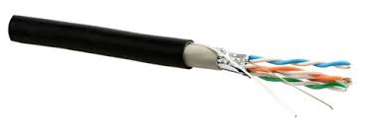
  - Individual and overall shield
Individual shielding using foil between the twisted pair sets, and also an outer foil or braided shielding. Common names: fully shielded twisted pair, screened foiled twisted pair, shielded foiled twisted pair, screened shielded twisted pair, shielded screened twisted pair. This type of shielding helps prevent EMI from entering or exiting the cable and also protects neighboring pairs from crosstalk. There three categories here they include: F/FTP, S/FTP, and SF/FTP.
- F/FTP Foiled with foiled Twisted Pairs - This type of cable features an overall foil shield with individually foil tape shielded twisted pairs. These are similar to F/UTP cables, with the addition of a foil shield around each twisted pair. The cable construction is designed to provide the assembly with greater protection from crosstalk from adjacent pairs and other cables, RFI and EMI.

- S/FTP Shielded with Foiled Twisted Pairs – In S/FTP each individual pairs are wrapped in a foil tape before being wrapped in an overall flexible yet mechanically strong brain screen. The additional foil on the twisted pair helps reduce crosstalk from adjacent pairs and other cables . The braid provides better grounding
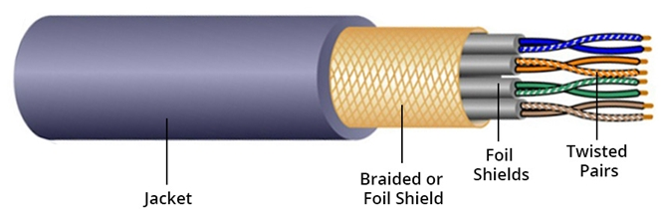
- SF/FTP:Shielded and Foiled With Foiled Twisted Pairs -This cable has both an overall braid shield and foil shield with individually foil tape screened twisted pairs. This type of cable provides the best level of protection from interference and better grounding due to the braid.
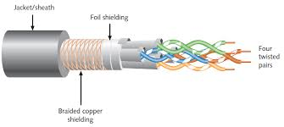
Advantages Shielded Twisted Pair:
- Shielding reduces chance of crosstalk and provide protection from interference.
- It has higher capacity as compared to unshielded twisted pair cable.
- It offers better electrical characteristics than unshielded cables.
Disadvantages
- Shielding increases overall diameter and weight of the cable. Hence it is more difficult to install compare to UTP cables. The larger thickness make them unfit for narrow cable ducts.
- Shield of STP cables must be grounded properly otherwise it acts like an antenna and picks up unwanted signals.
- It is more expensive as compared to UTP and coaxial cable.

Unshielded Twisted Pair (UTP) VS Shielded Twisted Pair (STP) cables:
UTP | STP
In UTP grounding cable is not necessary. | STP grounding cable is required.
Data rate in UTP is slow compared to STP. | Data rate in STP is high.
The cost of UTP is less. | STP is costlier than UTP.
In UTP much more maintenance are not needed. | STP much more maintenance are needed.
In UTP noise is high compared to STP. | STP noise is less.
In UTP the generation of crosstalk is also high compared to STP. | STP generation of crosstalk is also less.

5.1.2 Coaxial Cable
Coaxial cables are the guided media that carnes the signal of higher frequency range compared to twisted pair cable. Coaxial cables are also called coax. (short form). Two types of coaxial cables are widely used: 50 ohm cable and 75 ohm cable. 50 ohm cable is used for digital transmission and 75 ohm cable is used for analog transmission. Due to the shield provided, this cable has excellent noise immunity. It has a large bandwidth and low losses. Co-axial cables are easy to install. They are often installed either in a device to device daisy chain (Ethernet) or a star (ARC net).
Structure of coaxial cable
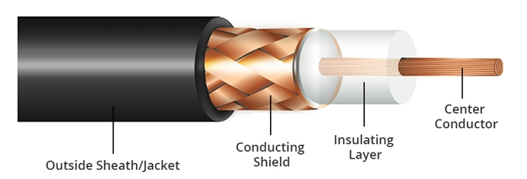
Center Conductor: At the heart of a coaxial cable is a center conductor. Typically constructed of either pure copper (in higher-end cables) or copper-coated steel or aluminum (in less-expensive cables), the center conductor is responsible for transmitting the cable's signal. As such, it must meet certain electrical properties (such as wire resistance). The rest of the cable construction is primarily designed to help the center conductor maintain its electrical integrity.
Dielectric Insulator: The dielectric insulator's purpose is two-fold; first, it acts as an insulator between the center conductor and the outer braided / foil shielding. Second, it helps physically hold the center conductor in the center of the cable. This is important, as signal loss can occur if the center conductor strays too close to the outer area of the cable. Various materials are commonly used for the dielectric. A few of the more common materials, in order of quality (from best to worst), are below:
  - Foamed Polyethylene (FPE)
  - Teflon
  - Polyethylene (PE)
  - Polypropylene (PP)
  - Polyvinylchloride (PVC)
When reading specifications on coaxial cables, you may see references to the dialetric constant. The closer this number is to 1.0, the better. Foamed Polyethylene (FPE), for example, generally has a dielectric constant somewhere around 1.5, while PVC's dialetric constant is around 3.0 to 4.0. (Foamed PE basically uses gas, often nitrogen, to create gas bubbles in the material to lower the dielectric constant. Marketing literature that refers to "gas-injected dielectric" usually indicates the use of FPE. It is one of the best dielectric materials in common use.)
Braided Shield: Long copper cables have a tendency to act like antennas, picking up stray signals from the environment. These unwanted signals, known as "interference", disrupt the signal that the cable is supposed to be carrying. Interference tends to come in two different flavors: electromagnetic interference (known as EMI) and radio frequency interference (RFI). EMI interference is often caused by heavy power lines, cell phone signals, etc. A braided shield protects the signal from EMI interference. When looking at cable specs, the braided shield will often be expressed in a percent coverage, which often ranges anywhere from 30% to 95% coverage. The higher the coverage, the better the protection.
Outer Jacket: The outer jacket is generally made out of flexible PVC (polyvinyl chloride) and serves primarily to hold the cable together and protect it from the elements.
Coaxial standards
There are different types of coaxial cable that vary by gauge and impedance. Most coaxial specifications have an impedance of 50, 52, 75 or 93 ohms. "Gauge" is the thickness of a given cable. It is measured by the radio guide measurement or RG number. The higher the RG number, the thinner the central core conductor. The lower the RG number, the thicker the core conductor. The following are the most common coaxial standards:
- 50-Ohm RG-7 or RG-11: Used for thick Ethernet or "thicknet".
- 50-Ohm RG-58: Used for thin Ethernet, or "cheapernet".
- 75-Ohm RG-59: Used for cable television.
- 93-Ohm RG-62: Used for ARCNET.

Applications of Coaxial Cables
- Television: Coaxial cable used for television would be 75 Ohm and RG-6 coaxial cable.
- Internet: Coaxial cables are also used for carrying internet signals, RG-6 cables are used for this.
- CCTV: The coaxial cables are also used in CCTV systems and both RG-59 AND RG-6 cables can be used.
- Video: The coaxial cables are also used in video Transmission the RG-6 is used for better digital signals and RG-59 for lossless transmission of video signals.
- HDTV: The HDTV uses RG-11 as it provides more space for signals to transfer.
Advantages of Coaxial cable:
- It is less susceptible to noise or interference (EMI or RFI) compare to twisted pair cable.
- It offers higher bandwidth as compared to twisted pair cable and can span longer distances.
- It can be used for both analog and digital transmission.
- Because of better shielding in coaxial cable, loss of signal or attenuation is less. The outer conductor in coaxial cable is used to improve attenuation and shield effectiveness.
- Better shielding also offers good noise immunity.
- It is relatively inexpensive as compared to optical fibers.
- It has lower error rates as compared to twisted pair.
Disadvantages of Coaxial cable:
- It is bulky.
- It is expensive to install for longer distances due to its thickness and stiffness.
- The security is a great concern as it is easy to tap the coaxial cable by breaking it and inserting T-joint (of BNC type) in between.
- It must be grounded to prevent interference.
5.1.3 Fiber Optic Cable
Fiber optics, or optical fiber, refers to the medium and the technology associated with the transmission of information as light pulses along a glass or plastic strand or fiber. Optical fiber is a very thin strand of pure glass which acts as a waveguide for light over long distances. It uses a principle known as total internal reflection. Fiber optic cable is actually composed of two layers of glass: The core, which carries the actual light signal, and the cladding, which is a layer of glass surrounding the core. The glass fiber core and the cladding each have a different refractive index that bends incoming light at a certain angle. The cladding has a lower refractive index than the core. When light signals are sent through the fiber optic cable, they reflect off the core and cladding in a series of zig-zag bounces, adhering to a process called total internal reflection.
Basic elements of Fiber optic cable:
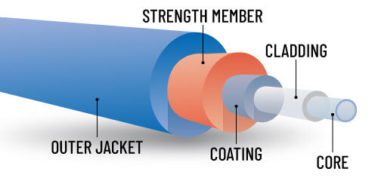 | 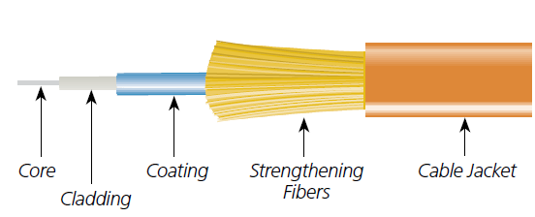
- Core: The optical fibre consists of a narrow strand of glass or plastic known as a core. A core is a light transmission area of the fibre. The more the area of the core, the more light will be transmitted into the fibre.
- Cladding: The concentric layer of glass is known as cladding. The main functionality of the cladding is to provide the lower refractive index at the core interface as to cause the reflection within the core so that the light waves are transmitted through the fibre.
- Primary Coating: The primary coating comes after the cladding, and is also known as the primary buffer. It is designed to absorb shocks, provide protection against excessive cable bends, and reinforce the fiber core. This primary coating is basically a layer of plastic which does not interfere with the cladding or the light transmission of the core.
- Strength Members: Also known as strengthening fibers, these are strands of Kevlar (Aramid yarn) which have been specifically placed to protect the core against excessive tension during installation and other crushing forces.
- Cable Jacket: The outer layer of any cable is known as the cable jacket. The protective coating consisting of plastic is known as a jacket. The main purpose of a jacket is to preserve the fibre strength, absorb shock and extra fibre protection.
Depending on the application, some fiber-optic cables have yellow, black, aqua, and other colored jackets. However, fiber-optic cables typically have an orange jacket. Different applications can be designated within a network by using different colors.

Types of Fiber optics:
Generally optical fiber is classified into two categories based on:
- The number of modes, and
- The refractive index. T

1. On the basis of the Number of Modes:
It is classified into 2 types single and multi-mode.
- Single-mode fiber ( SMF):
Single mode means the fiber enables one type of light mode to be propagated at a time. This type of fiber has a small core diameter (5um) and high cladding diameter (70um) and the difference between the refractive index of core and cladding is very small. There is no dispersion i.e. no degradation of the signal during traveling through the fiber.
Single-mode fiber gives a higher transmission rate and up to 50 times more distance than multimode, but it also costs more. Single-mode fiber has a much smaller core than multimode. The small core and single light-wave virtually eliminate any distortion that could result from overlapping light pulses, providing the least signal attenuation and the highest transmission speeds of any fiber cable type.
- Multi-mode fiber (MMF):
Multimode fiber allows a large number of modes for the light ray traveling through it. The core diameter is generally (40um) and that of cladding is (70um). The larger diametrical core permits multiple modes of light to pass through at a given time. This characteristic allows the number of light reflections created as the light passes through the core to increase, creating the ability for more data to pass through at any given time. The attenuation rate and high dispersion of this fiber reduce the signal quality over long distances. Multimode optical fiber is commonly used short distances, audio/video applications, and Local Area Networks (LANs).
2. On the basis of Refractive Index:
It is also classified into 2 types:
- Step-index optical fiber:
The refractive index of core is constant. The refractive index of the cladding is also constant. The rays of light propagate through it in the form of meridional rays which cross the fiber axis during every reflection at the core-cladding boundary.
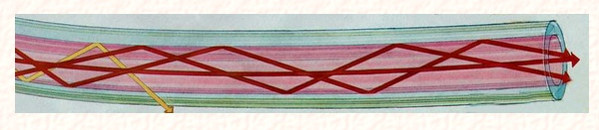
A ray that exceeds a certain "critical" angle escapes from the fiber (yellow line).
- Graded index optical fiber:
In this type of fiber, the core has a non-uniform refractive index that gradually decreases from the center towards the core-cladding interface. The cladding has a uniform refractive index. The light rays propagate through it in the form of skew rays or helical rays. it is not cross the fiber axis at any time.

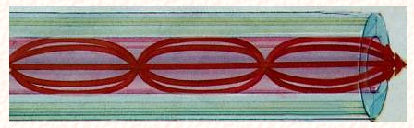
Advantages of Fiber optic
- Greater Bandwidth -Fiber optic cables provide more bandwidth for carrying more data than copper cables of the same diameter. Within the fiber cable family, single mode fiber delivers up to twice the throughput of multimode fiber.
- Faster Speeds – Their use of light signals enables these cables to transmit data at speeds far greater than traditional copper cables can achieve. These cables can achieve speeds of several terabits per second, making them perfect for high-demand applications like video streaming, cloud computing, and online gaming.
- Longer Distances - Fiber optic cables can carry signals much farther than the typical 328-foot limitation for copper cables. For example, some 10 Gbps single mode fiber cables can carry signals almost 25 miles. The actual distance depends on the type of cable, the wavelength and the network.
- Better Reliability -Fiber is immune to temperature changes, severe weather and moisture, all of which can hamper the connectivity of copper cable. Plus, fiber does not carry electric current, so it’s not bothered by electromagnetic interference (EMI) that can interrupt data transmission. It also does not present a fire hazard like old or worn copper cables can.
- Thinner - Compared to copper cables, fiber optic cables are thinner and lighter in weight.
- Security - Fiber optic internet cables provide a higher level of security compared to traditional cables. Since they transmit data using light signals, it’s challenging to tap into the cable and intercept information. This inherent security feature makes fiber optic cables an attractive option for transmitting sensitive data.
Disadvantages of Fiber optic
- Interfacing costs: As optical cables need to be connected standard electronic facilities requiring expensive interfaces.
- Strength: Optical cables have lower tensile strength than coaxial cable. They need an extra
coating of Kevlar and also a protective jacket of PVC. Glass fiber is also fragile making them
less attractive in case of hardware portability is required
- Remote electrical power: Occasionally, electrical power needs to be provided to remote interfaces,which cannot be accomplished using optical cables
- Losses through bending: Excessive bending, crushing, or pulling can cause signal loss or complete cable failure.
- Specialized tools, equipment and training: Special tools are required to splice and repair
cables and special test equipment are needed to make routine measurements. Technicians
working on optical cables need special skills and training.

5.2 Unguided Transmission Media
Unguided Transmission Media consists of a means for the data signals to travel but nothing to guide them along a specific path. The data signals are not bound to a cabling media and as such are often called Unbound Media. Unguided transmission media are wireless systems. Signals are normally broadcast through free space and thus are available to anyone who has a device capable of receiving them. Unguided signals can travel from the source to destination in several ways: ground propagation, sky propagation, and line-of-sight propagation
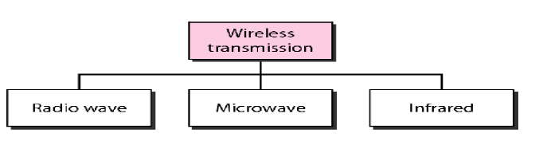

5.2.1 Radio Waves:
Although there is no clear-cut demarcation between radio waves and microwaves,
electromagnetic waves ranging in frequencies between 3 kHz and 1 GHz are normally called
radio waves; waves ranging in frequencies between 1 and 300 GHz are called microwaves.
However, the behavior of the waves, rather than the frequencies, is a better criterion for
classification.
Radio waves use omni-directional antennas that send out signals in all directions. The omni-directional characteristics of radio waves make them useful for multicasting, in which there is one sender but many receivers. AM and FM radio, television, cordless phones, and paging are examples of multicasting.
Advantages of Radio transmission:
- Radio transmission is mainly used for wide area networks and mobile cellular phones.
- Radio waves cover a large area, and they can penetrate the walls.
- Radio transmission provides a higher transmission rate.
5.2.2 Microwaves
Microwaves are electromagnetic waves having frequencies between 1 and 300 GHz. Microwaves are unidirectional. When an antenna transmits microwave waves, they can be narrowly focused. This means that the sending and receiving antennas need to be aligned. The unidirectional property has an obvious advantage. A pair of antennas can be aligned without interfering with another pair of aligned antennas. Microwaves, due to their unidirectional properties, are very useful when unicast (one-to-one) communication is needed between the sender and the receiver. Microwaves are of two types:
- Terrestrial microwave
- Satellite microwave communication.

Terrestrial Microwave Transmission
Terrestrial microwave typically use directional parabolic antennas to send and receive signals in the lower gigahertz range. The signals are highly focused and the physical path must be line-of –sight. The distance coverable by line-of-sight signal depends to a large extend on the height of antennas. The taller the antenna, the longer the sight distance. The height allow the signal to travel further without being stopped by the curvature of the planet and raises the signal above many surface obstacles such as low hills and tall buildings that would otherwise block transmission. Typically antennas are mounted on towers that are in turn mounted on hills or mountains.
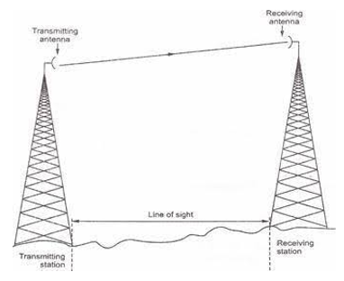
Microwave signals propagate in one direction at a time, which means that two frequencies are necessary for two-way communication such as telephone conversation. One frequency is reserved for microwave transmission in one direction and the other for transmission in the other. Each frequency require its own transmitter and receiver. Today both pieces of equipment are usually combined in a single piece of equipment called a transceiver, which allows a single antenna to serve both frequencies and functions.
Microwave transmission is used in environments where installing physical transmission media is difficult or impossible and where line-of-sight transmission is available. For example, microwave transmission is used in wide-open areas such as deserts or lakes; between buildings in a close geo- graphic area; or to communicate with a satellite.
Current users of microwave transmission include universities, hospitals, city governments, cable television providers, and telephone companies. Home and small business users who do not have other high-speed Internet connections available in their area also opt for lower-cost fixed wireless plans.
Advantages of Microwave:
- Microwave transmission is cheaper than using cables.
- It is free from land acquisition as it does not require any land for the installation of cables.
- Microwave transmission provides an easy communication in terrains as the installation of cable in terrain is quite a difficult task.
- Communication over oceans can be achieved by using microwave transmission.
Disadvantages of Microwave transmission:
- Eavesdropping: An eavesdropping creates insecure communication. Any malicious user can catch the signal in the air by using its own antenna.
- Out of phase signal: A signal can be moved out of phase by using microwave transmission.
- Susceptible to weather condition: A microwave transmission is susceptible to weather condition. This means that any environmental change such as rain, wind can distort the signal.
- Bandwidth limited: Allocation of bandwidth is limited in the case of microwave transmission.

Satellite Microwave Communication
A communications satellite is in effect a microwave relay station. It is used to link two or more ground based microwave transmitter/receivers. Known as earth stations, or ground stations. The satellite receives transmission on one frequency band(uplink), amplifies or repeats the signal, and transmit it on another frequency(downlink). A single orbiting satellite will operate on a number of frequency bands, called transponder channels, or simply transponders.Transmission from an earth-based station to a satellite is an uplink. Transmission from a satellite to an earth-based station is a downlink.

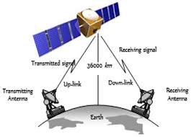
Applications such as air navigation, television and radio broadcasts, weather forecasting, video conferencing, paging, global positioning systems, and Internet connections use communications satellites. With the proper satellite dish and a satellite modem card, consumers access the Internet using satellite technology. With satellite Internet connections, however, uplink transmissions usually are slower than downlink transmissions. This difference in speeds usually is acceptable to most Internet satellite users because they download much more data than they upload. Although a satellite Internet connection is more expensive than cable Internet or DSL connections, sometimes it is the only high-speed Internet option in remote areas.
Advantages of Satellite Microwave Communication:
- The coverage area of a satellite microwave is more than the terrestrial microwave.
- The transmission cost of the satellite is independent of the distance from the centre of the coverage area.
- Satellite communication is used in mobile and wireless communication applications.
- It is easy to install.
- It is used in a wide variety of applications such as weather forecasting, radio/TV signal broadcasting, mobile communication, etc.
Disadvantages of Satellite Microwave Communication:
- It is a very high cost of placing the satellite into its orbit.
- Since the waves are transmitted by satellites all around the world. Therefore, the security of the message is fragile.
- Satellite use microwaves which are vulnerable to electromagnetic interferences.
- The Satellite needs to be monitored and controlled on regular periods so that it remains in orbit.
- The life of the satellite is about 12-15 years. Due to this reason, another launch of the satellite has to be planned before it becomes non-functional.

5.2.3 Infrared
An infrared transmission is a wireless technology used for communication over short ranges. The frequency of the infrared in the range from 300 GHz to 400 THz. It is used for short-range communication such as data transfer between two cell phones, TV remote operation, data transfer between a computer and cell phone resides in the same closed area.
Characteristics of Infrared:
- It supports high bandwidth, and hence the data rate will be very high.
- Infrared waves cannot penetrate the walls. Therefore, the infrared communication in one room cannot be interrupted by the nearby rooms.
- An infrared communication provides better security with minimum interference.
- Infrared communication is unreliable outside the building because the sun rays will interfere with the infrared waves.

6.0 MEDIA ACCESS CONTROL
Introduction
A media access control is a network data transfer policy that determines how data is transmitted between two computer terminals through a network cable. The media access control policy involves sub-layers of the data link layer 2 in the OSI reference model.
The essence of the MAC protocol is to ensure non-collision and eases the transfer of data packets between two computer terminals. A collision takes place when two or more terminals transmit data/information simultaneously. This leads to a breakdown of communication, which can prove costly for organizations that lean heavily on data transmission.
6.1 Types of Media access control
There are three forms of media access control this include:
- Contention
- Token Passing
- Polling
6.1.1 Contention
Contention-based media access describes a way of getting data on to the network whereby systems ‘contend for’ or share the media. On a contention-based network, systems can only transmit when the media is free and clear of signals. In this way, devices listen to the media, and if no other system is transmitting, they can go ahead and send data. In cases where more than one system finds the network free and attempts to transmit, a data collision will occur, and systems will need to retransmit. On busy networks, the number of collisions can quickly get very high, adversely affecting performance. Remember that in this scenario, only a single system truly has access to the media at any given time, even though multiple systems may have data to send. There two methods of contention this includes:

- Carrier Sense Multiple Access with Collision Detection (CSMA/CD).
- Carrier sense multiple access with collision avoidance (CSMA/CA)
  - Carrier Sense Multiple Access with Collision Detection( CSMA/CD)
Carrier Sense Multiple Access with Collision Detection (CSMA/CD) is a network protocol for carrier transmission that operates in the Medium Access Control (MAC) layer. It senses or listens whether the shared channel for transmission is busy or not, and defers transmissions until the channel is free.
To send a frame, listens to the medium to see if it is busy. If the medium is busy, waits per the persistent CSMA. If the station is able to transmit a frame, it listens to the medium for collision while transmitting the frame. If it detects a collision, it immediately stops the transmission and sends a short jamming signal to assure that all stations know that there has been a collision and then cease transmission. After a collision, it waits a random amount of time according to the Binary Exponential Backoff algorithm and then attempts to transmit again by repeating the whole process again.
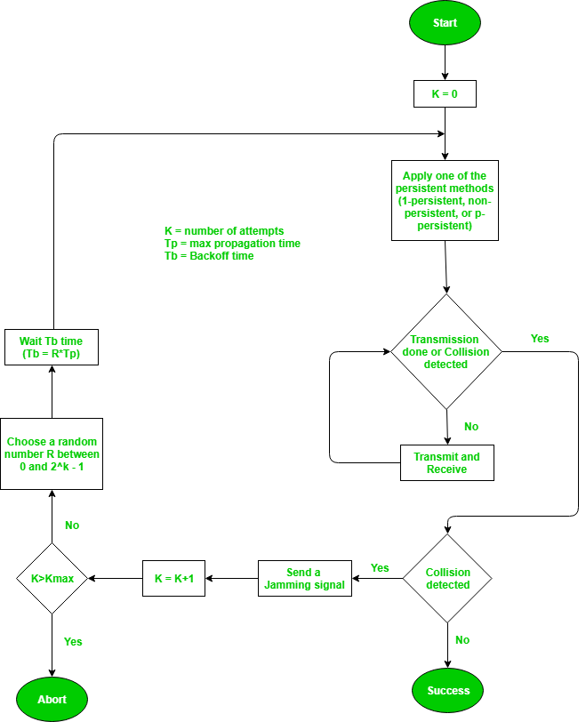
Though this algorithm detects collisions, it does not reduce the number of collisions. It is not appropriate for large networks performance degrades exponentially when more stations are added.
The algorithm of Collision Resolution is:
- The station continues transmission of the current frame for a specified time along with a jam signal, to ensure that all the other stations detect collision.
- The station increments the retransmission counter.
- If the maximum number of retransmission attempts is reached, then the station aborts transmission.
- Otherwise, the station waits for a backoff period which is generally a function of the number of collisions and restart main algorithm.

  - Carrier sense multiple access with collision avoidance (CSMA/CA)
CSMA stands for Carrier Sense Multiple Access with Collision Avoidance. It means that it is a network protocol that uses to avoid a collision rather than allowing it to occur, and it does not deal with the recovery of packets after a collision. It is similar to the CSMA CD protocol that operates in the media access control layer.
In Carrier sense multiple access with collision avoidance (CSMA/CA) the station ready to transmit, senses the line by using one of the persistent strategies. As soon as it find the line to be idle, the station waits for an IFG (Interframe gap) amount of time. If then waits for some random time and sends the frame. After sending the frame, it sets a timer and waits for the acknowledgement from the receiver. If the acknowledgement is received before expiry of the timer, then the transmission is successful. But if the transmitting station does not receive the expected acknowledgement before the timer expiry then it increments the back off parameter, waits for the back off time and resenses the line.
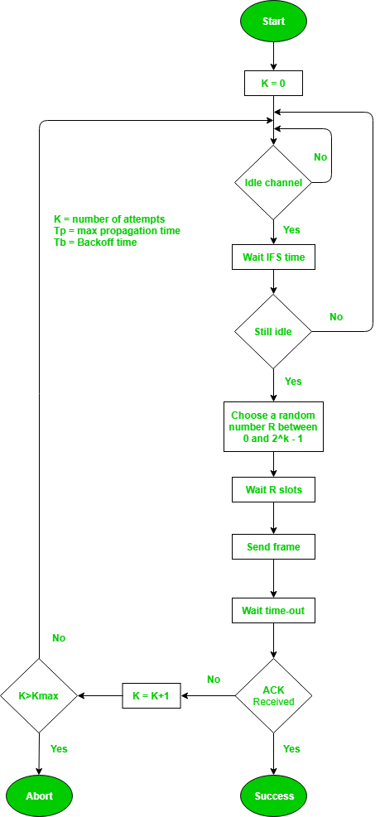

How CSMA/CA Works to Avoid Collisions
Collision Avoidance (CSMA/CA) avoids collisions by listening for a transmission signal before sending data. If a signal is detected, the sender starts a counter with a random value and then waits. Once this counter runs down, the sender will try again. This process repeats until the sender can send the data.
Once the line is clear, the station sends out a set of test data, and if no collisions are detected, it then sends the full payload of data. After the transmission completes, the receiver sends an acknowledgment telling the sender that it has received all the data. If the sender does not receive an acknowledgment from the receiver, it will then start transmitting the data all over again. CSMA/CA is used mostly in wireless networks. This is because wireless networks often have multiple stations that can see an access point, but not one another.
Difference between CSMA CA and CSMA CD
S. No | CSMA CD | CSMA CA
1. | It is the type of CSMA to detect the collision on a shared channel. | It is the type of CSMA to avoid collision on a shared channel.
2. | It is the collision detection protocol. | It is the collision avoidance protocol.
3. | It is used in 802.3 Ethernet network cable. | It is used in the 802.11 Ethernet network.
4. | It works in wired networks. | It works in wireless networks.
5. | It is effective after collision detection on a network. | It is effective before collision detection on a network.
6. | Whenever a data packet conflicts in a shared channel, it resends the data frame. | Whereas the CSMA CA waits until the channel is busy and does not recover after a collision.
7. | It minimizes the recovery time. | It minimizes the risk of collision.
8. | The efficiency of CSMA CD is high as compared to CSMA. | The efficiency of CSMA CA is similar to CSMA.
9. | It is more popular than the CSMA CA protocol. | It is less popular than CSMA CD.

Advantages of Contention
- Contention is a very simple simple access method that has low administrative overhead requirements. No network traffic is necessary to manage the access scheme.
- Actual user data throughout is rather high at low traffic levels in comparison to total amount of utilized network bandwidth.
Disadvantages of Contention
- At high traffic levels, data collisions and resulting retransmission diminish performance dramatically. It is theoretically possible that collisions can be so frequent at higher traffic levels that no station has a clear chance to transmit.
- Channel access is probabilistic rather than deterministic. Because of retransmissions and the time it takes to sense collisions, automated equipment that cannot tolerate delays cannot use this type of access.
- Contention offers no means of establishing the frequency of a stations opportunities to transmit.
    - Token Passing
In token passing scheme, all stations are logically connected in the form of a ring and control of the access to the medium is performed using a token. A token is a special bit pattern or a small packet, usually several bits in length, which circulate from node to node. Token passing can be used with both broadcast (token bus) and sequentially connected (token ring) type of networks.
In case of token ring, token is passed from a node to the physically adjacent node. On the other hand, in the token bus, token is passed with the help of the address of the nodes, which form a logical ring. In either case a node currently holding the token has the ‘right to transmit’. When it has got data to send, it removes the token and transmits the data and then forwards the token to the next logical or physical node in the ring.
If a node currently holding the token has no data to send, it simply forwards the token to the next node. The token passing scheme is efficient compared to the polling technique, but it relies on the correct and reliable operation of all the nodes. There exists a number of potential problems, such as lost token, duplicate token, and insertion of a node, removal of a node, which must be tackled for correct and reliable operation of this scheme.

Advantages of Token Passing
- Token Passing offers the highest data throughput possible under high traffic conditions. Only one transmission can occur at a time, and collisions cannot occur(non-contention). Therefore, token passing experiences less performance degradation at higher traffic levels than contention.
- Token passing is deterministic. Each station is guaranteed an opportunity to transmit each time the token travels around the ring.
- Some token passing systems enable you to set priorities for devices that need controlled access to the token
- As the traffic increases, data throughput also increases to a certain level and then stabilizes.
Disadvantages of Token Passing
- Token passing involves complicated protocols for managing the network and recovering from errors. The traffic associated with these protocols has higher band width overhead than is required for CSMA
- All devices require complicated software that needs to be modified whenever a station is added or removed.
- Some systems require an additional central controller that adds to the overhead and reduces throughput. Cabling and network hardware can be more expensive for token passing networks than for CSMA networks.

6.1.3 Polling
Polling is a deterministic way of allowing systems access to the network while also avoiding collisions. Polling is most closely associated with mainframe (point-to-point) computer networks. By using polling, one device such as a mainframe front-end processor, is designated as the primary device. Primaries also are known as the channel access administrators, controllers, or masters.
All access to the network is controlled by the primary. The primary queries(polls) each of the secondary devices, also known as slaves. As each secondary is polled, the primary inquires if the secondary has information to be transmitted. Only when it is polled does the secondary have access to the communication channel. Each system has rules pertaining to how long each secondary can transmit data. In this way, polling is similar to token passing, except that the central device controls the order in which systems are contacted.
Advantages of Polling
- Many characteristics of polling can be determined centrally, including the polling order and node priorities.
- Polling ensures that channel access is predictable and fixed. Because the time delays between the primary and secondary devices can be calculated, this access method is called deterministic. Deterministic access methods are suitable for controlling some automated equipment because each piece of equipment is guaranteed access to the network at predetermined intervals.
- Polled channels cannot be over saturated with traffic. As demand increases, traffic increases up to a maximum level. The polling mechanism ensures that maximum traffic level cannot be exceeded. Nor can excess traffic reduce the performance of the network.

Disadvantages of Polling
- Some applications cannot function with the time delays required for polling other devices.
- The process of polling involves large numbers of messages that take up available bandwidth. Traffic is required to poll each node, even nodes that are idle.
- Some polled networks use half-duplex transmission line. This means that the primary and secondary devices must “ turn around ” the line requiring some band width.
- Polling required a sophisticated central control mechanism that required extensive configuration.

7.0 TRANSMISSION IMPAIRMENTS
With any communications system, the signal that is received may differ from the signal that is transmitted, due to various transmission impairments. For analog signals, these impairments introduce various random modifications that degrade the signal quality. For digital signals, bit errors may be introduced, such that a binary 1 is transformed into a binary 0 or vice versa.
  - Attenuation
A signal may become too weak if it travels a long distance. Attenuation means a loss of energy. When a signal, simple or composite, travels through a medium, it loses some of its energy in overcoming the resistance of the medium. If the signal becomes too weak, data cannot be recognized at the destination.
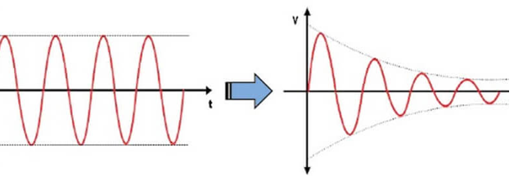
To compensate for this loss, amplifiers are used to amplify the signal(analog) or repeaters for digital signal.
  - Distortion
Distortion means that the signal changes its form or shape. Distortion can occur in a composite signal made of different frequencies. Each signal component has its own propagation speed through a medium and, therefore, its own delay in arriving at the final destination. Differences in delay may create a difference in phase if the delay is not exactly the same as the period duration. In other words, signal components at the receiver have phases different from what they had at the sender. The shape of the composite signal is therefore not the same.
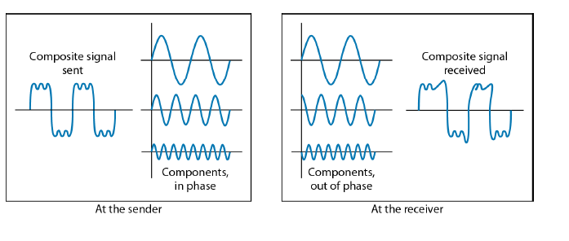
  - Jitter
Jitter is a variance in latency, or the time delay between when a signal is transmitted and when it is received. This variance is measured in milliseconds (ms) and is described as the disruption in the normal sequence of sending data packets. In short, the term "jitter" describes timing errors within a system. In a communications system, the accumulation of jitter will eventually lead to data errors.
Network jitter causes packets to be sent at irregular intervals. For example, there may be a delay after some packets are sent and then several packets may be sent all at once. This may cause packet loss if the receiving system is unable to process all the incoming packets.
Jitter is often caused by network congestion, timing drift and route changes. Essentially, the longer data packets take to arrive, the more jitter can negatively impact the video and audio quality.
Electronic noise and jitter are closely related phenomena, but they are not the same. While noise typically manifests as amplitude distortion, jitter pertains to timing of digital signals. Either of them may be caused by outside interference or internal sources.
  - Echo
We have echo when a sending device receives some of the energy it has sent. Echo can be a problem if the devices and medium are not correctly designed. A cable that does have a cable end(terminator) to remove the signal that reaches the end of the cable may bounce back part of the signal; every device will then receive the data a second time, but weaker and delayed. This creates errors. Echo can be prevented with good design and appropriate devices
  - Noise
Noise is unwanted signals that are inserted somewhere between transmission and reception. Noise is the major limiting factor in communications system performance. Noise may be divided into four categories:
- Thermal noise
- Intermodulation noise
- Crosstalk
- Impulse noise
- Thermal noise :
Thermal noise, or white noise, or Gaussian noise is unwanted signal due to the heat created by thermal agitation of electrons. It is present in all electronic devices and transmission media and is a function of temperature. Thermal noise is uniformly distributed across the bandwidths typically used in communications systems. Thermal noise is particularly significant for satellite communication.
- Intermodulation noise :
When signals at different frequencies share the same transmission medium, the result may be intermodulation noise. The effect of intermodulation noise is to produce signals at a frequency that is the sum or difference of the two original frequencies or multiples of those frequencies. For example, the mixing of signals at frequencies f1 and f2 might produce energy at the frequency f1+f2.
- Crosstalk:
Crosstalk is the effect of one medium on another. Each transmission medium acts as an antenna (sending and receiving). Crosstalk has been experienced by anyone who, while using the telephone, has been able to hear another conversation; it is an unwanted coupling between signal paths. It can occur by electrical coupling between nearby twisted pairs or, rarely coax cable lines carrying multiple signals. Crosstalk can also occur when microwave antennas pick up unwanted signals.
- Impulse noise:
An impulse noise, or spike noise, is noncontinuous, consisting of irregular pulses or noise spikes of short duration and of relatively high amplitude. It is generated from a variety of causes, including external electromagnetic disturbances, such as lightning, and faults and flaws in the communications system.
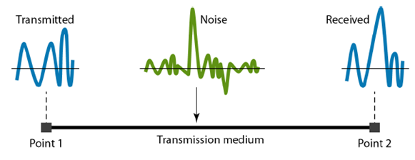
The effect of impulse noise depends on the speed of data transmission. If we are sending at a high data rate more bits are affected during the bit of the impulse noise; if we are sending at a low rate, less data are affected.

7.1 FLOW CONTROL
The most important responsibilities of the data link layer are flow control and error control. Collectively, these functions are known as data link control. Flow Control is a technique for assuring that a transmitting entity does not overwhelm a receiving entity with data.
Flow control is basically technique that gives permission to two of stations that are working and processing at different speeds to just communicate with one another. Flow control in Data Link Layer simply restricts and coordinates number of frames or amount of data sender can send just before it waits for an acknowledgment from receiver. Flow control is actually set of procedures that explains sender about how much data or frames it can transfer or transmit before data overwhelms receiver.
The receiving device also contains only limited amount of speed and memory to store data. This is why receiving device should be able to tell or inform the sender about stopping the transmission or transferring of data on temporary basis before it reaches limit. It also needs buffer, large block of memory for just storing data or frames until they are processed. Two types of mechanisms can be deployed to control the flow:
- Stop and wait
- Sliding window
7.1.1 Stop and Wait Flow control
This flow control mechanism forces the sender after transmitting a data frame to stop and wait until the acknowledgement of the data-frame sent is received.
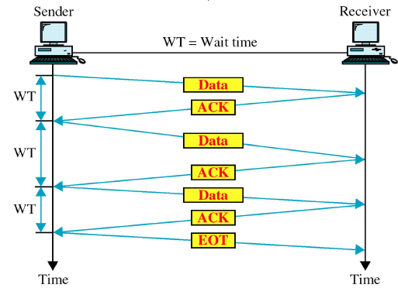

Advantages of Stop and Wait
- It is very simple to implement.
- The main advantage of this protocol is the accuracy. The next frame is sent only when the first frame is acknowledged. So, there is no chance of any frame being lost.

Disadvantages of Stop and Wait
- We can send only one packet at a time.
- If the distance between the sender and the receiver is large then the propagation delay would be more than the transmission delay. Hence, efficiency would become very low.
- After every transmission, the sender has to wait for the acknowledgment and this time will increase the total transmission time. This makes the transmission process slow.
7.1.2 Sliding Window
In this flow control mechanism, both sender and receiver agree on the number of data-frames after which the acknowledgement should be sent. In these protocols, the sender has a buffer called the sending window and the receiver has buffer called the receiving window.
In sliding window the Receiver allocates buffer space for W-frames and the Transmitter can send up to W frames without waiting for any ACK. Each frame is numbered to keep track of which frames have been Acknowledged and ACK includes number of next frame expected.
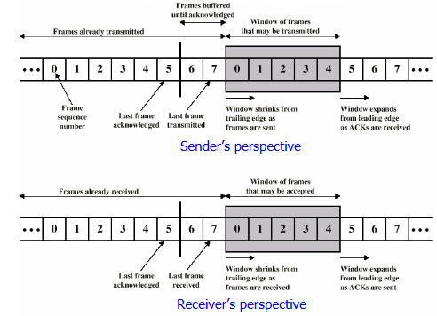
Shaded rectangle shows frames that may be sent. Sender transmits 5 frames starting with frame 0 when a frame is sent, shaded window shrinks. When a ACK is received, the shaded window grows . Frames between vertical bar and shaded window have been sent but not yet ACKed.
Example
Suppose that we have sender window and receiver window each of size 4. So the sequence numbering of both the windows will be 0,1,2,3,0,1,2 and so on. The following diagram shows the positions of the windows after sending the frames and receiving acknowledgments.
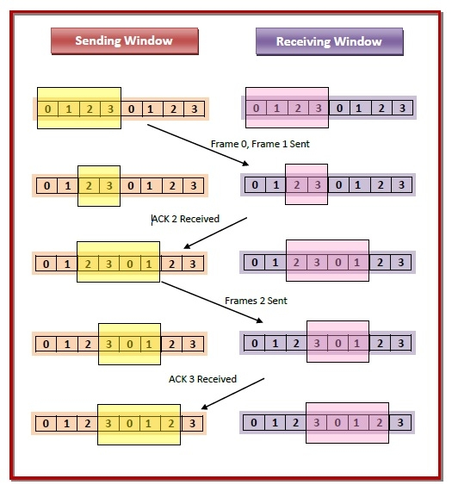

7.2 ERROR CONTROL

Error Control in the data link layer is a process of detecting and retransmitting the data which has been lost or corrupted during the transmission of data. Any reliable system must have a mechanism for detecting and correcting such errors. Error control in the data link layer is based on automatic repeat request (ARQ).

In Automatic Repeat-Request (ARQ), the transmitter sends the data and also an error detection code, which the receiver uses to check for errors, and request retransmission of erroneous data. In many cases, the request is implicit; the receiver sends an acknowledgement (ACK) of correctly received data, and the transmitter re-sends anything not acknowledged within a reasonable period of time.
    - Types of error
  - Single bit Error:
Whenever bits flow from one point to another, they are subject to unpredictable changes because of interference. This interference can change the shape of the signal. In a single-bit error, a 0 is changed to a 1 or a 1 to a 0. The term single-bit error means that only 1 bit of a given data unit (such as a byte, character, or packet) is changed from 1 to 0 or from 0 to 1.
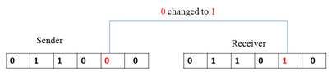
Single bit errors are very rare in the communication system because the noise must not a short duration that it can only disturb only one bit. So these errors in the communication system are less however this type of errors can happen in parallel communication where the noise will distribute in all the communication lines.
  - Burst Error
The term burst error means that 2 or more bits in the data unit have changed from 1 to 0 or from 0 to 1.
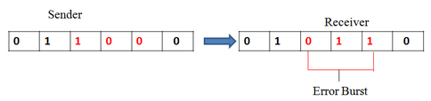
These errors are most common in serial communication where the noise can interfere the some amount of bits in sequence or in multiple bits. The number of corrupted bits depends on the data rate and noise duration. The error correction of this type is difficult which leads to incorporation of complex detecting and correcting algorithms.

7.2.2 Types of techniques of error control
There are three types of techniques available which Data-link layer may deploy to control the errors by Automatic Repeat Requests (ARQ).
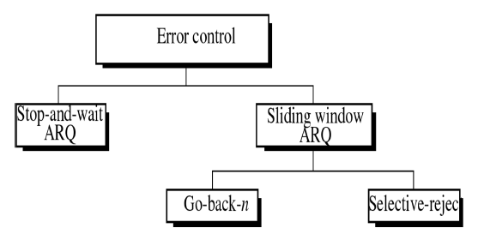
  - Stop-and-wait ARQ
In Stop-and-wait ARQ the source station transmits a single frame and then must await an acknowledgement (ACK). No other data frames can be sent until the destination stations reply arrives at the source station. The sending device keeps a copy of the last frame until it receives an acknowledgement for that frame. Keeping a copy allows the sender to retransmits lost or damaged frames until they are received correctly.

  - Go-Back-N ARQ
Stop and wait ARQ mechanism does not utilize the resources at their best. When the acknowledgement is received, the sender sits idle and does nothing. In Go-Back-N ARQ method, both sender and receiver maintain a window. The sending-window size enables the sender to send multiple frames without receiving the acknowledgement of the previous ones. The receiving-window enables the receiver to receive multiple frames and acknowledge them. The receiver keeps track of incoming frame’s sequence number.
When the sender sends all the frames in window, it checks up to what sequence number it has received positive acknowledgement. If all frames are positively acknowledged, the sender sends next set of frames. If sender finds that it has received NACK or has not receive any ACK for a particular frame, it retransmits all the frames after which it does not receive any positive ACK.

  - Selective Repeat ARQ
In Go-back-N ARQ, it is assumed that the receiver does not have any buffer space for its window size and has to process each frame as it comes. This enforces the sender to retransmit all the frames which are not acknowledged. In Selective-Repeat ARQ, the receiver while keeping track of sequence numbers, buffers the frames in memory and sends NACK for only frame which is missing or damaged. The sender in this case, sends only packet for which NACK is received

7.3 ERROR DETECTION:

Error detection is the process of verifying the received information whether it is correct or not at the receiver end without having any information of sent original message. In sender side some redundant bits are added to the original message based some property of message signal (i.e. parity bits) and in the receiver side by scanning this redundant bits, the error in the message will be predicted. Error detection and correction occur at both the transport layer and the data link layer.

7.3.1 Types of Error detection Checks
- Parity Checking
- Check Sum
- Cyclic Redundancy Check (CRC)
  - Parity Check
One extra bit is sent along with the original bits to make number of 1s either even in case of even parity, or odd in case of odd parity.
The sender while creating a frame counts the number of 1s in it. For example, if even parity is used and number of 1s is even then one bit with value 0 is added. This way number of 1s remains even.If the number of 1s is odd, to make it even a bit with value 1 is added.
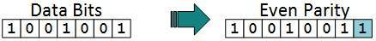
The receiver simply counts the number of 1s in a frame. If the count of 1s is even and even parity is used, the frame is considered to be not-corrupted and is accepted. If the count of 1s is odd and odd parity is used, the frame is still not corrupted. If a single bit flips in transit, the receiver can detect it by counting the number of 1s. But when more than one bits are erroneous, then it is very hard for the receiver to detect the error.
  - Checksum
In checksum error detection scheme, the data is divided into k segments each of m bits. In the sender’s end the segments are added using 1’s complement arithmetic to get the sum. The sum is complemented to get the checksum. The checksum segment is sent along with the data segments. At the receiver’s end, all received segments are added using 1’s complement arithmetic to get the sum. The sum is complemented. If the result is zero, the received data is accepted; otherwise discarded.

Example
Suppose that the sender wants to send 4 frames each of 8 bits, where the frames are 11001100, 10101010, 11110000 and 11000011.
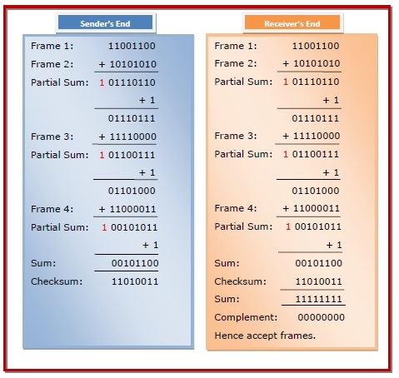
The sender adds the bits using 1s complement arithmetic. While adding two numbers using 1s complement arithmetic, if there is a carry over, it is added to the sum. After adding all the 4 frames, the sender complements the sum to get the checksum, 11010011, and sends it along with the data frames.
The receiver performs 1s complement arithmetic sum of all the frames including the checksum. The result is complemented and found to be 0. Hence, the receiver assumes that no error has occurred.
  - CRC (cyclic redundancy check)
CRC is based on binary division. In CRC, a sequence of redundant bits, called cyclic redundancy check bits, are appended to the end of data unit so that the resulting data unit becomes exactly divisible by a second, predetermined binary number. At the destination, the incoming data unit is divided by the same number. If at this step there is no remainder, the data unit is assumed to be correct and is therefore accepted. A remainder indicates that the data unit has been damaged in transit and therefore must be rejected. 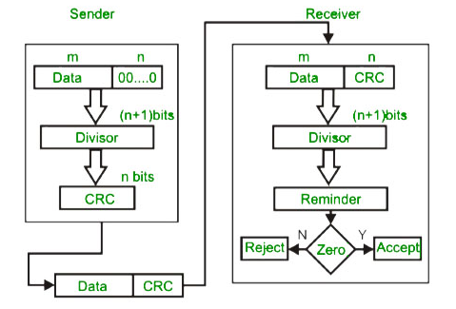
This method is commonly used in many forms of communication. It provides a high level of error detection with speed and ease of use.

8.0 NETWORKING DEVICES AND COMPONENTS
Network devices are physical devices that are required for communication and interaction between hardware on a computer network. The network devices work as a group and have a single purpose which securely transfers data as fast as possible. To meet this goal there are several networking devices this include:
- NIC
- Modem
- Repeater
- Router
- Hub
- Switch,
- Bridge
- Brouter
- Gateway
- Network Interface Card (NIC)
Networking cannot be done without this device. It is also known as a network adapter card, Ethernet card, or LAN card. A NIC allows a networking device to communicate with other networking devices. NIC card is a layer 2 device which means that it works on both physical and data link layer of the network model.
A NIC converts data packets between two different data transmission technologies. A PC uses parallel data transmission technology to transmit data between its internal parts whereas the media that provides connectivity between different PCs uses serial data transmission technology. A NIC converts a parallel data stream into the serial data stream and a serial data stream into the parallel data stream. Typically, all modern PCs have integrated NICs. If additional NICs are required, they can be installed as add-on devices.
MAC stands for Media Access Control. It’s either a 48-bit or 64-bit address given to a network adapter at the time of a computer’s manufacture. A MAC address is the hardware address for that device. An IP address, on the other hand, is a software address. Both of these can be found in that particular computer’s Network Interface Card (NIC). These addresses allow both hubs and switches to transmit data to a computer.
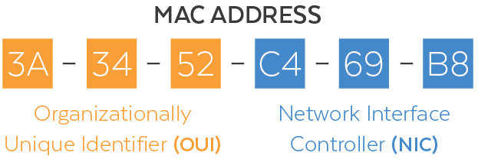
Types of NICs
  - Media Specific
A media-specific NIC supports a particular type of media. For example, to connect a coaxial cable, you need a NIC that has the BNC port whereas to connect an Ethernet cable, you need a NIC that has the RJ-45 port.
The BNC connector is a round connector, which is used for thinnet or 10Base-2 Local Area Network.RJ45 is the acronym for Registered Jack 45. RJ45 connector is an 8-pin jack used by devices to physically connect to Ethernet based local area networks (LANs). The cable used for Ethernet LANs are twisted pair ones and have RJ45 connector pins at both ends. These pins go into the corresponding socket on devices and connect the device to the network.
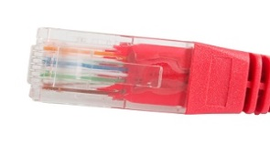
  - Network Design Specific
A network design-specific NIC supports a specific network topology. For example, FDDI, Token Ring, and Ethernet have their distinctive type of NIC cards. They cannot use other types of NIC cards.
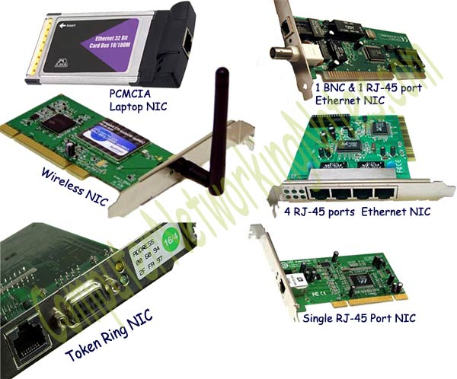

- Modem
Modem is a device that enables a computer to send or receive data over telephone or cable lines. Modem is a combination of two devices − modulator and demodulator. The modulator converts digital data into analog data when the data is being sent by the computer. The demodulator converts analog data signals into digital data when it is being received by the computer.
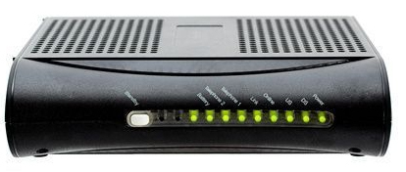
The data stored on the computer is digital whereas a telephone line or cable wire can transmit only analog data. The main function of the modem is to convert digital signal into analog and analog into digital signal.
- Repeater
As signals travel along a network cable (or any other medium of transmission), they degrade and become distorted in a process that is called attenuation. If a cable is long enough, the attenuation will finally make a signal unrecognizable by the receiver.
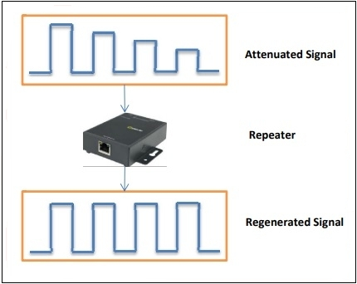
A Repeater enables signals to travel longer distances over a network. Repeaters work at the OSI's Physical layer. It has two Ethernet ports. 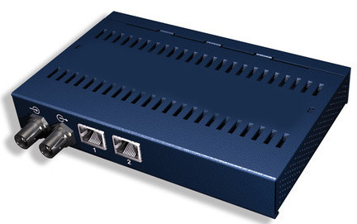
Repeater job is to regenerate the signal over the same network before the signal becomes too weak or corrupted so as to extend the length to which the signal can be transmitted over the same network. An important point to be noted about repeaters is that they do not amplify the signal. When the signal becomes weak, they copy the signal bit by bit and regenerate it at the original strength.
- Hub
Hub, sometimes referred to as concentrator or repeater hub is a centralized device that connects multiple devices in a single LAN network. Hubs cannot filter data, so data packets are sent to all connected devices. When a packet arrives at one port, it is copied to the other ports so that all segments of the LAN can see all packets. It connects LAN devices using similar protocols. Hubs work in the physical layer of the OSI model.
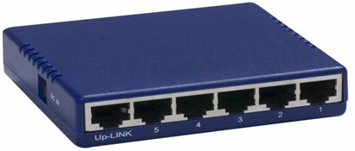
A hub is also regarded as a multiport repeater this is because it boosts the poor signals that have lost their strength after traveling for long distances over cables.
A hub can be used with both digital and analog data. This is achieved by configuring the settings to format the incoming information. For instance, when the incoming information is in a digital way, the hub transmits data in packets form, whereas when the incoming information is in an analog way, the hub transmits data in the signal form.
Types of hubs
There are mainly two types of Hub, they are:
- Active Hub: An Active hub is also known as Concentrator. Thus, it can analyze the data packets and regenerates the data signals, if needed.
- Passive Hub: It only provides communication between the networking devices and does not provide signal regeneration. In other words, it just forwards the data as it is.
- Switch
A Switch is a device that filters and forwards packets between LAN segments. Switch can perform error checking before forwarding data that makes it very efficient as it does not forward packets that have errors and forward good packets selectively to correct port only. On receiving a packet, it checks the destination address and transmits the packet to the correct port. Before forwarding, the packets are checked for collision.
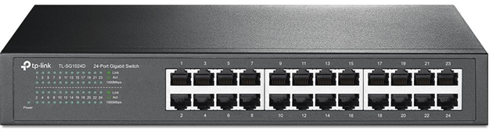
Switches operate at the data link layer (layer 2) and sometimes the network layer (layer 3) of the OSI Reference Model and therefore support any packet protocol. A device that operates simultaneously at more than one of these layers is known as a multilayer switch. LANs that use switches to join segments are called switched LANs or, in the case of Ethernet networks, switched Ethernet LANs.
In a local area network (LAN) using Ethernet, a network switch determines where to send each incoming message frame by looking at the media access control (MAC) address. Switches maintain tables that match each MAC address to the port receiving the MAC address.
Switches are higher-performance alternatives to hubs. Both pass data between devices connected to them. Hubs do so by broadcasting the data to all other connected devices, while switches first determine which device is the intended recipient of the data and then send it to that one device directly via a so-called "virtual circuit."
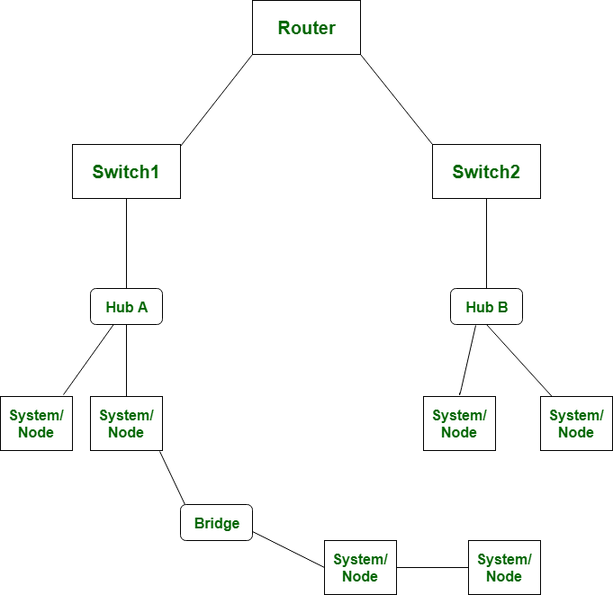
Switching Methods
Switches use three methods to deal with data as it arrives:
- Cut-through: In a cut-through configuration, the switch begins to forward the packet as soon as it is received. No error checking is performed on the packet, so the packet is moved through quickly. The downside of cut-through is that because the integrity of the packet is not checked, the switch can propagate errors. .
- Store-and-forward: In a store-and-forward configuration, the switch waits to receive the entire packet before beginning to forward it. It also performs basic error checking.
- Fragment-free: Building on the speed advantages of cut-through switching, fragment-free switching works by reading only the part of the packet that enables it to identify fragments of a transmission.
Difference between a Hub and switch
 | HUB | SWITCH
1. | Hub is operated on Physical layer of OSI model. | While switch is operated on Data link layer of OSI Model.
2. | Hub is a broadcast type transmission. | While switch is a Unicast, multicast and broadcast type transmission.
3. | Hub have 4/12 ports. | While switch can have 24 to 48 ports.
4. | In hub, there is only one collision domain. | While in switch, different ports have own collision domain.
5. | Hub is a half duplex transmission mode. | While switch is a full duplex transmission mode.
6. | In hub, Packet filtering is not provided. | While in switch, Packet filtering is provided.
7. | Hub cannot be used as a repeater. | While switch can be used as a repeater.
8. | Hub is not an intelligent device that sends message to all ports hence it is comparatively inexpensive. | While switch is an intelligent device that sends message to selected destination so it is expensive.
9. | Hub is simply old type of device and is not generally used. | While switch is very sophisticated device and widely used.
10. | Hacking of systems attached to hub is complex. | Hacking of systems attached to switch is little easy.
- Bridge
A Bridge is a device that connects two local-area networks (LANs), or two segments of the same LAN to creates a single network. The two LANs being connected can be alike or dissimilar. For example, a bridge can connect an Ethernet with a Token-Ring network.
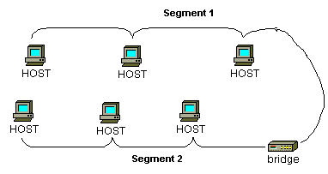
A bridge works at the Data link layer (Layer 2) of the OSI model hence referred to as layer 2 switches. The primary use of a bridge is to send, filter, or flood any arriving frame depending on the MAC address of that specific frame. It inspects incoming traffic and decide whether to forward it or filter it. Each incoming Ethernet frame is inspected for destination MAC address. If the bridge determines that the destination host is on another segment of the network, it forwards the frame to that segment. Similar to hubs and repeaters, bridges broadcast data to each node. But, maintains the MAC (media access control) address table to find out new segments hence
A bridge works on the principle that each network node has its own address. A bridge forwards the packets based on the address of the particular destination node. As traffic passes through the bridge, information about the computer addresses is then stored in the bridge's RAM. The bridge will then use this RAM to build a routing table based on source addresses. Bridges can be used to:
- Expand the distance of a segment.
- Provide for an increased number of computers on the network.
- Reduce traffic bottlenecks resulting from an excessive number of attached computers.
bridges serve a similar function as network switches. Conventionally, wired bridges support one incoming and one outgoing network connection, which is accessible through a hardware port, whereas switches usually offer four or more hardware ports. Switches are sometimes called multiport bridges for this reason.
Bridges lack the intelligence of network routers. Bridges do not understand the concept of remote networks and cannot redirect messages to different locations dynamically but instead support only one outside interface.
Types of Bridges:
There are mainly three types in which bridges can be characterized:
- Transparent Bridge: As the name suggests, it is an invisible bridge in the computer network. The main function of this bridge is to block or forward the data depending on the MAC address. The other devices within the network are unaware of the existence of bridges. These types of bridges are most popular and operate in a transparent way to the entire networks which are connected to hosts.
- Source Route Bridge: It derives its name from the fact that the path which packet takes through the network is implanted within the packet. It is mainly used in Token ring networks.
- Translational Bridge: The process of conversion takes place via Translational Bridge. It converts the data format of one networking to another. For instance Token ring to Ethernet and vice versa.

Key highlights of difference between Network Bridge and Router
- Routers are not transparent to the end stations. In contrast, Bridges are transparent to the end stations and does not rely on the protocol.
- In a bridge, frames are forwarded on the basis of the MAC address of the frame. As against, Router checks logical address (i.e., IP address) of the packets.
- The router can work on more than broadcast domain while Bridge can work on a single broadcast domain.
- Bridge functions at Data link layer while router operates at the Network layer of the OSI model.
- The bridge can relay frame from one segment to another whereas Router store and forward packets.

- Router
A router is a device like a switch that routes data packets based on their IP addresses. Routers work at the Network layer of the OSI model meaning that the Routers can switch and route packets across multiple networks. They do this by exchanging protocol-specific information between separate networks. Routers have access to more information in packets than bridges, and use this information to improve packet deliveries.
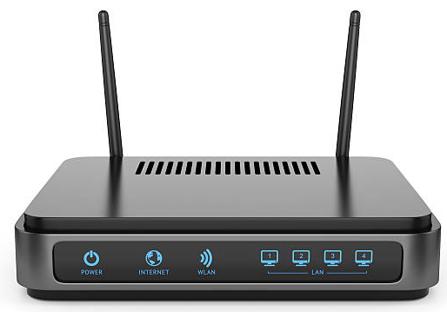
Routers can share status and routing information with one another and use this information to bypass slow or malfunctioning connections.
A router selects the best path for a data packet. It forward data packets from one network to another based on the address of the destination network in the incoming packet and an internal routing table. A router reads its routing table to decide the best available route the packet can take to reach its destination quickly and accurately. The routing table may be of these two types:
- Static : In a static routing table the routes are fed manually. So it is suitable only for very small networks that have maximum two to three routers.
- Dynamic: In a dynamic routing table, the router communicates with other routers through protocols to determine which routes are free. This is suited for larger networks where manual feeding may not be feasible due to large number of routers.
The main functions of routers are the following: -
- To connect different network segments.
- To connect different network protocols such as IP and IPX.
- To connect several smaller networks into a large network.
- To break a large network into smaller networks.
- To connect two different media types such as UTP and Fiber optical.
- To connect two different network architectures such as Token Ring and Ethernet.
- To access DSL services.
While hubs, switches, and routers all share similar physical appearance, routers differ substantially in their inner workings and contain significantly more logic. Traditional routers are designed to join together multiple local area networks (LANs) with a wide area network(WAN). Routers serve as intermediate destinations for network traffic. They receive incoming network packets, look inside each packet to identify the source and target network addresses, then forward these packets where needed to ensure the data reaches its final destination. Neither switches nor hubs can do these things.
Network switch vs. router
Network switches can be easily confused with routers. However, they have different functions and operate on separate layers. Here are the main differences between a switch and a router:
- A network switch is a Layer 2 device on the OSI model. A router is primarily a Layer 3 device.
- A router moves data between two or more computer networks, while a switch facilitates the sharing of resources by connecting multiple devices on a single LAN.
- To determine the route and destination of a packet, a router examines the IP addresses of packets. A switch looks at the MAC address of each device to transfer data to the correct destination.
- Routers use data packets, whereas switches, which are part of the data-link layer, typically work with data frames.
- A switch is less sophisticated than a router because, unlike a router, a switch doesn't use routing algorithms to direct data around large networks.
- A router offers network address translation, NetFlow and quality of service, while a switch offers none of these services.
- Routers can work within both wired and Wi-Fi networks, but a switch is restricted to wired network connections.
- Brouter
Brouters are the combination of both the bridge and routers. So it can operate at the data link and network layers of the OSI Model. They take up the functionality of the both networking devices serving as a bridge when forwarding data between networks, and serving as a router when routing data to individual systems. Brouter functions as a filter that allows some data into the local network and redirects unknown data to the other network.
- Gateway
Gateways usually work at the Transport layer and Session layer of the OSI model. It connects two networks that may work upon different networking models. Gateway takes data from one system, interpret it, and transfer it to another system. It also is known as protocol converters and can operate at any network layer. Gateways are generally more complex than switch or router. Gateway deals with numerous protocols and standards from different vendors. It performs all of the functions of routers. A router with added translation functionality is a gateway.
8.1 ROUTING
Routing is a process of selecting path along which the data can be transferred from source to the destination. Routing is performed by a special device known as a router. A Router works at the network layer in the OSI model and internet layer in TCP/IP model. A router is a networking device that forwards the packet based on the information available in the packet header and forwarding table.
The routing algorithms are used for routing the packets. The routing algorithm is nothing but a software responsible for deciding the optimal path through which packet can be transmitted. The routing protocols use the metric to determine the best path for the packet delivery. The metric is the standard of measurement such as hop count, bandwidth, delay, current load on the path, etc. used by the routing algorithm to determine the optimal path to the destination. The routing algorithm initializes and maintains the routing table for the process of path determination.
8.1.1 Types of Routing
1. Static routing
Static Routing is also known as Nonadaptive Routing. It is a technique in which the administrator manually adds the routes in a routing table. A Router can send the packets for the destination along the route defined by the administrator.
Advantages
- No routing overhead for router CPU which means a cheaper router can be used to do routing.
- It adds security because only administrator can allow routing to particular networks only.
- No bandwidth usage between routers.
Disadvantage
- For a large network, it is a hectic task for administrator to manually add each route for the network in the routing table on each router.
- The administrator should have good knowledge of the topology. If a new administrator comes, then he has to manually add each route so he should have very good knowledge of the routes of the topology.

2. Default Routing
Default Routing is a technique in which a router is configured to send all the packets to the same hop device, and it doesn't matter whether it belongs to a particular network or not. A Packet is transmitted to the device for which it is configured in default routing. Default Routing is used when networks deal with the single exit point.
It is also useful when the bulk of transmission networks have to transmit the data to the same hop device. When a specific route is mentioned in the routing table, the router will choose the specific route rather than the default route. The default route is chosen only when a specific route is not mentioned in the routing table.
3. Dynamic Routing
Dynamic routing makes automatic adjustment of the routes according to the current state of the route in the routing table. Dynamic routing uses protocols to discover network destinations and the routes to reach it. RIP and OSPF are the best examples of dynamic routing protocol. Automatic adjustment will be made to reach the network destination if one route goes down.
A dynamic protocol have following features:
- The routers should have the same dynamic protocol running in order to exchange routes.
- When a router finds a change in the topology then router advertises it to all other routers.
Advantages
- Easy to configure.
- More effective at selecting the best route to a destination remote network and also for discovering remote network.

Disadvantage
- Consumes more bandwidth for communicating with other neighbors.
- Less secure than static routing.

TYPES OF DYNAMIC ROUTING PROTOCOLS
- Distance Vector Routing Protocol (DVR)
Distance Vector Protocols advertise their routing table to every directly connected neighbor at specific time intervals using lots of bandwidths and slow converge.
In the Distance Vector routing protocol, when a route becomes unavailable, all routing tables need to be updated with new information.
- Information Protocol (RIP)
RIP is a dynamic routing protocol that uses hop count as a routing metric to find the best path between the source and the destination network. Hop count is the number of routers occurring in between the source and destination network. The path with the lowest hop count is considered as the best route to reach a network and therefore placed in the routing table.
- Interior Gateway Protocol (IGP)
IGRP is a subtype of the distance-vector interior gateway protocol developed by CISCO. It is introduced to overcome RIP limitations. The metrics used are load, bandwidth, delay, MTU, and reliability. It is widely used by routers to exchange routing data within an autonomous system.
- Exterior Gateway Protocol (EGP)
EGP is a protocol used to exchange data between gateway hosts that are neighbors with each other within autonomous systems. This routing protocol offers a forum for routers to share information across different domains. The full form for EGP is the Exterior Gateway Protocol. EGP protocol includes known routers, network addresses, route costs, or neighboring devices.
- Enhanced Interior Gateway Routing Protocol (EIGRP)
EIGRP is a hybrid routing protocol that provides routing protocols, distance vector, and link-state routing protocols. The full form routing protocol EIGRP is Enhanced Interior Gateway Routing Protocol. It will route the same protocols that IGRP routes using the same composite metrics as IGRP, which helps the network select the best path destination.
- Open Shortest Path First (OSPF)
Open Shortest Path First (OSPF) protocol is a link-state IGP tailor-made for IP networks using the Shortest Path First (SPF) method.
OSPF routing allows you to maintain databases detailing information about the surrounding topology of the network. It also uses the Dijkstra algorithm (Shortest path algorithm) to recalculate network paths when its topology changes. This protocol is also very secure, as it can authenticate protocol changes to keep data secure.

Difference Between Static and Dynamic Routing
- Static routing manually sets up the optimal paths between the source and the destination computers. On the other hand, the dynamic routing uses dynamic protocols to update the routing table and to find the optimal path between the source and the destination computers.
- The routers that use the static routing do not have any controlling mechanisms if any faults in the routing paths. These routers do not sense the faulty computers encountered while finding the path between two computers or routers in a network. The dynamic routing are used in the dynamic routers and these routers can sense a faulty router in the network. Also , the dynamic router eliminates the faulty router and finds out another possible optimal path from the source to the destination. If any router is down or faulty due to certain reasons, this fault is circulated in the entire network. Due to this dynamic routers, they are also called adaptive routers
- The static routing is suitable for very small networks and they cannot be used in large networks. As against this, dynamic routing is used for larger networks. The manual routing has no specific routing algorithm. The dynamic routers are based on various routing algorithms like OSPF( Open Shortest Path First), IGRP(Interior Gateway Routing Protocol) and RIP(Routing information Protocol).
- The static routing is the simplest way of routing the data packets from a source to a destination in a network. The dynamic routing uses complex algorithms for routing the data packets.
- The static routing has the advantage that is requires minimal memory. Dynamic router, however, have quite a few memory overhead, depending on the routing algorithm used. The network administrator finds out the optimal path and makes the changes in the routing table in the case of static routing. In dynamic routing algorithm, the algorithm and the protocol is responsible for routing the packets and making the changes accordingly in the routing table.

8.2 SWITCHING
A switched network is made up of a collection of interconnected nodes known as switches. Switches are devices that may establish temporary connections between two or more devices that are attached to the switch. Some of these nodes are connected to the end devices in a switched network. Switching is the process of transmitting packets from one port to another that leads to the destination.
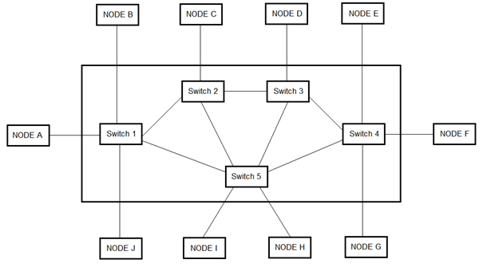

Generally, there are three switching techniques:
- Message switching
- Packet Switching
- Circuit Switching
    - Message Switching
Message Switching is a switching technique in which a message is transferred as a complete unit and routed through intermediate nodes at which it is stored and forwarded. In Message Switching technique, there is no establishment of a dedicated path between the sender and receiver. The destination address is appended to the message. Message Switching provides a dynamic routing as the message is routed through the intermediate nodes based on the information available in the message.
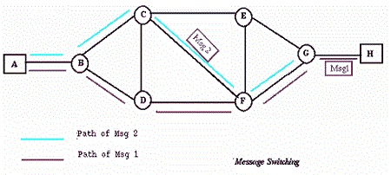
Message switches are programmed in such a way so that they can provide the most efficient routes. Each and every node stores the entire message and then forward it to the next node. This type of network is known as store and forward network. Message switching treats each message as an independent entity.
Advantages of Message Switching
Message switching has the following advantages:
- Because network devices share communication channels, bandwidth use is optimized.
- It aids in minimizing network congestion due by the store and forward approach. Switching nodes can hold messages in the event that a communication link is unavailable, therefore lowering traffic congestion.
- The size of the message which is sent over the network can be varied. Therefore, it can transmit messages of any size.
- The sender and receiver's transmission rates do not have to be the same because the message can be cached by the nodes
- It makes the traffic management efficient by assigning priorities to the messages.
- Unlike packet switching, out-of-order or missing packets have no effect on message switching.
Disadvantages of Message Switching
Message switching has the following disadvantages:
- Message switching cannot be used for real time applications as storing of messages causes delay.
- In message switching, message has to be stored for which every intermediate devices in the network requires a large storing capacity.
    - Packet Switching
The packet switching is a switching technique in which the message is not sent in one go, but it is divided into smaller pieces, and they are sent individually. The message splits into smaller pieces known as packets and packets are given a unique number to identify their order at the receiving end. Every packet contains some information in its headers such as source address, destination address and sequence number.
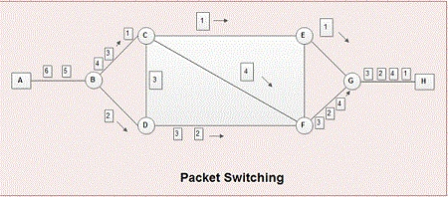
Packets will travel across the network, taking the shortest path as possible. All the packets are reassembled at the receiving end in correct order. If any packet is missing or corrupted, then the message will be sent to resend the message. If the correct order of the packets is reached, then the acknowledgment message will be sent.

Approaches of Packet Switching:
There are two approaches to Packet Switching:
- Datagram packet switching
- Virtual packet switching

Datagram Packet switching:
It is a packet switching technology in which packet is known as a datagram, is considered as an independent entity. Each packet contains the information about the destination and switch uses this information to forward the packet to the correct destination. The packets are reassembled at the receiving end in correct order.
In Datagram Packet Switching technique, the path is not fixed. Intermediate nodes take the routing decisions to forward the packets. Datagram Packet Switching is also known as connectionless switching.

Virtual Circuit Switching
Virtual Circuit Switching is also known as connection-oriented switching. In the case of Virtual circuit switching, a preplanned route is established before the messages are sent. Call request and call accept packets are used to establish the connection between sender and receiver. In this case, the path is fixed for the duration of a logical connection.

Advantages of Packet Switching
- Delay in delivery of packets is less, since packets are sent as soon as they are available.
- Switching devices don’t require massive storage, since they don’t have to store the entire messages before forwarding them to the next node.
- Data delivery can continue even if some parts of the network faces link failure. Packets can be routed via other paths.
- It allows simultaneous usage of the same channel by multiple users.
- It ensures better bandwidth usage as a number of packets from multiple sources can be transferred via the same link.

Disadvantages of Packet switching
- Data packets might get damaged or lost.
- Longer message delivery times owing to the time necessary to package and transport packets.
- They require complex protocols for delivery.
- Because of the utilization of shared physical links, there is the possibility of network security vulnerabilities.
- They are unsuitable for applications that cannot afford delays in communication like high quality voice calls.
- Packet switching high installation costs.
    - Circuit Switching
Circuit switching network establishes a fixed bandwidth circuit (channel) between nodes before the users may communicate, as if the nodes were physically connected with an electrical circuit. The bit delay is constant during the connection, as opposed to packet switching, where packet queues may cause varying delay.
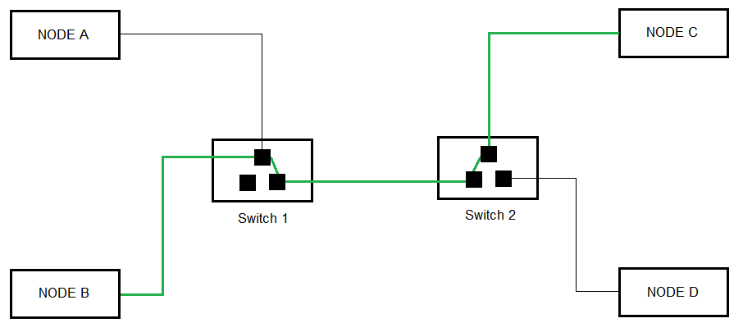
Each circuit cannot be used by other callers until the circuit is released and a new connection is set up. Even if no communication is taking place in a dedicated circuit then, that channel still remains unavailable to other users. Channels that are available for new calls to be set up are said to be idle. Telephone network is example of circuit switching system.
Virtual circuit switching is a packet switching technology that may emulate circuit switching, in the sense that the connection is established before any packets are transferred, and that packets are delivered in order.
Examples of Circuit-switched networks
- Traditional telephone networks, sometimes known as landlines, are an example of circuit switching technology.
- Dial-up transports IP data packets over a circuit-switched telephone network.

Advantages of circuit switching
Following are the advantages of circuit switching :
- Only the two endpoints have access to a dedicated communications channel circuit in circuit-switched networks.
- A dedicated circuit connecting two hosts for the lifetime of the connection reduces the possibility of data loss or other dependability issues.
- Because there are only two communication parties on a dedicated channel, circuit-switched networks are more secure than packet-switched networks.
- Once connected, this sort of network typically offers stable connection quality with no data flow delays.

Drawbacks or disadvantages of circuit switching
Following are the disadvantages of circuit switching:
- Circuit-switched networks are only accessible for voice transmission and cannot be used for other sorts of connectivity.
- Network bandwidth is wasted when a circuit is constantly reserved even when it is not in use.
- A dedicated channel is solely for circuit-switched network traffic and cannot be used for anything else. Connections can also fail if there aren't enough dedicated channels.
- A dedicated channel is more expensive per usage.
- Before data can be exchanged, additional time is needed to establish a connection.
9.0 NETWORKING PROTOCOLS
Network protocols are sets of established rules that dictate how to format, transmit and receive data so computer network devices from servers and routers to endpoints can communicate regardless of the differences in their underlying infrastructures, designs or standards. To successfully send and receive information, devices on both sides of a communication exchange must accept and follow protocol conventions. Support for network protocols can be built into software, hardware or both.
Standardized network protocols provide a common language for network devices. Without them, computers wouldn't know how to engage with each other. As a result, except for specialty networks built around a specific architecture, few networks would be able to function, and the internet as we know it wouldn't exist. Virtually all network end users rely on network protocols for connectivity.
9.1 Elements of a protocol
The key elements of a protocol are as follows:
- Syntax: Syntax refers to the structure or format of the data, meaning the order in which they are presented. For example a simple protocol might expect the first 8 bits of data to be the address of the sender, the second 8 bits to be the address of the receiver, and the rest of the stream to be the message itself.
- Semantics: Semantics refers to the meaning of each section of bits. How is a particular pattern to be interpreted and what action is to be taken based on that interpretation? For example, does an address identify the route to be taken or the final destination of the message?.
- Timing: Timing refers to two characteristics: when data should be sent and how fast they can be sent. For example, if a sender transmits data at 100 Mbps but the receiver can receive data at only 1 mbps, this transmission will overload the receiver and data will be largely lost.
9.2 A protocol performs the following functions:
1. Data sequencing. It refers to breaking a long message into smaller packets of fixed size. Data sequencing rules define the method of numbering packets to detect loss or duplication of packets, and to correctly identify packets, which belong to same message.
2. Data routing. Data routing defines the most efficient path between the source and destination.
3. Data formatting. Data formatting rules define which group of bits or characters within packet constitute data, control, addressing, or other information.
4. Flow control. A communication protocol also prevents a fast sender from overwhelming a slow receiver. It ensures resource sharing and protection against traffic congestion by regulating the flow of data on communication lines.
5. Error control. These rules are designed to detect errors in messages and to ensure transmission of correct messages. The most common method is to retransmit erroneous message block. In such a case, a block having error is discarded by the receiver and is retransmitted by the sender.
6. Precedence and order of transmission. These rules ensure that all the nodes get a chance to use the communication lines and other resources of the network based on the priorities assigned to them.
7. Connection establishment and termination. These rules define how connections are established, maintained and terminated when two nodes of a network want to communicate with each other.
8. Data security. Providing data security and privacy is also built into most communication software packages. It prevents access of data by unauthorized users.
9. Log information. Several communication software are designed to develop log information, which consists of all jobs and data communications tasks that have taken place. Such information may be used for charging the users of the network based on their usage of the network resources.
9.3 NETWORK MODELS
A network model reflects a design or architecture to accomplish communication between different systems. Network models are also referred to as network stacks or protocol suites. Examples of network models includes TCP/IP, Systems Network Architecture (SNA), Sequenced Packet Exchange/Internet Packet Exchange (SPX/ IPX) used by Novelle Netware, the Network Basic Input Output System (NetBIOS), which comprises the building blocks for most Microsoft networking and network applications; and AppleTalk, the network model for Apple Macintosh computers.
A network model usually consists of layers. Each layer of a model represents specific functionality. Within the layers of a model, there are usually protocols specified to implement specific tasks. Thus, a layer is normally a collection of protocols. There are a number of different network models. Some of these models relate to a specific implementation, such as the TCP/IP network model. Others simply describe the process of networking, such as the International Organization for Standardization/Open System Interconnection Reference Model (ISO/ OSI-RM, or more simply, OSI-RM).
9.3.1 Open System Interconnection (OSI) Model
In 1947, the International Standards Organization (ISO) proposed a network model that covers all network communications .This model is called Open Systems Interconnection (OSI) model. An open system is a model that allows any two different systems to communicate regardless of their underlying architecture. The OSI model is built of seven layers.
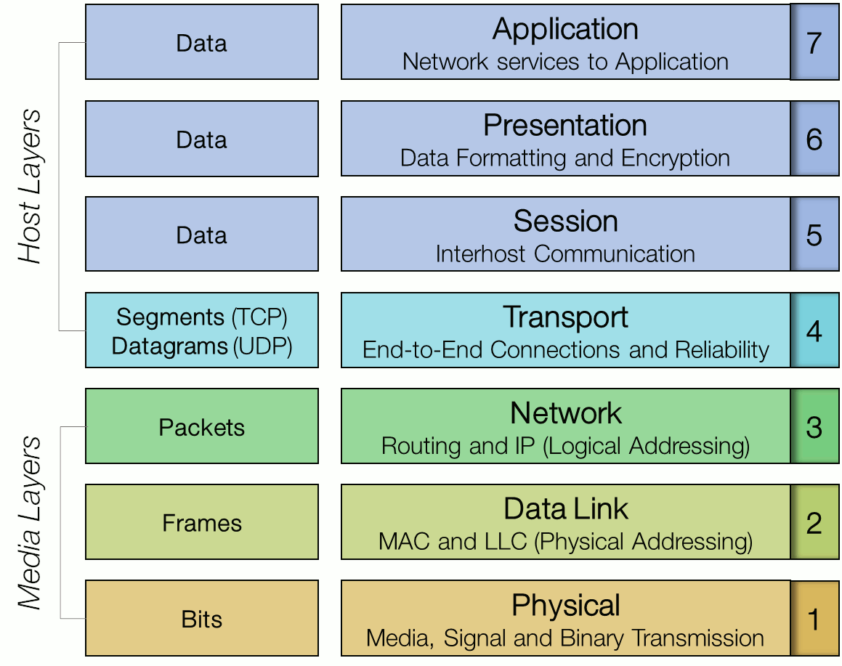
Physical layer (Layer 1)
The physical layer is the lowest layer of the OSI model and consists of the functionality that interacts with the actual hardware and signaling mechanism. It handles the transmission and reception of the unstructured raw bit stream over a physical medium and carries the signals for all of the higher layers. Physical layer refers to physical resources like as network hubs, cabling, repeaters, modem, and more.
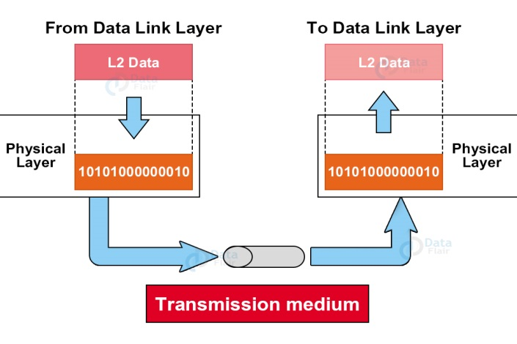
Physical layer performs the following functions :
- Data encoding: converting 1s and 0s into characteristics of the physical medium. It determines what signal state represents a binary 1, how the receiving station knows when "bit-time" starts and how the receiving station delimits a frame.
- Transmission technique: determines whether the encoded bits will be transmitted by baseband (digital) or broadband (analog) signaling.
- Physical medium transmission: transmits bits as electrical or optical signals appropriate for the physical medium. This determines what physical medium options can be used and how many volts/db should be used to represent a given signal state, using a given physical medium
- Synchronization of Bits: At the bit level, the transmitter and receiver should be synchronized. In another way transmitter and receiver, clocks should be synchronized.
- Data Rate: The number of bits sent per second which is also known as transmission rate is defined by this layer.
- Physical Topologies: To create a network the connection of devices is defined by physical topology. There are various topologies through which devices can be connected i.e, star topology (devices are connected through a central device), a ring topology (each device is attached to the next, making a ring), a mesh topology (each device connected to every other device), or a bus topology (each device on a common link)
- Mode of Transmission: The way of transmission between two devices i.e., simplex, half-duplex, or full-duplex is also defined by this layer.
Data Link (Layer 2)
The data link layer provides node-to-node transfer a link between two directly connected nodes. It defines the protocol to establish and terminate a connection between two physically connected devices, such as Point-to-Point Protocol (PPP).
This layer also handles packaging and unpacking the data in frames. The data link layer packages data from the physical layer into groups called frames. If frames are to be distributed to different systems on the network, the data link layer adds a header to the frame to define the physical address of the sender (source address) and/or receiver (destination address) of the frame. It also adds control information such as frame type, routing, and segmentation information to the data being sent. On the other hand for data coming from network layer it takes them and break them into frames.
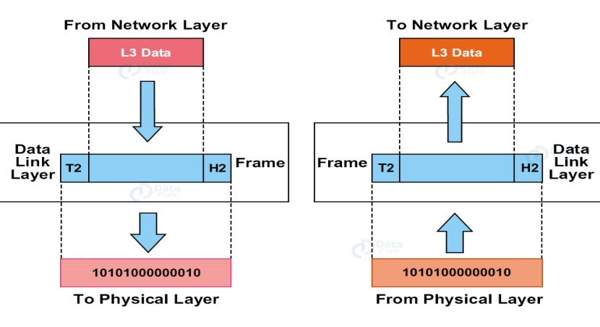
This layer also has provisions to make sure that error-free data is being passed on to the higher layers from the physical layer. Hence, it contains error detection and correction mechanisms to ensure the integrity of data is maintained.
This layer is sub-divided into two layers:
- Logical link control (LLC) layer – Provides addressing and control of the data link by establishes and maintains links between two communicating devices. It also handles error checking, flow control and frame synchronization.
- Medium access control (MAC) layer – controls how a node on the network gains access to the medium and permission to transmit to it i.e it basically controls the way multiple devices share the same media channel.
Data Link Layer - protocols
Protocols in this layer include Ethernet, ARP, PPP, Token ring, StarLAN, NDP, L2TP, etc.
Data Link Layer performs the following functions:
- Framing: The Data link layer performs a function known as framing. This creates a path by which significant information can be transferred to the receiver by the sender. From the network layer data packets are received by this layer which is encapsulated into frames. The hardware receives each frame bit-by-bit sent by the data link layer. A special bit pattern at the beginning and end of each frame is attached so that it can be assembled again by the receiver.
- Physical Addressing: The MAC address or physical address is added to the header of each frame of the sender and/or receiver by this layer.
- Flow Control: The data rate should be constant on both side i.e., the rate of generating the data must be equal to the rate of absorbing the data by the receiver. This flow of data is controlled by this layer.
- Error Control: By adding mechanisms to detect and retransmit damaged or lost frames, the data link layers adds reliability to the physical layer. It also deploys a method to restrict duplication of frames. Generally, error control is obtained via a trailer added to the frame end.
- Access Control: At a channel when there are more than one device connected this layer helps it to determine which device has command over it
Network layer (Layer 3)
The network layer delivers data in the form of a packet from source to destination, across as many links as necessary. The biggest difference between the network layer and the data link layer is that the data link layer is in charge of data delivery between adjacent systems (directly connected systems one hop away), while the network layer delivers data to systems that are not directly connected to the source.
Usually a network is divided into multiple subnets and the network layer with the help of routers forwards packets between such networks to establish a Wide Area Network (WAN).
The network layer breaks up segments from the transport layer into smaller units, called packets, on the sender’s device, and reassembling these packets on the receiving device. The network layer also takes care of mapping logical (IP) addresses to physical(MAC) addresses that are used in the Data Link layer.
This layer implements multiple packet routing system for identifying best physical route for data to arrive appropriate destination point like as choose of shortest path for making transmission of all packets, from number of routes are available. Network’s header contains all sender & receiver’s IP addresses. Routing and packet forwarding are functions of the network layer as well as addressing , internetworking, error control, congestion control, fragmentation and packet sequencing.
Network layer - protocols
Besides IP, the following common protocols are included in the Network layer: ICMP, IPsec, IPX, DDP, CLNP, etc.
The functions performed at the Network layer are:
- Logical Addressing: Network layer is responsible for logical addressing. It assigns a unique ID to each device on Layer-3 network which we call IP Address. Network Layer processes the incoming packets, filters them & sends them to their desired destination.
- Encapsulation: Network layer encapsulates Transport layer segments into Layer-3 Packets & forwards to Data Link Layer for further processing.
- Fragmentation: Network layer is also responsible for fragmentation of packets to match the MTU size of Layer-2 frames.
- Error Control: Error control and recovery also falls under the responsibilities & functions of Network Layer. Is uses error control mechanisms to ensure reliable delivery of data. Due to these acknowledgment mechanisms, the receiver can detect how many Layer-3 Packets have been corrupted during transmission. Receiver then requests the sender to send those Layer3 Packets again to ensure that no data is lost during
transmission.
Transport Layer (Layer 4)
The transport layer, provides transparent transfer of data between end systems, or hosts, and is responsible for end-to-end error detection, recovery and flow control. The transport layer performs error control on the receiving end by ensuring that the data received is complete, and requesting a retransmission if it isn’t. The transport layer typically sends an acknowledgement to the originator for messages received. This layer verifies that the application transmitting the data is actually allowed to access the network and verifies that both ends of the connection can start the data transfer process.
The transport layer is also responsible for flow control. Flow control determines an optimal speed of transmission to ensure that a sender with a fast connection doesn’t overwhelm a receiver with a slow connection.
The transport layer breaks larger messages from session layer into chunks called segments before sending it to network layer. The transport layer on the receiving device is responsible for reassembling the segments into data the session layer can consume.
Transport layer - protocols
Besides TCP and UDP, some common protocols that operating in the Transport layer include SPX, SCTP, RDP and DCCP.
The transport layer provides the following functions:
- Message segmentation: accepts a message from the (session) layer above it, splits the message into smaller units (if not already small enough), and passes the smaller units down to the network layer. The transport layer at the destination station reassembles the message.
- Message acknowledgment: provides reliable end-to-end message delivery with acknowledgments.
- Message traffic control: tells the transmitting station to "back-off" when no message buffers are available.
- Session multiplexing: multiplexes several message streams, or sessions onto one logical link and keeps track of which messages belong to which sessions.
Session Layer (Layer 5)
Session layer, sometimes called the dialog controller provides mechanism for controlling the dialogue between the two end systems. It defines how to start, control and end conversations (called sessions) between applications. Session layer protocols provide the logical connection entities at the application layer. These applications include file transfer protocols and sending email.
Session responsibilities include: network log-on and log-off procedures and user authentication. Session layer characteristics include virtual connections between applications, entities, synchronization of data flow for recovery purposes, creation of dialogue units and activity units, connection parameter negotiation, and partitioning services into functional groups.
Session layer - protocols
NetBIOS, RPC, SOCKS, L2TP, SDP, H.245, NFS, etc.
Presentation Layer (Layer 6)
The presentation layer formats the data to be presented to the application layer. It can be viewed as the translator for the network. When transmitting data from the sender to the receiver, the application of the sender moves the data to the Presentation layer. This layer then translates the data to a common format which can be read by both computers. On the receiving end, the Presentation layer translates the data to a format which the application can read.
Presentation layer - protocols
Common examples for protocols and technology that operate in the Presentation layer include X.25, ZIP, XML, JSON, ASCII, EBCDIC, JPEG, MP3, etc.
The presentation layer provides the following functions:
- Character code translation: for example, ASCII to EBCDIC.
- Data conversion: bit order, CR-CR/LF, integer-floating point, and so on.
- Data compression: reduces the number of bits that need to be transmitted on the network.
- Data encryption: encrypt data for security purposes. For example, password encryption.
Other functions include: serialization, protocol conversion, data file formatting, dialogue procedures, synchronization, interruption, and termination all fall in the functions of this layer.
Application Layer (Layer 7)
The Application layer is the highest layer of the OSI model. It provides the interface between the network protocol and the software running on the computer. The Application layer is the location where users and application processes access network services.
Application layer - protocols
Common application protocols that work in this layer include: HTTP, FTP, SMTP, DNS, Telnet, SSH, IMAP, POP, SNMP, etc.
The functions of the application layer are:
- FTAM (File Transfer Access and Management): This function allows the user to read, write, and perform various operations on a file on a remote computer.
- Network Virtual Terminal: This function allows the user to log on to a remote host.
- Directory Services: The access to database sources for global information is provided by this application.
- Mail Services: The e-mail forwarding and storage functionalities are also provided by this application.

9.3.2 Transmission Control Protocol/Internet Protocol (TCP/IP) Model
The TCP/IP reference model also referred as internet protocol suite is a layered model developed by the Defense Project Research Agency(ARPA or DARPA) of the United States as a part of their research project in 1960. Initially, it was developed to be used by defense only. But later on, it got widely accepted. The main purpose of this model is to connect two remote machines for the exchange of information. These machines can be operating in different networks or have different architecture. The TCP/IP reference model has four layers this includes: Application Layer, Transport Layer, Internet Layer and Network Access Layer.
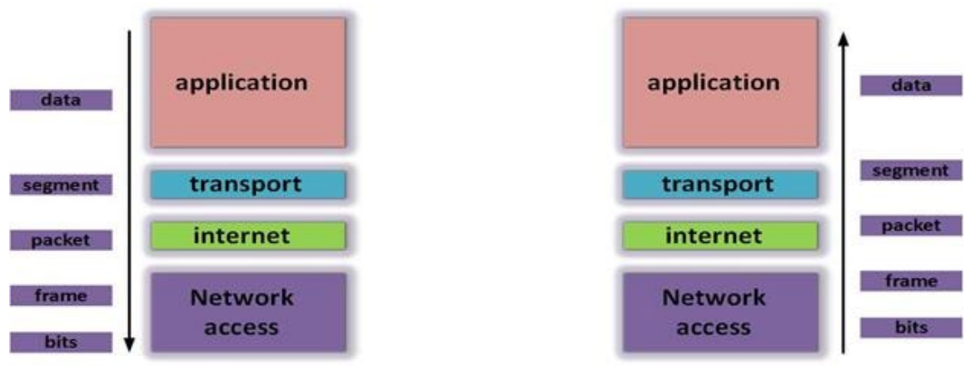
Each layer of the TCP/IP has a particular function to perform and each layer is completely separate from the layer(s) next to it. The communication process that takes place, at its simplest between two computers, is that the data moves from layer 4 to 3 to 2 then to 1 and the information sent arrives at the second system and moves from 1 to 2 to 3 and then finally to layer 4. The protocols at each layer as shown in the figure below
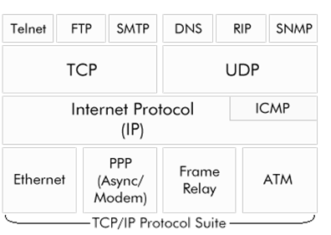
The Network Access Layer
A network access layer is the lowest layer of the TCP/IP model. A link layer is the combination of the Physical layer and Data Link layer defined in the OSI reference model. Network access layer, also called the link layer, is the interface to the actual network hardware.
This layer defines details of how data is physically sent through the network, including how bits are electrically or optically signaled by hardware devices that interface directly with a network medium, such as coaxial cable, optical fiber, or twisted pair copper wire. This layer is responsible for the transmission of the data between two devices on the same network.
The Network Access layer of the TCP/IP model uses Cables, Repeaters, Hubs, Switches, and bridges to Physically connect devices to the network and pass data within the same network subnet. The data unit is bits(1s and 0s) and frame.
Functions of Network Access Layer
- Access to physical medium, like cables, wireless.
- It provides MAC addressing and mapping of logical IP address to Physical MAC address.
- Error notification.
- It does the sequencing of frames
- It Provides Flow control.
The protocols/standards included in Network Access Layer are Ethernet, Token Ring, FDDI, X.25, Frame Relay etc.
Unlike higher level protocols, the network access layer protocols must understand the details of the underlying physical network, such as the packet structure, maximum frame size, and the physical address scheme that is used. Understanding the details and constraints of the physical network ensures that these protocols can format the data correctly so that it can be transmitted across the network.
In fact, TCP/IP does not specify any protocol here, but can use almost any network interface available, which illustrates the flexibility of the IP layer. Examples are IEEE 802.2, X.25 (which is reliable in itself), ATM, FDDI, and even SNA.
The protocols at this layer perform three distinct functions:
- They define how to use the network to transmit a frame, which is the data unit passed across the physical connection.
- They exchange data between the computer and the physical network.
- They deliver data between two devices on the same network. To deliver data on the local network, the network access layer protocols use the physical addresses of the nodes on the network. A physical address is stored in the network adapter card of a computer or other device, and it is a value that is "hardcoded" into the adapter card by the manufacturer.
The Internet Layer
The internet layer, also called network layer is responsible for routing messages through internetworks. Internet layer pack data into data packets known as IP datagrams, which contain source and destination address (logical address or IP address) information that is used to forward the datagrams between hosts and across networks. The Internet layer is also responsible for routing of IP datagrams.
Datagrams are packets of information that comprise a header, data, and a trailer. The header contains information, such as the destination address, that the network needs to route the datagram. A header can also contain other information, such as the source address and security labels. Trailers typically contain a checksum value, which is used to ensure that the data is not modified in transit.
Internet layer allow hosts to insert packets into network and have them delivered to the destination, on the same network or on another remote network. At the destination side data packets may appear in a different order than they were sent. It is the job of the higher layers to rearrange them in order to deliver them to proper network applications operating at the Application Layer.
Functions of Internet Layer
- It is responsible for source-to-destination delivery of a packet including routing through intermediate routers across multiple network segments.
- The internet layer is also responsible for the IP addressing scheme that uniquely identifies each host on a TCP/IP network.
- The internet layer also provides for fragmentation and reassembly of long datagrams.
- IP datagram contains source and destination address which is used to forward packets between IP networks.
- It also does error handling, congestion control and Quality of service(QoS).
In the network layer, the TCP/IP model supports internetworking protocol in short known as IP. The IP uses four protocols internally: ARP, RARP, ICMP & IGMP.
Internetworking protocol(IP):
Following are the responsibilities of this protocol:
- IP Addressing: This protocol implements logical host addresses known as IP addresses. The IP addresses are used by the internet and higher layers to identify the device and to provide internetwork routing.
- Host-to-host communication: It determines the path through which the data is to be transmitted.
- Data Encapsulation and Formatting: An IP protocol accepts the data from the transport layer protocol. An IP protocol ensures that the data is sent and received securely, it encapsulates the data into message known as IP datagram.
- Fragmentation and Reassembly: The limit imposed on the size of the IP datagram by data link layer protocol is known as Maximum Transmission unit (MTU). If the size of IP datagram is greater than the MTU unit, then the IP protocol splits the datagram into smaller units so that they can travel over the local network. Fragmentation can be done by the sender or intermediate router. At the receiver side, all the fragments are reassembled to form an original message.
- Routing: When IP datagram is sent over the same local network such as LAN, MAN, WAN, it is known as direct delivery. When source and destination are on the distant network, then the IP datagram is sent indirectly. This can be accomplished by routing the IP datagram through various devices such as routers.
The four protocol this Internetworking protocol(IP) uses include:
- ARP (Address Resolution Protocol): It is used to map the known I.P. addresses into Physical address.
- RARP(Reverse Address Resolution Protocol): It is used to map Physical address into I.P. address
- I.C.M.P.( Internet Control Message Protocol): It is used to send error & control Messages in the network
- I.G.M.P. (Internet Group Management Protocol): It is a protocol which is used to form multicast groups in a network to receive multicast messages.
The Transport Layer
The transport layer also called host-to-host layer, is the third layer of the four-layer TCP/IP model. It is responsible for providing end-to-end data integrity and provides a highly reliable communication service for entities that want to carry out an extended two-way conversation.
In addition to the usual transmit and receive functions, this layer uses open and close commands to initiate and terminate the connection. This layer accepts information to be transmitted as a stream of characters, and it returns information to the recipient as a stream. The service employs the concept of a connection (or virtual circuit). A connection is the state of the host-to-host transport layer between the time that an open command is accepted by the receiving computer and the time that the close command is issued by either computer.
Functions of Transport Layer
- The Transport layer chops the message received from the Application layer into segments and tags or numbers them to make a sequence. And then forwards it to the IP layer for further processing.
- The Transport layer ensures that data is delivered correctly in sequence to the correct destination host by doing error detection, correction (by resending), and reordering of messages.
- It responsible for providing end-to-end communication services for applications,
- It is also responsible for providing reliability by doing flow control and error control.
There are two transport-layer protocols in the TCP/IP protocol suite: the Transport Control Protocol (TCP) and the User Datagram Protocol (UDP).
- User Datagram protocol (UDP): UDP is a process to process protocol used for data transmission. It takes the data from upper layer of TCP/IP Model and adds following information to the data:
a) Port Address – Source port address of 16 bits and destination port address of 16 bits added to the data so that it reaches to correct destination and displays the correct source of data.
b) checksum error control – 16 bits of checksum data is added to the data received from upper layer, this is used for error control.
c) length of data – Length defines the total bytes of data in datagram.
Although this protocol finds the error in the transmission of data, it doesn’t specify the error which makes it hard to identify the actual error in transmission.
- Transmission Control Protocol (TCP): Unlike UDP which is a connectionless protocol, the TCP is a connection oriented protocol.
A connection must be made between sender and receiver before the transmission of data. TCP protocol divides the data in small units called segments. Each segment contains the sequence number which makes it possible to rearrange the segments in correct order at the receiver side to make the complete data.
It also adds acknowledgement number to the segments to verify that the data is actually reached its destination or not.Unlike UDP which is unable to specify the exact error in transmission, this protocol does error control and specifies the exact error which makes TCP a reliable protocol.
The Application Layer
The top layer in the Internet reference model is the application layer. This layer provides functions for users or their programs, and it is highly specific to the application being performed. It provides the services that user applications use to communicate over the network, and it is the layer in which user-access network processes reside. These processes include all of those that users interact with directly, as well as other processes of which the users are not aware. This layer includes all applications protocols that use the host-to-host transport protocols to deliver data. Other functions that process user data, such as data encryption and decryption and compression and decompression, can also reside at the application layer.
The application layer also manages the sessions (connections) between cooperating applications. In the TCP/IP protocol hierarchy, sessions are not identifiable as a separate layer, and these functions are performed by the host-to-host transport layer. Instead of using the term "session," TCP/IP uses the terms "socket" and "port" to describe the path (or virtual circuit) over which cooperating applications communicate.
Functions of Application Layer
- The Application layer is responsible for the user interfaces and application services.
- The application services include e-mail, file transfer, remote login, and world wide web
- The Application layer is responsible for formatting messages into a format that the underlying transport layer services can transport. It also ensures that messages are properly received and interpreted by the receiving application.
- The application layer ensures that the data is delivered to the correct application process.
Most of the application protocols in this layer provide user services, and new user services are added often. For cooperating applications to be able to exchange data, they must agree about how data is represented. The application layer is responsible for standardizing the presentation of data.
The various protocols that are used at the Application Layer are:
- Telnet: Terminal Emulation, Telnet is a program that runs on your computer and connects your PC to a server on the network. You can then enter commands through the Telnet program and they will be executed as if you were entering them directly on the server console. Port Number :23
- FTP: File Transfer Protocol, the protocol used for exchanging files over the Internet. FTP is most commonly used to download a file from a server using the Internet or to upload a file to a server. Port Number : 20(data port) ,21(control port)
- HTTP: Hyper Text Transfer Protocol is the underlying protocol used by the World Wide Web. HTTP defines how messages are formatted and transmitted, and what actions Web servers and browsers should take in response to various commands. For example, when we enter a URL in the browser, this actually sends an HTTP command to the Web server directing it to fetch and transmit the requested Web page. Port Number :80
- NFS: Network File System, a client/server application that allows all network users to access shared files stored on computers of different types. Users can manipulate shared files as if they were stored locally on the user's own hard disk. Port Number :2049
- SMTP: Simple Mail Transfer Protocol, a protocol for sending e-mail messages between servers. In addition, SMTP is generally used to send messages from a mail client to a mail server. Port Number :25
- POP3: Post Office Protocol, a protocol used to retrieve e-mail from a mail server. Most e-mail applications (sometimes called an e-mail client) use the POP, although some can use the newer IMAP (Internet Message Access Protocol)as a replacement for POP3 Port Number :110
- TFTP: Trivial File Transfer Protocol, a simple form of the File Transfer Protocol (FTP). TFTP provides no security features. It is often used by servers to boot diskless workstations, X-terminals, and routers. Port Number :69
- DNS: Domain Name System (or Service or Server), an Internet service that translates domain names into IP addresses. Because domain names are alphabetic, they're easier to remember. The Internet however, is really based on IP addresses. Every time you use a domain name, a DNS service must translate the name into the corresponding IP address. For example, the domain name www.example.com might translate to 198.105.232.4. Port Number :53
- DHCP: Dynamic Host Configuration Protocol, a protocol for assigning dynamic IP addresses to devices on a network. With dynamic addressing, a device can have a different IP address every time it connects to the network. Dynamic addressing simplifies network administration because the software keeps track of IP addresses rather than requiring an administrator to manage the task. Port Number : 67(Server),68(Client)
- BOOTP: Bootstrap Protocol (BOOTP) is utilized by diskless workstations to gather configuration information from a network server. This enables the workstation to boot without requiring a hard or floppy disk drive. Port Number : 67(Server),68(Client)
- SNMP: Simple Network Management Protocol, a set of protocols for managing complex networks. SNMP works by sending messages, called protocol data units (PDUs), to different parts of a network. Port Number :161

9.4 OSI vs TCP/IP Model

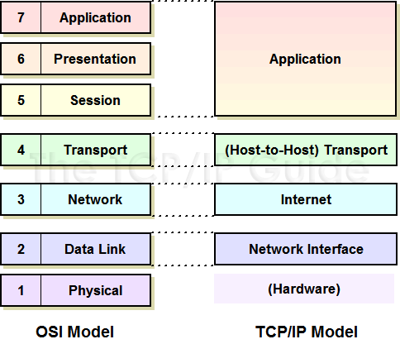

9.4.1 Differences between OSI and TCP / IP Reference Models
- OSI model is a generic model that is based upon functionalities of each layer. TCP/IP model is a protocol-oriented standard.
- OSI model distinguishes the three concepts, namely, services, interfaces, and protocols. TCP/IP does not have a clear distinction between these three.
- OSI model gives guidelines on how communication needs to be done, while TCP/IP protocols layout standards on which the Internet was developed. So, TCP/IP is a more practical model.
- In OSI, the model was developed first and then the protocols in each layer were developed. In the TCP/IP suite, the protocols were developed first and then the model was developed.
- The OSI has seven layers while the TCP/IP has four layers.

9.4.2 Similarities between OSI and TCP / IP Reference Models
- Both the reference models are based upon layered architecture.
- The layers in the models are compared with each other. The physical layer and the data link layer of the OSI model correspond to the link layer of the TCP/IP model. The network layers and the transport layers are the same in both the models. The session layer, the presentation layer and the application layer of the OSI model together form the application layer of the TCP/IP model.
- In both the models, protocols are defined in a layer-wise manner.
- In both models, data is divided into packets and each packet may take the individual route from the source to the destination.

