To run the program navigate jar file

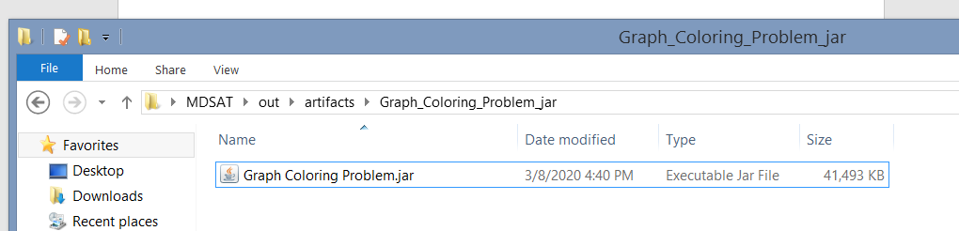

Open cmd then copy relatively:

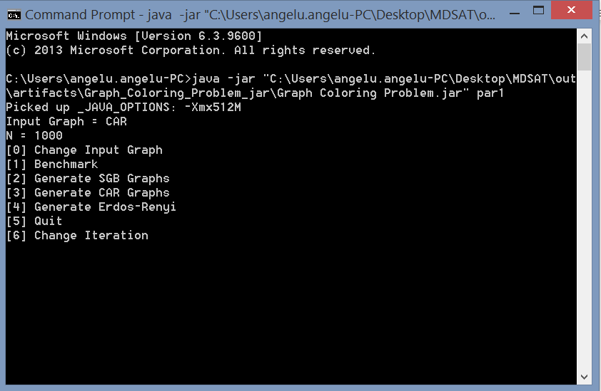

If you want to run the program from IDE, install first libraries inside zip file

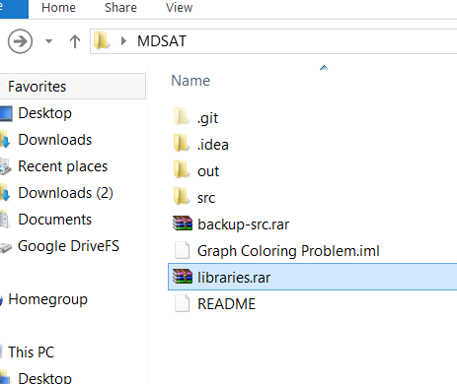

Benchmark instances can be found here : <https://turing.cs.hbg.psu.edu/txn131/index.html>

Program reads the links inside these two folders,



Then outputs the text format here:



WARNING: the contents of the textfiles generated in these folders are sometimes incomplete. Manually copy and paste from the source to make sure.

This feature was only designed to automate the task of file creation.

Erdos Renyi graphs go here:



Benchmark results are written here:

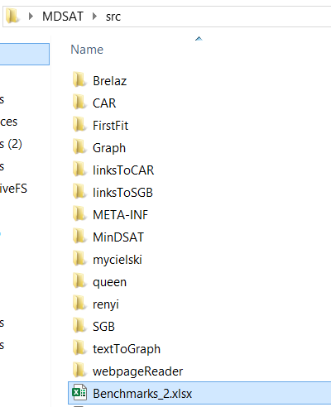

* If generated txt files do not appear, restart program.
* Change iteration = change number of benchmark runs(default 1000 runs)
* Open “original-src.rar” to view original benchmark results