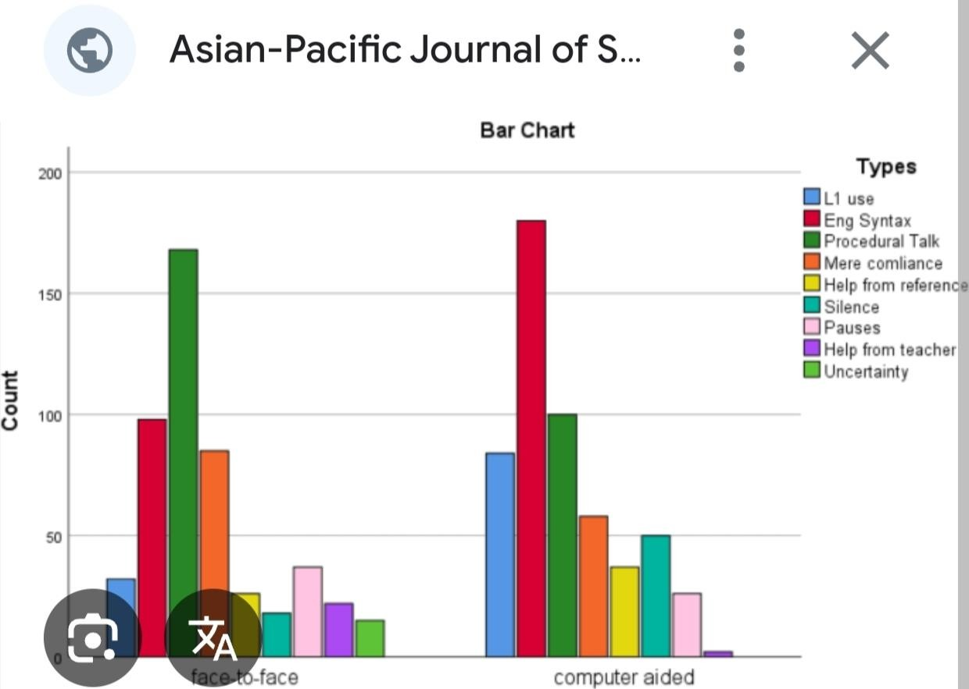

# Final Deliverables

* + Final Jupyter/Colab Notebook (cleaned and well-commented)
  + Dashboard file or link (Power BI/Tableau/Plotly Dash)
  + Final Report (PDF/DOC format)

def display_statistics(df):

stats = calculate_statistics(df)

s

t.subheader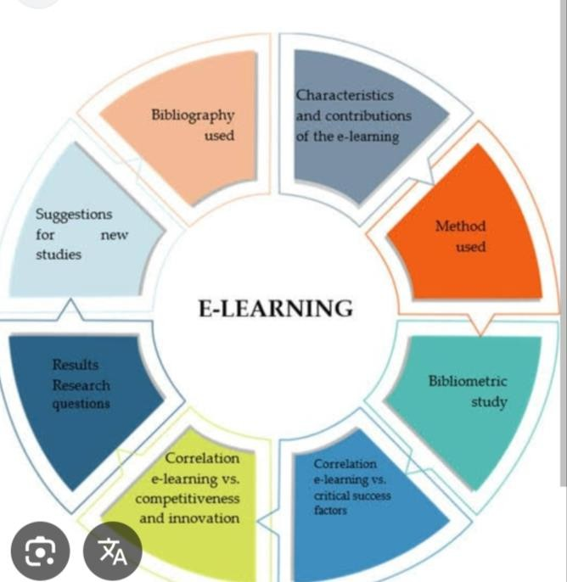 ("Basic Statistics")

for stat, value in stats.items(): st.write(f"{stat.replace('_', ' ').title()}: {value:.2f}")

def plot_engagement_distribution(df): """Plot engagement time distribution."""

st.subheader("Engagement Time Distribution") fig, ax = plt.subplots()

sns.histplot(df['engagement_time'], kde=True, ax=ax) st.pyplot(fig)

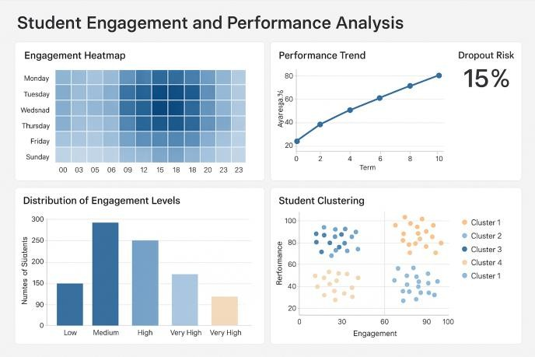

# Future Scope

* + Suggest at least 2–3 areas for improvement or extension:
    - Real-time data pipeline integration
    - Advanced visualization tools (D3.js, Power BI automation)
    - Adding NLP sentiment analysis on reviews
    - Connecting insights to marketing automation or CRM actions

Integrate with live LMS platforms Real-time analytics and interventions NLP-based feedback analysis Gamified adaptive learning paths

Voice and emotion recognition for engagement

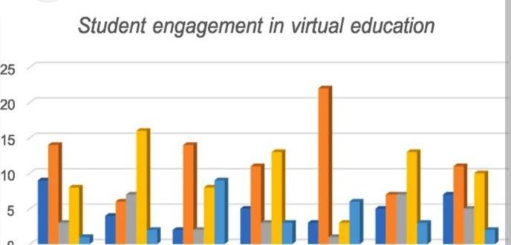

1. **Team Members and Roles**

|  |  |
| --- | --- |
| **Name** | **Responsibility** |
| K. Saravanavel | Data collection and preprocessing |
| V. Robinstan | Exploratory data analysis and modeling |
| N. Santhoshkumar | Dashboard  development and visualization |