Step 1:Enter Android Studio Web page.

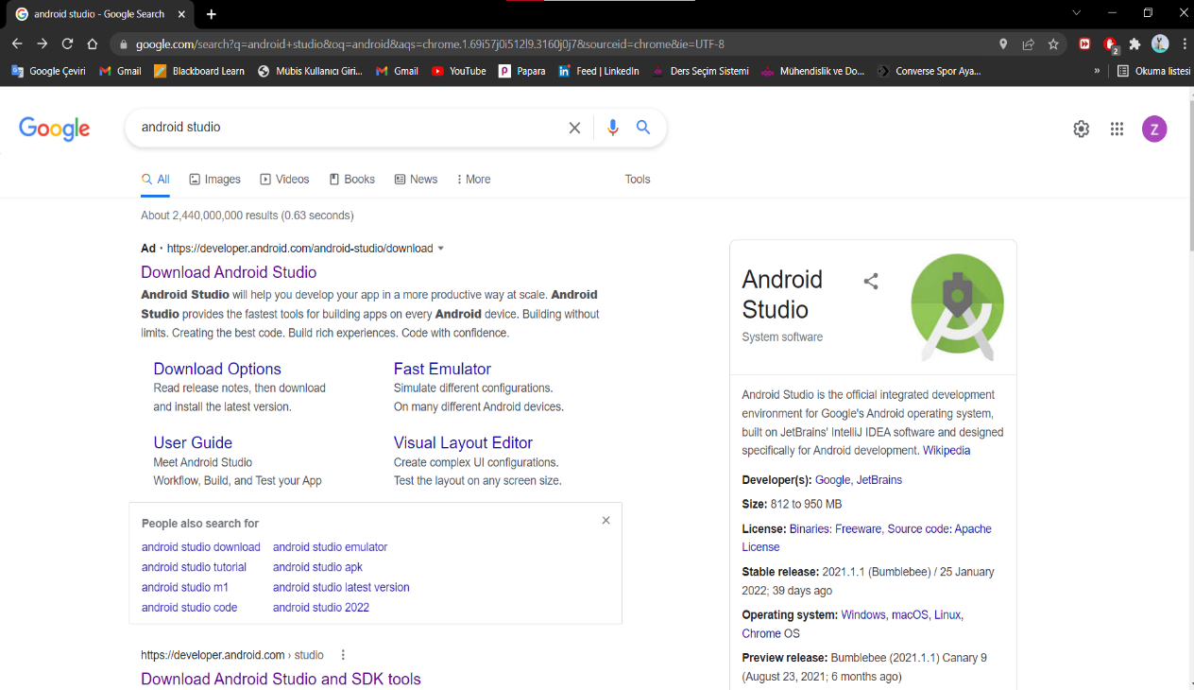

metin içeren bir resim

Açıklama otomatik olarak oluşturulduStep 2:Press Download Android Studio.

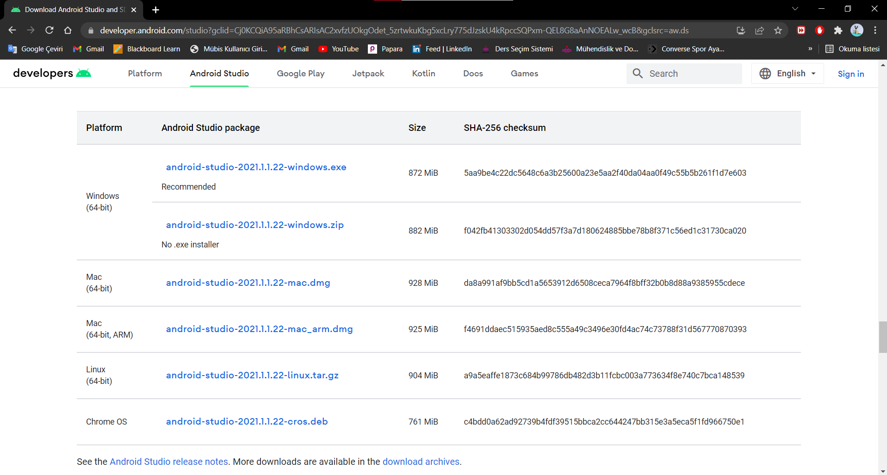Step 3:Select first link(android-studio-2021.1.1.2-windows.exe)

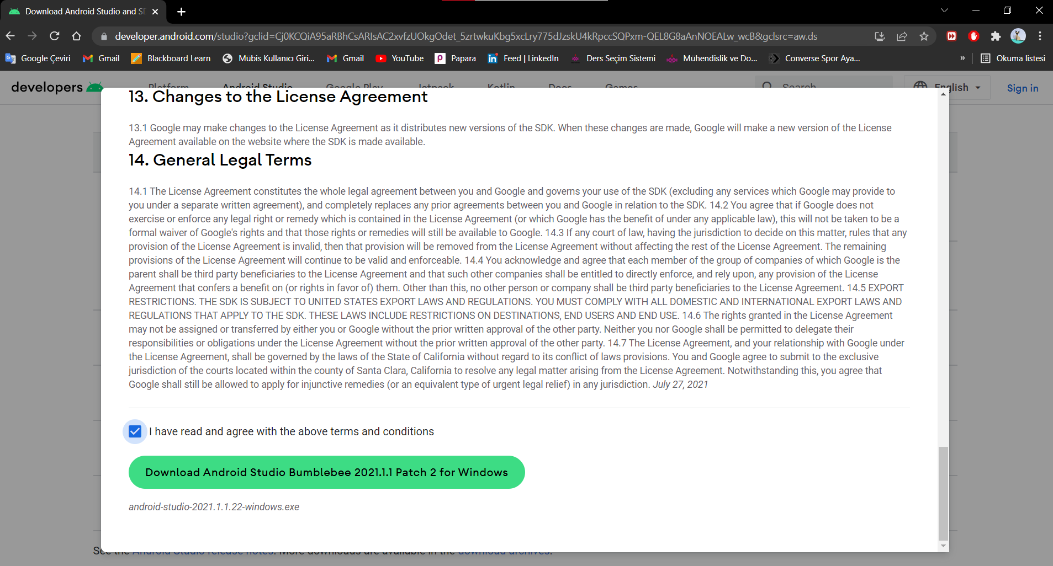Step 4:Agree to terms and download.

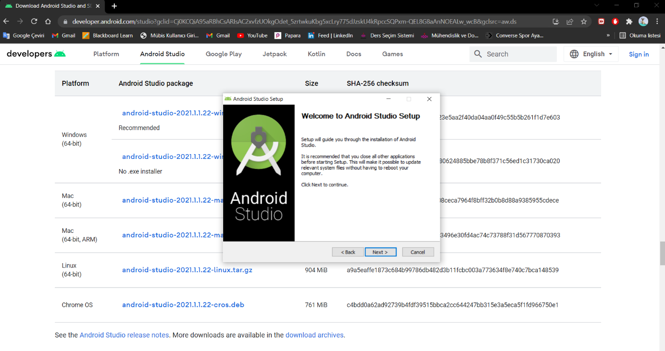Step 5:Click next.

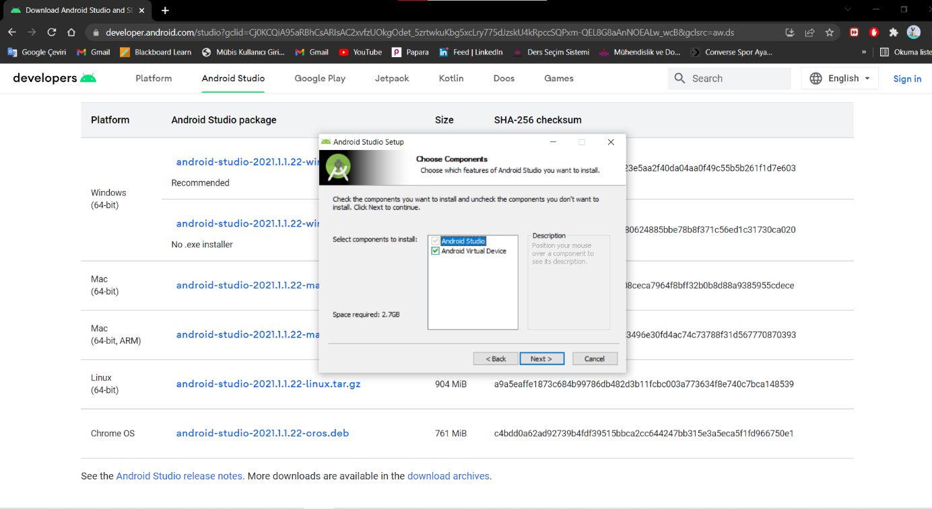Step 6:Click next with both options selected.

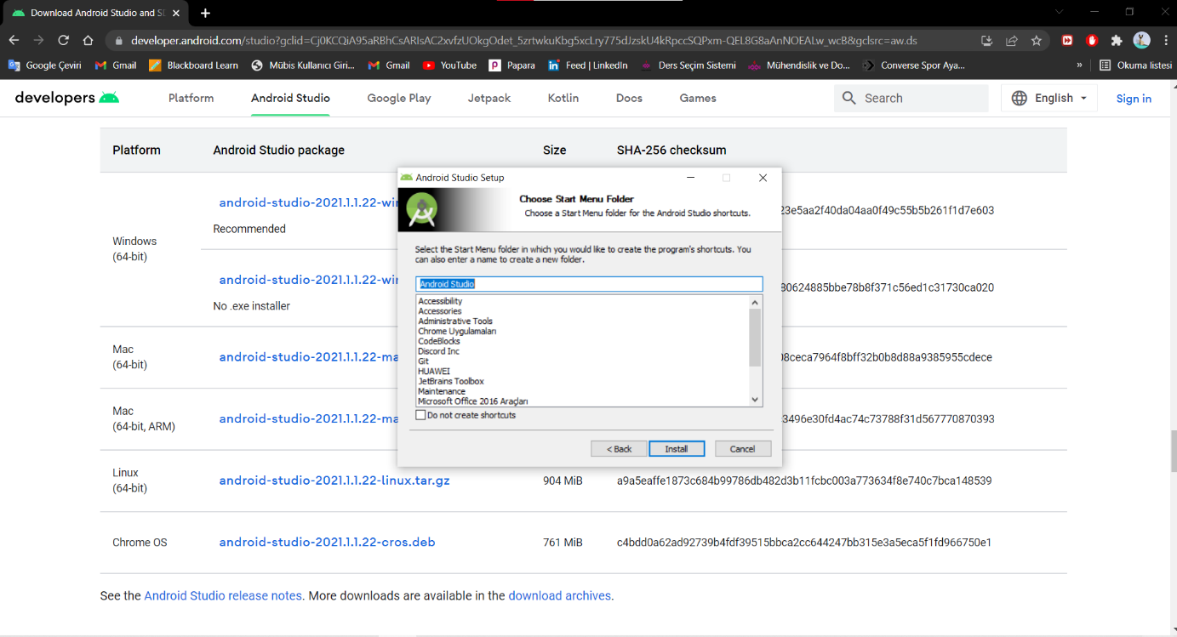Step 7:Click next without changing anything.

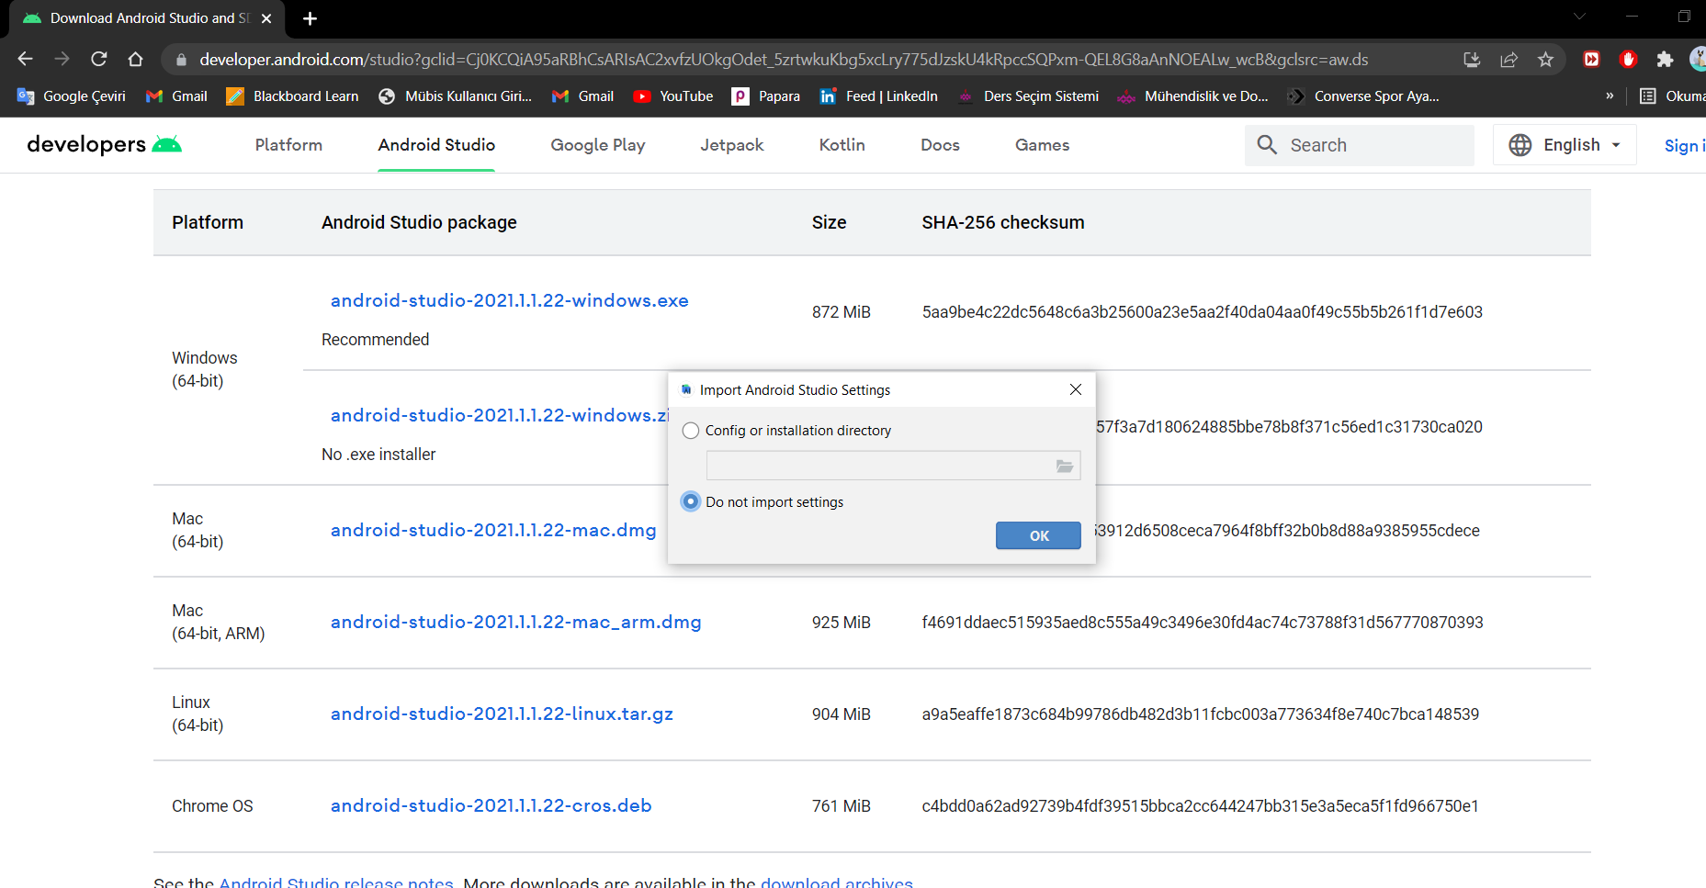Step 8:Click OK.

Step 9:You will see Android Studio’s welcome page just continue.

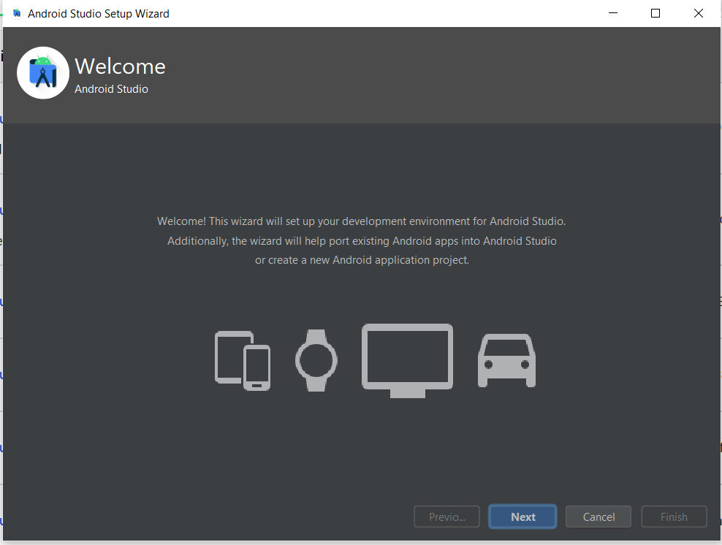

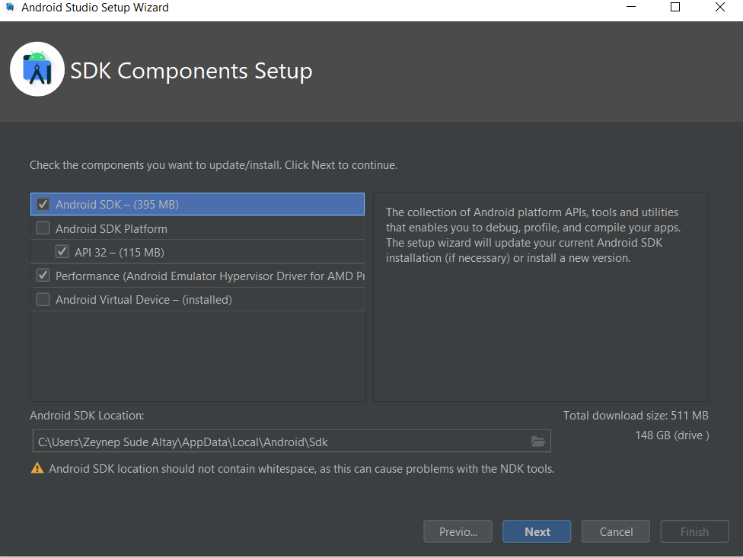Step 10:Choose Android SDK-API 32-Performance and click next.

Step 11: Accept each licence then press finish button.

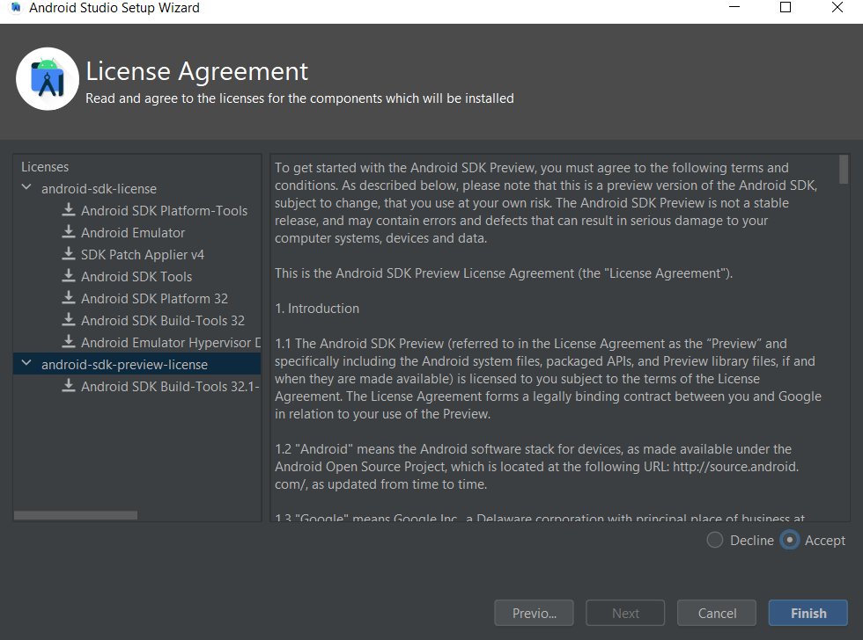

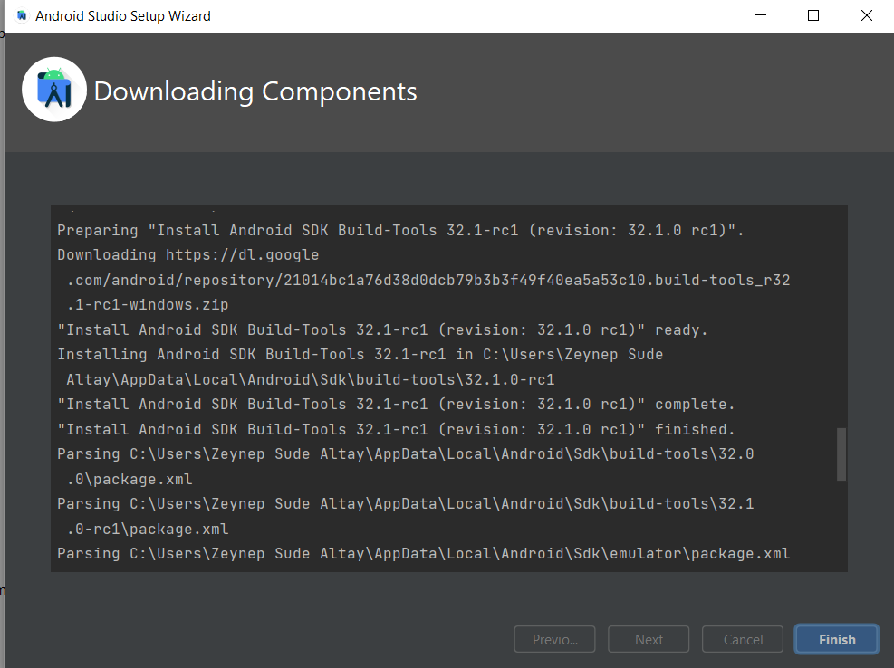Step 12: Finish installing.

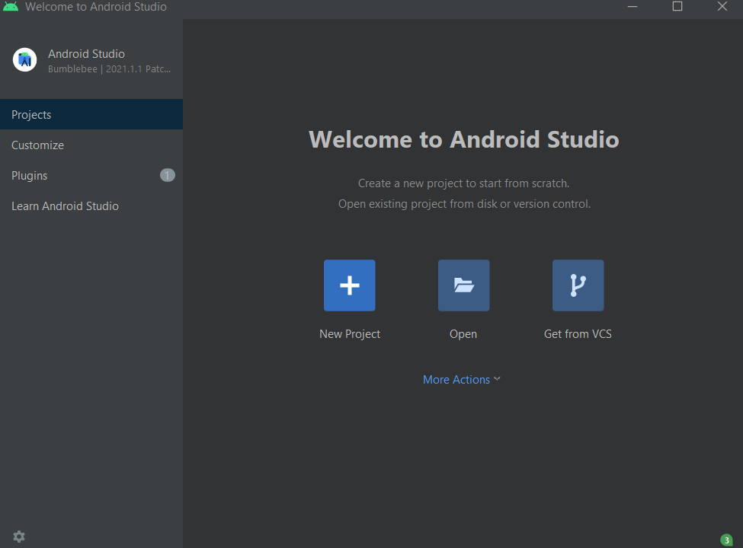Step 13: Create a new Project.

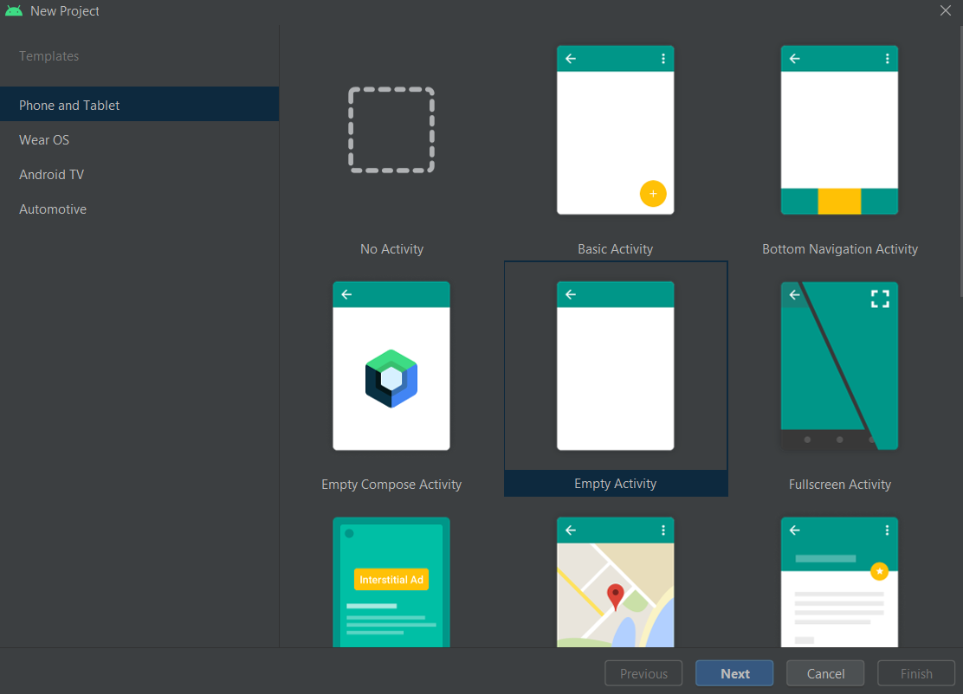Step 14: Select Empty Activity.

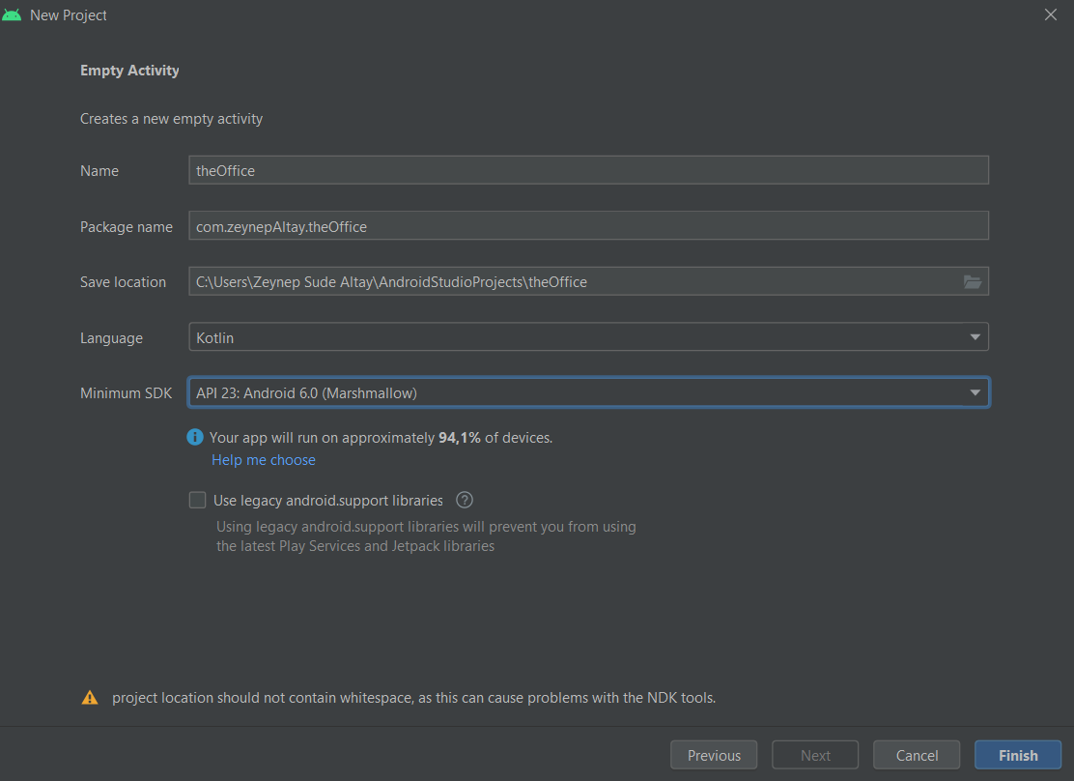Step 15: Write Project name, package name, choose location and Minimum SDK than Finish.

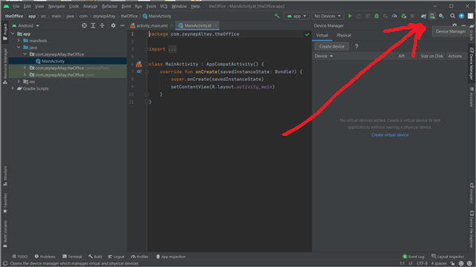Step 16: Select Device Manager which is at up-right corner.

Step 17:Select the phone that you will use and press next button.

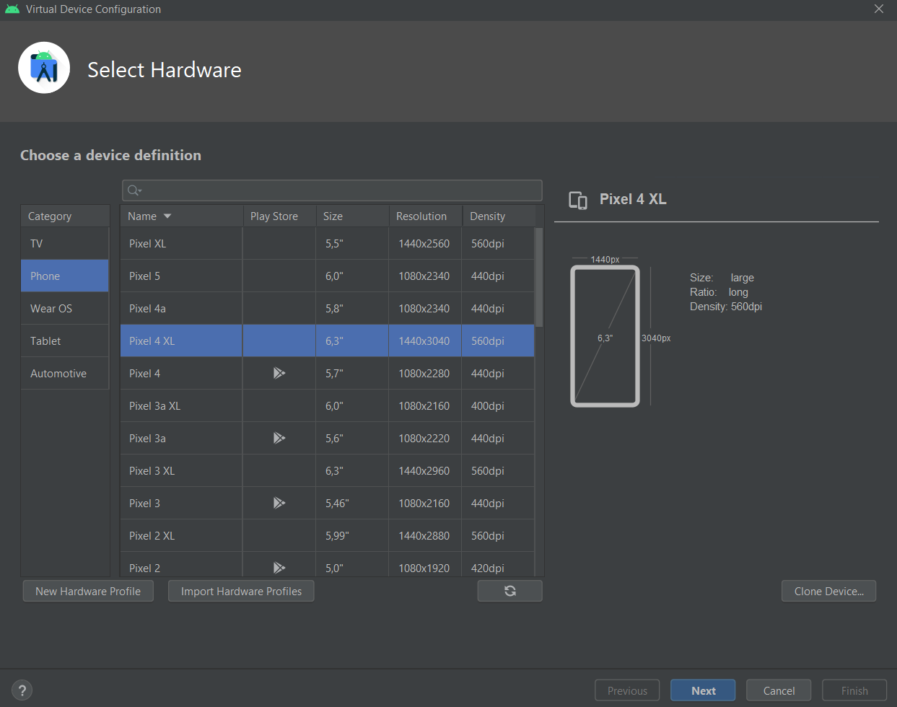

Step 18:Select System Image, I select R, and then download it

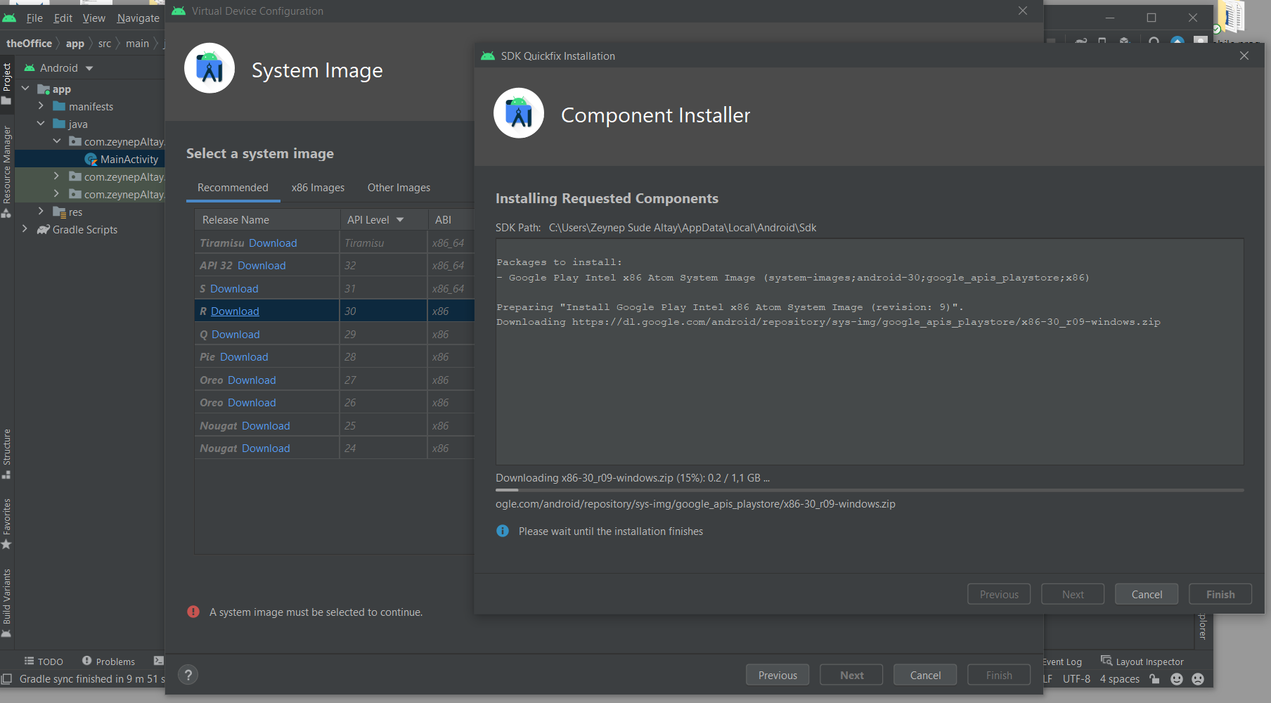

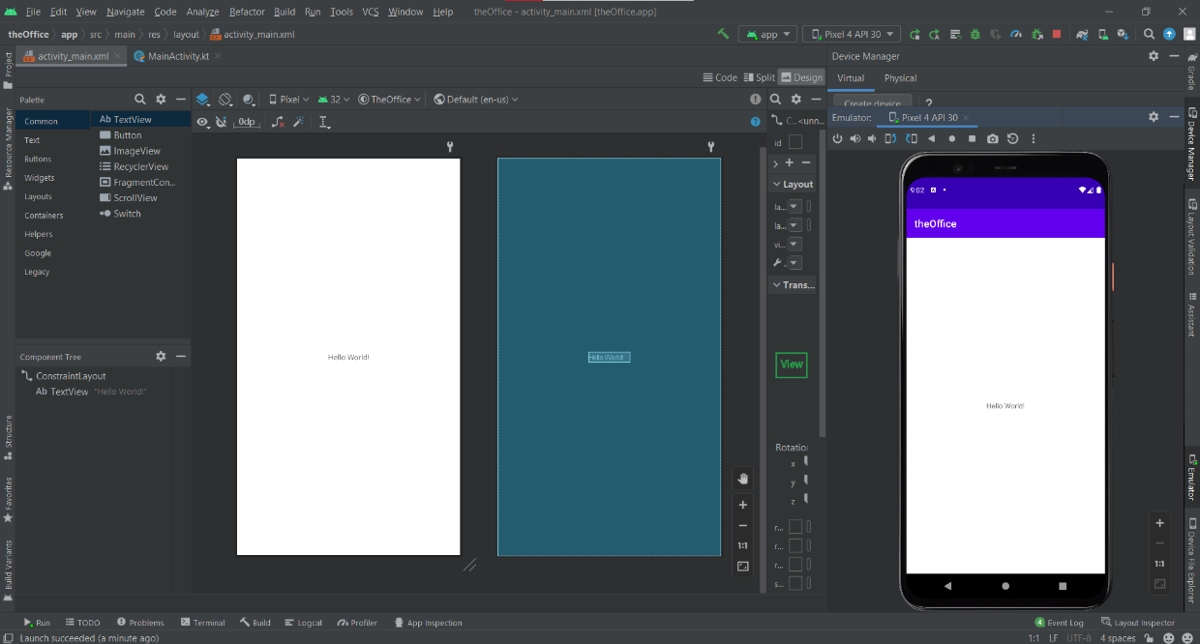Step 20:When your selections is downloaded press finish then you will have Emulator and you can open it by pressing the Start Button from up-right corner.