|  |  |
| --- | --- |
| **Student Name:** | **Michael Edwards** |
| **Student ID:** | **20074694** |
| **Task:** | **2** |
| **Task Title:** | **Portfolio: Task 2** |
| **Task Code:** | **AT2 POR-Task-2** |
| **Due Date:** | ***Session 09***  *Please see blackboard for the most accurate due date.* |
| **Notes:** | *If you did not DOUBLE CLICK this template, then close the file and do so to create your blank report.* |

Table of Contents

01 Create a new pycharm project 3

02 Create an ‘event’ class 4

03 Print human readable info 5

04 SImple testing and inspection 6

05 Events are, well, events 7

06 Analysis: Class Diagram 8

07 Analysis: adding events 9

08 Analysis: Sequence Diagram (success) 10

09 Sequence Diagram (alternate scen.) 11

10 Implement the method 12

11 Keep your project safe 13

Appendix A: Template Instructions 14

Appendix B: Before Submission 15

# 01 Create a new pycharm project

#### Please upload the project as a zip-file (remove virtual environment before uploading to Blackboard).

# 02 Create an ‘event’ class

#### No evidence required in this document.

# 03 Print human readable info

#### Explain the choice you made for what to print as human readable info.

The __str__ outputs a string with variable names along with their values. The variables are separated by a ‘|’ character to help differentiate them. This simple output ensures there isn’t too much text to sift through to get needed information.

# 04 SImple testing and inspection

#### Provide a screenshot of the output of your script after it has run

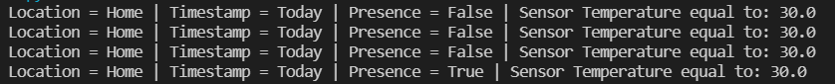

# 05 Events are, well, events

#### No evidence needed in this document.

# 06 Analysis: Class Diagram

#### Show the Class Diagram below.

# 07 Analysis: adding events

#### Show the updated Class Diagram below.

# 08 Analysis: Sequence Diagram (success)

#### Show the Sequence Diagram below.

# 09 Sequence Diagram (alternate scen.)

#### Show the updated Sequence Diagram(s) below.

# 10 Implement the method

#### No evidence required for this question in this document.

# 11 Keep your project safe

#### No evidence required for this question.

# Appendix A: Template Instructions

Some basic instructions on using this template.

These instructions include:

* Adding references, and
* What to do **before** submitting the assessment.

# Appendix B: Before Submission

Before you submit the assessment:

1. Ensure you have completed all the steps and answered all questions in the assessment task.
2. Then update the Table of Contents
3. Save this document as per instructions in the assessment task.

Once all the above is completed then you are able to submit the work for assessment.