Report Title | : | Automated Container deployment and Administration in the cloud
Module Code | : | B9IS121
Student Name | : | Ahmad Raza
Student ID | : | 20074749
Instructor Name | : | Kingsley Ibomo
Summary Word Cout | :
Full Report Word Count | :

- Summary
This project focuses on automating the deployment of a web application in the cloud using modern DevOps tools and practices. The deployment was carried out on Microsoft Azure, where cloud resources were created and managed automatically instead of being set up manually.
Terraform was used to build the cloud infrastructure, including the virtual machine and network setup. Ansible was used to configure the server and install required software like Docker. The application was containerized using Docker, which makes it easier to run and manage. A GitHub Actions pipeline was then created to automate the build and deployment process, ensuring that any code updates are quickly reflected in the cloud environment.
This report describes each stage of the automation process, the tools used, and the challenges faced. The overall outcome shows that using automation tools together makes cloud deployment faster, repeatable, and more reliable.
- Introduction
Cloud computing allows users to create and manage servers, networks, and applications easily without needing physical hardware. Automation in the cloud helps save time, reduce errors, and make deployments faster and more reliable. This project focuses on using automation tools to deploy a containerized web application on Microsoft Azure.
The main goal of the project is to build and manage an automated cloud environment using different DevOps tools. Terraform is used to create the Azure infrastructure, Ansible is used to configure the server, Docker is used to run the application inside a container, and GitHub Actions is used to create a CI/CD pipeline that automatically builds and deploys the application when changes are made.
This report explains each part of the process — infrastructure setup, configuration, container deployment, and CI/CD integration. It also includes challenges faced during the project, how they were solved, and suggestions for improvement. The aim is to show how cloud automation makes application deployment faster, repeatable, and easier to manage.
- Creating an Azure Account (Student Subscription)
Before beginning the automation work, it was necessary to have access to a cloud platform where the resources could be deployed. For this project, a Microsoft Azure for Students account was created. The Azure Student subscription provides free cloud credits and access to several important services without requiring any credit card. It is designed to help students learn and practice cloud computing in a safe environment.
To create the account, the Microsoft Azure for Students page was opened, and the registration process was completed using a valid college email address. After verifying the student status, Microsoft activated the account and provided free credits that could be used to deploy virtual machines, storage, and networking components. Once the setup was complete, the Azure portal became available for managing all cloud resources.
The creation of this account was an essential first step because it gave full access to Azure tools and services used throughout the project. It also allowed the deployment of the Terraform scripts, configuration management with Ansible, and the Docker container hosting on a virtual machine—all without any cost.
Here is the screenshot of the Azure Student Account: 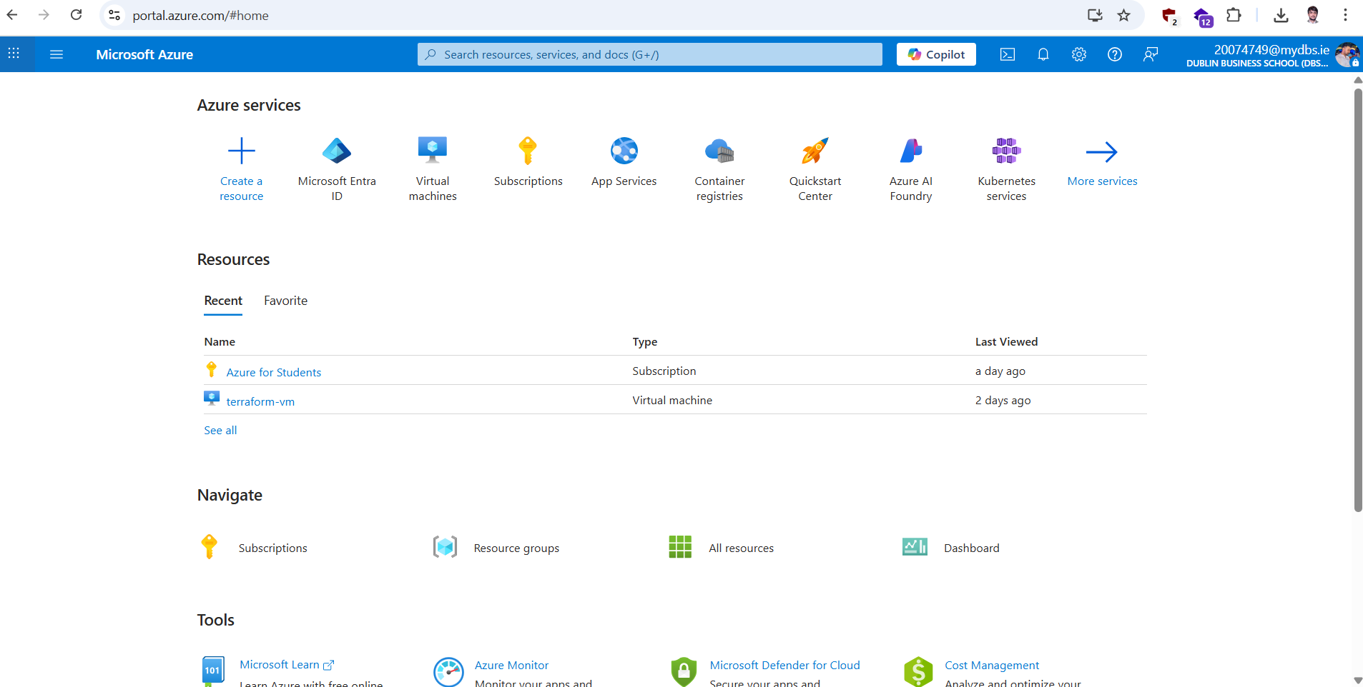
- Infrastructure Setup (Terraform on Azure)

4.1 Overview
The infrastructure setup formed the foundation of this project by providing the cloud environment required to host and deploy the containerized web application. This setup was completed using Terraform on Microsoft Azure, which allowed all required resources to be created automatically using Infrastructure as Code (IaC). Using Terraform made the deployment faster, repeatable, and consistent compared to manual configuration in the Azure portal.

4.2 Purpose of Infrastructure Setup
The purpose of this stage was to automate the creation of an Azure-based infrastructure where the Docker container could run. Terraform was used to deploy an Ubuntu Virtual Machine (VM) along with supporting resources such as a Resource Group, Virtual Network, Subnet, Network Security Group (NSG), and a Public IP address. This setup ensured a secure, reliable, and fully connected environment for later deployment and automation processes.

4.3 Resources Created
Using Terraform, several Azure resources were automatically created as part of this setup:
- Resource Group: Used to organize and manage all project-related resources under one container.
- Virtual Network (VNet): Provided a secure communication layer for the Azure resources.
- Subnet: A smaller network inside the VNet used to logically group and manage resources.
- Network Security Group (NSG): Controlled inbound and outbound traffic to the virtual machine. Two important ports were opened:
  - Port 22 – for secure SSH access to the virtual machine.
  - Port 8080 – for web access to the Dockerized calculator application.
- Public IP Address: Automatically generated by Terraform during the terraform apply command to allow external access to the VM. The deployment assigned the public IP 40.89.174.160 dynamically after successful execution.
- Virtual Machine (Ubuntu): Served as the main compute resource where Docker and the web application were deployed.
Together, these resources provided a fully functional environment suitable for application deployment and testing.

4.4 Why Terraform Was Used
Terraform was selected because it enables Infrastructure as Code (IaC), which allows users to define infrastructure in reusable configuration files. This makes it easy to create, modify, or destroy cloud environments automatically. Terraform also integrates seamlessly with Azure, enabling consistent and efficient resource creation.
Using Terraform reduced manual setup time, minimized human errors, and ensured that the same environment could be recreated whenever needed. This was especially useful for deploying multiple stages of the project, including Docker and Ansible automation.

4.5 Terraform Configuration Files
The Terraform setup was divided into several configuration files for clarity and reusability:
- main.tf: Defined all the Azure resources, including the Resource Group, VNet, Subnet, NSG, Public IP, and Virtual Machine.
- variables.tf: Contained reusable variables such as the region, VM size, and admin username.
- outputs.tf: Displayed important details after deployment, including the dynamically generated public IP (40.89.174.160).
This modular structure made it easier to understand, update, and maintain the infrastructure configuration.

4.6 Deployment and Verification
After preparing the Terraform files, the deployment process began. Terraform was initialized, planned, and then applied using the standard commands. During the terraform apply execution, Azure resources were automatically created as defined in the configuration files.
Once completed, the Azure portal showed all deployed components, including the Ubuntu Virtual Machine, Virtual Network, Subnet, Network Security Group, and the auto-generated public IP (40.89.174.160). The NSG rules confirmed that port 22 (for SSH) and port 8080 (for the web application) were open. This verified that the infrastructure was correctly set up and ready for application deployment.
Screen Shot:
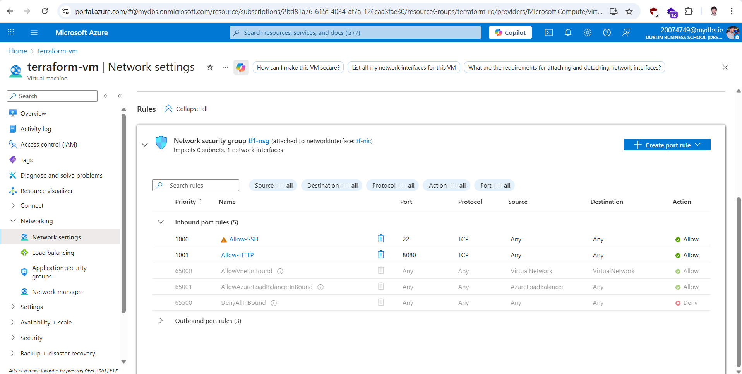Azure portal showing the running Ubuntu Virtual Machine and open ports (22 and 8080).
4.7 Summary
The Terraform-based infrastructure setup was successfully deployed on Microsoft Azure. The process automatically created all essential resources, including the Resource Group, Virtual Network, Subnet, Network Security Group, Public IP, and Virtual Machine. The public IP (40.89.174.160) was dynamically generated during deployment, providing access for SSH and web traffic through ports 22 and 8080. This setup provided a strong foundation for deploying the Docker container and automating configuration management with Ansible.
- Docker Container Deployment
5.1 Overview
After completing the Azure infrastructure setup using Terraform, the next step of the project involved deploying a sample web application using Docker. Docker is a popular containerization platform that allows applications to run in isolated environments with all necessary dependencies included.
For this project, a simple calculator web application was developed using HTML, CSS, and JavaScript. This web app served as a demonstration of how Docker can simplify application deployment in the cloud and ensure consistency across different environments.

5.2 Purpose of Docker Deployment
The purpose of this stage was to package the calculator application into a Docker container and deploy it on the Azure Virtual Machine (Ubuntu). Before automating the process, Docker was first installed and tested manually on the VM to gain a better understanding of containerization concepts. This manual process helped to understand how images, containers, and ports work together before automating the entire deployment using Ansible.

5.3 Technologies Used
The following technologies and tools were used during this stage of the project:
- Docker: Used to create, manage, and run containers for the web application.
- Docker Hub: Used to store and share the Docker image of the calculator app.
- HTML, CSS, and JavaScript: Used to design and build the calculator web application.
- Azure Virtual Machine (Ubuntu): Hosted the Docker container for running the application.
- Port 8080: Configured to make the application accessible through a web browser.
- Terraform and Ansible: Used later to automate infrastructure and configuration processes.
These technologies together provided a complete environment for developing, containerizing, and deploying the web application.
5.4 Manual Setup and Application Creation
Before moving to automation, Docker was manually installed on the Ubuntu Virtual Machine created through Terraform. This helped to understand each step of Docker installation and configuration. After installation, a simple calculator application was created using HTML, CSS, and JavaScript, which performed basic arithmetic operations.
This calculator web app was chosen because it is lightweight, easy to deploy, and clearly demonstrates how containerized applications can be hosted and accessed in the cloud.
5.5 Docker Image Creation and Push to Docker Hub
Once the application was ready, it was packaged into a Docker image. The image included all necessary files and a small web server to host the application. After testing the image locally on the VM, it was tagged and uploaded to Docker Hub.
Pushing the image to Docker Hub allowed it to be accessed and deployed easily on any system. This made the deployment process flexible, reusable, and well suited for automation in the next stages of the project.
5.6 Deployment and Verification
After the image was uploaded to Docker Hub, it was pulled back to the Azure Virtual Machine and deployed as a container. The container was configured to expose port 8080, which allowed the application to be accessed externally through a web browser.
When the container started, the calculator application loaded successfully, confirming that the containerization and networking were configured correctly. This verified that Docker was functioning properly on the VM and that the web app could run consistently in a containerized environment.
5.7 Summary
The Docker container deployment was completed successfully using the calculator web application. The process began with a manual setup to gain practical understanding, followed by the creation and testing of the Docker image. The image was pushed to Docker Hub and deployed on the Azure Virtual Machine, where it ran successfully on port 8080. This stage showed how Docker can simplify deployment, improve portability, and serve as a foundation for automation in the next phase using Ansible.
- Ansible Configuration Management
6.1 Overview
After successfully deploying the Docker container manually on the Azure Virtual Machine, the next step was to automate the configuration and deployment process using Ansible.
Ansible is an open-source configuration management tool that automates software installation, system setup, and application deployment. It uses simple YAML-based playbooks that describe automation steps in a reusable way.
In this project, Ansible was used to automate the installation of Docker on the Ubuntu Virtual Machine, pull the calculator web application image from Docker Hub, and run it automatically as a container. This eliminated the need for manual commands and made the deployment process completely automated.
6.2 Purpose of Ansible Automation
The main purpose of using Ansible was to make the deployment faster, repeatable, and error-free.
Instead of manually connecting to the VM and running Docker commands, Ansible automatically performed these tasks in sequence.
Once the playbook was executed, it handled:
- Installing Docker and its dependencies.
- Pulling the Docker image of the calculator app from Docker Hub.
- Running the container on port 8080 automatically.
This automation ensured that the same environment and application setup could be recreated anytime with a single command.
6.3 Using Ansible on Windows with WSL
Since Ansible does not work natively on Windows, it was necessary to use Windows Subsystem for Linux (WSL) to run Ansible in a Linux-like environment.
The process started by installing WSL and selecting Ubuntu as the default Linux distribution. Inside the WSL Ubuntu terminal, Ansible was installed and configured.
This allowed Ansible to connect securely to the Azure Virtual Machine via SSH and execute automation playbooks just like it would in a standard Linux setup.
Using WSL made it possible to run full Ansible automation on a Windows computer, providing an effective solution for cloud configuration management in this project.
Cmd : wsl –install
6.4 Ansible Files Used
Only two Ansible files were created and used in this project:
- inventory.ini – contained the IP address and login information of the Azure Virtual Machine.
- deploy_docker.yml – defined all automation tasks such as installing Docker, pulling the calculator image from Docker Hub, and running the container on port 8080.
This minimal setup was sufficient to automate the entire deployment process effectively.
6.5 Deployment Process
The public IP address of the Azure Virtual Machine (40.89.174.160) was added to the inventory file, and the playbook was executed.
Ansible connected to the VM through SSH, installed Docker, pulled the web application image, and started the container automatically.
Once the playbook finished, the running container was verified, and the application was successfully accessed from a web browser at:
http://40.89.174.160:8080
This confirmed that Ansible automation worked correctly and the application was deployed successfully.
6.6 Summary
Ansible successfully automated the Docker installation and container deployment process on the Azure Virtual Machine.
Because Ansible does not run directly on Windows, WSL (Windows Subsystem for Linux) was used to provide a compatible Linux environment.
With only two simple files — inventory.ini and deploy_docker.yml — the entire configuration and deployment process was automated.
This made the setup efficient, repeatable, and easy to manage, forming a strong foundation for the next stage: integrating CI/CD automation using GitHub Actions.
- CI/CD Pipeline Using GitHub Actions
7.1 Overview
After successfully automating the infrastructure setup with Terraform, configuration with Ansible, and container deployment with Docker, the final stage of the project was to automate the entire build and deployment workflow using GitHub Actions.
GitHub Actions is a continuous integration and continuous deployment (CI/CD) tool that allows automation of software workflows directly from a GitHub repository.
In this project, a CI/CD pipeline was created to automatically build, push, and deploy the Dockerized calculator web application whenever new changes were pushed to the GitHub repository. This made the deployment process fully automated and eliminated the need for manual intervention.
7.2 Purpose of the CI/CD Pipeline
The main goal of creating the CI/CD pipeline was to ensure that every code change is automatically built, tested, and deployed to the Azure Virtual Machine.
The pipeline handled the following tasks automatically:
- Build the latest Docker image for the calculator application.
- Log in securely to Docker Hub and push the image.
- Connect to the Azure Virtual Machine through SSH.
- Execute the Ansible playbook (deploy_docker.yml) on the VM to:
  - Remove any previously running container of the application.
  - Install Docker (if not already installed).
  - Pull the latest Docker image from Docker Hub.
  - Start the container on port 8080.
- Run Git push commands to synchronize any configuration or code changes back to the repository.
This ensured that the deployed application was always up to date and that the server remained clean without old containers interfering with the latest version.
7.3 Workflow File (ci_cd.yml)
A workflow file named ci_cd.yml was created in the .github/workflows/ directory of the repository.
This file defined the complete automation process for building and deploying the Dockerized application.
The workflow was triggered automatically whenever a commit was pushed to the main branch.
It included steps for checking out the repository, building the Docker image, pushing it to Docker Hub, and executing the Ansible playbook on the Azure Virtual Machine for automated deployment.
The playbook execution was enhanced to first remove any previously running container to prevent conflicts, ensuring a clean deployment every time.
7.4 GitHub Secrets and Variables
Before running the pipeline, several sensitive credentials and environment details were securely stored in GitHub Secrets and Actions Variables to protect private information.
The following secrets and variables were configured:
- DOCKER_USERNAME: Docker Hub account username.
- DOCKER_PASSWORD: Docker Hub personal access token (used for security instead of the password).
- VM_HOST: Public IP address of the Azure Virtual Machine (e.g., 40.89.174.160).
- VM_USER: Username of the VM (e.g., automation).
- SSH_PRIVATE_KEY: Private key used for SSH authentication to the VM.
Using GitHub Secrets ensured that no sensitive data such as passwords or private keys were exposed in the code or workflow file. The pipeline accessed these credentials securely during execution.
7.5 CI/CD Execution Process
- When code was pushed in the main branch, GitHub Actions automatically triggered the ci_cd.yml workflow.
- The workflow built the Docker image for the calculator web application using the latest code.
- It logged in to Docker Hub using the stored credentials and pushed the new image.
- The pipeline connected securely to the Azure Virtual Machine using the cryptographic key.
- On the VM, the workflow executed the Ansible playbook (deploy_docker.yml), which:
  - Removed any previously running Docker container of the calculator application.
  - Installed Docker (if not already installed).
  - Pulled the updated Docker image from Docker Hub.
  - Started the container on port 8080.
- The pipeline executed Git push commands to synchronize any local configuration or automation scripts back to the repository.
- Once the workflow completed, the container was verified, and the application was accessible at:
http://40.89.174.160:8080
This process ensured that deployments were clean, reproducible, and always up to date with the latest code.
7.6 Summary
The GitHub Actions CI/CD pipeline successfully automated the build and deployment of the Dockerized calculator application on the Azure Virtual Machine.
The workflow file (ci_cd.yml) managed all stages — from building the Docker image to deploying it via the Ansible playbook — without any manual steps.
New features such as removing previous containers and automated Git push ensured clean and consistent deployments.
Sensitive credentials such as Docker Hub tokens, SSH keys, VM IP, and username (automation) were securely stored in GitHub Secrets to maintain security.
This implementation demonstrated the full DevOps automation cycle — from code commit to automatic deployment — ensuring speed, consistency, and reliability in cloud-based application delivery.
- Provide Rationale for the Tools Used
Microsoft Azure:
Azure was chosen because I already had experience using it, and the student subscription offers free credits without needing a card. It integrates easily with Terraform and GitHub Actions.
Alternative (AWS/GCP): AWS needs credit card verification, and GCP is more complex for networking.
Benefit: Simple setup and free access.
Limitation: Some services are restricted in the student plan.
Terraform:
Terraform was used for creating the cloud infrastructure automatically.
Alternative (ARM Templates/CloudFormation): These are cloud-specific, while Terraform supports multi-cloud and uses easier HCL syntax.
Benefit: Easy, reusable, and cloud-independent.
Limitation: State file handling needs care.
Ansible:
Ansible was used for automation and deployment. It runs through WSL on Windows.
Alternative (Chef/Puppet): I’m not familiar these tools and difficult for beginners
Benefit: Agentless and simple YAML syntax.
Limitation: Doesn’t run natively on Windows.
GitHub Actions:
Used for CI/CD pipeline automation.
Alternative (Azure DevOps/Jenkins): Azure DevOps setup is complex and needs extra configuration; Jenkins needs a separate server.
Benefit: Built into GitHub with easy secret management.
Limitation: Limited free minutes for jobs.
9. Challenges Faced
1. Azure Student Subscription Limitation:
One of the main challenges during this project was the limited access of the Azure Student subscription. Many services and regions were not available under the free plan. While creating the virtual machine through Terraform, several regions like East US and West Europe returned permission errors or failed to deploy resources. After multiple trials, only the France Central region worked properly and allowed all required configurations such as networking, virtual machine creation, and SSH access. This limitation slightly delayed progress, but adjusting the Terraform configuration to France Central resolved the issue and allowed the setup to complete successfully.
2. GitHub Actions Workflow Errors:
Another major challenge was related to the GitHub Actions CI/CD workflow. Initially, the workflow failed to run the Ansible playbook correctly. Several errors appeared, including missing SSH permissions, incorrect file paths, and environment variable issues. Since Ansible does not run natively on Windows, additional configuration using WSL (Windows Subsystem for Linux) was required to execute playbooks properly.
To fix these problems, extensive troubleshooting and research were done on CI/CD documentation and forums. Gradually, the errors were resolved by correctly defining secrets such as Docker credentials, SSH keys, VM public IP, and usernames. After successful configuration, the workflow became fully automated — now, whenever a change is pushed to GitHub, GitHub Actions triggers automatically, removes the previous container, deploys the new one on Azure VM, and the updates appear live through the public IP instantly.

