Game Design Document
Fill up the Following document

- Write the title of your project.
Reach the top

- What is the goal of the game?
The Goal of the game is to complete the assigned works to reach the top of leader board.

- Write a brief story of your game?
In the story a task will be given each and every step will be explained,

like making a chappati the recipe will be explained and the player

should make in the same way, based on the output score and few

Diamonds will be given. In middle there will be few enemies of that person who will try to disturb him.

If he wins against them the player will be getting his own hotel where no one can disturb him. This hotel would be unlocked if he answers the given question correctly otherwise he will be losing the hotel and he has to start his game from the first.

- Which are the playing characters of this game?
- Playing characters are the ones which respond to the user based on the input from the user
- Cars, monkeys, dinos, wizards etc, are the playing characters in the game.
Number | Character Name | What can this character do?
1 | Player | Person who completes the assigned task.
2 | Enemies | Try to disturb the player.
3
4
5
6
7
8

- Which are the Non Playing Characters of this game?
- Non Playing characters are the ones which don't have an action or a behaviour when the user interacts with the game.
- Hurdles, stones, bananas, coins, etc are non playing characters in the game.
Number | Character Name | What can this character do?
1 | Things given to the player to complete his assigned task.  Like the dough to make pizza. | They just move when the player needs them.
2 | Hotel | It will just get unlocked the player answers the question.
3 | Background | It just attracts the player to play.
4
5
6
7
8

Draw your imagination of this game. What does this game look like?
- Draw the game either on your computer or on paper,
- Add images of scenes of the game to show each of the playing and non-playing characters at least once.
Non playing Characters:
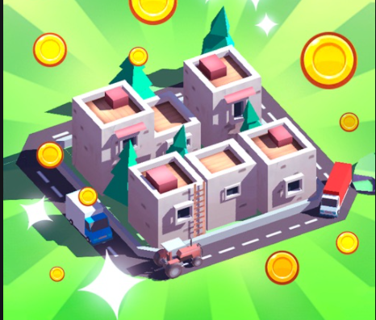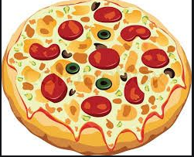
Playing Characters:

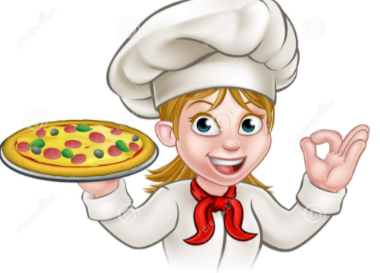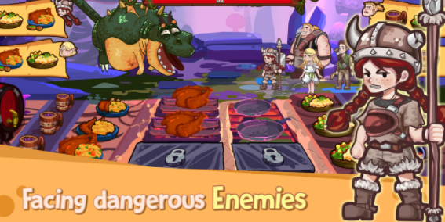

How do you plan to make your game engaging?
By increasing the level of a/q and preparing something.
By making the rate of enemies more.

