- Basic concepts
Algorithms : Step by step procedure to solve a problem or achieve some end
An Algorithm in CS is : A problem solving method suitable for implementing as a computer program and a set of rules a computer follows to achieve a certain goal.
Most algorithms need data organized in a specific way to work. Data structures
Phonebook problem : Start from middle and proceed.
Known as Binary search. However works only with Ordered data structures
Types of problems : Computable problems, non-computable problems.

Algorithm analysis : techniques that allow us to compare possible algorithms based on their characteristics.
Ex : Quantifying Execution time .
We consider each step as a Basic unit of computation.
Execution time expressed as the number of steps required by the algorithm to solve the problem.
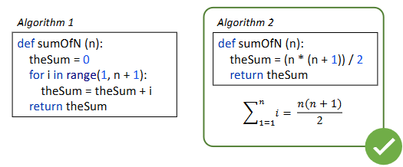

We use Assignments as the basic unit of computation.
The order of magnitude describes which increases the fastest at the value of n increases in T(n)
Order of magnitude is called the big O notation, written as 0(f(n))
The big O helps us characterize : Time complexity, Space complexity.

Best case – Big teta
Average case – Big omega
Best case – Big O
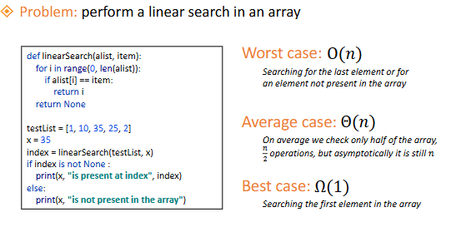

A Data structure is a particular way of organizing data so that it can be used effectively.
An Abstract data type (ADT) is the logical description of a data type and its operations.
An ADT is Implementation independent – meaning we can have different implementations for the same ADT but the interface of the structure should be the same.
A data structure is an implementation of ADT.

Data abstraction similar to prodecural abstraction used for functions. Example sqrt(), we know what it returns but now how its implemented
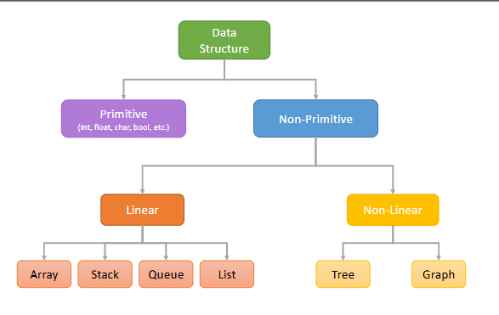
Atomic data types, int, float, bool
Collection data type : list, string, tuple (ordered), set, dictionary (unordered)

In python, ordered means the items maintain order of insertion and can be referred by an index
Unordered means the items does not maintain order of insertion and cannot be referred by an index.
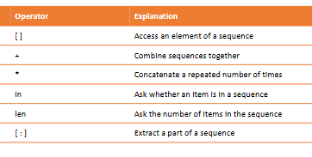
Built in data structure | List | Tuples | String | Set | Dictionary
Syntax | [1,2,3] | (1,2,3) | “blah” | {1,2,3} | {“italy”:”rome]
Hetero? | Heterogenous | Heterogenous |  | Heterogenous
Mutable? | Mutable | Immutable | Immutable | Mutable | Mutable
 |  |  | Not modifiable directly | Don’t allow duplicates | Key:value pair

Dictionaries extremely fast at set,get,delete,in. However they have high memory occuptation

- Linear data structures
Main linear data structures :
Stacks
Queues
Qedues
Arrays
Lists
Linear data structure items are arranged sequentially. Linear structures always have two ends
A Stack is a collection of items where the addition of a new item and the removal of an existing item takes place at the same end (LIFO – last in first out)
Stake(). Push(item).pop(),(peak),isEmpty(), size()
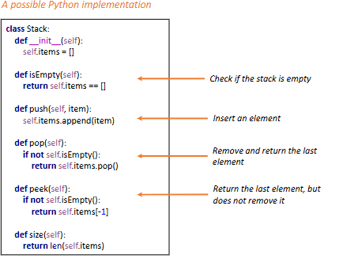
A queue is a collection of items where the addition of one items happens at the rear end and removal happens at the front end.
Queue(), enqeue(item),dequeue, isEmpty(), size().
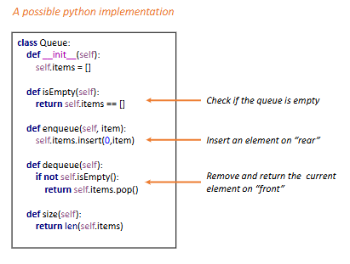

A Priority queue is a particular queue which has a priority. Position of an element in queue depends on its priority, highest priority removed first
A Deque (dek) is a double ended queue where items can be added either front or rear
Deque(), addFront(item), addRear(item), removeFront(), removeRear(), isEmpty()
m

