AI AGENT VALIDATION AND
ASSURANCE SYSTEM
Based on the OWASP Framework for Agentic Applications
━━━━━━━━━━━━━━━━━━━━━━━━━━━━━━━━━━━━━━━━━━

DOCUMENTARY BASIS AND KNOWLEDGE ORIGIN
The system is built on three official OWASP documents specific to agentic AI systems:

1. OWASP Top 10 for Agentic AI (ASI01–ASI10)
Defines the 10 highest-level risks for AI agents. Each risk (ASI) groups related threats and serves as a severity classifier.

2. Agentic AI Threats and Mitigations v1.1 (T1–T17)
A catalog of 17 granular threats with technical descriptions, exploitation scenarios, mitigations, and a taxonomy navigator (Taxonomy Navigator) that connects the agent’s operational capabilities with specific threats. It includes Appendix A: the canonical matrix that maps each threat (T-ID) to the OWASP risks (ASI-IDs) it activates.

3. Securing Agentic Applications Guide 1.0
A catalog of security controls organized into 8 domains (authentication, data, prompts, tools, inter-agent communication, supply chain, monitoring, deployment), 5 assurance methods (ASSUR-01 to ASSUR-05), and 6 operational playbooks for incident response.
All information from these three documents was structured, normalized, and linked through shared identifiers in a single JSON file that acts as the system’s Knowledge Base. The KB does not infer or interpret: it faithfully replicates the official information with identifiers traceable to their sources. Changing the OWASP version requires updating the KB, not rewriting the system.

WHAT THE SYSTEM DOES
Given an AI agent with certain declared capabilities, the system determines:
(a) Which security threats are active according to those capabilities.
(b) Which OWASP risks are activated by those threats.
(c) Which security controls are mandatory to mitigate those risks.
(d) Whether the controls are implemented and verified.
(e) Whether the agent is APT to operate in production.
The final result is a verdict with three possible values:
APT | All critical controls are covered.
APT_WITH_RESTRICTIONS | Minor controls or conditions are pending.
NOT_APT | Critical risks remain unmitigated.

The system is agnostic to the agent type and business domain. It works for any agent as long as its capabilities are declared correctly at the beginning.

THE THREE SYSTEM INPUTS
The system receives three inputs when an assessment begins:

1. CAPABILITY WIZARD
A structured questionnaire with binary (Yes/No) and closed-selection questions. It covers 46 capability_flags organized into 7 sections: agent type, architecture, tools, operational capabilities (API, code, database, web, operating system, critical systems), memory, human oversight, and lifecycle.
Each affirmative response activates one or more flags; the flags are the only input the analysis engine needs to start.

2. BUSINESS CONTEXT
Three structured fields declared by the evaluator:
• business_domain: the agent’s business sector (finance, healthcare, etc.).
• architecture_id: architectural pattern (ARCH-SINGLE, ARCH-CENTRAL, ARCH-SWARM, depending on whether the agent operates alone, has sub-agents, or is part of a distributed swarm).
• lifecycle_phases: the phases in which it is operating (design, build, runtime).
These fields do not change the set of risks in the verdict, but they scale recommendations and filter controls by phase.

3. AIBOM (AI Bill of Materials — CycloneDX 1.6 schema)
An inventory of the agent’s components: models, datasets, dependencies, supply chain, and declared sensitive data. In v1, its use is specific: the presence of a signed AIBOM constitutes attestation evidence for the supply chain control (CTRL-SC-01), and the sensitive-data metadata feeds data-protection recommendations. It does not directly modify the verdict.

SYSTEM ARCHITECTURE: LAYERS AND MODULES
The system is organized into 4 functional layers that clearly separate responsibilities. Within these layers, 7 specialized modules plus an assurance component operate, all coordinated by a central orchestrator.

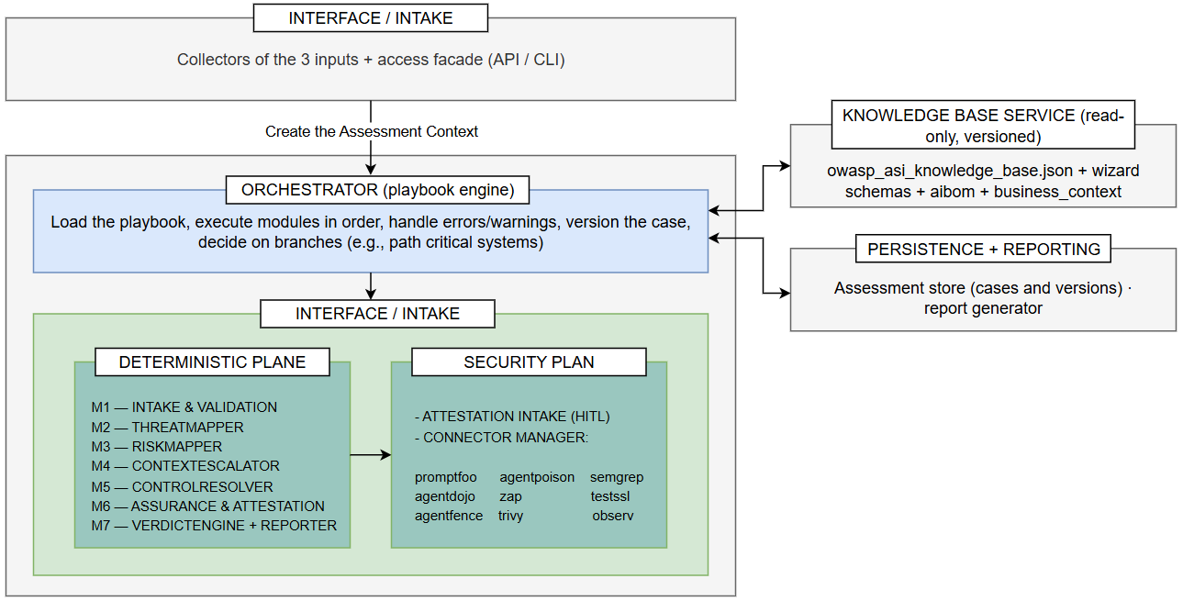

LAYER 1 — INTERFACE / INTAKE
Entry point. It receives the evaluator’s 3 inputs (wizard, business context, aibom) and creates the case object (Assessment Context) that will flow through the entire system.

LAYER 2 — ORCHESTRATOR
Executes the playbook: the declarative sequence of modules and transition conditions. It contains no security logic; it only coordinates. It manages errors, warnings, branches, and the assurance pause. The playbook is data (YAML/JSON), not code, which allows variants without modifying the orchestrator.
Two clearly differentiated planes operate within Layer 2:

DETERMINISTIC PLANE
Modules that are pure functions over inputs and the KB. They have no external effects and are reproducible and cacheable:
• M1 Intake & Validation, M2 ThreatMapper, M3 RiskMapper, M4 ContextEscalator, M5 ControlResolver, M7 VerdictEngine, R Reporter.

ASSURANCE PLANE
The only non-deterministic component:
• M6 Assurance & Attestation, which manages human evidence (HITL) and the execution of external tools (connectors).

LAYER 3 — KNOWLEDGE BASE SERVICE
Read-only access to the KB (owasp_asi_knowledge_base.json). All modules query the KB through this service; none hardcode OWASP semantics. It is versioned: each assessment records which KB version it used, ensuring reproducibility and auditability.

LAYER 4 — PERSISTENCE + REPORTING
Stores each Assessment Context and its transition history for auditing. It allows assessments paused during assurance to be resumed and produces the final report in human-readable and machine-readable formats.

The distinction between the deterministic plane and the assurance plane is the central architectural decision: modules M1–M5, M7, and R can run, be cached, and be rerun without any external tool or human intervention. The verdict (M7) can only be calculated after M6 completes evidence collection. This is the reason for the pause at step 6 of the playbook.

HOW INFORMATION FLOWS: THE PIPELINE
The three inputs pass through the 7 modules in sequence through the Assessment Context: a single case object that each module reads and enriches. There is no hidden state between modules; everything a module produces is written to that same object.
Risk derivation follows a single path, faithful to the OWASP framework:
capability_flags → Taxonomy Navigator (STEPs) → Active threats (T-IDs)
→ Appendix A (maps_to_asi) → Active risks (ASI-IDs)
→ critical_controls_by_risk → Mandatory controls → Verdict
There is no direct path between capabilities and risks. The system always passes through the intermediate levels (STEPs → T-IDs → ASI), because this is how the OWASP documentation defines the relationship and because this path produces the complete traceability required for an auditable verdict.

THE 7 MODULES

M1 — INTAKE & VALIDATION
Receives the three inputs and verifies their completeness and consistency. It detects inconsistencies between the wizard and the business context (for example: multi-agent architecture declared in business_context but multi_agent_architecture=false in the wizard). Blocking errors stop the pipeline; warnings accumulate and processing continues.

M2 — THREATMAPPER
For each active capability_flag, it identifies which STEPs of the Taxonomy Navigator are activated. For each active STEP, it extracts the corresponding threats (T-IDs) according to the KB. It produces the set of active threats with complete traceability: each T-ID records which flag and which STEP originated it.

M3 — RISKMAPPER
For each active T-ID, it queries Appendix A (threat_catalog.maps_to_asi) and accumulates the set of active ASI risks. The relationship is M:N: one threat can activate multiple ASIs, and one ASI can group multiple threats. The set of active ASIs is the input that determines which controls are blocking for the verdict.
Special case T9 (Identity Spoofing): it activates a threat but has no associated ASI in Appendix A. Its controls appear as recommendations, not as blocking conditions for the verdict. This is faithful to the OWASP documentation.

M4 — CONTEXTESCALATOR
Applies the business context and the aibom to the analysis. It increases the required oversight if the agent operates in high-risk domains (finance, healthcare, critical systems — aligned with the EU AI Act). It reads the declared architecture and adds pattern-specific security recommendations (ARCH-CROSS practices are always included). It does not modify the set of ASIs used for the verdict.

M5 — CONTROLRESOLVER
Produces two control lists with different purposes:
• Sub-path A (for the verdict): queries critical_controls_by_risk[ASI] and obtains the minimum mandatory controls for each active ASI. These are 27 unique controls that determine APT / NOT_APT.
• Sub-path B (for the report): queries the complete control catalog (48 controls across 8 domains), filters by active threats and lifecycle phase, and produces the recommendation list. The controls in sub-path A are a subset of this list.

M6 — ASSURANCE & ATTESTATION [ONLY MODULE THAT CANNOT BE FULLY AUTOMATED]
Manages verification that the controls are implemented. It has two components:
• Attestation intake (HITL): the evaluator receives a checklist of critical controls (one for each CTRL-ID in sub-path A), declares the implementation status, and provides evidence for each control.
• Connector manager: invokes technical validation tools (scanners, red-teaming frameworks, behavioral analyzers) and collects their results as structured evidence.
The controls are divided into three validation categories:
• herramienta_tecnica (28): verifiable with automated tools.
• revision_configuracion (13): require configuration inspection.
• proceso_humano (7): require a formal declaration or organizational process.
This module is the pipeline’s only assurance point. M7 cannot issue a verdict until M6 has completed evidence collection.

M7 — VERDICTENGINE + REPORTER
Evaluates critical-control coverage against the decision framework:
• If all controls in sub-path A are covered → APT.
• If minor controls are pending or HITL is incomplete → APT_WITH_RESTRICTIONS.
• If a critical control for a high-severity ASI (ASI01, ASI02, ASI03, ASI05, ASI06) is missing, or there is no incident response plan → NOT_APT.
Generates the final report with the verdict, complete traceability (flag → threat → risk → control), the list of pending controls, complete recommendations from sub-path B, and the applicable playbooks.

SEPARATION BETWEEN TAXONOMY AND DECISION
The OWASP framework defines the risk and control taxonomy, but it does not define when an agent is “fit for production.” That definition is the system’s own contribution, declared explicitly:
Taxonomy (100% OWASP) | capability_flags → Threats → ASI → controls.
Decision (system layer) | APT / APT_WITH_RESTRICTIONS / NOT_APT, the high-severity thresholds, and the coverage-evaluation logic.

This separation is deliberate: it makes it possible to audit that the system follows the OWASP framework in the analysis layer and to audit that the production criteria are reasonable in the decision layer, without mixing the two responsibilities.

TRACEABILITY AND AUDITABILITY
The final verdict includes the complete trace for each decision:
For each required critical control:
• which ASI requires it
• which T-IDs activated that ASI
• which capability_flags activated those T-IDs
• which evidence supports that the control is implemented
This allows any part of the verdict to be traced back to a declared agent capability and to the corresponding OWASP article. There are no opaque decisions.

