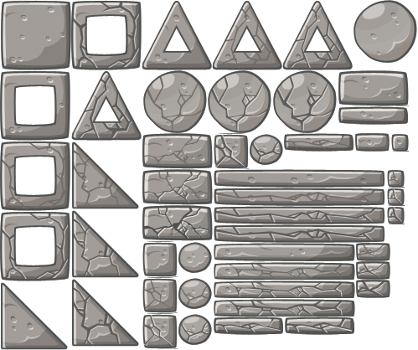
1
2
3
4
6
7
13
8
14
5
9
10
11
12
23
22
21
19
20
18
16
28
17
15
32
33
26
25
27
29
30
31
34
35

24

36

37

38
40

39
41

42

SE COMIENZA DE ARRIBA,DERECHA,ABAJO,IZQUIERDA:

- (0,334.4) (0,418)(83.17,418)(83.17,334.4)
- (83.17,334.4) (83.17,418)(166.34,418)(166.34,334)
- (166.34,334) (166.34,418)(249.51,418)(249.51,334.4)
- (249.51,334.4) (249.51,418)(332.68,418)(332.68,334.4)
- (332.68,334.4) (332.68,418)(415.85,418)(415.85,334.4)
- (415.85,334.4) (415.85,418)(499,418)(499,334.4)
- (0,250.8)(0,334.4)(83.17,334.4)(83.17,250.8)
- (83.17,250.8) (83.17,334.4)(166.34,334.4)(166.34,250.8)
- (166.34,250.8) (166.34,334.4)(249.51,334.4)(249.51,250.8)
- (249.51,250.8) (249.51,334.4)(332.68,334.4)(332.68,250,8)
- (332.68,250,8) (332.68,334.4)(415.85,334.4)(415.85,250.8)
- (415.85,250.8) (415.85,334.4)(499,334.4)(499,250.8)
- (0,167.2)(0,250.8)(83.17,250.8)(83.17,167.2)
- (83.17,167.2) (83.17,250.8)(166.34,250.8)(166.34,167.2)
- (0,83.6)(0,167.2) (83.17,167.2)(83.17,83.6)
- (83.17,83.6) (83.17,167.2)(166.34,167.2)(166.34,83.6)
- (0,0)(0,83.6)(83.17,83.6)(83.17,0)
- (83.17,0) (83.17,83.6)(166.34,83.6)(166.34,0)
- (166.34,209)(166.34,250.8)(249.51,250.8)(249.51,209)
- (166.34,167.2)(166.34,209) (249.51,209)(249.51,167.2)
- (166.34,125.4)(166.34,167.2) (249.51,167.2)(249.51,125.4)
- (166.34,83.6)(166.34,125.4)(207.925,125.4)(207.925,83.6)
- (249.51,209) (249.51,250.8)(291.095,250.8)( 291.095,209)
- ------------------------
- ( 291.095,209) (291.095,250.8)(332.68,250.8)( 332.68,209)
- (332.68,229.9)(332.68,250.8)(415.85,250.8)(415.85,229.9)
- (415.85,229.9) (415.85,250.8)(499,250.8)( 499,229.9)
- a y b respectivamente: (249.51,188.1)(249.51,209)(457.495,209)( 457.495,188.1) -------------------------------------------(249.51,167.2)(249.51,188.1) ( 457.495,188.1)(457.495,167.2)
- a y b resp. :(249.51,146.3)(249.51,167.2) (457.495,167.2)(457.495,146.3)------------------ (249.51,125.4)(249.51,146.3) (457.495,146.3)(457.495,125.4)
- a y b respect: (249.51,104.5)(249.51,125.4)(415.85,125.4)(415.85,104.5)--------------------------- (249.51,83.6)(249.51,104.5) (415.85,104.5)(415.85, 83.6)
- a y b respect.: (249.51,62.7)(249.51,83.6) (415.85, 83.6)(415.85,62.7)----------------------------- (249.51,41.8)(249.51,62.7) (415.85,62.7)(415.85,41.8)
- (166.34,41.8)(166.34,83.6)(207.925,83.6)(207.925,41.8)
- (166.34,0)(166.34,41.8) (207.925,41.8)(207.925,0)
- (249.51,20.9)(249.51,41.8)(332.68,41.8)(332.68,20.9)
- (332.68,20.9) (332.68,41.8)(415.85,41.8)(415.85,20.9)
- a y b resp. : ( 457.495,188.1) (457.495,209)(478.2125,209)( 478.2125,188.1)--------------------------- (457.495,167.2) ( 457.495,188.1) ( 478.2125,188.1) (478.2125,167.2)
- (457.495,146.3)(457.495,167.2) (478.2125,167.2)(478.2125,146.3)
- a y b respect. : (415.85,104.5) (415.85,125.4)(457.495,125.4)(457.495,104.5)------------------ (415.85, 83.6) (415.85,104.5) (457.495,104.5)(457.495,83.6)
- (415.85,62.7) (415.85, 83.6) (457.495,83.6) (457.495,62.7)
- (207.925,83.6) (207.925,125.4)(249.51,125.4)(249.51,83.6)
- (207.925,41.8)(207.925,83.6) (249.51,83.6)(249.51,41.8)
- (207.925,0)(207.925,41.8) (249.51,41.8)(249.51,0)

374
249.34
0.0

124.67


129.3
388
258.6


0.0
78.3
156.6
234.9
313.2
391.5
470
135


374
129.3
249.34
388
124.67
258.6
0.0


0,0
79
158
237
316
395
111


511
340.6
170.3
0,0
166.67
333.334
500

