In a distribution of 8,500 different measurements of the variable *x,* 26.5 is the 56th percentile and 37.1 is the 78th percentile. Which of the following is closest to the number of measurements of *x* that are in the distribution such that 26.5 ≤ *x ≤*37.1 ?  **A**. 1,850 B. 2,200 C. 3,500 D. 4,750 E. 6,650

X percent of y = y percent of x

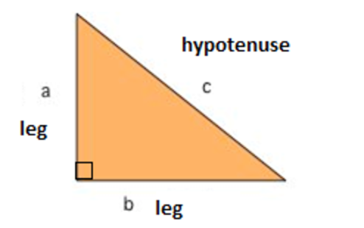

nearest tenth of a percent : 26.5%=>30%

