

DAA-20CS2220AH

DESIGN & ANALYSIS OF ALGORITHMS(DAA)

PROJECT DOCUMENTATION

TEAM MEMBERS:-

1) VIYYAPU V S D SAI VAMSI – 2010030529

Under Guidance of :-

Dr. Udaya Rani Gurala

TABLE OF CONTENTS:-

|  |  |  |
| --- | --- | --- |
| S.No. | Title | Pg.No. |
| 1 | Abstract |  |
| 2 | Introduction |  |
| 3 | Literature Review |  |
| 4 | Flow Process |  |
| 5 | Methods |  |
| 6 | Implementation |  |
| 7 | Conclusion |  |

Project Abstract:-

In the vertex splitting problem, the objective is to determine a minimum number of vertices from the graph to split such that the resulting graph has no path of length greater than a given δ.

The problem has been proven to be NP-hard. A Genetic Algorithm is used to solve the DAG Vertex Splitting Problem.

This approach uses a variable string length to represent the vertices that split the graph and a dynamic population size

Introduction:-

Directed Acyclic Graphs are often used to model circuits and networks. The path length in such Directed Acyclic Graphs represents circuit or network delays. I has many applications in the fields of computer science and electrical engineering

Algorithms for this project:-

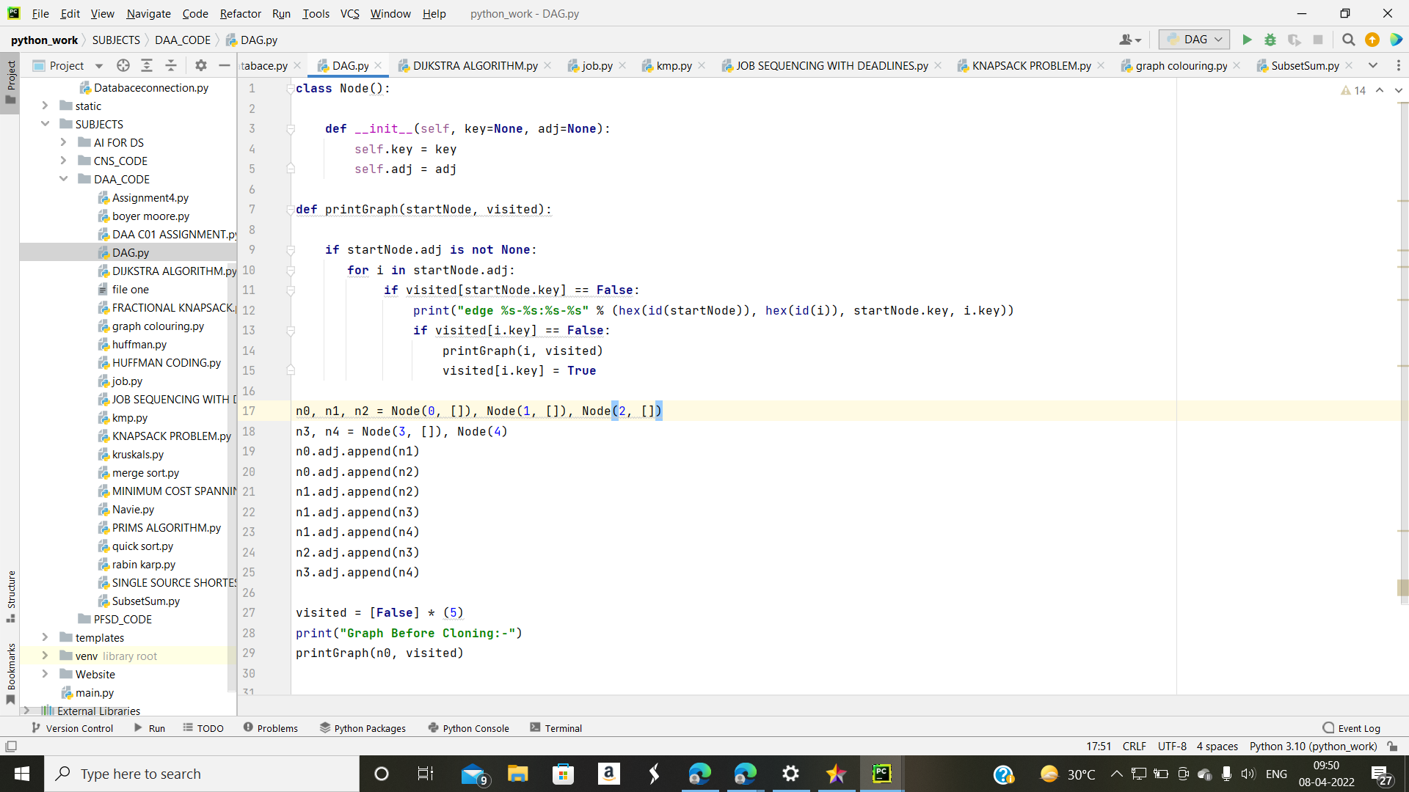

Flow Process:-

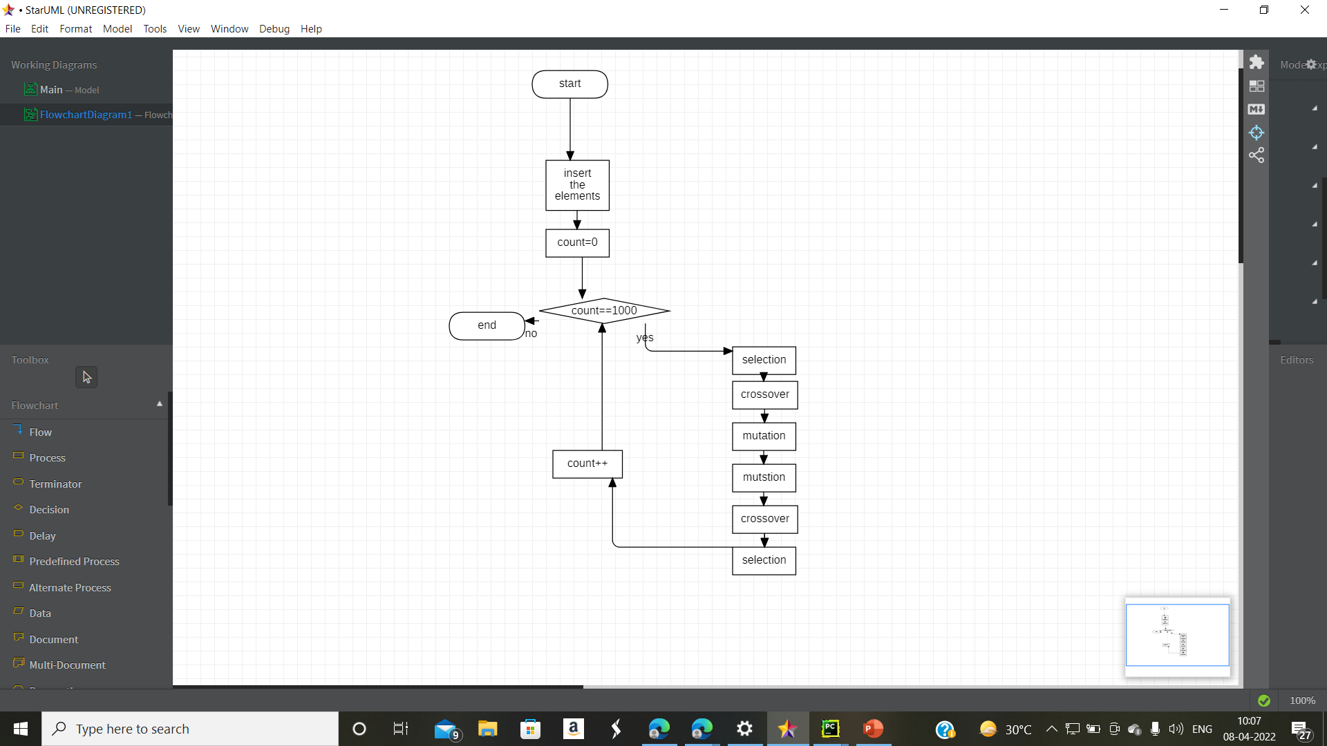

Implementation :-

* We can use Genetic Algorithms for vertex splitting

Basically, the algorithm works as follows

* 1) try to find a suboptimal solution by splitting x vertices
* 2) if a suboptimal solution is found, reduce the number o f vertices and try again
* 3) if no solution has been found within a certain number of generations, expand the
* number o f vertices and try again
* equation
* Let G = (V, E, w) be a weighted directed acyclic graph (WDAG) with vertex set V, edge
* 2
* set E, and edge function w. w(i, j) is the weight of the edge <i, j> e E. w(i, j) is a positive
* real number for <i, j> e E and is undefined if <i, j> £ E. The delay, d(P), on the path P, is
* the sum of the weights of all the edges on that path. The delay, d(G), of the graph G is the
* maximum path delay in the graph.

Project GitHub:-



Conclusion: -using this we can find the shortest distance