ENCRYPTION

The ciphertext is generated from the plain text by using an encryption process in this method the message is generated like a code the sender give some input(keys) so that the message Shaffle its positions and the user can repeat this process as many times he can and as many times he does this the plane text turn in very complex to decode

APPLICATIONS

We use this process mainly in storing the passwords

The password we create are stored in the data base in encrypted form because id the hacker is gets aces with database he can also see all usernames and passwords because of this reason we use encrypted passwords instead of real passwords 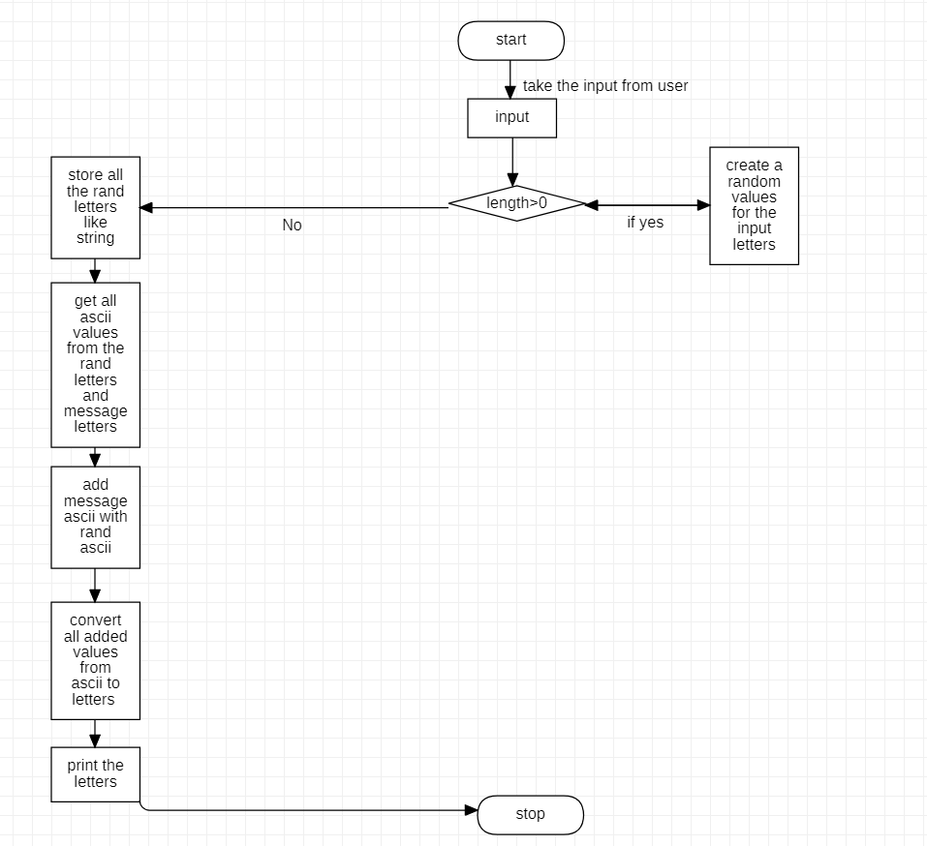

PROCESS

I did this project using python so

First we have to give input , the input can be any size after that we generate random values for each letter in the message so this random values are used as keys this keys are used in decryption process we take ascii values of each letter and add with ascii value of randomly generated message so we get a bunch of ascii values we have to convert to letters and this letters are stored as string this string is known as ciphertext or Encrypted message

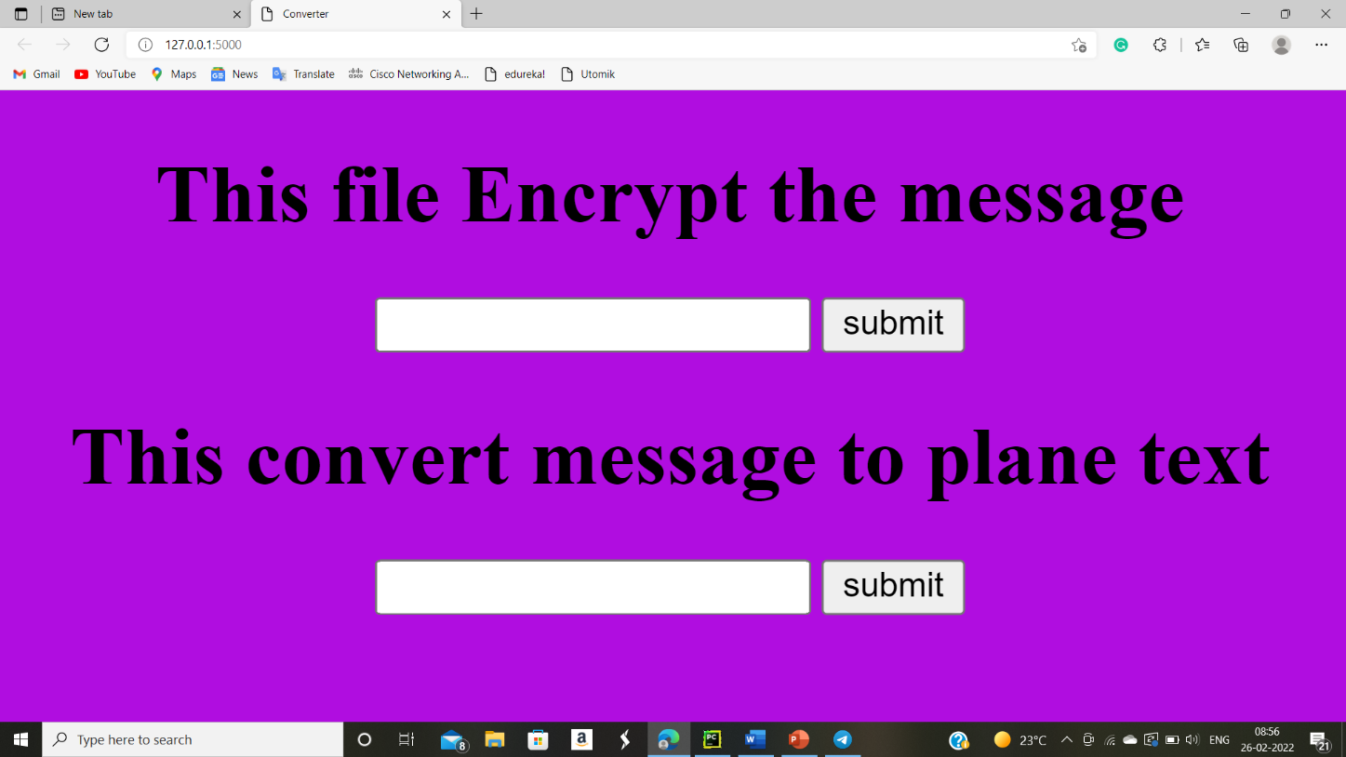

The above text box is to give the message and it encrypt the message the below text bare is to decrypt the message