# PRINTF SCANF

Q1. WAP with

1a. function readdisplay() to read the following data types only one at a time at run time and to display.

1. char type
2. integer type
3. char array of maximum 80 characters
4. short type
5. float type

TestData:

‘c’, 8978, “hello”, 8, 45.678

‘H’, 254, “hello Hi How”, 256, 145.2678

A:

1b. Create a copy of readdisplay() as function readdisplay2() with changes below

* Instead of reading 1 data at a time, read all inputs using a single scanf().

Test readdisplay2() by changing the read order. Do you observe any issue?

A:

1c. display the char array content in upper case

A:

1d. Add code to display the size of each data type mentioned in Q1a and sizeof the variables of each datatype (You may refer sample code in data_type_size.c )

A:

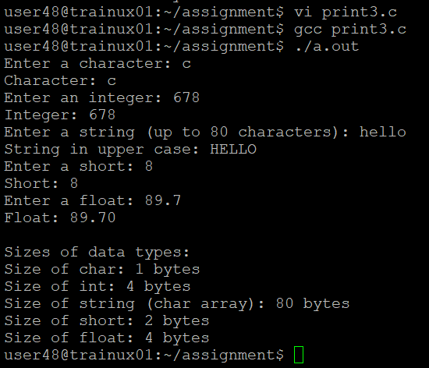

Q2. Try to run the program with code snippet below. Check the output and analyse. Fix it to get correct result.

#include<stdio.h>

int main()

{

unsigned long int ul = 200333333334340;

printf("value is:%d\n", ul);

return 0;

}

A: The %d specifier is used for signed int types, but we need to use %lu to print unsigned long int.This fix will correctly display the value of ul.

