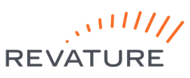  
[APPLICATION_NAME]

[Description, no more than four (4) lines]

**Team Members:**

**Users can:**

· Register.

· Login/Logout.

· Recover their password.

o Email feature.

· [User Story 1].

· [User Story 2].

· [User Story 3].

· [User Story 4].

**Technology Stack:**