Network hw04

FTP - by TCP

Koomin University – Computer Science

TEAM 7

Manual

1. Server
2. Command : ./server port

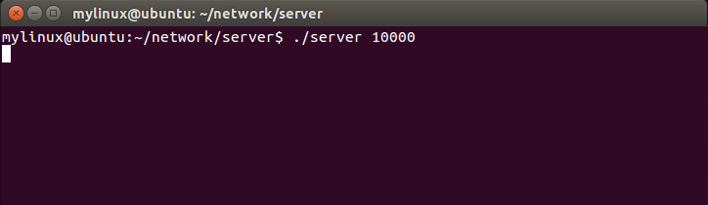

1. If client connect to server,

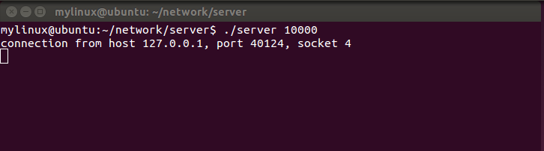

1. Receive File from client / Send File to client

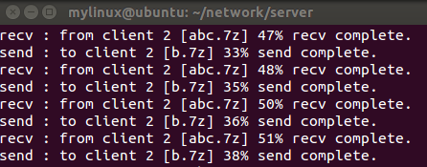

1. Cleint
2. Command

* Excute : ./client

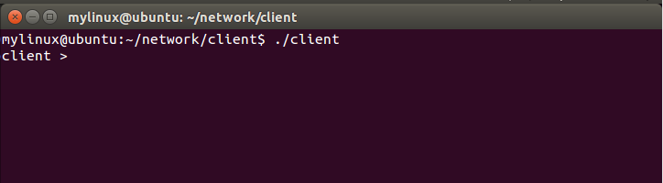

* Connect : connect [server port] [server ip]

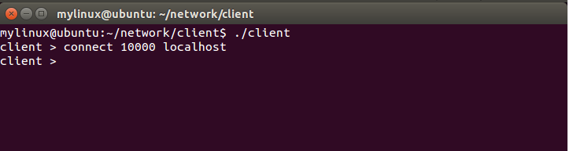

* Send rate / Receive rate : ratecurr

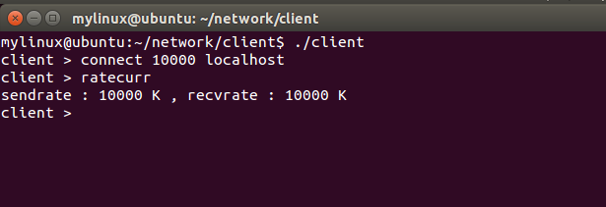

* Chage rate : sendrate [value] / receiverate [value]

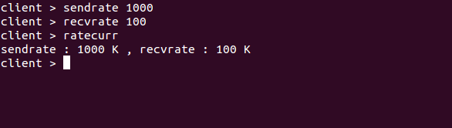

* File send to server : put [filename]

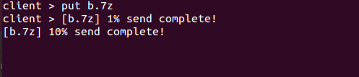

* File receive from server : get [filename]

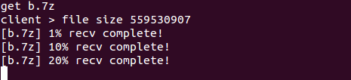

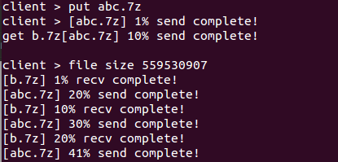

* Disconnect : close

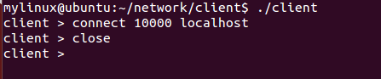

* End : quit

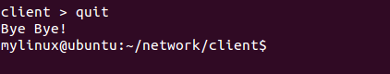

Explanation

1. UI
2. Server

* The server is implemented to output a time condition to the second.

1. Client

* The client has implemented so as to output the state every time a file is changed by 10%. In this way, the console window without very busy, and so the user can use console window for command.

1. Speed Control

* We measure the data transfer rate per second. If it is given and is higher than the rate, to control the speed by using the usleep().

1. Option

* We use the " fork () ", put function and get function is implemented as separate runs. Moreover, it assigned a TCP socket, one for each function. Therefore, it is possible to satisfy both Option A and Option B.

GitHub : https://github.com/20103306/network