Chapter 1 Assignment

1、Suppose Tl(n) = O(f(n)) and T2(n) = O(f(n)). Which of the following are true?
a. T1(n) + T2(n) = O(f(n))
对. T1(N) + T2(N) = max{O(f(N)), O(f(N))} = O(f(N)).
b. T1(n) - T2(n) = O(f(n))
对.T1(N)-T2(N) <= min{O(f(N)), O(f(N))}= O(f(N))，O非严格小于，等式成立
原题为o则错误，因为o是严格小于， T1(N) = 2N = O(N)且T2(N) = N = O(N)，T1(N)-T2(N)=n≠o(f(n))
c. T1(n)/T2(n) = O(1)
错. T1(N) = N^2 = O(N^2)且T2(N) = N = O(N^2).
所以 f(N) = N^2 但 T1(N)/T2(N) = N^2/N = N ≠ O(1).
d. T1(n) = O(T2(n))
错. T1(N) = N^2 = O(N^2) 且 T2(N) = N = O(N^2)
f(N) = N^2 and T1(N) = N^2 ≠ O(N) = O(T2(N))
2、For each of the following six program fragments:
a. Give an analysis of the running time (Big-Oh will do).
b. Implement the code in C language, and give the running time
for several values of n.
c. Compare your analysis with the actual running times.

(1) sum = 0;
for( i=0; i<n; i++ )
sum++;
O(n) 在for循环的每次迭代过程中执行的操作c为常量，并且迭代n次。所以c * n = O(n).
(2) sum = 0;
for( i=0; i<n; i++ )
for( j=0; j<n; j++ )
sum++;
O(n^2) 在for循环的每次迭代过程中执行的操作c为常量，并且迭代n^2次 c ∗n^2 = O(n^2)
(3) sum = 0;
for( i=0; i<n; i++ )
for( j=0; j<n*n; j++ )
sum++;
O(n^3 )

(4) sum = 0;
for( i=0; i<n; i++ )
for( j=0; j<i; j++ )
sum++;
O(n^2 )
(5) sum = 0;
for( i=0; i<n; i++ )
for( j=0; j<i*i; j++ )
for( k=0; k<j; k++)
sum++;
O(n^5)

(6) sum = 0;
for( i=1; i<n; i++ )
for( j=1; j<i*i; j++ )
if( j%i == 0 )
for( k=0; k<j; k++ )
sum++;
O(n^4 )
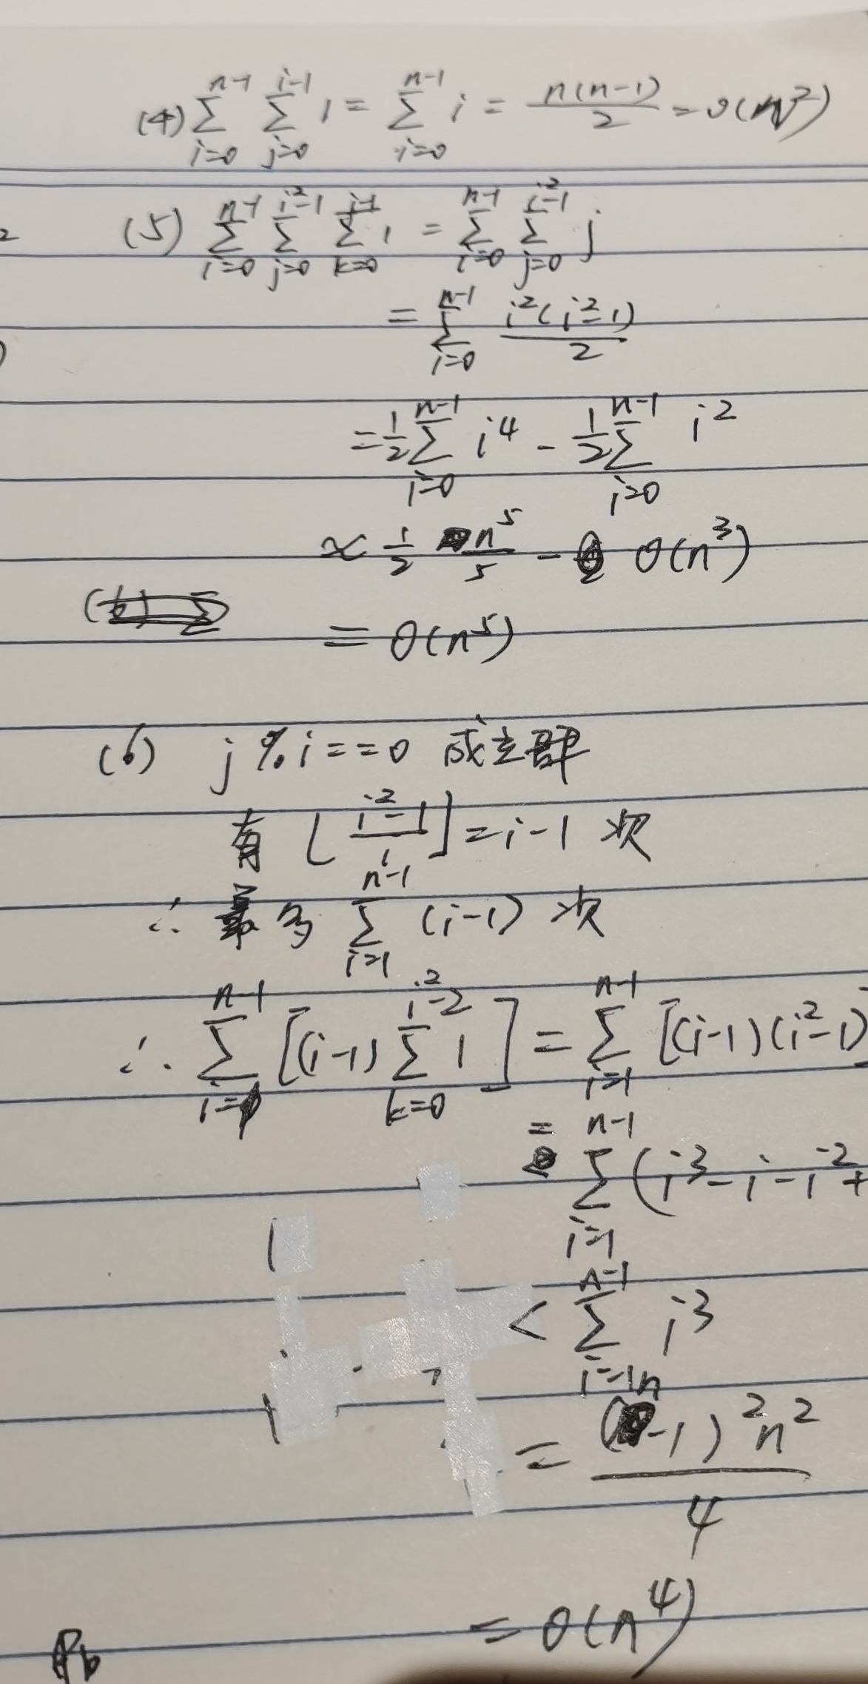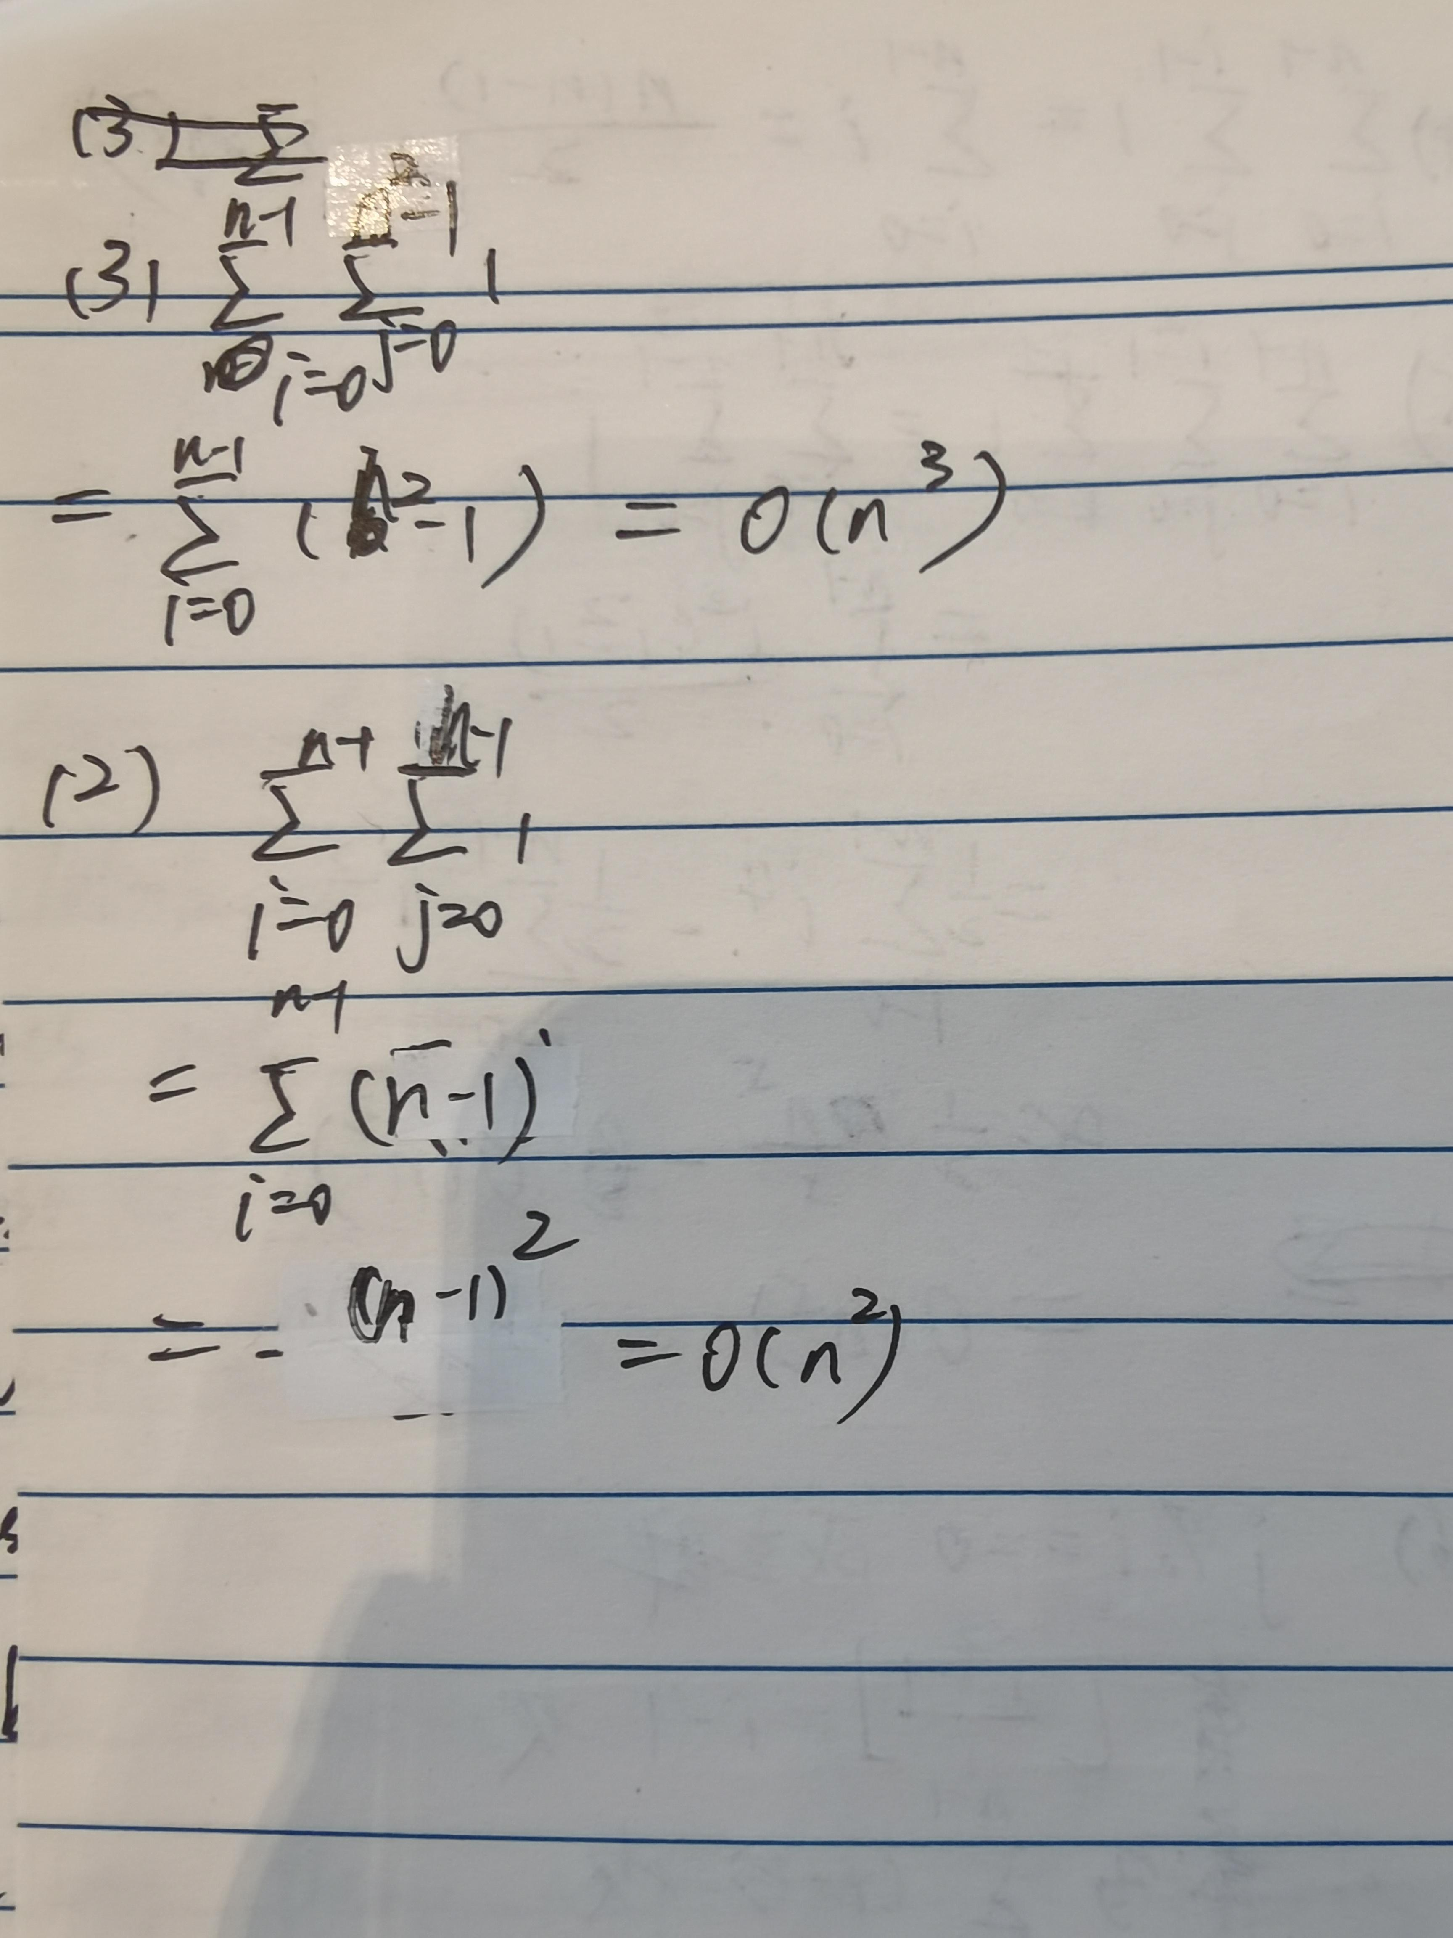

3、Give an efficient algorithm to determine if there exists an integer i such that ai = i in an array of integers a1< a2 < a3< . . . < an
. What is the running time of your algorithm?
第一种：
#include<cstdio>
#include<cstdlib>
#include<cstring>
#include<iostream>
using namespace std;
int k,num,data1[10086],flag;
int main()
{

cin>>k;
while(k!=0)
{
memset(data1,0,sizeof(data1));
flag=0;
cin>>num;
for(int i=0;i<=num-1;i++)
{
cin>>data1[i];
if(data1[i]==i&&flag==0)
{
cout<<i<<endl;
flag=1;
}
//cout<<data1[i]<<" ";
}
if(!flag)
{
cout<<"-1"<<endl;
}
k--;
}
return 0;
}
最坏时间复杂度 ： O(N)
第二种
#include<cstdio>
#include<cstdlib>
#include<cstring>
#include<iostream>
#include<cmath>
using namespace std;
int k,num,data1[10086],flag;
int find(int a[], int N)
{
int lower=1, upper=N, mid;
while (lower <= upper)
{
mid = (lower+upper)/2;
if (a[mid]>mid)
upper = mid-1;
else if (a[mid]<mid)
lower = mid+1;
else
return mid;
}
return 0;
}
int main()
{

cin>>k;
while(k!=0)
{
memset(data1,0,sizeof(data1));
flag=0;
cin>>num;
for(int i=1;i<=num;i++)
{
cin>>data1[i];
data1[i]++;
}
flag=find(data1,num);
if(flag)
cout<<flag-1<<endl;
else
{
cout<<-1<<endl;
}
k--;
}
return 0;
}
最坏时间复杂度 ： O(logN)
但是在oj上反而不如第一种

4、 To display the complexity of the following expression with ascending sort order.

A 、n*log₂(n) B、n+n²+n³ C、24 D、n^{0.5}
cdab
C：常量，最小
D：n^0.5
A:n^1>n^0.5,n*log2(n)>n^0.5
B:相当于O（n^3）n>log2(n),n*log2(n)<n^3

5、With a big O notation to describe the complexity of the following expression.

A、5n^{5/2}+n^{2/5} O(N^5/2) n^(5/2)>n^(2/5)
B、6*log₂n + 9n O(N) n>log2(n)
C、3n⁴+n*log₂n O(N^4) n>log2(n),n^3*n>n*log2(n)
D、5n²+n^{3/2} O(N^2) n^2>n^(3/2)

