

Here I have used use, show collections, create collection query



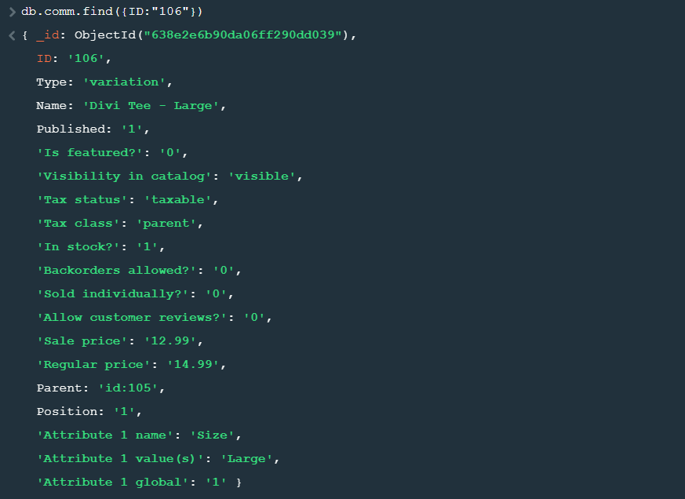

Here by using find query we have found the data of ID:106

Find().limit(2)-shows you only 2 documents.

Remove()-remove all the documents which matches the conditions.

Count()-count the Number of documents in the collection

CountDocuments()-gives you the count of the documents

updateOne()-update only one data that matches the condition

updateMany()-update more than one.

replaceOne()-replace the data of one document requires 2 conditons 1.that helps to find 2.the one you want to replace with.

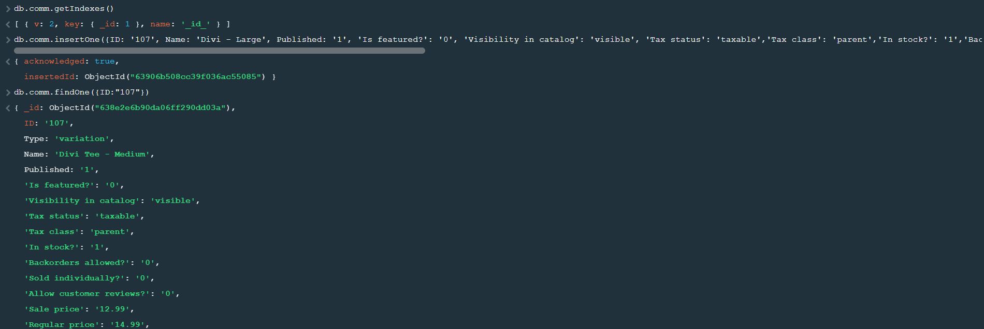

getIndexes()-used to get the default id in a collection

insertOne()-used to insert one data in a collection

insertMany()-used to insert more than one query

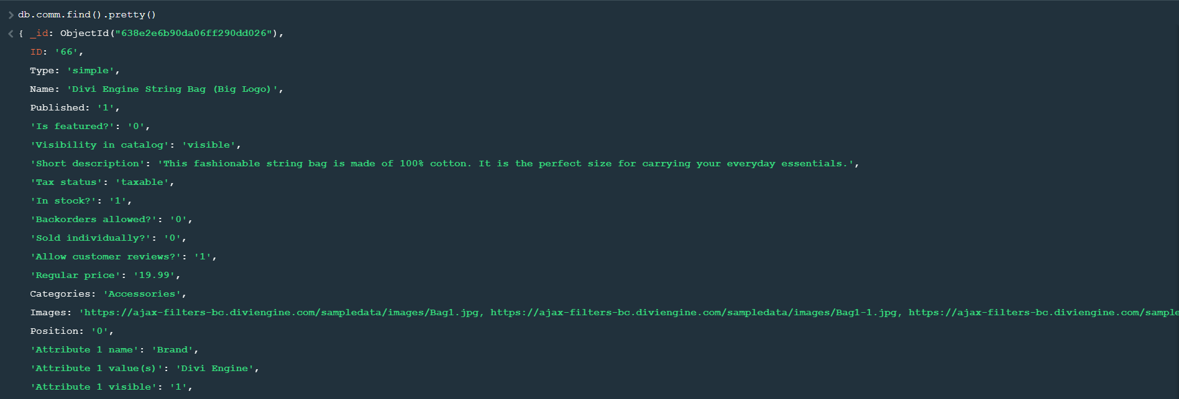

Find().pretty()-gives you all the data present in the collection on it will give you more

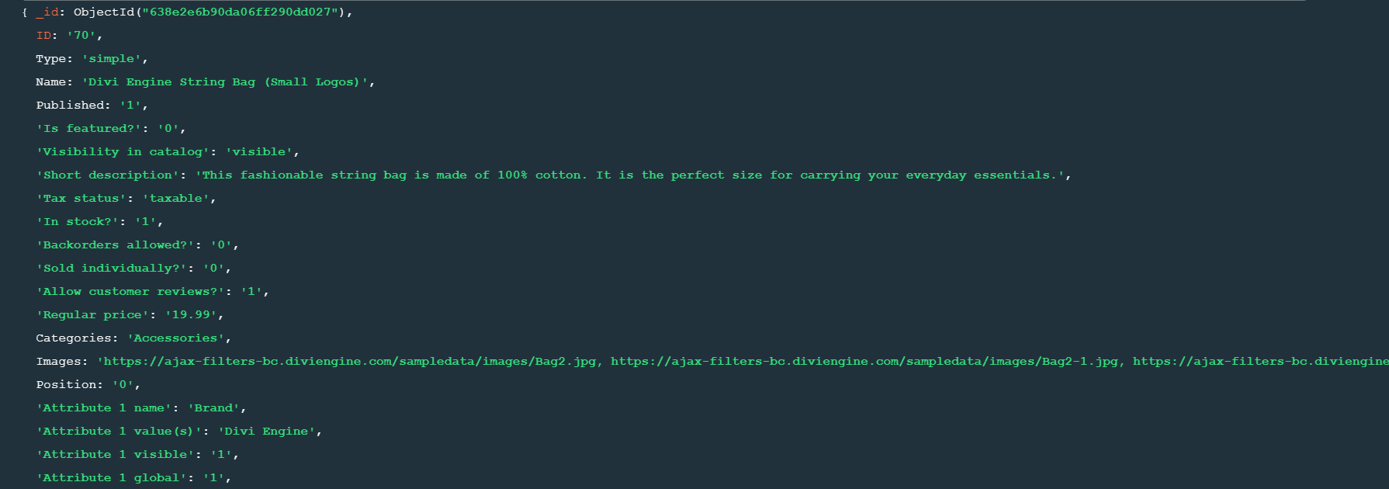

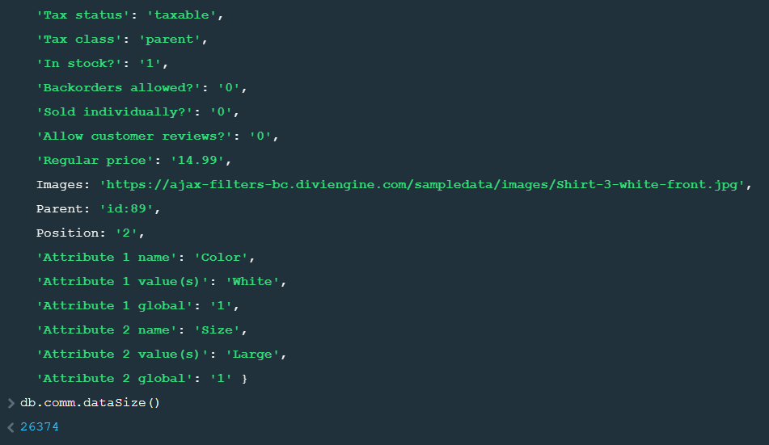

dataSize()-gives the size of the data

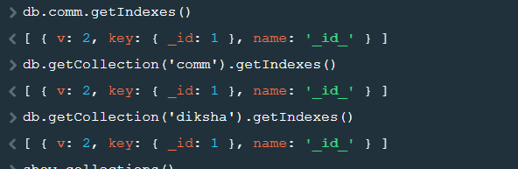

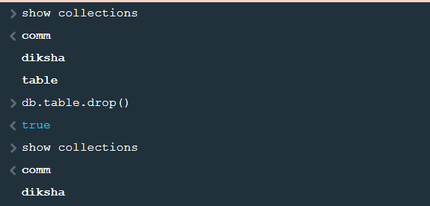

Drop()-used to drop the collection

First we had 3 collections after using drop query it droped table collection from data base ecomm

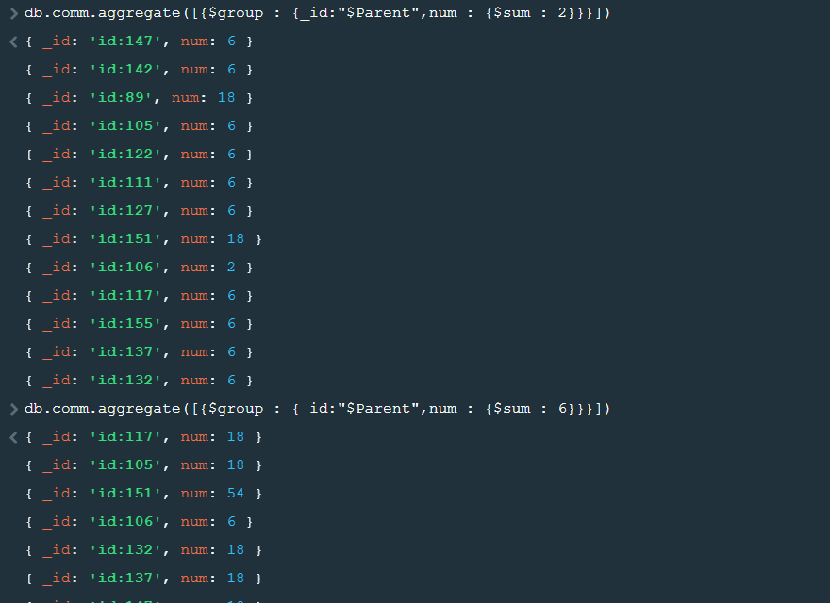

Aggregate()-this query is used to make groups I have grouped the data whose Parent id’s are same .Then we can have sum, avg, min and max

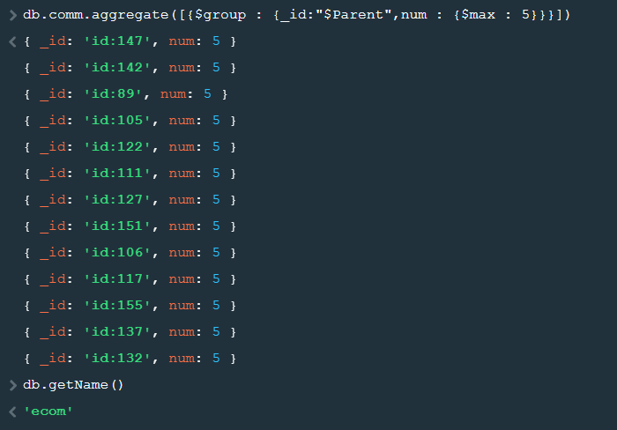

getName()-to get the name of the database

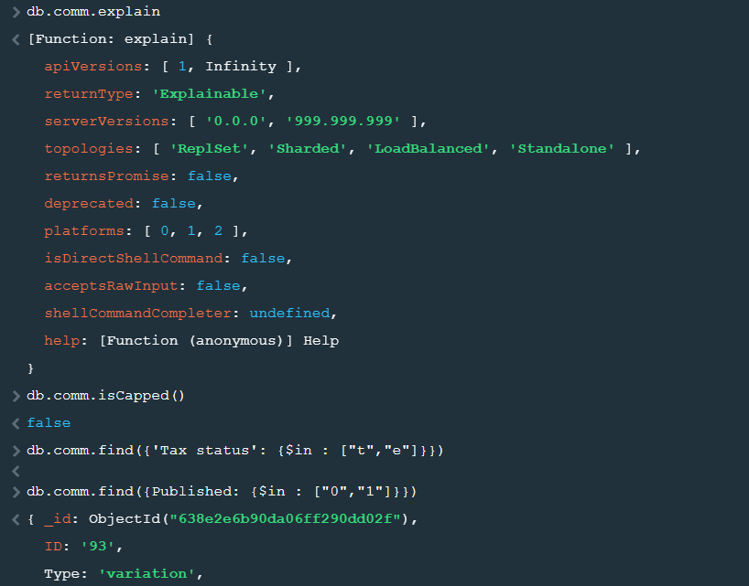

isCapped()-gives you either true or false tells you if the data is of fixed size or not

find($in)-find the data which lie between 0 and 1

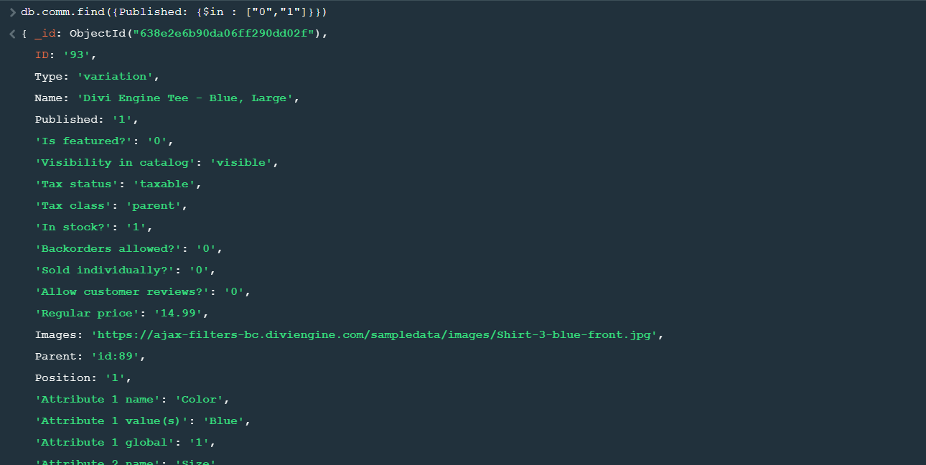

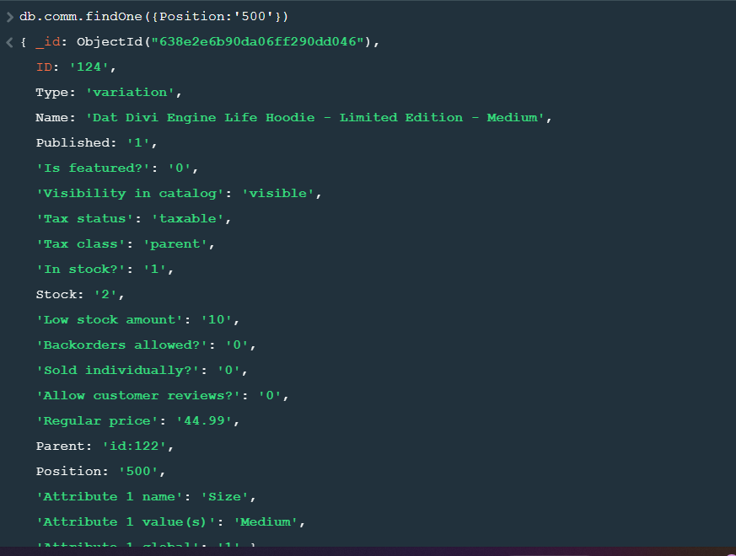

findOne() and findMany()-gives you the data of one and find many gives you the data of more than one value that satisfy the condition

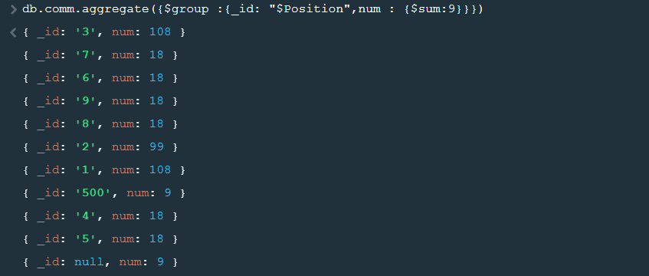

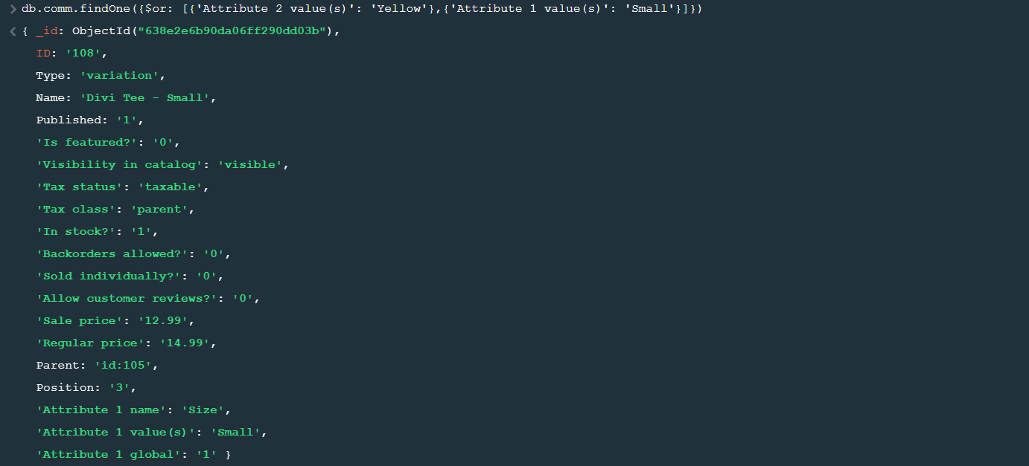

findOne/findMany using and or conditions-or that satisfy either

of the conditions and that satisfy both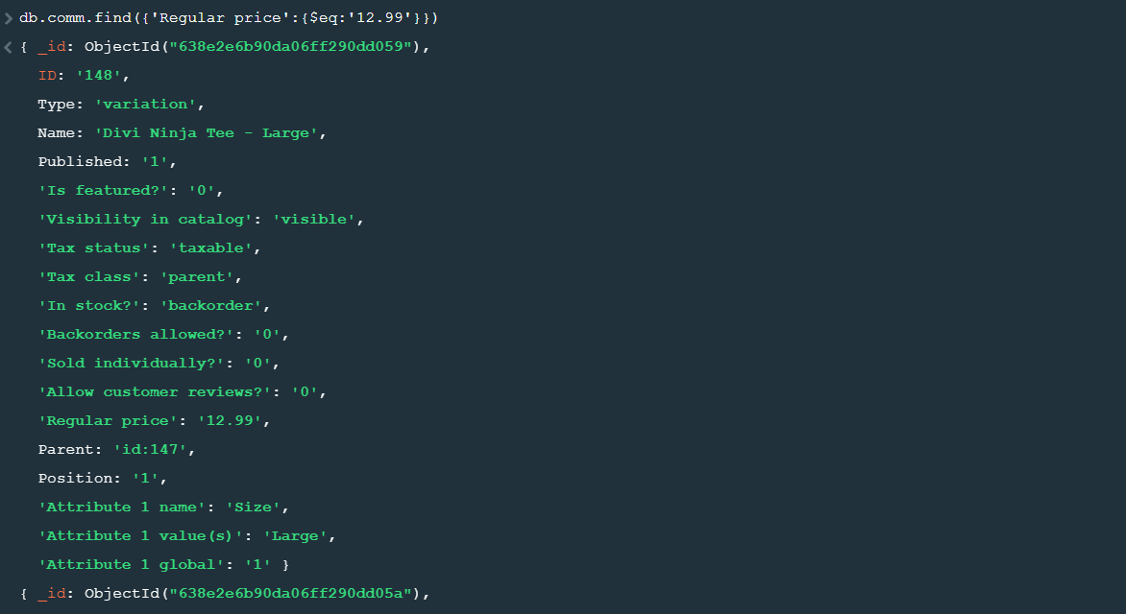

findOne() by using equal, not equal, less than , greater than conditions



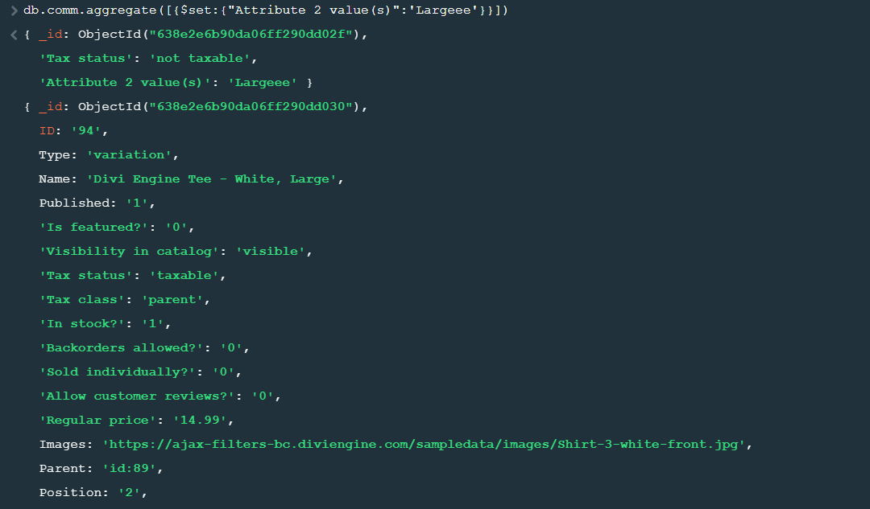

Aggregate and update- make a group of Attribute 2 value(s) and then set the value Largee



deleteOne()-delete only one Value which satisfy the given condition.