Introduction to Game Design (2024-2025)

Assignment Step 1

# Portfolio, Brainstorm, Pitch and Project Plan

Brainstorming Trello Board:

<https://trello.com/invite/b/672247c18dec3ed9d4f246cb/ATTIf1e7abc99bd2dcfd3b1652563bf58cea5C23592E/brainstorming-session-game-pitch>

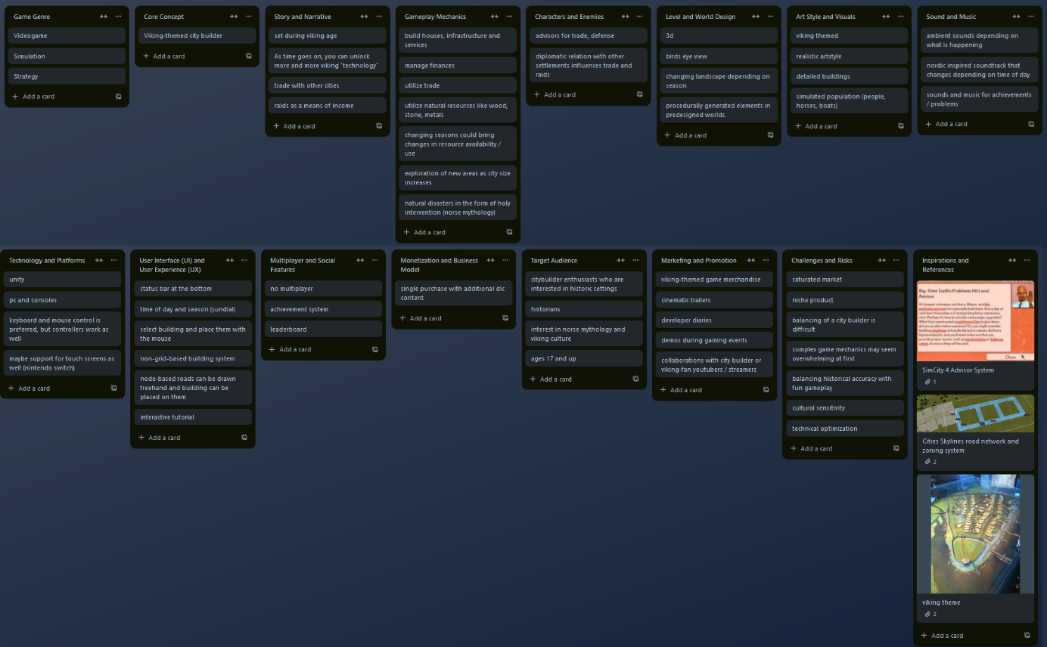

The brainstorming session was conducted by Finn and Leon on the 30/10/2024 from 2:56 – 3:39 pm on the SETU college street campus.