SIDEBAR

Na functions.php

//sidebar sidebar

register_sidebar(

array(

'name' => 'sidebar',

'id' => 'sidebar-id',

'before_widget' => '<div class="card mb-4">',

'after_widget' => '</div>',

'before_title' => '<h5 class="card-header">',

'after_title' => '</h5>',

)

);

Cria assim a área sidebar no painel de controle / widget

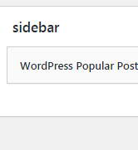

Na pagina

get_sidebar = pega o arquivo sidebar.php

<?php get_sidebar(); ?>

Criar arquivo sidebar.php

<div class="col-4 sidebar">

<?php dynamic_sidebar('sidebar'); ?>

</div>