**Introduction:**

Agriculture is vital to the economies of least developed countries (LDCs) such as Pakistan. In Pakistan, agriculture is a key component of the economy, contributing 21% to the Gross Domestic Product (GDP) with an annual growth rate of 2.7% [1]. Agriculture provides 44% employment and 62% of rural population are dependent on agriculture for their livelihood. In 2022, agricultural products worth **5.9 billion U.S. dollars** were exported from Pakistan [2]. Agriculture plays multiple roles in a nation's economy, including ensuring food security, reducing poverty, driving industrialization, and fostering economic growth, particularly in developing countries [3]. The importance of agriculture in the economic sector can be viewed from three perspectives: 1) it supplies food for the nation and raw materials for domestic industries; 2) it serves as a source of foreign exchange earnings; and 3) it provides goods and services for both domestic industries and international markets. In 2014-15, the agricultural sector experienced a 2.7% growth, driven by positive performance across all sub-sectors, including crops, livestock, forestry, and fishing.

To boost agricultural production despite limited resources, significant technological advancements have been made throughout human history. However, the ongoing population growth and climate change continue to threaten the balance between food supply and demand. With the global population projected to reach 9 billion by 2050—an increase of about twenty-five percent over the current figure—these challenges are becoming more urgent [4]. Technologies have become very important in physical products, like farm machinery or agrochemicals. Speedy growth in such sectors has led to a rapid development of private firms that make, produce and sell technology and products based on agrochemicals. Innovation and technology development has always been the main source of agriculture because agricultural progress and enlargement depends upon interference of modern technology tools by agricultural scientists and experts.

In Pakistan, productivity in various sectors of agriculture continues to be rather low relative to the developed and many developing countries with similar resource bases. This research paper will focus on increasing the efficiency and performance of the agricultural sector with the help of technology. The center of attention of this research paper will be on problems faced in the agricultural sector and how these problems can be solved with the help of technology. This paper aims to provide practical solutions for transforming Pakistan's agricultural sector into a more productive and sustainable industry.

**Methodology:**

This research is conducted in order to determine how technological advancement can help Pakistan in its agricultural sector. The research will be based on previous data, surveys and the problems faced by the agricultural sector. First we will collect the previous data from different resources like from past research paper’s. Then we will compare those previous data and analyze the numbers that with the passage of time the efficiency in agriculture is increasing or not. After that we will distribute a survey form and interview some people from the related sector. With the help of the survey and interviews we will get to know why people don't use technology in this sector of Pakistan and what are the problems faced by the people in the Pakistani agricultural sector. We will analyze and conclude all the previous data and results of the survey and we will present our own solution on how technology will come handy in the growth of the Pakistani agricultural sector.

**Surveys and its results:**

We conducted a survey in which we asked people 6 questions about our related topic. The results of the survey are mixed. Everyone has their own opinion but in one question 100% people agree on one thing: yes, technology will increase efficiency of Pakistani agriculture. The questions and their results are:

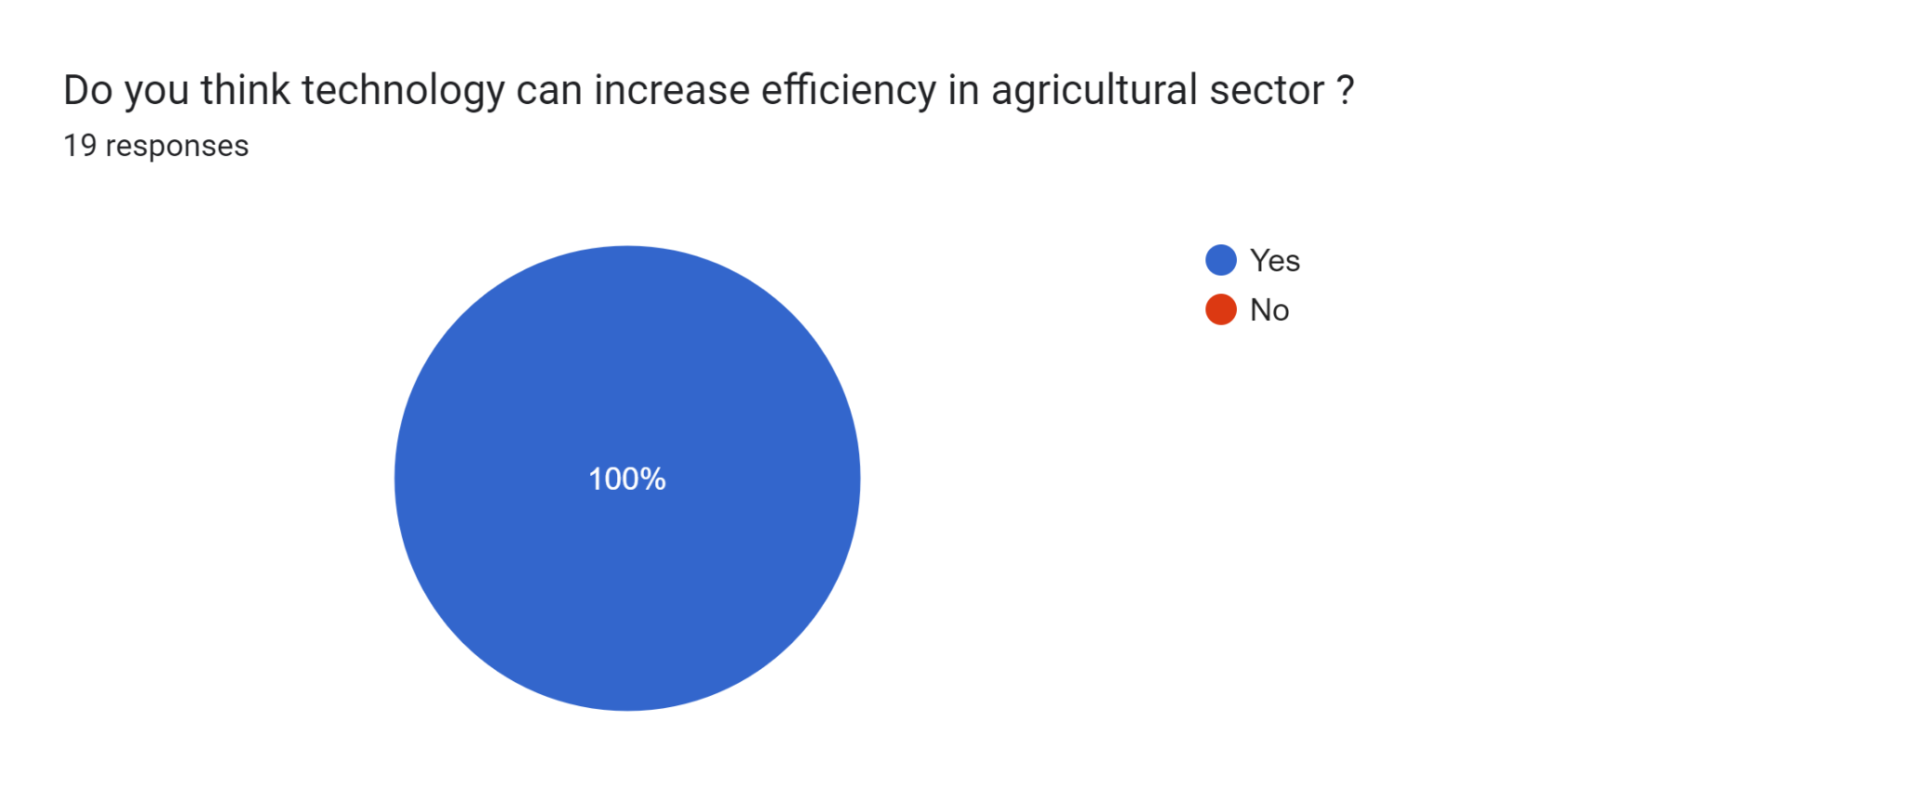

100% of people who were part of this survey agreed that technology will increase efficiency in the agricultural sector of Pakistan.

Forms response chart. Question title: How effective do you think the government has been in promoting the use of technology in agriculture?
. Number of responses: 18 responses.

Most of the people voted that the government is not too serious nor too ineffective regarding promotion of technology in agriculture. It's right because the government is not too serious about technology in any part of any field.

Forms response chart. Question title: What types of technology do you currently use in agriculture? (Select all that apply)
. Number of responses: 18 responses.

It is right we did not develop or try to promote any other machinery and technology other than tractors. We didn’t educate farmers about technology and we don't manufacture the latest machinery. This world moves forward but Pakistan we go backwards.

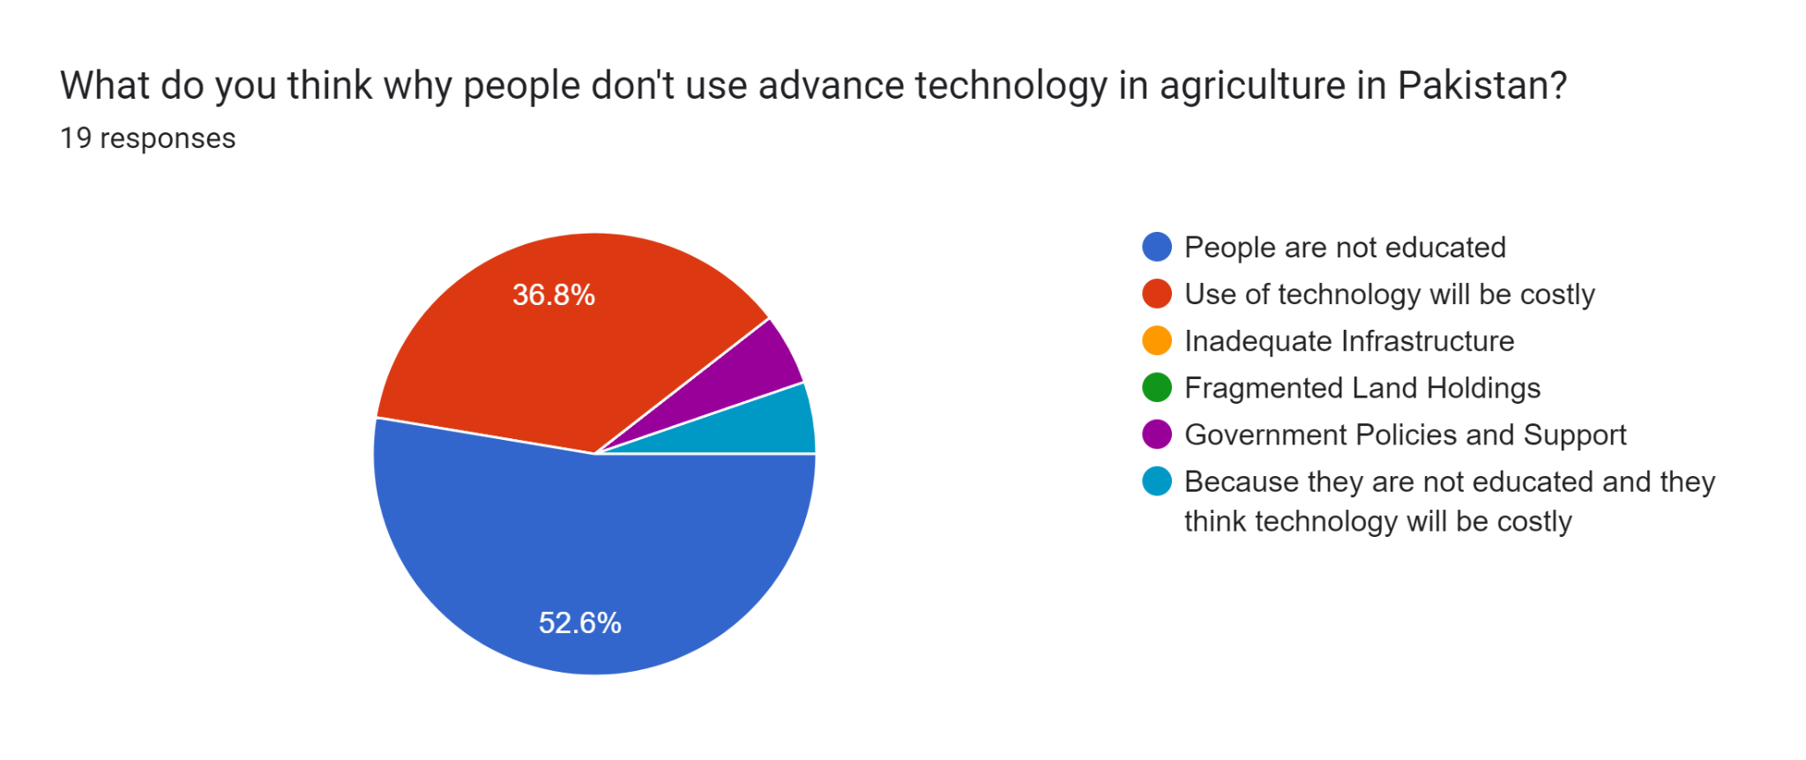

Most people think that people are not educated on the benefits of technology and how to use it. Because the government does not focus on the technological sector. If someone is educated and wants to use technology in agriculture the machinery will be costly because he/she has to import those machinery from other countries because Pakistan does not make any latest technology. If somehow he/she imports those machines, then he/she has to pay the taxes for importing the machinery, it will cost him/her so much.

Forms response chart. Question title: How do you think technology can improve agricultural productivity in Pakistan? (Select all that apply)
. Number of responses: 19 responses.

It's obvious that introducing technology in the agricultural sector will increase productivity and efficiency. When productivity and efficiency will increase it will also increase crop yields.

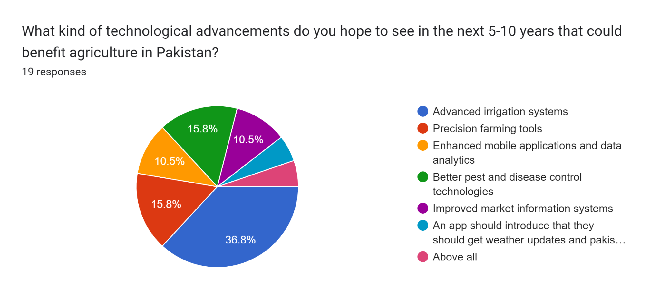

Pakistan has one of the biggest irrigation systems but it is not maintained so people hope that they will see an advanced irrigation system.

**Comparison of agricultural data of Pakistan and technology giant:**

Japan is a technology giant. Japan, a renowned technology giant, excels in advanced electronics, robotics, and automotive industries while also integrating technology into agriculture. Pioneering innovations, such as high-speed trains and cutting-edge consumer gadgets, underscore its global influence. Companies like Sony, Toyota, and Panasonic epitomize Japan's technological prowess. Additionally, Japan's commitment to research and development, including smart farming techniques and agricultural robots, fosters continuous advancements, securing its position at the forefront of technological progress.

In this section we will compare data of Pakistan and Japan on their gross production value of Rice and Wheat.

First we will compare the gross production value of rice of Pakistan and Japan.

This is the gross production value of rice of Pakistan [5]:

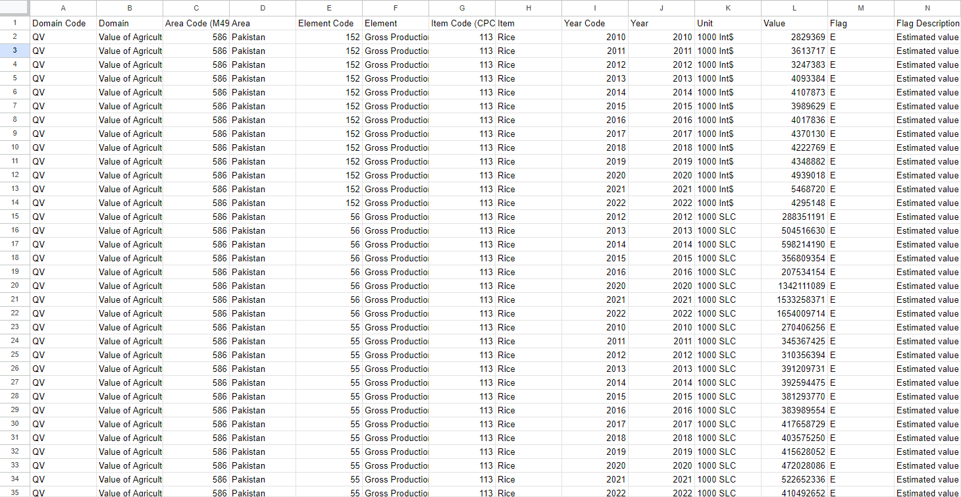

This the gross production value of rice of Japan [5]:

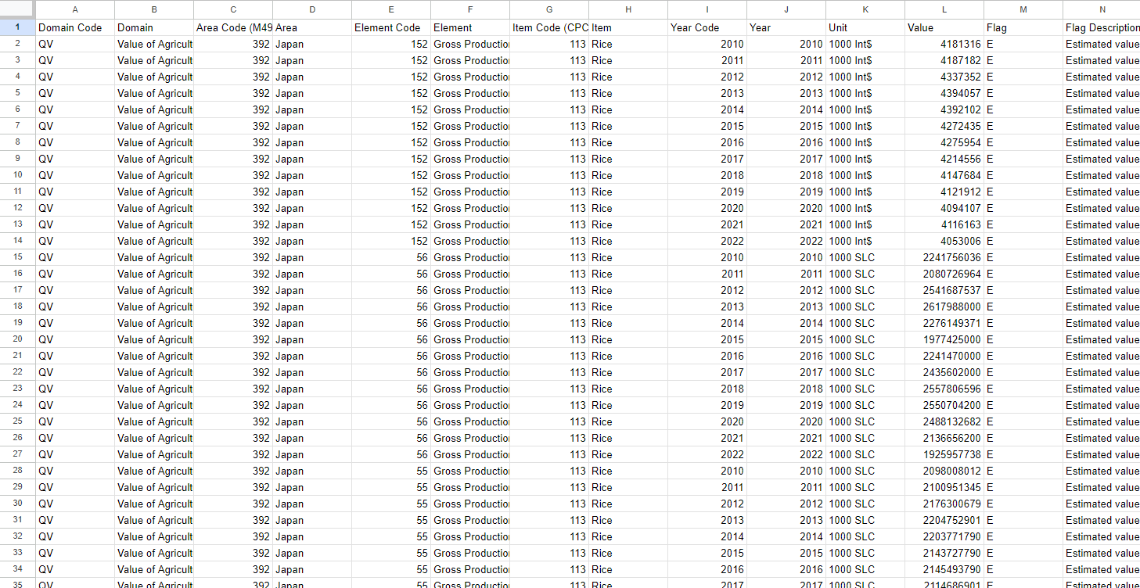

This is the gross production value of wheat of Pakistan [5]:

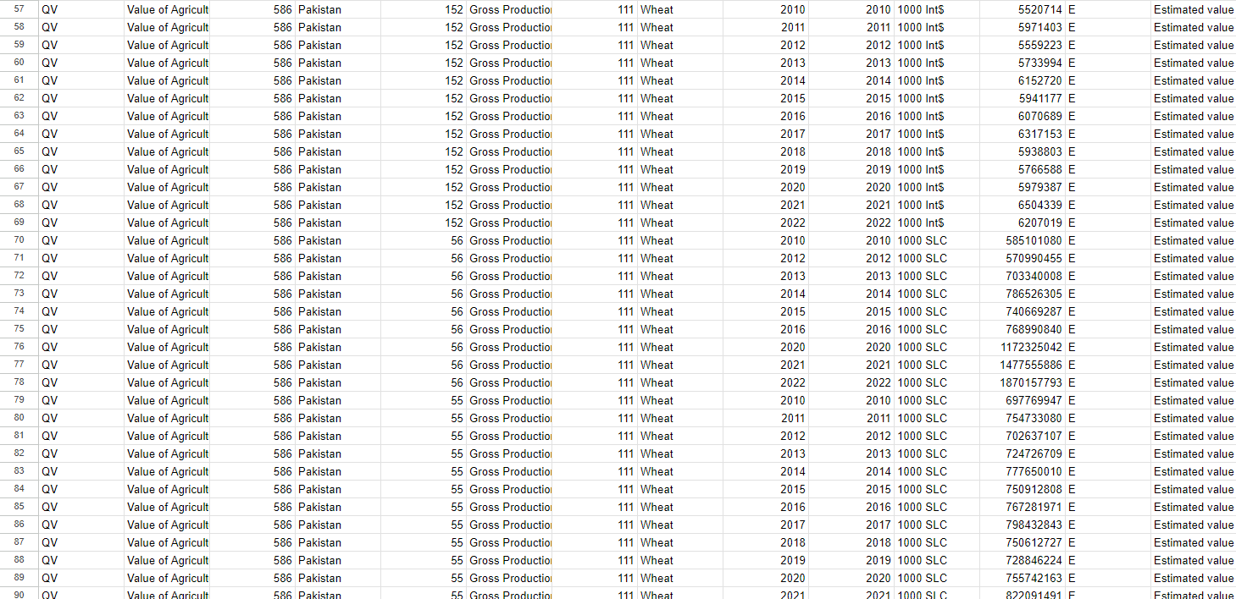

This is the gross production value of wheat of Japan [5]:

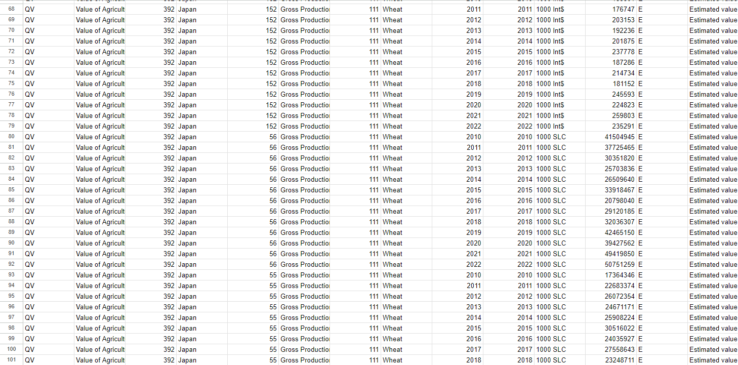

**\*We got this data from FAOSTAT**

The numbers clearly show that there is a huge difference between the gross production value of Pakistan and Japan. Japan is way ahead of Pakistan in technology, they use technology in nearly every aspect of life. People are well educated there, they know the importance of technology that's why they keep evolving with the time. Japanese agriculture is highly mechanized and sophisticated, with extensive use of precision farming, automated systems and modern irrigation techniques. The country benefits from significant investment in agricultural research and development, leading to efficient post-harvest processes and strong government support. In contrast, Pakistan's agriculture is less mechanizedand relies more on traditional methods with little advanced technology and infrastructure. Challenges in water supply, lower investment in research and development, and slower technology adoption hinder agricultural productivity and efficiency.

**References from other research papers:**

In the research paper “SCIENCE & TECHNOLOGY BASED AGRICULTURE VISION OF PAKISTAN AND PROSPECTS OF GROWTH ” By Muhammad Iqbal and Munir Ahmed [6], they addressed the issues in Pakistan agricultural sector and they gave their suggestions, let's summarize that: The agriculture sector in Pakistan is poised to remain crucial for the country's economy, with its growth being imperative for overall economic development, stability, employment generation, and poverty reduction, particularly in rural areas. However, the sector faces numerous challenges, including the scarcity of irrigation water, which is expected to be the most limiting factor in the coming years. To address this, maximizing output per drop of water through water-conserving technologies and enhancing irrigation efficiency is crucial. Additionally, expanding cultivated areas is becoming increasingly challenging, although there is potential in bringing culturable wastelands into production with significant investments and improved water availability. While conventional breeding methods have limitations in further enhancing yields, recent advances in agricultural biotechnology hold promise for increasing productivity, improving nutritional quality, and enhancing resistance against pests and diseases. However, the effectiveness of these advancements relies heavily on a well-funded and efficiently managed National Agricultural Research System (NARS), which currently suffers from underfunding, inadequate infrastructure, and a lack of skilled personnel. To address the various issues faced by the sector, actions such as strengthening extension systems, developing high-yielding and stress-resistant crop varieties, improving seed production and distribution, enhancing irrigation techniques, promoting organic farming, and investing in post-harvest infrastructure are essential. Furthermore, there is a need to address land degradation, nutrient management, water efficiency, livestock productivity, post-harvest losses, quality control, and the exploitation of inland fisheries. Emphasizing these areas and enhancing research, funding, infrastructure, and human resources within the agricultural sector are crucial for achieving sustainable growth and food security in Pakistan.

Another research paper:

“TECHNOLOGY TRANSFER AND AGRICULTURAL GROWTH IN PAKISTAN” By Zahoor Hussain Javed , Muhammad Farooq and Hamid Ali, there study investigates the impact of technology transfer on Pakistan's agricultural growth from 1971 to 2007 [7]. Regression analysis suggests potential issues of spurious regression due to non-stationary variables and overlooks dynamic aspects. However, Johansen's cointegration method reveals a long-run equilibrium relationship between fertilizer and tube wells with agricultural growth, while pesticides and tractors show insignificant or negative effects. The findings highlight the importance of proper attention to fertilizer and tube well usage for enhancing agricultural growth, suggesting that effective policies and infrastructure programs can yield significant benefits for Pakistan's economy through technology transfer.

**References:**

[1] Govt. of Pakistan, (2004/05), Economic Survey, Ministry of Finance, Islamabad.

[2]<https://www.statista.com/statistics/824432/export-of-commodities-from-pakistan/#:~:text=In%202022%2C%20agricultural%20products%20worth,dollars%20were%20exported%20from%20Pakistan>.

[3] Timer, CP (2002). “Agriculture and Economic Development in BL gardener & GC Rausser (ed), Handbook of agriculture economics, Amsterdam, North Holland, Vol. 2A, pp. 1487-546.

[4] Union, U. World Population Projected to Reach 9.8 Billion in 2050, and 11.2 Billion in 2100; UN DESA: New York, NY, USA, 2017

[5] https://www.fao.org/faostat/en/#data/QV

[6]<https://d1wqtxts1xzle7.cloudfront.net/45970542/science_technology_based_agriculture_vis20160526-19863-1q7d2hr-libre.pdf?1464279279=&response-content-disposition=inline%3B+filename%3DScience_and_Technology_Based_Agriculture.pdf&Expires=1716761992&Signature=HM419cLfoZGjd4~8vzR6liOjJ8N2zLu110OIkuJrAYKAFXse3PldSSDyvR1Nxs9bxXnUlLWn2MAdKg441FiNQ54wf9pm0rTqvtINdJxdbC5JmKRp0JryemAcTYgeB-FByuzpFS1M8sxQ5JbY-azo72Z9ds0MKI7CmLsdc-y8056yYsY6pLcp-HeiJi4Ml-BUKROZRlwnc27J7mjwz5Jy8Nb5BOCovW5R4aLWa0BCkAzVC6w~3wrwXbyvQAiqTzxdyeOHn9qdPIt63CjtMAUeo2Z0zCBxbQ0JDEwcfr9gw4rixqrQ7bR0t0WB7dBxoL3N0CJ3QLzkKoCPDvH6sJe~aQ__&Key-Pair-Id=APKAJLOHF5GGSLRBV4ZA>

[7]<https://d1wqtxts1xzle7.cloudfront.net/94571302/17-libre.pdf?1668993850=&response-content-disposition=inline%3B+filename%3DTechnology_transfer_and_agricultural_gro.pdf&Expires=1716762641&Signature=WoxhjPiu5ClVMMlaBPL4KU~XckFLLwDzAXitOukmj559mJ6vOw4-a63S~oVM71DA2Mkf39yfMw8YDYgErZui38m0EV6~~aJqQVE9VTB77n~-JMpoOk20P-o9u0tAn6Jn1WuvvS9q0RrKwQotO~0Whm6UWAxwz~SpJ7zMfYSx2qKi3vPia5E4dbU6f5IkzUMUwDGxx21FRE4ORQGSw3viznwPAnUhZy4I6aaX5gM7JFN9~M38xS3fRc48kAJ07nEGuVbnlpavPg3Jn1XQo5yemnUL6nNfOjhgR9SV6Y8NCRG25fFvoHcQZSTMgn7lp7mQFnyPn3h8ta3yvd2jNc0hew__&Key-Pair-Id=APKAJLOHF5GGSLRBV4ZA>