**Global Quest Technologies**

**PROJECT REPORT ON**

**“**RESUME**”**

**Using front end technologies**

Submitted by

SEELISETTY CHANDU

(GQT-S0217)

Under the esteemed guidance of

KESHAV MURTHY

(FRONTEND Trainer at GQT)

________________ ___________________

Signature of Trainer Signature of CEO (GQT)

KESHAV MURTHY NARENDRA REDDY

Date: Date:

**Introduction**

**Resume**

**Scope of the document:-**

Creating a resume using HTML and CSS can be a great way to showcase my skills and qualifications in a visually appealing format. With HTML and CSS, we have full control over the design and layout of your resume. CSS is used for styling, allowing you to define fonts, colours, layout, and responsiveness.

Ultimately, the goal is to create a visually appealing, well-organized, and easily readable document that highlights your skills and experience to potential employers or recruiters.

**ROOT STRUCTURE:**

* Chandu_Resume



* Code
* Html
* Resume.html
* CSS
* Resume.css
* Image
* 20125A0518
* Screenshots
* Ss1.png
* Ss2.png

**PROJECT REPORT**

* FRONT END PROJECT 1 RESUME.DOC

**SCREENSHOTS**

* ALL THE CORRESPONDING SCREENSHOTS OF PAGES.

**CONTROL FLOW DIAGRAM:**

Click

Resume.html is opened

Resume.html

# HISTORY OF HTML:

# HTML stands for Hyper Text Markup Language.

* It is used to share the information over the internet.
* HTML id developed by Tim Berner’s Lee in 1991.But officially in 1993.
* The First version of HTML consists of “18 tags”.
* HTML follows certain rules and regulations setup by “**ISO**”.
* International Organization for standardization is set of rules and regulation are present in ‘**SGML**’ document.

# Versions of HTML

* **HTML-1** version in the year 1993.
* **Html-2** version in the year 1995.
* **HTML-3.02** version in the year 1997.
* **HTML-4.1** version in the year 1999.
* **HTML-5** version in the year 2014.

**Features of HTML**

* It is easy to Learn.
* It is a tag-based language.
* HTML is supported by multiple browsers.
* First web browser is Netscape navigation which was developed by the “Mosaic”.
* It is a portable language.
* **WORA** stands for ‘write once run anywhere’

**Limitations of HTML**

* HTML has fewer designing capabilities
* It is dependent on other technology such as CSS in order to develop well designed webpages.
* HTML has no programming capabilities.
* Using HTML and CSS we can develop only static Web page.
* In order to write the HTML code required an editor such as VS Code, Notepad, Eclipse.
* In order to execute the HTML code, we required Web browsers like Chrome, Firefox, edge, Opera Safari.

**CSS**

* **CSS** stands for “Cascading Style Sheets”.
* It was developed by W3C to add stylings to the HTML elements.
* W3C stands for World Wide Web.com

**Versions of CSS:**

* **CSS-1** (Level-1) in the year 1996.
* **CSS-2** (Level-2) in the year 1998.
* **CSS-3** (Level-3) in the year 1999.

**Why do we require CSS ?**

* Since HTML has fewer designing capabilities we cannot create well designed or most appealing Websites.
* Using HTML we cannot add style, animation and transitions to the Webpage.
* Therefore, we require CSS to create well designed Webpage

**Advantages of CSS**

* It allows to add styles, animation and various effects to the Webpage.
* It allows us to develop the Webpage rapidly. It is also known as RAD ( rapid application Developer).
* It allows us to separate from formatting develop page to the presentation of Webpage.
* It allows to create well designed Websites.

**Limitations of CSS**

* Using CSS, we can perform static styles for the Webpages.
* In order to create dynamic styling for the Websites. We must make use of scripting language such as JavaScript and Libraries of JavaScript.

**Types of CSS:**

1. Inline CSS
2. Internal CSS
3. External CSS
4. Default Browser CSS

**Inline CSS:**

Defining all the CSS properties within the style attribute inside the opening of the tag is referred to as Inline CSS.

**Internal CSS:**

Defining all the CSS properties within <style> inside the HTML document is referred to as Internal CSS.

**External CSS:**

Defining all the CSS properties within as external Script or File with an extension CSS is referred to as External CSS.

* In order to link external CSS file within the HTML document we must use of <link>.
* The value for the ‘ref’ attribute should be “stylesheet”.

**Our Project**

**Source Code:-**

Resume.html

<!DOCTYPE html>

<html lang="en">

<head>

    <meta charset="UTF-8">

    <meta name="viewport" content="width=device-width, initial-scale=1.0">

    <title>Resume</title>

    <link rel="stylesheet" href=" Resume.css">

</head>

<body>

 <div id="div1A">

    <div id="div1h">

        <h1 class="head1">Seelisetty Chandu</h1>

        <h4 style="text-align:center;color:white">Full Stack Developer</h4>

    </div>

    <div id="div2">

    <img src="20125A0518_photo.JPG" alt="Photo" width="200px" height="200px" class="img">

    <h3 class="cls1">Technical Skills</h3>

    <ul type="disc">

        <li>C</li>

        <li>Core Java</li>

        <li>HTML5, CSS3, Bootstrap and JavaScript</li>

        <li>MySQL</li>

    </ul>

    <h3 class="cls1">Achievements</h3>

    <ul type="disc">

        <li>Silver-Level in java </li>

        <li>Bronze-level in Python</li>

        <li>Bronze-level in C</li>

    </ul>

    <h3 class="cls1">Strengths</h3>

    <ul type="disc">

        <li>Self-Motivation</li>

        <li>Hard Work</li>

        <li>Positive Attitude</li>

    </ul>

    <h3 class="cls1">Interests</h3>

    <ul type="disc">

        <li>Wed Development</li>

        <li>Software Development</li>

    </ul>

    <h3 class="cls1">Languages</h3>

    <ul type="disc">

        <li>English</li>

        <li>Telugu</li>

    </ul>

    <h3 class="cls1">Contact</h3>

    <b  style="margin-left:25px;">Email id: </b>seelisettychandu@gmail.com<br><br>

    <b  style="margin-left:25px;">Mobile no :</b>6302157105<br><br>

    <b  style="margin-left:25px;">Address :</b>  #4/51,Muthulurupadu,

    &nbsp;&nbsp;&nbsp;&nbsp;&nbsp;&nbsp;&nbsp;&nbsp;&nbsp;&nbsp;&nbsp;

    &nbsp;&nbsp;&nbsp;&nbsp;&nbsp;&nbsp;&nbsp;&nbsp;&nbsp;&nbsp;&nbsp;

    &nbsp;&nbsp;&nbsp;&nbsp;&nbsp;&nbsp;&nbsp;&nbsp;&nbsp;&nbsp;&nbsp;

    &nbsp;&nbsp;&nbsp;&nbsp;&nbsp;&nbsp;&nbsp;&nbsp;&nbsp;&nbsp;&nbsp;Kahipet,Kadapa-516203

  </div>

  <div id="divb">

      <h3 class="cls2">OBJECTIVE</h3>

        <p class="p">

         To work in the field of IT field in the software development. My career objective is to contribute 100% towards Productivity and quality.

        </p>

        <h3 class="cls2">CERTIFICATIONS</h3>

        <ul type="disc">

            <li>Java basic certification on Hacker Rank</li>

            <li>NPTEL Online Certificate</li>

            <li> Global Certification on Salesforce Certified Platform Developer 1</li>

        </ul>

        <h3 class="cls2" >PROJECTS</h3>

        <h4>Student Intervention Program to Reduce Dropdown Rate</h4>

        <ul type="disc" >

            <li class="p">A machine learning model predicted student dropout rates and academic success by identifying at-risk students and providing targeted interventions. We create a website to solve this problem.</li>

            <li class="p">The users can login to the website and enter the student details like Examination marks, extra-circular activities, Parents background, Area od living etc., based on this, analysis made by using machine learning techniques.</li>

            <li class="p"> By using decision tree classifier we can predict the accuracy and if the accuracy is less than 60%. The model will display the "Student needs Intervention" otherwise, it will display does not need intervention.</li>

        </ul>

        <h4>An immersive model for predicting air quality using machine learning approach.</h4>

        <ul type="disc">

           <li class="p">Air pollution is dangerous for human health and should be decrease fast in urban and rural areas so it is necessary to predict the quality of air accurately.</li>

           <li class="p">There are many types of pollution like water pollution, air pollution, soil pollution etc but most important among these is air pollution which should be controlled immediately as humans inhale oxygen through air.</li>

           <li class="p">By using this project we can provide the awareness to the people about the air pollution. It displays the causes of air pollution based on the causes the people can know to avoid those reasons.

            And the people stay Healthy with pollution free environment.</li>

        </ul>

        <h3 class="cls2">EDUCATION</h3>

        <table cellpadding="10px">

            <thead>

                <tr>

                <th style="text-align:left;">University/College</th>

                <th>Passing year</th>

                <th>Percentage/CGPA</th>

                </tr>

            </thead>

            <tbody>

                <tr>

                    <td>Sree Vidyanikethan Engineering College</td>

                    <td>2023</td>

                    <td>8.6</td>

                </tr>

                <tr>

                    <td>Loyola Polytechnic College(YSRR)</td>

                    <td>2020</td>

                    <td>90.4</td>

                </tr>

            </tbody>

        </table>

    </div>

</div>

</body>

</html>

Resume.css

body{

    margin-left: 250px;

}

#div1A{

    border:2px solid black;

    width:85%;

    height: 1000px;

}

#div1h{

    width:100%;

    height:150px;

    background-color:#2C446F;

    margin-top:-25px;

}

.head1{

   color:white;

   text-align:center;

   padding-top:50px;

}

.img{

    border-radius:50%;

    margin-top:-100px;

    margin-left:20px;

    border:2px white solid;

}

#div2{

    width:35%;

    height:853px;

    margin-left:10px;

    background-color:rgb(226, 216, 221);

    margin-left:0px;

    border-right:2px solid black;

}

.cls1{

    color:#2C446F;

    text-decoration: 2px underline;

    font-weight: bold;

    margin-left:10px;

}

#divb{

    width:63%;

    height:850px;

    float:right;

    margin-top:-850px;

}

.cls2{

    color:#2C446F;

    text-decoration: 2px underline;

    font-weight: bold;

}

.p{

    margin-right: 5px;

    text-align: left;

}

**Output:-**

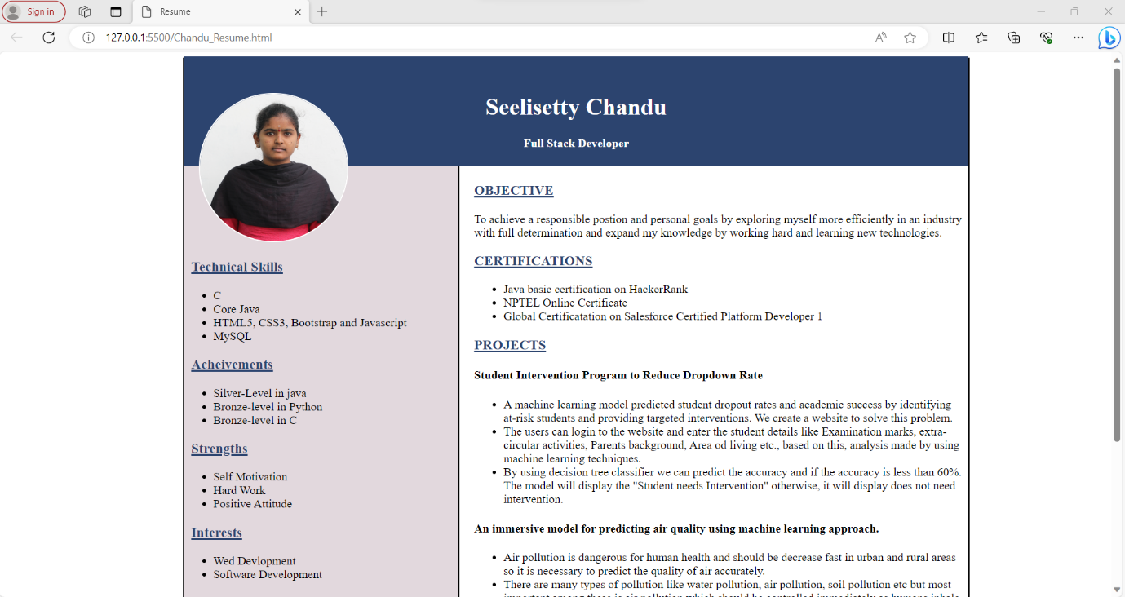

Fig1.1

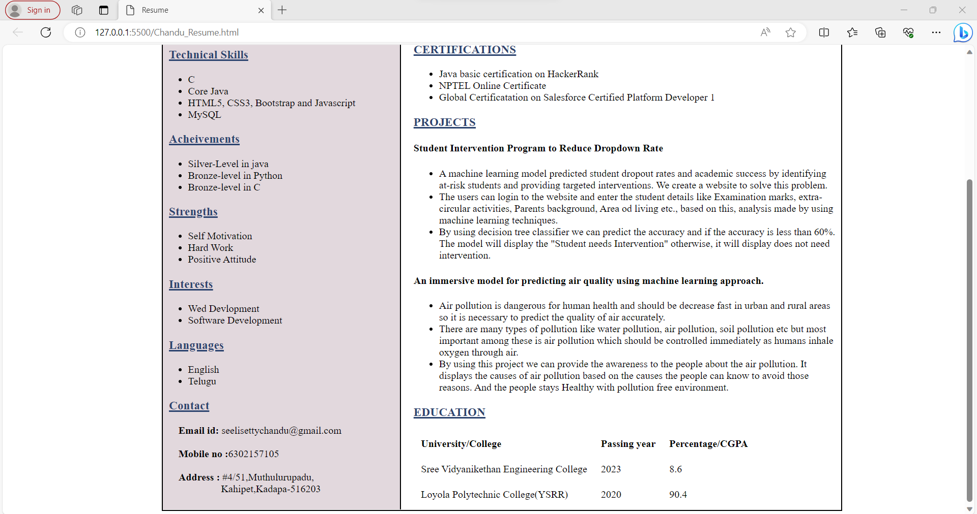

Fig1.2

**Conclusion**

In conclusion, using HTML and CSS to create your resume gives you the freedom to design a visually appealing and interactive document that can help you stand out in today's competitive job market. Just remember to strike a balance between creativity and professionalism, ensuring that your resume effectively communicates my qualifications and experiences to potential employers.