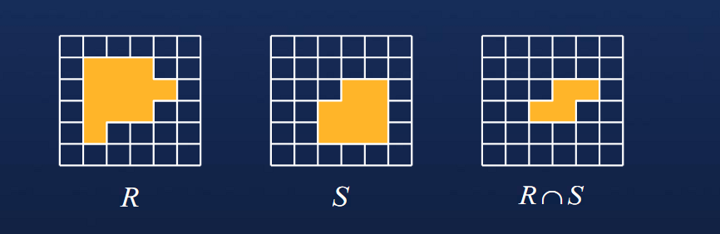
Intersection交集

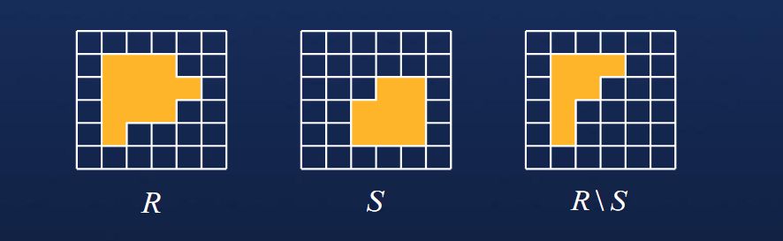
Differece补集

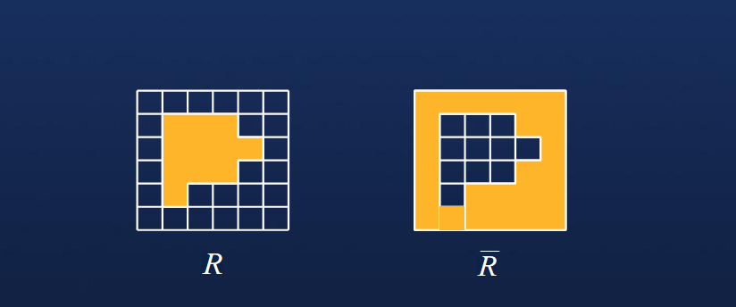
Complement反选

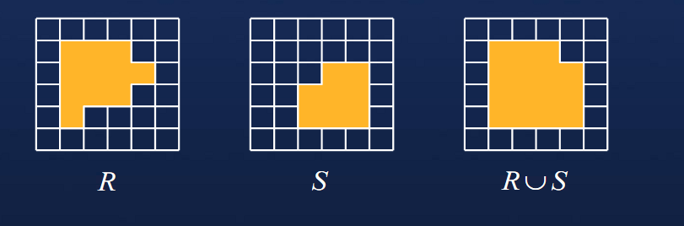
Union合并

