Assignment3

컴퓨터전공

2013011491

안찬영

1. how to run program

The zoom in and zoom out functions are implemented in the render function so that zoom in and zoom out from gluLookAt function is close to 0 or far away. The basic rendering method is implemented by using glDrawElements function by calling drawUnitCube_glDrawElements (). In this case, when the file is dragged and dropped, the set_dropcallback function is set and the drop_callback function is called. At this time, the specified obj file is opened and the file code is read. Only when the first word is v, vn and f, the vertex Recorded.

1. Implementation to requirement

The keycallback function was added to zoom in and zoom out when a and s key were pressed. When the polygon is more than square, the vertices of the vertices are triangulated and stored in indexarray separately. When Z key is pressed, wireframe / solid mode is implemented by changing zmode variable to GL_LINE and GL_FILL in glPolygonMode (GL_FRONT_AND_BACK, zmode).

1. I only used two sources of light. Each light position is equal to lightPos = (3., 3., 3., 1.), LightPos1 = (-3, 3., - 3., 1.) And both light types are set the same. ambientLightColor = (.1, .1, .1,1.), diffuseLightColor = (1., 1., 1., 1.), specularLightColor = (1., 1., 1., 1..)

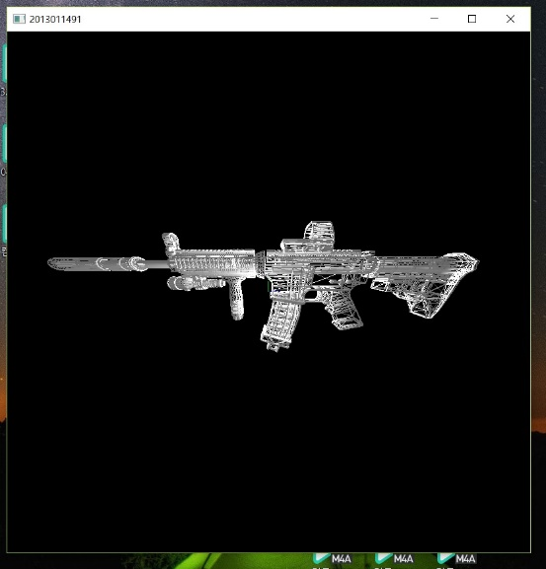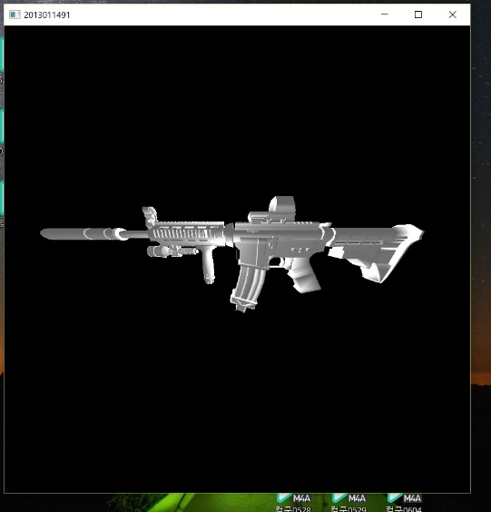

Result A : ordinary mode result B : Z mode

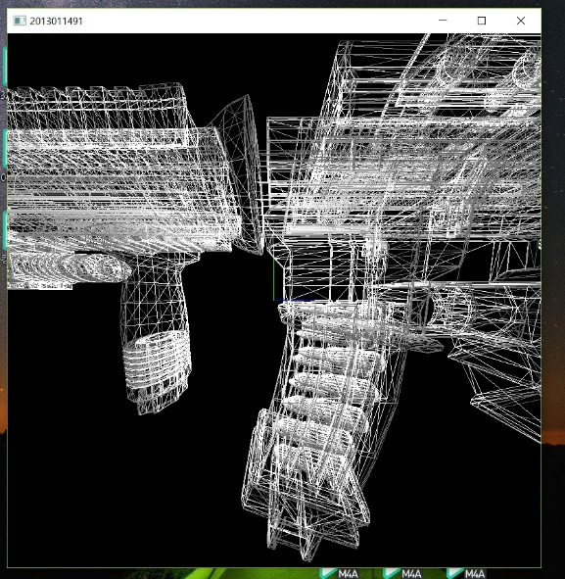

Result C : zoom out in z mode