**Efficiency of Different Routing Protocols**

**Sharda University**

**School of Engineering and Technology**

**Computer Science Engineering**

Prepare by:

Yar Mohammad Hafizy

Roll no: 130101202

Ramin Agha Amin

Roll no: 130101137

08/02/2017

**Routing information protocol:**

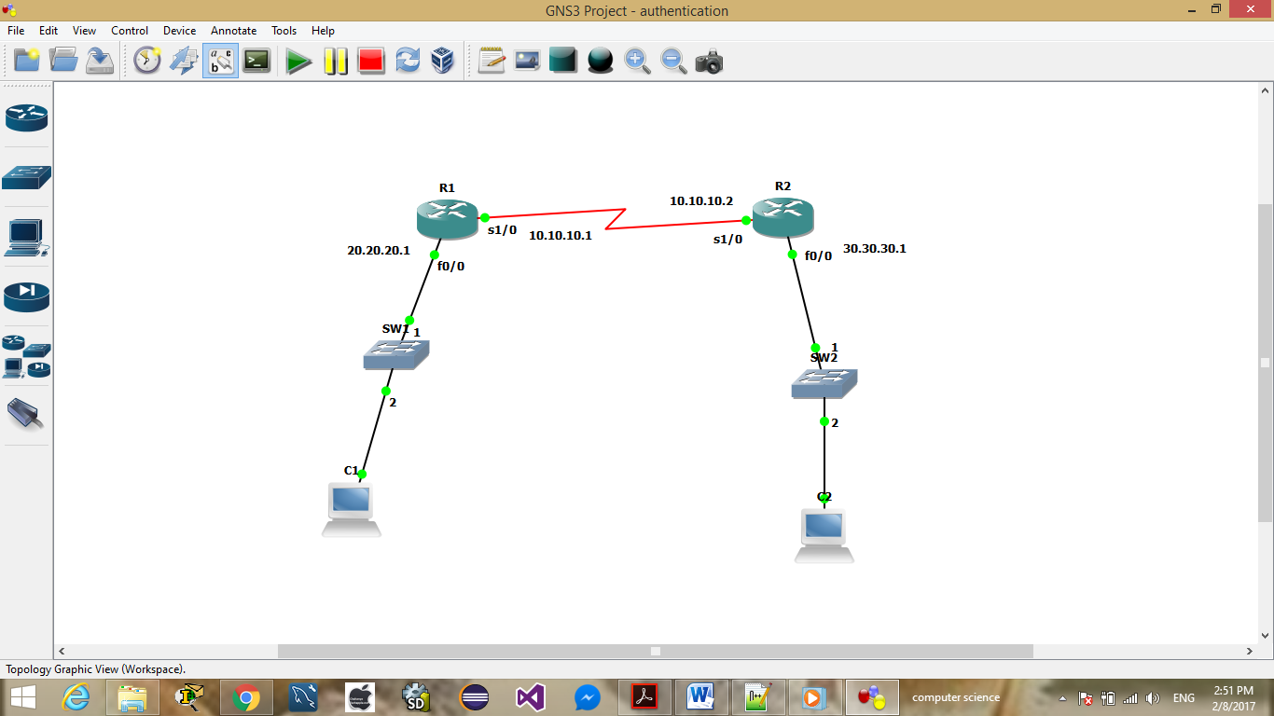

**Objective**: we are going to configure RIP routing protocol by using this topology

Step one: assign IP address to the routers.

Assign IP address to the router one (R1)

R1#config t

R1(config)#int se1/0

R1(config-if)# ip add 10.10.10.1 255.0.0.0

R1(config-if)#no shut

R1(config)#int f0/0

R1(config-if)# ip add 20.20.20.1 255.0.0.0

R1(config-if)#no shut

Assign IP address to the router two (R2)

R1#config t

R1(config)#int se1/0

R1(config-if)# ip add 10.10.10.2 255.0.0.0

R1(config-if)#no shut

R1(config)#int f0/0

R1(config-if)# ip add 30.30.30.1 255.0.0.0

R1(config-if)#no shut

Step 2: configuring routing information protocol

configuring routing information protocol on router one(R1)

Router#conf t

Router(config)#

Router(config)#router rip

Router(config-router)#version 2

Router(config-router)#network 20.0.0.0 255.0.0.0

Router(config-router)#network 10.0.0.0 255.0.0.0

configuring routing information protocol on router two(R2)

Router#conf t

Router(config)#

Router(config)#router rip

Router(config-router)#version 2

Router(config-router)#network 30.0.0.0 255.0.0.0

Router(config-router)#network 10.0.0.0 255.0.0.0

For verifying RIP protocol

R1#show ip route

RIP authentication

**RIP authentication**

RIP version one does not support authentication but RIP version two supports authentication, RIP links can require authentication keys (passwords) before they become active. Authentication provides an additional layer of security on the network beyond the other security features. By default, this authentication is disabled.

Authentication keys can be specified in either plain-text or MD5 form. Authentication requires all routers within the RIP network to have the same authentication type and key (password) configured.

There are two types of authentication

Simple password authentication

Routers send packet and key and the other router checks whether the key matches or not, if key does not match the router will not accept. This authentication is not secure.

MD5 authentication

In this configure a password and key id, router generate a message digest of key , password and message. Message digest is sent with packet and key is not sent. This authentication is more secure.

Enabling Authentication with MD5 Authentication

for enabling MD5 authentication we need to assign IP address to the routers R1 and R2

step 1: assign IP address to the routers

Assign IP address to the router one (R1)

R1#config t

R1(config)#int se1/0

R1(config-if)# ip add 10.10.10.1 255.0.0.0

R1(config-if)#no shut

R1(config)#int f0/0

R1(config-if)# ip add 20.20.20.1 255.0.0.0

R1(config-if)#no shut

Assign IP address to the router two (R2)

R1#config t

R1(config)#int se1/0

R1(config-if)# ip add 10.10.10.2 255.0.0.0

R1(config-if)#no shut

R1(config)#int f0/0

R1(config-if)# ip add 30.30.30.1 255.0.0.0

R1(config-if)#no shut

Step 2: configure RIP to each router

configuring routing information protocol on router one(R1)

Router#conf t

Router(config)#

Router(config)#router rip

Router(config-router)#version 2

Router(config-router)#network 20.0.0.0 255.0.0.0

Router(config-router)#network 10.0.0.0 255.0.0.0

configuring routing information protocol on router two(R2)

Router#conf t

Router(config)#

Router(config)#router rip

Router(config-router)#version 2

Router(config-router)#network 30.0.0.0 255.0.0.0

Router(config-router)#network 10.0.0.0 255.0.0.0

Step 3: provide key chain to each router:

Key chain for router one(R1)

R1# configure terminal

R1(config)# key chain RIP

R1(config-keychain)# key 1

R1(config-keychain-key)# key-string RGjtl5ANYa

R1(config-keychain-key)# end

Key chain for router two (R2)

R1# configure terminal

R1(config)# key chain RIP

R1(config-keychain)# key 2

R1(config-keychain-key)# key-string RGjtl5ANYa

R1(config-keychain-key)# end

The key chain name, “RIP”, is user-defined and can be whatever you want it to be. It does not need to be the same on both routers.

The identifier number of the authentication key, “key 1″, does not need to be identical unless you are using MD5 authentication.

The key string, “**key-string RGjtl5ANYa**”, is the actual password. It does, of course, need to match on both sides.

Step 4: configure md5 to each interface

For router one (R1)

R1# configure terminal

R1(config)# interface serial 0/0

R1(config-if)# ip rip authentication mode md5

R1(config-if)# end

For router two (R2)

R2# configure terminal

R2(config)# interface serial 0/0

R2(config-if)# ip rip authentication mode md5

R2(config-if)# end

For verifying authentication: R2# debug ip rip.

EIGRP (Enhanced Interior Gateway Routing Protocol)

To create an EIGRP routing process, use the following commands beginning in global configuration mode:

Router(config)# router eigrpautonomous-system

Router(config-router)# network network-number

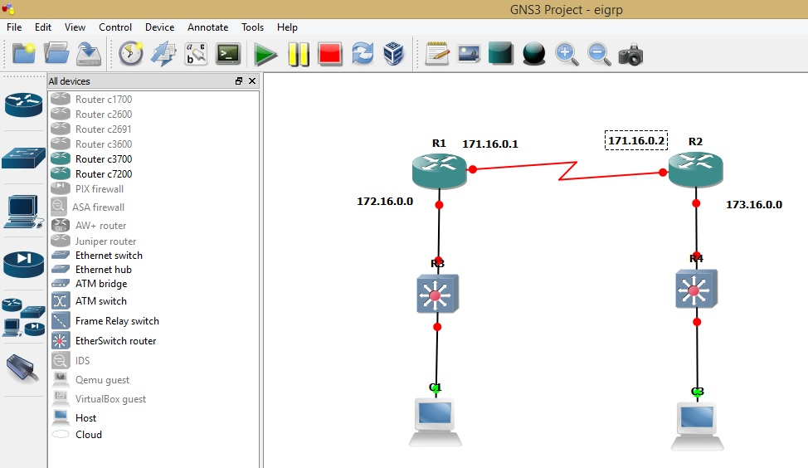

**Enabling Eigrp in the following above figure:**

For R1:

R1(config)# routereigrp42

R1(config-router)# network 172.16.0.0 255.255.0.0

R1(config-router)# network 171.16.0.0 255.255.0.0

R1(config-router)# network 170.16.0.0 255.255.0.0

R1(config-router)# no auto-summary

**For R2:**

R2(config)# routereigrp42

R2(config-router)# network 172.16.0.0 255.255.0.0

R2(config-router)# network 171.16.0.0 255.255.0.0

R2(config-router)# network 170.16.0.0 255.255.0.0

R2(config-router)# no auto-summary

**Route Authentication:**

The following example enables MD5 authentication on EIGRP packets in autonomous system 1. Figure 52shows the scenario.

**R1 Configuration:**

R1# configure terminal

R1(config)# key chain EIGRP

R1(config-keychain)# key 1

R1(config-keychain-key)# key-string RGjtl5ANYa

R1(config-keychain-key)# end

**R2 Configuration:**

R2# configure terminal

R2(config)# key chain EIGRP

R2(config-keychain)# key 1

R2(config-keychain-key)# key-string RGjtl5ANYa

R2(config-keychain-key)# end

**R1 Configuration:**

R1# configure terminal

R1(config)# interface serial 0/0

R1(config-if)# ip authentication key-chain eigrp 42 EIGRP

R1(config-if)# ip authentication mode eigrp 42 md5

R1(config-if)# end

**R2 configuration:**

R2# configure terminal

R2(config)# interface serial 0/0

R2(config-if)# ip authentication key-chain eigrp 42 EIGRP

R2(config-if)# ip authentication mode eigrp 42 md5

R2(config-if)# end

**OSPF Configuring Multi-Area:**

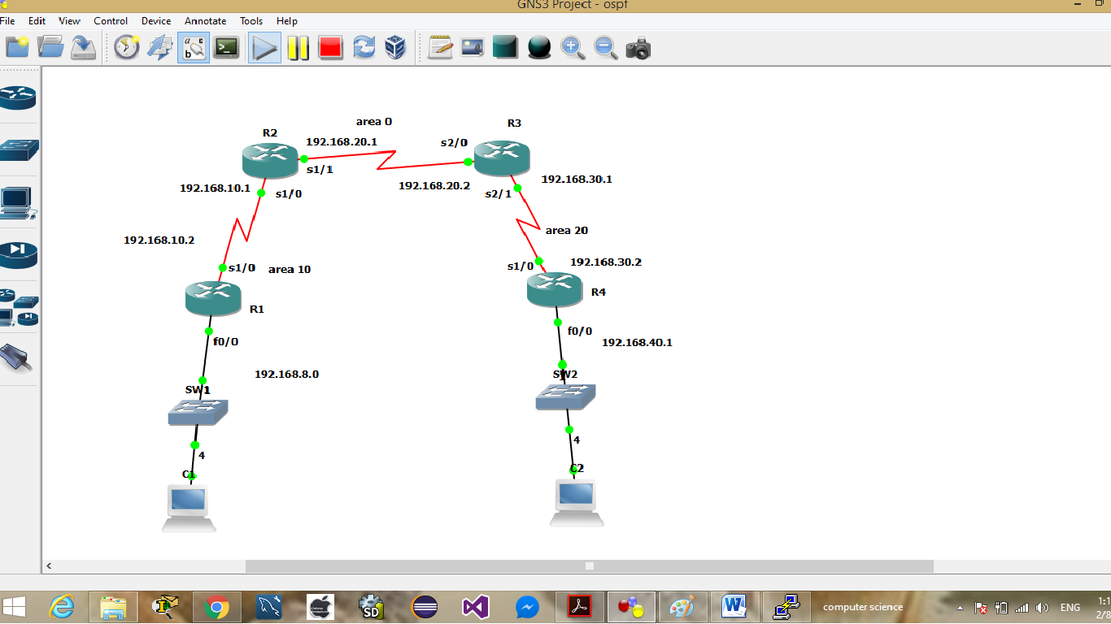

**Objective**

In this lab we show how to configure OSPF routing protocol with multi area.

Step 1: assign IP address to the interfaces of routers.

Assign IP address to router one(R1)

R1#conf t

R1(config)#int fa0/0

R1(config-if)#ip add 192.168.8.1 255.255.255.0

R1(config-if)#no shut

R1(config-if)#exi

R1(config)#int s1/0

R1(config-if)#ip add 192.168.10.2 255.255.255.0

R1(config-if)#no shut

R1(config-if)#exit

**Assign IP address to the router 2 (R2)**

R2#conf t

R2(config)#int s1/0

R2(config-if)#ip add 192.168.10.1 255.255.255.0

R2(config-if)#no shut

R2(config-if)#exit

R2(config)#int s1/1

R2(config-if)#ip add 192.168.20.1 255.255.255.0

R2(config-if)#no shut

R2(config-if)#exit

**Assign IP address to the router 3 (R3)**

R2#conf t

R3(config)#int s2/0

R3 (config-if)#ip add 192.168.20.2 255.255.255.0

R3 (config-if)#no shut

R3 (config-if)#exit

R3 (config)#int s2/1

R3 (config-if)#ip add 192.168.30.1 255.255.255.0

R3 (config-if)#no shut

R3 (config-if)#exit

**Assign IP address to the router 4 (R4)**

R4#conf t

R4(config)#int fa0/0

R4(config-if)#ip add 192.168.40.1 255.255.255.0

R4(config-if)#no shut

R4(config-if)#exi

R4(config)#int s1/0

R4(config-if)#ip add 192.168.30.2 255.255.255.0

R4(config-if)#no shut

R4(config-if)#exit

**Step 2: configuring OSPF routing protocol on router one**

Assign router one’s interfaces in area 10

R1#conf t

R1(config)#router ospf 10

R1(config-router)#net

R1(config-router)#network 192.168.8.0 0.0.0.255 area 10

R1(config-router)#network 192.168.10.0 0.0.0.255 area 10

R1(config-router)#exit

**configuring OSPF routing protocol on router two(R2)**

assign the router interfaces s1/0 network (192.168.10.0) to area 10 and assign the router interface se1/1 to area zero

R2#conf t

R2(config)#router ospf 20

R2(config-router)#net

R2(config-router)#network 192.168.2.0 0.0.0.255 area 0

R2(config-router)#network 192.168.10.0 0.0.0.255 area 10

R2(config-router)#exit

**configuring OSPF routing protocol on router three(R3)**

assign the router interfaces s2/0 network (192.168.20.0) to area zero and assign the router interface se2/1 to area 20

R3#conf t

R3(config)#router ospf 30

R3(config-router)#net

R3(config-router)#network 192.168.2.0 0.0.0.255 area 0

R3(config-router)#network 192.168.30.0 0.0.0.255 area 10

R3(config-router)#exit

**configuring OSPF routing protocol on router four(R4)**

Assign router one’s interfaces in area 20

R4#conf t

R4(config)#router ospf 40

R4(config-router)#net

R4(config-router)#network 192.168.3.0 0.0.0.255 area 20

R4(config-router)#network 192.168.40.0 0.0.0.255 area 20

R4(config-router)#exit

**For verifying OSPF routes**

R1# show ip route

Or

R1#show ip protocol

**For verifying OSPF database:** R1#show ip ospf databae

**For verifying OSPF neighbor:** R1#show ip ospf neighbor

**Note:** area zero should be backbone it means all other areas should be connected to area zero and area 0 should be as transit.

Configuring OSPF Authentication

OSPF authentication comes in two forms: plain-text and MD5. Because a secure method was specified, we have to use MD5 authentication in our environment (plain-text is not secure).

We configure clear text authentication and message digest five on this topology:

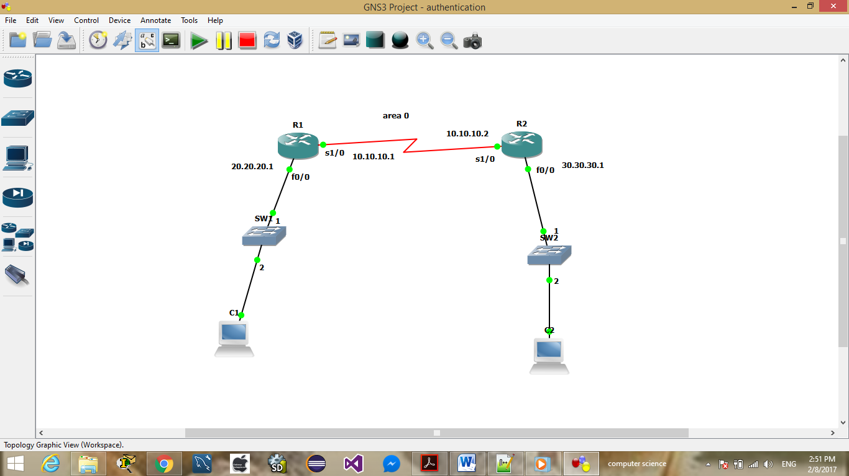

Clear text authentication

Step 1: assign IP address to the interfaces of routers

Step 2: configure OSPF routing protocol on each router

We know how to assign IP add and configure ospf protocol. So don’t need to do here again.

Step3: configure clear text authentication

Authentication on router one (R1)

Step 1: assign IP address to the interfaces of routers

R1(config)#int se1/0

R1(config-if)# ip add 10.10.10.1 255.0.0.0

R1(config-if)#no shut

R1(config)#int f0/0

R1(config-if)# ip add 20.20.20.1 255.0.0.0

R1(config-if)#no shut

Step 2: configure OSPF routing protocol on each router

R1(config)#router ospf 10

R1(config-router)#net 10.0.0.0 0.255.255.255 a 0

R1(config-router)#net 20.0.0.0 0.255.255.255 a 0

R1(config-router)#exi

Step3: configure clear text authentication

R1(config)#int se1/0

R1(config-if)#ip ospf authentication

R1(config-if)#ip ospf authentication-key cisco123

R1(config-router)#exi

Authentication on router two (R2)

Step 1: assign IP address to the interfaces of routers

R2(config)#int se1/0

R2(config-if)# ip add 10.10.10.2 255.0.0.0

R2(config-if)#no shut

R2(config)#int f0/0

R2(config-if)# ip add 30.30.30.1 255.0.0.0

R2(config-if)#no shut

Step 2: configure OSPF routing protocol on R2

R2(config)#router ospf 10

R2(config-router)#net 10.0.0.0 0.255.255.255 a 0

R2(config-router)#net 30.0.0.0 0.255.255.255 a 0

R2(config-router)#exi

Step3: configure clear text authentication

R2(config)#int se1/0

R2(config-if)#ip ospf authentication

R2(config-if)#ip ospf authentication-key cisco123

R2(config-router)#exi

Message digest 5 authentication

We work on the same topology which we did for clear text authentication

Step 1: assign IP address to each interfaces of router

Step 2: configure OSPF on each router

We did these two steps in above clear text authentication. We need to configure MD5 only on each interface of routers

**Now configure MD5 on router one(R1)**

R1(config)#int se1/0

R1(config-if)#ip ospf ip ospf authentication message-digest

R1(config-if)#ip ospf message-digest-key 2 md5 cisco123

R1(config-router)#exi

**Now configure MD5 on router two(R2)**

R1(config)#int se1/0

R1(config-if)#ip ospf ip ospf authentication message-digest

R1(config-if)#ip ospf message-digest-key 2 md5 cisco123

R1(config-router)#exi