**PROJECT TITLE**

MATERIAL INSPECTION WITH IIOT AND AUGMENTED REALITY

PROBLEM STATEMENT

High-production outcome requires fast inspection cycles. Checking parts and objects manually without the right tools during an entire shift is very difficult, hence leading to slow inspection cycles.

**INTRODUCTION TO PROPOSED SOLUTION**

Programmable Logic Controller is hardware device which takes input from machine or plant via sensors, transmitters and executes its logic, programmed in it’s memory. Produces useful output vis actuators to control machine. PLC is been programmed in TIA PORTAL(Totally Integrated Automation) using logic ladder programming language.

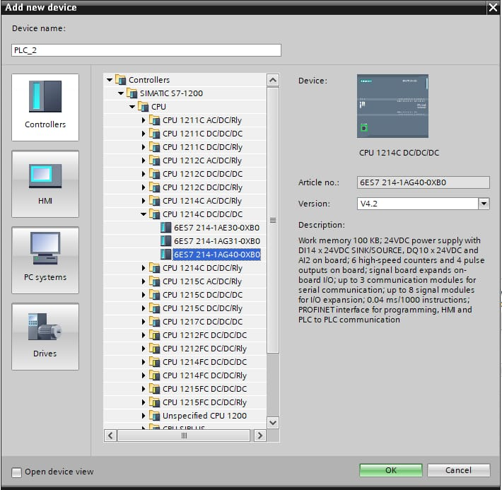

PLC configuration

Ladder Logic Program

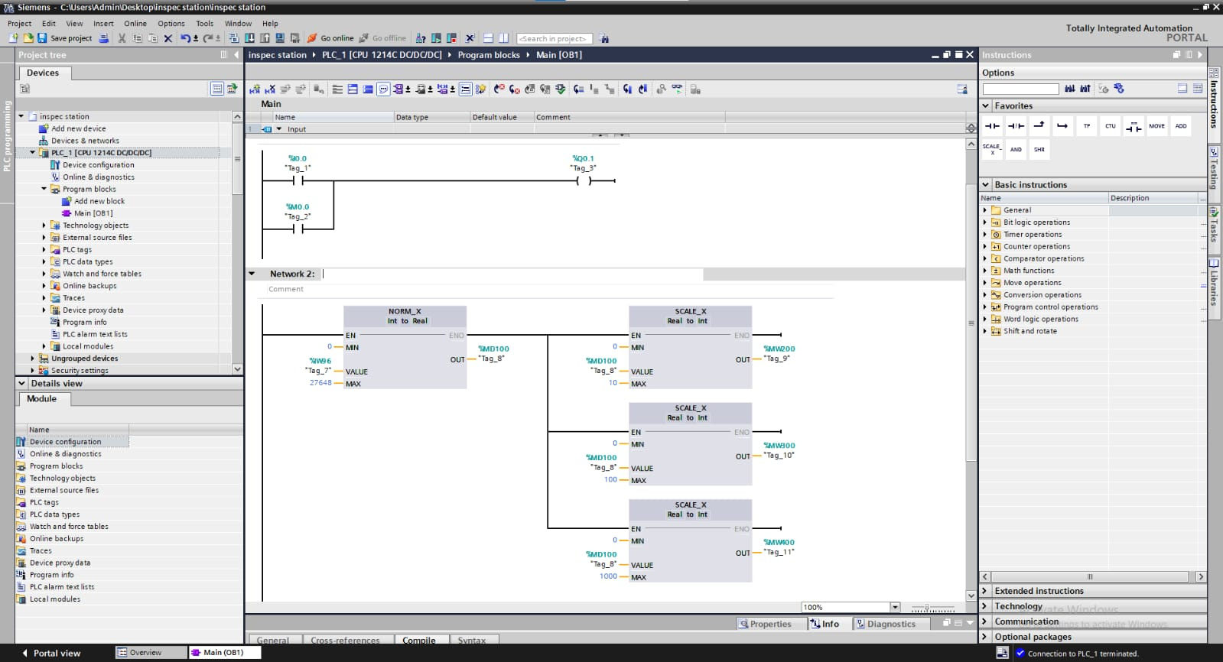

PLC is connected to Thingworx kepware server. kepware offers tools to control user server access, data source, or data values, regulate read/write access, connect or disconnect client applications, and configure secure data tunnels.

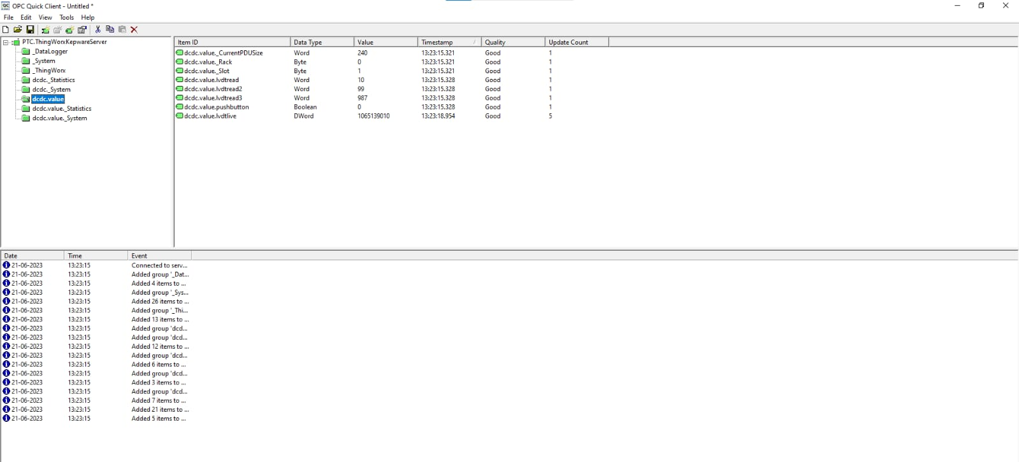

Live data of Analog and Ditigal Input/output of PLC are streaming in Kepware server

Kepware server is then integrated with Thingworx cloud platform. PLC can be controlled automatically via Thingworx Properties and Thingworx Mashups using memory addresses.

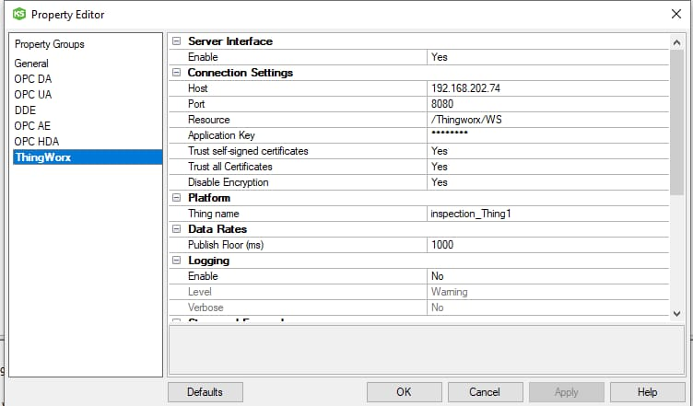

Integrating Kepware server with Thingworx software

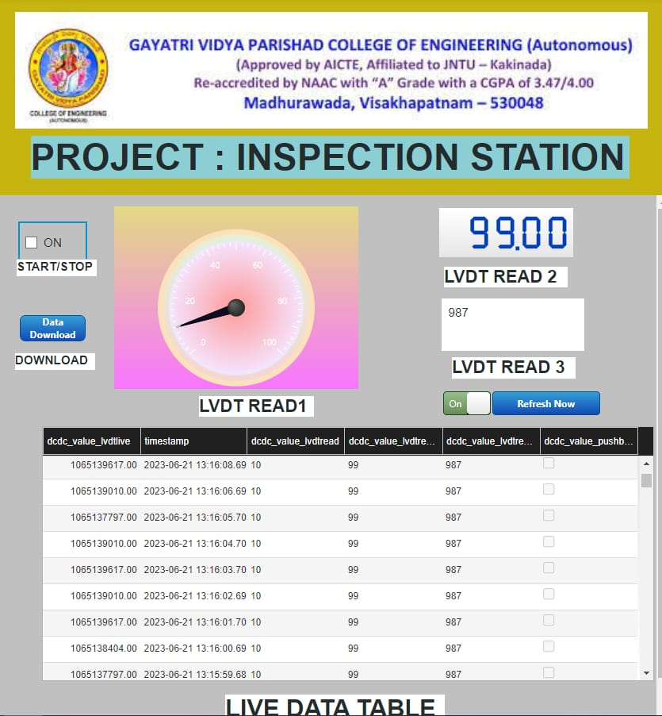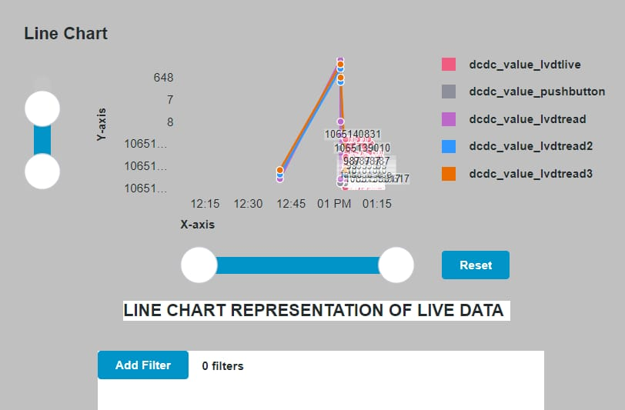

Monitoring and Controlling Analog Values in Thingworx Mashup Screen

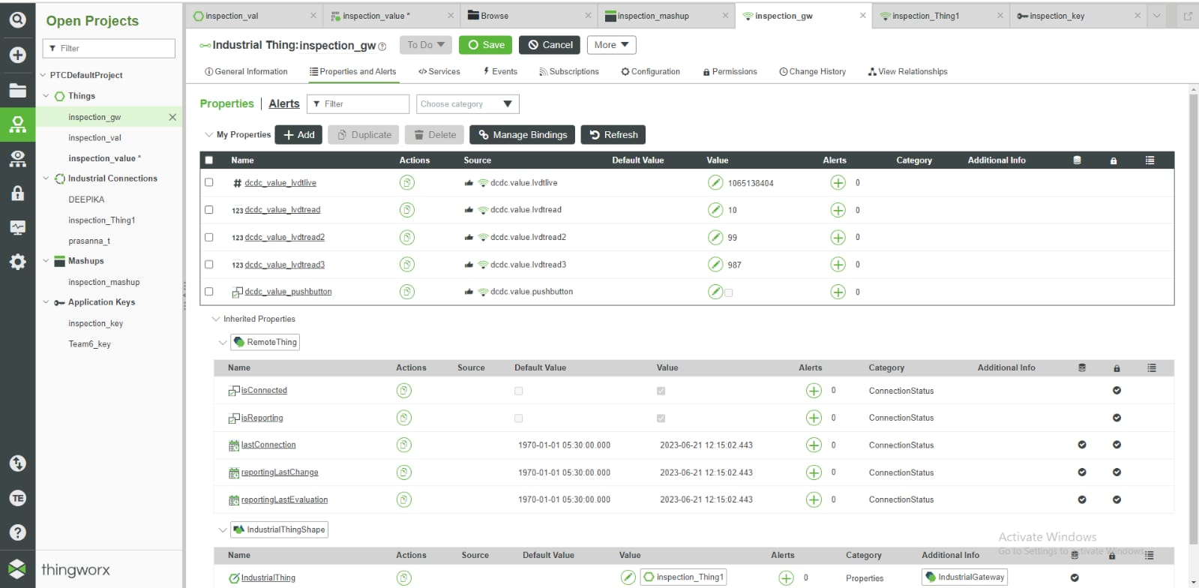

Monitoring and Controlling Analog Values in Thingworx Properties

Thingworx is been further integrated with Augmented Reality(AR). Automated assessment using the mobile device camera and Vuforia’s leading computer vision technology. AR overlays show the worker if an object passed the check or if something is wrong.

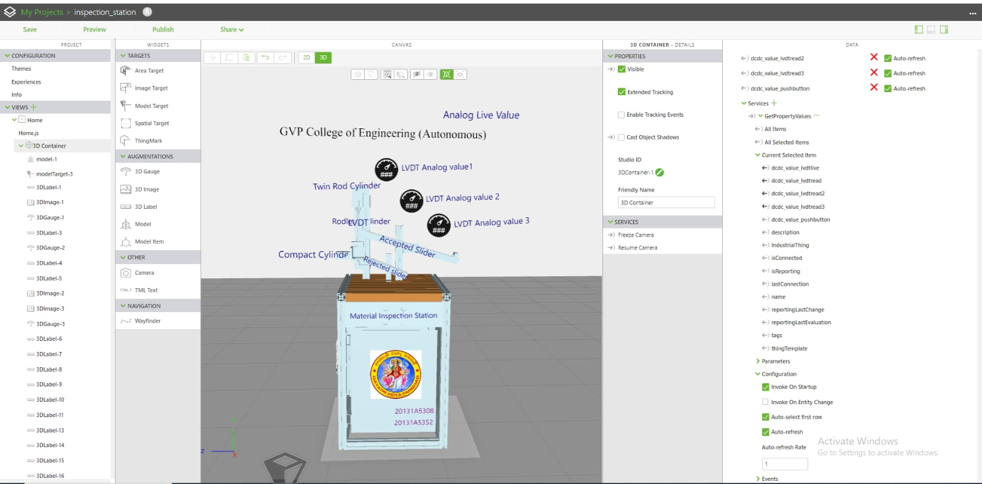

AR Screen of Material Inspection Station where we can automate the entire Inspection and Quality control process and  identify parts, classify the object’s state, and automatically learn from pass/fail decisions. This virtual screen is been designed in Vuforia Studio Software

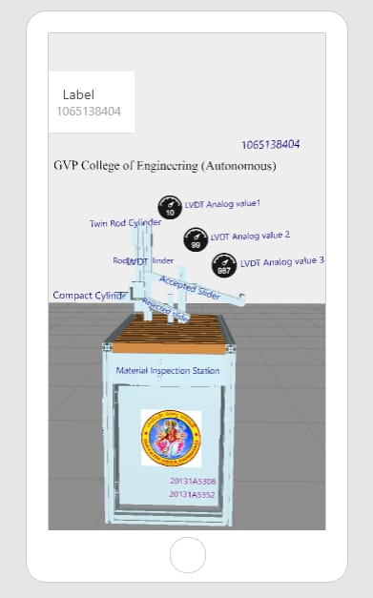

Material Inspection Station

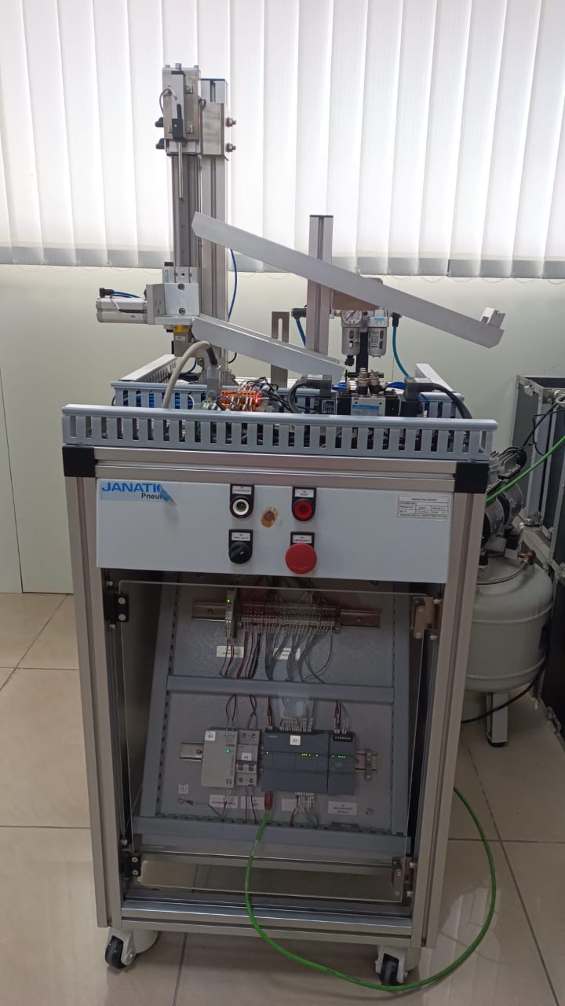

Mobile Preview of Inspection Station

CONCLUSION :

Inspection is a critical part in the quality control process in manufacturing.AI-enhanced visual inspection detects false parts, and with AR, guides workers to improve quality control.