河流降温效应在一个具有复杂地形的超大城市——以重庆为例

## Abstract

* 研究不足：在关于水体降温效应的研究中，关于河流的研究较少。同时，周边环境地形特征对其的影响尚未得到较好地研究。
* 本研究目的：因此，本研究关注正常夏日和极端夏日的河流对周边城市环境的降温效应，考虑地形、三维建筑特征、土地利用特征、河流宽度为环境因素来分析环境因素在不同背景天气条件下对河流降温效应的影响。该研究采用BRT模型，
* 初步结论：RCI和CRCI均有较大的空间差异性，且空间格局相似。
* 地形因素是影响RCI和CRCI最大的因素。研究发现土地利用配置的影响要强于土地利用的组成。同时，三维特征的影响较弱。
* 在极端炎热和正常的日子里，周围关键[景观指标](https://www.sciencedirect.com/topics/earth-and-planetary-sciences/landscape-metrics" \o "从 ScienceDirect 的 AI 生成的主题页面了解有关景观指标的更多信息)与 PCE之间的关系是非线性的。且影响主要在因素值的特定范围内出现。

意义：研究结果可以作为城市规划者制定热舒适缓解和城市更新策略的基础。

## Introduction

### UHI

* 【up2023 1229 16:04】
* With population explosion and economic development, the urban population has witnessed significant expansion globally.
* According to the prediction from the United Nations, this trend will continue in the following decades and the urbanization rate is estimated to be up to 68 % by 2050 (United Nations. 2019).
* As has been observed in many cities over the world, urbanization has caused multiple adverse effects on local environment, such as water and air pollution, ecosystem degradation and urban heat island (Wang et al., 2020; Ahmad et al., 2021).
* Urban heat island is a phenomenon by which temperatures in urban areas tend to be higher compared to those in the surrounding rural areas.
* Elevated temperatures have been found to increase the intensities and durations of heatwaves and they will inevitably enhance energy consumption and pose threats to public health of urban residents in summer (Guan et al., 2017; Nieuwenhuijsen et al., 2018).
* Therefore, certain measures are necessary to address the associated negative effects.

### 水体降温效应机理~150 words【up2023_1208 09:53】

* 【up2023 1229 16:43】
* Primary measures to address excessive heat in urban areas include altering surface materials, optimizing spatial layout of land cover, and promoting ventilation (Azhdari et al., 2018; Taleghani，2018; He, 2020).
* In terms of land cover, the roles of blue and green spaces have received much attention.
* Blue spaces refer to urban surfaces that are dominated by water (Ampatzidis et al., 2020).
* Compared to impermeable surfaces, the lower thermal conductivity and higher specific heat capacity of water make blue spaces absorb less heat during the day.
* In addition, evaporation from water surfaces can reduce release of sensible heat.
* Consequently, blue spaces can be considered to be cooling sources and they play important roles in lowering temperatures of surrounding areas.
* According to a research in Chengdu, the contrast of surface temperature between lakeside and inland areas can be more than 8 °C (Du et al., 2016).
* Observations have also demonstrated that the cooling abilities of water bodies can be stronger than green spaces .
* For example, the average temperature of green spaces is about 2 °C higher than that of water surfaces in the summer daytime of Berlin (Dugard et al., 2014).

### 1.3 水体降温时空异质性&水体降温效应的影响因素（强调缺乏对地形影响的研究）~250 words

* According to previous studies, there are large diversities in the cooling effects of blue spaces and the dominant contributing factors vary with time and space.
* In terms of temporal variation, water cooling intensities in daytime are usually stronger than those in nighttime (Hathway et al., 2012).
* Existing observations demonstrate that waterfront areas can be warmer than the surrounding inland areas during nighttime. (Moyer et al., 2017).
* As for the spatial variation of water cooling, a difference of more than 9 °C can be discovered within a city (Wu et al., 2020).
* With large temporal and spatial variations of water cooling revealed in previous researches, the interaction of water bodies with environmental variables have become an important issue in the mitigation of urban heat.
* Morphological characteristics of water bodies are mostly found to be important factors.
* Specifically, stronger cooling effects tend to appear near larger water bodies (Theeuwes et al., 2013).
* As for the relationship between shape regularity and cooling effect, the conclusions are contradictory.
* For example, observations in Shanghai and Beijing indicate that water cooling effect is strengthened with improved shape regularity, while the corresponding relation is insignificant in Chengdu (Du et al., 2016; Sun et al., 2012; Wu et al., 2021).
* In addition to characteristics of blue spaces, the roles of land use pattern and 3-dimensional urban structure of waterfront areas have also been explored.
* Based on previous researches, proportion of vegetation cover, street width, average building height, floor area ratio (FAR) and the ratio of building area potentially take effects.
* It is worth noting that topographic features are probable to take effects on urban climate in cities with uneven surfaces.
* Primarily because of the mechanical force, wind directions and intensities of urban areas are affected by local topographic variations, such as hills, ridges, and cliffs (Zhou et al., 2020).
* Therefore, it can be speculated that topographical variables can be potential influencing factors of water cooling effect.
* However, most previous studies on water cooling effect are performed in plain cities.
* The relationships between different topographic indicators and cooling effects of water bodies are still poorly understood.
* Despite numerous studies on water cooling effects, there are still limitations in the understanding of this issue.
* Firstly, in previous studies, the relationships between water cooling and influencing factors are analyzed based on linear equations.
* However, due to the complexity and irregularity of urban characteristics, the impacts of influencing factors on urban climate are often non-linear (Li et al., 2020).
* Therefore, more effective methods are needed to analyze the non-linear effects of geographical features to fully understand water cooling effect.
* In addition, there are contrasts in morphological characteristics between rivers and lakes.
* A large proportion of lakes are polygonal or circular in shapes and located dispersedly within a city, while rivers have a narrow and linear layout, mostly traversing or flowing around urban areas.
* As a result, the cooling effects of rivers on the surrounding areas are different from those of lakes or ponds.
* In the northeastern Chinese cities of Changchun and Jilin City, river cooling effects are found to be stronger than those of lakes and green spaces (Xue et al., 2019).
* However, previous researches on water cooling focus more on ponds, lakes and wetlands (Cheval et al., 2020; Xue et al., 2019; Yao et al., 2023).
* River, as an important type of water body in cities, has received much less attention.
* Rivers flow through or around many cities over the world and they have effects on the climate characteristics of surrounding areas, so it’s necessary have more in-depth explorations on river cooling.
* The practical significance of studying water cooling lies in understanding the relationship between environmental factors and cooling effects, allowing targeted measures to be taken to alleviate the negative impacts of extreme heat.
* However, existing relevant studies focus on normal summer days and the understanding of water cooling effects on extremely hot days is insufficient.
* In fact, under the background of global warming and urbanization, the intensity of heatwaves and their potential negative effects on urban residents are expected to increase significantly.
* Many studies have revealed higher urban heat island intensities during in heatwave days compared to those on normal summer days, which is particularly common in metropolitan areas of China (Ramamurthy et al., 2017; Gao et al., 2019).
* Therefore, it’s essential to pay more attention to water cooling in extremely hot days which has important practical implications for heat mitigation of urban areas.

### 1.4 研究目的~100 words

* As a mountainous city located in the upper reach of Yangtze River, Chongqing is renowned for its hot and humid summer.
* A systematic research on the cooling effect of rivers in the city of Chongqing is beneficial for policymakers in urban planning and management.
* This research aims to explore the quantitative effects of river cooling and their contributors, taking Chongqing as an example.
* The purpose is to answer the following questions:
* (1) What are the intensities and spatial patterns of river cooling effects on the normal summer day and the extremely hot day?
* (2) How much do individual environmental variables contribute to the river cooling effects?
* (3) How do the key factors affect river cooling in different weather conditions?

## Data and Methods

* The analytical procedures of this study can be divided into three major steps.
* Firstly, land surface temperature (LST) of the study area is calculated based on Landsat-8 images.
* Then we divide the riverside areas of Chongqing into segments and calculate indexes of river cooling for individual segments.
* Finally, boosted regression tree (BRT) model is utilized to evaluate the non-linear impacts of environmental variables on river cooling in different weather conditions.
* The flow chart is shown in Fig. 1.

### 2.1. Study area

* Chongqing is a megacity located in the upper reach of the Yangtze River.
* The Yangtze River flows through this city, and its major tributary, the Jialing River, converges with it in the city center (Fig. 2).
* The urban area of Chongqing is primarily composed of hills and mountains and it is therefore characterized by significantly undulating terrain with elevations ranging from 170 meters to more than 400 meters.
* Chongqing is located in the subtropical monsoon climate zone.
* Summer periods normally last from May to September, which are characterized by high temperatures and high humidities.
* On average, there can be more than 40 heatwave days with maximum air temperatures being larger than 35 °C in a year , mostly distributed in July and August.
* The highest air temperature can reach up to 43 °C.
* In last decades, Chongqing has experienced a rapid process of urbanization with urban population surging from 6 million in 2000 to 10 million in 2020.
* With a huge influx of population, urban construction accelerates, and the built-up area expands rapidly.

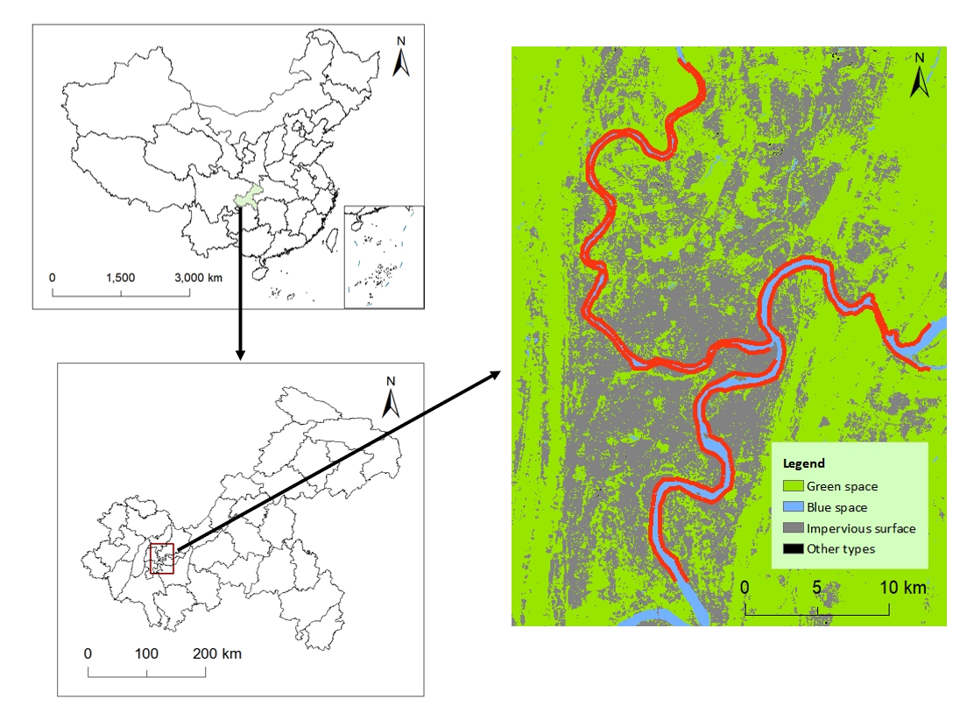

Fig. 2 Location of the study area. The image on the right shows land use pattern of the study area. The red lines along the rivers indicate river sections selected in this research.

### 2.2. Data

* Satellite images from Landsat-8 OLI/TIRS surface reflectance products are utilized in this study to calculate LST, extract river surface and obtain land use patterns of the study area.
* These data were obtained from United States Geological Survey (http://earthexplorer.usgs.gov).
* Two sunny days are selected as representatives of the normal summer day and the extremely hot day, respectively.
* In this study, we select 8th, May, 2022 and 12th, Aug, 2022 to represent the normal summer day and the extremely hot day, respectively.
* The weather conditions of the two days are shown in Table 1.
* 3-dimensional (3D) buildings data are gained from the online map service platform Baidu maps.
* Specifically, heights of buildings are calculated by multiplying the number of floors by 3.
* Elevation data were produced based on digital topographic maps.
* 土地覆盖数据由landsat-8 遥感影像解译获得。采用基于最大似然（ML）的监督分类方法，划分出水体、绿地、建筑物和不透水地（主要包括道路和广场）四种土地覆盖类型。
* 建筑分布及高度数据由百度地图提供。其中，建筑高度的计算是基于楼层数*3m得到的。

### 2.3. Calculation of land surface temperature

* Before the calculation of LST, preprocessing steps are required for original Landat-8 images.
* They include radiometric calibration and atmospheric correction.
* Then, radiative transfer equation (RTE) method is adopted. The equation can be expressed as:
* where *Lλ* is the radiation intensity of thermal infrared band obtained by the sensor, represents the downward atmospheric radiance, represents the upward atmospheric radiance, *ε*stands for surface emissivity,*τ* is the atmospheric transmissivity and B(Ts) is the black body radiance.
* By converting the above equation, we can get B(Ts) as follows:
* In this study, values of and *τ* were obtained by NASA Atmospheric Correction Parameter Calculator.
* *ε* is calculated by the following formula:
* In this formula, represents surface emissivity of vegetation cover, represents surface emissivity of soil and *Pv* is the percentage of vegetation cover calculated by:
* where *NDVI* is normalized difference vegetation index, *NDVIveg* is the NDVI value of area fully covered by vegetation and *NDVIsoil* is the NDVI value of area fully covered by soil.
* Once black body radiance is calculated, LST values are obtained by the following equation:
* For Landsat-8 images, the default values of K1 and K2 are 774.89 and 1321.08, respectively.
* All the above steps are performed in ENVI software.

### 2.4. Quantification of river cooling effects

* In order to accurately quantify the cooling effects of rivers, the riverbanks are partitioned at the interval of 1 kilometer.
* As a result, a total of 185 riverbank segments are generated along the two rivers in the metropolitan area of Chongqing, with 97 segments along the Yangtze River, and 88 segments along the Jialing River.
* LST values of waterfront areas are highly related to the distances from the riverbank.
* Specifically, the temperature gradually rises from the edge of water surface to the inland area until a certain point where the trend of temperature rise stops and this point is defined as the first turning point.
* The temperature value at the first turning point is defined as turning temperature.
* The waterfront area represented by the non-linear curve from the original point to the first turning point is considered to be cooled by river and is employed to calculate relevant indexes of river cooling effects.
* Specifically, River Cooling Intensity (RCI) is defined as the temperature contrast between the original point and the first turning point, as shown in the following equation:

(1)

* where *Tp* is the turning temperature, while *Tr* is temperature at the edge of water surface.
* The index of RCI has the disadvantage that it only reveals the maximum temperature reduction within the waterfront area, while the non-linear variation of surface temperature is not embodied.
* In order to have a better understanding of the inland penetration processes of river cooling, the index of Cumulative River Cooing Intensity (CRCI) is adopted here.
* To calculated CRCI, River Cooling Distance (RCD) is firstly defined as the distance between the original point to the first turning point.
* CRCI is then calculated as the accumulated difference between turning temperature and the non-linear temperature curve from riverbank to the first turning point, which is illustrated in the shading area of Fig. 3.
* The equation is given by:

(2)

* where *Tc* is the temperature along the non-linear temperature curve.

### 2.5. Calculation of influencing factors

* The potential influencing factors of river cooling effects can primarily be classified into the following types: river characteristics, land cover patterns, 3D urban structure and topography.
* In terms of river characteristics, river width and average curvature of riverbank are considered in this study.
* River width of each segment is calculated as the distance from the central point of the corresponding riverbank to the opposite riverbank.
* Average curvature of riverbank is used here to characterize the shape features of segments along individual riverbanks.
* As for land cover, proportion, mean aggregation index , mean patch shape index of two major patch types (i.e green space and impervious surface) are selected.
* Aggregation index is defined as the ratio of actual like adjacencies to the theoretical maximum number of like adjacencies for a patch type and it indicates the degree of agglomeration.
  + 【参考Quantifying spatial morphology and connectivity of urban heat islands in a megacity: A radius approach】
* Patch shape index is used here to reflect shape complexity of a patch type.
* The equation for calculating mean aggregation index of a patch type (*AI_MN*) is shown below:
* where 𝑔𝑖𝑖 is the number of like adjacencies of patch type i, 𝑚𝑎𝑥−𝑔𝑖𝑖 is the maximum number of like adjacencies of type i and 𝑃𝑖 represents the ratio of landscape compromised of type i.
* Mean patch shape index of a patch type (*SHAPE_MN*) is calculated by the following equation:
* where *n* is the total number of patches of patch type i, *aij* is the area of patch ij and *pij* represents the perimeter of patch ij with the unit of meter.
* In this study, the above landscape metrics are calculated using R-landscapemetrics packages.
* 3D urban structure is considered to have potential impacts as urban architecture can affect thermal environment by changing surface energy balance, providing shadow areas and altering ventilation.
* According to building characteristics of the study area, floor area ratio (FAR), mean building height (MBH) and standard deviation of building heights (SDBH) are chosen.
* SDBH is selected as it reflects the diversity of building heights of an area and negative relationship between SDBH and temperature in urban areas has been observed in previous researches (Zhou et al., 2019; Han et al., 2023).
* Topography is considered as the urban area of Chongqing is marked by moderate fluctuations in elevation.
* The selected topography variables consist of averaged elevation and averaged slope.
* They are calculated based on DEM data in ArcMap 10.7.

### 2.6. Boosted Regression Tree

* Urban climate is formed by comprehensive effects of multiple factors with non-linear processes.
* However, the relationships between urban thermal environment and environmental factors were mostly investigated using simple linear regression or stepwise regression in previous researches.
* In this study, boosted regression tree (BRT) model is adopted for investigating the comprehensive effects of potential influencing factors on river cooling.
* BRT model is a combination of regression tree algorithm and the boosting method.
* In the regression tree, the dependent variable is iteratively fitted with predictors to enhance the accuracy of the model.
* Through the boosting method, input data is weighted in subsequent trees to increase the probability of poorly modeled data from previous trees to be selected in the new tree.
* Compared to traditional regression methods, BRT model can handle complex non-linear effects and it exhibits robustness to missing values and outliers.
  + 参考：
    - https://support.bccvl.org.au/support/solutions/articles/6000083202-boosted-regression-tree
* In our analysis, we firstly use variance inflation factor (VIF) to assess the covariance of independent variables and select variables with VIF values being less than 10.
* This step is performed to remove factors with high collinearity.
* Then, the BRT model is applied by using “gbm” package in R.
* By exploring relative contributions and marginal effects of independent variables, a more detailed understanding of river cooling effects and their influencing factors can be revealed.
* R2 and root-mean-square error (RMSE) are applied to validate the prediction from random forest model.
* The random forest model is an ensemble learning method for classification and regression. It builds multiple decision trees to form a random forest and combines the computed results of each tree through weighted regression, providing strong robustness and accuracy.

## Results

### 3.1 River cooling effects in the normal summer day and the extremely hot day

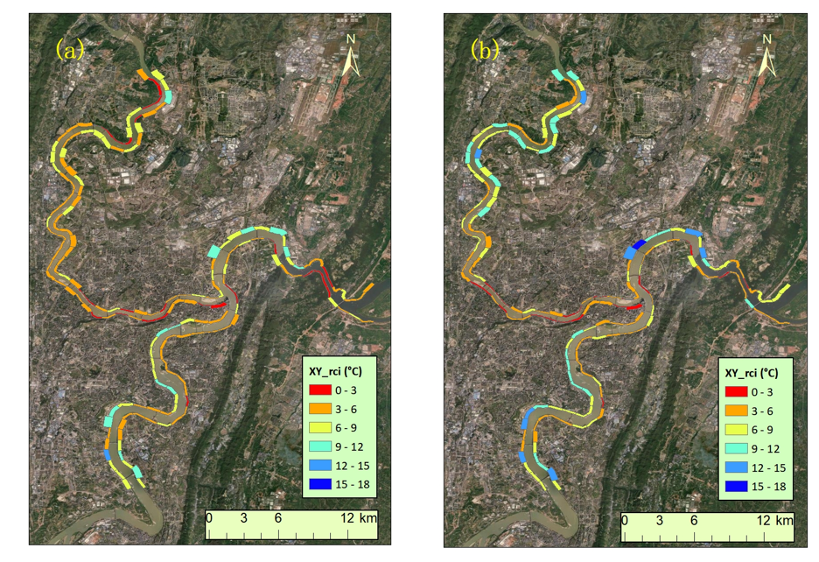

Fig. 4 The spatial pattern of average RCI of individual segments of riverside areas in the normal summer day and the extremely hot day, respectively. The widths of segments represent river cooling distances.

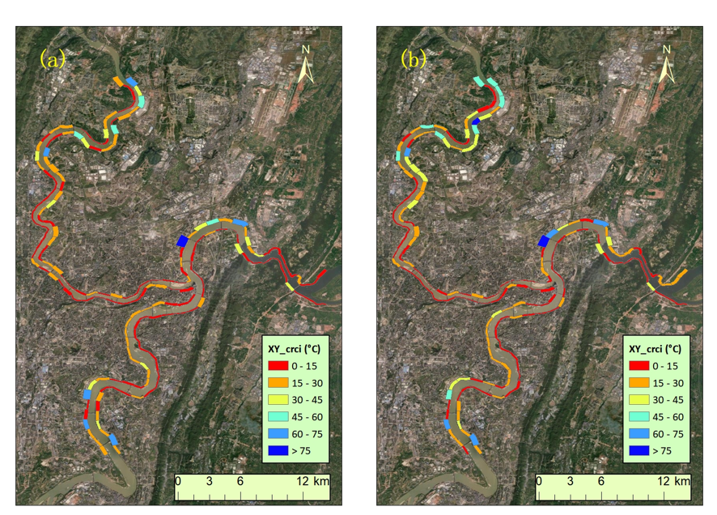

Fig. 5 The spatial pattern of average CRCI of individual segments of riverside areas in the normal summer day and the extremely hot day, respectively. The widths of segments represent river cooling distances.

* The spatial patterns of river cooling intensities on the typical normal summer day (8th, May, 2022) and the extremely hot day (12th,Aug, 2022) are demonstrated in Fig. 4.
* On the normal summer day, the maximum and average values of RCI over all segments of riverside areas are 12.2 °C and 5.5 °C, respectively.
* On the extremely hot day, the RCI magnitudes are evidently higher, with the maximum and average values being 15.5 °C and 6.3 °C, respectively.
* It should be noted that there are also larger diversities of RCI magnitudes among individual segments in the 2 case days.
* Specifically, the standard deviation is 2.4°C on the normal summer day, while the corresponding value is 3.1°C on the extremely hot day.
* It can also be observed that the spatial patterns of RCI magnitudes are similar on both case days.
* For riverbanks along the Jialing River, the RCI magnitudes are relatively lower compared to the Yangtze River.
* Specifically, the mean RCI magnitude of riverside segments along the Jialing River are 4.8°C and 5.9°C on the normal summer day and the extremely hot day, respectively.
* For the Yangtze River, the corresponding magnitudes are 6.1°C and 6.7°C, both being about 1°C higher than the Jialing River.
* The wider river width of the Yangtze River is speculated to cause this difference.
* We can also observe that the RCI magnitudes are significantly lower for riverside segments near the Tongluo Mountain in the eastern suburb of Chongqing compared to the surrounding areas.
* It can be easily inferred that the higher mountainous terrain near the riverbanks plays an obstructive role in the inland penetration of river cooling effects.
* Furthermore, in the city center where most high-rise buildings are located, the RCI magnitudes are relatively lower than the surrounding suburban areas.
* The blocking effect of dense buildings is believed to explain this phenomenon.
* As shown in Fig. 5, similar spatial patterns of CRCI magnitudes on the normal summer day and the extremely hot day are presented.
* On the normal summer day, the average magnitude of CRCI is 16.7°C and the corresponding magnitudes is 19.2°C on the extremely hot day.
* Segments with CRCI magnitudes being less than 15 °C mostly appear in the city center and near the Tongluo Mountain where there are high buildings and steep terrains.

### 3.2 Contributions of influencing factors on river cooling effects

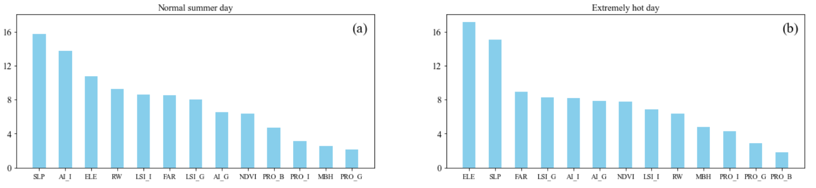

Fig. 6 Relative importance of influencing factors on RCI in the normal summer day and the extremely hot day, respectively.

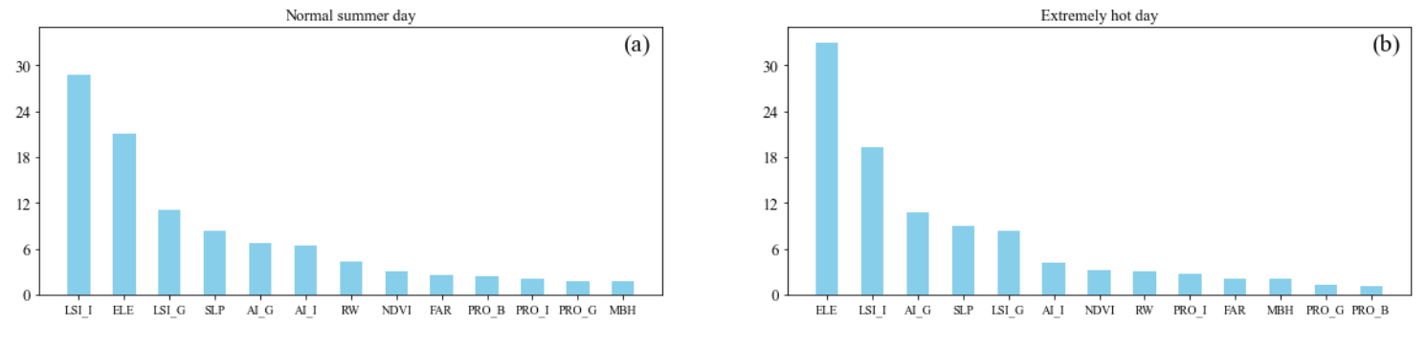

Fig. 7 Relative importance of influencing factors on CRCI in the normal summer day and the extremely hot day, respectively.

* Fig. 6 illustrates the contributions of potential influencing factors on river cooling effects in the two selected case days.
* Unlike other studies which reveal that land use patterns or 3D building characteristics play dominant roles in water cooling effects, the results here show that topography exerts significant impacts on river cooling effects in the metropolitan area of Chongqing with complex topography.
* In terms of RCI, average slope is most influential among all potential factors in the normal summer day as it contributes 15.7 % .
* The contribution of average elevation is slightly smaller, accounting for 10.8 %.
* The role of topography is found to be even stronger in the extremely hot day as average slope and elevation make contributions of 17.1 % and 15.0 %, ranking first and second, respectively.
* Both proportions are more than 6 % higher than the contributions of other variables.
* As for land use patterns, the results clearly demonstrate that configuration plays more important roles than composition in explaining RCI variations.
* In the normal summer day, AI_I is the most important 2D landscape index with a contribution rate of 13.7 %, followed by LSI_I (8.6 %), LSI_G (8.0 %) and AI_G (6.5 %).
* In the extremely hot day, LSI_G (8.3%) contributes most, followed by AI_I (8.1%), AI_G (7.8 %) and LSI_I (6.9 %).
* In contrast, the contributions of the two indices of land use compositions are both less than 5% for the 2 case days.
* For 3D building characteristics, FAR makes much more contributions than MBH and it contributes 8.5 % and 9.0 % in the normal summer day and the extremely hot day, respectively.
* As described in Sect. 3.1, the effect of river width can not be ignored.
* According to the analysis of relative importance, its contributions on RCI are 9.3 % and 6.3 % in the 2 case days.
* Similar to RCI, CRCI is also largely affected by topography as average slope and elevation contribute 8.3 % and 22.1 % in the normal summer day. In the extremely hot day, the corresponding contributions are even higher, being 32.9 % and 9.0 %, respectively.
* Compared to the relative importance of 2D land use patterns in influencing RCI, their contributions on CRCI are significantly stronger.
* LSI_I stands out as the predominant factor, making a substantial contribution of 28.8 %, surpassing the second-largest factor by more than 7 % in the normal summer day.
* Factors of LSI_G (11.0 %), AI_G (6.7 %), AI_I (6.4 %), PRO_I (2.1 %) and PRO_G (1.8 %) follow in succession in terms of contribution.
* In the extremely hot day, the contribution of LSI_I is significantly smaller, being 19.3 %.
* AI_G, LSI_G, AI_I, PRO_I and PRO_G rank successively with relative importance of 10.8 %, 8.3 %, 4.1 %, 2.8 % and 1.3 %, respectively.
* It should be noted that 3D building characteristics make little contributions on CRCI. Both variables (FAR and MBH) contribute less than 3 % in the 2 case days.
* In addition, river width contributes 4.3 % and 3.1 % in the normal summer day and the extremely hot day, respectively.

### 3.3. Marginal effects of key impact factors on river cooling effect

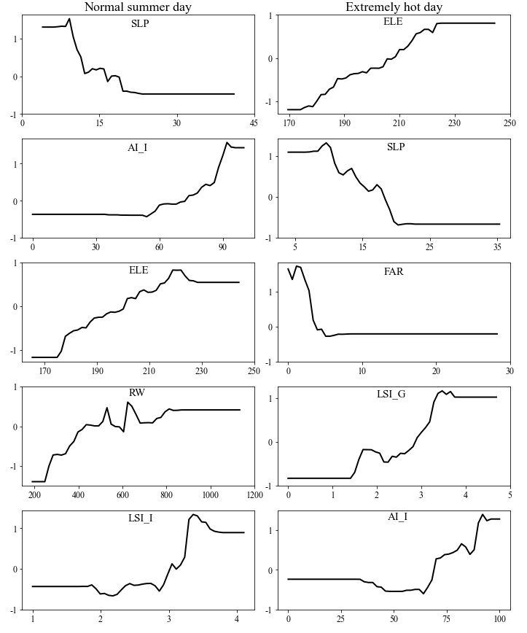

Fig. 8 Marginal effects of the top five most influential factors on RCI in the normal summer day and the extremely hot day, respectively.

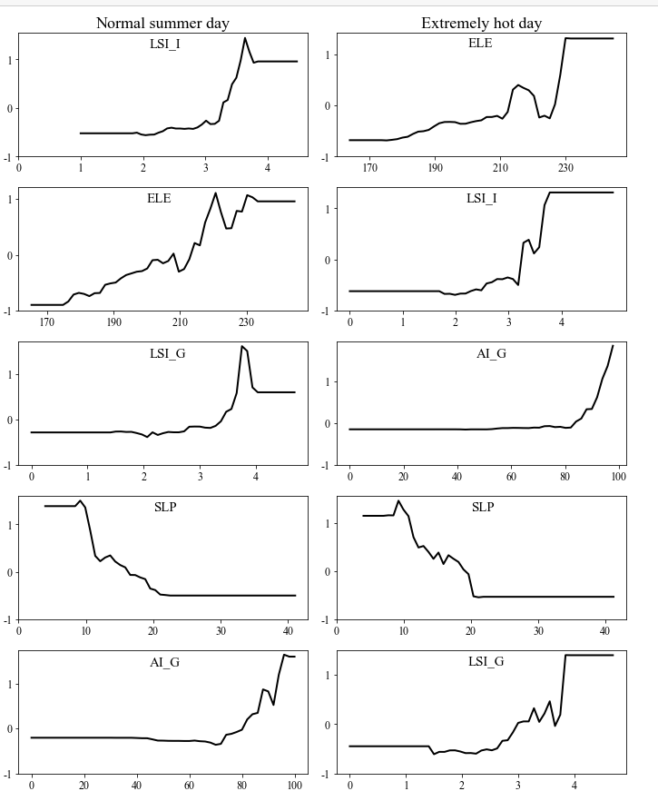

Fig. 9 Marginal effects of the top five contributing factors on CRCI in the normal summer day and the extremely hot day, respectively.

* The the top five contributing variables are used for the subsequent analysis of marginal effects in the 2 case days.
* The results demonstrate the non-linear influences of environmental factors on river cooling.
* As the most contributing factor in explaining RCI in the normal summer day, average slope takes effect in the form of descent pattern.
* When average slope increases from 9.2 to 23.3, the cooling intensity induced by river would be weakened from 6.8 °C to 4.3 °C, demonstrating that larger slope of the riverside area is not beneficial for the heat mitigation generated by the nearby river.
* With values of average slope being larger than 23.3, its influence on RCI can be neglected.
* In contrast, the influences of other factors (AI_I, ELE, RW, LSI_I) are characterized by ascent patterns.
* The positive relationship between AI_I and RCI appears when AI_I is between 54 and 94.
* This demonstrates that cooling intensity provided by river can be stronger with improved aggregation levels.
* As for ELE, RW and LSI_I, they positively affect RCI when their values are within 174.8 - 218.4, 246.7 - 812.3 and 1.7 - 3.4, respectively.
* In the extremely hot day, the top five contributing variables are ELE, SLP, FAR, LSI_G and AI_I.
* Ascent patterns appear in the relative influences of ELE, LSI_G and AI_I.
* RCI increases when their values are within 174.1 - 225.0, 1.4 - 3.5 and 34 - 92, respectively.
* The relative influences of SLP and FAR are characterized by descent patterns and RCI decreases when their values are within 9.6 - 22.8 and 1.1 - 5.0.
* The marginal effects of the top five most contributing factors on CRCI in the 2 case days are shown in Fig. 9.
* The relative influences of LSI_I, ELE, LSI_G and AI_G are characterized by ascent patterns in the 2 case days.
* As the only factor with descent patterns in the 2 case days, average slope reduces CRCI when it’s between 9.2 - 22.5 in the normal summer day and 9.2 - 20.4 in the extremely hot day.
* Its relative influences are characterized by decent patterns in the normal summer day and the extremely hot summer day.
* This is reasonable as the river cooling effect is weakened in densely built areas caused by the blocking effect of large-volume buildings.
* It should be noted that the decent pattern is limited within a certain range of average building height.
* When floor area ratio is larger than a certain value, the relative influence of floor area ratio is insignificant.
* Specifically, in the normal summer day, the decent pattern ranges from 0 to xx for RCI and 0 to xx for CRCI.
* In the extremely hot summer day, the corresponding ranges are 0 to xx and 0 to xx for RCI and CRCI respectively.
* Similar to floor area ratio, average slope of the riverside area demonstrates decent influences on river cooling.
* In the normal summer day, it shows a negative effect on RCI and CRCI when the average slope is larger than xx and xx.
* This indicates that larger slope of the riverside area is not beneficial for the heat mitigation generated by the river.
* In the extremely hot summer day, the influences are similar. The negative effect appears when the average slope is larger than xx and xx.
* The influence of Impervious surface coverage is characterized by decent pattern.

## Discussions

### The impacts of influencing factors on river cooling effects

* As can be seen from Fig. 4 and Fig. 5, this research reveals comparable magnitudes and similar spatial patterns of river cooling effects on the normal summer day and the extremely hot day.
* Stronger temperature reduction tends to appear in suburban areas with sparse distributions of buildings.
* In the normal summer day, the average RCI magnitude is 5.5 °C, which is comparable to the results from previous researches (Manteghi et al., 2015; Wu et al., 2021).
* Compared to the RCI magnitude of Songhua River based on a study in Jilin, China, this magnitude is slightly higher (Xue et al., 2019).
* This is likely to be caused by the difference of river widths as the width of the Yangtze River in Chongqing can be more than 1 kilometer which is larger than those in other relevant researches.
* In addition, background weather condition and surrounding urban environment are likely to explain the differences of river cooling effects.
* As global warming and urbanization continue, it is expected that the negative effects of future extreme heatwaves will continue to increase.
* Therefore, focusing on the river cooling effects during extreme weather conditions can provide scientific insights for addressing future urban climate change.
* This study reveals a large difference of river cooling effects between the normal summer day and the extremely hot day.
* The spatial heterogeneity of RCI and CRCI are larger in the extremely hot day compared to the normal summer day.
* It is similar to a study of sea breeze cooling in Adelaide, which shows that there are larger spatial inconsistency of sea breeze cooling power in heatwave days compared to normal summer days.
* Distinct large-scale synoptic patterns are inferred to cause this difference.
* Oke et al. (2017) mentioned that topography plays a significant role in shaping urban climate and significant relation between LST and elevation has been observed in case studies.
* In this study, the dominant role of average slope in influencing river cooling effects is revealed.
* This is reasonable as surface roughness increases with elevated slope and this can directly weaken the cooling ability induced by the surrounding river.
* In terms of two-dimensional land use features, this study found that the role of land use composition is small.
* The insignificant correlation between river cooling and proportion of green space can be explained by the interaction between vegetation and river cooling.
* Due to the lower baseline temperature in vegetation areas, the impact of river cooling is weaker compared to the impervious land.
* On the other hand, areas with vegetation are mostly open areas, which facilitates the inward penetration of airflow from the river.
* With the influences mentioned above, the overall effects of green space ratio on river cooling are limited.
* In terms of variables of 3D building characteristics, this study found that the impact of FAR is more pronounced compared to MBH.
* This is different from previous studies in which the two variables are negatively correlated with LST.
* In fact, building height affects LST mainly by altering shading areas and airflow patterns, while its influence on river cooling is more associated with airflow patterns.
* Therefore, the stronger role of FAR is probably because of the fact that the airflow pattern in Chongqing is more directly related to the total building volume rather than the height of buildings.
* Few studies paid attention to the relationship between urban climate and topography.
* A study in Guilin reveals that the unique geomorphological characteristics lead to the occurrence of anomalous heat island phenomenon in winter (Mo et al., 2024).
* However, there is still insufficient understanding on the role of topography in the cooling effects of blue and green spaces. This study found that topography has a significant impact on the cooling effects of rivers, and this effect can even be stronger than the influence of land cover layout.
* In fact, the impact of rivers on the thermal environment of surrounding areas is primarily driven by inland airflow. Irregular terrain can significantly alter the direction and intensity of airflow, thereby modulating the spatial pattern of the thermal environment. Therefore, the role of topography cannot be overlooked in the thermal environmental effects of blue-green spaces.
* 这与XX研究相似。XX发现xxx. 建筑高度对河流降温效应的影响主要是通过对水体与陆地之间对流产生影响而形成的。同时，三维空间格局还会影响太阳辐射的布局，从而改变地表能量平衡。同样需要注意的是，由于建筑高度的标准差与其它指标的高度相似性。因此，并没有被纳入本研究中。同时，在几个涉及建筑格局的指标（容积率、建筑高度、cubic指数），容积率的影响最大。

### Implications for urban planning

* The urban heat island may have negative effects on the physical and mental health of local residents, especially in cities with a relatively hot climate in summer.
* Effectively utilizing existing blue spaces to cool the surrounding areas can mitigate the health risks associated with extreme urban heat.
* This study reveals significant spatial variations in river cooling effects resulted from different environmental characteristics of waterfront areas.
* It analyzes the non-linear impacts of various environmental factors on river cooling effects.
* The findings provide references for climate-friendly urban planning to improve residents' living environment.
* The study emphasizes the crucial role of topography in river cooling effects of waterfront areas.
* Regions with significant topographical variations negatively impact the inland penetration of river cooling effects.
* Therefore, primary activity areas for residents should avoid locations with substantial topographical changes.
* Regarding river cooling effects, this study reveals that the influences of two-dimensional land use features are comparable to that of 3D building characteristics.
* Additionally, the configuration of different land use types is more important than the composition in influencing RCI and CRCI.
* So it can be derived that emphasis should be placed on the layout of two-dimensional land-use types in urban planning and design of waterfront areas.
* According to the results, both aggregation index and landscape shape index show significantly positive correlations with RCI and CRCI.
* Therefore, it is recommended to increase the aggregation level of individual land use types and adjust their shape regularity to effectively promote river cooling and provide a more climate-friendly living environment.
* Furthermore, based on the results of the BRT model, the impact of important factors on river cooling occurs within specific ranges.
* Therefore, considerations in urban planning should account for the ranges in which different factors take effects to more effectively implement river cooling measures.

### Limitations of this study and future work

* There are some limitations in this study.
* Located in the Sichuan basin, the average wind speed in Chongqing is much lower than that of other cities in hina.
* Consequently, the influences of wind speed and wind direction on river cooling effects are not considered in this study.
* Future research should further investigate these factors, particularly in cities with higher wind speed, to provide a more comprehensive understanding of river cooling from the perspective of background climate.
* In addition, Chongqing is a city with a small number of sunshine hours, limiting the availability of suitable Landsat images.
* In this study, only one image is used to represent the normal summer day and the extremely hot day, respectively.
* Therefore, further investigations are necessary to use multiple images for normal and extreme summer days to enhance the robustness of the results.
* Furthermore, this study only focuses on river cooling effects within only one year.
* In fact, like other Chinese cities, Chongqing has experienced a rapid process of urbanization in last decades.
* Due to limitations in the available building data, we are unable to perform the analysis of river cooling during this urbanization process.
* The impacts of dynamic changes of 3D urban structure during urban construction on river cooling effects cannot be well explored.
* A quantitative analysis spanning over 20 years to investigate the annual variations in river cooling effects could provide valuable insights into the influences of environmental variables on river cooling.
* Relevant results have implications for urban planning and management of cities in developing countries.

## Conclusions

本研究以重庆市为例，关注正常夏日和极端夏日的河流对周边城市环境的降温效应，考虑地形、三维建筑特征、土地利用特征、河流宽度为环境因素来分析环境因素在不同背景天气条件下对河流降温效应的影响。BRT模型用于分析各因素对河流降温效应的贡献程度以及边缘效应。相对于之前在水体降温效应研究中常用的线性回归分析等传统分析方法，该方法能较好地描述因素对河流降温效应的非线性影响。

结果表明：

RCI和CRCI均有较大的空间差异性，且空间格局相似。然而，在正常夏日和极端夏日之间幅度有较大的不同。在正常夏日，RCI和CRCI的均值为，而在极端夏日，RCI和CRCI的均值为xx

地形因素是影响RCI和CRCI最大的因素。而对于土地利用的影响，研究发现土地利用配置的影响要强于土地利用的组成。不透水面、植被土地利用组成的影响在正常夏日和极端夏日之间均小于5.

另外，三维建筑指标的影响相对较弱。

对于各影响因素边缘效应的分析表明了不同环境变量对XX的非线性影响，且多数影响都局限在特定时间段。其中，坡度的影响由descent pattern描述，而两个景观指标（LSI&AI）和河流宽度的影响则为ascent格局。

。这一发现提供了对周围景观在影响公园降温效果中的作用的科学理解。它可以指导城市规划者如何通过优化周边景观来增强公园的降温效果。

## References

* Ahmad, Mahmood, et al. "Modelling the dynamic linkages between eco-innovation, urbanization, economic growth and ecological footprints for G7 countries: does financial globalization matter?." Sustainable Cities and Society 70 (2021): 102881.
* Ampatzidis, Petros, and Tristan Kershaw. "A review of the impact of blue space on the urban microclimate." Science of the total environment 730 (2020): 139068.
* An, N., Dou, J., González-Cruz, J. E., Bornstein, R. D., Miao, S., & Li, L. (2020). An observational case study of synergies between an intense heat wave and the urban heat island in Beijing. Journal of Applied Meteorology and Climatology, 59(4), 605-620.
* Azhdari, Abolghasem, Ali Soltani, and Mehdi Alidadi. "Urban morphology and landscape structure effect on land surface temperature: Evidence from Shiraz, a semi-arid city." Sustainable cities and society 41 (2018): 853-864.
* Cheval, S., Popa, A. M., Șandric, I., & Iojă, I. C. (2020). Exploratory analysis of cooling effect of urban lakes on land surface temperature in Bucharest (Romania) using Landsat imagery. Urban Climate, 34, 100696.
* Deng, Ying, et al. "Assessing urban wetlands dynamics in Wuhan and Nanchang, China." Science of The Total Environment 901 (2023): 165777.
* Du, Hongyu, et al. "Research on the cooling island effects of water body: A case study of Shanghai, China." Ecological indicators 67 (2016): 31-38.
* Dugord, Pierre-Adrien, et al. "Land use patterns, temperature distribution, and potential heat stress risk–the case study Berlin, Germany." Computers, Environment and Urban Systems 48 (2014): 86-98.
* Estoque, Ronald C., Yuji Murayama, and Soe W. Myint. "Effects of landscape composition and pattern on land surface temperature: An urban heat island study in the megacities of Southeast Asia." Science of the Total Environment 577 (2017): 349-359.
* Han, S., Hou, H., Estoque, R. C., Zheng, Y., Shen, C., Murayama, Y., ... & Hu, T. (2023). Seasonal effects of urban morphology on land surface temperature in a three-dimensional perspective: A case study in Hangzhou, China. Building and Environment, 228, 109913.
* Hathway, E. A., & Sharples, S. (2012). The interaction of rivers and urban form in mitigating the Urban Heat Island effect: A UK case study. Building and environment, 58, 14-22.
* He, Baojie. Mitigating urban heat island effects: An analysis of precinct ventilation performance and its impact on urban heat islands and outdoor thermal comfort. Diss. UNSW Sydney, 2020.
* Gao, Z., Hou, Y., & Chen, W. (2019). Enhanced sensitivity of the urban heat island effect to summer temperatures induced by urban expansion. Environmental Research Letters, 14(9), 094005.
* Guan, Huade, et al. "Incorporating residual temperature and specific humidity in predicting weather-dependent warm-season electricity consumption." Environmental Research Letters 12.2 (2017): 024021.
* Hathway, E. A., and Steve Sharples. "The interaction of rivers and urban form in mitigating the Urban Heat Island effect: A UK case study." Building and environment 58 (2012): 14-22.
* Li, D., Sun, T., Liu, M., Yang, L., Wang, L., & Gao, Z. (2015). Contrasting responses of urban and rural surface energy budgets to heat waves explain synergies between urban heat islands and heat waves. Environmental Research Letters, 10(5), 054009.
* Li, Y., Sun, Y., Li, J., & Gao, C. (2020). Socioeconomic drivers of urban heat island effect: Empirical evidence from major Chinese cities. Sustainable Cities and Society, 63, 102425.
* Liu, Yuan, et al. "Trade-offs and synergistic relationships of ecosystem services under land use change in Xinjiang from 1990 to 2020: A Bayesian network analysis." Science of The Total Environment 858 (2023): 160015.
* Mo, N., Han, J., Yin, Y., & Zhang, Y. (2024). Seasonal analysis of land surface temperature using local climate zones in peak forest basin topography: A case study of Guilin. Building and Environment, 247, 111042.
* Moyer, A. N., & Hawkins, T. W. (2017). River effects on the heat island of a small urban area. Urban Climate, 21, 262-277.
* Oke, T. R., Mills, G., Christen, A., & Voogt, J. A. (2017). Urban climates. Cambridge University Press.
* Nieuwenhuijsen, Mark J. "Influence of urban and transport planning and the city environment on cardiovascular disease." Nature reviews cardiology 15.7 (2018): 432-438.
* Shen, Chuhui, et al. "Prediction of the future urban heat island intensity and distribution based on landscape composition and configuration: A case study in Hangzhou." Sustainable Cities and Society 83 (2022): 103992.
* Ramamurthy, P., González, J., Ortiz, L., Arend, M., & Moshary, F. (2017). Impact of heatwave on a megacity: an observational analysis of New York City during July 2016. Environmental Research Letters, 12(5), 054011.
* Sun, Ranhao, and Liding Chen. "How can urban water bodies be designed for climate adaptation?." Landscape and Urban Planning 105.1-2 (2012): 27-33.
* Taleghani, Mohammad. "Outdoor thermal comfort by different heat mitigation strategies-A review." Renewable and Sustainable Energy Reviews 81 (2018): 2011-2018.
* Tan, Xingyu, et al. "Comparison of cooling effect between green space and water body." Sustainable Cities and Society 67 (2021): 102711.
* Theeuwes, Natalie E., Anna Solcerova, and Gert J. Steeneveld. "Modeling the influence of open water surfaces on the summertime temperature and thermal comfort in the city." Journal of Geophysical Research: Atmospheres 118.16 (2013): 8881-8896.
* United Nations. (2019). World urbanization prospects: The 2018 revision.
* Wang, Shaojian, et al. "Strategizing the relation between urbanization and air pollution: Empirical evidence from global countries." Journal of Cleaner Production 243 (2020): 118615.
* Wu, J., Li, C., Zhang, X., Zhao, Y., Liang, J., & Wang, Z. (2020). Seasonal variations and main influencing factors of the water cooling islands effect in Shenzhen. Ecological indicators, 117, 106699.
* Wu, Sujuan, et al. "The effects of the cooling efficiency of urban wetlands in an inland megacity: A case study of Chengdu, Southwest China." Building and Environment 204 (2021): 108128.
* Xue, Zhenshan, et al. "Quantifying the cooling-effects of urban and peri-urban wetlands using remote sensing data: Case study of cities of Northeast China." Landscape and Urban Planning 182 (2019): 92-100.
* Yang, Jie, and Xin Huang. "The 30 m annual land cover dataset and its dynamics in China from 1990 to 2019." Earth System Science Data 13.8 (2021): 3907-3925.
* Yao, L., Sailor, D. J., Yang, X., Xu, G., & Zhao, L. (2023). Are water bodies effective for urban heat mitigation? Evidence from field studies of urban lakes in two humid subtropical cities. Building and Environment, 245, 110860.
* Yu, K., Chen, Y., Liang, L., Gong, A., & Li, J. (2020). Quantitative analysis of the interannual variation in the seasonal water cooling island (WCI) effect for urban areas. Science of the Total Environment, 727, 138750.
* Zhou, Y., Guan, H., Huang, C., Fan, L., Gharib, S., Batelaan, O., & Simmons, C. (2019). Sea breeze cooling capacity and its influencing factors in a coastal city. Building and Environment, 166, 106408.
* Zhou, Z., Zhang, Z., Zou, X., Zhang, K., & Zhang, W. (2020). Quantifying wind erosion at landscape scale in a temperate grassland: Nonignorable influence of topography. Geomorphology, 370, 107401.
* Manteghi, G., limit, H., & Remaz, D. (2015). Water bodies an urban microclimate:A review. Modern Applied Science, 9, 1–12. <https://doi.org/10.5539/mas.v9n6p1>
* Xue, Z., Hou, G., Zhang, Z., Lyu, X., Jiang, M., Zou, Y., Shen, X., Wang, J. and Liu, X., 2019. Quantifying the cooling-effects of urban and peri-urban wetlands using remote sensing data: Case study of cities of Northeast China. Landscape and Urban Planning, 182, pp.92-100.

## 补充

* SHAPE_MN公式参考：https://www.mdpi.com/2072-4292/15/9/2414