河流降温效应在一个具有复杂地形的超大城市——以重庆为例

## Abstract

* 研究不足：在关于水体降温效应的研究中，关于河流的研究较少。同时，周边环境地形特征对其的影响尚未得到较好地研究。
* 本研究目的：因此，本研究关注正常夏日和极端夏日的河流对周边城市环境的降温效应，考虑地形、三维建筑特征、土地利用特征、河流宽度为环境因素来分析环境因素在不同背景天气条件下对河流降温效应的影响。该研究采用BRT模型，
* 初步结论：RCI和CRCI均有较大的空间差异性，且空间格局相似。
* 地形因素是影响RCI和CRCI最大的因素。研究发现土地利用配置的影响要强于土地利用的组成。同时，三维特征的影响较弱。
* 在极端炎热和正常的日子里，周围关键[景观指标](https://www.sciencedirect.com/topics/earth-and-planetary-sciences/landscape-metrics" \o "从 ScienceDirect 的 AI 生成的主题页面了解有关景观指标的更多信息)与 PCE之间的关系是非线性的。且影响主要在因素值的特定范围内出现。

意义：研究结果可以作为城市规划者制定热舒适缓解和城市更新策略的基础。

## Introduction

【up2024 0127 09:15】

The ongoing global phenomena of population explosion and economic development have led to a substantial expansion of the urban population. Projections from the United Nations indicate that this trend will persist in the forthcoming decades, with the urbanization rate anticipated to reach 68% by 2050 (United Nations, 2019). Across numerous cities worldwide, the process of urbanization has been associated with various detrimental impacts on the local environment, encompassing issues such as water and air pollution, ecosystem degradation, and the emergence of urban heat island (Wang et al., 2020; Ahmad et al., 2021). Urban heat island manifests as elevated temperatures within urban areas relative to the cooler rural surroundings. Elevated temperature has been identified as the contributor to heightened intensities and prolonged durations of heatwaves, resulting in increased energy consumption and posing potential threats to the public health of urban residents, particularly during the summer months (Guan et al., 2017; Nieuwenhuijsen et al., 2018). Consequently, it becomes imperative to implement strategic measures to mitigate the adverse consequences associated with urbanization.

【up2024 0127 10:19】

Primary strategies to mitigate excessive heat in urban environment encompass modifications to surface materials, optimization of land use patterns, and enhancement of ventilation (Azhdari et al., 2018; Taleghani, 2018; He, 2020). Notably, as pivotal roles of land cover, blue and green spaces have garnered significant attention. Blue spaces indicate urban surfaces predominantly characterized by water features (Ampatzidis et al., 2020). In comparison to impervious surfaces, augmented specific heat capacity of water contributes to decreased temperatures during daylight hours. Furthermore, water surfaces facilitate evaporation, thereby curbing the release of sensible heat to the overlying air. Consequently, blue spaces function as cooling sources, playing a crucial role in decreasing temperatures of the surrounding areas. A study conducted in Chengdu revealed a temperature contrast exceeding 8 °C between lakeside and inland areas (Du et al., 2016). Observations have also suggested that water bodies can exhibit stronger cooling capability than green spaces. For instance, during the summer daytime in Berlin, water surfaces exhibited an average temperature being approximately 2 °C cooler than green spaces (Dugard et al., 2014).

【up2024 0127 18:00】

Based on existing studies, the cooling effects of blue spaces exhibit significant spatiotemporal variations. Regarding temporal variations, the cooling intensity is higher in summer compared to winter (Wu et al., 2020). Throughout a day, the daytime observation of water cooling intensity typically exceeds that of nighttime (Hathway et al., 2012). Some researches also suggested that waterfront areas might be warmer than the surrounding inland areas during the night. For example, a measurement conducted in central Pennsylvania revealed that the average temperature decreased with increasing distance from the riverbank during 22:00 – 05:00 (Moyer et al., 2017). In addition, observations have found noteworthy spatial heterogeneities in water cooling effects within same cities (Lin et al., 2020; Wu et al., 2020). Considering the spatiotemporal variations in water cooling revealed in previous researches, the interactions between water bodies and environmental variables have become a crucial aspect in the understanding of urban heat mitigation. The morphological characteristics of water bodies are often considered to be important factors, with stronger cooling effects frequently observed near larger water bodies (Theeuwes et al., 2013). Regarding the relationship between shape regularity and cooling effects, the conclusions are contradictory. Researches in Shanghai and Beijing suggested that water cooling effects were strengthened with improved shape regularity, while an investigation in the northeastern China indicated that wetlands with more complex shapes had better cooling effects (Du et al., 2016; Sun et al., 2012; Xue et al., 2019). In addition to the features of blue spaces, the roles of land use patterns and the three-dimensional architectural characteristics of waterfront areas have also been explored. Several studies showed that higher and denser buildings may reduce water cooling, while a study in the Pearl River Delta urban agglomeration suggested that better cooling effects tended to appear at wetlands near densely built areas (Peng et al., 2020a; Xue et al., 2019). Furthermore, factors such as proportion of vegetation cover, street width, average building height, floor area ratio (FAR), and building area ratio also potentially take effects (Hathway et al., 2012; Syafii et al., 2017; Zhou et al., 2022).

【up2024 0127 20:25】

Principally influenced by mechanical forces, urban wind patterns, including both directions and intensities, are impacted by local topographic variations, such as hills, ridges, and cliffs (Chen et al., 2021; Zhou et al., 2020). As wind can play a role in bringing in cool air and expelling excess heat of specific areas, there is a speculation that the spatial patterns of water cooling are more complex in cities with uneven surfaces and topographical variables may serve as potential influencing factors. However, the majority of prior investigations on water cooling effects were conducted in plain cities, leaving the relationships between various topographic indicators and water cooling effects poorly understood in urban areas characterized by relatively complex terrains.

【up2024 0127 22:53】

Despite numerous studies on water cooling effects, the understanding of this phenomenon still faces certain limitations. Firstly, there are differences of morphological characteristics between rivers and lakes. Lakes commonly assume polygonal or circular shapes and are dispersed throughout a city, while rivers follow a narrow and linear layout, predominantly traversing or flowing around urban areas. Consequently, the cooling effects of rivers on their surroundings differ from those of lakes or ponds. In the northeastern Chinese cities of Changchun and Jilin City, river cooling effects have been found to surpass those of lakes and green spaces (Xue et al., 2019). However, prior researches on water cooling primarily centered around ponds, lakes, and wetlands (Cheval et al., 2020; Xue et al., 2019; Yao et al., 2023). Rivers, as crucial water bodies in cities, have received comparatively less attention. Hence, there is a need for more in-depth explorations of cooling effects caused by rivers.

【up2024 0128 00:09】

Additionally, the practical significance of studying water cooling lies in enabling targeted measures to alleviate the negative impacts of extreme heat stress. However, existing relevant studies primarily focus on normal summer days, typically characterized by days with maximum temperatures below 35 °C. The understanding of water cooling in extremely hot days is insufficient. As differences in urban climate characteristics have been found between normal summer days and extremely hot days, it is essential to pay more attention to water cooling in extremely hot days, which has crucial practical implications for heat mitigation in urban areas (Ramamurthy et al., 2017; Gao et al., 2019).

【up2024 0128 15:42】

As a mountainous city located in the upper reach of the Yangtze River, Chongqing experiences hot and humid summers. This study aimed to use the Boosted Regression Trees (BRT) model to explore the quantitative effects of river cooling and their influencing factors in a normal summer day and an extremely hot day, taking Chongqing as an example. The purpose is to answer the following questions: (1) What are the spatial patterns of river cooling effects under different weather conditions? (2) What are the relative importances of individual environmental variables on river cooling effects? (3) How do key influencing factors affect river cooling effects? The findings of this research are expected to provide valuable insights into mitigating urban excessive heat and offer guidance for the climate-friendly planning and design of urban riverside areas.

## Data and Methods

【up2024 0129 09:39】

Before the analysis steps of this study, relevant environmental variables were calculated based on the collected data. During the analysis process, we firstly calculated indexes of river cooling effects using land surface temperatures of the study area. Subsequently, the BRT model was employed to investigate the relative importances of various influencing factors on river cooling effects. Finally, the marginal effects of the top 5 contributing factors were analyzed under different weather conditions. The flowchart of this study is illustrated in Fig. 1.

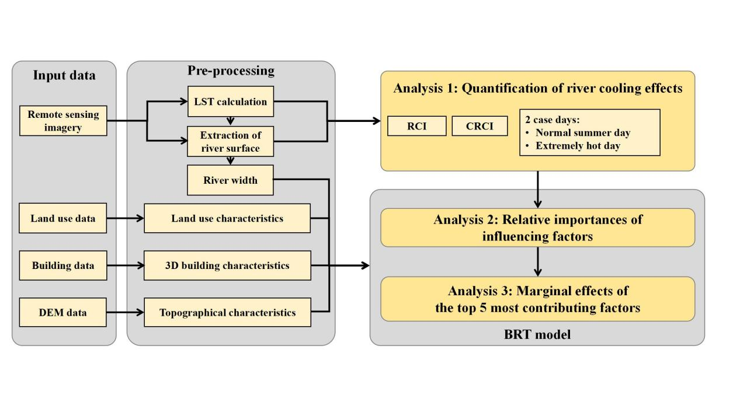

【up2024 0129 09:56】

Fig. 1 Flowchart of this study

### 2.1. Study area

【up2024 0129 10:15】

Chongqing is a megacity located in the upper reach of the Yangtze River. The Yangtze River flows through this city, and its major tributary, the Jialing River, converges with it in the city center (Fig. 2). The urban area of Chongqing is primarily composed of hills and mountains and it is therefore characterized by significantly undulating terrains with elevations ranging from 170 meters to more than 400 meters. Chongqing is located in the subtropical monsoon climate zone. Summer periods normally last from May to September, which are featured by high temperatures and high humidities. On average, there can be more than 30 heatwave days with maximum air temperatures exceeding 35 °C in a year, mostly distributed in July and August. In last decades, Chongqing has experienced a rapid process of urbanization with urban population surging from 6 million in 2000 to 10 million in 2020. With a huge influx of population, urban construction accelerates, and the built-up area expands fast.

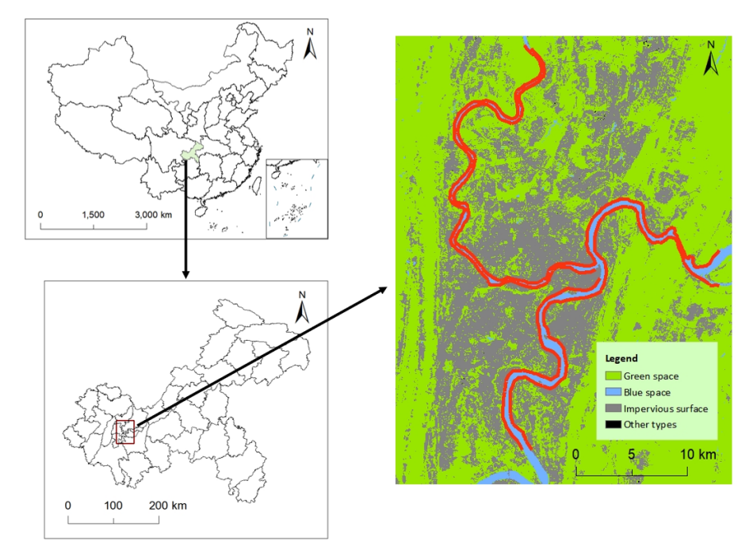

【up2024 0129 10:19】

Fig. 2 Location of the study area. The image on the right shows the land use pattern of the metropolitan area of Chongqing. The red lines along the rivers indicate river sections selected in this research.

### 2.2. Data

【up2024 0129 10:25】

Remote sensing imagery, land use data, building data, and Digital Elevation Model (DEM) data were utilized in this study. The detailed information of each data set is provided in Table 1.

【up2024 0129 10:28】

Table 1 Detailed information of data source.

|  |  |  |  |
| --- | --- | --- | --- |
| Name | Data source | Date | Spatial resolution |
| Remote sensing imagery | Landsat-8 OLI/TIRS surface reflectance products | May 8, 2022 & August 12, 2022 | 30 meters |
| Land use data | China Land Cover Dataset (CLCD) | 2022 | 30 meters |
| Building data | Baidu online Maps | 2022 | 1 meter |
| DEM data | Shuttle Radar Topography Mission (SRTM) |  | 30 meters |

【up2024 0129 10:44】

Landsat-8 OLI/TIRS surface reflectance products were used to calculate land surface temperature and extract river surfaces within the study area. The data were obtained from the United States Geological Survey (USGS) (http://earthexplorer.usgs.gov). Two specific days, May 8, 2022 and August 12, 2022 were chosen to represent the normal summer day and the extremely hot day, respectively. The minimum air temperatures (*Tmin*), maximum air temperatures (*Tmax*), and mean air temperatures (*Tmean*) for these selected days are presented in Table 2.

【up2024 0129 10:44】

Table 2 Minimum, maximum and mean air temperatures of the 2 selected case days.

|  |  |  |
| --- | --- | --- |
| Date | May 8, 2022 | August 12, 2022 |
| *Tmin* (°C) | 22.6 | 33.2 |
| *Tmax* (°C) | 33.0 | 41.0 |
| *Tmean* (°C) | 28.2 | 36.9 |

【up2024 0129 10:55】

3-dimensional (3D) building data were acquired from the service platform on the Baidu online map. This data set includes information on the outlines and numbers of floors of buildings within the study area. Building heights in this study were calculated by multiplying the numbers of floors by 3. Elevation data were sourced from the Shuttle Radar Topography Mission (SRTM) with a spatial resolution of 30 meters, available for download from <http://earthexplorer.usgs.gov.> Land use data were obtained from the annual China Land Cover Dataset (CLCD) with a spatial resolution of 30 meters. Produced by Wuhan University based on Landsat images, this data set provides valuable information for the analysis of land use characteristic (Yang et al., 2021).

### 2.3. Calculation of land surface temperature

【up2024 0129 15:38】

Before the calculation of land surface temperature, it was imperative to perform radiometric calibration and atmospheric correction on the original Landsat-8 images. Subsequently, the radiative transfer equation (RTE) method was employed. The equation can be expressed as:

(1)

where *Lλ* denotes the radiation intensity of the thermal infrared band captured by the sensor, represents the downward atmospheric radiance, represents the upward atmospheric radiance, *ε* stands for the surface emissivity, and *τ* is the atmospheric transmissivity. Addiationally, *B(Ts)* represents the black body radiance and *Ts* represents the land surface temperature.

By converting the above equation, we can get *B(Ts)* as follows:

(2)

In this study, values of and *τ* were obtained by NASA Atmospheric Correction Parameter Calculator. Once the black body radiance was calculated, *Ts* in the unit of Kelvin can be obtained by the following equation:

(3)

According to the default values of Landsat-8 images, *K1* and *K2* were set to be 774.89 and 1321.08, respectively. In the following analysis, the unit of *Ts* was converted to Celsius. All the aforementioned procedures were executed using ENVI software.

### 2.4. Quantification of river cooling effects

【up2024 0130 17:08】

To precisely measure the cooling effects of rivers, the riverbanks were segmented at one-kilometer intervals. Consequently, a total of 185 river segments were generated along the two rivers within the metropolitan area of Chongqing, encompassing 97 segments along the Yangtze River and 88 segments along the Jialing River.

【up2024 0130 17:13】

The land surface temperature of waterfront area exhibited a notable correlation with the distance from the riverbank. More precisely, the temperature gradually increased from the river surface's edge toward the inland area until reaching a point where the upward temperature trend ceased. This point was defined as the first turning point and the temperature value at this point was the turning temperature. It was clear that the waterfront area represented by the non-linear curve from the river surface's edge to the first turning point was influenced by river cooling. Therefore, this area was utilized to compute relevant indices of river cooling effects. Specifically, the distance from the river surface's edge to the first turning point was defined as the River Cooling Distance (RCD). The River Cooling Intensity (RCI) was characterized to be the temperature contrast between the river surface's edge and the first turning point, expressed in the following equation:

(4)

where *Tp* is the turning temperature, and *Tr* is the temperature at the river surface's edge.

【up2024 0130 17:30】

The index of RCI has a limitation in that it only indicates the maximum temperature reduction within the waterfront area, neglecting the non-linear variations in surface temperature. To provide a more comprehensive insight into the inland penetration of river cooling, the index of Cumulative River Cooling Intensity (CRCI) was employed in this study. CRCI was defined as the cumulative difference between the turning temperature and the non-linear temperature curve from the river surface's edge to the first turning point, as depicted in the shaded area of Fig. 3. The equation is given by:

(5)

where *Tc* is the temperature on the non-linear temperature curve.

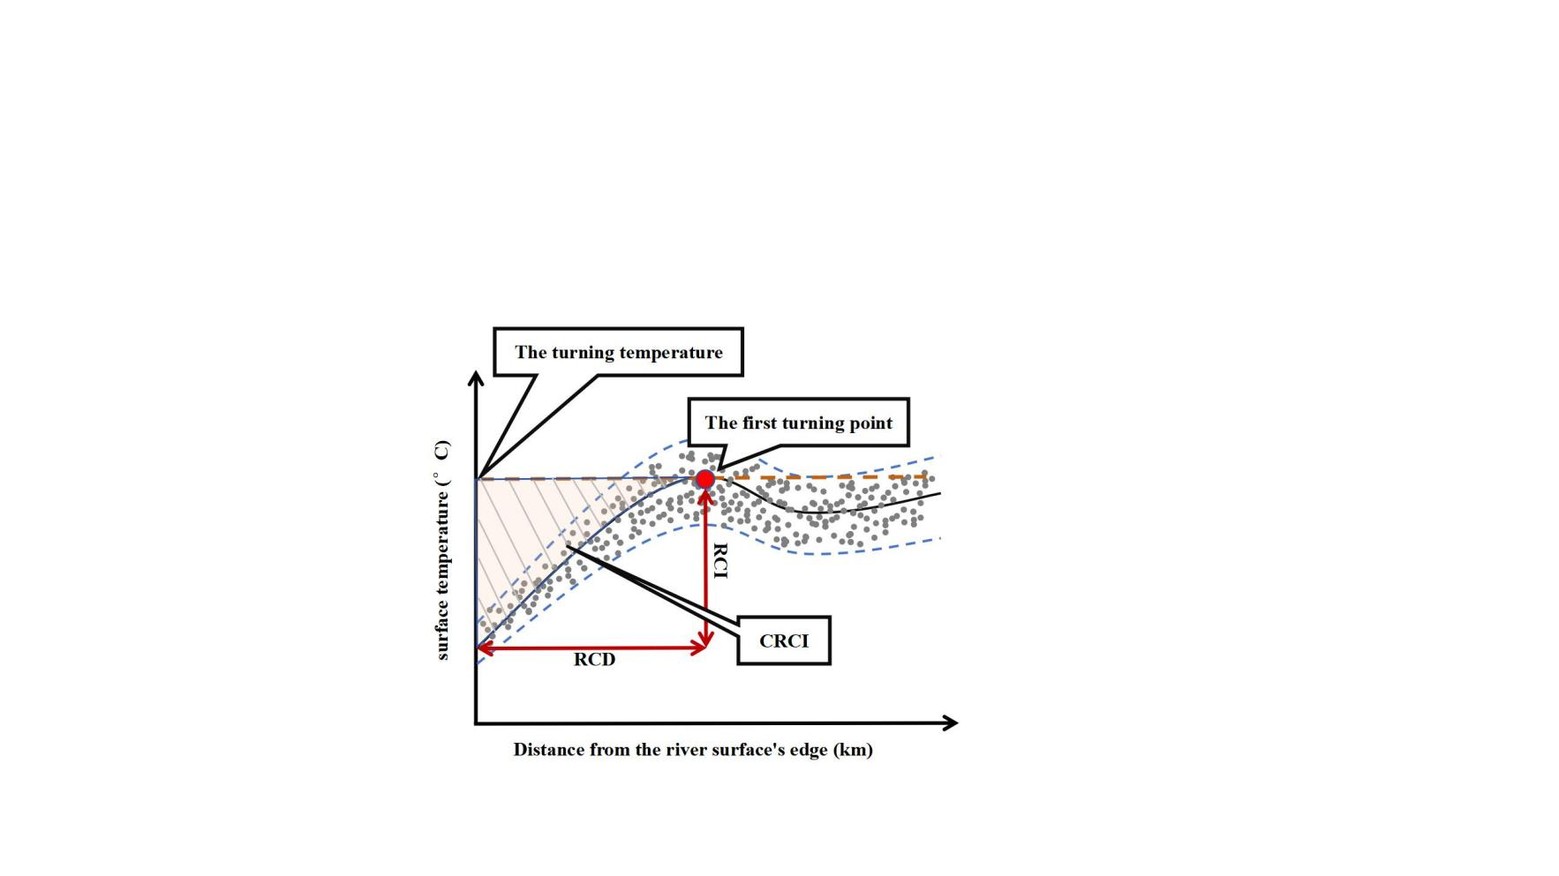

【up2024 0130 17:41】

Fig. 3 Illustration of indexes of river cooling effects.

### 2.5. Calculation of influencing factors

【up2024 0130 18:10】

The potential influencing factors of river cooling effects can be classified into the following types: river width, land use characteristics, 3D building characteristics, and topographical characteristics.

【up2024 0130 18:16】

River width for each river segment was calculated as the distance from the midpoint of the corresponding riverbank to the opposite bank along the line perpendicular to the riverbank. Regarding land use characteristics, area percentage of impervious surface (PLAND_I), area percentage of vegetation (PLAND_V), aggregation index of impervious surface (AI_I), aggregation index of vegetation (AI_V) and patch density (PD) were selected as potential influencing factors.

【up2024 0130 18:43】

The aggregation index was used here to reflect the aggregating level of patches for particular land use types. It is defined as the ratio of actual number to the theoretical maximum number of like adjacencies. The equation for calculating aggregation index for a particular land use type is shown below:

(6)

where *AI* represents the aggregation index of a particular land use type, 𝑔𝑖𝑖 is the number of like adjacencies of type i, 𝑚𝑎𝑥−𝑔𝑖𝑖 is the theoretical maximum number of like adjacencies of type i.

【up2024 0130 18:58】

PD was employed here to reflect the fragmentation of landscape within each river segment. It is defined as the density of patches in a particular area and is calculated by:

(7)

where *N* is the number of patches in a particular area and *A* is the area in the unit of square meters (Peng et al., 2020b).

【up2024 0130 19:04】

3D buildings characteristics were recognized to have potential impacts, as urban architecture can influence the thermal environment by modifying surface energy balance, creating shaded areas, and altering ventilation patterns. In this study, floor area ratio (FAR) and mean building height (MBH) were selected as representative 3D building characteristics. FAR is defined as the ratio of the total floor area to the total land area, while MBH represents the area-weighted mean building height within a particular area. Both metrics were calculated using the collected building data.

【up2024 0130 19:12】

Topographical characteristics were chosen because of the moderate fluctuations in elevation in the metropolitan area of Chongqing. Average elevation (ELE) and average slope (SLP) were employed here to explain the spatial variations of river cooling effects. ELE served to indicate the absolute height level of each river segment, while SLP was utilized to represent the relative change in elevation within each river segment.

### 2.6. Boosted Regression Tree

【up2024 0130 20:15】

The relationships between the cooling effects of water bodies and environmental variables have been examined primarily by simple linear regression or stepwise regression. However, urban climate characteristics are shaped by the complex interactions of multiple factors involving non-linear processes. Traditional linear regression approaches may not effectively capture the non-linear effects of these influencing factors. In this study, we utilized the boosted regression tree (BRT) model to explore the effects of influencing factors on river cooling.

【up2024 0130 20:39】

The BRT model is a combination of the decision tree and the boosting algorithm. Utilizing the boosting algorithm, the decision tree iteratively adapts to randomly selected subsets of the training data set, thereby interactively improving predictive performance (Elith et al., 2008). In contrast to conventional regression methods, the BRT model demonstrates good learning capabilities. It can effectively address complex non-linear effects and exhibit robustness to missing values and outliers. Its predictive performance outperforms that of many traditional modeling methods. In addition, the model does not necessitate consideration of the interactions among independent variables.

【up2024 0130 20:55】

In this study, the BRT model was implemented using the "gbm" package in R. The data set was partitioned into training (75%) and testing (25%) subsets for model development. Initially, we analyzed the relative importances of individual influencing factors to RCI and CRCI. Subsequently, the marginal effects of the top 5 contributing factors were examined.

【up2024 0130 21:00】

Marginal effect reveals the influence of each independent variable on the dependent variable after accounting for the average effect of other variables. Positive marginal effect, denoted by the value larger than 0, indicates a positive effect. Additionally, R2 and root mean square error (RMSE) were employed to validate the predictions generated by the BRT model.

## Results

### 3.1 River cooling effects in the normal summer day and the extremely hot day

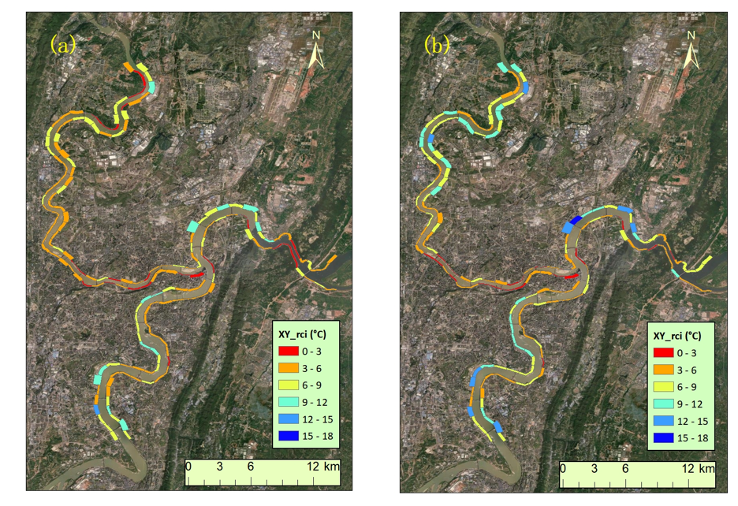

Fig. 4 The spatial pattern of average RCI of individual segments of riverside areas in the normal summer day and the extremely hot day, respectively. The widths of segments represent river cooling distances.

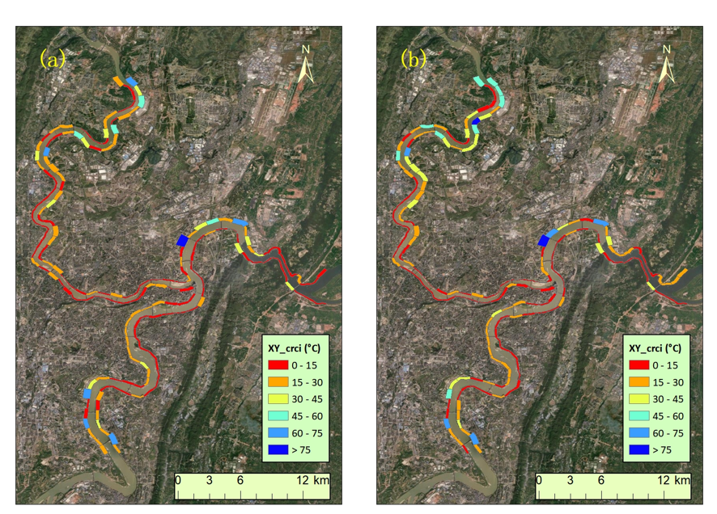

Fig. 5 The spatial pattern of average CRCI of individual segments of riverside areas in the normal summer day and the extremely hot day, respectively. The widths of segments represent river cooling distances.

【ing2024 0130 21:08】

The spatial patterns of river cooling intensities on the typical normal summer day (8th, May, 2022) and the extremely hot day (12th,Aug, 2022) are demonstrated in Fig. 4.

* On the normal summer day, the maximum and average values of RCI over all segments of riverside areas are 12.2 °C and 5.5 °C, respectively.
* On the extremely hot day, the RCI magnitudes are evidently higher, with the maximum and average values being 15.5 °C and 6.3 °C, respectively.
* It should be noted that there are also larger diversities of RCI magnitudes among individual segments in the 2 case days.
* Specifically, the standard deviation is 2.4°C on the normal summer day, while the corresponding value is 3.1°C on the extremely hot day.
* It can also be observed that the spatial patterns of RCI magnitudes are similar on both case days.
* For riverbanks along the Jialing River, the RCI magnitudes are relatively lower compared to the Yangtze River.
* Specifically, the mean RCI magnitude of riverside segments along the Jialing River are 4.8°C and 5.9°C on the normal summer day and the extremely hot day, respectively.
* For the Yangtze River, the corresponding magnitudes are 6.1°C and 6.7°C, both being about 1°C higher than the Jialing River.
* The wider river width of the Yangtze River is speculated to cause this difference.
* We can also observe that the RCI magnitudes are significantly lower for riverside segments near the Tongluo Mountain in the eastern suburb of Chongqing compared to the surrounding areas.
* It can be easily inferred that the higher mountainous terrain near the riverbanks plays an obstructive role in the inland penetration of river cooling effects.
* Furthermore, in the city center where most high-rise buildings are located, the RCI magnitudes are relatively lower than the surrounding suburban areas.
* The blocking effect of dense buildings is believed to explain this phenomenon.
* As shown in Fig. 5, similar spatial patterns of CRCI magnitudes on the normal summer day and the extremely hot day are presented.
* On the normal summer day, the average magnitude of CRCI is 16.7°C and the corresponding magnitudes is 19.2°C on the extremely hot day.
* Segments with CRCI magnitudes being less than 15 °C mostly appear in the city center and near the Tongluo Mountain where there are high buildings and steep terrains.

### 3.2 Contributions of influencing factors on river cooling effects

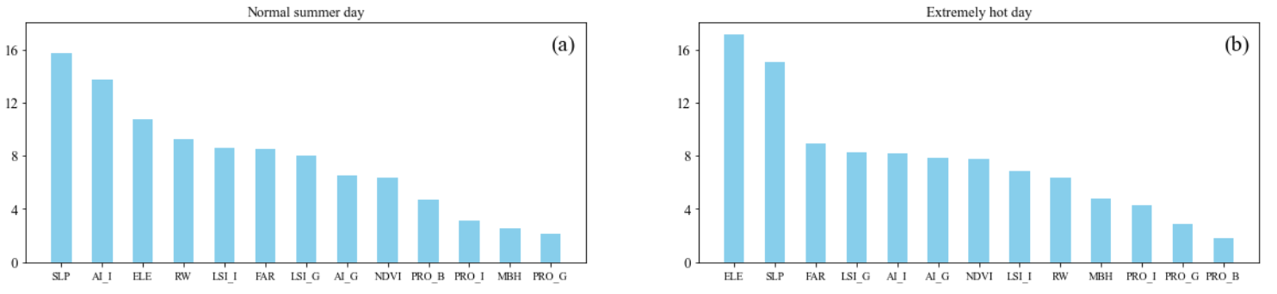

Fig. 6 Relative importance of influencing factors on RCI in the normal summer day and the extremely hot day, respectively.

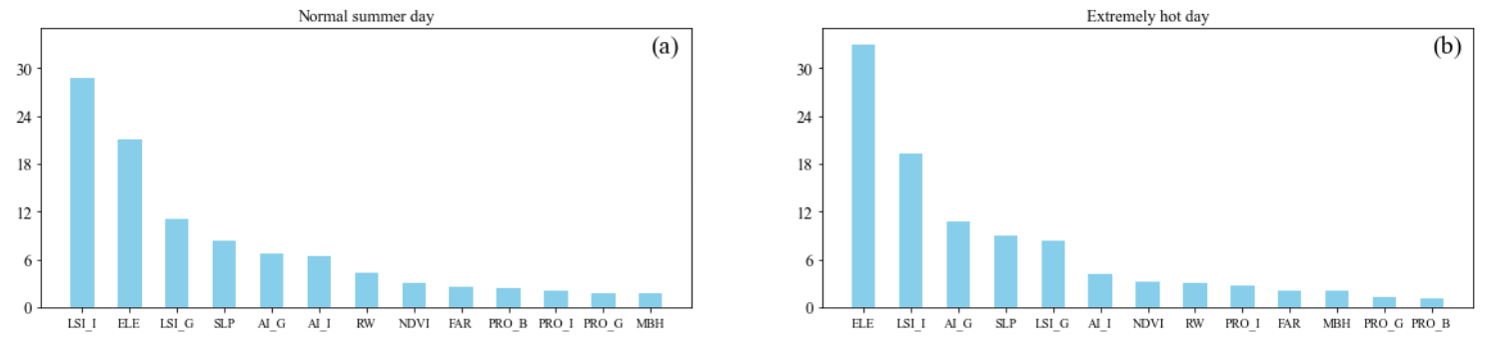

Fig. 7 Relative importance of influencing factors on CRCI in the normal summer day and the extremely hot day, respectively.

* Fig. 6 illustrates the contributions of potential influencing factors on river cooling effects in the two selected case days.
* Unlike other studies which reveal that land use patterns or 3D building characteristics play dominant roles in water cooling effects, the results here show that topography exerts significant impacts on river cooling effects in the metropolitan area of Chongqing with complex topography.
* In terms of RCI, average slope is most influential among all potential factors in the normal summer day as it contributes 15.7 % .
* The contribution of average elevation is slightly smaller, accounting for 10.8 %.
* The role of topography is found to be even stronger in the extremely hot day as average slope and elevation make contributions of 17.1 % and 15.0 %, ranking first and second, respectively.
* Both proportions are more than 6 % higher than the contributions of other variables.
* As for land use patterns, the results clearly demonstrate that configuration plays more important roles than composition in explaining RCI variations.
* In the normal summer day, AI_I is the most important 2D landscape index with a contribution rate of 13.7 %, followed by LSI_I (8.6 %), LSI_G (8.0 %) and AI_G (6.5 %).
* In the extremely hot day, LSI_G (8.3%) contributes most, followed by AI_I (8.1%), AI_G (7.8 %) and LSI_I (6.9 %).
* In contrast, the contributions of the two indices of land use compositions are both less than 5% for the 2 case days.
* For 3D building characteristics, FAR makes much more contributions than MBH and it contributes 8.5 % and 9.0 % in the normal summer day and the extremely hot day, respectively.
* As described in Sect. 3.1, the effect of river width can not be ignored.
* According to the analysis of relative importance, its contributions on RCI are 9.3 % and 6.3 % in the 2 case days.
* Similar to RCI, CRCI is also largely affected by topography as average slope and elevation contribute 8.3 % and 22.1 % in the normal summer day. In the extremely hot day, the corresponding contributions are even higher, being 32.9 % and 9.0 %, respectively.
* Compared to the relative importance of 2D land use patterns in influencing RCI, their contributions on CRCI are significantly stronger.
* LSI_I stands out as the predominant factor, making a substantial contribution of 28.8 %, surpassing the second-largest factor by more than 7 % in the normal summer day.
* Factors of LSI_G (11.0 %), AI_G (6.7 %), AI_I (6.4 %), PRO_I (2.1 %) and PRO_G (1.8 %) follow in succession in terms of contribution.
* In the extremely hot day, the contribution of LSI_I is significantly smaller, being 19.3 %.
* AI_G, LSI_G, AI_I, PRO_I and PRO_G rank successively with relative importance of 10.8 %, 8.3 %, 4.1 %, 2.8 % and 1.3 %, respectively.
* It should be noted that 3D building characteristics make little contributions on CRCI. Both variables (FAR and MBH) contribute less than 3 % in the 2 case days.
* In addition, river width contributes 4.3 % and 3.1 % in the normal summer day and the extremely hot day, respectively.

### 3.3. Marginal effects of key impact factors on river cooling effect

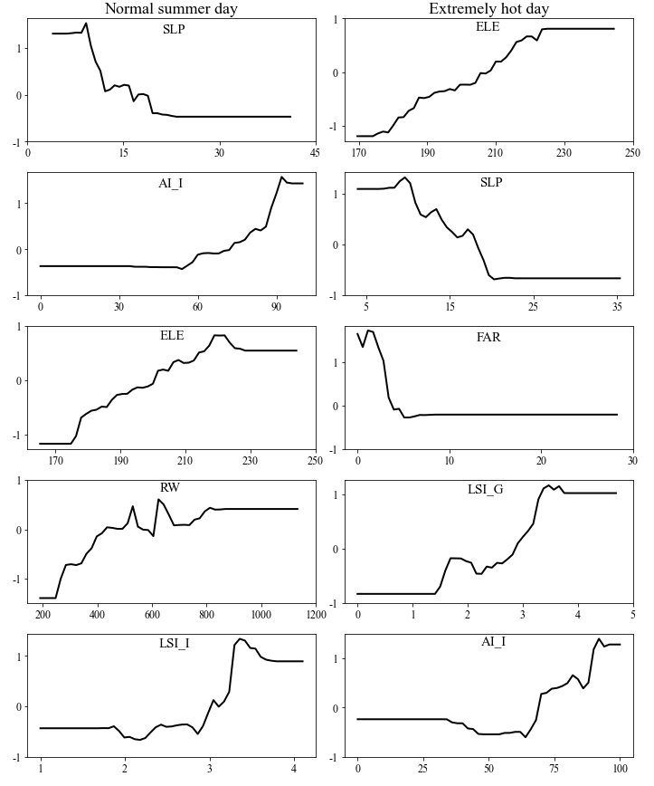

Fig. 8 Marginal effects of the top five most influential factors on RCI in the normal summer day and the extremely hot day, respectively.

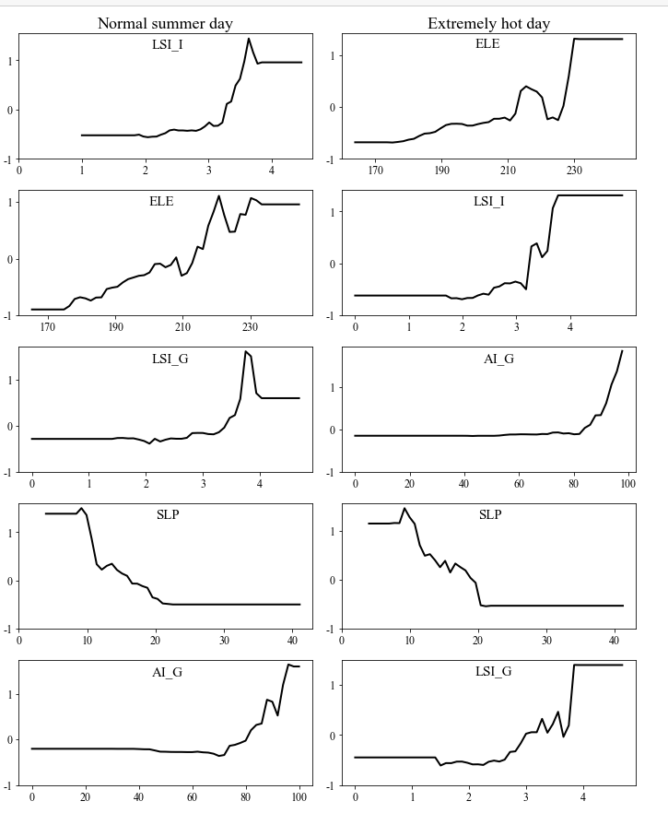

Fig. 9 Marginal effects of the top five contributing factors on CRCI in the normal summer day and the extremely hot day, respectively.

* The the top five contributing variables are used for the subsequent analysis of marginal effects in the 2 case days.
* The results demonstrate the non-linear influences of environmental factors on river cooling.
* As the most contributing factor in explaining RCI in the normal summer day, average slope takes effect in the form of descent pattern.
* When average slope increases from 9.2 to 23.3, the cooling intensity induced by river would be weakened from 6.8 °C to 4.3 °C, demonstrating that larger slope of the riverside area is not beneficial for the heat mitigation generated by the nearby river.
* With values of average slope being larger than 23.3, its influence on RCI can be neglected.
* In contrast, the influences of other factors (AI_I, ELE, RW, LSI_I) are characterized by ascent patterns.
* The positive relationship between AI_I and RCI appears when AI_I is between 54 and 94.
* This demonstrates that cooling intensity provided by river can be stronger with improved aggregation levels.
* As for ELE, RW and LSI_I, they positively affect RCI when their values are within 174.8 - 218.4, 246.7 - 812.3 and 1.7 - 3.4, respectively.
* In the extremely hot day, the top five contributing variables are ELE, SLP, FAR, LSI_G and AI_I.
* Ascent patterns appear in the relative influences of ELE, LSI_G and AI_I.
* RCI increases when their values are within 174.1 - 225.0, 1.4 - 3.5 and 34 - 92, respectively.
* The relative influences of SLP and FAR are characterized by descent patterns and RCI decreases when their values are within 9.6 - 22.8 and 1.1 - 5.0.
* The marginal effects of the top five most contributing factors on CRCI in the 2 case days are shown in Fig. 9.
* The relative influences of LSI_I, ELE, LSI_G and AI_G are characterized by ascent patterns in the 2 case days.
* As the only factor with descent patterns in the 2 case days, average slope reduces CRCI when it’s between 9.2 - 22.5 in the normal summer day and 9.2 - 20.4 in the extremely hot day.
* Its relative influences are characterized by decent patterns in the normal summer day and the extremely hot summer day.
* This is reasonable as the river cooling effect is weakened in densely built areas caused by the blocking effect of large-volume buildings.
* It should be noted that the decent pattern is limited within a certain range of average building height.
* When floor area ratio is larger than a certain value, the relative influence of floor area ratio is insignificant.
* Specifically, in the normal summer day, the decent pattern ranges from 0 to xx for RCI and 0 to xx for CRCI.
* In the extremely hot summer day, the corresponding ranges are 0 to xx and 0 to xx for RCI and CRCI respectively.
* Similar to floor area ratio, average slope of the riverside area demonstrates decent influences on river cooling.
* In the normal summer day, it shows a negative effect on RCI and CRCI when the average slope is larger than xx and xx.
* This indicates that larger slope of the riverside area is not beneficial for the heat mitigation generated by the river.
* In the extremely hot summer day, the influences are similar. The negative effect appears when the average slope is larger than xx and xx.
* The influence of Impervious surface coverage is characterized by decent pattern.

## Discussions

### The impacts of influencing factors on river cooling effects

* As can be seen from Fig. 4 and Fig. 5, this research reveals comparable magnitudes and similar spatial patterns of river cooling effects on the normal summer day and the extremely hot day.
* Stronger temperature reduction tends to appear in suburban areas with sparse distributions of buildings.
* In the normal summer day, the average RCI magnitude is 5.5 °C, which is comparable to the results from previous researches (Manteghi et al., 2015; Wu et al., 2021).
* Compared to the RCI magnitude of Songhua River based on a study in Jilin, China, this magnitude is slightly higher (Xue et al., 2019).
* This is likely to be caused by the difference of river widths as the width of the Yangtze River in Chongqing can be more than 1 kilometer which is larger than those in other relevant researches.
* In addition, background weather condition and surrounding urban environment are likely to explain the differences of river cooling effects.
* As global warming and urbanization continue, it is expected that the negative effects of future extreme heatwaves will continue to increase.
* Therefore, focusing on the river cooling effects during extreme weather conditions can provide scientific insights for addressing future urban climate change.
* This study reveals a large difference of river cooling effects between the normal summer day and the extremely hot day.
* The spatial heterogeneity of RCI and CRCI are larger in the extremely hot day compared to the normal summer day.
* It is similar to a study of sea breeze cooling in Adelaide, which shows that there are larger spatial inconsistency of sea breeze cooling power in heatwave days compared to normal summer days.
* Distinct large-scale synoptic patterns are inferred to cause this difference.
* Oke et al. (2017) mentioned that topography plays a significant role in shaping urban climate and significant relation between LST and elevation has been observed in case studies.
* In this study, the dominant role of average slope in influencing river cooling effects is revealed.
* This is reasonable as surface roughness increases with elevated slope and this can directly weaken the cooling ability induced by the surrounding river.
* In terms of two-dimensional land use features, this study found that the role of land use composition is small.
* The insignificant correlation between river cooling and proportion of green space can be explained by the interaction between vegetation and river cooling.
* Due to the lower baseline temperature in vegetation areas, the impact of river cooling is weaker compared to the impervious land.
* On the other hand, areas with vegetation are mostly open areas, which facilitates the inward penetration of airflow from the river.
* With the influences mentioned above, the overall effects of green space ratio on river cooling are limited.
* In terms of variables of 3D building characteristics, this study found that the impact of FAR is more pronounced compared to MBH.
* This is different from previous studies in which the two variables are negatively correlated with LST.
* In fact, building height affects LST mainly by altering shading areas and airflow patterns, while its influence on river cooling is more associated with airflow patterns.
* Therefore, the stronger role of FAR is probably because of the fact that the airflow pattern in Chongqing is more directly related to the total building volume rather than the height of buildings.
* Few studies paid attention to the relationship between urban climate and topography.
* A study in Guilin reveals that the unique geomorphological characteristics lead to the occurrence of anomalous heat island phenomenon in winter (Mo et al., 2024).
* However, there is still insufficient understanding on the role of topography in the cooling effects of blue and green spaces. This study found that topography has a significant impact on the cooling effects of rivers, and this effect can even be stronger than the influence of land cover layout.
* In fact, the impact of rivers on the thermal environment of surrounding areas is primarily driven by inland airflow. Irregular terrain can significantly alter the direction and intensity of airflow, thereby modulating the spatial pattern of the thermal environment. Therefore, the role of topography cannot be overlooked in the thermal environmental effects of blue-green spaces.
* 这与XX研究相似。XX发现xxx. 建筑高度对河流降温效应的影响主要是通过对水体与陆地之间对流产生影响而形成的。同时，三维空间格局还会影响太阳辐射的布局，从而改变地表能量平衡。同样需要注意的是，由于建筑高度的标准差与其它指标的高度相似性。因此，并没有被纳入本研究中。同时，在几个涉及建筑格局的指标（容积率、建筑高度、cubic指数），容积率的影响最大。

### Implications for urban planning

* The urban heat island may have negative effects on the physical and mental health of local residents, especially in cities with a relatively hot climate in summer.
* Effectively utilizing existing blue spaces to cool the surrounding areas can mitigate the health risks associated with extreme urban heat.
* This study reveals significant spatial variations in river cooling effects resulted from different environmental characteristics of waterfront areas.
* It analyzes the non-linear impacts of various environmental factors on river cooling effects.
* The findings provide references for climate-friendly urban planning to improve residents' living environment.
* The study emphasizes the crucial role of topography in river cooling effects of waterfront areas.
* Regions with significant topographical variations negatively impact the inland penetration of river cooling effects.
* Therefore, primary activity areas for residents should avoid locations with substantial topographical changes.
* Regarding river cooling effects, this study reveals that the influences of two-dimensional land use features are comparable to that of 3D building characteristics.
* Additionally, the configuration of different land use types is more important than the composition in influencing RCI and CRCI.
* So it can be derived that emphasis should be placed on the layout of two-dimensional land-use types in urban planning and design of waterfront areas.
* According to the results, both aggregation index and landscape shape index show significantly positive correlations with RCI and CRCI.
* Therefore, it is recommended to increase the aggregation level of individual land use types and adjust their shape regularity to effectively promote river cooling and provide a more climate-friendly living environment.
* Furthermore, based on the results of the BRT model, the impact of important factors on river cooling occurs within specific ranges.
* Therefore, considerations in urban planning should account for the ranges in which different factors take effects to more effectively implement river cooling measures.

### Limitations of this study and future work

* There are some limitations in this study.
* Located in the Sichuan basin, the average wind speed in Chongqing is much lower than that of other cities in hina.
* Consequently, the influences of wind speed and wind direction on river cooling effects are not considered in this study.
* Future research should further investigate these factors, particularly in cities with higher wind speed, to provide a more comprehensive understanding of river cooling from the perspective of background climate.
* In addition, Chongqing is a city with a small number of sunshine hours, limiting the availability of suitable Landsat images.
* In this study, only one image is used to represent the normal summer day and the extremely hot day, respectively.
* Therefore, further investigations are necessary to use multiple images for normal and extreme summer days to enhance the robustness of the results.
* Furthermore, this study only focuses on river cooling effects within only one year.
* In fact, like other Chinese cities, Chongqing has experienced a rapid process of urbanization in last decades.
* Due to limitations in the available building data, we are unable to perform the analysis of river cooling during this urbanization process.
* The impacts of dynamic changes of 3D urban structure during urban construction on river cooling effects cannot be well explored.
* A quantitative analysis spanning over 20 years to investigate the annual variations in river cooling effects could provide valuable insights into the influences of environmental variables on river cooling.
* Relevant results have implications for urban planning and management of cities in developing countries.

## Conclusions

本研究以重庆市为例，关注正常夏日和极端夏日的河流对周边城市环境的降温效应，考虑地形、三维建筑特征、土地利用特征、河流宽度为环境因素来分析环境因素在不同背景天气条件下对河流降温效应的影响。BRT模型用于分析各因素对河流降温效应的贡献程度以及边缘效应。相对于之前在水体降温效应研究中常用的线性回归分析等传统分析方法，该方法能较好地描述因素对河流降温效应的非线性影响。

结果表明：

RCI和CRCI均有较大的空间差异性，且空间格局相似。然而，在正常夏日和极端夏日之间幅度有较大的不同。在正常夏日，RCI和CRCI的均值为，而在极端夏日，RCI和CRCI的均值为xx

地形因素是影响RCI和CRCI最大的因素。而对于土地利用的影响，研究发现土地利用配置的影响要强于土地利用的组成。不透水面、植被土地利用组成的影响在正常夏日和极端夏日之间均小于5.

另外，三维建筑指标的影响相对较弱。

对于各影响因素边缘效应的分析表明了不同环境变量对XX的非线性影响，且多数影响都局限在特定时间段。其中，坡度的影响由descent pattern描述，而两个景观指标（LSI&AI）和河流宽度的影响则为ascent格局。

。这一发现提供了对周围景观在影响公园降温效果中的作用的科学理解。它可以指导城市规划者如何通过优化周边景观来增强公园的降温效果。

## References

* Ahmad, Mahmood, et al. "Modelling the dynamic linkages between eco-innovation, urbanization, economic growth and ecological footprints for G7 countries: does financial globalization matter?." Sustainable Cities and Society 70 (2021): 102881.
* Ampatzidis, Petros, and Tristan Kershaw. "A review of the impact of blue space on the urban microclimate." Science of the total environment 730 (2020): 139068.
* An, N., Dou, J., González-Cruz, J. E., Bornstein, R. D., Miao, S., & Li, L. (2020). An observational case study of synergies between an intense heat wave and the urban heat island in Beijing. Journal of Applied Meteorology and Climatology, 59(4), 605-620.
* Azhdari, Abolghasem, Ali Soltani, and Mehdi Alidadi. "Urban morphology and landscape structure effect on land surface temperature: Evidence from Shiraz, a semi-arid city." Sustainable cities and society 41 (2018): 853-864.
* Chen, X., Wang, Z., & Bao, Y. (2021). Cool island effects of urban remnant natural mountains for cooling communities: A case study of Guiyang, China. Sustainable Cities and Society, 71, 102983.
* Cheval, S., Popa, A. M., Șandric, I., & Iojă, I. C. (2020). Exploratory analysis of cooling effect of urban lakes on land surface temperature in Bucharest (Romania) using Landsat imagery. Urban Climate, 34, 100696.
* Deng, Ying, et al. "Assessing urban wetlands dynamics in Wuhan and Nanchang, China." Science of The Total Environment 901 (2023): 165777.
* Du, Hongyu, et al. "Research on the cooling island effects of water body: A case study of Shanghai, China." Ecological indicators 67 (2016): 31-38.
* Dugord, Pierre-Adrien, et al. "Land use patterns, temperature distribution, and potential heat stress risk–the case study Berlin, Germany." Computers, Environment and Urban Systems 48 (2014): 86-98.
* Elith, J., Leathwick, J. R., & Hastie, T. (2008). A working guide to boosted regression trees. Journal of animal ecology, 77(4), 802-813.
* Estoque, Ronald C., Yuji Murayama, and Soe W. Myint. "Effects of landscape composition and pattern on land surface temperature: An urban heat island study in the megacities of Southeast Asia." Science of the Total Environment 577 (2017): 349-359.
* Han, S., Hou, H., Estoque, R. C., Zheng, Y., Shen, C., Murayama, Y., ... & Hu, T. (2023). Seasonal effects of urban morphology on land surface temperature in a three-dimensional perspective: A case study in Hangzhou, China. Building and Environment, 228, 109913.
* Hathway, E. A., & Sharples, S. (2012). The interaction of rivers and urban form in mitigating the Urban Heat Island effect: A UK case study. Building and environment, 58, 14-22.
* He, Baojie. Mitigating urban heat island effects: An analysis of precinct ventilation performance and its impact on urban heat islands and outdoor thermal comfort. Diss. UNSW Sydney, 2020.
* Hu, N., Wang, G., Ma, Z., Ren, Z., Zhao, M., & Meng, J. (2023). The cooling effects of urban waterbodies and their driving forces in China. Ecological Indicators, 156, 111200.
* Gao, Z., Hou, Y., & Chen, W. (2019). Enhanced sensitivity of the urban heat island effect to summer temperatures induced by urban expansion. Environmental Research Letters, 14(9), 094005.
* Guan, Huade, et al. "Incorporating residual temperature and specific humidity in predicting weather-dependent warm-season electricity consumption." Environmental Research Letters 12.2 (2017): 024021.
* Guo, F., Zhao, J., Zhang, H., Dong, J., Zhu, P., & Lau, S. S. Y. (2023). Effects of urban form on sea cooling capacity under the heatwave. Sustainable Cities and Society, 88, 104271.
* Hathway, E. A., and Steve Sharples. "The interaction of rivers and urban form in mitigating the Urban Heat Island effect: A UK case study." Building and environment 58 (2012): 14-22.
* Li, D., Sun, T., Liu, M., Yang, L., Wang, L., & Gao, Z. (2015). Contrasting responses of urban and rural surface energy budgets to heat waves explain synergies between urban heat islands and heat waves. Environmental Research Letters, 10(5), 054009.
* Li, Y., Sun, Y., Li, J., & Gao, C. (2020). Socioeconomic drivers of urban heat island effect: Empirical evidence from major Chinese cities. Sustainable Cities and Society, 63, 102425.
* Lin, Y., Wang, Z., Jim, C. Y., Li, J., Deng, J., & Liu, J. (2020). Water as an urban heat sink: Blue infrastructure alleviates urban heat island effect in mega-city agglomeration. Journal of Cleaner Production, 262, 121411.
* Liu, Yuan, et al. "Trade-offs and synergistic relationships of ecosystem services under land use change in Xinjiang from 1990 to 2020: A Bayesian network analysis." Science of The Total Environment 858 (2023): 160015.
* Mo, N., Han, J., Yin, Y., & Zhang, Y. (2024). Seasonal analysis of land surface temperature using local climate zones in peak forest basin topography: A case study of Guilin. Building and Environment, 247, 111042.
* Moyer, A. N., & Hawkins, T. W. (2017). River effects on the heat island of a small urban area. Urban Climate, 21, 262-277.
* Oke, T. R., Mills, G., Christen, A., & Voogt, J. A. (2017). Urban climates. Cambridge University Press.
* Peng, J., Liu, Q., Xu, Z., Lyu, D., Du, Y., Qiao, R., & Wu, J. (2020a). How to effectively mitigate urban heat island effect? A perspective of waterbody patch size threshold. Landscape and Urban Planning, 202, 103873.
* Peng, J., Hu, Y., Dong, J., Liu, Q., & Liu, Y. (2020b). Quantifying spatial morphology and connectivity of urban heat islands in a megacity: A radius approach. Science of The Total Environment, 714, 136792.
* Nieuwenhuijsen, Mark J. "Influence of urban and transport planning and the city environment on cardiovascular disease." Nature reviews cardiology 15.7 (2018): 432-438.
* Shen, Chuhui, et al. "Prediction of the future urban heat island intensity and distribution based on landscape composition and configuration: A case study in Hangzhou." Sustainable Cities and Society 83 (2022): 103992.
* Ramamurthy, P., González, J., Ortiz, L., Arend, M., & Moshary, F. (2017). Impact of heatwave on a megacity: an observational analysis of New York City during July 2016. Environmental Research Letters, 12(5), 054011.
* Sun, Ranhao, and Liding Chen. "How can urban water bodies be designed for climate adaptation?." Landscape and Urban Planning 105.1-2 (2012): 27-33.
* Syafii, N. I., Ichinose, M., Kumakura, E., Jusuf, S. K., Chigusa, K., & Wong, N. H. (2017). Thermal environment assessment around bodies of water in urban canyons: A scale model study. Sustainable cities and society, 34, 79-89.
* Taleghani, Mohammad. "Outdoor thermal comfort by different heat mitigation strategies-A review." Renewable and Sustainable Energy Reviews 81 (2018): 2011-2018.
* Tan, Xingyu, et al. "Comparison of cooling effect between green space and water body." Sustainable Cities and Society 67 (2021): 102711.
* Theeuwes, Natalie E., Anna Solcerova, and Gert J. Steeneveld. "Modeling the influence of open water surfaces on the summertime temperature and thermal comfort in the city." Journal of Geophysical Research: Atmospheres 118.16 (2013): 8881-8896.
* United Nations. (2019). World urbanization prospects: The 2018 revision.
* Wang, Shaojian, et al. "Strategizing the relation between urbanization and air pollution: Empirical evidence from global countries." Journal of Cleaner Production 243 (2020): 118615.
* Wu, J., Li, C., Zhang, X., Zhao, Y., Liang, J., & Wang, Z. (2020). Seasonal variations and main influencing factors of the water cooling islands effect in Shenzhen. Ecological indicators, 117, 106699.
* Wu, Sujuan, et al. "The effects of the cooling efficiency of urban wetlands in an inland megacity: A case study of Chengdu, Southwest China." Building and Environment 204 (2021): 108128.
* Xue, Zhenshan, et al. "Quantifying the cooling-effects of urban and peri-urban wetlands using remote sensing data: Case study of cities of Northeast China." Landscape and Urban Planning 182 (2019): 92-100.
* Yang, Jie, and Xin Huang. "The 30 m annual land cover dataset and its dynamics in China from 1990 to 2019." Earth System Science Data 13.8 (2021): 3907-3925.
* Yao, L., Sailor, D. J., Yang, X., Xu, G., & Zhao, L. (2023). Are water bodies effective for urban heat mitigation? Evidence from field studies of urban lakes in two humid subtropical cities. Building and Environment, 245, 110860.
* Yu, K., Chen, Y., Liang, L., Gong, A., & Li, J. (2020). Quantitative analysis of the interannual variation in the seasonal water cooling island (WCI) effect for urban areas. Science of the Total Environment, 727, 138750.
* Zhou, Y., Guan, H., Huang, C., Fan, L., Gharib, S., Batelaan, O., & Simmons, C. (2019). Sea breeze cooling capacity and its influencing factors in a coastal city. Building and Environment, 166, 106408.
* Zhou, Z., Zhang, Z., Zou, X., Zhang, K., & Zhang, W. (2020). Quantifying wind erosion at landscape scale in a temperate grassland: Nonignorable influence of topography. Geomorphology, 370, 107401.
* Manteghi, G., limit, H., & Remaz, D. (2015). Water bodies an urban microclimate:A review. Modern Applied Science, 9, 1–12. <https://doi.org/10.5539/mas.v9n6p1>
* Xue, Z., Hou, G., Zhang, Z., Lyu, X., Jiang, M., Zou, Y., Shen, X., Wang, J. and Liu, X., 2019. Quantifying the cooling-effects of urban and peri-urban wetlands using remote sensing data: Case study of cities of Northeast China. Landscape and Urban Planning, 182, pp.92-100.
* Yang, J., & Huang, X. (2021). The 30 m annual land cover dataset and its dynamics in China from 1990 to 2019. Earth System Science Data, 13(8), 3907-3925.
* Zhou, X., Zhang, S., Liu, Y., Zhou, Q., Wu, B., Gao, Y., & Zhang, T. (2022). Impact of urban morphology on the microclimatic regulation of water bodies on waterfront in summer: A case study of Wuhan. Building and Environment, 226, 109720.

## 补充

* aggregation index的介绍参考Effects of landscape patterns on the morphological evolution of surface urban heat island in Hangzhou during 2000 – 2020