Investigating the river cooling effects in a mountainous city : Comparison between normal and extreme summer weather conditions

## Abstract

Although urban rivers are considered to have a mitigating effect on extreme heat stress, the influences of topographical characteristics remain poorly understood, particularly in extremely hot weather conditions. Taking the mountainous city of Chongqing as an example, this research focused on the river cooling effects on the surrounding urban environment during normal and extreme summer days. Employing the Boosted Regression Tree (BRT) model, the impacts of environmental variables on river cooling effects were analyzed under different weather conditions. The results revealed that the average values and spatial variations of River Cooling Intensity (RCI) and Cumulative River Cooling Intensity (CRCI) were higher on the extremely hot day compared to the normal summer day. Topographical characteristics exhibited strong impacts on both RCI and CRCI, whereas the impacts of land cover compositions were found to be minimal. On the extremely hot day, average elevation made larger contributions on RCI and CRCI compared to the normal summer day. The relationships between key environmental variables and river cooling effects were non-linear, with most variables exerting their impacts within specific ranges. These findings can provide a foundation for urban planners and managers to develop strategies aimed at improving the thermal environment of riverside areas.

## Introduction

The ongoing global phenomena of population explosion and economic development have led to a substantial expansion of the urban population. Projections from the United Nations indicate that this trend will persist in the forthcoming decades, with the urbanization rate anticipated to reach 68% by 2050 (United Nations, 2019). Across numerous cities worldwide, the process of urbanization has been associated with various detrimental impacts on the local environment, encompassing issues such as water and air pollution, ecosystem degradation, and the emergence of urban heat island (Wang et al., 2020; Ahmad et al., 2021). Urban heat island manifests as elevated temperatures within urban areas relative to the cooler rural surroundings. Elevated temperature has been identified as the contributor to heightened intensities and prolonged durations of heatwaves, resulting in increased energy consumption and posing potential threats to the public health of urban residents, particularly during the summer months (Guan et al., 2017; Nieuwenhuijsen et al., 2018). Consequently, it becomes imperative to implement strategic measures to mitigate the adverse consequences associated with urbanization.

Primary strategies to mitigate excessive heat in urban environment encompass modifications to surface materials, optimization of land cover patterns, and enhancement of ventilation (Azhdari et al., 2018; Taleghani, 2018; He, 2020). Notably, as pivotal roles of land cover, blue and green spaces have garnered significant attention. Blue spaces indicate urban surfaces predominantly characterized by water features (Ampatzidis et al., 2020). In comparison to impervious surfaces, augmented specific heat capacity of water contributes to decreased temperatures during daylight hours. Furthermore, water surfaces facilitate evaporation, thereby curbing the release of sensible heat to the overlying air. Consequently, blue spaces function as cooling sources, playing a crucial role in decreasing temperatures of the surrounding areas. A study conducted in Chengdu revealed a temperature contrast exceeding 8 °C between lakeside and inland areas (Wu et al., 2021). Observations have also suggested that water bodies can exhibit stronger cooling capability than green spaces. For instance, during the summer daytime in Berlin, water surfaces exhibited an average temperature being approximately 2 °C cooler than green spaces (Dugord et al., 2014).

Based on existing studies, the cooling effects of blue spaces exhibit significant spatiotemporal variations. Regarding temporal variations, the cooling intensity is higher in summer compared to winter (Wu et al., 2020). Throughout a day, the daytime observation of water cooling intensity typically exceeds that of nighttime (Hathway et al., 2012). Some researches also suggested that waterfront areas might be warmer than the surrounding inland areas during the night. For example, a measurement conducted in central Pennsylvania revealed that the average temperature decreased with increasing distance from the riverbank during 22:00 – 05:00 (Moyer et al., 2017). In addition, observations have found noteworthy spatial heterogeneities in water cooling effects within same cities (Lin et al., 2020). Considering the spatiotemporal variations in water cooling revealed in previous researches, the interactions between water bodies and environmental variables have become a crucial aspect in the understanding of urban heat mitigation (Hu et al., 2023). The morphological characteristics of water bodies are often considered to be important factors, with stronger cooling effects frequently observed near larger water bodies (Theeuwes et al., 2013). Regarding the relationship between shape regularity and cooling effects, the conclusions are contradictory. Researches in Shanghai and Beijing suggested that water cooling effects were strengthened with improved shape regularity, while an investigation in the northeastern China indicated that wetlands with more complex shapes had better cooling effects (Du et al., 2016; Sun et al., 2012; Xue et al., 2019). In addition to the features of blue spaces, the roles of land cover patterns and the three-dimensional architectural characteristics of waterfront areas have also been explored. Several studies showed that higher and denser buildings may reduce water cooling, while a study in the Pearl River Delta urban agglomeration suggested that better cooling effects tended to appear at wetlands near densely built areas (Peng et al., 2020a; Guo et al., 2023). Furthermore, factors such as proportion of vegetation cover, street width, average building height, floor area ratio, and building area ratio also potentially take effects (Hathway et al., 2012; Syafii et al., 2017; Zhou et al., 2022).

Principally influenced by mechanical forces, urban wind patterns, including both directions and intensities, are impacted by local topographic variations, such as hills, ridges, and cliffs (Chen et al., 2021; Zhou et al., 2020). As wind can play a role in bringing in cool air and expelling excess heat of specific areas, there is a speculation that the spatial patterns of water cooling are more complex in cities with uneven surfaces and topographical variables may serve as potential influencing factors. However, the majority of prior investigations on water cooling effects were conducted in plain cities, leaving the relationships between various topographic indicators and water cooling effects poorly understood in urban areas characterized by relatively complex terrains.

Despite numerous studies on water cooling effects, the understanding of this phenomenon still faces certain limitations. Firstly, there are differences of morphological characteristics between rivers and lakes. Lakes commonly assume polygonal or circular shapes and are dispersed throughout a city, while rivers follow a narrow and linear layout, predominantly traversing or flowing around urban areas. Consequently, the cooling effects of rivers on their surroundings differ from those of lakes or ponds. In the northeastern Chinese cities of Changchun and Jilin City, river cooling effects have been found to surpass those of lakes and green spaces (Xue et al., 2019). However, prior researches on water cooling primarily centered around ponds, lakes, and wetlands (Cheval et al., 2020; Yao et al., 2023). Rivers, as crucial water bodies in cities, have received comparatively less attention. Hence, there is a need for more in-depth explorations of cooling effects caused by rivers.

Additionally, the practical significance of studying water cooling lies in enabling targeted measures to alleviate the negative impacts of extreme heat stress. However, existing relevant studies primarily focus on normal summer days, typically characterized by days with maximum temperatures below 35 °C. The understanding of water cooling in extremely hot days is insufficient. As differences in urban climate characteristics have been found between normal summer days and extremely hot days, it is essential to pay more attention to water cooling in extremely hot days, which has crucial practical implications for heat mitigation in urban areas (Li et al., 2015; Ramamurthy et al., 2017; Gao et al., 2019; An et al., 2020).

As a mountainous city located in the upper reach of the Yangtze River, Chongqing experiences hot and humid summers. This study aimed to use the Boosted Regression Tree model to explore the quantitative effects of river cooling and their influencing factors in a normal summer day and an extremely hot day, taking Chongqing as an example. The purpose is to answer the following questions: (1) What are the spatial patterns of river cooling effects under different weather conditions? (2) What are the relative importances of individual environmental variables on river cooling effects? (3) How do key influencing factors affect river cooling effects? The findings of this research are expected to provide valuable insights into mitigating urban excessive heat and offer guidance for the climate-friendly planning and design of urban riverside areas.

## Data and Methods

Before the analysis steps of this study, relevant environmental variables were calculated based on the collected data. During the analysis process, we firstly calculated indexes of river cooling effects using land surface temperatures of the study area. Subsequently, the Boosted Regression Tree model was employed to investigate the relative importances of various influencing factors on river cooling effects. Finally, the marginal effects of the top 4 contributing factors were analyzed under different weather conditions. The flowchart of this study is illustrated in Fig. 1.

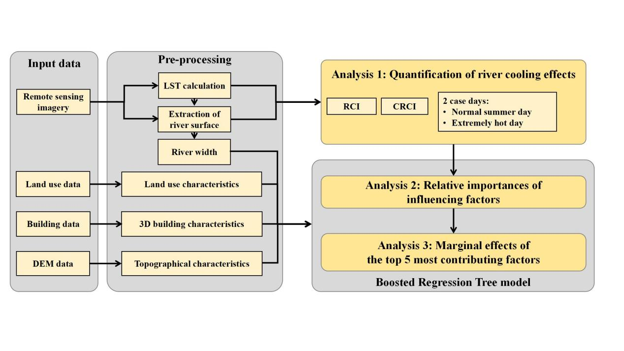

Fig. 1 Flowchart of this study

### 2.1. Study area

Chongqing is a megacity located in the upper reach of the Yangtze River. The Yangtze River flows through this city, and its major tributary, the Jialing River, converges with it in the city center (Fig. 2). The urban area of Chongqing is primarily composed of hills and mountains and it is therefore characterized by significantly undulating terrains with elevations ranging from 170 meters to more than 400 meters. Chongqing is located in the subtropical monsoon climate zone. Summer periods normally last from May to September, which are featured by high temperatures and high humidities. On average, there can be more than 30 heatwave days with maximum air temperatures exceeding 35 °C in a year, mostly distributed in July and August. In last decades, Chongqing has experienced a rapid process of urbanization with urban population surging from 6 million in 2000 to 10 million in 2020. With a huge influx of population, urban construction accelerates, and the built-up area expands fast.

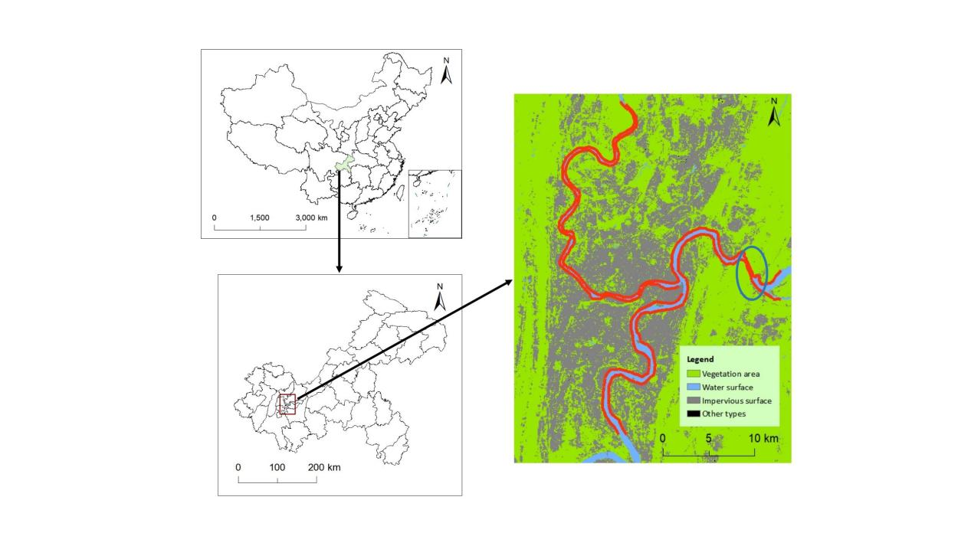

Fig. 2 Location of the study area. The image on the right shows the land cover pattern of the metropolitan area of Chongqing. The red lines along the rivers indicate river sections selected in this research. The blue ellipse shows the riverside area located in the Tongluo Mountain.

### 2.2. Data

Remote sensing imagery, land cover data, building data, and Digital Elevation Model (DEM) data were utilized in this study. The detailed information of each data set is provided in Table 1.

Table 1 Detailed information of data source.

|  |  |  |  |
| --- | --- | --- | --- |
| Name | Data source | Date | Spatial resolution |
| Remote sensing imagery | Landsat-8 OLI/TIRS surface reflectance products | May 8, 2022 & August 12, 2022 | 30 meters |
| Land cover data | China Land Cover Dataset (CLCD) | 2022 | 30 meters |
| Building data | Baidu online Maps | 2022 | 1 meter |
| DEM data | Shuttle Radar Topography Mission (SRTM) |  | 30 meters |

Landsat-8 OLI/TIRS surface reflectance products were used to calculate land surface temperature and extract river surfaces within the study area. The data were obtained from the United States Geological Survey (USGS) (http://earthexplorer.usgs.gov). Two specific days, May 8, 2022 and August 12, 2022 were chosen to represent the normal summer day and the extremely hot day, respectively. The minimum air temperatures (*Tmin*), maximum air temperatures (*Tmax*), and mean air temperatures (*Tmean*) for these selected days are presented in Table 2.

Table 2 Minimum, maximum and mean air temperatures of the 2 selected case days.

|  |  |  |
| --- | --- | --- |
| Date | May 8, 2022 | August 12, 2022 |
| *Tmin* (°C) | 22.6 | 33.2 |
| *Tmax* (°C) | 33.0 | 41.0 |
| *Tmean* (°C) | 28.2 | 36.9 |

3-dimensional (3D) building data were acquired from the service platform on the Baidu online map. This data set includes information on the outlines and numbers of floors of buildings within the study area. Building heights in this study were calculated by multiplying the numbers of floors by 3. Elevation data were sourced from the Shuttle Radar Topography Mission (SRTM) with a spatial resolution of 30 meters, available for download from <http://earthexplorer.usgs.gov.> Land cover data were obtained from the annual China Land Cover Dataset (CLCD) with a spatial resolution of 30 meters. Produced by Wuhan University based on Landsat images, this data set provides valuable information for the analysis of land cover patterns (Yang et al., 2021).

### 2.3. Calculation of land surface temperature

Before the calculation of land surface temperature, it was imperative to perform radiometric calibration and atmospheric correction on the original Landsat-8 images. Subsequently, the radiative transfer equation (RTE) method was employed. The equation can be expressed as:

$L_{λ} = [εB(T_{s}) + (1−ε)L_{d}^{↓}]τ+L_{μ}^{↑}$ (1)

where *Lλ* denotes the radiation intensity of the thermal infrared band captured by the sensor, $L_{d}^{↓}$ represents the downward atmospheric radiance, $L_{μ}^{↑}$ represents the upward atmospheric radiance, *ε* stands for the surface emissivity, and *τ* is the atmospheric transmissivity. Addiationally, *B(Ts)* represents the black body radiance and *Ts* represents the land surface temperature.

By converting the above equation, we can get *B(Ts)* as follows:

$B(T_{s})= {[L}_{λ} − L_{μ}^{↑} − τ (1−ε)L_{d}^{↓}]/τε$ (2)

In this study, values of $L_{d}^{↓}, L_{μ}^{↑},$ and *τ* were obtained by NASA Atmospheric Correction Parameter Calculator. Once the black body radiance was calculated, *Ts* in the unit of Kelvin can be obtained by the following equation:

$T_{s} = \frac{K_{2}}{ln(\frac{K_{1}}{B(T_{s})}+1)}$ (3)

According to the default values of Landsat-8 images, *K1* and *K2* were set to be 774.89 and 1321.08, respectively. In the following analysis, the unit of *Ts* was converted to Celsius. All the aforementioned procedures were executed using ENVI software.

### 2.4. Quantification of river cooling effects

Near the confluence of the Yangtze River and the Jialing River, a small area is obscured by cloud cover on the Landsat image of the extremely hot day. Therefore, this area was not used for the subsequent analysis. For the rest of the area, the riverbanks were segmented at one-kilometer intervals. Consequently, a total of 182 river segments were generated along the two rivers within the metropolitan area of Chongqing, encompassing 94 segments along the Yangtze River and 88 segments along the Jialing River.

The land surface temperature of riverside area exhibited a notable correlation with the distance from the riverbank. More precisely, the temperature gradually increased from the river surface's edge toward the inland area until reaching a point where the upward temperature trend ceased. This point was defined as the first turning point and the temperature value at this point was the turning temperature. It was clear that the riverside area represented by the non-linear curve from the river surface's edge to the first turning point was influenced by river cooling. Therefore, this area was utilized to compute relevant indices of river cooling effects. Specifically, the distance from the river surface's edge to the first turning point was defined as the River Cooling Distance (RCD). The River Cooling Intensity (RCI) was characterized to be the temperature contrast between the river surface's edge and the first turning point, expressed in the following equation:

$RCI =T_{p} − T_{r}$ (4)

where *Tp* is the turning temperature, and *Tr* is the temperature at the river surface's edge.

The index of RCI has a limitation in that it only indicates the maximum temperature reduction within the riverside area, neglecting the non-linear variations in surface temperature. To provide a more comprehensive insight into the inland penetration of river cooling, the index of Cumulative River Cooling Intensity (CRCI) was employed in this study. CRCI was defined as the cumulative difference between the turning temperature and the non-linear temperature curve from the river surface's edge to the first turning point, as depicted in the shaded area of Fig. 3. The equation is given by:

$CRCI = \sum_{0}^{RCD}{(T_{p} − T_{c})}$ (5)

where *Tc* is the temperature on the non-linear temperature curve.

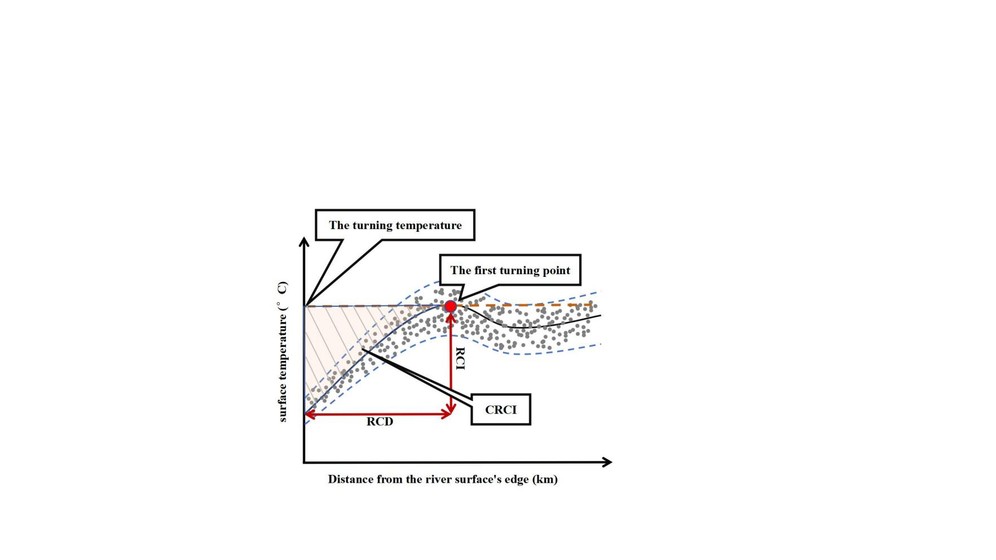

【up2024 0130 17:41】

Fig. 3 Illustration of indexes of river cooling effects.

### 2.5. Calculation of influencing factors

The potential influencing factors of river cooling effects can be classified into the following types: river width, land cover characteristics, 3D building characteristics, and topographical characteristics.

River width (RW)(m) for each river segment was calculated as the distance from the midpoint of the corresponding riverbank to the opposite bank along the line perpendicular to the riverbank. Regarding land cover characteristics, area percentage of impervious surface (PLAND_I)(%), area percentage of vegetation (PLAND_V)(%), aggregation index of impervious surface (AI_I)(%), aggregation index of vegetation (AI_V)(%) and patch density (PD) were selected as potential influencing factors.

The aggregation index was used here to reflect the aggregating level of patches for particular land cover types. It is defined as the ratio of actual number to the theoretical maximum number of like adjacencies. The equation for calculating aggregation index for a particular land cover type is shown below:

$AI = [\frac{g_{ii}}{max − g_{ii}} ] (100)$ (6)

where *AI* represents the aggregation index of a particular land cover type, 𝑔𝑖𝑖 is the number of like adjacencies of type i, 𝑚𝑎𝑥−𝑔𝑖𝑖 is the theoretical maximum number of like adjacencies of type i.

PD was employed here to reflect the fragmentation of landscape within each river segment. It is defined as the density of patches in a particular area with the unit of number per square kilometer and is calculated by:

$PD = \frac{N}{A}×{10}^{6}$ (7)

where *N* is the number of patches in a particular area and *A* is the area in the unit of square meters (Peng et al., 2020b).

3D buildings characteristics were recognized to have potential impacts, as urban architecture can influence the thermal environment by modifying surface energy balance, creating shaded areas, and altering ventilation patterns. In this study, floor area ratio (FAR), building coverage ratio (BCR) and mean building height (MBH)(m) were selected as representative 3D building characteristics. FAR is defined as the ratio of the total floor area to the total land area, while MBH represents the area-weighted mean building height within a particular area. Both metrics were calculated using the collected building data.

Topographical characteristics were chosen because of the moderate fluctuations in elevation in the metropolitan area of Chongqing. Average elevation (ELE)(m) and average slope (SLP) were employed here to explain the spatial variations of river cooling effects. ELE served to indicate the absolute height level of each river segment, while SLP was utilized to represent the relative change in elevation within each river segment.

It is worth noting that land cover characteristics, 3D building characteristics, and topographical characteristics were calculated based on the riverside areas within the river cooling distance in this study.

### 2.6. Boosted Regression Tree

The relationships between the cooling effects of water bodies and environmental variables have been examined primarily by simple linear regression or stepwise regression. However, urban climate characteristics are shaped by the complex interactions of multiple factors involving non-linear processes. Traditional linear regression approaches may not effectively capture the non-linear effects of these influencing factors. In this study, we utilized the Boosted Regression Tree (BRT) model to explore the effects of influencing factors on river cooling.

The BRT model is a combination of the decision tree and the boosting algorithm. Utilizing the boosting algorithm, the decision tree iteratively adapts to randomly selected subsets of the training data set, thereby interactively improving predictive performance (Elith et al., 2008). In contrast to conventional regression methods, the BRT model demonstrates good learning capabilities. It can effectively address complex non-linear effects and exhibit robustness to missing values and outliers. Its predictive performance outperforms that of many traditional modeling methods. In addition, the model does not necessitate consideration of the interactions among independent variables.

In this study, the BRT model was implemented using the "gbm" package in R. The data set was partitioned into training (75%) and testing (25%) subsets for model development. Initially, we analyzed the relative importances of individual influencing factors to RCI and CRCI. Subsequently, the marginal effects of the top 4 contributing factors were examined.

Marginal effect reveals the influence of each independent variable on the dependent variable after accounting for the average effect of other variables. Positive marginal effect, denoted by the value larger than 0, indicates a positive effect. Additionally, R2 and root mean square error (RMSE) were employed to validate the predictions generated by the BRT model.

## Results

### 3.1. River cooling effects on the normal summer day and the extremely hot day

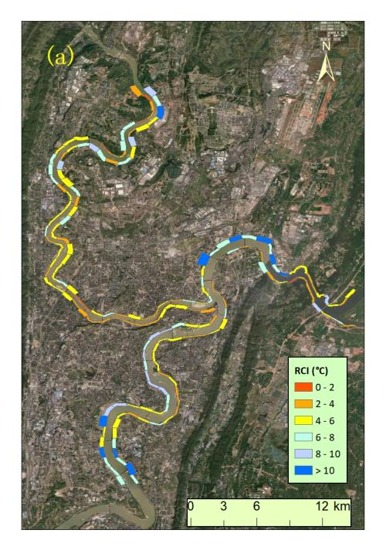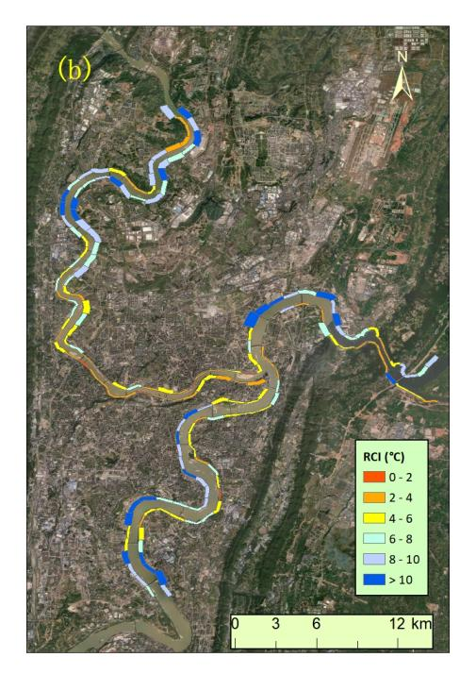

Fig. 4 The spatial patterns of average RCI of individual river segments on the normal summer day (a) and the extremely hot day (b), respectively. The widths of river segments represent the corresponding RCD.

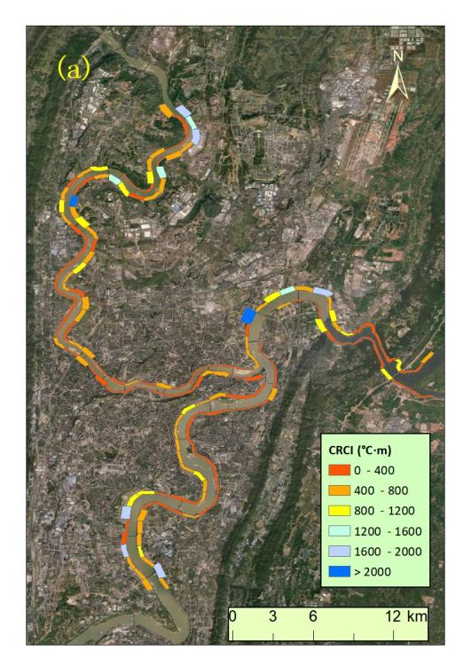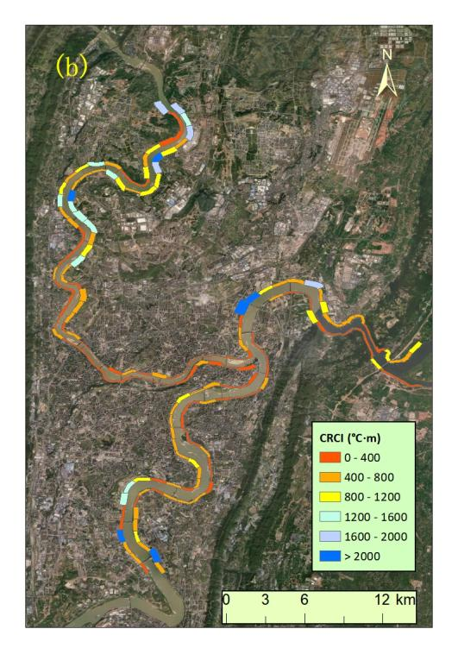

Fig. 5 The spatial patterns of average CRCI of individual river segments on the normal summer day (a) and the extremely hot day (b), respectively. The widths of river segments represent the corresponding RCD.

The spatial patterns of RCI during the selected 2 case days are illustrated in Fig. 4. The widths of river segments represent the corresponding RCD, ranging from 60 meters to 720 meters. On the normal summer day, RCI exhibited maximum and average values of 12.2 °C and 5.5 °C across all river segments. On the extremely hot day, RCI were notably higher, with maximum and average values reaching 15.5 °C and 6.4 °C, respectively. Notably, there were considerable variations in RCI values among individual segments on both case days. Specifically, the standard deviation was 2.4 °C on the normal summer day and increased to 3.1 °C on the extremely hot day.

Additionally, it was observed that the spatial patterns of RCI remained similar on both case days. Along the Jialing River, RCI values were comparatively lower than those along the Yangtze River. Specifically, the mean RCI values for river segments along the Jialing River were 4.8 °C and 5.9 °C on the normal summer day and the extremely hot day, respectively. In contrast, for the Yangtze River, the corresponding values were 6.1 °C and 6.9 °C, approximately 1 °C higher than those along the Jialing River. This difference was speculated to be resulted from the wider river width of the Yangtze River.

Furthermore, RCI values were notably lower for river segments near the Tongluo Mountain in the eastern suburb of Chongqing compared to the surrounding areas. The higher mountainous terrain near the riverbanks was inferred to obstruct the inland penetration of river cooling. In the city center where numerous high-rise buildings were concentrated, RCI values were relatively lower than those in the surrounding suburban areas. This observation can be attributed to the obstructive effect of dense buildings on river cooling.

Similar spatial patterns of CRCI values on the 2 case days are presented in Fig. 5. On the normal summer day, the average CRCI value was 505.8 °C·m and it increased to 582.5 °C·m on the extremely hot day. The spatial diversity were also more pronounced in hotter ambient weather conditions with the standard deviation rising from 462.7 °C on the normal summer day to 553.2 °C on the extremely hot day. River segments exhibiting CRCI values below 400 °C·m were predominantly concentrated in the city center and near the Tongluo Mountain, which were characterized by dense buildings or rugged topography.

### 3.2. Model performance

Table 3 Performances of the BRT model in modelling RCI on the 2 case days.

|  |  |  |
| --- | --- | --- |
| Weather condition | R2 | RMSE (°C) |
| Normal summer day | 0.61 | 1.00 |
| Extremely hot day | 0.54 | 1.44 |

Table 4 Performances of the BRT model in modelling CRCI on the 2 case days.

|  |  |  |
| --- | --- | --- |
| Weather condition | R2 | RMSE (°C·m) |
| Normal summer day | 0.72 | 192.85 |
| Extremely hot day | 0.71 | 264.44 |

The validation results of the BRT model are shown in Table 3 and Table 4. For the effects of environmental variables on RCI, the R2 values were 0.61 and 0.54 on the normal summer day and the extreme summer day, respectively. The corresponding RMSE values were 1.00 °C and 1.44 °C. In terms of CRCI, the R2 values on the 2 case days were 0.72 and 0.71, with the corresponding RMSE values being 192.8 (°C·m) and 264.4 (°C·m). It can be observed that the explanatory powers of the selected environmental variables were higher on CRCI compared to RCI.

### 3.3. Contributions of influencing factors on river cooling effects

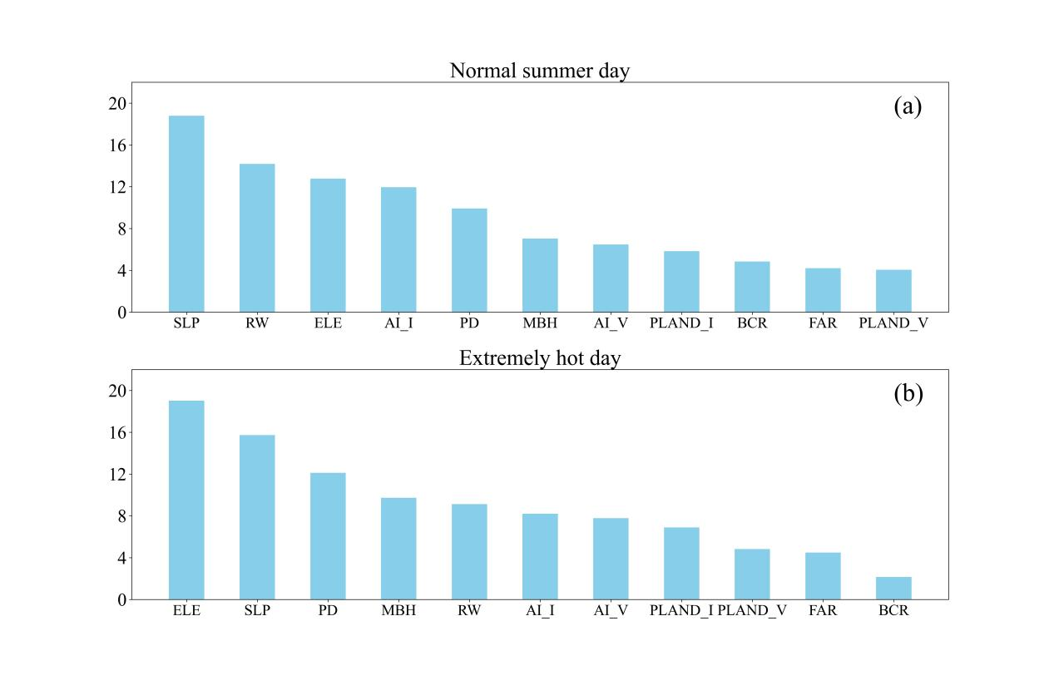

Fig. 6 Relative importances of influencing factors on RCI in the normal summer day (a) and the extremely hot day (b), respectively.

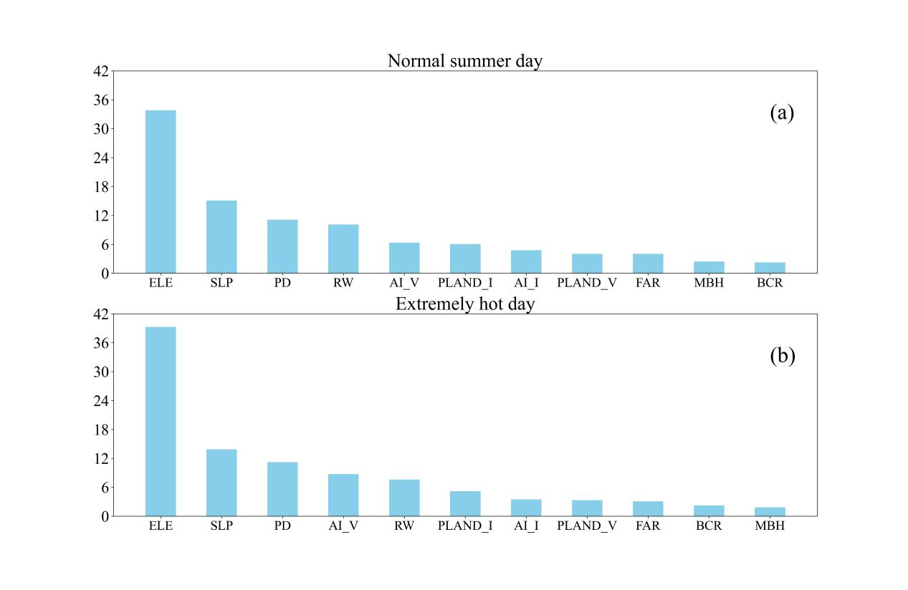

Fig. 7 Relative importances of influencing factors on CRCI in the normal summer day (a) and the extremely hot day (b), respectively.

Fig. 6 and Fig. 7 illustrate the relative importances of influencing factors on river cooling effects during the 2 case days. In contrast to prior studies emphasizing the dominance of land cover characteristics or 3D building characteristics in affecting water cooling effects, our results highlighted the substantial impacts of topography in the metropolitan area of Chongqing, which is characterized by complex terrains.

Regarding RCI, average slope emerged as the most influential factor among all potential contributors on the normal summer day, constituting 18.8 %. The contribution of average elevation was slightly smaller, accounting for 12.8 %. The role of topography intensified on the extremely hot day, with average elevation and slope contributing 19.0 % and 15.7 %, ranking as the first and second most significant factors, respectively.

As has been mentioned in Sect. 3.1, the impacts of river width cannot be overlooked. It contributed 14.2 % and 9.1 % to RCI on the normal summer day and the extremely hot day, respectively.

In terms of land cover characteristics, the findings distinctly highlighted that the configuration of land cover played a more pivotal role than the composition in explaining variations of RCI. On the normal summer day, AI_I emerged as the most influential factor among all the land cover characteristics with a contribution rate of 11.9%, followed by PD (9.9%) and AI_V (6.5%). On the extremely hot day, PD (12.1 %) contributed most, followed by AI_I (8.2%) and AI_V (7.8%). In contrast, the contributions of area percentages for impervious surface and vegetation were both below 7% on the 2 selected case days. For 3D building characteristics, FAR made significantly larger contributions than MBH and it contributed 7.0 % and 9.7 % on the normal summer day and the extremely hot day, respectively.

.

Similar to RCI, CRCI was also significantly influenced by topography. As the most influential factor, average elevation contributed 33.8% and 39.3% to CRCI on the normal summer day and the extremely hot day, respectively. Average slope ranked second, with the corresponding relative importances of 15.1% and 13.9%. Overall, topography exerted a stronger impact on the cumulative effect than on the intensity of cooling in riverside areas.

For land cover characteristics, the indexes were ranked in contributions as PD, AI_V, PLAND_I, AI_I and PLAND_V on the 2 case days with the corresponding relative importances being 11.1%, 6.3%, 6.0%, 4.8% and 4% on the normal summer day and 11.2%, 8.8%, 5.2%, 3.5% and 3.3% on the extremely hot day, respectively.

The impacts of river width and 3D building characteristics on CRCI were relatively smaller compared to their effects on RCI. The ranking of relative importances was as follows on the normal summer day: RW (10.1%), FAR (4.0%), MBH (2.4%), and BCR (2.2%). On the extremely hot day, the ranking was RW (7.6%), FAR (3.1%), BCR (2.2%), and MBH (1.8%).

Overall, in comparison to the normal summer day, the relative influences of average elevation exhibited notable increases on the extremely hot day for both RCI and CRCI, while the impacts of average slope and river width were weakened significantly.

### 3.4. Marginal effects of key impact factors on river cooling effect

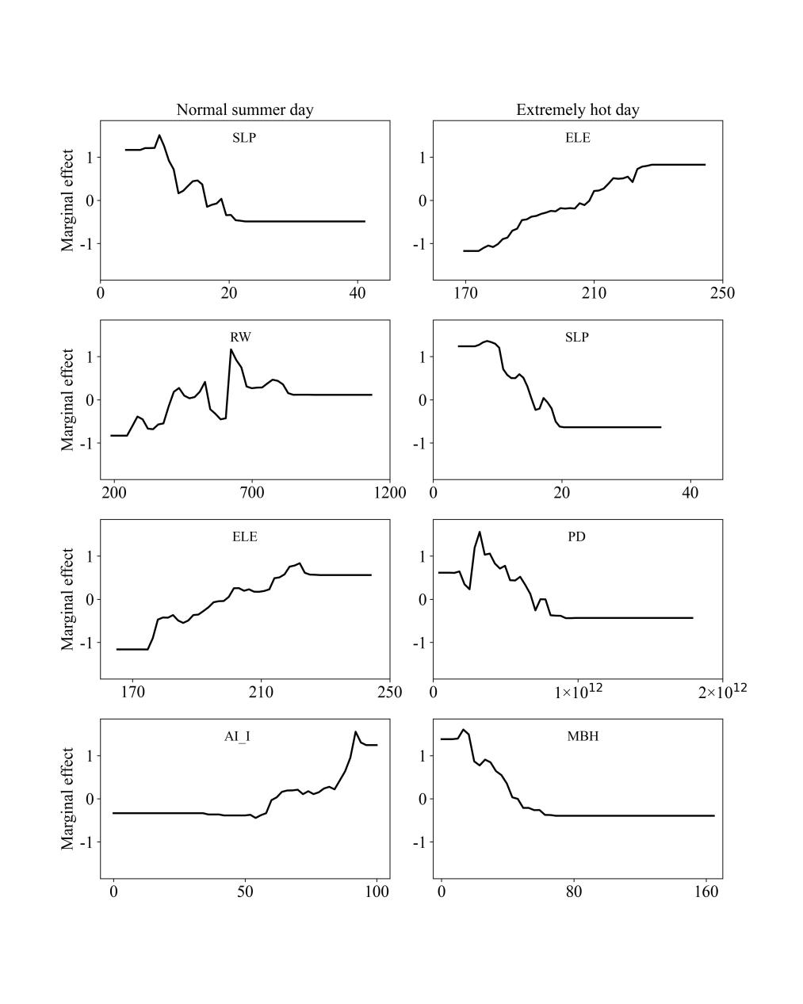

Fig. 8 Marginal effects of the top 4 contributing factors on RCI on the 2 case days.

The top 4 contributing factors were selected for the subsequent analysis of marginal effects on the two case days. The results unveiled the non-linear influences of environmental variables on river cooling. As the most contributing factor in explaining RCI on the normal summer day, average slope manifested in a descent pattern. When it increased from 6.2 to 22.5, the cooling intensity induced by the river decreased from 6.6 to 3.9 °C, indicating that the larger slope in the riverside area was not conducive to the heat mitigation provided by the nearby river. It should be noted that when SLP was greater than 22.5, the RCI value remained relatively stable.

The influence of river width exhibited a fluctuated pattern. As RW increased within the range of 246.8 to 623.8 meters, RCI showed an fluctuating upward trend. Subsequently, RW gradually decreased until it reached 868.9 meters. Overall, the increased river width was associated with a corresponding enhanced RCI. This observation aligns with the higher RCI for river segments in the Yangtze River compared to the Jialing River, as discussed in Sect. 3.1.

For the other 2 factors, namely ELE and AI_I, the impacts were illustrated through ascent patterns. RCI demonstrated an increase when ELE ranged between 174.7 and 225.1 meters or when AI_I fell within the range of 34% to 96%. Beyond these specified ranges, the RCI values remained relatively stable.

Similar to the normal summer day, the impacts of ELE and SLP on RCI during the extremely hot day were characterized by ascent and descent patterns, respectively. An upward trend in RCI was observed as ELE increased within the range of 174.1 to 228.0 meters. Conversely, when SLP was between 7.1 and 20.3, RCI exhibited a decreasing trend.

The relative impact of PD on RCI demonstrated an initial increase followed by a continuous decrease on the extremely hot day. When the PD value exceeded 7.1×1011, its effect on RCI turned negative. As the fourth most influential factor, MBH exhibited a descent pattern in its influence on RCI, resulting in a negative effect when MBH exceeded 46.1 meters.

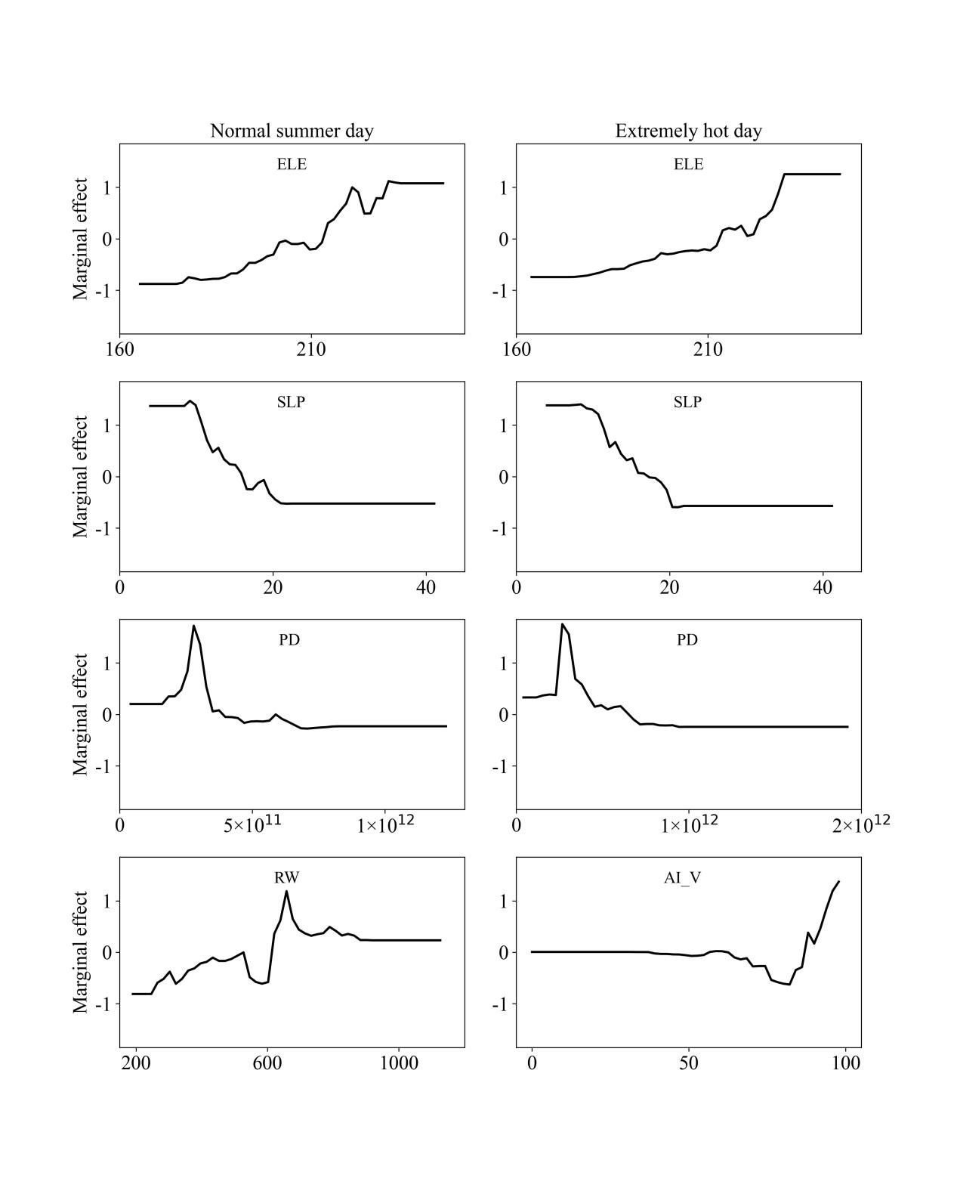

Fig. 9 Marginal effects of the top 4 contributing factors on CRCI on the 2 case days.

Fig. 9 illustrates the marginal effects of the top 4 contributing factors on CRCI. On both case days, the influences of the 2 topographical variables, namely ELE and SLP, on CRCI were characterized by ascent and descent patterns, respectively. This is similar to their effects on RCI. CRCI exhibited an upward trend when ELE increased from 174.8 to 233.3 meters on the normal summer day and from 173.6 to 229.9 meters on the extremely hot day. Meanwhile, opposing trends in CRCI were observed when SLP increased within the ranges of 8.4 to 22.5 and 7.0 to 21.8 on the 2 case days.

The impact of PD on CRCI displayed a pattern of initial increase followed by a subsequent decrease on the 2 case days. On the normal summer day and the extremely hot day, peak values were observed at 2.8×1011 and 2.7×1011, respectively. The overall effect was negative when PD exceeded 4.0×1011 and 6.8×1011.

RW emerged as the fourth most influential factor on the normal summer day, exhibiting a notable ascent pattern in its impact on CRCI. In contrast, on the extremely hot day, AI_I took the position of the fourth most influential factor, with its relative influence characterized by an initial decline followed by a rapid increase.

By synthesizing the findings presented in Fig. 8 and Fig. 9, it can be deduced that ELE and AI_I demonstrated ascent patterns in influencing river cooling on both summer days, whereas SLP and MBH exhibited descent patterns. Noteworthy variations were observed in the impacts of RW, AI_V, and PD.

## Discussions

### The impacts of influencing factors on river cooling effects

As illustrated in Fig. 4 and Fig. 5, this investigation revealed similar spatial patterns of river cooling effects between the normal summer day and the extremely hot day. Notably, greater temperature reductions were observed in suburban areas characterized by sparse architectural layouts. On the normal summer day, the average RCI was 5.5 °C, consistent with findings from prior studies (Manteghi et al., 2015). When compared to the cooling intensity of less than 4 °C near the Huangpu River reported in a study conducted in Shanghai, our observed intensity was significantly higher (Du et al., 2016). This contrast can be explained by the difference in river width, as the Yangtze River is approximately 1 kilometer wide, while the Huangpu River is only about 400 meters wide. Furthermore, background weather conditions and surrounding urban characteristics were potential contributors to the observed river cooling effects.

As global warming and urbanization continue, the increase in the adverse impacts of future extreme heatwaves becomes inevitable. Consequently, focusing on river cooling effects during extreme weather conditions can offer valuable scientific insights for addressing future urban climate change. This study unveiled higher average values of RCI and CRCI on the extremely hot day compared to the normal summer day. This difference can be explained by the mechanism of water cooling on heatwave days, as the larger temperature difference between the land and the nearby water body can lead to a stronger cooling potential for the waterfront area. Due to the significantly higher temperature, the intensity of evaporative cooling from the water surface is also greater. Additionally, this research revealed that the spatial variations of river cooling effects were larger on the extremely hot day. This finding is consistent with an observation of cooling from the nearby sea in Adelaide, which demonstrated significantly larger spatial variations in sea breeze cooling capacity under heatwave conditions (Zhou et al., 2020). Overall, existing researches about water cooling on heatwave days are still limited, necessitating further explorations in related fields.

Some studies have explored the relationship between urban climate and topography (Oke et al., 2017; Liao et al., 2022; Mo et al., 2024). However, the role of topography in affecting water cooling remains inadequately understood. This study revealed that topography exerted a significant influence on the cooling effects of rivers, surpassing the impact of land cover and 3D building characteristics. This is reasonable as rivers significantly shape the thermal environment of their surroundings through the modulation of inland airflow. The irregularity of terrain can alter the direction and intensity of airflow, thus influencing the spatial pattern of the thermal environment. Steeper terrain hinders the inland penetration of water cooling effects, leading to a reduction in cooling intensity. Additionally, this study identified a positive correlation between elevation and river cooling, which was likely to be attributed to the temperature decrease caused by the elevated altitude.

In terms of 2-dimensional land cover characteristics, this study observed a relatively minor role of land cover composition. The limited correlation between river cooling and the proportion of vegetation area can be explained by their complex interactions. On one hand, the lower temperature of green space compared to impervious surface weakens the impact of river cooling. On the other hand, vegetated areas are mostly open areas, which facilitate the inward penetration of cooler airflow from the river. Considering the aforementioned influences, the overall effects of vegetation cover ratio on river cooling are complicated. While some studies indicated an increase in water cooling with expanded vegetation cover, an opposite correlation has been discovered elsewhere (Sun et al., 2012; Wu et al., 2020). In Chengdu, no significant correlation was found between the cooling intensity of wetland and the proportion of vegetation cover (Wu et al., 2021). Hence, further investigations are required to gain a better understanding of the intricate relationship between land cover composition and water cooling.

### Implications for urban planning

The extreme heat stress can have adverse effects on the physical and mental well-being of local residents, particularly in cities with hot summer climates. Effective utilization of existing blue spaces to cool the surrounding areas has the potential to alleviate relevant health risks. This study unveiled notable spatial variances of river cooling effects influenced by diverse environmental characteristics. The insights gained from these findings offered valuable references for climate-friendly urban planning to improve residents' living environment.

Because of the negative correlation between slope and river cooling effect found in this study, areas designated for residents' leisure activities should preferably avoid locations with significant changes in topography.

Additionally, considering that the configurations of different land cover types exerted stronger influences on RCI and CRCI than the compositions, urban planning for riverside areas should prioritize the layouts of individual land cover types. This is particularly crucial for areas designated for residents' leisure activities, such as parks and squares. The results also indicated that the aggregation index demonstrated significantly positive correlations with RCI and CRCI. Hence, it is advisable to enhance the aggregation levels of individual land cover types to foster a more climate-friendly living environment.

Furthermore, based on the outcomes of the BRT model, the influencing factors affecting river cooling exhibited specific ranges. Therefore, the ranges within which various factors exert their influences should be taken into account, which can contribute to a more effective implementation of river cooling measures.

### Limitations of this study and future work

This study has certain limitations. Situated in the Sichuan basin, Chongqing experiences significantly lower average wind speed compared to other cities over the world. As a result, the impacts of wind speed and wind direction on river cooling effects have not been comprehensively addressed in this study. Future research endeavors should consider these factors to offer a more comprehensive understanding of river cooling dynamics from the standpoint of background weather conditions, especially in cities characterized by higher wind speeds.

In addition, Chongqing, characterized by a relatively low number of sunshine hours, poses constraints on the accessibility of suitable Landsat images. In this study, 2 images were employed to characterize the normal summer day and the extremely hot day. Hence, additional research endeavors are imperative to incorporate more images for normal and extreme summer days, thereby augmenting the robustness of the finding.

Furthermore, this study is confined to river cooling effects within a single year. Similar to other cities in developing countries, Chongqing has undergone rapid urbanization in the past few decades. Due to the limitations in available building data, an analysis of river cooling during this urbanization process is unfeasible. The impacts of dynamic changes in the 3D urban structure during urban construction remain unexplored. A quantitative analysis spanning over 20 years, investigating annual variations in river cooling effects with dynamic building data, could offer valuable insights. Such findings hold implications for urban planning and management in developing countries.

## Conclusions

This study took Chongqing as an example and focused on the cooling effects of rivers on the surrounding urban environment during normal and extreme summer days. Environmental factors, including river width, land cover characteristics, 3D building characteristics, and topographical characteristics, were considered to analyze the impacts of these factors on river cooling intensity and cumulative river cooling intensity under different background weather conditions. The Boosted Regression Tree model was employed to assess the relative importances of individual factors and the marginal effects of the top 4 contributing factors. In contrast to traditional analytical methods such as linear regression, this approach effectively captured the non-linear effects of influencing factors on river cooling effects.

The conclusions are as follows:

1. The river cooling effects exhibited significant spatial variations with similar spatial patterns. In addition, the average values and spatial variations of RCI and CRCI were higher on the extremely hot day compared to the normal summer day.
2. Explanatory powers of the environmental variables on CRCI were notably higher compared to those on RCI for the 2 case days.
3. Topographical features showed strong impacts on RCI and CRCI, while small influences of land cover compositions were observed. River width, 3D building characteristics, and land cover configurations also contributed to river cooling. On the extremely hot day, average elevation made larger contributions on RCI and CRCI compared to the normal summer day, while the contributions of average slope and river width were smaller.
4. Through the examination of marginal effects, non-linear influences of the top 4 contributing factors on river cooling effects were identified, with most variables exerting their impacts within specific ranges. ELE and AI_I exhibited ascent patterns on both summer days, while SLP and MBH displayed descent patterns.

These findings provide a scientific understanding of the role of environmental characteristics in shaping river cooling effects. They offer guidance for optimizing urban planning and management to improve the thermal environment of riverside areas, especially for cities with uneven surfaces.

## References

Ahmad, Mahmood, et al. "Modelling the dynamic linkages between eco-innovation, urbanization, economic growth and ecological footprints for G7 countries: does financial globalization matter?." Sustainable Cities and Society 70 (2021): 102881.

Ampatzidis, Petros, and Tristan Kershaw. "A review of the impact of blue space on the urban microclimate." Science of the total environment 730 (2020): 139068.

An, N., Dou, J., González-Cruz, J. E., Bornstein, R. D., Miao, S., & Li, L. (2020). An observational case study of synergies between an intense heat wave and the urban heat island in Beijing. Journal of Applied Meteorology and Climatology, 59(4), 605-620.

Azhdari, Abolghasem, Ali Soltani, and Mehdi Alidadi. "Urban morphology and landscape structure effect on land surface temperature: Evidence from Shiraz, a semi-arid city." Sustainable cities and society 41 (2018): 853-864.

Chen, X., Wang, Z., & Bao, Y. (2021). Cool island effects of urban remnant natural mountains for cooling communities: A case study of Guiyang, China. Sustainable Cities and Society, 71, 102983.

Cheval, S., Popa, A. M., Șandric, I., & Iojă, I. C. (2020). Exploratory analysis of cooling effect of urban lakes on land surface temperature in Bucharest (Romania) using Landsat imagery. Urban Climate, 34, 100696.

Du, Hongyu, et al. "Research on the cooling island effects of water body: A case study of Shanghai, China." Ecological indicators 67 (2016): 31-38.

Dugord, Pierre-Adrien, et al. "Land use patterns, temperature distribution, and potential heat stress risk–the case study Berlin, Germany." Computers, Environment and Urban Systems 48 (2014): 86-98.

Elith, J., Leathwick, J. R., & Hastie, T. (2008). A working guide to boosted regression trees. Journal of animal ecology, 77(4), 802-813.

Gao, Z., Hou, Y., & Chen, W. (2019). Enhanced sensitivity of the urban heat island effect to summer temperatures induced by urban expansion. Environmental Research Letters, 14(9), 094005.

Guan, Huade, et al. "Incorporating residual temperature and specific humidity in predicting weather-dependent warm-season electricity consumption." Environmental Research Letters 12.2 (2017): 024021.

Guo, F., Zhao, J., Zhang, H., Dong, J., Zhu, P., & Lau, S. S. Y. (2023). Effects of urban form on sea cooling capacity under the heatwave. Sustainable Cities and Society, 88, 104271.

Hathway, E. A., & Sharples, S. (2012). The interaction of rivers and urban form in mitigating the Urban Heat Island effect: A UK case study. Building and environment, 58, 14-22.

He, Baojie. Mitigating urban heat island effects: An analysis of precinct ventilation performance and its impact on urban heat islands and outdoor thermal comfort. Diss. UNSW Sydney, 2020.

Hu, N., Wang, G., Ma, Z., Ren, Z., Zhao, M., & Meng, J. (2023). The cooling effects of urban waterbodies and their driving forces in China. Ecological Indicators, 156, 111200.

Li, D., Sun, T., Liu, M., Yang, L., Wang, L., & Gao, Z. (2015). Contrasting responses of urban and rural surface energy budgets to heat waves explain synergies between urban heat islands and heat waves. Environmental Research Letters, 10(5), 054009.

Liao, Shubing, et al. "Combined impacts of the abnormal and urban heat island effect in Guiyang, a typical Karst Mountain City in China." Urban Climate 41 (2022): 101014.

Lin, Y., Wang, Z., Jim, C. Y., Li, J., Deng, J., & Liu, J. (2020). Water as an urban heat sink: Blue infrastructure alleviates urban heat island effect in mega-city agglomeration. Journal of Cleaner Production, 262, 121411.

Manteghi, G., limit, H., & Remaz, D. (2015). Water bodies an urban microclimate:A review. Modern Applied Science, 9, 1–12. <https://doi.org/10.5539/mas.v9n6p1>

Mo, N., Han, J., Yin, Y., & Zhang, Y. (2024). Seasonal analysis of land surface temperature using local climate zones in peak forest basin topography: A case study of Guilin. Building and Environment, 247, 111042.

Moyer, A. N., & Hawkins, T. W. (2017). River effects on the heat island of a small urban area. Urban Climate, 21, 262-277.

Oke, T. R., Mills, G., Christen, A., & Voogt, J. A. (2017). Urban climates. Cambridge University Press.

Peng, J., Liu, Q., Xu, Z., Lyu, D., Du, Y., Qiao, R., & Wu, J. (2020a). How to effectively mitigate urban heat island effect? A perspective of waterbody patch size threshold. Landscape and Urban Planning, 202, 103873.

Peng, J., Hu, Y., Dong, J., Liu, Q., & Liu, Y. (2020b). Quantifying spatial morphology and connectivity of urban heat islands in a megacity: A radius approach. Science of The Total Environment, 714, 136792.

Nieuwenhuijsen, Mark J. "Influence of urban and transport planning and the city environment on cardiovascular disease." Nature reviews cardiology 15.7 (2018): 432-438.

Ramamurthy, P., González, J., Ortiz, L., Arend, M., & Moshary, F. (2017). Impact of heatwave on a megacity: an observational analysis of New York City during July 2016. Environmental Research Letters, 12(5), 054011.

Sun, R., & Chen, L. (2012). How can urban water bodies be designed for climate adaptation?. Landscape and Urban Planning, 105(1-2), 27-33.

Syafii, N. I., Ichinose, M., Kumakura, E., Jusuf, S. K., Chigusa, K., & Wong, N. H. (2017). Thermal environment assessment around bodies of water in urban canyons: A scale model study. Sustainable cities and society, 34, 79-89.

Taleghani, Mohammad. "Outdoor thermal comfort by different heat mitigation strategies-A review." Renewable and Sustainable Energy Reviews 81 (2018): 2011-2018.

Theeuwes, Natalie E., Anna Solcerova, and Gert J. Steeneveld. "Modeling the influence of open water surfaces on the summertime temperature and thermal comfort in the city." Journal of Geophysical Research: Atmospheres 118.16 (2013): 8881-8896.

United Nations. (2019). World urbanization prospects: The 2018 revision.

Wang, Shaojian, et al. "Strategizing the relation between urbanization and air pollution: Empirical evidence from global countries." Journal of Cleaner Production 243 (2020): 118615.

Wu, J., Li, C., Zhang, X., Zhao, Y., Liang, J., & Wang, Z. (2020). Seasonal variations and main influencing factors of the water cooling islands effect in Shenzhen. Ecological indicators, 117, 106699.

Wu, Sujuan, et al. "The effects of the cooling efficiency of urban wetlands in an inland megacity: A case study of Chengdu, Southwest China." Building and Environment 204 (2021): 108128.

Wu, Y., Hou, H., Wang, R., Murayama, Y., Wang, L., & Hu, T. (2022). Effects of landscape patterns on the morphological evolution of surface urban heat island in Hangzhou during 2000–2020. Sustainable Cities and Society, 79, 103717.

Xue, Zhenshan, et al. "Quantifying the cooling-effects of urban and peri-urban wetlands using remote sensing data: Case study of cities of Northeast China." Landscape and Urban Planning 182 (2019): 92-100.

Yang, J., & Huang, X. (2021). The 30 m annual land cover dataset and its dynamics in China from 1990 to 2019. Earth System Science Data, 13(8), 3907-3925.

Yao, L., Sailor, D. J., Yang, X., Xu, G., & Zhao, L. (2023). Are water bodies effective for urban heat mitigation? Evidence from field studies of urban lakes in two humid subtropical cities. Building and Environment, 245, 110860.

Zhou, Y., Guan, H., Gharib, S., Batelaan, O., & Simmons, C. T. (2021). Cooling power of sea breezes and its inland penetration in dry-summer Adelaide, Australia. Atmospheric Research, 250, 105409.

Zhou, Z., Zhang, Z., Zou, X., Zhang, K., & Zhang, W. (2020). Quantifying wind erosion at landscape scale in a temperate grassland: Nonignorable influence of topography. Geomorphology, 370, 107401.

Zhou, X., Zhang, S., Liu, Y., Zhou, Q., Wu, B., Gao, Y., & Zhang, T. (2022). Impact of urban morphology on the microclimatic regulation of water bodies on waterfront in summer: A case study of Wuhan. Building and Environment, 226, 109720.