Investigating the river cooling effects in a mountainous city : Comparison between normal and extreme summer weather conditions

Yifei Zhoua,b, Rongfei Zhangb,*, Fei Xua, Baojie Hec,d,e

a Key Laboratory of the Three Gorges Reservoir Region's Eco-Environment, Ministry of Education, Chongqing University, Chongqing 400045, China

b College of Environment and Ecology, Chongqing University, Chongqing 400045, China

c Centre for climate Resilient and Low-Carbon Cities, School of Architecture and Urban Planning Key Laboratory of New Technology for Construction of Cities in Mountain Area, Ministry of Education, Chongqing University, Chongqing 400045, China

d Institute for Smart City of Chongqing University in Liyang, Chongqing University, Liyang 213300, Jiangsu, China

e CMA Key Open Laboratory of Transforming Climate Resources to Economy, Chongqing Climate Center, Chongqing 401147, China

## Abstract

Although urban rivers are considered to have a mitigating effect on the extreme heat stress, the influences of topographical characteristics still remain poorly understood, particularly under extremely hot weather conditions. Taking the mountainous city of Chongqing as an example, this research focuses on the river cooling effects on the surrounding urban environment during normal and extreme summer days. Employing the Boosted Regression Tree (BRT) model, the impacts of environmental variables on river cooling effects have been explored. The results reveal that the average values and standard deviations in River Cooling Intensity (RCI) were 5.5°C and 2.4°C on the normal summer day. The corresponding values became significantly higher on the extremely hot day, being 6.4°C and 3.1°C. Topographical characteristics exhibited strong impacts on river cooling effects, with the relative importance of average elevation for RCI being 11.0% and 16.1% on the normal summer day and the extremely hot day, respectively. Moreover, average elevation and slope exhibited ascent and descent patterns in their influences on river cooling, while the impacts of patch density and river width were relatively fluctuating, showing descent and ascent patterns as a whole. These findings can provide a foundation for urban planners and managers to develop strategies aimed at improving the thermal environment of riverside areas.

## Introduction

Across numerous cities worldwide, the process of urbanization has been associated with various detrimental impacts on the local environment, encompassing issues such as water and air pollution, ecosystem degradation, and urban heat island[1,2]. Urban heat island manifests as elevated temperatures within urban areas relative to their rural surroundings. Elevated temperature is the contributor to heightened intensities and prolonged durations of heatwaves, resulting in increased energy consumption and posing potential threats to the public health of urban residents, particularly during the summer months [3,4]. Consequently, it is imperative to implement strategic measures to mitigate the adverse consequences associated with urban heat. Strategies for mitigating the heat in urban environment encompass modification to surface materials, optimization of land cover patterns, and enhancement of ventilation [5-7]. Notably, blue and green spaces have garnered significant attention. Blue spaces are urban surfaces predominantly characterized by water features [8]. In comparison to impervious surfaces, augmented specific heat capacity of water contributes to decreased temperatures during daylight hours. Furthermore, water surfaces facilitate evaporation, thereby curbing the release of sensible heat to the overlying air. A study conducted in Chengdu revealed a temperature contrast exceeding 8 °C between lakeside and inland areas [9]. Observations have also suggested that water bodies can exhibit stronger cooling capability than green spaces. For instance, during the summer daytime in Berlin, water surfaces exhibited an average temperature being approximately 2 °C cooler than green spaces [10].

The cooling effects of blue spaces exhibit significant spatiotemporal variations. The cooling intensity is higher in the summer compared to the winter [11]. Throughout a day, the daytime water cooling intensity typically exceeds that of nighttime [12]. Some studies have also suggested that waterfront areas might be warmer than the surrounding inland areas during the night. For instance, a measurement conducted in central Pennsylvania revealed that the average temperature decreased with the distance from the riverbank during 22:00 – 05:00 [13]. In addition, observations have found noteworthy spatial heterogeneities in water cooling effects within same cities [14]. Accordingly, the interaction between water bodies and environmental variables has become a crucial aspect in the understanding of urban heat mitigation [15]. The morphological characteristics of water bodies are important factors affecting their cooling effects, with stronger cooling frequently observed near larger water bodies [16]. However, conclusions on the relationship between shape regularity and cooling effects are often contradictory. Studies in Shanghai and Beijing suggested that water cooling effects were strengthened with improved shape regularity, while an investigation in the northeastern China indicated that wetlands with more complex shapes had better cooling effects [17-19]. The roles of land cover patterns and 3D building characteristics in waterfront areas have also been explored, showing varied impacts. Several studies showed that higher and denser buildings may reduce water cooling, while a study in the Pearl River Delta suggested that better cooling effects tended to appear at wetlands near densely built areas [20,21]. Furthermore, factors such as proportion of vegetation cover, mean building height, and building coverage ratio, also potentially take effects [22,23].

Despite numerous studies, the understanding of water cooling effects still faces certain limitations. Firstly, wind plays a crucial role in transporting cool air and expelling excess heat from specific areas. As mechanical forces resulting from local topographic variations such as hills and mountains can alter urban wind patterns, it can be speculated that topographical features could significantly impact water cooling [24,25]. Previous researches on water cooling effects were primarily conducted in cities with flat terrains, resulting in a gap in understanding how various topographic indicators influence water cooling of urban areas with more complex terrains [8]. Secondly, there are differences of morphological characteristics between rivers and lakes. Lakes commonly assume polygonal or circular shapes and are dispersed throughout a city, while rivers follow a narrow and linear layout, predominantly traversing or flowing around urban areas. Consequently, the cooling effects of rivers on their surroundings differ from those of lakes or ponds. According to a study in the northeastern Chinese cities of Changchun and Jilin City, river cooling effects were found to surpass those of lakes and green spaces [19]. However, prior studies on water cooling primarily centered around ponds, lakes, and wetlands [26,27]. Rivers, as crucial water bodies in cities, have received comparatively less attention. Finally, existing relevant studies mostly focused on normal summer days, typically characterized by days with maximum air temperatures below 35 °C. The understanding of water cooling on extremely hot days is insufficient. However, the practical significance of studying water cooling lies in enabling targeted measures to alleviate the negative impacts of extreme heat. As differences in urban climate characteristics have been found between normal summer days and extremely hot days, it is essential to pay more attention to water cooling on extremely hot days [28-31].

Given the above-mentioned shortcomings, this study aims to explore the quantitative effects of river cooling and examine their influencing factors on a normal summer day and an extremely hot day by the Boosted Regression Tree model, taking the mountainous city of Chongqing as an example. The purpose is to answer the following questions: (1) What are the spatial patterns of river cooling effects under different weather conditions? (2) What are the contributions of individual environmental variables on river cooling effects? (3) How do key influencing factors affect river cooling effects? The findings of this research are expected to provide valuable insights into mitigating urban heat and offer guidance for the heat-resilient planning and design of urban riverside areas.

## Data and Methods

Before the analysis steps of this study, relevant environmental variables were calculated based on the collected data. During the analysis process, we firstly calculated indexes of river cooling effects under different weather conditions using land surface temperatures of the study area. Subsequently, the Boosted Regression Tree model was employed to investigate the relative importances of various influencing factors on river cooling effects. Finally, the marginal effects of the top 4 most influential factors were analyzed. The flowchart of this study is illustrated in Fig. 1.

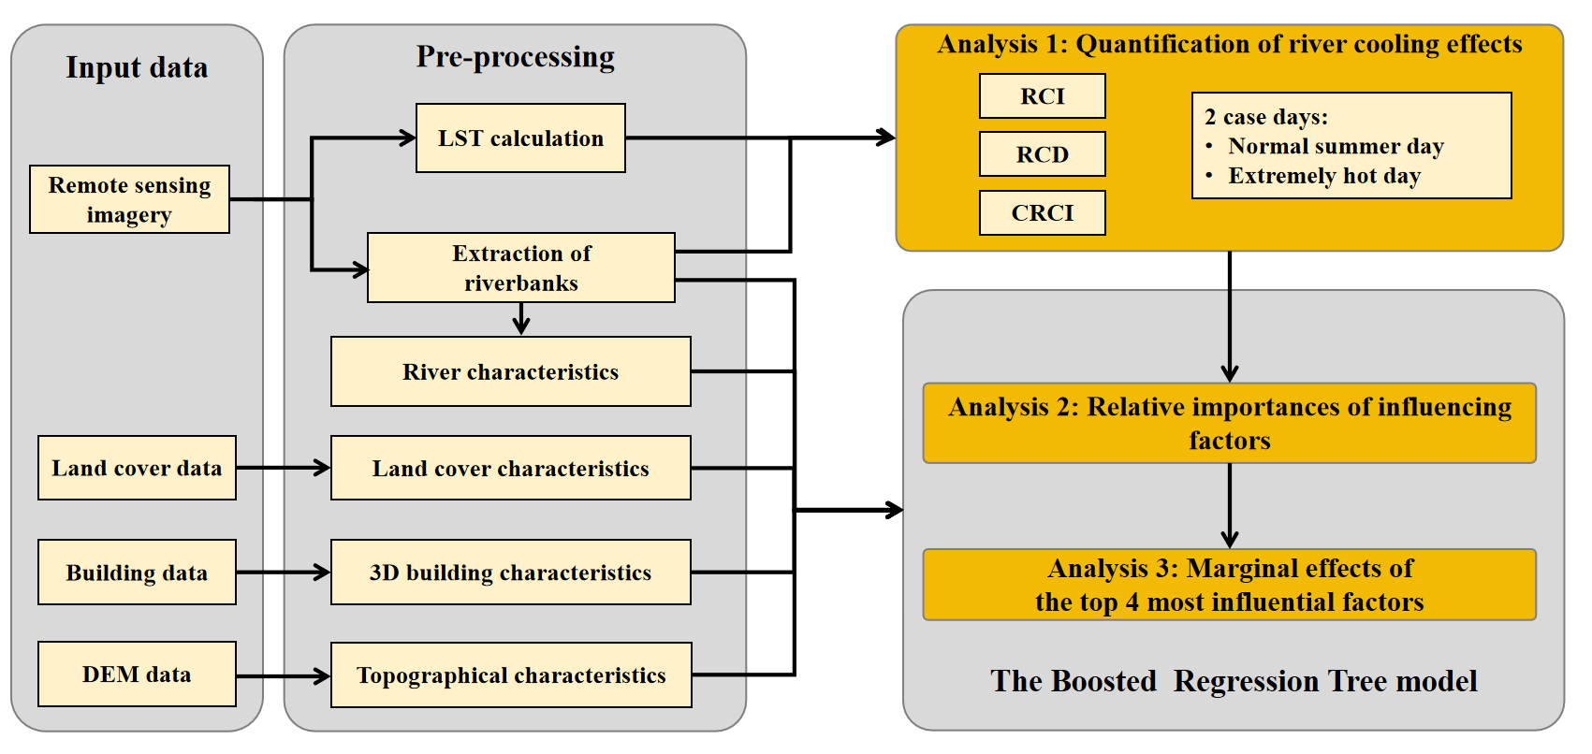

Fig. 1 Flowchart of this study

### 2.1. Study area

Chongqing is a megacity located in the upper reach of the Yangtze River. The Yangtze River flows through this city, and its major tributary, the Jialing River, converges with it in the city center (Fig. 2). The urban area of Chongqing is primarily composed of hills and mountains and it is therefore characterized by significantly undulating terrains with elevations ranging from 170 meters to more than 400 meters. Chongqing is located in the subtropical monsoon climate zone. Summer periods normally last from May to September, which are featured by high temperature and high humidity. On average, there can be more than 30 heatwave days with maximum air temperatures exceeding 35 °C in a year, mostly in July and August. In last decades, Chongqing has experienced a rapid process of urbanization with urban population surging from 6 million in 2000 to 10 million in 2020. With a huge influx of population, urban construction has accelerated, and the built-up area has expanded fast.

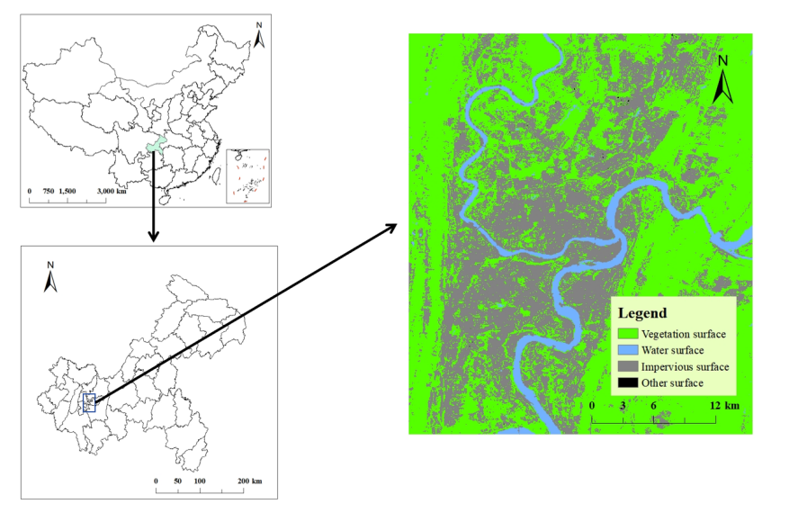

Fig. 2 Location of the study area. The image on the right shows the land cover pattern of the metropolitan area of Chongqing.

### 2.2. Data

Remote sensing imagery, land cover data, building data, and Digital Elevation Model (DEM) data were utilized in this study. The detailed information of each data set is provided in Table 1.

Table 1 Detailed information of data source.

|  |  |  |  |
| --- | --- | --- | --- |
| Name | Data source | Date | Spatial resolution |
| Remote sensing imagery | Landsat-8 OLI/TIRS products | May 8, 2022 & August 12, 2022 | 30 meters |
| Land cover data | China Land Cover Dataset (CLCD) | 2022 | 30 meters |
| Building data | Baidu online map | 2022 | 1 meter |
| DEM data | Shuttle Radar Topography Mission (SRTM) |  | 30 meters |

Landsat-8 OLI/TIRS products were used to calculate land surface temperature and extract river surface within the study area. The data were obtained from the United States Geological Survey (USGS) (http://earthexplorer.usgs.gov). Two specific days, May 8, 2022 and August 12, 2022 were chosen to represent the normal summer day and the extremely hot day, respectively. The minimum air temperatures (*Tmin*), maximum air temperatures (*Tmax*), and mean air temperatures (*Tmean*) for these selected days are presented in Table 2.

Table 2 Minimum, maximum and mean air temperatures of the 2 selected case days.

|  |  |  |
| --- | --- | --- |
| Date | May 8, 2022 | August 12, 2022 |
| *Tmin* (°C) | 22.6 | 33.2 |
| *Tmax* (°C) | 33.0 | 41.0 |
| *Tmean* (°C) | 28.2 | 36.9 |

Building data were acquired from the service platform on the Baidu online map. This data set includes information on the outlines and numbers of floors of buildings within the study area. Elevation data were sourced from the Shuttle Radar Topography Mission (SRTM) with a spatial resolution of 30 meters, available for download from <http://earthexplorer.usgs.gov.> Land cover data were obtained from the annual China Land Cover Dataset (CLCD) with a spatial resolution of 30 meters. Produced by Wuhan University based on Landsat images, this data set provides valuable information for the analysis of land cover patterns [32].

### 2.3. Calculation of land surface temperature

Before the calculation of land surface temperature, it was imperative to perform radiometric calibration and atmospheric correction on the original Landsat-8 images. Subsequently, the radiative transfer equation (RTE) method was employed. The equation can be expressed as:

(1)

where *Lλ* denotes the radiation intensity of the thermal infrared band captured by the sensor, represents the downward atmospheric radiance, represents the upward atmospheric radiance, *ε* stands for the surface emissivity, *τ* is the atmospheric transmissivity, *B(Ts)* represents the black body radiance and *Ts* represents the land surface temperature.

By converting the above equation, we can get *B(Ts)* as follows:

(2)

In this study, values of and *τ* were obtained by NASA Atmospheric Correction Parameter Calculator. Once the black body radiance was calculated, *Ts* in the unit of Kelvin can be obtained by the following equation:

(3)

According to the default values of Landsat-8 images, *K1* and *K2* were set to be 774.89 and 1321.08, respectively. In the following analysis, the unit of *Ts* was converted to Celsius. All the aforementioned procedures were executed using ENVI software.

### 2.4. Quantification of river cooling effects

Near the confluence of the Yangtze River and the Jialing River, a small area is obscured by cloud cover on the Landsat image of the extremely hot day. Therefore, this area was not used for the subsequent analysis. For the rest of the area, the riverbanks were segmented at one-kilometer intervals in length. Consequently, a total of 182 river segments were generated along the two rivers within the metropolitan area of Chongqing, encompassing 94 segments along the Yangtze River and 88 segments along the Jialing River.

The land surface temperature of riverside area exhibits a notable correlation with the distance from the riverbank. More precisely, the temperature gradually increases from the river surface's edge toward the inland area until reaching a point where the upward temperature trend ceases (Fig.3). This point is defined as the first turning point and the temperature value at this point is characterized to be the turning temperature. It’s clear that the riverside area represented by the non-linear curve from the river surface's edge to the first turning point is influenced by river cooling. Therefore, this area can be utilized to compute relevant indices of river cooling effects. The distance from the river surface's edge to the first turning point is defined as the River Cooling Distance (RCD). The River Cooling Intensity (RCI) is characterized to be the temperature contrast between the river surface's edge and the first turning point, expressed in the following equation:

(4)

where *Tp* is the turning temperature, and *Tr* is the temperature at the river surface's edge.

The index of RCI has a limitation in that it only indicates the maximum temperature reduction within the riverside area, neglecting the non-linear variations in surface temperature. To provide a more comprehensive insight into the inland penetration of river cooling, the index of Cumulative River Cooling Intensity (CRCI) was employed in this study. CRCI is defined as the cumulative difference between the turning temperature and the non-linear temperature curve from the river surface's edge to the first turning point, as depicted in the shaded area of Fig. 3. The equation is given by:

(5)

where *Tc* is the temperature on the non-linear temperature curve.

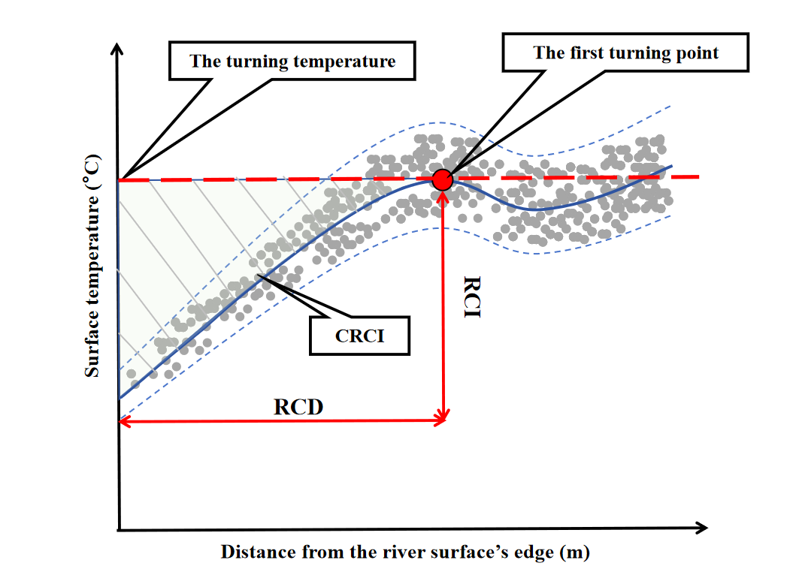

Fig. 3 Illustration of indexes related to river cooling effects.

### 2.5. Calculation of influencing factors

The potential influencing factors of river cooling effects can be classified into the following types: river characteristics, land cover characteristics, 3D building characteristics, and topographical characteristics. It is worth noting that the calculation of land cover, 3D building, and topographical characteristics were based on the riverside areas within the river cooling distances in this study.

We chose river width (RW, unit: m), river orientation (ORI, unit: °) and river rotation angle (ROT, unit: °) to represent the characteristics of rivers. Regarding land cover characteristics, area percentage of impervious surface (PLAND_I, unit: %), area percentage of vegetation (PLAND_V, unit: %), aggregation index of impervious surface (AI_I, unit: %), aggregation index of vegetation (AI_V, unit: %) and patch density (PD, unit: 100ha-1) were selected as potential influencing factors. The aggregation index is defined as the ratio of actual number to the theoretical maximum number of like adjacencies. It was used here to reflect the aggregating level of patches for particular land cover types. Patch density is defined as the number of patches in a particular area and it can reflect the fragmentation of landscape within each river segment.

3D building characteristics were recognized to have potential impacts, as urban architecture can influence the thermal environment by modifying surface energy balance, creating shaded areas, and altering ventilation patterns. In this study, floor area ratio (FAR), building coverage ratio (BCR, unit: %) and mean building height (MBH, unit: m) were selected as representative 3D building characteristics. FAR is defined as the ratio of the total floor area to the total land area, while MBH represents the area-weighted mean building height of a specific building area. Topographical characteristics were chosen because of the moderate fluctuations in elevation in the metropolitan area of Chongqing. Average elevation (ELE, unit: m) and average slope (SLP, unit: °) were employed here to explain the spatial variations of river cooling effects. ELE served to indicate the absolute height level of each river segment, while SLP was utilized to represent the relative change in elevation within each river segment.

### 2.6. The Boosted Regression Tree model

The relationships between the cooling effects of water bodies and environmental variables have been examined primarily by simple linear regression or stepwise regression. However, urban climate characteristics are shaped by the complex interactions of multiple factors involving non-linear processes. Traditional linear regression approaches may not effectively capture the non-linear effects of these influencing factors [33]. In this study, we utilized the Boosted Regression Tree (BRT) model to explore the effects of influencing factors on river cooling.

The BRT model is a combination of the decision tree and the boosting algorithm. Utilizing the boosting algorithm, the decision tree iteratively adapts to randomly selected subsets of the training data set, thereby interactively improving predictive performance [34]. In contrast to conventional regression methods, the BRT model demonstrates good learning capabilities. It can effectively address complex non-linear effects and exhibit robustness to missing values and outliers. Its predictive performance outperforms that of many traditional modeling methods. In addition, the model does not necessitate consideration of the interactions among independent variables.

In this study, the BRT model was implemented using the "gbm" package in R. The data set was partitioned into training (75%) and testing (25%) subsets for model development. R2 and root mean square error (RMSE) were employed to validate the predictions generated by the BRT model. After the model validation, we analyzed the relative importances of individual influencing factors to RCI, RCD and CRCI. Subsequently, the marginal effects of the top 4 most influential factors were examined. The marginal effect reveals the influence of each independent variable on the dependent variable after accounting for the average effect of other variables. Positive marginal effect, denoted by the value larger than 0, indicates a positive effect.

## Results

### River cooling effects on the normal summer day and the extremely hot day

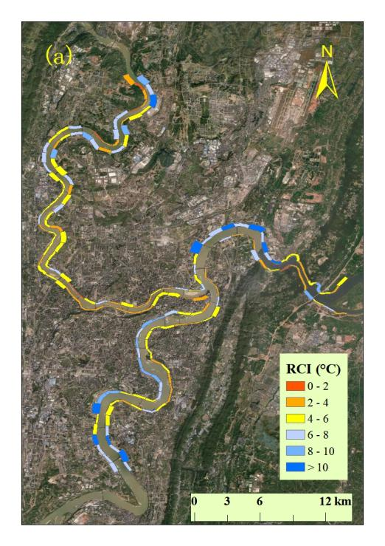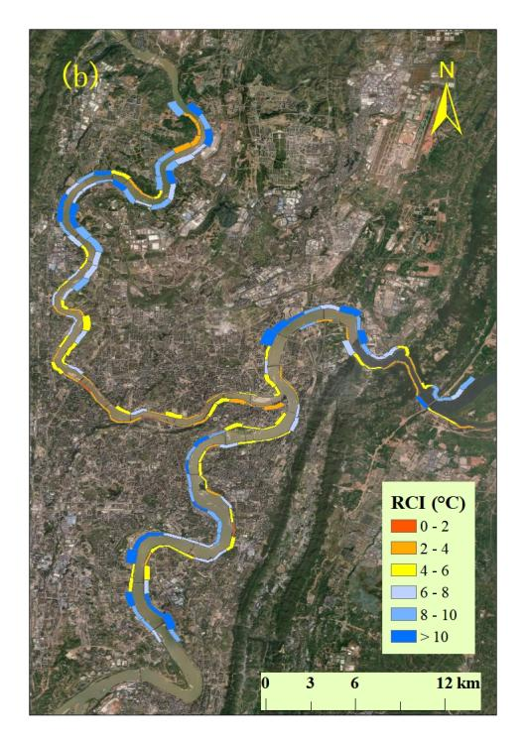

Fig. 4 The spatial patterns of average RCI of individual river segments on the normal summer day (a) and the extremely hot day (b), respectively. The widths of river segments represent the corresponding RCD.

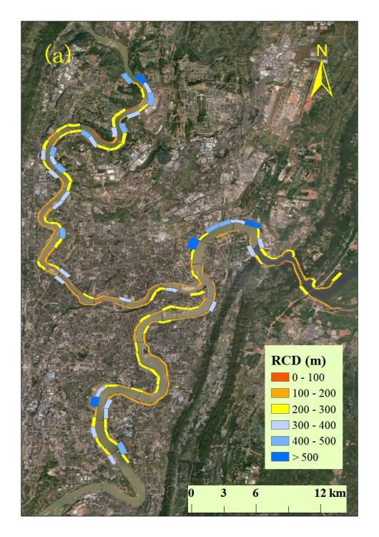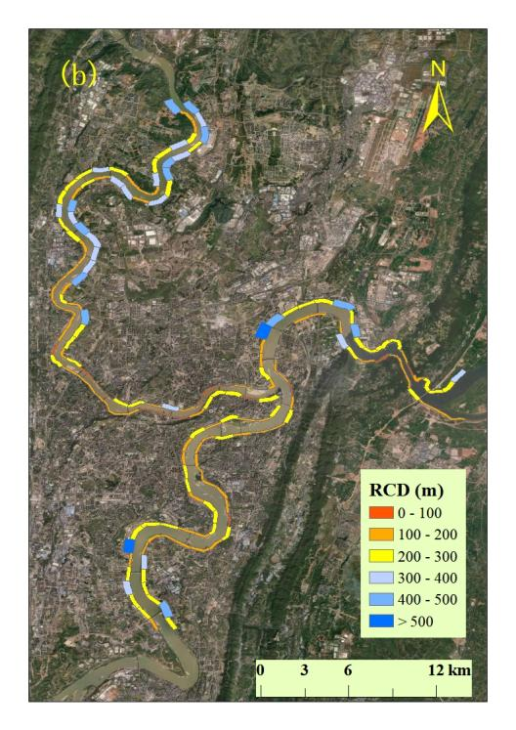

Fig. 5 The spatial patterns of average RCD of individual river segments on the normal summer day (a) and the extremely hot day (b), respectively.

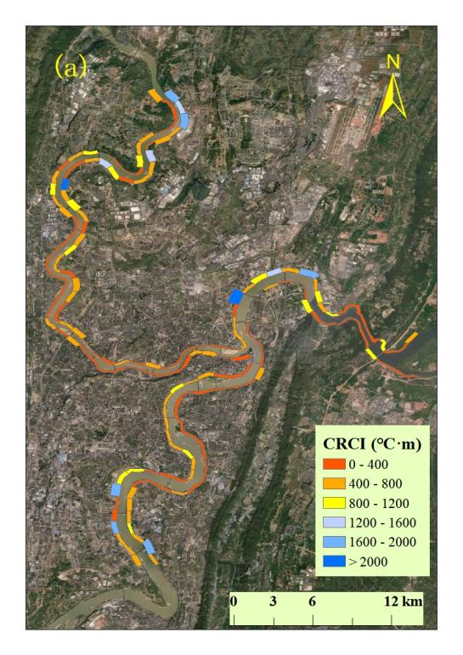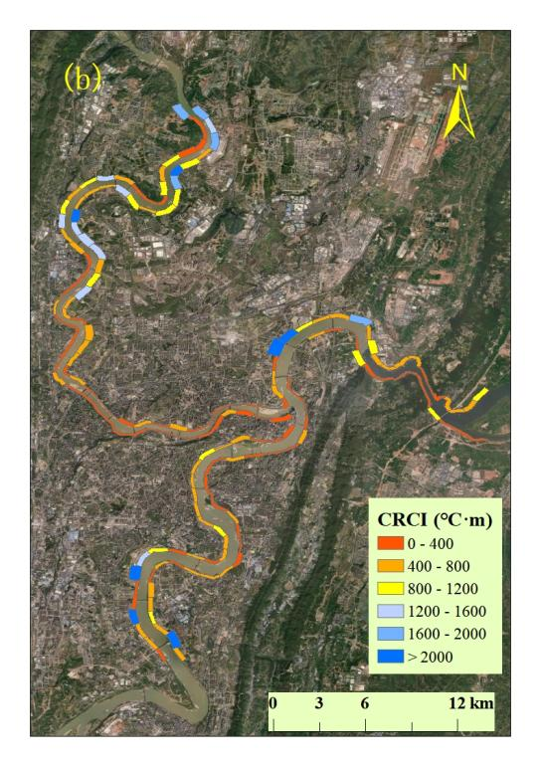

Fig. 6 The spatial patterns of average CRCI of individual river segments on the normal summer day (a) and the extremely hot day (b), respectively.

The spatial patterns of RCI are illustrated in Fig. 4. On the normal summer day, RCI exhibited maximum and average values of 12.2 °C and 5.5 °C across all river segments. On the extremely hot day, the cooling intensities became notably higher, with maximum and average values reaching 15.5 °C and 6.4 °C, respectively. Notably, there were considerable variations in RCI values among individual segments on both case days. Specifically, the standard deviation was 2.4 °C on the normal summer day and it increased to 3.1 °C on the extremely hot day.

Additionally, it can be observed that the spatial patterns of RCI remained similar on both case days. Along the Jialing River, RCI values were comparatively lower than those along the Yangtze River. Specifically, the mean RCI values for river segments along the Jialing River were 4.8 °C and 5.9 °C on the normal summer day and the extremely hot day, respectively. In contrast, for the Yangtze River, the corresponding values became 6.1 °C and 6.9 °C, approximately 1 °C higher. This difference was speculated to be resulted from the wider river width of the Yangtze River. Additionally, the cooling intensities on the left banks of rivers were significantly higher than those on the right banks. Specifically, the average RCI on the left banks were 5.8°C and 6.8°C on the 2 case days. The corresponding magnitudes became 5.1°C and 6.0°C for the right banks.

RCI values were notably lower for river segments near the Tongluo Mountain in the eastern suburb of Chongqing compared to the surrounding areas. The higher mountainous terrain near the riverbanks was inferred to obstruct the inland penetration of river cooling. In the city center where numerous high-rise buildings were concentrated, RCI values were relatively lower than those in the surrounding suburban areas. This observation can be attributed to the obstructive effect of dense buildings on river cooling.

As for RCD, the values varied from 60 to 720 meters with average distances of 225.8 meters on the normal summer day and 222.2 meters on the extremely hot day (Fig. 5). Similar spatial patterns of CRCI values on the 2 case days are presented in Fig. 6. On the normal summer day, the average CRCI value was 505.9 °C·m and it increased to 587.0 °C·m on the extremely hot day. The spatial diversity were also more pronounced in hotter ambient weather conditions with the standard deviation rising from 461.7 °C·m to 565.5 °C·m. River segments exhibiting CRCI values below 400 °C·m were predominantly concentrated in the city center and near the Tongluo Mountain, which were characterized by dense buildings or rugged topography.

### 3.2. Model performance

Table 3 Performances of the BRT model in modelling river cooling effects on the 2 case days.

|  |  |  |  |
| --- | --- | --- | --- |
| Index | Weather condition | R2 | RMSE |
| RCI | Normal summer day | 0.60 | 0.8 (°C) |
| Extremely hot day | 0.57 | 1.3 (°C) |
| RCD | Normal summer day | 0.69 | 46.3 (m) |
| Extremely hot day | 0.75 | 40.7 (m) |
| CRCI | Normal summer day | 0.72 | 169.0 (°C·m) |
| Extremely hot day | 0.64 | 208.5 (°C·m) |

The validation results of the BRT model are shown in Table 3. The R2 values of the RCI simulations were 0.60 on the normal summer day and 0.57 on the extreme hot day, with the RMSE values being 0.8 °C and 1.3 °C, respectively. In comparison to RCI, the explanatory powers of environmental factors were relatively higher for RCD and CRCI. Specifically, the corresponding R2 values were 0.69 and 0.75 for the RCD simulations, with the corresponding RMSE values being 46.3 m and 40.7 m. For the CRCI simulations, the corresponding R2 values were 0.72 and 0.64, with the RMSE values being 169.0 °C·m and 208.5 °C·m, respectively.

### 3.3. Relative importance of influencing factors

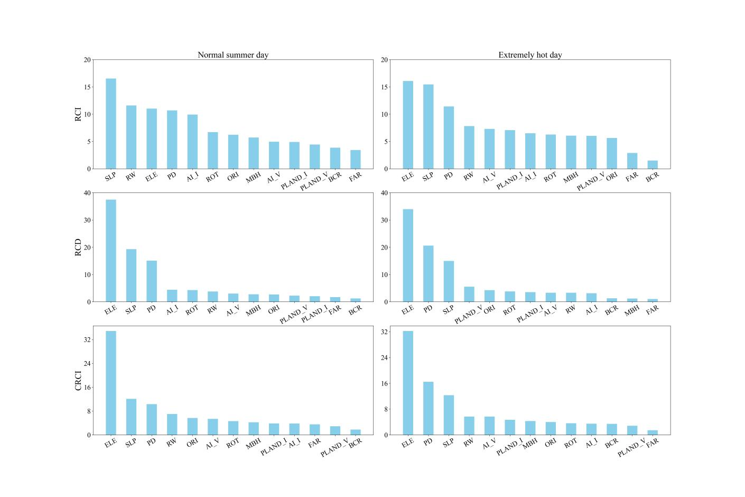

Fig. 7 Relative importance of influencing factors for RCI, RCD and CRCI on the normal summer day and the extremely hot day, respectively.

Fig. 7 illustrates the relative importance of influencing factors for river cooling effects during the 2 case days. Our results highlight the substantial impacts of topography in the metropolitan area of Chongqing, the city characterized by undulating terrain. Regarding RCI, average slope emerged as the most influential factor among all potential contributors on the normal summer day, constituting 16.5%. The contribution of average elevation was smaller, accounting for 11.0%. On the extremely hot day, average elevation emerged as the most influential factor with the relative importance being 16.1%.

In terms of land cover characteristics, the findings distinctly highlight that the configuration of land cover played a more pivotal role than the composition in explaining the variations of RCI. On the normal summer day, PD was the most important land cover characteristic with a contribution rate of 10.7%, followed by AI_I (9.9%), AI_V (4.9%), PLAND_I (4.9%) and PLAND_V (4.4%). On the extremely hot day, PD (11.4%) also contributed most, followed by AI_V (7.3%), PLAND_I (7.1%), AI_I (6.5%) and PLAND_V (6.0%). Regarding 3D building characteristics, the contributions of MBH were 5.7% and 6.1% on the 2 case days, which were significantly higher than those of FAR and BCR. This implies that height played a larger role in affecting river cooling intensity compared to density or volume of buildings.

As has been mentioned in Sect. 3.1, the impacts of river characteristics cannot be overlooked. Our results show that river width made the contributions of 11.6% and 7.8% on the normal summer day and the extremely hot day, ranking second and fourth among all the selected environmental variables. The roles of rotation angle and orientation of river decreased successively, accounting for 6.7% and 6.2% on the normal summer day. On the extremely hot day, the proportions were further decreased to 6.3% and 5.6%.

Similar to RCI, RCD was also significantly influenced by topography. As the most influential factor, average elevation contributed 37.5% and 34.0% to RCD on the 2 case days. The ratios were much higher than those to RCI. In addition, the factors ranked from second to fourth in relative importance were SLP (19.3%), PD (15.1%) and AI_I (4.4%) on the normal summer day and PD (20.6%), SLP (15.0%) and PLAND_V (5.6%) on the extremely hot day. As for CRCI, the top 4 most influential factors in sequence were ELE (34.9%), SLP (12.1%), PD (10.3%) and RW (7.0%) on the normal summer day and ELE (32.2%), PD (16.5%), SLP (12.3%) and RW (5.7%) on the extremely hot day.

The results also reveal that there were obvious differences in the contributions of environmental variables on river cooling effects between the 2 case days. Specifically, in comparison to the normal summer day, the relative importance of patch density was increased, while the role of river width was decreased.on the extremely hot day.

### 3.4. Marginal effects of key influencing factors on river cooling effects

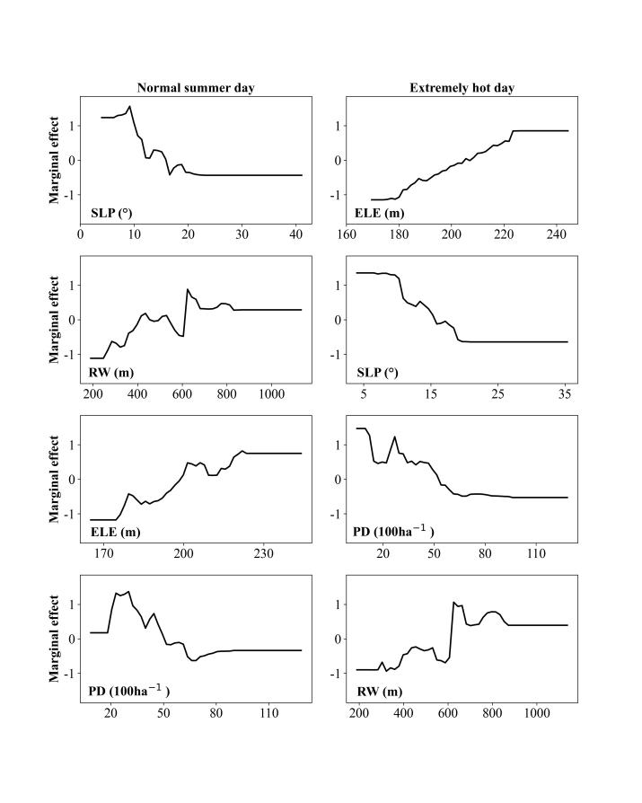

Fig. 8 Marginal effects of the top 4 most influential factors on RCI on the 2 case days.

The top 4 most influential factors were selected for the subsequent analysis of the marginal effects on the 2 case days. The results unveil the non-linear effects of environmental variables on river cooling. As the most influential factor in explaining RCI on the normal summer day, average slope manifested a descent pattern. When it increased from 9.2° to 23.3 °, the average cooling intensity induced by the rivers decreased, indicating that larger slope of riverside area was not conducive to the enhanced heat mitigation provided by the nearby river. It should be noted that when SLP was greater than 23.3 °, the RCI value remained relatively stable. In contrast to SLP, the effects of RW and ELE demonstrated ascent patterns with fluctuations. RCI demonstrated an increase when RW ranged from 246.7 to 623.8 meters or ELE fell within the range of 174.6 - 222.0 meters. Beyond these specific ranges, the RCI value remained relatively stable. The positive relation between river width and RCI revealed here aligned with the higher RCI for river segments of the Yangtze River compared to the Jialing River, as discussed in Sect. 3.1. The influence of patch density exhibited a relatively complicated pattern. As PD increased within the range of 18.2/100ha - 30.2/100ha, RCI showed a fluctuating upward trend. Subsequently, PD gradually decreased until it reached 66.1/100ha. As a whole, the increased patch density was associated with the corresponding reduced RCI.

Similar to the normal summer day, the impacts of ELE and SLP on RCI on the extremely hot day were characterized by ascent and descent patterns, respectively. An upward trend in RCI was observed as ELE increased within the range from 174.1 to 226.4 meters. Conversely, when SLP was between 6.5° and 20.9°, RCI exhibited a decreasing trend. In addition, the marginal effects of PD and RW on RCI can be described as descent and ascent patterns with fluctuations.

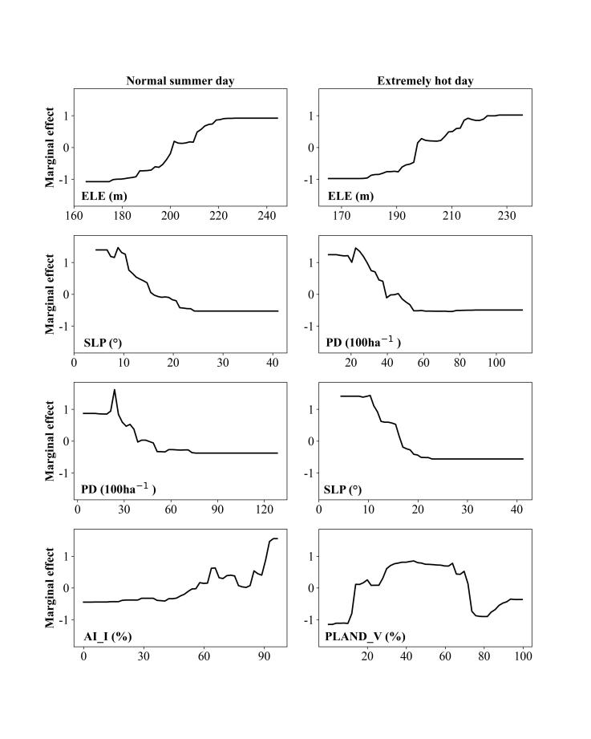

Fig. 9 Marginal effects of the top 4 most influential factors on RCD on the 2 case days.

Fig. 9 illustrates the marginal effects of the top 4 most influential factors on RCD. On both case days, the influences of the 2 topographical variables, namely ELE and SLP, on RCD were characterized by ascent and descent patterns, respectively. RCD exhibited an upward trend when ELE increased from 174.7 to 226.9 meters on the normal summer day and from 175.2 to 230.0 meters on the extremely hot day. Meanwhile, opposing trends in RCD were observed when SLP increased within the ranges of 8.9° to 25.0° and 10.4° to 22.8° on these days. Similar to the effects on RCI, the effects of PD on RCD can be characterized by fluctuating downward trends on the 2 case days. The fourth most influential factor on the normal summer day was AI_I, which was characterized by a fluctuating ascent pattern within the range of 3.9% - 94.5%. On the extremely hot day, the fourth most influential factor became PLAND_V. The corresponding effect can be primarily described by an increase followed by a rapid decrease. It can be derived that the effect of vegetation cover ratio on RCD was complicated.

Similar to the influences on RCI, the top 4 most influential factors for CRCI in sequence were ELE, SLP, PD and RW on the normal summer day and ELE, PD, SLP and RW on the extremely hot day. The marginal effects of ELE and SLP were characterized by ascent and descent patterns, respectively. The influences of PD and RW were relatively fluctuating, showing descent and ascent patterns as a whole.

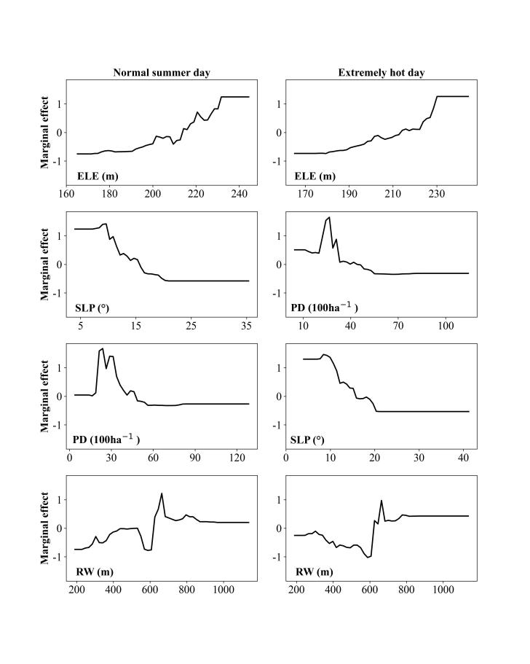

Fig. 10 Marginal effects of the top 4 most influential factors on CRCI on the 2 case days.

## Discussions

### The impacts of influencing factors on river cooling effects

As illustrated in Fig. 4 - 6, this investigation reveals similar spatial patterns of river cooling effects between the normal summer day and the extremely hot day. Notably, greater temperature reductions were observed in suburban areas characterized by sparse architectural layouts. In addition, the average RCI was 5.5 °C on the normal summer day, consistent with findings from prior studies targeting at other types of water bodies [35]. When compared to the cooling intensity of less than 4 °C near the Huangpu River reported in Shanghai, our observed intensity was significantly higher [17]. This contrast can be explained by the difference in river width, as the average river width in Chongqing is larger than that of the Huangpu River. Furthermore, background weather conditions and surrounding urban characteristics were potential contributors to the observed river cooling effects.

As global warming and urbanization continue, the increase in the adverse impacts of future extreme heatwaves becomes inevitable. Consequently, focusing on river cooling effects during extreme weather conditions can offer valuable scientific insights for addressing future urban climate change. This study unveils higher average values of RCI and CRCI on the extremely hot day compared to the normal summer day. This difference can be explained by the mechanism of water cooling on heatwave days, as the larger temperature difference between the land and the nearby water body can lead to a stronger cooling potential for the waterfront area. Due to the significantly higher temperature, the intensity of evaporative cooling from the water surface is also larger. Additionally, it has been found that the spatial variations of river cooling effects were larger on the extremely hot day. This finding is consistent with an observation of cooling from the nearby sea in Adelaide, which demonstrated significantly larger spatial variations in sea breeze cooling capacity under heatwave conditions [25].

Some studies have explored the relationship between urban climate and topography [36-38]. However, the role of topography in affecting water cooling remains inadequately understood. This study reveals that topography exerted a significant influence on the cooling effects of rivers, surpassing the impact of land cover and 3D building characteristics. This is reasonable as rivers significantly shape the thermal environment of their surroundings through the modulation of inland airflow. Specifically, the irregularity of terrain can alter the direction and intensity of airflow, thus influencing the spatial pattern of the thermal environment. For waterfront area with steep terrain, the inland penetration of water cooling effect is weakened, leading to a reduction in cooling intensity. Additionally, this study identifies a positive correlation between elevation and river cooling, which was likely to be attributed to the temperature decrease caused by the elevated altitude.

In terms of land cover characteristics, this study observes an intricate correlation between river cooling and the proportion of vegetation area, which can be explained by their complex interactions. On one hand, the lower temperature of green space compared to impervious surface weakens the impact of river cooling. On the other hand, vegetated areas are mostly open areas, which facilitate the inward penetration of cooler airflow from the river. Considering the aforementioned influences, the overall effects of vegetation cover ratio on river cooling are complicated. While some studies indicated an increase in water cooling with expanded vegetation cover, opposite correlations have been discovered elsewhere [11,18]. In Chengdu, no significant correlation was found between the cooling intensity of wetland and the proportion of vegetation cover [9]. Hence, further investigations are required to gain a better understanding of the relationship between land cover composition and water cooling.

### Implications for urban planning

This study unveils notable spatial variances of river cooling effects influenced by diverse environmental variables. The insights gained from these findings offer valuable references for climate-friendly urban planning to improve residents' living environment. Firstly, because of the negative correlation between slope and river cooling effect found in this study, areas designated for residents' leisure activities should preferably avoid locations with significant changes in topography. Additionally, considering that the configurations of different land cover types can exert stronger influences on river cooling than the compositions, it’s recommended to prioritize the layouts of individual land cover types in urban planning. The result also indicates that patch density demonstrated a negative correlation with river cooling. Hence, it’s advisable to reduce the density of landscape patches to foster a more climate-friendly living environment.

### Limitations of this study and future work

This study has certain limitations. Situated in the Sichuan basin, Chongqing experiences significantly lower average wind speed compared to other cities over the world. As a result, the impacts of wind speed and wind direction on river cooling effects have not been comprehensively addressed in this study. Future research endeavors should consider these factors to offer a more comprehensive understanding of river cooling dynamics from the standpoint of background weather conditions, especially in cities characterized by higher wind speeds. In addition, the city of Chongqing, featured by a relatively low number of sunshine hours, poses constraints on the accessibility of suitable cloud-free Landsat images. In this study, only 2 images were employed to characterize the normal summer day and the extremely hot day. In the future work, additional research endeavors are imperative to incorporate more images for normal and extreme summer days, thereby augmenting the robustness of the finding. Furthermore, like other cities in developing countries, Chongqing has undergone rapid urbanization in the past few decades. However, because of the limitations of available building data, an analysis of river cooling during this urbanization process is unfeasible. Therefore, the impacts of urban structure on river cooling during urban construction remain unexplored. A quantitative analysis spanning over 20 years, investigating annual variations of river cooling effects with dynamic building data, could offer valuable insights. Such findings hold implications for urban planning and management in developing countries.

## Conclusions

This study focuses on the cooling effects of rivers on the surrounding urban environment on normal and extreme summer days, taking the mountainous city of Chongqing as an example. Environmental variables, including river characteristics, land cover characteristics, 3D building characteristics, and topographical characteristics, have been considered. The Boosted Regression Tree model was employed to assess the relative importance of individual influencing factors for RCI, RCD and CRCI and the corresponding marginal effects of the top 4 most influential factors. In contrast to traditional analytical methods such as linear regression, this approach can effectively capture the non-linear effects of influencing factors on river cooling effects.

The conclusions are as follows:

1. The river cooling effects exhibited significant spatial variations with similar spatial patterns. In addition, the average values and spatial variations of RCI and CRCI were higher on the extremely hot day compared to the normal summer day. Specifically, the average values and standard deviations in River Cooling Intensity (RCI) were 5.5°C and 2.4°C on the normal summer day and they increased to 6.4°C and 3.1 °C on the extremely hot day.
2. Explanatory powers of the environmental variables on RCD and CRCI were notably higher compared to RCI for the 2 case days.
3. Topographical characteristics exhibited strong impacts on river cooling effects, with the relative importance of average elevation for RCI being 11.0% and 16.1% on the normal summer day and the extremely hot day, respectively. In comparison to the normal summer day, the relative importance of patch density was increased, while the role of river width was decreased on the extremely hot day.
4. Through the examination of marginal effects, non-linear influences of the top 4 most influential factors on river cooling effects were identified, with most variables exerting their impacts within specific ranges. ELE and SLP exhibited ascent and descent patterns on both summer days, while the impacts of PD and RW were relatively fluctuating, showing descent and ascent patterns as a whole.

These findings provide a scientific understanding of the roles of environmental variables in shaping river cooling effects. They offer guidance for optimizing urban planning and management to improve the thermal environment of riverside areas, especially for cities with uneven surfaces.

## Acknowledgement

This study was supported by the National Natural Science Foundation of China (No. 42101036), Youth Innovation Team Project (No. CMA2024QN15) and CMA Key Open Laboratory of Transforming Climate Resources to Economy (2023018).

## References

1. S. Wang, S. Gao, S. Li, K. Feng, Strategizing the relation between urbanization and air pollution: Empirical evidence from global countries, J. Clean. Prod. 243 (2020) 118615.

[2] M. Ahmad, P. Jiang, M. Murshed, K. Shehzad, R. Akram, L. Cui, Z. Khan, Modelling the dynamic linkages between eco-innovation, urbanization, economic growth and ecological footprints for G7 countries: does financial globalization matter?, Sustain. Cities Soc. 70 (2021) 102881.

[3] H. Guan, S. Beecham, H. Xu, G. Ingleton, Incorporating residual temperature and specific humidity in predicting weather-dependent warm-season electricity consumption, Environ. Res. Lett. 12(2) (2017) 024021.

[4] M. J. Nieuwenhuijsen, Influence of urban and transport planning and the city environment on cardiovascular disease, Nat. Rev. Cardiol. 15(7) (2018) 432-438.

[5] A. Azhdari, A. Soltani, M. Alidadi, Urban morphology and landscape structure effect on land surface temperature: Evidence from Shiraz, a semi-arid city, Sustain. Cities Soc. 41 (2018) 853-864.

[6] M. Taleghani, Outdoor thermal comfort by different heat mitigation strategies-A review, Renew. Sustain. Energy Rev. 81 (2018) 2011-2018.

[7] B. He, Mitigating urban heat island effects: An analysis of precinct ventilation performance and its impact on urban heat islands and outdoor thermal comfort, PhD diss., UNSW Sydney, 2020.

[8] P. Ampatzidis, T. Kershaw, A review of the impact of blue space on the urban microclimate, Sci. Total Environ. 730 (2020) 139068.

[9] S. Wu, H. Yang, P. Luo, C. Luo, H. Li, M. Liu, Y. Ruan, et al., The effects of the cooling efficiency of urban wetlands in an inland megacity: A case study of Chengdu, Southwest China, Build. Environ. 204 (2021) 108128.

[10] P.-A. Dugord, S. Lauf, C. Schuster, B. Kleinschmit, Land use patterns, temperature distribution, and potential heat stress risk–the case study Berlin, Germany, Comput. Environ. Urban Syst. 48 (2014) 86-98.

[11] J. Wu, C. Li, X. Zhang, Y. Zhao, J. Liang, Z. Wang, Seasonal variations and main influencing factors of the water cooling islands effect in Shenzhen, Ecol. Indic. 117 (2020) 106699.

[12] E. A. Hathway, S. Sharples, The interaction of rivers and urban form in mitigating the Urban Heat Island effect: A UK case study, Build. Environ. 58 (2012) 14-22.

[13] A. N. Moyer, T. W. Hawkins, River effects on the heat island of a small urban area, Urban Clim. 21 (2017) 262-277.

[14] Y. Lin, Z. Wang, C. Y. Jim, J. Li, J. Deng, J. Liu, Water as an urban heat sink: Blue infrastructure alleviates urban heat island effect in mega-city agglomeration, J. Clean. Prod. 262 (2020) 121411.

[15] N. Hu, G. Wang, Z. Ma, Z. Ren, M. Zhao, J. Meng, The cooling effects of urban waterbodies and their driving forces in China, Ecol. Indic. 156 (2023) 111200.

[16] N. E. Theeuwes, A. Solcerova, G. J. Steeneveld, Modeling the influence of open water surfaces on the summertime temperature and thermal comfort in the city, J. Geophys. Res. Atmos. 118(16) (2013) 8881-8896.

[17] H. Du, X. Song, H. Jiang, Z. Kan, Z. Wang, Y. Cai, Research on the cooling island effects of water body: A case study of Shanghai, China, Ecol. Indic. 67 (2016) 31-38.

[18] R. Sun, L. Chen, How can urban water bodies be designed for climate adaptation?, Landsc. Urban Plan. 105(1-2) (2012) 27-33.

[19] Z. Xue, G. Hou, Z. Zhang, X. Lyu, M. Jiang, Y. Zou, X. Shen, J. Wang, X. Liu, Quantifying the cooling-effects of urban and peri-urban wetlands using remote sensing data: Case study of cities of Northeast China, Landsc. Urban Plan. 182 (2019) 92-100.

[20] J. Peng, Q. Liu, Z. Xu, D. Lyu, Y. Du, R. Qiao, J. Wu, How to effectively mitigate urban heat island effect? A perspective of waterbody patch size threshold, Landsc. Urban Plan. 202 (2020) 103873.

[21] F. Guo, J. Zhao, H. Zhang, J. Dong, P. Zhu, S. S. Y. Lau, Effects of urban form on sea cooling capacity under the heatwave, Sustain. Cities Soc. 88 (2023) 104271.

[22] N. I. Syafii, M. Ichinose, E. Kumakura, S. K. Jusuf, K. Chigusa, N. H. Wong, Thermal environment assessment around bodies of water in urban canyons: A scale model study, Sustain. Cities Soc. 34 (2017) 79-89.

[23] X. Zhou, S. Zhang, Y. Liu, Q. Zhou, B. Wu, Y. Gao, T. Zhang, Impact of urban morphology on the microclimatic regulation of water bodies on waterfront in summer: A case study of Wuhan, Build. Environ. 226 (2022) 109720.

[24] X. Chen, Z. Wang, Y. Bao, Cool island effects of urban remnant natural mountains for cooling communities: A case study of Guiyang, China, Sustain. Cities Soc. 71 (2021) 102983.

[25] Z. Zhou, Z. Zhang, X. Zou, K. Zhang, W. Zhang, Quantifying wind erosion at landscape scale in a temperate grassland: Nonignorable influence of topography, Geomorphology 370 (2020) 107401.

[26] S. Cheval, A.-M. Popa, I. Șandric, I.-C. Iojă, Exploratory analysis of cooling effect of urban lakes on land surface temperature in Bucharest (Romania) using Landsat imagery, Urban Clim. 34 (2020) 100696.

[27] L. Yao, D. J. Sailor, X. Yang, G. Xu, L. Zhao, Are water bodies effective for urban heat mitigation? Evidence from field studies of urban lakes in two humid subtropical cities, Build. Environ. 245 (2023) 110860.

[28] D. Li, T. Sun, M. Liu, L. Yang, L. Wang, Z. Gao, Contrasting responses of urban and rural surface energy budgets to heat waves explain synergies between urban heat islands and heat waves, Environ. Res. Lett. 10(5) (2015) 054009.

[29] P. Ramamurthy, J. González, L. Ortiz, M. Arend, F. Moshary, Impact of heatwave on a megacity: an observational analysis of New York City during July 2016, Environ. Res. Lett. 12(5) (2017) 054011.

[30] Z. Gao, Y. Hou, W. Chen, Enhanced sensitivity of the urban heat island effect to summer temperatures induced by urban expansion, Environ. Res. Lett. 14(9) (2019) 094005.

[31] N. An, J. Dou, J. E. González-Cruz, R. D. Bornstein, S. Miao, L. Li, An observational case study of synergies between an intense heat wave and the urban heat island in Beijing, J. Appl. Meteorol. Climatol. 59(4) (2020) 605-620.

[32] H. Liu, P. Gong, J. Wang, N. Clinton, Y. Bai, S. Liang, Annual dynamics of global land cover and its long-term changes from 1982 to 2015, Earth Syst. Sci. Data 12(2) (2020) 1217-1243.

[33] J. Ma, J. C. Cheng, F. Jiang, W. Chen, J. Zhang, Analyzing driving factors of land values in urban scale based on big data and non-linear machine learning techniques, Land Use Policy 94 (2020) 104537.

[34] J. Elith, J. R. Leathwick, T. Hastie, A working guide to boosted regression trees, J. Anim. Ecol. 77(4) (2008) 802-813.

[35] G. Manteghi, H. bin Limit, D. Remaz, Water bodies an urban microclimate: A review, Mod. Appl. Sci. 9(6) (2015) 1.

[36] T. R. Oke, G. Mills, A. Christen, J. A. Voogt, Urban climates, Cambridge University Press, 2017.

[37] S. Liao, H. Cai, P. Tian, B. Zhang, Y. Li, Combined impacts of the abnormal and urban heat island effect in Guiyang, a typical Karst Mountain City in China, Urban Clim. 41 (2022) 101014.

[38] N. Mo, J. Han, Y. Yin, Y. Zhang, Seasonal analysis of land surface temperature using local climate zones in peak forest basin topography: A case study of Guilin, Build. Environ. 247 (2024) 111042.