## Introduction

|  |  |
| --- | --- |
| * 【up2024 1105 16:57】 * The urban heat island effect refers to the phenomenon where temperatures in cities are significantly higher than those in surrounding rural areas (Oke, 1995), resulting in greater heat exposure for urban residents during hot seasons. * With the ongoing trend of global warming, the frequency and intensity of urban heatwaves are expected to increase. According to projections, summer temperatures in urban areas could rise by as much as 3°C by 2050 (Huang et al., 2019). * With the increasing frequency and intensity of urban heatwaves, extreme weather events like torrential rainfall may become more common (Ganeshan et al., 2013). * Additionally, these heatwaves have various negative impacts on urban socioeconomic activities, including increased energy consumption, reduced living comfort, and even elevated mortality risk among residents (Santamouris, 2020; Huang et al., 2024; Gao et al., 2023). * As awareness of the urban heat island effect's impact continues to increase, effectively mitigating this effect has become a pressing environmental concern in urban areas. | * 总结 * UHI概述 * 未来UHI趋势 * UHI危害 * 缓解UHI很有必要 * 城市热岛效应是指城市气温显著高于周边农村地区的现象（Oke, 1995），使得城市居民在炎热季节遭受比乡村更大的热暴露。 * 随着全球变暖的持续，城市热浪的频率和强度预计将不断上升。根据预测，到2050年，夏季城市气温可能上升高达3℃（Huang et al., 2019）。 * 愈发频繁和强烈的城市热浪会对城市生态系统造成负面影响。具体而言，它会抑制植被生长，增加森林火灾风向等（Ganeshan et al., 2013）。此外，这些热浪对城市的社会经济活动产生多方面的负面影响，包括增加能源消耗、降低居民生活舒适度，甚至提高居民的死亡风险（Santamouris, 2020; Huang et al., 2024; Gao et al., 2023）。 * 随着人们对城市热岛效应危害的认识加深，如何有效缓解城市热岛效应并调节城市小气候，已成为当前最紧迫的城市环境问题之一。 |
| * 【up2024 1105 19:43】 * One primary cause of the urban heat island effect is the significantly higher coverage of impervious surfaces in cities compared to rural areas. To address this challenge, a range of strategies can be employed to lower urban temperatures, including increasing urban vegetation, utilizing cool roofs, and implementing cool pavements (Khare et al., 2021; Wang et al., 2021). * Among these approaches, the creation and use of green spaces have become particularly effective in mitigating the negative impacts of extreme heatwaves. Specifically, urban vegetation reduces heat absorption through shading and evapotranspiration, thereby lowering local temperatures. * Currently, many remote sensing studies have analyzed the cooling effects of green spaces and the factors influencing them. Notably, characteristics such as the area and configuration of green spaces are critical factors affecting surface heat flux and temperature regulation. * For example, a study conducted in Mexico found that green space area accounts for up to 30% of the variability in its cooling intensity (Gomez-Martinez et al., 2021). Regarding the influence of green space configuration, research has shown that UHI intensity is negatively correlated with patch density and patch shape index, while positively correlated with the edge density of green space. * In addition to the characteristics of green spaces themselves, surrounding urban features, such as building density and the proportion of impervious surfaces, play a significant role in determining the intensity and extent of their cooling effects (Qiu et al., 2020; Liao et al., 2023). A higher proportion of impervious surfaces tends to reduce the range of parks' cooling effects (Han et al., 2023). | * 总结 * UHI原因 * 概述UHI缓解方法 * 提及绿地影响 * 【补充】强调延伸效应 * 介绍相关研究 * 讨论绿地降温影响因素 * 绿地自身、周边环境特征 * 为应对未来潜在的城市热浪增加的风险，可以采用多种策略来降低城市温度，例如增加城市植被、使用凉爽的屋顶和实施凉爽的人行道（Khare等，2021；Wang等，2021）。 * 其中，合适地创建和布局绿地已被证明在缓解极端热浪的负面影响方面特别有效。具体来说，城市植被通过遮阴和蒸散作用减少热量吸收，从而降低局部温度。 * 目前已有大量研究关注了环境因素对绿地降温效应的影响。其中，绿地面积景观格局受到了较为广泛的关注。例如，墨西哥的一项研究发现，绿地面积可解释其降温强度的多达30%的变异性（Gomez-Martinez等，2021）。 * 关于绿地配置的影响，普遍表明城市热岛（UHI）强度与绿地斑块密度和形状指数呈负相关，而与边缘密度呈正相关。 * 除了绿地本身的特征外，周围的城市特征（如土地覆盖格局、三维形态特征等）也在决定其降温效果的强度和范围方面发挥重要作用（Qiu等，2020；Liao等，2023）。 * 目前，相对于2D因素的影响，3D因素的考虑相对较少。然而，一些研究表明3D几何构型可能对城市热环境产生更显着的作用。它可以阻挡和引导气流，影响地面辐射的接受和损失。 * 【举例】 |
| * - Currently, the main methods for studying the cooling effects of green spaces include remote sensing analysis, model simulations, and in situ measurements. * - Model simulations inevitably simplify real-world conditions to some extent, while remote sensing analysis focuses on surface temperature, which differs from air temperature at pedestrian height. * - For example, a study in Shenzhen found that the spatial distribution of cooling and warming hotspots based on surface temperature does not align with that of air temperature (Cao et al., 2021). This discrepancy arises from their different driving mechanisms: surface temperature is directly driven by solar radiation and varies greatly depending on surface material properties, whereas air temperature is mainly influenced by surface radiation. Additionally, the temporal variation and influencing factors of these two temperature types also differ (Sheng et al., 2017). Therefore, analyses based on in situ measurements can more accurately reflect the actual local microclimate. * - There are already some case studies on green space cooling based on in situ data. For instance, a study in Beijing observed that the temperature difference between inside and outside the Beijing Olympic Park can reach 4.8°C (Yan et al., 2018). In another study in the high-density city of Hong Kong, it was found that the cooling effect of pocket parks is influenced by environmental variables such as building density and building area ratio (Lin et al., 2017). * - However, current in situ studies on green space cooling are mainly concentrated on a few sites around green spaces, with low monitoring density, making it challenging to accurately capture the fine-scale spatial patterns of thermal environments around large green spaces and their driving factors. * - Therefore, it is essential to establish a high-density meteorological monitoring network to conduct field monitoring of the thermal environment surrounding green spaces, and to further quantify the fine-scale spatial and temporal patterns of air temperature, relative humidity, and thermal comfort as influenced by environmental factors. | * 总结 * 介绍绿地降温研究方法 * 指出只有实测才准确 * 介绍实测相关研究 * 指出实测相关研究的不足——密度低 * 指出有必要开展高密度监测 * 目前，研究绿地降温效果的主要手段包括遥感分析、模型模拟和现场实测。 * 模型模拟不可避免地会对实际情况进行一定程度的简化，而遥感分析基于地表温度，与人行高度的气温存在一定差异（Cao 等, 2021）。这是因为两者的驱动机制不同，地表温度直接受太阳辐射驱动，变化幅度较大且与地表材料的特性密切相关，而气温则主要受到地表辐射的影响。此外，两者的时间变化特征及其影响因素也有所不同（Sheng 等, 2017）。基于现场实测的分析尽管相对来说需要投入更大的成本，但能够更准确地反映当地的微气候状况。 * 当前，已有一些基于实测数据的绿地降温研究案例。有研究关注绿地内部的环境特征。如XX。同样，还有研究关注绿地周边的热环境特征，即绿地降温的延伸效应。例如，在高密度城市香港的研究中，发现口袋公园的降温效果受到建筑密度和建筑面积比等环境变量的影响（Lin 等, 2017）。 * 然而，当前关于绿地降温的实测研究主要集中于绿地周边的个别监测点，监测密度较低。不能反映气温等热环境指标的高精度连续变化，难以准确反映大型绿地周边热环境的精细尺度空间格局及其驱动因素，尤其是对降温距离、降温强度等绿地降温指标的估算精准度不够。 * 因此，有必要建立高密度的气象监测网络，以便对绿地周边热环境进行现场监测，进一步量化绿地周边气温、相对湿度和热舒适度的精细尺度时空格局及其受到的环境因素影响。 |
| * It is important to note that the influence of green spaces on urban microclimates is not limited to temperature; they also significantly affect the spatiotemporal patterns of humidity. According to observations by Zhang et al. (2013), while green spaces in subtropical cities can reduce temperatures by up to 5°C, they can also increase relative humidity by up to 8%. In the high-density urban environment of Hong Kong, both humidifying and dehumidifying effects of small parks have been observed (Cheung et al., 2021). * Although temperatures around green spaces may decrease to some extent, the spatiotemporal patterns of thermal comfort, which are influenced by both temperature and relative humidity, are not yet fully understood, especially in the context of high summer temperatures. For urban residents, thermal comfort is more directly related to their thermal perception than temperature alone. * Therefore, it is necessary to establish a high-density monitoring network to assess the thermal environment around green spaces. By considering multiple meteorological indicators, we can gain a more comprehensive understanding of the impact of large urban green spaces on the surrounding thermal environment. | * 总结 * 绿地对湿度有影响 * 绿地对热舒适度有影响 * 但相关研究不足，需要深入 * 需要注意的是，绿地不仅影响城市微气候的温度，还对湿度的时空格局有显著影响。根据Zhang等(2013)的观测结果，尽管绿地在亚热带城市中能够降低气温达5°C，但同时也使相对湿度增加了8%。在香港的高密度城市环境中，小型公园的增湿和减湿效应均有观测到（Cheung et al., 2021）。 * 需要注意的是，尽管绿地周边的温度有所下降，但相对湿度的增加会在一定程度上抵消温度下降带来的热舒适缓解。 * 因此，在气温和相对湿度的综合作用下，绿地对热舒适度影响的时空格局及其影响因素仍不完全明了，特别是在夏季高温背景下。 * 事实上，不同于反映环境热状况的温度和地表温度，热舒适是一种代表对热环境满意度的意识状态[9]，它[反映](https://www.sciencedirect.com/science/article/pii/S0360132321009604" \l "bib9)了人们对环境的感知。对于城市居民来说，与气温等基于测量的气象变量相比，热舒适度与他们的热感知更加直接相关。 * 因此，有必要基于高密度监测网络对绿地周边的热环境进行监测，从多个气象指标的角度，更全面地理解大型城市绿地对周边热环境的影响。 |
| * To this end, this study selected Chongqing Central Park and employed mobile measurement methods to conduct fine-scale, high-density meteorological measurements of the park's surrounding areas. The aim is to understand the thermal environment characteristics around the green space from the perspective of temperature, humidity, and their combined effects, and to quantify the roles of various influencing factors. * The specific research objectives are as follows: (1) Analyze the microclimate characteristics of the environment surrounding the green space; (2) Investigate how environmental factors affect meteorological variables at different distances from the park; (3) Quantify the intensity and extent of the cooling effect of the green space and analyze the roles of influencing factors. * The results of this study will contribute to a deeper understanding of the thermal environment characteristics around green spaces and their interactions with surrounding environmental features. | * 总结 * 研究目的-概述 * 研究目的-细则 * 为此，本研究选取了重庆中央公园，采用移动测量方法对公园周边的气象变量进行了精细尺度的高密度测量。研究旨在从温度、湿度及其综合效应的角度，深入理解绿地周边的热环境特征，并量化各影响因素的作用。 * 具体研究目标如下：（1）分析绿地周边环境的微气候特征；（2）探讨在不同距公园距离下，环境因素如何影响气象变量；（3）量化绿地的降温强度和范围，并分析相关影响因素的作用。 * 本研究的结果将有助于进一步深入理解绿地周边的热环境特征及其与周边环境特征的交互作用。 |

## Data and Methods

|  |  |
| --- | --- |
| * In this study, we first selected measurement points and conducted meteorological data collection on appropriate dates. Following the field measurements, we calculated the thermal comfort index based on air temperature and relative humidity. We then performed Pearson correlation analysis between meteorological variables (temperature, relative humidity, and Discomfort Index) and environmental variables across streets on all measurement days to examine the impact of environmental factors on meteorological variables. Given the significant day-to-day variations in meteorological variables like temperature and humidity, we used the average values from all measurement days for correlation analysis. * Additionally, we calculated the penetration distance and intensity of the park's influence on surrounding meteorological variables and quantified their correlation with environmental variables. All data analyses were conducted in R version 4.3. | * 在本研究中，我们首先选定了测量点，并在合适的日期进行气象数据的测量。在完成实地测量后，我们基于气温和相对湿度计算了热舒适度指数，并对所有测量日中各街道的气象变量（气温、相对湿度和不适指数）与环境变量进行了皮尔逊相关分析，以探讨环境因素对气象变量的影响。鉴于气温和相对湿度等气象变量在不同日期间存在显著变化，我们采用所有测量日的均值进行相关分析。 * 此外，我们还计算了公园对周边环境气象变量的渗透距离和影响强度，并量化其与环境变量的相关性。所有数据分析均在 R 4.3 中完成。 |
| 2.1 Study area |  |
| * 【up2024 1105 21:09】 * Chongqing is a megacity located in southwestern China, positioned in the upper reaches of the Yangtze River basin. Over the past two decades, its urban population has surged from 6 million in 2000 to 10 million in 2020. * The city experiences a subtropical monsoon climate, with winter primarily occurring from December to January, characterized by cold and damp conditions. The summer season lasts from May to September, during which high temperatures are common. Each year, Chongqing can experience up to 40 extremely hot days with temperatures exceeding 35°C and the maximum temperature can reach 43°C. * Chongqing Central Park, located in the northern part of the metropolitan area, spans approximately 1.6 square kilometers and has a rectangular layout, extending about 2 kilometers from north to south and 0.8 kilometers from east to west, making it the largest urban park in the city. The park is primarily surrounded by newly constructed residential and commercial buildings, including high-rise buildings, low-rise apartment blocks, and villas. * As this area is a newly developed urban zone, pedestrian and vehicle traffic remains relatively low, allowing us to consider the impact of human activity on the thermal environment as negligible. * This study will conduct field measurements to assess the impact of Chongqing Central Park on the thermal environment of its surrounding areas, focusing on temperature, relative humidity, and a thermal comfort index. | * 重庆是中国西南地区的一座特大城市，位于长江流域上游。在过去的二十多年里，重庆的城市人口迅速增长，从2000年的600万增加到2020年的1000万。 * 重庆属于亚热带季风气候。冬季主要集中在12月至1月，天气阴冷潮湿；夏季在5月至9月之间，高温天气频繁。每年气温超过35°C的高温天气可达40天，日最高气温可达43°C。 * 中央公园位于重庆市区北部，占地约1.6平方公里，呈规则的长方形布局，南北长约2公里，东西宽约0.8公里，是重庆市最大的城市公园。公园周边主要是新建的住宅区和商业区，包括高层塔式建筑、低层板式建筑和别墅等。 * 由于该区域是新开发的城区，人流量和车流量相对较少，因此人类活动对该区域热环境的影响可以忽略不计。 * 本研究将基于气温、相对湿度和热舒适度对中央公园及其周边地区的热环境影响进行实地测量和研究。 |
| 2.2. Field measurement |  |
| * 【up2024 1105 22:49】 * The summer season in Chongqing typically extends from May to September, with July and August being the hottest months. For this study, meteorological measurements were conducted in August 2023. To minimize the impact of rainy weather on the area's thermal environment and ensure representative results, we specifically selected six sunny days with minimal cloud cover. * On each of these six days, measurements were taken at two time periods—14:00 and 21:00—capturing both daytime and nighttime conditions. The daytime measurement was chosen to capture the hottest period of the day, when intense sunlight significantly influences the spatial distribution of meteorological variables. Nighttime measurements were taken after sunset, allowing us to observe the urban heat island effect more clearly due to heat released from buildings and other impervious surfaces. According to data from a nearby meteorological station, temperatures at 14:00 over these six days ranged from 28.5°C to 36.8°C, with relative humidity between 44% and 56%, reflecting typical summer weather in Chongqing. The basic meteorological conditions for each of the six measurement days are shown in Table 1. | 重庆的夏季通常从5月持续至9月，其中7月和8月是最炎热的月份。本研究选择在2023年8月进行气象数据测量。为尽量减少阴雨天气对区域热环境的影响，并确保所选日子的代表性，我们特意选取了6个少云且晴朗的日子。  在这6天中，我们每天在两个时间段进行测量，分别从14:00和21:00开始，对应白天和夜间。白天的测量时间处于一天中最热的时段，此时日照强烈，对气象变量的空间分布有显著影响。夜间测量虽然日照减弱，但由于建筑物等不透水表面释放的热量，城市热岛效应相对白天更为显著。根据附近标准气象站的监测数据，这6天中14:00的气温在28.5°C至36.8°C之间，相对湿度在44%至56%之间，能代表重庆盛夏的典型天气状况。6个测量日的基本气象状况如表1所示。 |
| * 【up2024 1106 09:22】 * This study focuses on fine-scale meteorological measurements, resulting in high-density measurement points. Therefore, a mobile measurement approach was adopted to collect data. * For field measurements, we selected six parallel routes, all oriented east-west and perpendicular to Chongqing Central Park. Each route starts at the park’s edge and extends 500 meters into residential areas, primarily featuring high-rise towers, low-rise apartment buildings, and villas, as shown in Figure 1. * Six volunteers conducted measurements simultaneously along their assigned routes, moving forward 10 meters every minute and recording data at each point for later analysis. Each route includes 50 measurement points, totaling 300 points across the study area. To minimize the impact of obstructions like vegetation, all points were chosen away from street trees and other shaded areas. The sampling duration for each route was 50 minutes. * To account for difference in measurement time across the various points, we established two fixed reference points near the routes, approximately 500 meters from the park. This ensured that the reference points were minimally influenced by the park. In the analysis, we used the start time of each period as the baseline. By calculating differences in meteorological data between each reference point and the baseline, we adjusted the mobile measurement data, allowing for comparative analysis across all datasets at a common reference time. | * 本研究侧重于精细尺度的气象测量，因此测量点密度较高。因此，我们采用移动测量方法来收集数据。 * 对于现场测量，我们选择了六条平行路线，所有路线都东西向，垂直于重庆中央公园。每条路线从公园边缘开始，延伸 500 米进入住宅区，主要以高层塔楼、低层公寓楼和别墅为特色，如图 1 所示。 * 六名志愿者沿着他们指定的路线同时进行测量，每分钟向前移动 10 米，并记录每个点的数据以供日后分析。每条路线包括 50 个测量点，整个研究区域共有 300 个点。为了最大限度地减少植被等障碍物的影响，所有点都远离街道树木和其他阴影区域。每条路线的采样时间为 50 分钟。 * 为了解释各个点之间的测量时间差异，我们在路线附近建立了两个固定参考点，距离公园约 500 米。这确保了参考点受公园的影响最小。在分析中，我们以每个时段的开始时间为基线，通过计算各参考点与基线的气象数据差异，调整移动测量数据，从而实现在共同的参考时间对所有数据集进行对比分析。 |
| * 【up2024 1106 09:36】 * We used the TESTO 175H1 data logger to measure meteorological variables, including temperature and relative humidity. This device offers quick response and high measurement accuracy, with error ranges of ±0.1°C for temperature and ±0.1% for relative humidity. During measurement, the data logger was fixed at a height of approximately 1.5 meters and shielded by a radiation shelter to minimize interference from external factors. In this study, the logger recorded data every 60 seconds. * Additionally, a GPS recorder was used to capture geographic location information, such as latitude and longitude, for each measurement point. * All devices were mounted on a portable pole at a fixed height of 1.5 meters. During measurements, the pole was attached to a cart that each volunteer pushed slowly, allowing for smooth movement between measurement points. | * 我们使用 TESTO 175H1 数据记录仪测量气象数据，包括气温和相对湿度。该设备具有较高的测量精度，气温误差为 ±0.1°C，相对湿度误差为 ±0.1%，并且响应时间迅速。测量时，数据记录仪被固定在约 1.5 米的高度，并用百叶箱遮挡，以避免辐射等外界因素的干扰。本研究中，记录仪每 60 秒记录一次数据。 * 此外，我们使用 GPS 记录仪获取每个测量点的经纬度等地理位置信息。 * 所有设备均安装在一个可移动的竖杆上，固定高度为 1.5 米。在测量过程中，竖杆被绑在手推车上，每位志愿者推着手推车缓慢移动。 |
| 2.3. Data |  |
| * 【up2024 1106 11:39】 * High-resolution GF-2 remote sensing imagery was used for land cover classification in this study. * This imagery, with a spatial resolution of 1 meter, was captured on May 24, 2023, and was obtained from the China Remote Sensing Satellite Data Sharing Service Platform. * We used a supervised classification approach to categorize the study area into three main land cover types: vegetation, impervious surfaces (such as roads and plazas), and other types (such as water bodies or bare land). * All building information, including location, footprint, and number of floors, was collected from the Amap platform. Based on typical building characteristics in Chongqing, we multiplied the number of floors by 3 to estimate the actual building height, which was then used to calculate building-related environmental variables. | * GF-2高分辨率遥感影像被用于本研究中的土地覆盖分类分析。 * 该影像具有1米的空间分辨率，拍摄时间为2023年5月24日，并通过中国遥感卫星数据共享服务平台获取。 * 我们采用监督分类的方法，将研究区域划分为3种主要的土地覆盖类型，分别为植被、不透水地表（如道路和广场）以及其他类型（如水体或裸地）。 * 所有的建筑信息（包括位置、足迹、楼层数）均采集自高德地图。根据重庆市住宅楼的实际情况，我们将建筑层数乘以3，以估算实际的建筑高度信息，用于计算建筑相关的环境指标。 |
| 2.4. Indexes |  |
| * It is generally considered that meteorological variables around green spaces show a gradual variation trend. As the distance from green space increases, temperature gradually rises until it stabilizes at a certain distance. Similarly, other meteorological variables that tend to decrease with distance (e.g., relative humidity) will also stabilize at a certain point. We refer to this stabilization point as the turning point of the variable. Figure 1 illustrates this pattern for temperature, where point P1 represents the turning point. * Previous studies have shown that the variation trend of meteorological variables with distance from green spaces follows a cubic function pattern. We use the algorithm provided by Lin to calculate the position of the turning point, defining it as the first inflection point of a fitted cubic polynomial. The distance between the starting point and the turning point is defined as the penetration distance, and the difference in the meteorological variable between these two points is considered the impact intensity. * For temperature, relative humidity, and discomfort index (DI), the penetration distance is referred to as the "park cooling distance," "park humidification distance," and "park cooling distance of thermal comfort," respectively. Similarly, their impact intensities are defined as "park cooling intensity," "park humidification intensity," and "park cooling intensity of thermal comfort." * Taking the temperature, which gradually increases with distance from the green space, as an example, the penetration distance is defined by Equation 1. $$PD = {(−2b−\sqrt{4b^{2}−12ac})}/{(6a)}$$* For relative humidity, which gradually decreases with increasing distance from green space, the penetration distance is calculated using the following equation. $$PD = {(2b−\sqrt{4b^{2}−12ac})}/{(−6a)}$$* Accordingly, the impact intensity is defined as the difference in the meteorological variable between the starting point and the turning point, as shown below. $II = a×{PD}^{3}+b×{PD}^{2}+c×$  PD | * 通常认为，绿地周围的气象变量会呈现渐进变化的趋势。随着与绿地距离的增加，气温会逐渐上升，直到某一距离后停止上升，进入相对稳定的状态。同样，对于其它一些随着距离增加而波动下降的气象变量（如相对湿度），这种下降趋势也会在某一距离停止。我们将这种趋势终止的点称为该变量的转折点。图1以气温为例展示了其随距离变化的格局，其中点P1即为转折点。 * 已有研究表明，气象变量随与绿地距离增加的变化趋势呈现三次函数的格局。我们采用Lin提供的算法来计算转折点的位置，即将转折点定义为拟合的三次多项式的第一个拐点。起始点与转折点之间的距离被定义为渗透距离，而这两个点对应气象变量的差值则被视为影响强度。 * 对于气温、相对湿度和不舒适指数（DI），渗透距离分别被称为"公园降温距离"、"公园变湿距离"和"公园降温距离 of 热舒适"；其影响强度则分别被定义为"公园降温强度"、"公园变湿强度"和"公园降温强度 of 热舒适"。 * 以随与绿地距离增加而逐渐上升的气温为例，渗透距离被定义为式子1。 $$PD = {(−2b−\sqrt{4b^{2}−12ac})}/{(6a)}$$* 而对于随与绿地距离增加而逐渐下降的相对湿度而言，渗透距离则由下列式子计算： $$PD = {(2b−\sqrt{4b^{2}−12ac})}/{(−6a)}$$* 相应地，影响强度则为起始点与转折点之间的气象变量之差，如下所示。 $II = a×{PD}^{3}+b×{PD}^{2}+c×$  PD |
| 2.5. Driving factors |  |
| * Urban climate characteristics result from the combined effects of various factors. To calculate these environmental variables and analyze their relationships with meteorological variables, we established a 100-meter buffer zone. This buffer size was determined by comparing the relationship between environmental factors and meteorological variables at different buffer sizes, with the most correlated size selected. * This study considers multiple environmental variables across dimensions such as land cover characteristics, urban morphology, and relative position to explore the impact of urban green spaces on the surrounding thermal environment. * For land cover characteristics, we included the building area ratio and green area ratio. * For urban morphology, variables such as average building height, sky view factor (SVF), and street width were selected. It should be noted that, as the study area is primarily residential, buildings of different types are arranged along east-west roads, creating a uniform building orientation. Therefore, the influence of building orientation was not considered in this study. * Average building height refers to the area-weighted mean height of buildings within the site. The sky view factor represents the ratio of visible sky area to the total sky area at each location, which may affect the extent of sunlight obstruction at that location. * Street width is defined as the shortest distance between buildings on either side of a given street, which remains constant for each street. In this study, the widths of the six streets range from 29 to 54 meters. * Additionally, the distance between green spaces and measurement points was also considered an important factor, as proximity to parks has a more pronounced influence on the thermal environment. | * 城市气候特征是由多种因素共同作用的结果。为了计算这些环境变量并分析其与气象变量之间的关系，我们设置了半径为100米的缓冲扇区。该缓冲区大小是通过比较不同缓冲区尺寸下环境因素与气象变量之间的关系，并选择相关性最大的尺寸来确定的。 * 本研究从土地覆盖特征、城市形态特征以及相对位置等多个维度，选取了多个环境变量，以探讨城市绿地对周边热环境的影响。 * 关于土地覆盖特征，我们考虑了建筑面积比和绿地面积比。 * 对于城市形态，平均建筑高度、天空视角因子（SVF）和街道宽度被选为变量。需要注意的是，由于研究区主要为住宅区，不同类型的建筑沿东西走向的道路排列，因此建筑朝向趋于一致，本研究不考虑建筑朝向的影响。 * 平均建筑高度是指场地范围内各建筑按建筑面积加权的高度均值。天空视角因子表示各位置的可视天空面积与总天空面积之比，这一指标可能影响该位置日照被遮挡的程度。 * 街道宽度由对应街道两侧建筑物之间的最近距离表征，对于每条街道，这一宽度保持不变。本研究中，6条街道的宽度在29-54米之间。 * 此外，绿地与测量点之间的距离也作为一个重要因素，这是因为与公园的距离越近，热环境受其影响越显著。 |
| 2.6. Discomfort Index |  |
| * To assess the combined effect of air temperature and humidity on human thermal comfort, we used the Discomfort Index (DI), which was introduced by Thom and has since been widely applied in urban thermal comfort evaluations. The calculation formula is as follows: $$DI = T_{a} − (0.55 − 0.0055 ×RH) × (T_{a} − 14.5)$$* Where Ta is the ambient dry-bulb temperature (°C), and RH is the relative humidity (%). | 为了评估空气温度和湿度对人体热舒适的综合作用，我们采用了不适指数（Discomfort Index，DI）。该指数由Thom提出，目前已被广泛应用于城市热舒适度的相关评估。其计算公式如下： $DI = T_{a} − (0.55 − 0.0055 ×RH) × (T_{a} − 14.5)$   其中，Ta为环境干球温度（℃），RH为相对湿度（%）。 |

## 3. 结果

### 3.1 气象变量的时空格局

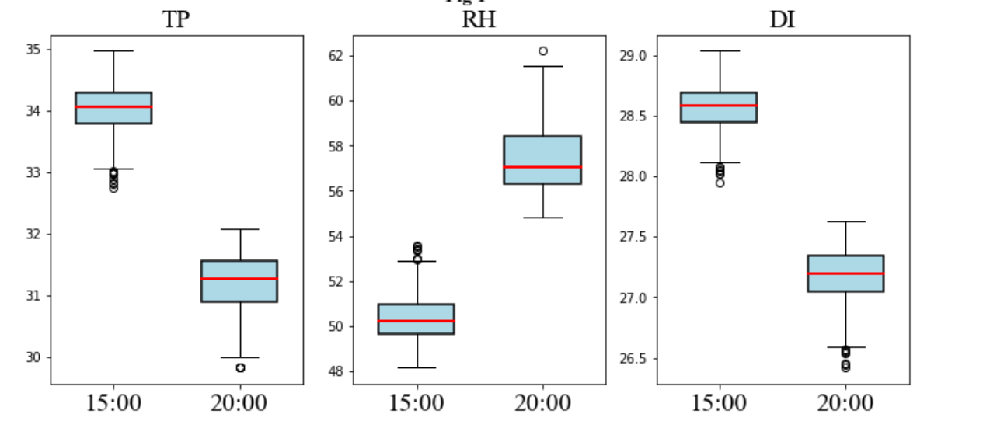

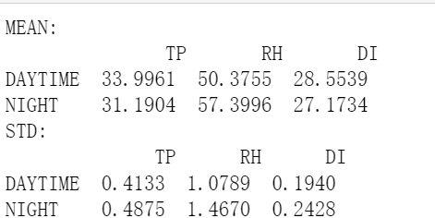

图1展示了所有测量点白天和夜间的日均温度、相对湿度和不适指数的分布箱线图。可以清楚地看出，相较于白天，夜间气温降低，而相对湿度增加。在气温和相对湿度的共同作用下，不适指数仍然显著下降。根据表1中列出的这三个气象变量的均值，从白天到夜间，气温的平均值从34.0℃降至31.2℃，相对湿度的平均值从50.4%升至57.4%。相应地，不适指数从28.6℃下降至27.2℃。这表明，尽管相对湿度有所上升，绿地的降温作用仍能降低热不适感，使周围环境更为舒适，尽管热不适感的下降幅度低于气温的降低。此外，该图还显示，夜间不同测量点之间的这三个气象指标的标准差比白天更大。根据表1中列出的标准差数据，气温、相对湿度和不适指数的标准差分别从白天的0.41℃、1.1%和0.19℃增加到夜间的0.49℃、1.5%和0.24℃。

The boxplots in Figure 1 illustrate the distribution of daily average temperature, relative humidity, and discomfort index for all measurement points during the day and at night. It is clearly observed that, compared to daytime, nighttime temperatures decrease while relative humidity increases. Due to the combined effects of temperature and relative humidity, the discomfort index still significantly decreases. According to the averages of these three meteorological variables in Table 1, from day to night, the average temperature drops from 34.0°C to 31.2°C, and the average relative humidity rises from 50.4% to 57.4%. Consequently, the discomfort index decreases from 28.6°C to 27.2°C. This indicates that despite the increase in relative humidity, the cooling effect of green spaces can still reduce thermal discomfort, making the surrounding environment more comfortable, although the decrease in thermal discomfort is less pronounced than the reduction in temperature. Additionally, the figure shows that at night, the standard deviations of these three meteorological indicators are larger across different measurement points compared to daytime. According to the standard deviations of the three variables listed in Table 1, the temperature, relative humidity, and discomfort index increase from 0.41°C, 1.1%, and 0.19°C during the day to 0.49°C, 1.5%, and 0.24°C at night, respectively.

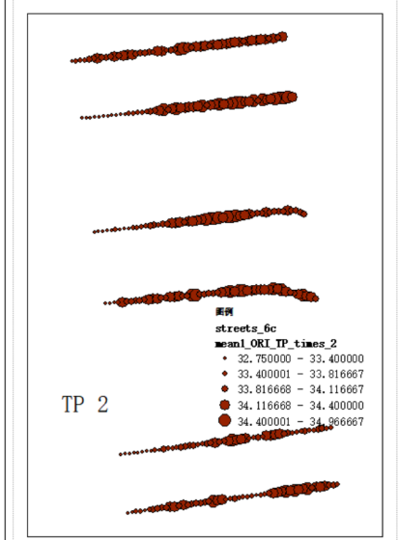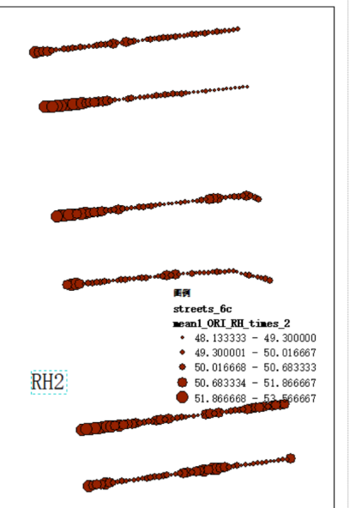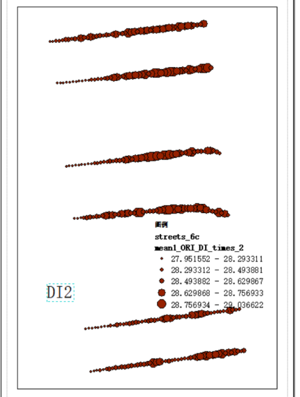

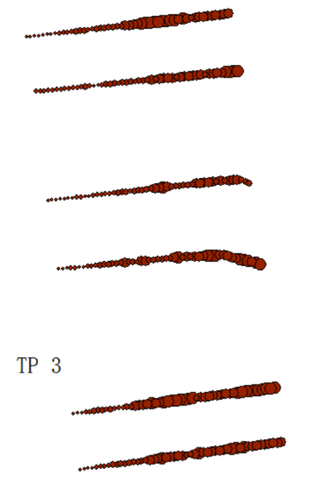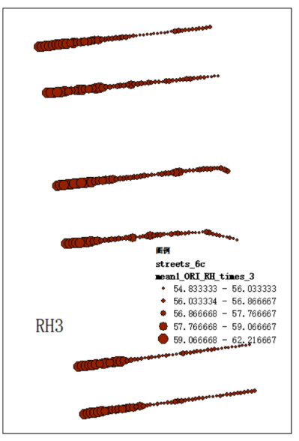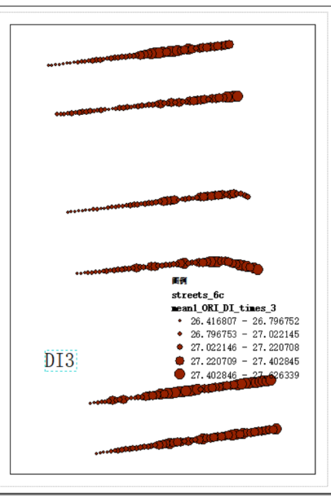

图2展示了三个气象变量日均值的空间分布格局。可以清晰地看出，在距绿地不同距离的位置，这些气象变量存在显著差异。具体而言，距离绿地较近的区域气温较低，相对湿度较高，这表明绿地具有降温和增湿的作用。在气温和相对湿度的共同影响下，不适指数（DI）也有所降低，夜间的效果尤为显著。

夜间，日均气温低于33℃的区域主要集中在距绿地约200米以内，而这些区域的相对湿度均值大多高于54%，不适指数低于27%。此外，我们还发现，与夜间相比，白天绿地对周围区域的降温、增湿和降低不适指数的效果较为有限。同时，在某些街道上，绿地的影响范围也相对较小，仅延伸至绿地以外的数十米。因此，白天三个变量从绿地边缘向外的变化趋势较弱。

具体来说，气温的降幅从夜间的约2℃减少至白天的约1℃，相对湿度的升幅从夜间的约4%下降至2%，不适指数的降幅也从2℃降低为1℃。这可以解释为什么夜间的日均温度分布范围显著大于白天。

Figure 2 illustrates the spatial distribution patterns of the daily averages of three meteorological variables. It is evident that there are significant differences in these variables at varying distances from the green space. Specifically, areas closer to the green space tend to have lower temperatures and higher relative humidity, demonstrating the cooling and humidifying effects of green spaces. As a result of the combined impact of temperature and relative humidity, the discomfort index (DI) also decreases, especially during the night.

At night, regions with daily average temperatures below 33°C are primarily located within approximately 200 meters of the green space, and these areas generally show relative humidity averages above 54% and DI values below 27%. Additionally, it is observed that, compared to nighttime, the cooling, humidifying, and DI-reducing effects of green spaces near the surrounding areas are more limited during the daytime. In some streets, the influence of green spaces is also relatively confined, extending only a few dozen meters beyond the green space. Consequently, the trends in the three variables from the edge of the green space outward are less pronounced during the day.

Specifically, the temperature reduction due to green spaces decreases from around 2°C at night to about 1°C during the day. Similarly, the increase in relative humidity drops from around 4% at night to 2% during the day, while the effect on DI is reduced from 2°C to 1°C. This also explains why the range of daily average temperatures is significantly larger at night compared to the daytime.

### 3.2 气象变量的影响因素

随着距绿地距离的增加，绿地的影响逐渐减弱，其他环境因素的影响则相应变化。因此，本研究将研究区域按距绿地的距离分为5个区段，分别为0-100米、100-200米、200-300米、300-400米和400-500米。针对每个区段，量化分析环境因素与气象变量之间的关系。

图3展示了不同距绿地区段下白天和夜间气温与距离的散点图。

【昼夜比较】可以看出，在夜间，气温与距离之间的关系在距绿地300米以内较为显著。具体而言，在0-100米范围内，二者的相关系数为0.71；在100-200米和200-300米范围内，相关系数分别下降至0.57和0.41。在300-500米的两个区段内，气温与距离的相关性均小于0.3。白天时，气温与距离的相关性明显减弱。在0-100米范围内，相关系数为0.44，而在100-500米的四个区段中，相关性均显著低于0.2。这表明白天绿地对100米以外区域的影响较弱。类似的情况也出现在相对湿度（RH）与距离的相关性分析中。夜间，在0-100米和100-200米范围内，相关系数分别为0.76和0.66，而白天仅在0-100米区间内相关系数为0.42，其余区段均小于0.3。对于不适指数（DI）与距离的相关性，夜间在五个区段内的相关系数依次从0-100米的0.67降低至400-500米的0.17，而白天仅在0-100米区间的相关系数大于0.3。

总体来看，随着距绿地距离的增加，影响程度显著减弱，直到特定距离后几乎消失。影响的范围在一天的不同时间段内也存在显著差异。夜间，绿地对周围气象变量的影响可达200-300米，而白天的影响范围则一般在100米左右。

As the distance from the green space increases, the influence of the green space gradually weakens, while other environmental factors change accordingly. Therefore, this study divided the study area into five segments based on the distance from the green space: 0-100 meters, 100-200 meters, 200-300 meters, 300-400 meters, and 400-500 meters. A quantitative analysis was conducted to examine the relationship between environmental factors and meteorological variables for each segment.

Figure 3 shows scatter plots of temperature versus distance from the green space for different segments during the day and night. It can be seen that at night, the relationship between temperature and distance is more pronounced within 300 meters of the green space. Specifically, the correlation coefficient is 0.71 within 0-100 meters, but it decreases to 0.57 and 0.41 in the 100-200 meter and 200-300 meter ranges, respectively. In the 300-500 meter segments, the correlation between temperature and distance is less than 0.3. During the day, the correlation between temperature and distance weakens significantly. In the 0-100 meter range, the correlation coefficient is 0.44, while in the 100-500 meter segments, it is significantly below 0.2. This indicates that during the day, the influence of the green space is weaker beyond 100 meters. A similar pattern can be observed in the correlation analysis of relative humidity (RH) with distance. At night, the correlation coefficients for the 0-100 meter and 100-200 meter ranges are 0.76 and 0.66, respectively. However, during the day, only the 0-100 meter range shows a correlation coefficient of 0.42, with all other segments below 0.3. For the discomfort index (DI), the correlation coefficients at night decrease across the five segments, from 0.67 in the 0-100 meter range to 0.17 in the 400-500 meter range, while during the day, only the 0-100 meter segment has a correlation coefficient greater than 0.3.

Overall, as the distance from the green space increases, the degree of influence significantly weakens and almost disappears beyond a certain distance. The range of influence also varies considerably between different times of the day. At night, the green space's impact on surrounding meteorological variables extends up to 200-300 meters, while during the day, the influence is generally limited to around 100 meters.

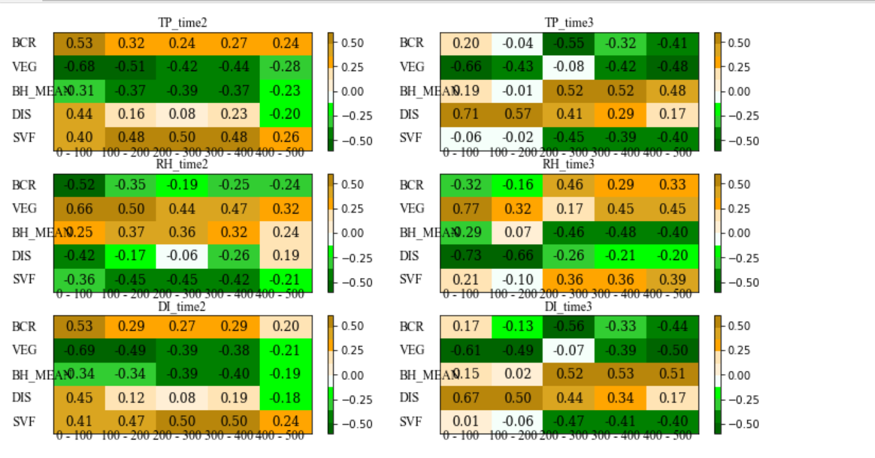

图XX显示了对于不同的与绿地距离区间，环境因素对气象变量的影响。上图已经表明，随着与绿地距离的增加，距离的影响程度显著削弱直到特定距离后几乎消失。然而对于其它变量，影响的程度也显著变化。

在夜间，可以看到0-200米和200-500米区间段内的气温与环境因素的相关性格局呈现显著的差异性。在200-500米的区间内，SVF/BH/VEG和BCR对气温的影响显著。其中，平均建筑高度对气温呈正相关，而建筑面积与植被面积与气温负相关。植被面积与气温的负相关较易理解，这是因为随着周围植被面积的增加，植被的蒸散作用增强，对气温的下降起到促进作用。而至于建筑高度与气温的正相关可以被解释为增加的周围建筑高度可以增加研究区域的储热。周边面积与气温的负相关可能是由于其与建筑高度的负相关性所导致的。

由上图可以看到，在200-500米的范围内，建筑高度的相关性整体上最强，在3个区间分别为0.52、0.52和0.48.，植被面积、建筑面积、SVF的相对作用相对较弱。这表明建筑高度带来的储热效应对夜间绿地影响较弱区域起最为显著的作用。需要注意的是，在200-300米的区间内，植被对气温的影响较弱，这可能是由于绿地降温对该区域的渗透作用使得该区域不仅受建筑和周边植被影响，还受来自中央公园的降温作用的影响。这使得气温格局更为复杂。

与200米以外的区间不同，在距中央公园200米以内的区域，距绿地的距离的影响显著增加。同时，植被面积的影响同样增加。这可以由以下事实解释：距公园距离越近，植被比例越高。由于公园降温的作用，其它与建筑形态相关的指标对气温的影响可以忽略不计。因此，可以得到以下事实，即对于夜间气温来说，在公园降温效应没起作用的区域，建筑形态起重要作用。而在公园降温效应起作用的区域，公园的降温可以覆盖掉其它因素的影响。

环境因素对相对湿度的影响与对气温的影响正好相反。在200-500米的区间，建筑高度对相对湿度起显著的负效应。而植被比例、建筑比例和SVF对其起显著的正效应，且影响的强度相对较弱。而在0-200米的区间内，与公园的距离和植被覆盖比例的影响较强。其中，与公园的距离的相关系数为0.77、0.6，与植被覆盖的相关系数分别为0.77、0.32.

此外，在气温与相对湿度的综合作用下，环境因素对DI的影响与对气温的影响呈现相似的格局和强度。其中，建筑高度的影响最强，在300-500米的三个区间段的相关系数分别为0.52、0.53和0.51，SVF、BCR和VEG的相关系数相对较弱。因此，相比于相对湿度，气温对DI时空格局及其与环境因素关系影响更为显著。

==

在白天，环境因素对气象变量的影响与夜间有显著差异，这很大程度上是由白天和夜间之间气象指标的驱动机制以及来自中央公园的降温效应的差异所导致的。在100-500米的区间范围内，SVF和植被覆盖比例对气温的影响最强，尤其是SVF。这很容易解释，因为SVF越大，太阳直射的面积越大，因此气温就越高。而白天由于日照强烈，因此相对于其它建筑形态变量，SVF对气温的影响起主导作用。此外，受植被蒸散作用等效应的影响，植被对周边环境的降温仍起显著作用。需要注意的是，在白天，建筑形态指标对气温的影响与夜间正好相反。这可能是由于不同时间建筑形态影响气温的机制不同。在夜间，影响气温的主要因素是储热释放，因此过高的建筑会增加储热释放，而在研究区中，建筑高度与SVF和建筑面积呈显著负相关，因此建筑高度与气温呈正相关，而SVF和建筑面积呈负相关。相反在白天，建筑储热的释放起的作用有限，太阳辐射差异是导致气温空间格局的主要影响因素。还需要注意的是，相对于夜间，建筑高度和建筑覆盖比例的影响在白天相对较弱。

在白天，环境因素对相对湿度的影响与对气温的影响趋势相反。需要注意的是，在对相对湿度的影响分析中我们发现，植被覆盖比例的影响程度略微上升，而SVF影响的程度相对下降。这表明日照差异主要影响气温，而植被对相对湿度的影响更为显著。

与夜间相同，相对于相对湿度，DI也更受到气温的影响，与环境因素的相关系数更接近于气温与环境因素的相关分析结果。

==

### 3.3 降温指标及其影响因素

图XX显示降温指标的箱线图。可以看到，整体而言，夜间的降温强度和降温距离显著大于白天。对于气温，夜间的降温幅度在XX-XX之间，平均值为XX，而在白天，降温幅度仅为XX-XX，平均值为XX。至于降温距离，夜间（XX-XX）同样大于白天（XX-XX）。

就相对湿度而言，DRH影响距离的范围从白天的XX-XX增加至夜间的XX-XX，平均值则从XX增加至XX。影响强度的平均值则从XX下降至XX。DI的影响强度和渗透距离与TP和RH相似，在夜间均值为XX，而在白天均值则为XX。

对于降温指标，我们选择了街道宽度和建筑高度作为影响因素。结果表明，街道宽度和建筑高度对于降温距离影响显著，然而对降温强度的影响不明显。对于气温的降温距离，SW和BH的影响率为0.18和0.13。而对于RH，两者的影响程度相对下降，为xx和xx。对于DI，这两个指标则分别为xx和xx。

在白天，上述两个因素的影响强度显著低于夜间。对于气温、相对湿度和DI，两者的影响指标分别为XX,XX XX, XX, XX, XX.

总体而言，建筑高度和街道宽度均与降温距离呈负相关。相对于建筑高度、街道宽度对降温效应的影响显著更强。这表明相对较窄的道路更有利于公园降温效应的向内陆渗透。

## 参考文献

* Huang, K., Li, X., Liu, X., Seto, K.C., 2019. Projecting global urban land expansion and heat island intensification through 2050. Environ. Res. Lett. 14 (11), 114037.
* Oke, T. R. (1995). The heat island of the urban boundary layer: characteristics, causes and effects. Wind climate in cities, 81-107.
* X. Li, W. Zhou, Optimizing urban greenspace spatial pattern to mitigate urban heat island effects: extending understanding from local to the city scale, Urban For. Urban Green. 41 (2019) 255–263.
* Hong, T., & Heo, Y. (2023). Exploring the impact of urban factors on land surface temperature and outdoor air temperature: A case study in Seoul, Korea. Building and Environment, 243, 110645.
* Cao, J., Zhou, W., Zheng, Z., Ren, T., & Wang, W. (2021). Within-city spatial and temporal heterogeneity of air temperature and its relationship with land surface temperature. Landscape and Urban Planning, 206, 103979.
* Ganeshan, M., Murtugudde, R., & Imhoff, M. L. (2013). A multi-city analysis of the uhiinfluence on warm season rainfall. Urban Climate, 6(6), 1–23.
* Santamouris, M. (2020). Recent progress on urban overheating and heat island research. Integrated assessment of the energy, environmental, vulnerability and health impact. Synergies with the global climate change. Energy and Buildings, 207, 109482.
* Huang, H., Lu, Z., Fan, X., Zhai, W., Zhang, L., Xu, D., ... & Hang, Y. (2024). Urban heatwave, green spaces, and mental health: A review based on environmental health risk assessment framework. Science of The Total Environment, 174816.
* Gao, S., Chen, Y., Li, K., He, B., Hou, P., & Guo, Z. (2023). Frequent heatwaves limit the indirect growth effect of urban vegetation in China. Sustainable Cities and Society, 96, 104662.
* Khare, V. R., Vajpai, A., & Gupta, D. (2021). A big picture of urban heat island mitigation strategies and recommendation for India. Urban Climate, 37, 100845.
* Wang, C., Wang, Z. H., Kaloush, K. E., & Shacat, J. (2021). Cool pavements for urban heat island mitigation: A synthetic review. Renewable and Sustainable Energy Reviews, 146, 111171.
* Yu, Z., Yang, G., Zuo, S., Jørgensen, G., Koga, M., & Vejre, H. (2020). Critical review on the cooling effect of urban blue-green space: A threshold-size perspective. Urban forestry & urban greening, 49, 126630.
* Li, X., & Zhou, W. (2019). Optimizing urban greenspace spatial pattern to mitigate urban heat island effects: Extending understanding from local to the city scale. Urban Forestry & Urban Greening, 41, 255-263.
* Qiu, K., & Jia, B. (2020). The roles of landscape both inside the park and the surroundings in park cooling effect. Sustainable Cities and Society, 52, 101864.
* Liao, W., Guldmann, J. M., Hu, L., Cao, Q., Gan, D., & Li, X. (2023). Linking urban park cool island effects to the landscape patterns inside and outside the park: A simultaneous equation modeling approach. Landscape and Urban Planning, 232, 104681.
* Gomez-Martinez, F., De Beurs, K. M., Koch, J., & Widener, J. (2021). Multi-temporal land surface temperature and vegetation greenness in urban green spaces of Puebla, Mexico. Land, 10(2), 155.
* Han, D., Xu, X., Qiao, Z., Wang, F., Cai, H., An, H., ... & Han, W. (2023). The roles of surrounding 2D/3D landscapes in park cooling effect: Analysis from extreme hot and normal weather perspectives. Building and Environment, 231, 110053.
* Sheng, L., Tang, X., You, H., Gu, Q., & Hu, H. (2017). Comparison of the urban heat island intensity quantified by using air temperature and Landsat land surface temperature in Hangzhou, China. Ecological Indicators, 72, 738-746.
* Yan, H., Wu, F., & Dong, L. (2018). Influence of a large urban park on the local urban thermal environment. Science of the Total Environment, 622, 882-891.
* Lin, P., Lau, S. S. Y., Qin, H., & Gou, Z. (2017). Effects of urban planning indicators on urban heat island: a case study of pocket parks in high-rise high-density environment. Landscape and urban planning, 168, 48-60.
* Zhang, Z., Lv, Y., & Pan, H. (2013). Cooling and humidifying effect of plant communities in subtropical urban parks. Urban forestry & urban greening, 12(3), 323-329.
* Cheung, P. K., Jim, C. Y., & Siu, C. T. (2021). Effects of urban park design features on summer air temperature and humidity in compact-city milieu. Applied Geography, 129, 102439.