# 相关分析总结

## Influence of urban form on the cooling effect of a small urban river

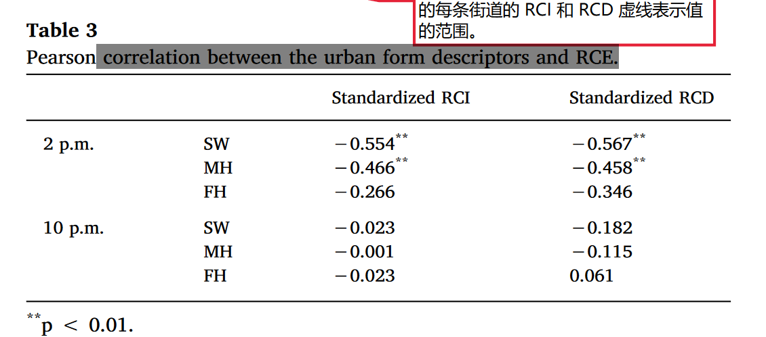

* 结论
  + 下午的降温与环境因素的相关性显著强于晚上
  + 相关系数范围在白天：街道宽度（0.5-0.6）,平均高度（0.4-0.5），FH（0.2-0.4）

## Large urban parks summertime cool and wet island intensity and its influencing factors in Beijing, China

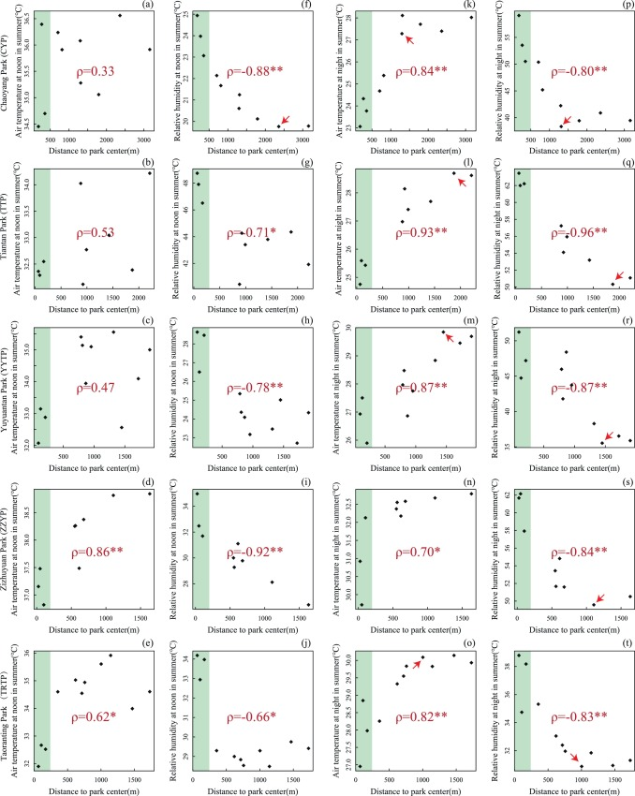

* 距离相关性
  + 夏季白天TP：0.33-0.86
  + 夏季白天RH:0.66-0.92
  + 夏季夜间TP:0.7-0.93
  + 夏季夜间RH:0.8-0.96

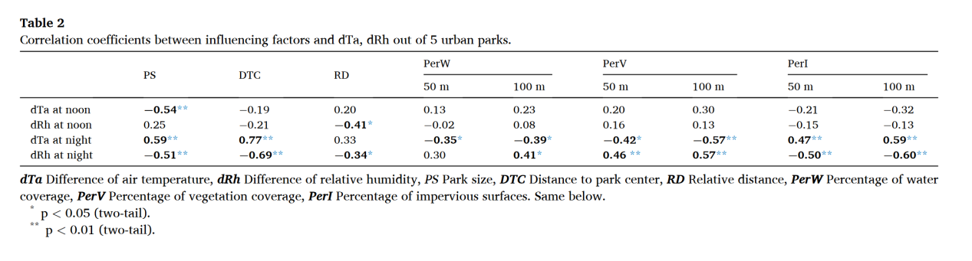

* 距离：夜间（约0.7）强于白天
* 土地覆盖：夜间（约0.4-0.6）强于白天

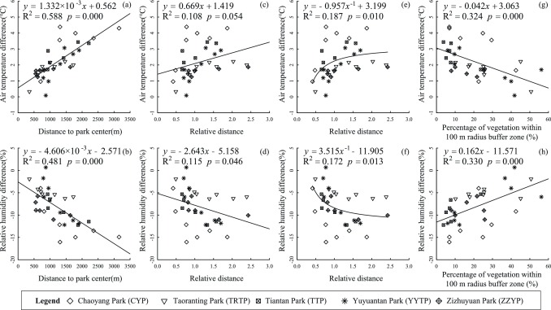

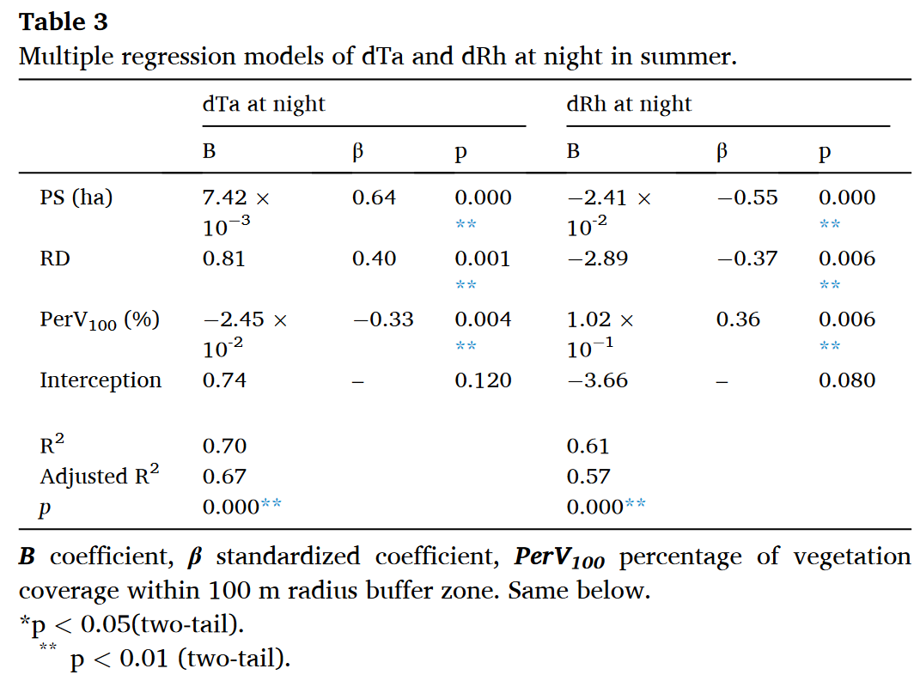

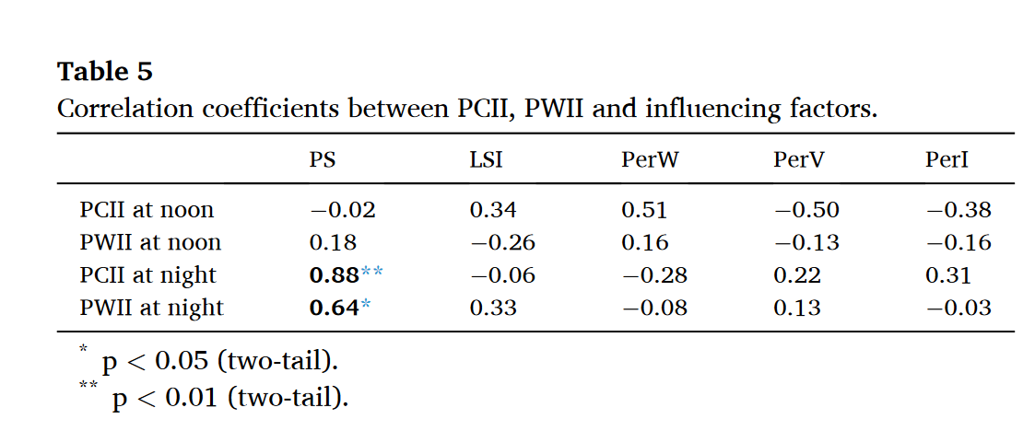

* 夜间强

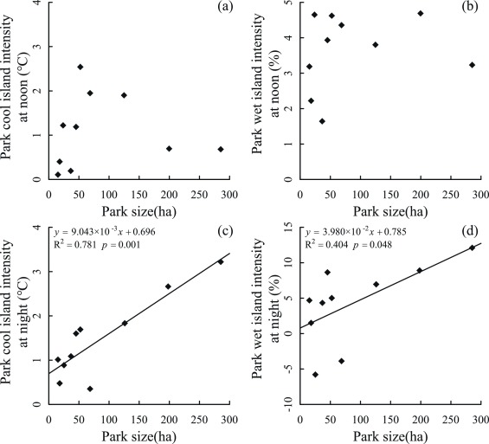

## Influence of a large urban park on the local urban thermal environment

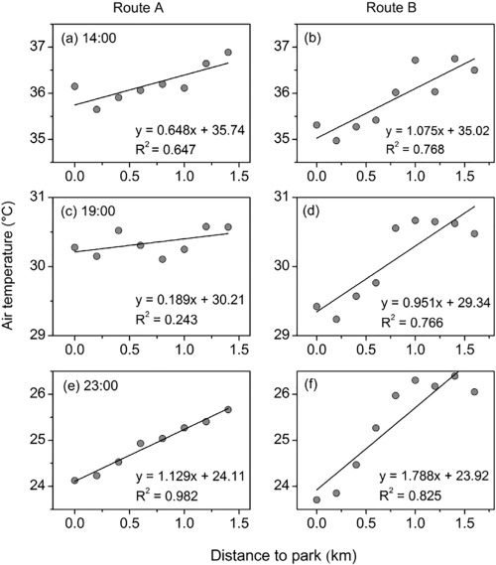

* 距离对气温影响：夜间大于白天

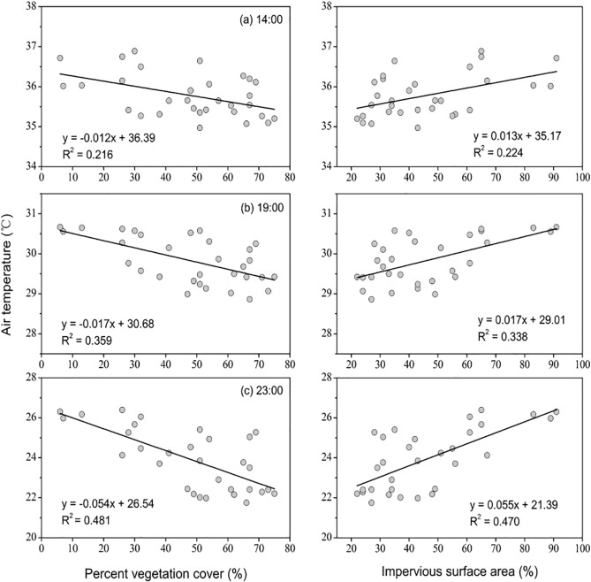

* 土地覆盖影响（弱于距离）：夜间大于白天

## Assessing the effects of landscape design parameters on intra-urban air temperature variability: The case of Beijing, China

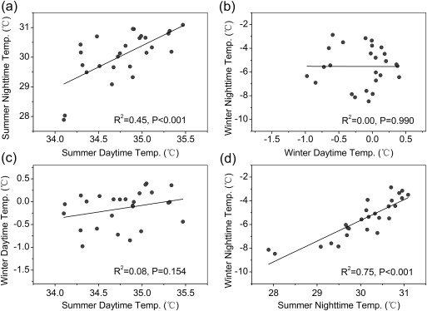

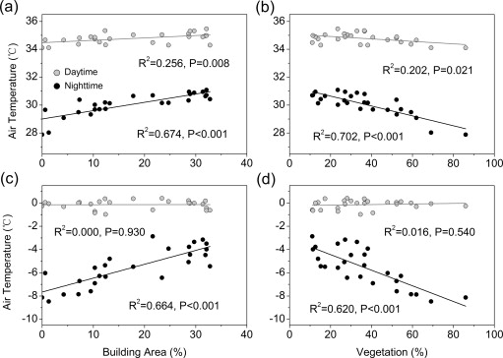

* 土地覆盖影响：夜间大于白天

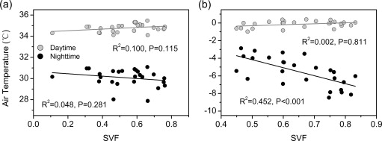

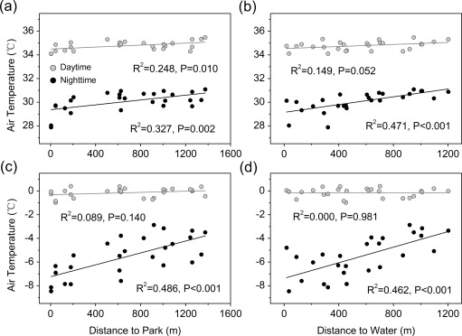

* 距离影响：夜间大于白天

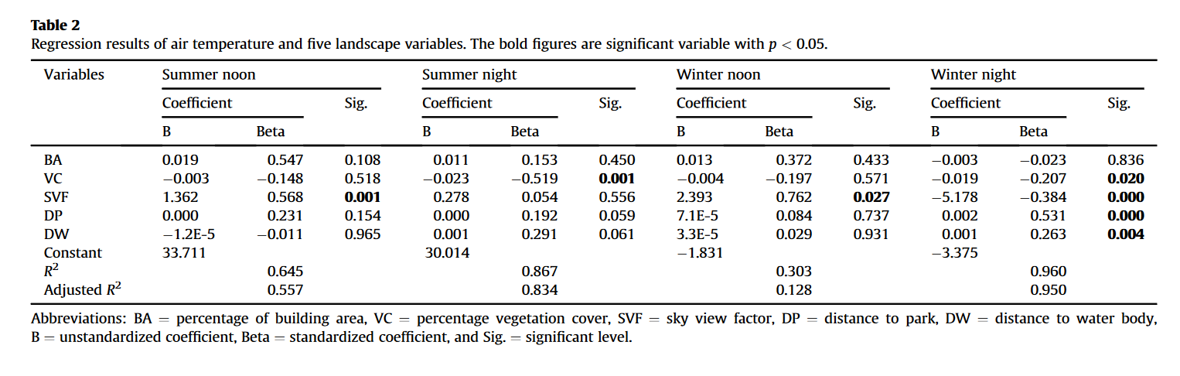

* SVF在白天有用
* 植被覆盖在夜间有用

## Impacts of land use/ land cover types on interactions between urban heat island effects and heat waves

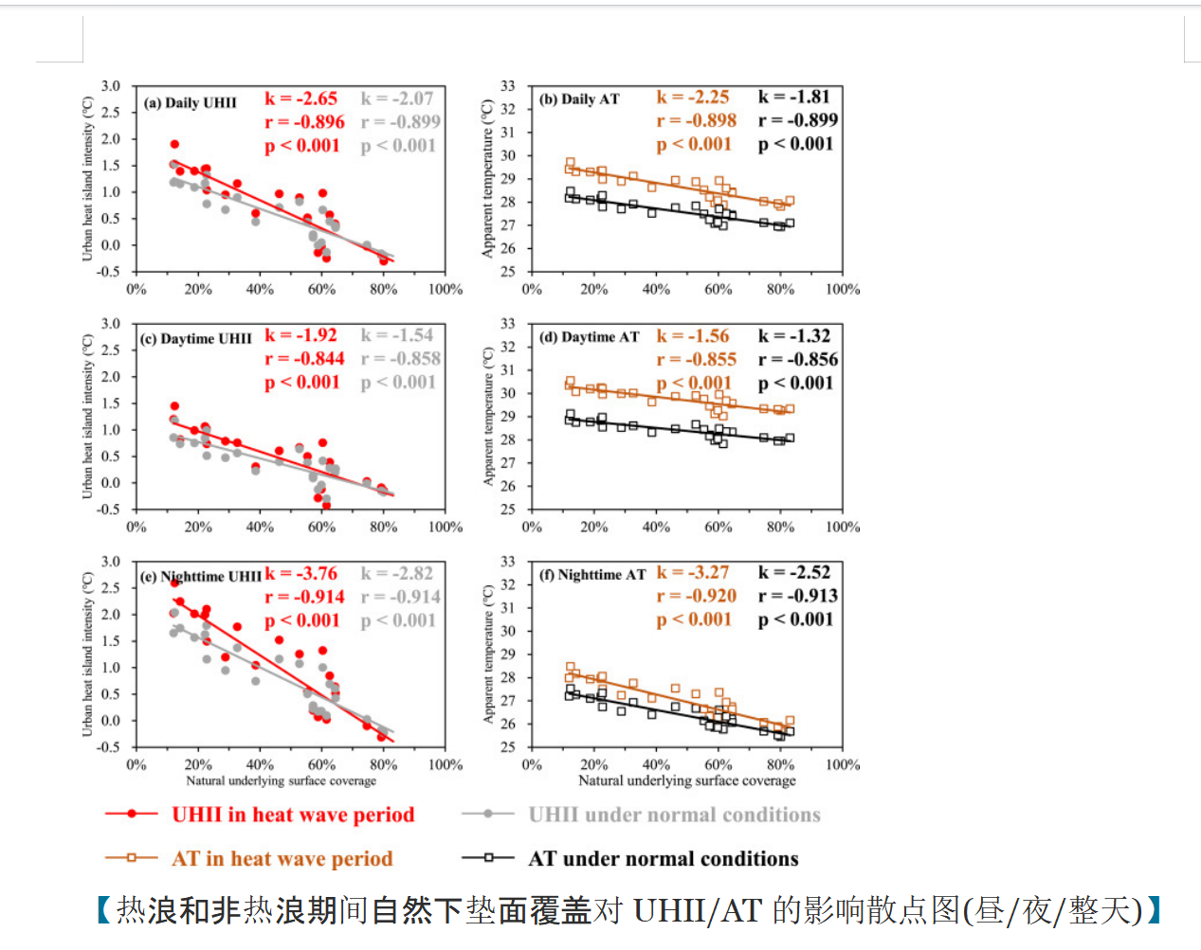

* 夜间影响程度略高于白天

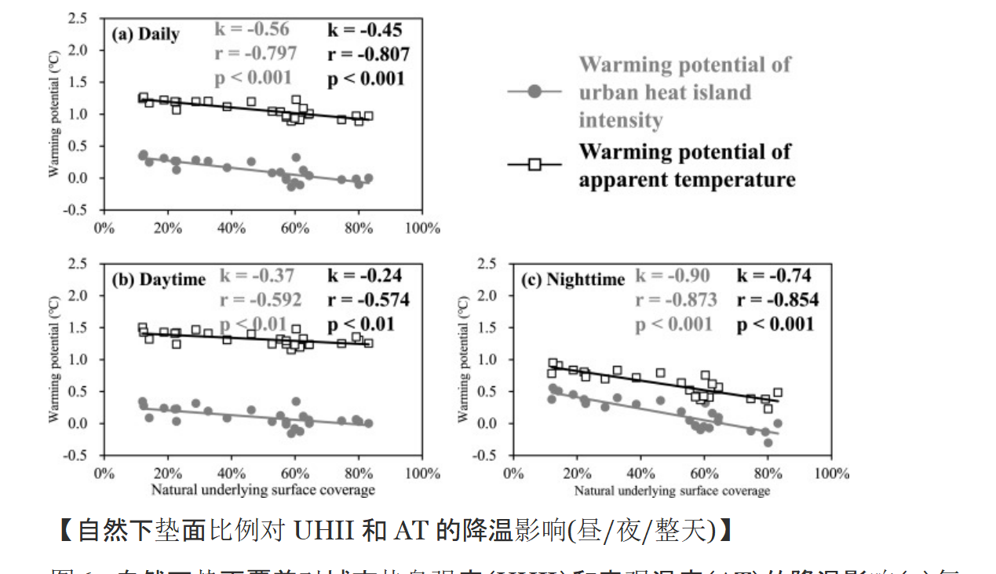

* 夜间显著高于白天

## Effects of urban planning indicators on urban heat island: a case study of pocket parks in high-rise high-density environment

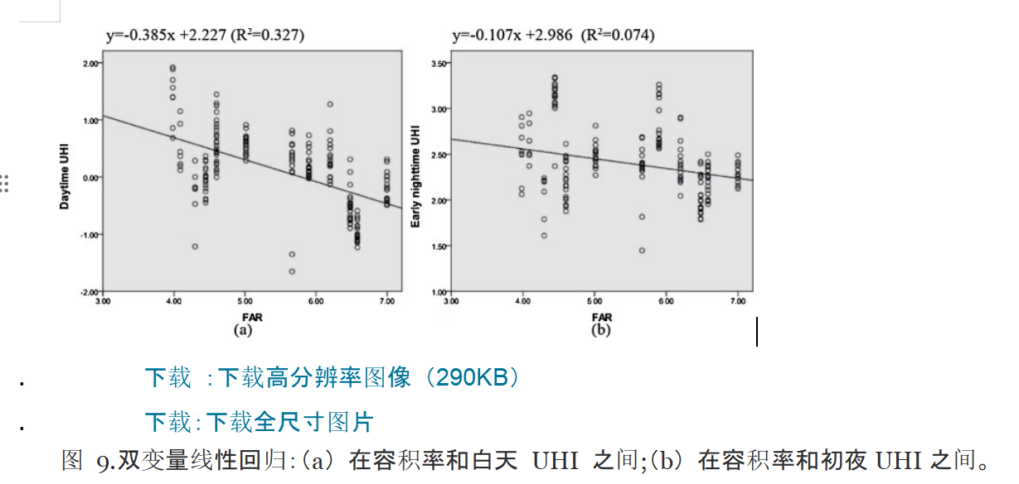

* 容积率对UHI的影响在白天大于夜间

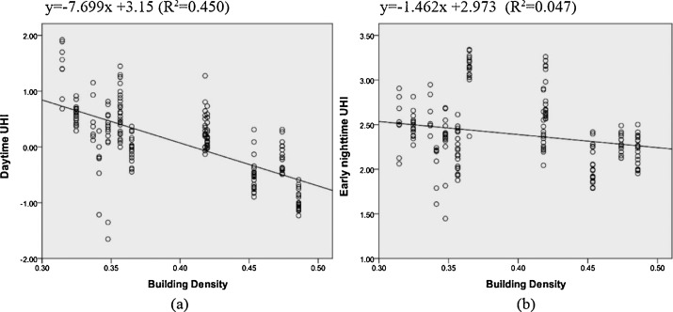

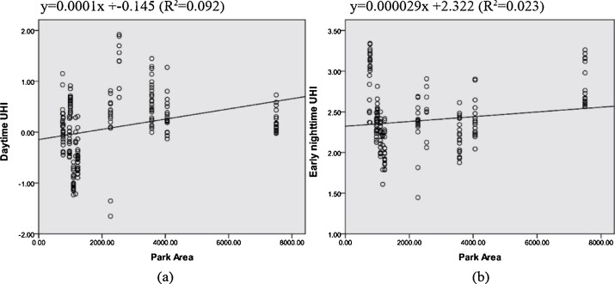

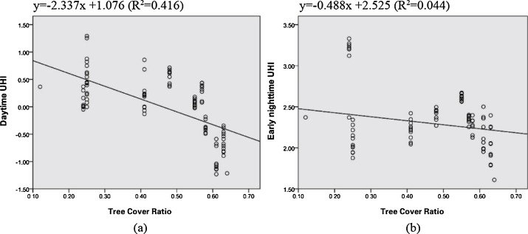

## Do water bodies play an important role in the relationship between urban form and land surface temperature?

# 本研究估计

## TIME3 TP

|  |  |  |  |  |  |
| --- | --- | --- | --- | --- | --- |
|  | 1 | 2 | 3 | 4 | 5 |
| DIS |  |  |  |  |  |
| BH_MEAN |  |  |  |  |  |
| BLD |  |  |  |  |  |
| VEG |  |  |  |  |  |

## TIME3 TP-RCE

|  |  |
| --- | --- |
| SW |  |
| BH_MEAN |  |

## TIME3 RH

|  |  |  |  |  |  |
| --- | --- | --- | --- | --- | --- |
|  | 1 | 2 | 3 | 4 | 5 |
| DIS |  |  |  |  |  |
| BH_MEAN |  |  |  |  |  |
| BLD |  |  |  |  |  |
| VEG |  |  |  |  |  |

## TIME3 RH-RCE

|  |  |
| --- | --- |
| SW |  |
| BH_MEAN |  |