## 基于Landsat 8数据的LST计算

* 参考(Jiang et al., 2021)

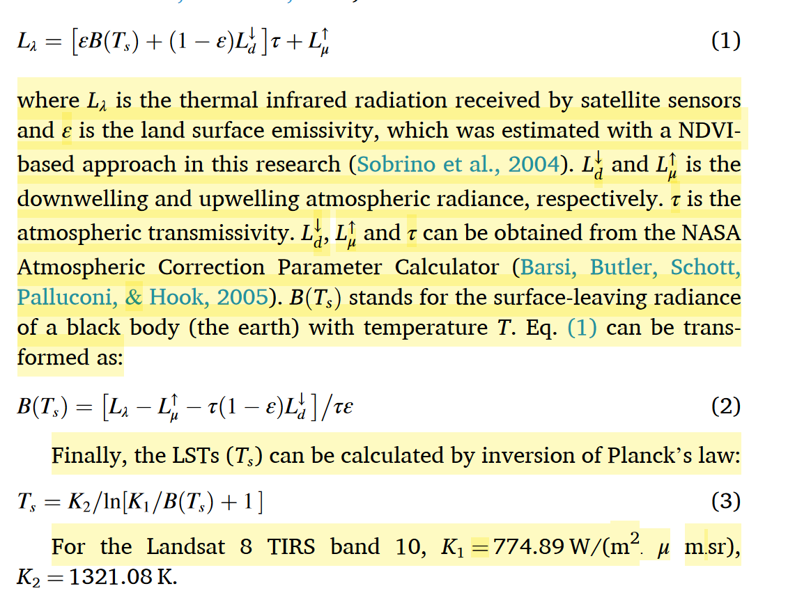

* NASA Atmospheric Correction Parameter Calculator的使用基于链接：
  + <https://atmcorr.gsfc.nasa.gov/>
* 地表发射率的计算方法1详见(Sobrino et al., 2004)

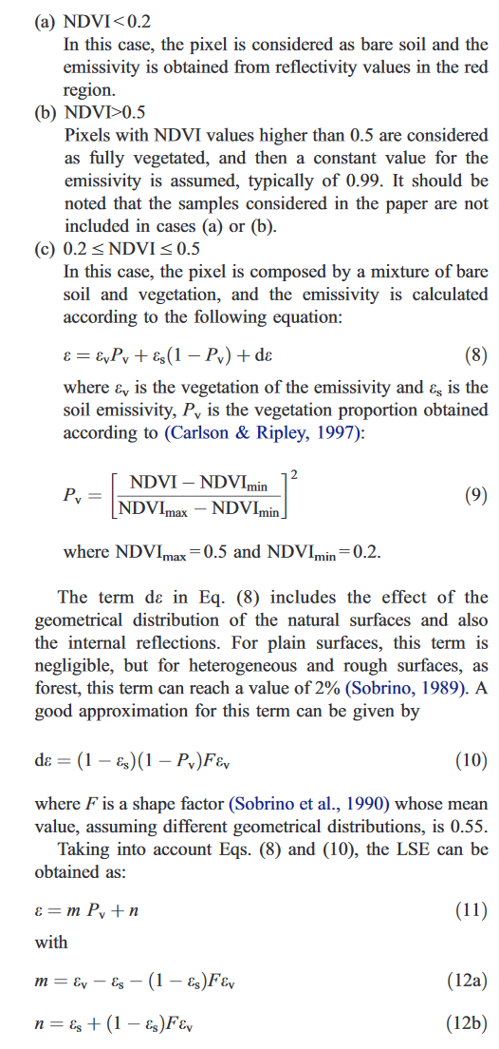

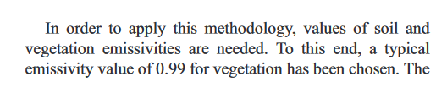

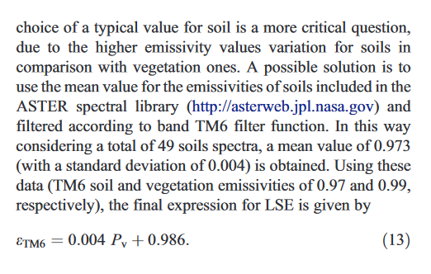

# 地表发射率的计算方法2

* + 参考 (Yu et al., 2020)
  + 详见 (Yu et al., 2014)

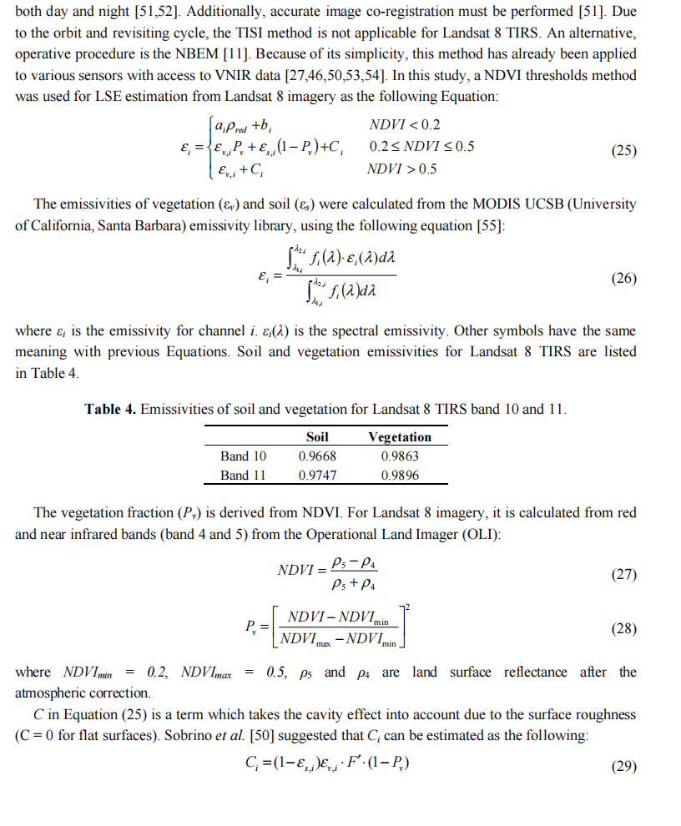

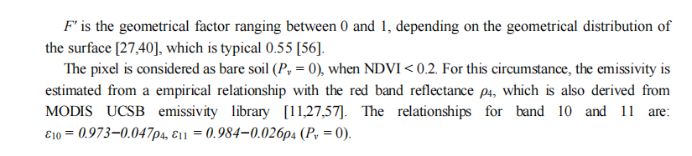

### 参考文献：

* Jiang, L., Liu, S., Liu, C., & Feng, Y. (2021). How do urban spatial patterns influence the river cooling effect? A case study of the Huangpu Riverfront in Shanghai, China. *Sustainable Cities and Society*, *69*, 102835.
* Sobrino, J. A., Jiménez-Muñoz, J. C., & Paolini, L. (2004). Land surface temperature retrieval from LANDSAT TM 5. *Remote Sensing of environment*, *90*(4), 434-440.
* Yu, X., Guo, X., & Wu, Z. (2014). Land surface temperature retrieval from Landsat 8 TIRS—Comparison between radiative transfer equation-based method, split window algorithm and single channel method. *Remote sensing*, *6*(10), 9829-9852.
* Yu, K., Chen, Y., Liang, L., Gong, A., & Li, J. (2020). Quantitative analysis of the interannual variation in the seasonal water cooling island (WCI) effect for urban areas. *Science of the Total Environment*, *727*, 138750.