## 遥感指数计算总结

### NDVI

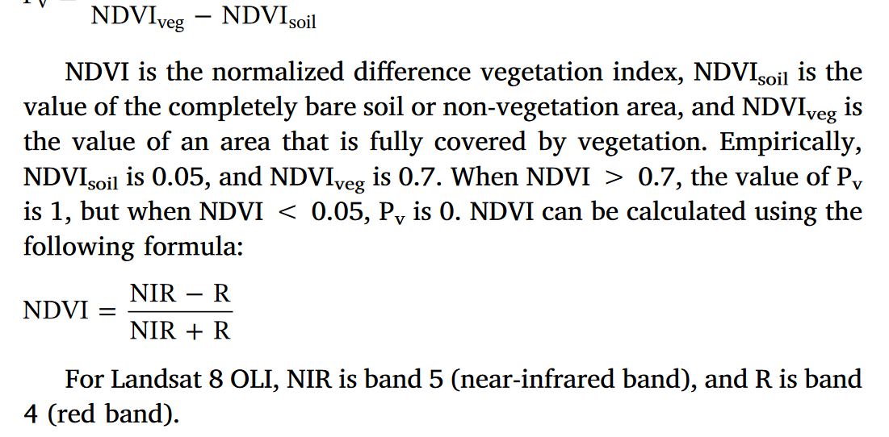

* 参考(Cai et al., 2018)

### MNDWI&NDBI

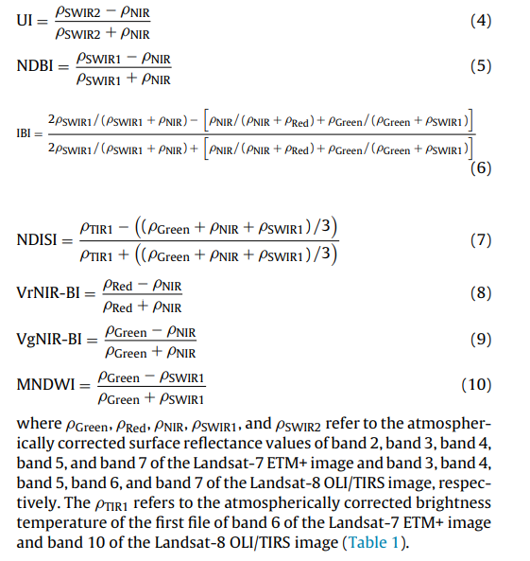

* 参考(Estoque et al., 2015)

### 参考文献：

* Cai, Z., Han, G., & Chen, M. (2018). Do water bodies play an important role in the relationship between urban form and land surface temperature?. *Sustainable cities and society*, *39*, 487-498.
* Estoque, R. C., & Murayama, Y. (2015). Classification and change detection of built-up lands from Landsat-7 ETM+ and Landsat-8 OLI/TIRS imageries: A comparative assessment of various spectral indices. *Ecological indicators*, *56*, 205-217.