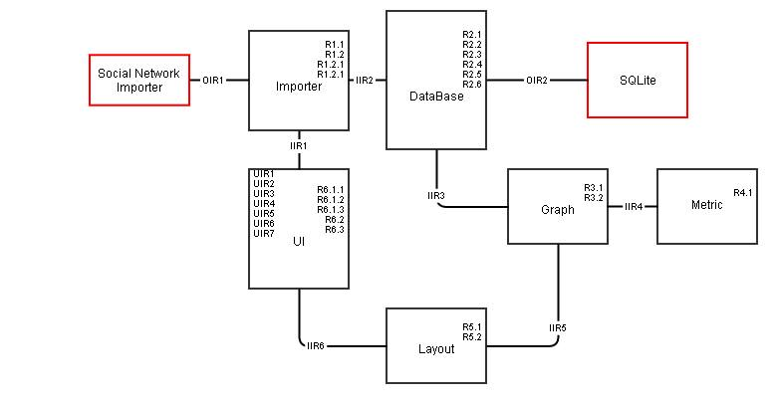

|  |  |
| --- | --- |
| **Data Importer** | |
| Functional Requirement | |
| R1.1 | Load data from file |
| R1.2 | Import data from SNS |
| R1.2.1 | Import data from Facebook |
| R1.2.2 | Import data from Twitter |
|  |  |
| **DataBase** | |
| Non-Functional Requirement | |
| R2.1 | Memory usage should be more efficient than original NodeXL |
| Functional Requirement | |
| R2.2 | Select table |
| R2.3 | Select which column of the data to be used as vertices. |
| R2.4 | Filter rows by derived restriction |
| R2.5 | Match an (weighted) edge according to relationship between vertices (select edge) |
| R2.6 | Export data into other format (graphML) |
|  |  |
| **Graph** | |
| Functional Requirement | |
| R3.1 | Convert selected data to "Graph" structure |
| R3.2 | Compute graph measures & metrics |
| **Metric** | |
| Functional Requirement | |
| R4.1 | Compute selected metrics of the graph (vertex degree, betweenness, closeness, centrality, pagerank, edge reciprocation...) |
|  |  |
| **Layout** | |
| Functional Requirement | |
| R5.1 | Present graph according to the chosen layout |
| R5.2 | Export layout result into image file |
|  |  |
| **UI** | |
| Functional Requirement | |
| R6.1.1 | Show table (menu) |
| R6.1.2 | Show graph (menu) |
| R6.1.3 | Export data to image file or graphML file (menu) |
| R6.2 | Select layout and show on UI (dropdown list) |
| R6.3 | Select what metric to be computed (dropdown list) |
|  |  |