**V. 이벤트 적용**

이제 넥사크로의 [출력]버튼을 더블클릭하여 이벤트를 적용하여 다음과 같이 코드를 정의하자!

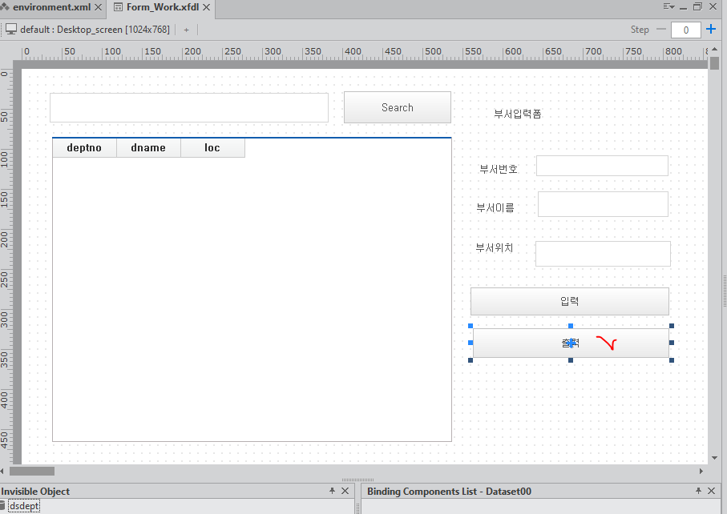

|  |
| --- |
| // 출력버튼  this.Button02_onclick = function(obj:nexacro.Button,e:nexacro.ClickEventInfo)  {  this.transaction(  "urlTest01", //strSvcID,  "strURL::selectDept.do", //strURL("http://localhost:8080/step01/all" 직접 링크는 됨)  "", //strInDatasets,  " dsdept=ar ", //strOutDatasets 데이터셋에 바인딩 될 부분,  "", //"deptno=10dname=총무부", //strArgument 이부분은 파라미터 ,  "fn_callback" //strCallbackFunc[,bAsync[,nDataType[,bCompress]]]  );  this.fn_callback = function(svcID, errCD, errMSG){  let ret = (errMSG=="FAILED" || svcID != "urlTest01") ? "error" : "success";  if(ret=="error")  this.alert("[폼이름_fn_callback] "+ret + " : " + svcID + ", " + errCD + ", " + errMSG);  else  this.alert(ret);  };  }; |

[결과]

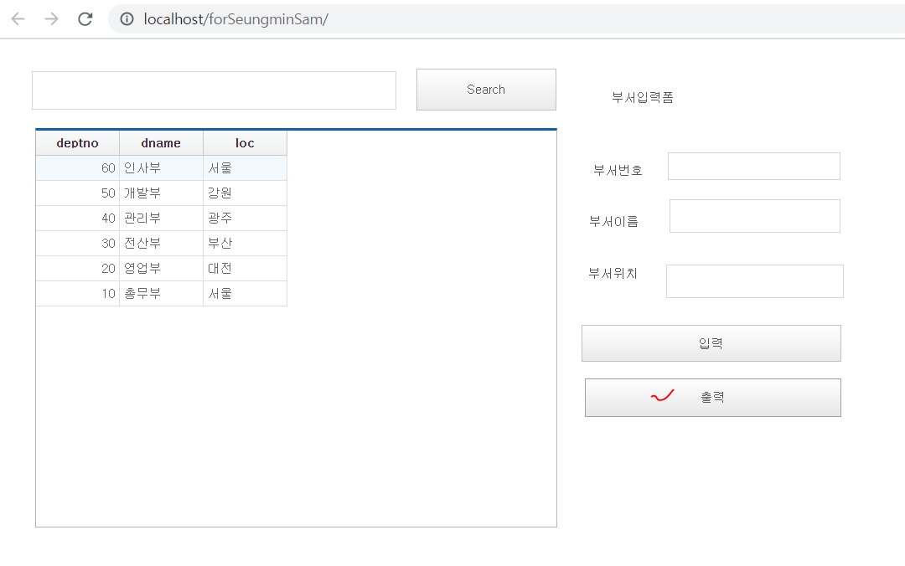  
‘success’ alert 창은 뜨는 DataSet에 안본인다면? 수정된 dsdept를 Grid로 다시 드래그해야한다.

**VI. 입력하기**

입력할 Edit 의 id 값들을 지정해야 한다. deptnov / dnamev / locv

|  |
| --- |
| // 입력버튼  this.Button01_onclick = function(obj:nexacro.Button,e:nexacro.ClickEventInfo)  {  var deptno_val = encodeURI(this.deptnov.value,"UTF-8");  var deptname_val = encodeURI(this.dnamev.value,"UTF-8");  var deptloc_val = encodeURI(this.locv.value,"UTF-8");  this.alert(deptno_val + ":"+ deptname_val)  var id = "urlTest02";  //var url = "strURL::deptAdd;  var url ="http://localhost:8080/step03/addDept.do?deptno="+deptno_val+"&dname="+deptname_val+"&loc="+deptloc_val;  var reqDs = "";  var respDs = "";  var args = "";  var callback = "received";  this.transaction(id, url, reqDs, respDs, args, callback);  this.received = function(id, code, message)  {  alert(code + "/" + message);  } }; |
| 서버측 |
| @RequestMapping(value="/addDept.do")  **public** String addDept(DeptVO vo, HttpServletRequest request) {  **try** {  request.setCharacterEncoding("euc-kr");  String dnamev =URLDecoder.*decode*(vo.getDname(), "UTF-8");  String loc = URLDecoder.*decode*(vo.getLoc(), "UTF-8");  System.***out***.println(dnamev);  System.***out***.println(loc);  vo.setDname(dnamev);  vo.setLoc(loc);  deptDao.addDept(vo);  } **catch** (UnsupportedEncodingException e) {  e.printStackTrace();  }  //return "success"; 입력 성공 확인 후 "redirect:selectDept"  **return** "redirect:selectDept";  } |
|  |

(*) 입력 후 다시 화면 새로고침을 해야 출력이 되는데?

서버측 설정

|  |
| --- |
| <insert id=*"add"* parameterType=*"deptvo"*>  insert into dept values(#{deptno},#{dname},#{loc})  </insert> |
| @Repository  **publicclass** DeptDao {  @Autowired  **private** SqlSessionTemplate ss;  **public int** addDept(DeptVO vo) {  **return** ss.insert("dept.add",vo);  }  } |
| @RequestMapping(value="/deptAdd")  **public** String addDept(DeptVO vo, HttpServletRequest request) {  **try** {  request.setCharacterEncoding("euc-kr");  String dnamev =URLDecoder.*decode*(vo.getDname(), "UTF-8");  String loc = URLDecoder.*decode*(vo.getLoc(), "UTF-8");  System.***out***.println(dnamev);  System.***out***.println(loc);  vo.setDname(dnamev);  vo.setLoc(loc);  deptDao.addDept(vo);  } **catch** (UnsupportedEncodingException e) {  e.printStackTrace();  }  **return** "redirect:all";  } |

[ 추가 ] 입력 후 에디터를 공백으로 지정하려면?

**VII. 입력처리 및 최초 로딩시에 데이터를 로딩??? 이건 안되는뎅**

|  |
| --- |
| this.myload = function(obj:nexacro.Form,e:nexacro.LoadEventInfo)  {  this.transaction(  "urlTest01", //strSvcID,  "strURL::all", //strURL("http://localhost/forSeungminSam/all" 직접 링크는 됨)  "", //strInDatasets,  "dsdept=ar", //strOutDatasets 데이터셋에 바인딩 될 부분,  "", //"employee_id=121 first_name=Michael", //strArgument 이부분은 파라미터 ,  "fn_callback" //strCallbackFunc[,bAsync[,nDataType[,bCompress]]]  );  this.fn_callback = function(svcID, errCD, errMSG){  let ret = (errMSG=="FAILED" || svcID != "urlTest01") ? "error" : "success";  if(ret=="error")  this.alert("[폼이름_fn_callback] "+ret + " : " + svcID + ", " + errCD + ", " + errMSG);  else  this.alert(ret);  };  }; |

**[연습문제] 아래의 그림처럼 UI를 수정한 후 검색이 되도록 구현하시오.**

|  |
| --- |
|  |
| [답안] this.alert(this.searchtype.value+":"+this.searchvalue.value);  var searchtypev =this.searchtype.value;  var searchvaluev = encodeURI(this.searchvalue.value,"UTF-8");  var id = "urlTest03";  //var url = "strURL::deptAdd;  var url ="http://localhost/forSeungminSam/search?searchtype="+searchtypev+"&searchvalue="+searchvaluev;  var reqDs = "";  var respDs = " dsdept=ar ";  var args = "";  var callback = "received";  this.transaction(id, url, reqDs, respDs, args, callback);  (서버코드 mapper)  <selectid=*"search"*parameterType=*"searchvo"*resultType=*"deptvo"*>  select * from dept2  <iftest=*"searchtype != null"*>  <where>  <choose>  <whentest=*"searchtype == 1"*>  deptno = #{searchvalue}  </when>  <whentest=*"searchtype == 2"*>  dname like '%'|| #{searchvalue} ||'%'  </when>  <whentest=*"searchtype == 2"*>  loc like '%'|| #{searchvalue} ||'%'  </when>  </choose>    </where>  </if>  order by 1 desc  </select>  (dao)  **public** List<DeptVO> getsearchDeptList(SearchVO vo){  **return** ss.selectList("dept.search",vo);  }  (controller)  @RequestMapping(value="/search")  **public** String searchDept(SearchVO vo,Model model) {  List<DeptVO>list= **null**;  **try** {  System.***out***.println("searchType :"+vo.getSearchtype());  String searchValue = URLDecoder.*decode*(vo.getSearchvalue(), "UTF-8");  System.***out***.println("searchValue:"+searchValue);  vo.setSearchvalue(searchValue);  list= deptDao.getsearchDeptList(vo);  } **catch** (UnsupportedEncodingException e) {  list= deptDao.getDeptList();  e.printStackTrace();  }    DataSet ds = **new** DataSet("ar");  ds.addColumn("deptno", DataTypes.***INT***,10);  ds.addColumn("dname", DataTypes.***STRING***,20);  ds.addColumn("loc", DataTypes.***STRING***,20);  **for**(DeptVO e : list){  **int**row = ds.newRow();  ds.set(row, "deptno", e.getDeptno());  ds.set(row, "dname", e.getDname());  ds.set(row, "loc", e.getLoc());  }  model.addAttribute("ds", ds);  **return** "all";  } |