**双十二活动任务**

1. **预热（**测试：11.21；提代码：11.27；上线：12.1**）**

1. T1充值返券，充值部分开发成标准可复用挂件（晨曦）

1. T3全月满赠（子文）
2. T2每日任务（晨曦）
3. T0.5标准弹窗挂件（会芹）  
    1）允许页面内配置多个  
    2）增加默认值

**二、正式（**测试：11.29；提代码：12.6；上线：12.8**）**

1. T1修改标准挂件图标相关配置，要求左上角图标图片及大小可配，双图标存在时，第一个图标不存在则第二个图标需前移，新加描述及配置，横排挂件按钮右移，要修改的挂件包括：（媛媛）  
    1）商品挂件112缩小间距版standard_goods_112xs（图标大小可配右移）
2. 商品挂件112_定时standard_goods_112_2（图标大小可配右移）

（图标大小是100*100; 文字现在不确定是一排还是两排; 按钮离距离上面和左边的位置都是24px; 已抢光的位置居中; 还有图片的大小290px; 图片移到最左边;）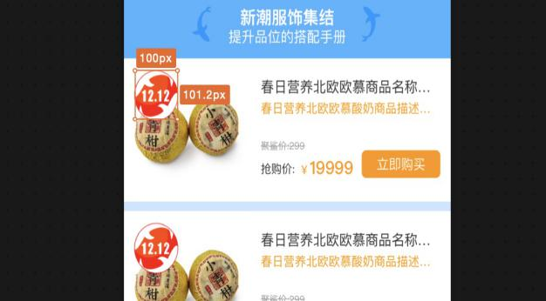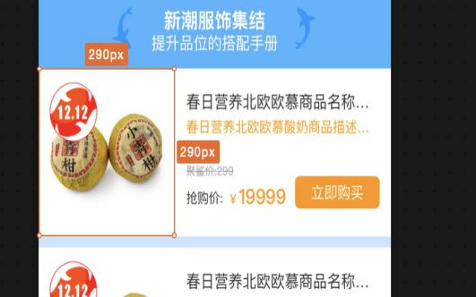

3）bigact_part_present（NO1/2/3图片可配）

4）bigact_part_goods123（双图标大小可配，图标位置，加描述）

参考bigact_venue_TV的接口，可以直接把页面赋值过来，然后修改样式。Config里面也要修改，把活动的名字传过来。  
 5）20180915_venue_part（图标位置）  
2. T0.5修改标准导航挂件高度可配,要修改的挂件包括：（媛媛）

1）标准导航(可滑动)standard_slide_nav

2）标准导航(可滑动)standard_slide_newnav

3）标准导航（不可滑动）active_standard_nav4  
3. T0.5修复图片挂件现有两个bug:（会芹）  
 1）图片挂件400(17212_image)，选择配置竖排时，左右间距的值影响显示问题

2）图片挂件401(stand_image)，不配置链接时，后端link字段返回字符串0，前端代码判断的是int类型的0，导致链接不对  
4. T1大活动主会场上导航，开发成标准挂件，配置项：背景色、图标、选中字色，选中背景色、选中字色、导航分类数（媛媛）  
5. T2大活动底部导航（跳转优化）（会芹）  
6. T2头图帧动画（4）  
7. T0.5头图下方三个入口以及领赠品四个区域入口（媛媛）配成图就行

8. T3秒杀挂件，开发成可配置复用的（会芹）  
9. T2分会场满赠挂件（子文）

1. T0.5修改标准导航挂件高度可配（媛媛）  
    1）商品挂件111 standard_goods_111

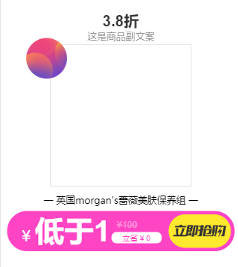 按钮会被挤掉 字的大小  
 2）商品挂件111_定时

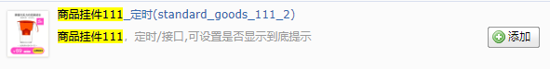这个不会掉下去

1. T3新图片导航挂件（晨曦）
2. T0.5新增商品挂件，仿照TV会场，居中显示加描述，查看更多可显示隐藏，可配置显示时间（媛媛） 在config中修改，添加活动截止时间，在default.html的js中判断一下，和现在的时间比一下，然后看是不是到了，直接利用js让DOM消失

### 20180915_venue_part（图标位置）： 清空默认值

 左一图标 默认值为双十二的链接

1. 没有背景图片隐藏
2. 字体 8.5折 18px 8折24px

### 20181116 :

1. 该显示的缩略图
2. 将分类改到1212

### Bigact_venue_TV2:

1. 确定结束日期的默认值
2. 添加缩略图
3. 描述字体颜色 默认
4. 描述往下移动 有空隙
5. 圆角2px
6. 所有字都是居中显示
7. T0.5新增商品挂件，仿照TV会场，居中显示加描述，查看更多可显示隐藏，可配置显示时间（媛媛） 在config中修改，添加活动截止时间，在default.html的js中判断一下，和现在的时间比一下，然后看是不是到了，直接利用js让DOM消失

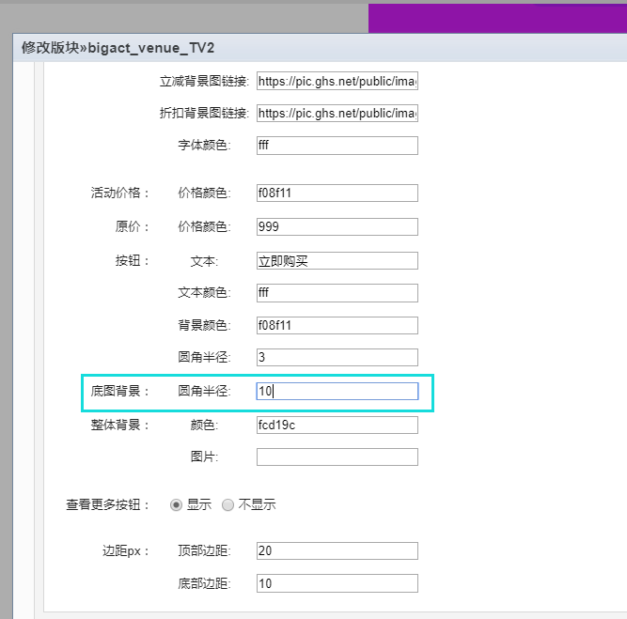

### Bigact_venue_TV：

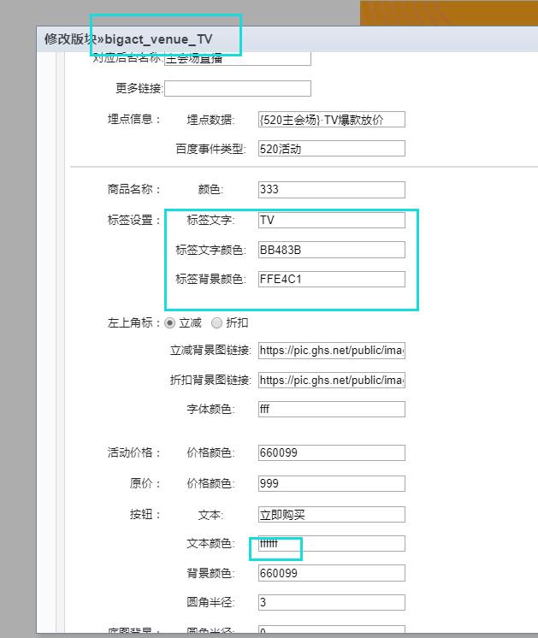

bigact_part_goods124：

1. 已抢光太大了
2. 颜色#999
3. 划线价格20px
4. 左二图片背景图不显示
5. 8.5折 20px 8折 28px
6. 描 述往下移动

<style>

/*单商品*/

.v_g718 .tap_718{color:#<{$setting.tip_textColor}>;background:#<{$setting.tip_bg}>;}

.v_g718 .discount_718{position:absolute;top:.24rem;left:.986rem;color:#fff;text-align:center;

background: url("<{$setting.dis_bg_img}>")no-repeat center center/100% 100%;}

/* 嗨购双十一 */

.v_g718 .discount_1111{position:absolute;top:.24rem;left:.24rem;color:#fff;text-align:center;

background: url("<{$setting.dis_bgimg}>")no-repeat center center/100% 100%;}

.venImg_718{overflow:hidden;width:10rem}

.venImg_718 a{position:relative;display:block;width:100%;height:100%}

.venImg_718 .venImgGood_718{padding:0 .267rem;}

.venImg_718 .venImgGood_718 li{position:relative;width:4.667rem;height:6.667rem}

.venImg_718 .venImgGood_718 .leftImg{padding-right:.133rem;}

.venImg_718 .venImgGood_718 .leftImg img{display:inline-block;width:100%;height:100%}

.venImg_718 .rightGood .rImg{display:block;margin:0 auto;width:4.053rem;height:4.053rem}

.venImg_718 .venImgGood_718{display:flex;font-size:0}

.venImg_718 .venImgGood_718 .rightGood{overflow:hidden;}

.venImg_718 .venImgGood_718 .rightGood a{background:#fff}

.venImgGood_718 .partTitle{position:absolute;top:3.253rem;right:0;padding:0 .107rem 0 .16rem;height:.533rem;line-height:.533rem;font-size:.32rem;text-align:center;text-indent:.1rem;

border-bottom-left-radius:.267rem;border-top-left-radius:.267rem;}

.venImgGood_718 .goodsInfo2{box-sizing:border-box;margin:0 auto;padding:.133rem .267rem 0 .267rem;width:100%}

.venImgGood_718 .goodsName2{overflow:hidden;color:#333;text-overflow:ellipsis;white-space:nowrap;font-size:.373rem;height:.5rem;line-height:.5rem}

.venImgGood_718 .goodsName2 span{position:relative;display:inline-block;}

.venImgGood_718 .goodsName2 span:nth-child(1){top:.053rem;width:.373rem;height:.373rem;border-radius:50%;margin-right: .053rem;overflow:hidden;

background-position:center center;background-size:1rem .667rem;}

.venImgGood_718 .womenP{display:block;margin-top:.1rem;height:.48rem;position:relative;}

.venImgGood_718 .womenP>div{float:left;}

.venImgGood_718 .qprice2{height:.48rem;font-size:.32rem;line-height:.48rem;}

.venImgGood_718 .qprice2 span{font-size:.48rem;font-weight:bold;}

.venImgGood_718 .goodsprice2{position:relative;top:.08rem;left:.08rem;color:#999;text-decoration:line-through;font-size:.267rem;}

.venImgGood_718 .m-buy-now{position:absolute;bottom:.267rem;width:4.133rem;height:.8rem;line-height:.8rem;border-radius:.133rem;

color:#fff;text-align:center;font-size:.426rem;background:#fe59a8;}

.venImgGood_718 .buy_end{position:absolute;top:0.95983rem;right:0;left:0;z-index:2;display:none;margin:0 auto;width:2.133rem;height:2.133rem;line-height:2.133rem;background:rgba(0,0,0,0.6);border-radius:50%;font-size: .4267rem;text-align: center;color: #fff;}

.venImgGood_718 .buy_discount{width:<{$data.icon_width}>;height:<{$data.icon_height}>;line-height:<{$data.icon_height}>;font-size:.347rem;position: absolute;top: .24rem;left: 1.45rem;}

.venImgGood_718 .buy_discount span{font-size:.4rem}

/* 右上角单独图片 */

.venImgGood_718 .buy_double{width:<{$data.icon_width}>;height:<{$data.icon_height}>;font-size: .293rem;position: absolute;top: .24rem;left: .48rem;}

.venImgGood_718 .buy_save p{font-size:.4rem;line-height:.48rem}

.venImgGood_718 .buy_save p:first-child{padding-top:.133rem;font-size:.32rem}

/*多商品*/

.venue_partCopy{display: none;}

.bigPart_718{font-weight:400;width:10rem;display:flex;flex-wrap:wrap;box-sizing:border-box;padding-left:.267rem;margin-top:.133rem;}

.bigPart_718 [fl]{float:left}

.bigPart_718 [fr]{float:right}

.bigPart_718 b{font-weight:400}

.bigPart_718 i{font-style:normal}

.bigPart_718 .goods-wrap{width:3.067rem;height:5.253rem;margin:.133rem .133rem 0 0;}

.bigPart_718 .goods{width:100%;height:100%;display:flex;flex-direction:column;align-items:center;background-color:#fff;position:relative;overflow:hidden}

.bigPart_718 .hide{display:none}

.bigPart_718 .goods-img{width:2.933rem;height: 2.933rem;margin-top: .08rem;display:block;box-sizing:border-box}

.bigPart_718 .goods-name,.bigPart_718 .goods-price,.bigPart_718 .buy{width:2.533rem;}

.bigPart_718 .goods-name{padding-top:.22rem;height:.44rem;line-height:.5rem;overflow:hidden;text-overflow:ellipsis;white-space:nowrap;

text-align:left;font-size:.32rem;color:#333;}

.bigPart_718 .goods-name span{position:relative;display:inline-block;}

.bigPart_718 .goods-name span:nth-child(1){top:.053rem;width:.32rem;height:.32rem;border-radius:50%;margin-right: .053rem;overflow:hidden;

background-position:center center;background-size:.48rem 0.32rem;}

/*价格*/

.bigPart_718 .goods-price{position:absolute;left:0;right:0;bottom:.987rem;width:auto;margin:auto;padding-left:.267rem;font-size:.32rem;line-height:1;overflow:hidden;white-space:nowrap;}

.bigPart_718 .goods-price>span{float:left;display:inline-block;text-align:left;font-size:.267rem;}

.bigPart_718 .goods-price>span:first-child{letter-spacing:.006rem;padding-right:.14rem;}

.bigPart_718 .goods-price>span:first-child+span{text-decoration:line-through;position:relative;top: .14rem;}

.bigPart_718 .act-price{font-size:.427rem;font-weight:bold;}

/*按钮*/

.bigPart_718 .buy{position:absolute;left:.267rem;bottom:.267rem;height:.533rem;line-height:.533rem;

text-align:center;font-size:.32rem;color:#fff;border-radius:.053rem;}

.bigPart_718 .buy-end{width:2rem;height:2rem;line-height:2rem;border-radius:1rem;position:absolute;background:rgba(0,0,0,.6);color:#fff;text-align:center;font-size:.4rem;top:.427rem;left:0;right:0;margin:0 auto}

/*标签*/

.bigPart_718 .buy_discount{width:1.0667rem;height:1.0667rem;line-height:1.0667rem;font-size:.293rem;}

.bigPart_718 .buy_discount span{font-size:.293rem;}

/* 嗨购双十一 */

.bigPart_718 .buy_double{width:1.0667rem;height:1.0667rem;font-size: .293rem;}

.bigPart_718 .buy_double span{display: inline-block;width:.853rem;height:.64rem;line-height: 1.0667rem;letter-spacing: 0;position: absolute;left: 0;top: 0;bottom: 0;right: 0;margin: auto;}

.bigPart_718 .logo{position:absolute;right:0;top:2.32rem;padding:0 .107rem 0 .16rem;height:.373rem;line-height:.373rem;text-align:center;font-size:.267rem;text-indent:.06rem;

border-bottom-left-radius:.187rem;border-top-left-radius:.187rem;}

.bigPart_718 .goods-wrap:nth-of-type(1),.bigPart_718 .goods-wrap:nth-of-type(2),.bigPart_718 .goods-wrap:nth-of-type(3){margin-top:0}

/*品牌*/

.ven_brand{margin:.293rem auto 0;padding-bottom:.32rem;width:9.467rem;height:2.027rem;display:flex;justify-content:space-between;}

.ven_brand a{width:4.64rem;height:2.027rem;}

.ven_brand img{width:100%;height:100%;}

.moveLeft{left: 0.156rem !important;}

.moveLeft1{left: 0.38rem !important;}

.bigPart_718 .buy_discount .fontbig {font-size: 0.48rem;}

.bigPart_718 .buy_discount .fontsmall{font-size: 0.64rem;}

</style>

<div class="venue_partCopy <{$setting.domDef}>" id="venue_partCopy">

<div class="goods-wrap">

<a class="goods" href="product-000000.html" data-s="<{$setting.statistics}>">

<img class="goods-img" src="" />

<div class="buy_double discount_1111"></div>

<div class="buy_discount discount_718 <{if $setting.dis_bgimg ==''}>moveLeft<{/if}>"><span class="zitigaibian"></span>折</div>

<p class="goods-name">

<span></span>

</p>

<p class="goods-price">

<span style="color:#<{$setting.button_bg_color}>"><i>&yen;</i><b class="act-price"></b></span>

<span style="color:#999;">&yen;<b class="ori-price"></b></span>

</p>

<div class="buy" style="background-color:#<{$setting.button_bg_color}>;"><span>立即购买</span></div>

<div class="buy-end hide">已抢光</div>

<div class="logo tap_718"><{$setting.tip_text}></div>

</a>

</div>

</div>

<div class="v_g718" style="background-color: #<{$setting.background}>;padding-top:<{$data.padding_top}>;padding-bottom:<{$data.padding_bottom}>;">

<!--单商品-->

<div class="venImg_718 <{$setting.widgetID1}>" data-s="<{$setting.statistics}>">

<ul class="venImgGood_718">

<li class="leftImg">

<a href="<{$setting.moreLink}>">

<img src="<{$setting.main_pic}>">

</a>

</li>

<li class="rightGood">

<a href="javascript:;">

<img class="rImg"/>

<div class="buy_end">已抢光</div>

<div class="partTitle tap_718"><{$setting.tip_text}></div>

<div class="goodsInfo2">

<div class="goodsName2">

<span></span>

</div>

<div class="womenP">

<div class="qprice2" style="color: #<{$setting.button_bg_color}>;">¥<span></span></div>

<div class="goodsprice2"></div>

</div>

<div class="m-buy-now" style="background-color:#<{$setting.button_bg_color}>;">立即购买</div>

</div>

<div class="buy_double discount_1111"></div>

<div class="buy_discount discount_718 <{if $setting.dis_bgimg ==''}>moveLeft1<{/if}>"><span></span>折</div>

</a>

</li>

</ul>

</div>

<!--多商品-->

<div class="<{$setting.widgetID}> bigPart_718"></div>

<!--品牌-->

<div class="<{$setting.brand}> ven_brand" data-s="<{$setting.statistics}>">

<a class="vb_left"><img src="" alt=""></a>

<a class="vb_right"><img src="" alt=""></a>

</div>

</div>

<script src="/wap_themes/default/images/goods/public_goods.js"></script>

<script>

$(function () {

var uid = getUrlParam('uid');

var sourceOrder = getUrlParam('sourceOrder');

var versionQuery = getQueryString1("version");

if(sourceOrder==null){

sourceOrder='';

}

if (uid == undefined||uid == 0) {

uid = "";

}

var data_s =$('.<{$setting.widgetID1}>').attr('data-s');

/*图片埋点*/

$(".<{$setting.widgetID1}> .leftImg a").each(function (index,item) {

var href = $(item).attr('href') + '?uid=' + uid + "&version=" + versionQuery + '&sourceOrder='+sourceOrder+data_s+'(图片)';

$(item).attr('href', href);

$(item).on("click",{"index":index},function () {

_hmt.push(['_trackEvent',"<{$setting.baiduData}>","点击",data_s+"(图片)", ""]);

});

});

$(".<{$setting.widgetID1}> .rightGood a").each(function (index,item) {

$(item).attr('sourceOrder',data_s+"(商品#0)");

$(item).on("click",{"index":index},function () {

_hmt.push(['_trackEvent',"<{$setting.baiduData}>","点击",data_s+"(商品#0)", ""]);

});

});

/*商品*/

$.ajax({

url: "/index.php/activity-special_goods.html",

type: "post",

dataType: "json",

data: {"member_id":uid,"activity_type_name":'<{$setting.partName}>',"sign": wapSign},

success: function (data) {

if(data){

/*------生成元素-----*/

var curData = data.data.returndata;

var curNum = data.data.total_num;

/*单商品写入*/

var rgood= $('.<{$setting.widgetID1}> .rightGood');

rgood.find('a').attr('href','product-'+curData[0].bn+'.html').attr("sourceOrder", data_s+'(商品#0)');

rgood.find('img').attr('src',curData[0].image_default_id);

if(curData[0].store<=0){

rgood.find('.buy_end').show();

}

var disco = curData[0].ghs_price - curData[0].price;

/*无折扣*/

if (disco <= 0) {

rgood.find(".goodsprice2").hide();

rgood.find(".buy_discount").hide();

}else{

rgood.find(".buy_discount").find('span').html(curData[0].privilege);

rgood.find('.goodsprice2').html('¥'+curData[0].ghs_price);

}

rgood.find('.goodsName2').html('<span></span>'+curData[0].name);

if(curData[0].is_display == '1'){

rgood.find('.goodsName2').find('span').eq(0).css('background-image',"url('"+curData[0].label_img+"')");

}else{

rgood.find('.goodsName2').find('span').eq(0).hide();

}

rgood.find('.qprice2').find('span').html(curData[0].price);

/*多商品写入*/

addContain(curNum-1,$('.<{$setting.widgetID}>'),$('.<{$setting.domDef}> .goods-wrap'));

var curDom = $('.<{$setting.widgetID}>').find('.goods-wrap');

for(var i=0;i<curNum-1;i++){

var j=i+1;

//埋点

curDom.eq(i).find('a').attr('href','product-'+curData[j].bn+'.html').attr("sourceOrder", data_s+'(商品#'+j+')');

curDom.eq(i).find('.goods-img').attr('src',curData[j].image_default_id);

/*已抢光*/

if(curData[j].store<=0){

curDom.eq(i).find('.buy-end').removeClass("hide");

}

var chajia = curData[j].ghs_price - curData[j].price;

/*无折扣*/

if (chajia <= 0) {

curDom.eq(i).find(".goods-price").find('span').eq(1).css("display", "none");

curDom.eq(i).find(".buy_discount").hide();

}else{

curDom.eq(i).find(".buy_discount").find('span').html(curData[j].privilege);

}

if(curData[j].privilege.length == 1){

console.log('111')

curDom.eq(i).find('.zitigaibian').addClass('fontbig');

}

else{

curDom.eq(i).find('.zitigaibian').addClass('fontsmall');

}

curDom.eq(i).find('.goods-name').html('<span></span>'+curData[j].name);

if(curData[j].is_display == '1'){

curDom.eq(i).find('.goods-name').find('span').eq(0).css('background-image',"url('"+curData[j].label_img+"')");

}else{

curDom.eq(i).find('.goods-name').find('span').eq(0).hide();

}

curDom.eq(i).find('.ori-price').html(curData[j].ghs_price);

curDom.eq(i).find('.act-price').html(curData[j].price);

}

/*埋点*/

$(".<{$setting.widgetID}> .goods-wrap a").each(function (index,item) {

$(item).off().on("click",{"index":index},function () {

_hmt.push(['_trackEvent',"<{$setting.baiduData}>","点击",data_s+"(商品#"+index+")", ""]);

});

});

}

}

});

/*品牌*/

$.ajax({

url: "/activity-brand_list.html",

type: "post",

dataType: "json",

data: {"activity_name":'<{$setting.partName}>'},

success: function (data) {

var data_s = $('.<{$setting.brand}>').attr('data-s');

if(data&&data.data.returndata){

for(var i=0;i<data.data.returndata.length;i++){

$(".<{$setting.brand}> a").eq(i).attr('href','<{$setting.brand_link}>?brand_id='+data.data.returndata[i].brand_id+ '&version='+versionQuery+ '&uid='+uid+ '&sourceOrder='+sourceOrder+data_s+'(品牌#'+i+')');

$(".<{$setting.brand}> img").eq(i).attr('src',data.data.returndata[i].brand_images);

}

}else{

$(".<{$setting.brand}>").hide();

}

$(".<{$setting.brand}> a").each(function (index,item) {

$(item).attr('sourceOrder',data_s+"(品牌#"+index+")");

$(item).on("click",{"index":index},function () {

_hmt.push(['_trackEvent',"<{$setting.baiduData}>","点击",data_s+"(品牌#"+index+")", ""]);

});

});

}

});

});

</script>