**REPORT**

ECP_203_2007

GUI Requirements

Option: Design Option:

Set all Target Ratio for design default to **1**

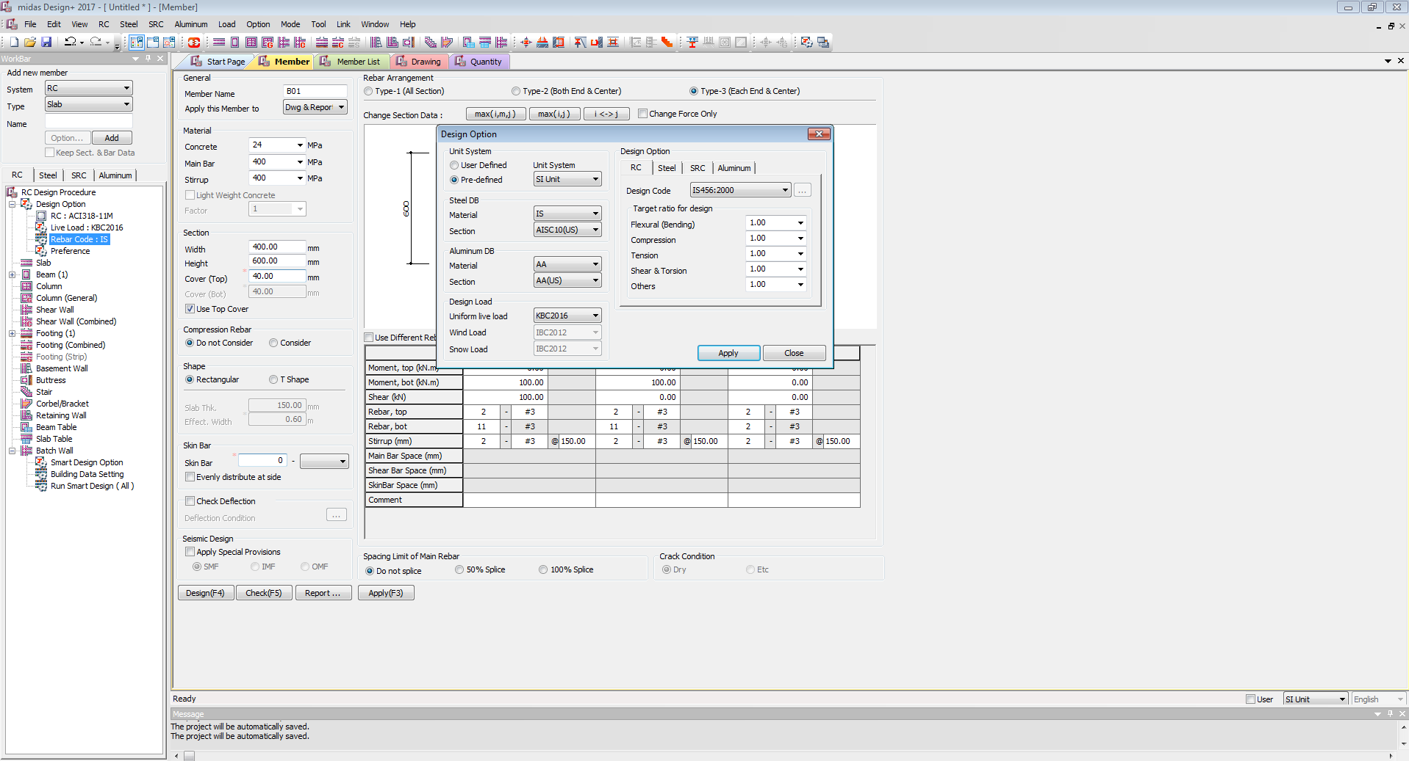

**Option**

**Design Option**

**RC**

Design code: **ECP_203_2007**

Target ratio for Design

All to **1**

Section Data Base

Material **ECP**

Default

ECP_203_2007

KBC2016

Beam Option Glow

ECP

NEWBUTTON

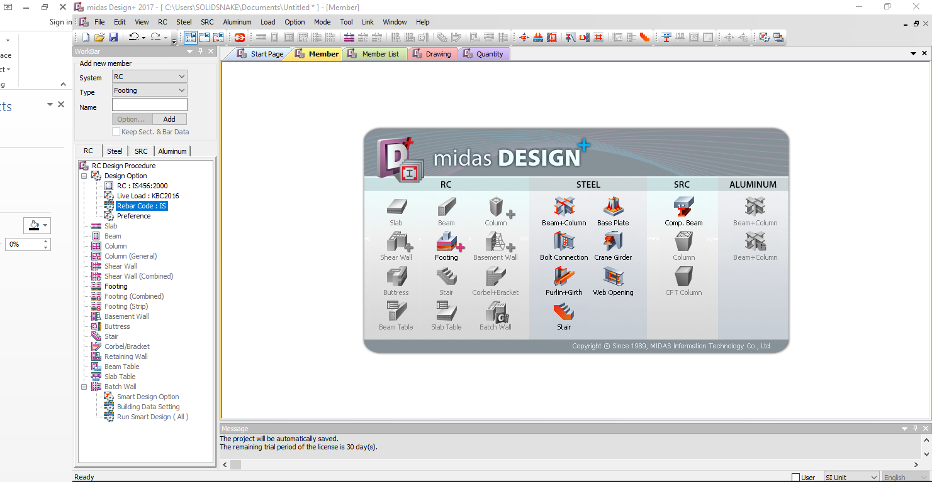

Default setup: On Click New Button

On Click New Button set Default as:

RC: **ECP_203_2007**

Live Load: **KBC2016**

Rebar Code: **ECP**

Preferences: General

Set Default Preferences as per Listed to ECP_203_2007

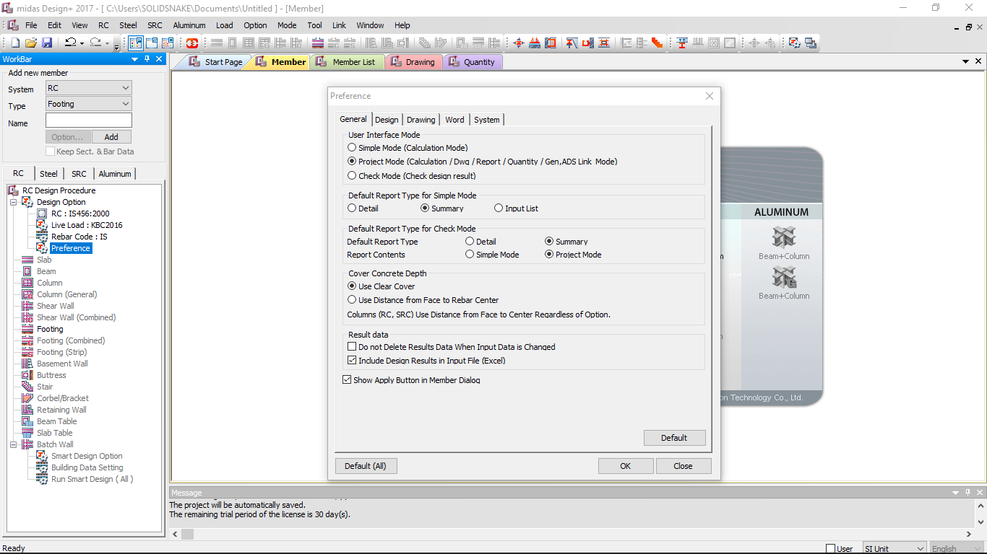

Default setup: In Preferences

**General**

User Interface Mode: **Project Mode**

Default Report type for simple Mode: **Summary**

Default Report type for check Mode

Default Report Type: **Summary**

Report Contents: **Project Mode**

Cover concrete Depth: **Use Clear Cover or Use Distance from Face to center**

Result Data

* + - **NO** do not delete Results Data
    - **YES** Include Design Results in File
    - **YES** show apply Button in Member Dialog

Preferences: Design

Increment to 50mm

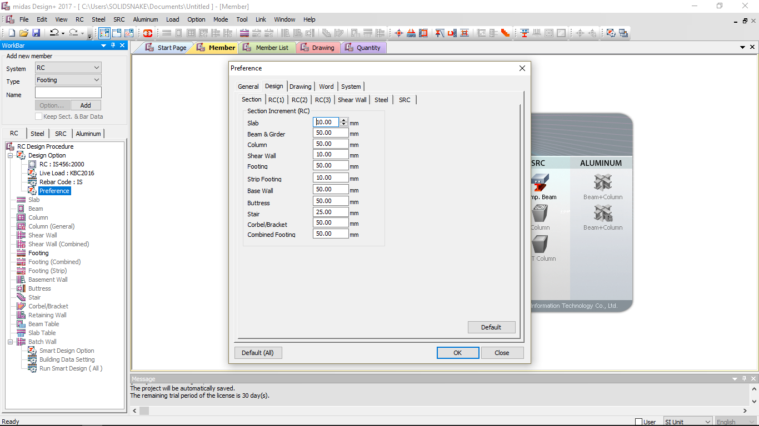







Default setup: In Preferences

**Design**

**Section**

Beam and Girder Increment to **50 mm**

Preferences: Design

Set Default Preferences as per Listed to ECP_203_2007

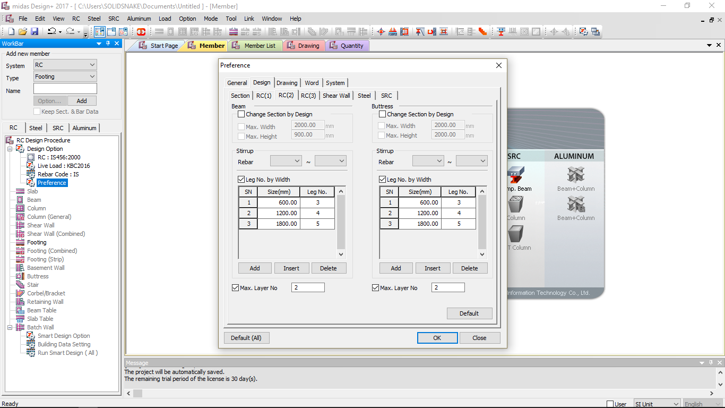





Default setup: In Preferences

**Design**

**RC(2)**

Beam

Check **No** Change Section by Design (If we push design it may change section design)

Check **Yes** Max Width **2000 mm**

Check **Yes** Max Height **2000 mm**

Stirrup

Rebar **6mm – 25mm**

Check **Yes** Leg number by Width

Size **250**  Leg No **2**

Size **600**  Leg No **3**

Size **1200** Leg No **4**

Size **1800** Leg No **5**

Check **Yes** Max Layer No **2**

Preferences: Drawing

Set Default Preferences as per Listed to ECP_203_2007

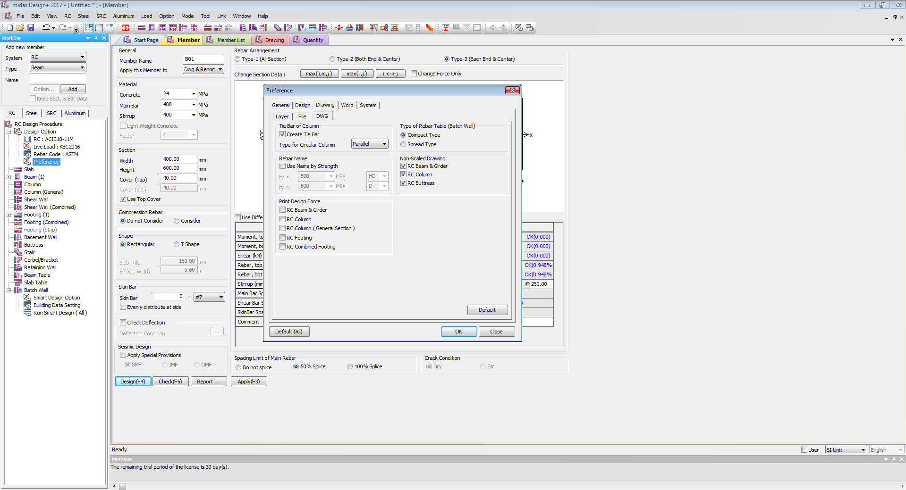









Default setup: In Preferences

**Drawing**

**Layer**

**DWG**

Non Scale Drawing

Check **Yes** RC Beam Drawing

Print Design Force

Check **Yes** RC Beam and Girder

Rebar Option:

Set Default Rebar Option as per Listed in ECP_203_2007

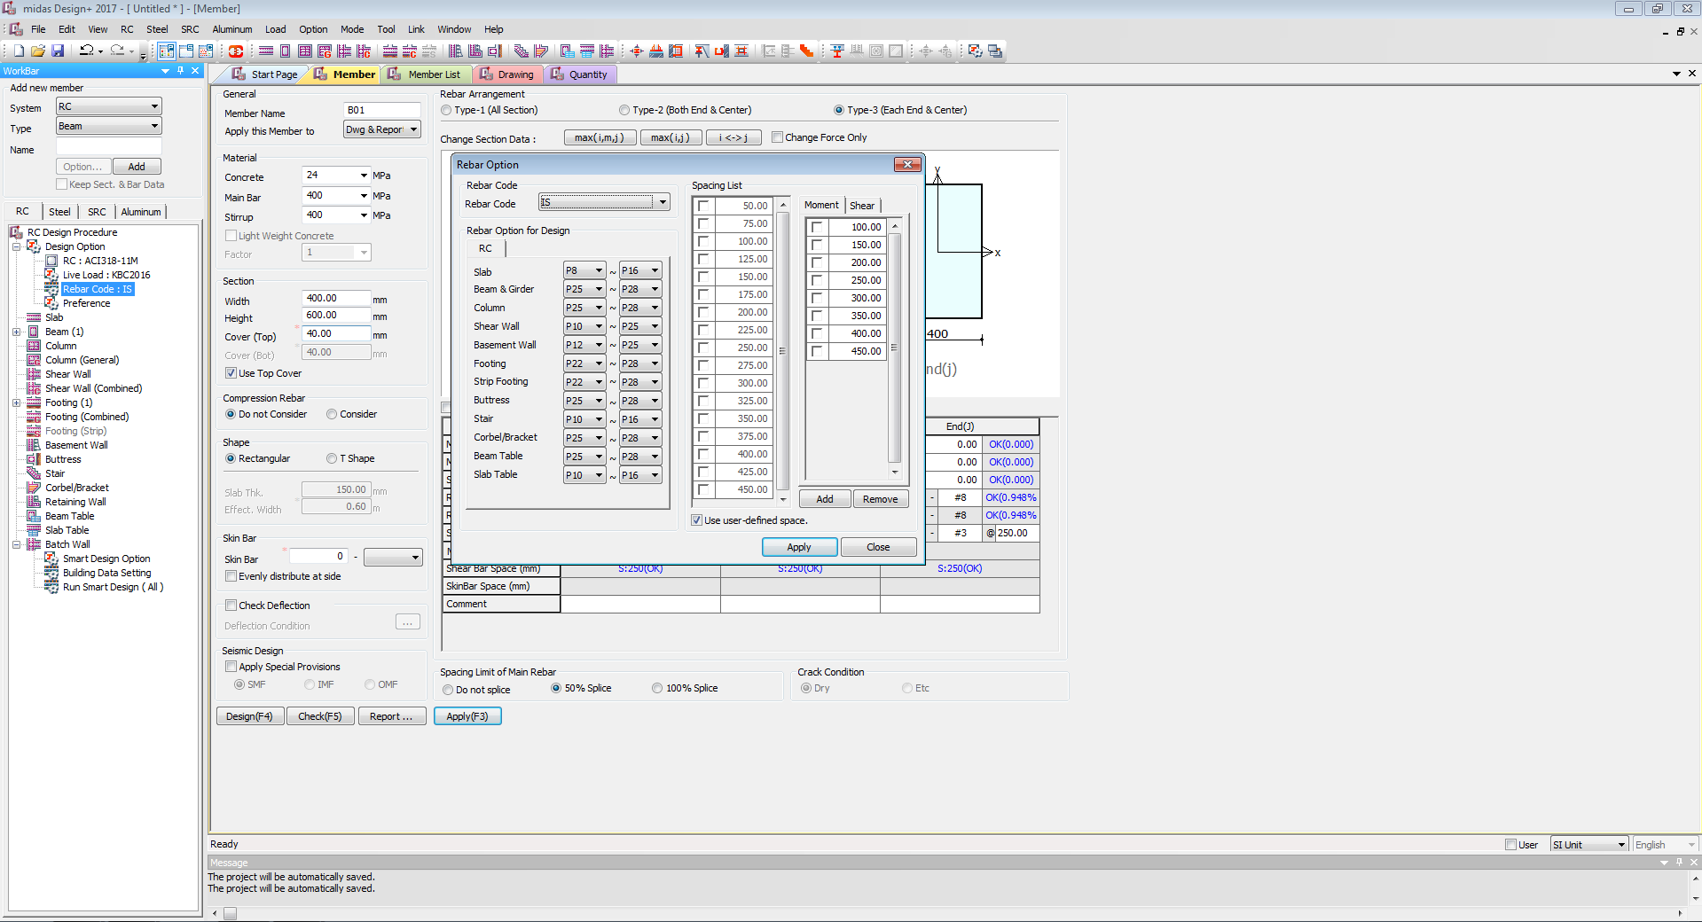









Default setup: In Rebar Code

**Rebar Code**

Rebar Code **ECP**

Rebar Option for Design

Beam & Girder **P6 – P28**

Spacing List

Add **50 -100-150-200-250-300-350-450** for Moment and Shear

Set Default Rebar Option as per Listed

**Project Mode:**

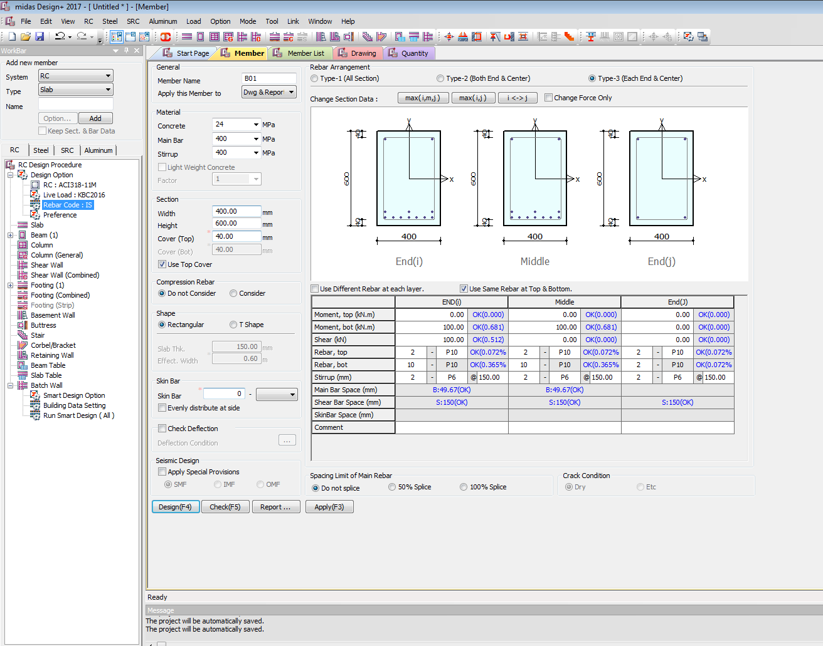











Project Mode: Default are:

General

Rebar Arrangement: **Type-3(Each End & Centre)**

Apply this Member to: **Dwg & Report**

Material

Concrete: **10 15 20 25 30 35 40 45 50 55 60 70 80 90**| Default **25**

Main Bar: **240 415 500 550 600** | Default **415**

Stirrup: **240 415 500 550 600** | Default **415**

Section

Width: **230 250 300 350 400 450…**| Default **230**

**(Show in red if width is below 230) or (If width is below 230 auto update to 230 by pop up window)**

Height: **250 300 350 400 450 500…** | Default **300**

Cover (Top): **40 45 50 55 60** | Default **40**

Cover (Bot): **40 45 50 55 60** | Default **40**

**(Show in red if clear cover is below 40) or (If clear cover is below 40 auto update to 40 by pop up window)**

Check **YES** Use Top Cover

Compression Rebar

Check **YES** do not Consider

Shape

Default Check **YES** Rectangular

If Check YES T**-Shape**

Slab Thickness **120**

Effective Width **600(Calculate as per code book formula)**

Skin Bar **(Considered if Depth is greater than 700 i.e as per code book)**

Default Skin bar **2** – **P6**

Check **NO** Evenly distribute at side

**DEFLECTION**

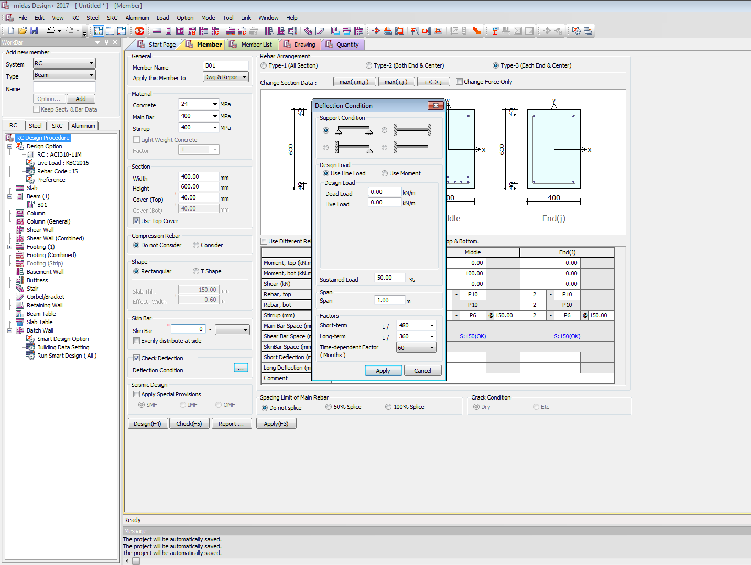

DEFLECTION

Default Check **NO** Deflection Check

If Check **YES** Deflection Check

Activate **Deflection Condition** Menu

Deflection Condition Default to be

Support Condition

**Simply Supported**

Design Load

Default Check **Use Line Load**

Design Load

**Dead Load**

**Live Load**

Sustained Load **50%** (Default)

Span **1** Meter (default)

Factor

Short-Term **L/360**

Short-Term **L/360**

Time Dependent Factor **30** (Default)

Set Default Rebar Option as per Listed



Seismic Design

Check **NO** Default Apply Special Provisions

IF Check **YES** Default Apply Special Provisions (Design as per IS seismic design code book)

Set **SMF** default

Spacing Limit of Main Rebar

**Do Not Splice**

Crack Condition **Dry or Etc (Deactivate)**

Check **NO** default Use Different Rebar at each layer

Check **YES** default Use Different Rebar at each layer

If check **YES** Use different Rebar at each layers

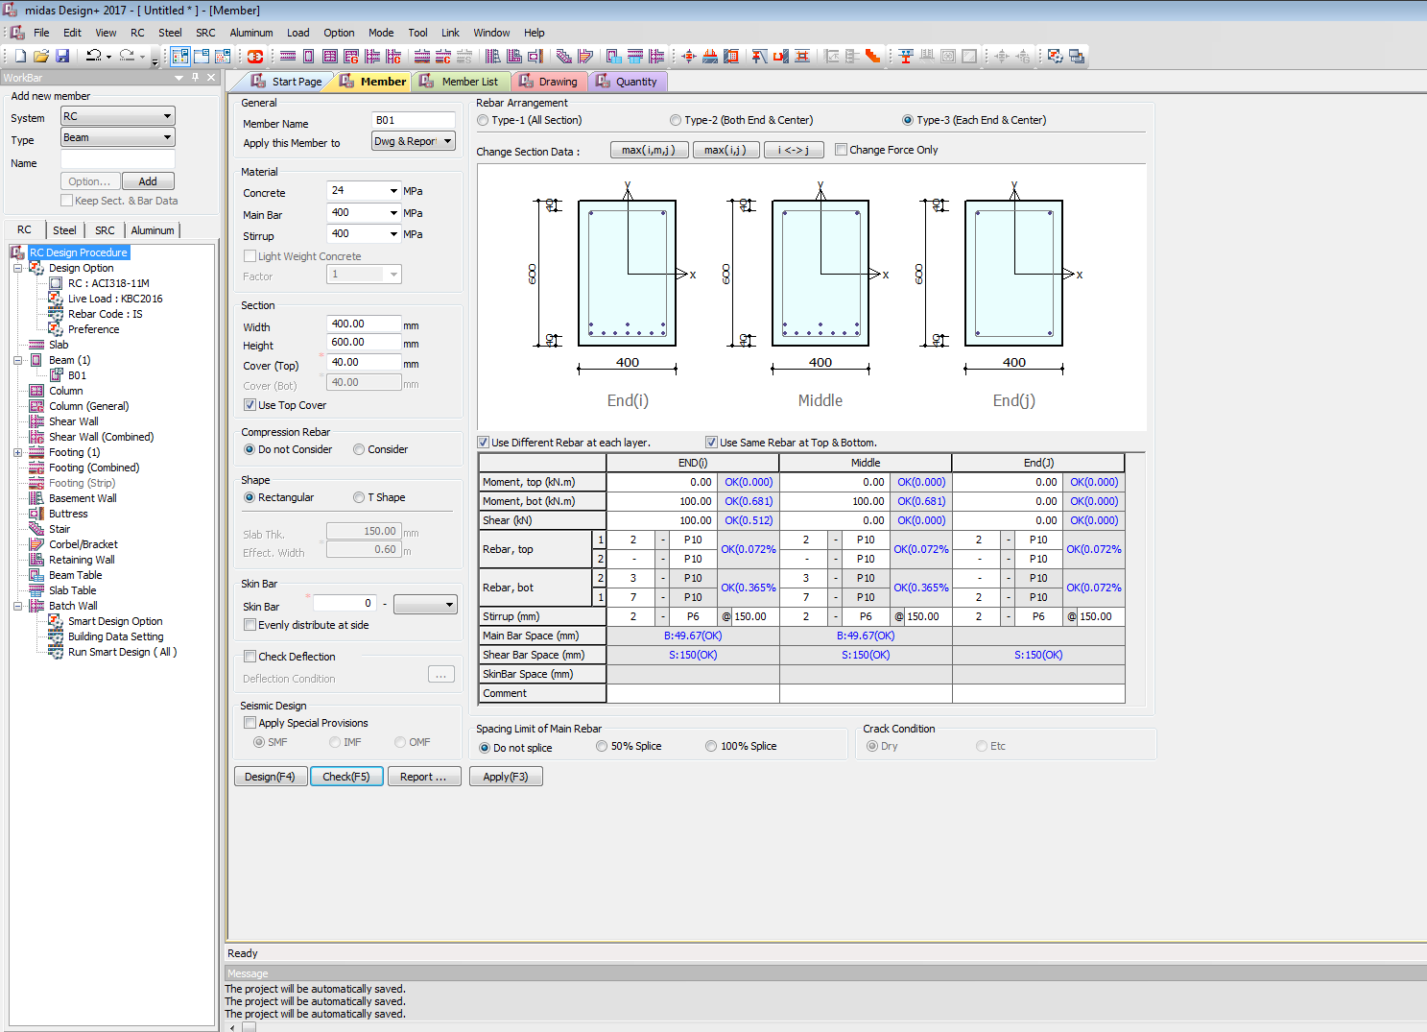

On Check **YES** default Use Different Rebar at each layer

User can input different Rebar details in different **Layers**

Member List

**Project Mode: Member list**

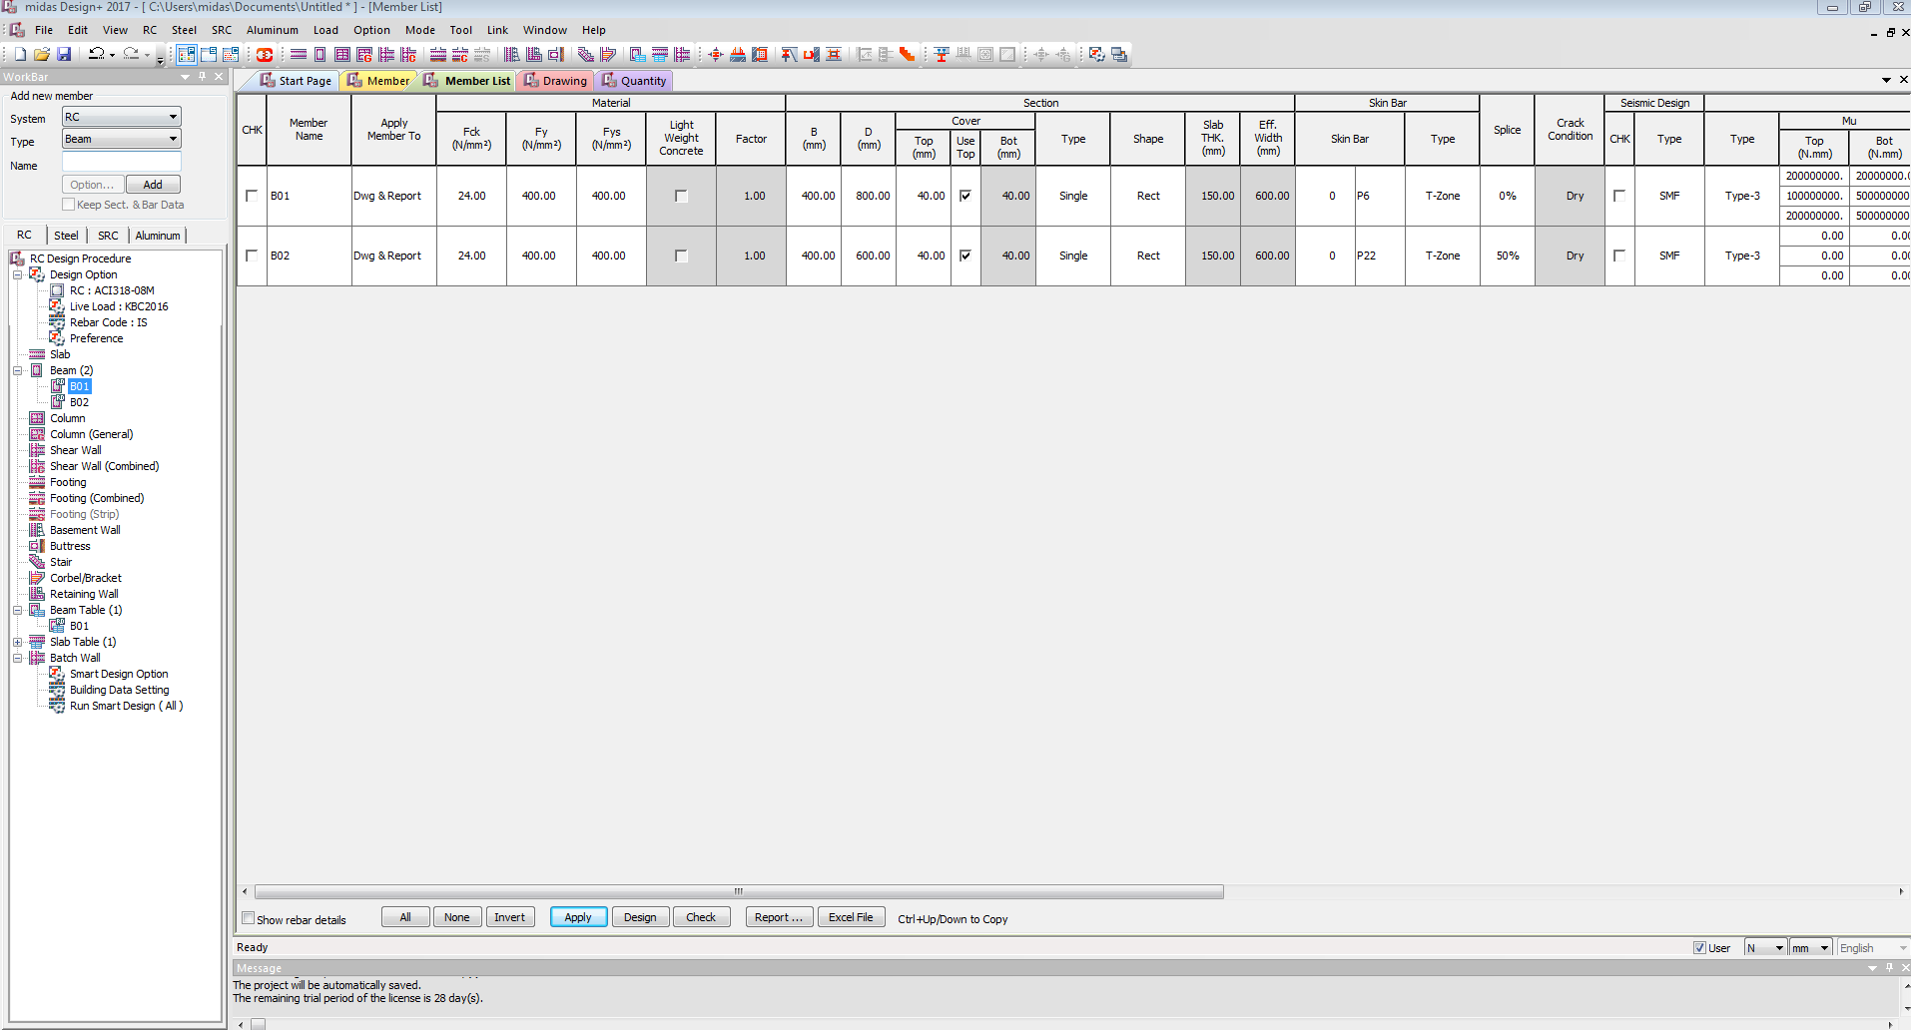



**Project Mode: Member list**

Check **NO** (Default) to Show Rebar Details

Drawing

**Project Mode: Drawing**

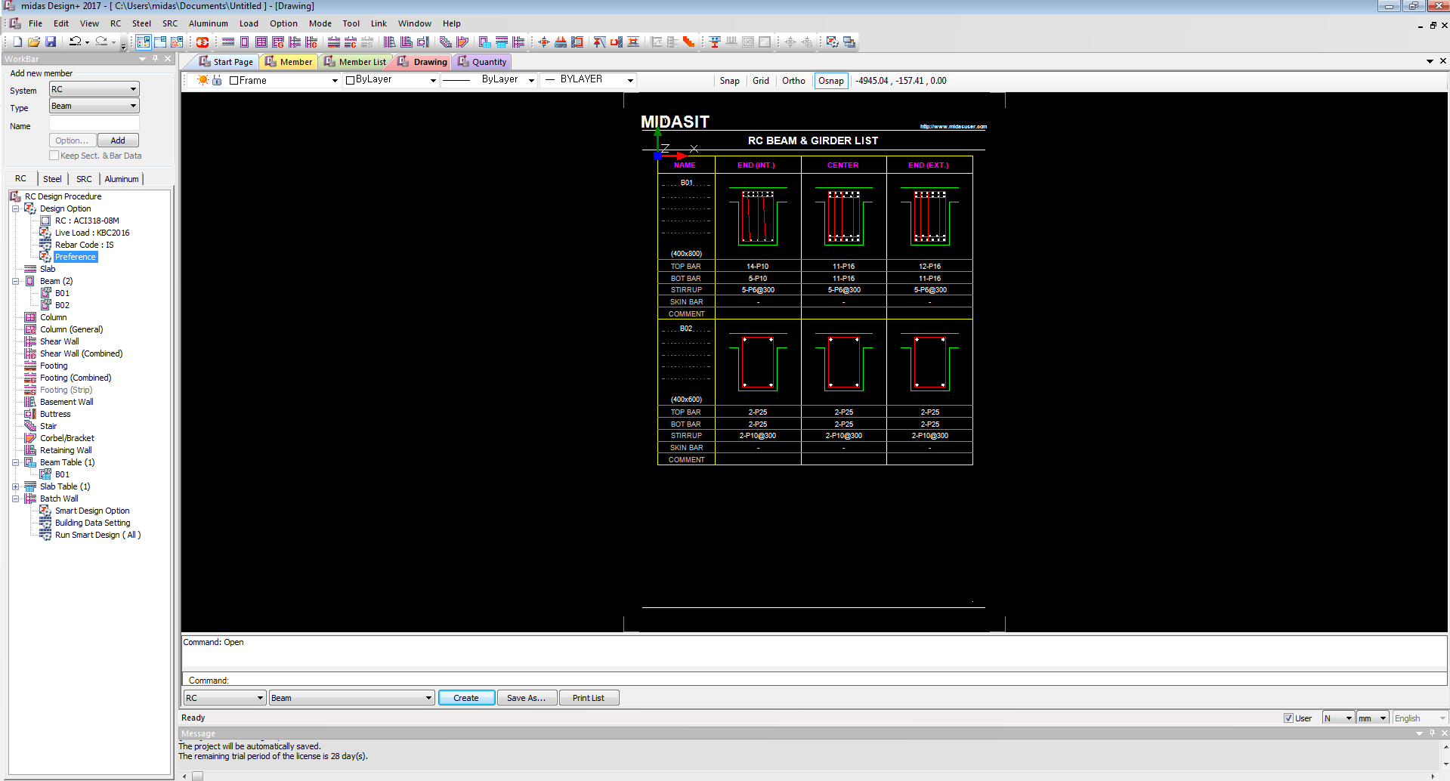

Detail Drawing







**Project Mode: Member list**

**RC BEAM** (Default)

Quantity

**Project Mode: Quantity**

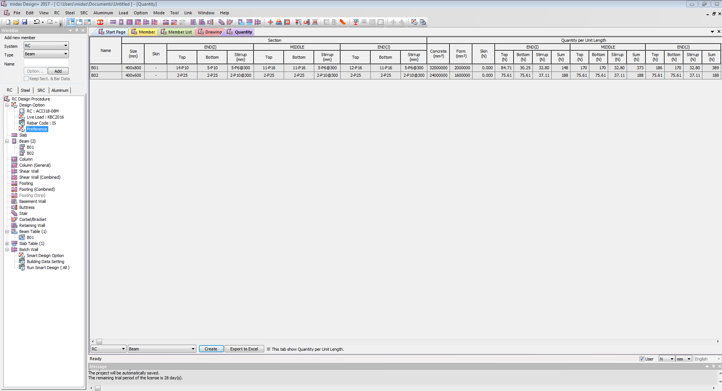





**Project Mode: Quantity**

**RC BEAM** (Default)

**Section Mode:**

SECTION MODE Activation

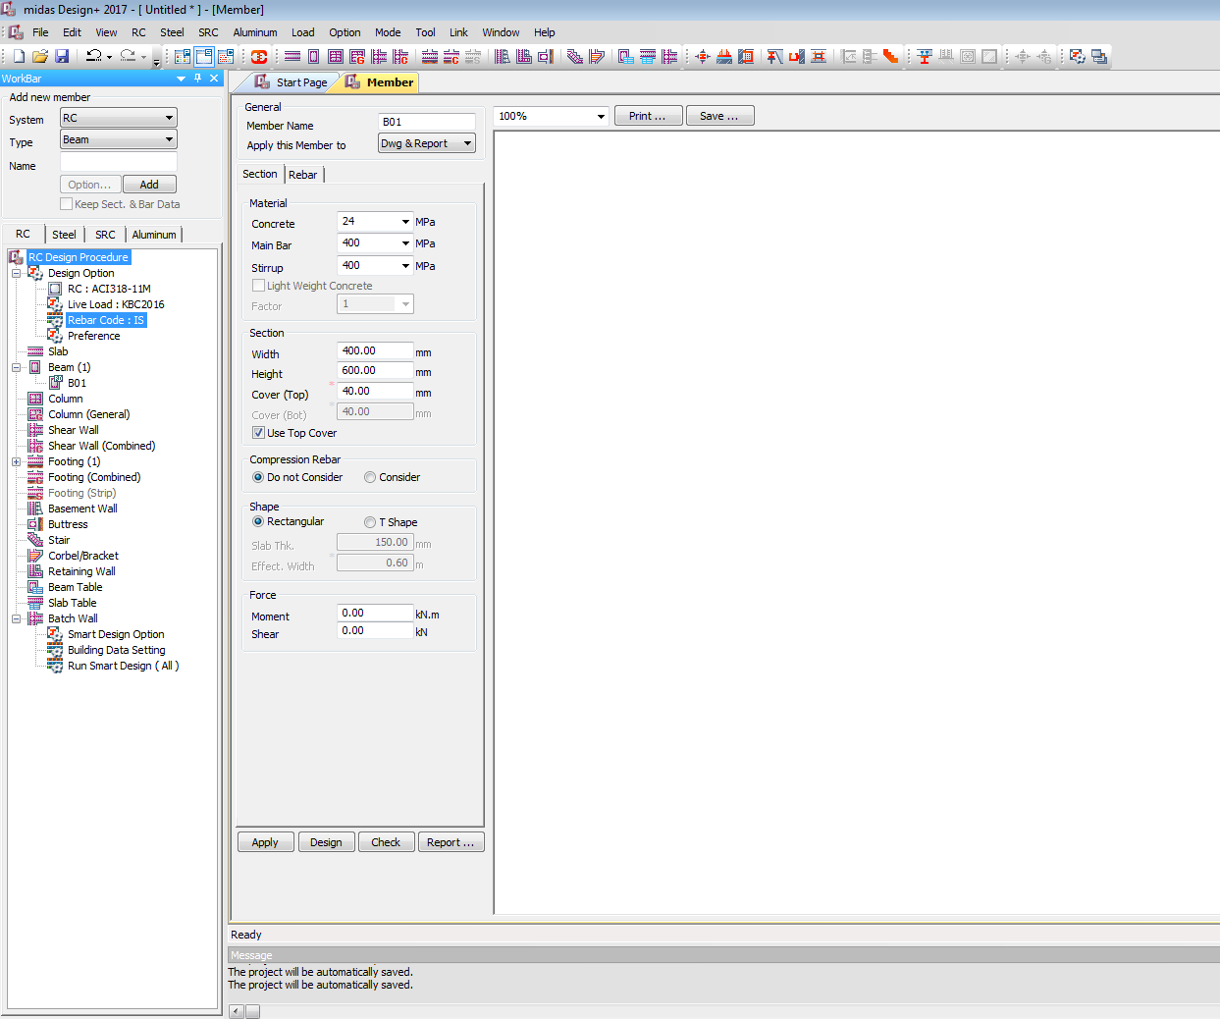

Section Mode: Default are:

General

Apply this Member to: **Dwg & Report**

Material

Concrete: **10 15 20 25 30 35 40 45 50 55 60 70 80 90**| Default **25**

Main Bar: **240 415 500 550 600** | Default **415**

Stirrup: **240 415 500 550 600** | Default **415**

Section

Width: **230 250 300 350 400 450…**| Default **230**

**(Show in red if width is below 230) or (If width is below 230 auto update to 230 by pop up window)**

Height: **250 300 350 400 450 500…** | Default **300**

Cover (Top): **40 45 50 55 60** | Default **40**

Cover (Bot): **40 45 50 55 60** | Default **40**

**(Show in red if clear cover is below 40) or (If clear cover is below 40 auto update to 40 by pop up window)**

Check **YES** Use Top Cover

Compression Rebar

Check **YES** do not Consider

Shape

Default Check **YES** Rectangular

If Check YES T**-Shape**

Slab Thickness **120**

Effective Width **600(Calculate as per code book formula)**

Force

Moment **0** (Default)

Shear **0** (Default)

**Check Mode:**

CHECK MODE Activation

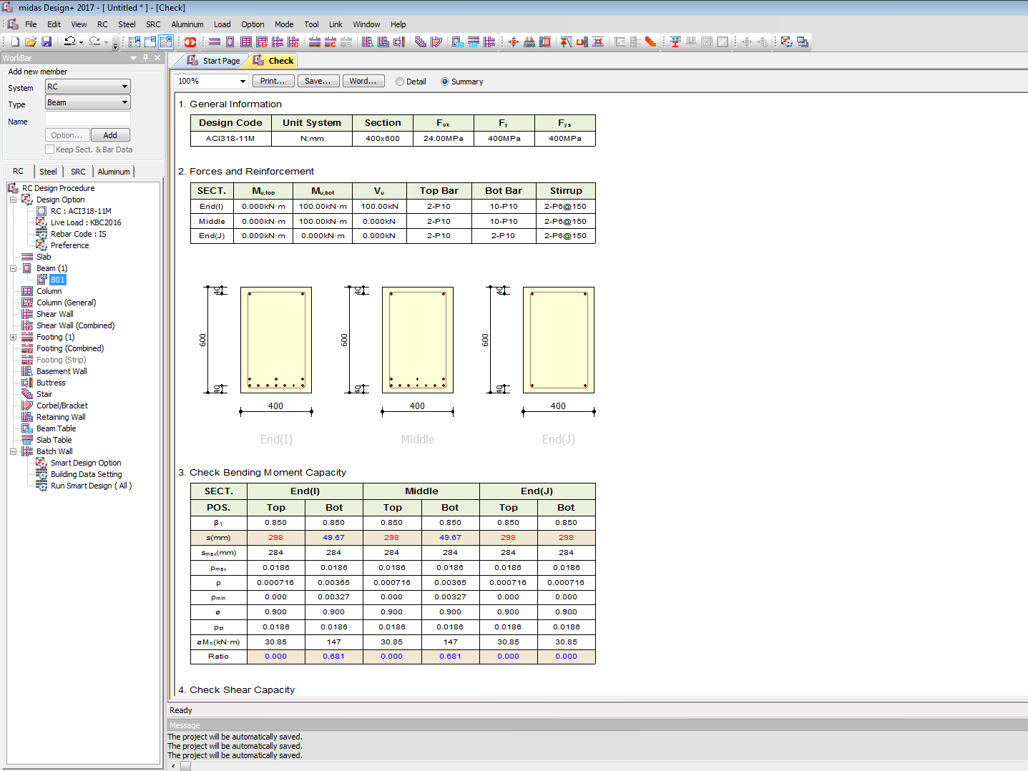

CHECK Mode: Default are:

**SUMMARY report**(Section Mode)

BEAM TABLE

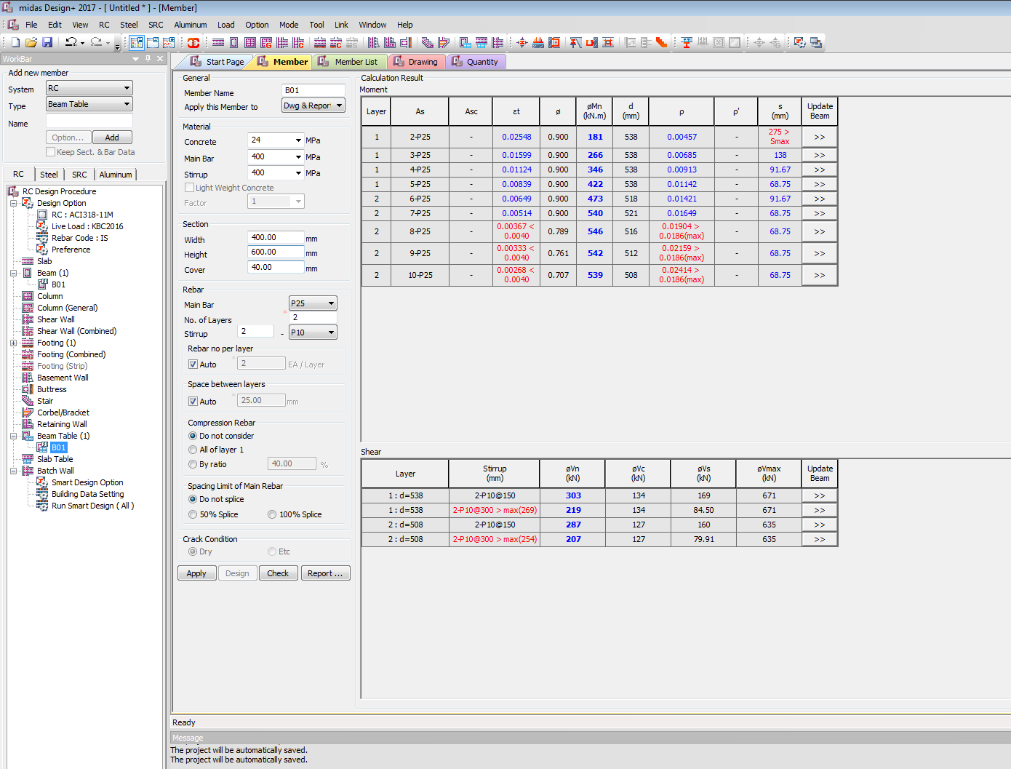

In **Beam Table**:

General

Apply this Member to: **Dwg & Report**

Material

Concrete: **10 15 20 25 30 35 40 45 50 55 60 70 80 90**| Default **25**

Main Bar: **240 415 500 550 600** | Default **415**

Stirrup: **240 415 500 550 600** | Default **415**

Section

Width: **230 250 300 350 400 450…**| Default **230**

**(Show in red if width is below 230) or (If width is below 230 auto update to 230 by pop up window)**

Height: **250 300 350 400 450 500…** | Default **300**

Cover: **40 45 50 55 60** | Default **40**

**(Show in red if clear cover is below 40) or (If clear cover is below 40 auto update to 40 by pop up window)**

Rebar

Main Bar  **P10**  (Default)

No of Layers **2** (Default)

Stirrup **2 – P8** (Default)

Rebar No per Layer

Check **YES** Auto

Spacing Between Layers

Check **YES** Auto

Compression Rebar

Check **YES** do not Consider

Spacing Limit of Main Rebar

Check **Yes** Do not Splice

Crack Condition

Deactivate

BEAM DESIGN OUT PUT

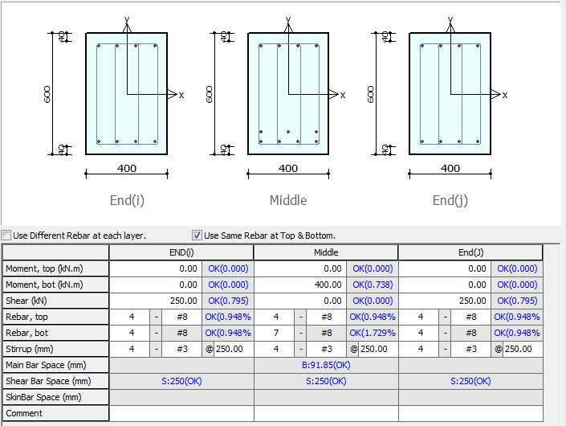

Target ratio = Vinput / Vn

Check Min Max Spacing of Bars

Ratio=Ast /b d (Checks min max)

Target ratio = Minput / Mn